Supplemental Digital Content
ID | Sample | Simulation box side size (nm) | Number of water molecules | Number of ions | Simulation time (ns) | Description
Sim 1-4 | Rocuronium | 4.92 | 3759 | Na:18 / Cl:11 | 500  (4 runs) | Encapsulation process
Sim 5-7 | Vecuronium | 4.92 | 3757 | Na:18 / Cl:11 | 500  (3 runs) | Encapsulation process
Sim 8 | Propofol | 4.58 | 3017 | Na:17 / Cl:9 | 5 | Energy calculation
Sim 9 | Dexamethasone | 4.58 | 3014 | Na:17 / Cl:9 | 5 | Energy calculation
Sim 10 | Atracurium | 4.58 | 2993 | Na:15 / Cl:9 | 5 | Energy calculation
Sim 11 | Ketamine | 4.58 | 3021 | Na:17 / Cl:9 | 5 | Energy calculation
Sim 12 | Flucloxacillin | 4.58 | 3015 | Na:18 / Cl:9 | 5 | Energy calculation
Sim 13 | Betamethasone | 4.58 | 3011 | Na:17 / Cl:9 | 5 | Energy calculation
Sim 14 | Fusidic acid | 4.58 | 3008 | Na:18 / Cl:9 | 5 | Energy calculation
Sim 15 | Pancuronium | 4.58 | 3003 | Na:15 / Cl:9 | 5 | Energy calculation
Sim 16 | Toremifene | 4.58 | 3006 | Na:17 / Cl:9 | 5 | Energy calculation
Sim 17 | Vecuronium | 4.58 | 2999 | Na:16 / Cl:9 | 5 | Energy calculation
Sim 18 | Rocuronium | 4.58 | 3007 | Na:16 / Cl:9 | 5 | Energy calculation
Sim 19 | Propofol | 4.54 | 3021 | Na:17 / Cl:9 | 1000 | Low binding with Sugammadex
Sim 20 | Rocuronium | 4.54 | 3007 | Na:16 / Cl:9 | 100 | Energy calculation
Sim 21 | Vecuronium | 4.54 | 3021 | Na:16 / Cl:9 | 100 | Energy calculation
Sim 22-24 | Pancuronium | 4.96 | 3889 | Na:17 / Cl: 11 | 500  (3 runs) | Encapsulation process
Table S- 1: Details of molecular dynamics simulations of studied drug-sugammadex complexes.

100 ns long molecular dynamics simulations were performed for the two most interesting compounds, rocuronium and vecuronium (simulation 21-22, table S-1) to see any difference in calculation of the relative binding free energy. 900 snapshots were used with 100-ps intervals over the last 90 ns of the simulations to calculate $∆H$ using gmx_MMPBSA. We have got very similar results (Table S-2) in comparison with the 5 ns simulations
Drug | $$∆H_{{MM}/{PBSA}} \left(kcal⋅mol^{-1}\right)$$
 | 5 ns simulation | 100 ns simulation
Rocuronium | $$-3.8±0.1$$ | $$-3.5±0.3$$
Vecuronium | $$-3.4±0.2$$ | $$-3.3±0.2$$
Table S- 2 Comparison between relative binding free energy for drug-sugammadex complex calculated from short (5ns) and long (100 ns) simulations. Errors are 95% confidence interval.

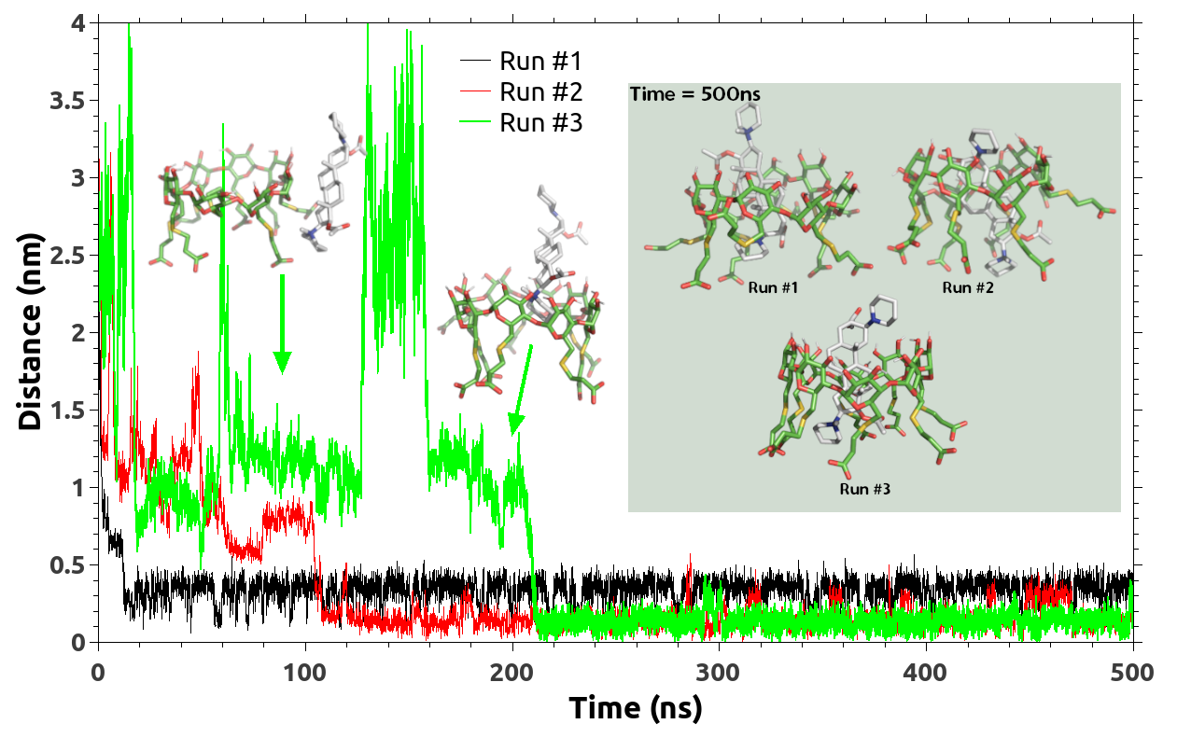
Figure S- 1: Distances between center-of-mass of vecuronium and sugammadex during the simulation course of 500 ns. Inset is the last frame of simulation indicating the vecuronium-sugammadex complex.
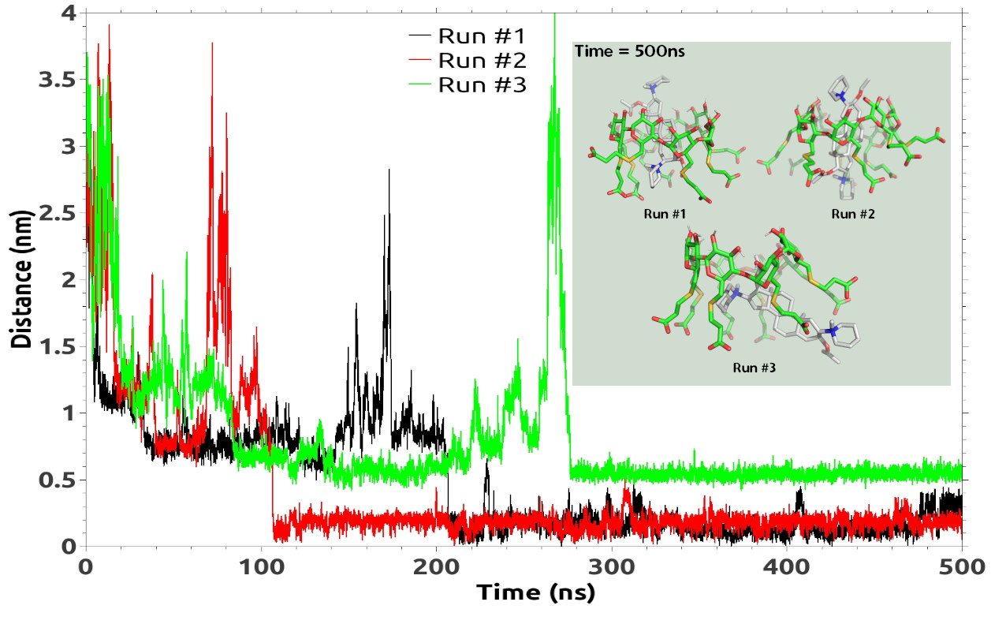
Figure S- 2: Distances between center-of-mass of pancuronium and sugammadex during the simulation course of 500 ns. Inset is the last frame of simulation indicating the pancuronium-sugammadex complex.

Figure S-2 shows the distance between cnetre-of-mass of pancuronium and sugammadex for three replication runs over the 500 ns of the encapsulation process. On average, pancuronium shows needs a longer time, in comparison with rocuronium, to be captured by sugammadex. The first two runs are mostly like the rocuronium/vecuronium encapsulation process reaching the sugammadex from the hydrophilic side of the sugammadex while the third run shows that the pancuronium reaches the sugammadex from the other side (the carboxylate groups side).

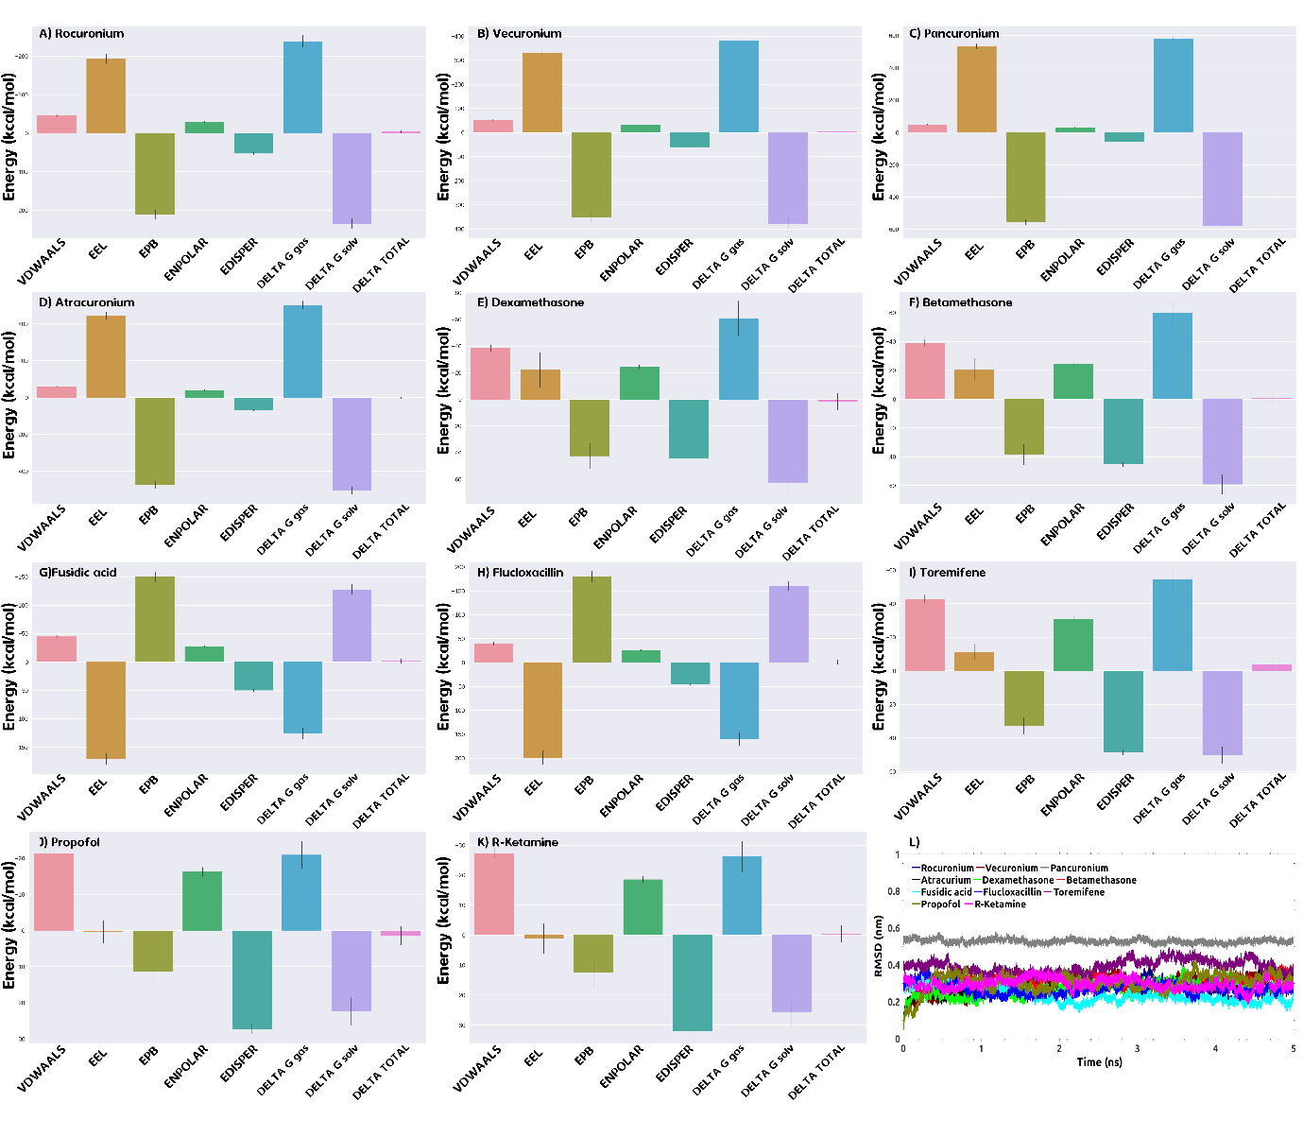
Figure S- 3 : Panel A to K: Energetic components of relative binding free energy for studied drugs-sugammadex complex and each panel contains; Van der Waals energy (VDWAALS), electrostatic energy (EEL), polar energy of solvation (EPB), nonpolar energy of repulsive solute-solvent interactions (ENPOLAR) and nonpolar energy of attractive solute-solvent interactions (EDISPER). DELTA G gas is the total energy changes in gas state (VDWAALS+ EEL) and DELTA G solv is the total energy changes in solvation state (EPB+ ENPOLAR+ EDISPER). Finally, DELTA TOTAL is the combination of gas and solvation energies. Panel L: Root mean standard deviation for the drug-sugammadex complex over the simulation course shows the stability of the complexes.

Cortical slice experimental methods
For the cortical slice experiments, the mice were anesthetized with carbon dioxide, decapitated and the brain rapidly dissected into ice-cold HEPES-buffered 'normal' artificial cerebrospinal fluid, oxygenated with 95% oxygen (Perfecto2 oxygen concentrator, Invacare, New Zealand). The normal artificial cerebrospinal fluid contained 130 mM sodium chloride, 2.5 mM potassium chloride, 1 mM magnesium chloride, 2 mM calcium chloride, 2.5 mM NaHCO3, 10 mM HEPES and 20 mM D-glucose in double-distilled water. The pH of the solution was adjusted to 7.4 with 10 M sodium hydroxide. Apart from HEPES (ITW Reagents, Spain) and sodium chloride (EMSURE, Denmark), the artificial cerebrospinal fluid ingredients were obtained from Sigma (USA). The posterior and anterior sections of the brain were removed with a razor blade and the remaining tissue block (approximately between Bregma 1 and -5 mm) was glued onto a metallic plate and placed into oxygenated ice-cold normal artificial cerebrospinal fluid for coronal slicing (400 µm thick) using a vibratome (Campden Instruments Ltd., United Kingdom). The corpus callosum of each slice was cut with a scalpel blade before being transferred to normal artificial cerebrospinal fluid for a minimum 1-hour recovery at room temperature. Following the minimum recovery period, two or three slices at a time were moved to a submersion-style perfusion bath (Kerr Scientific Instruments, New Zealand). The perfusion bath was replenished continuously with oxygenated artificial cerebrospinal fluid void of magnesium ions (no-Mg artificial cerebrospinal fluid) by gravity-feed at a rate of 5 mL/min. The lack of magnesium ions in solution activates the tissue by unblocking NMDA receptors, resulting in the generation of repeating population bursts known as seizure-like events. The no-Mg artificial cerebrospinal fluid contained 130 mM sodium chloride, 5 mM potassium chloride, 2 mM calcium chloride, 2.5 mM NaHCO3, 10 mM HEPES and 20 mM D-glucose. The pH of the solution was adjusted to 7.4 with 10 M sodium hydroxide. Three custom-made 75 µm silver/silver chloride (GoodFellow Ltd., United Kingdom) electrodes were positioned in layer IV of the somatosensory cortex to record spontaneous local field potential (LFP) seizure-like events activity. Where possible, a single electrode was placed in each slice. When this was not possible due to poor slice viability (two occasions), two electrodes were positioned in opposite hemispheres in the same slice. In these cases, because the corpus callosum had been cut, the activity at each location was independent. The analogue signal was recorded via a headstage placed near the slice preparation. The signal was amplified 1000 times, low pass (300 Hz) and high pass (1 Hz) filtered (Model 3000 differential amplifier, A-M Systems, USA) and converted to a digital signal (Powerlab, ADInstruments, Australia) at 1 kHz. The amplified and filtered signal was stored for later analysis
All drugs were added to pre-oxygenated no-Mg artificial cerebrospinal fluid to the required concentrations. The experimental protocol consisted of a baseline drug-free recording period of at least 10 minutes, followed by concurrent perfusion of propofol (34 µM) and sugammadex (20 µM) for 30 minutes and then wash with drug-free no-Mg artificial cerebrospinal fluid for 60 minutes (n=6, 6 slices, 2 animals). These were compared to equivalent experiments run with propofol (34 µM) only (n=6, 4 slices, 2 animals). As a control, sugammadex (20 µM) was perfused on its own in 2 slices (3 locations). Seizure-like event activity was quantified across the extent of each recording for inter-event frequency, peak-peak amplitude and length. Each parameter was averaged across three windows, baseline, during drug perfusion and during drug wash — and expressed as the percent change compared to baseline.

