Mechanical power ratio and respiratory treatment escalation in COVID-19 pneumonia: a secondary analysis of a prospectively enrolled cohort
Gattarello S^{1,2} MD, PhD; Coppola S MD³; Chiodaroli E³ MD; Pozzi T³ MD; Camporota L⁴ MD; Saager L^{2,5} MD; Chiumello D³ MD; Gattinoni L² MD, FRCP.

1. Anesthesia and Intensive Care Medicine, IRCCS San Raffaele Scientific Institute (Milan, Italy).
2. Department of Anesthesiology, University Medical Center, Göttingen (Göttingen, Germany);
3. Department of Anesthesiology and Intensive Care, ASST Santi Paolo e Carlo. University of Milan (Milan, Italy).
4. Guy’s and St Thomas’ NHS Foundation Trust, Department of Adult Critical Care (London, United Kingdom).
5. Outcomes Research Consortium, Cleveland, OH, USA

Corresponding author:
Luciano Gattinoni. Department of Anesthesiology, Medical University of Goettingen, University Medical Center Göttingen. Robert Koch Strasse 40, 37075 Göttingen, Germany.
Phone: 0049 551 3967713; E-Mail: gattinoniluciano@gmail.com

ONLINE SUPPLEMENT

Supplemental methods:
Pharmacological and non-ventilatory clinical management:
Patients received dexamethasone 6 mg per day for five consecutive days. After publication of the Recovery Trial (February 2021) the treatment was continued up to 10 days if the patient was not improving. Low molecular weight heparin was administered daily. Twenty-five patients received remdesevir according to infectiology’s judgement.
A progression of disease – whether due to worsening of the underlying condition or lack of response to treatment – was captured by the changes in physiological parameters.

Non-invasive respiratory support interfaces:
Continuous Positive Airway Pressure (CPAP) was administered through helmet, inflated by a gas mixture of medical oxygen and room air through a high flow generator (VitalSigns inc., Totowa, USA; Myo 3133A, Pulmodyne). Positive End-Expiratory Pressure (PEEP) was set by an adjustable mechanical valve. Non-Invasive Ventilation was administered through a facemask connected to the ventilator.

Minute ventilation, respiratory rate and tidal volume:
ExSpiron (Respiratory Motion, Inc., Waltham, MA) is a noninvasive respiratory volume monitor that continuously measures the value and the trend of minute ventilation, tidal volume, respiratory rate, by the use of bioelectrical impedance (Voscopoulos C., Brayanov J, Ladd D et al. Anesth Analg. 2013 Jul;117(1):91-100). In the present study, the commercial electrode pad (which encompasses several electrodes) was placed along the sternum according to the indications of the producer. Here below is reported an example of the provided values:
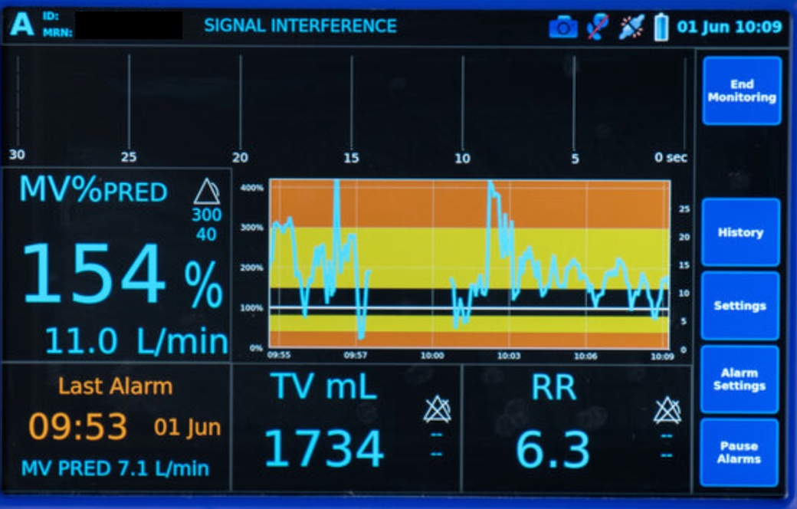

Esophageal pressure measurement:
Esophageal pressure was measured with a radio-opaque catheter equipped with a balloon in the lower part: SmartCath Bicore, USA or Nutrivent, Sidam Srl., Modena, Italy. Smart Cath was filled with 1.5 mL of air and Nutrivent with 4 mL of air, which are non-stress volumes that prove reliable over a wide pressure range for Smart Cath and Nutrivent (Chiumello D, Caccioppola A, Pozzi T et al. Minerva Anestesiol. 2020;86(10):1047-1056). The body position was standardized at a 40° degrees angle of the upper part of the bed. The catheter was introduced trans-nasally and advanced to reach the stomach (generally at a least depth of 55 cm from the nose). The intragastric position of the catheter was confirmed by a rise in intra-abdominal pressure following external manual epigastric compression. Then, it was retracted into the esophagus (i.e., confirmed by the presence of cardiac artifacts in the pressure tracing and by the difference in the absolute pressure), in the lower third of the esophagus at a depth between 35 and 40 cm from the nose. All traces were processed and displayed on a dedicated data acquisition system (Optivent SIDAM Srl, Modena, Italy). Here below we report an example of esophageal pressure tracing:
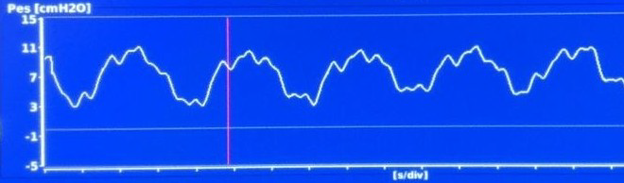
The recording of the tidal esophageal pressure was performed as follows: observation of tidal volume during at least 2 minutes; whether the respiratory pattern was stable and the morphology of the esophageal pressure wave was unchanged over following breaths, the value was recoded. The only criteria to exclude a breath was the presence of abnormal morphology of the esophageal pressure curve. In this situation, the investigator waited the patient to have a stable breathing pattern and collected such value.
The measurement of esophageal pressure is a challenging procedure that could lead to better outcomes in specific subsets of patients. However, it is not clear when and in which patient the esophageal pressure monitoring could be beneficial or not; because the position of the esophageal probe may be associated, especially in awake patients, with clinical complications, the choice to monitor or not the esophageal pressure should be carefully assessed.

Gas-volume and tissue-mass:
For each patient, the expected normal gas-volume (functional residual capacity: FRC) was calculated according to Ibanez et al. (Ibanez J, Raurich JM. Intensive Care Med. 1982;8(4):173-7):

$FRC healthy female \left(mL\right)=1.39*h-0.424$ (1)
$FRC healthy male \left(mL\right)=5.48*h-7.05$ (2)

FRC: functional residual capacity; h: height (m).
The normal expected tissue-mass was computed according to Cressoni et al. (Cressoni M, Gallazzi E, Chiurazzi C et al. Crit Care. 2013;17(3):R93):

$Lung weight \left(g\right)=-1806.1+1663.7*h$ (3)

Equations for the derivation of lung mechanics:
All the following equations refer to the static conditions as the pressure required to move gas is ignored. The tidal pleural pressure (ΔP_{pl}), generated either by artificial, muscular or a combination of these forces, is the inspiratory pleural pressure minus the expiratory pleural pressure. As the changes of pleural pressure equal the changes of esophageal pressure, ΔP_{pl} can be surrogated by ΔP_{es}. ΔP_{es} can be defined as:

$∆P_{pl}= ∆P_{es}= P_{es.insp}-P_{es.esp}$ (4)

Dynamic lung elastance was calculated as follows:

$E_{L.dyn}= \frac{{∆P}_{pl}}{Vt}$ (5)

According to the literature (Gattinoni L, Carlesso E, Cadringher P et al. Eur Respir J. 2003;47:15s-25s), we assumed that $\frac{E_{lung}}{E_{RS}}=0.7$.
Because:

$E_{tot}={ E}_{lung}*0.7= E_{CW}*0.3$ (6)

The dynamic chest-wall (E_{CW}) and respiratory system elastances (E_{TOT}) were derived as follows:

$E_{CW}= \frac{E_{lung }* 0.7}{0.3}$ (7); and $E_{TOT}={ E}_{lung}+{ E}_{lung}$ (8)

During assisted mechanical ventilation the possible action of the patient’s respiratory muscles (P_{musc}) on the pleural pressure changes must be considered. Therefore:

${∆P}_{pl}= ∆P_{aw }∙\frac{E_{w}}{E_{TOT}} - ∆P_{musc }∙\frac{E_{L}}{E_{TOT}}$ (9)

This equation describes the changes of esophageal pressure (equal to pleural pressure) when both mechanical ventilation and muscular activity are acting together. Note that ΔP_{aw} alone increases ΔP_{pl} while the ΔP_{musc} decreases it, thus justifying the subtraction between ΔP_{aw} and ΔP_{musc}. The E_{w}/E_{TOT} is the ratio between the chest-wall elastance and total respiratory system elastance, while E_{L}/E_{TOT} is the ratio between the lung elastance and the total respiratory system elastance.
Because the study population was in C-PAP, ΔP_{aw} equals zero; therefore, the tidal muscular pressure (ΔP_{musc}) was calculated as follows:

${∆P}_{musc}= - ∆P_{pl }∙\frac{E_{TOT}}{E_{L}}$ (10)

Depending on the direction of the pressure generated by the respiratory muscles, the sign may be positive or negative. Because patients were not receiving any support-pressure but C-PAP, the absolute value of the tidal muscular pressure was used for calculations.
The ventilatory ratio was calculated as follows:

$VR=\frac{V_{E} * {PaCO}_{2}}{0.1 *{ 40 * Kg}_{ibw} }$ (11)

Where V_{E} is the minute ventilation, PaCO₂ is the arterial tension of CO₂, 0.1 is the ideal minute ventilation per kilogram at rest (Gattinoni L, Carlesso E, Cadringher P et al. Eur Respir J. 2003;47:15s-25s), and 40 is the normal value of CO₂ at rest.

Derivation of the respiratory-system mechanical power:
The standard equation for the calculation of the mechanical power applied to the respiratory system (MP_{RS}) is the following (Gattinoni L, Tonetti T, Cressoni M et al. Intensive Care Med. 2016; 42(10):1567-1575):

${MP}_{RS} \left(J/min\right)=0.098*RR*\left({Vt}^{2}*\left(0.5*E_{RS}+RR* \frac{1 + I:E}{60 * I:E}* R_{aw}\right)+Vt*PEEP\right)$ (12)

Where 0.098 converts L*cmH₂O into J/min; RR is the respiratory rate; V_{t} is the tidal volume; E_{RS} is the total elastance; I:E is the inspiratory-expiratory ratio, which we assumed to be 0.5; R_{aw} is the resistance of the airway, assumed to equal 10 cmH₂O/mL*sec, and PEEP is the positive end-expiratory pressure.
According to the literature (Gattinoni L, Carlesso E, Cadringher P et al. Eur Respir J. 2003;47:15s-25s), we assumed that:

$\frac{E_{lung}}{E_{RS}}=0.7$ (13); therefore: $\frac{E_{RS}}{E_{lung}}=1.43$ (14)

Where E_{lung} and E_{RS} are the elastances of lung and respiratory system.
Given that:

$E_{RS}=\frac{∆P_{aw}}{V_{t}}$ (15);

Solving the numerical multiplications of the values that we assumed as fixed (I:E = 0.5 and R_{aw} = 10), the final equation is obtained:

${MP}_{RS} \left(J/min\right)= 0.098*RR*\left( {Vt}^{2}*\left(0.5*1.43* \frac{∆P_{pl}}{V_{t}}+RR*\frac{1 + 0.5}{60 * 0.5}*10\right)+Vt*PEEP\right)$ (16)
${MP}_{RS} \left(J/min\right)= 0.098*RR*\left({Vt}^{2}*\left(0.714* \frac{∆P_{pl}}{V_{t}}+RR*0.5\right)+Vt*PEEP\right)$ (17)

Derivation of the expected baseline mechanical power:
The expected baseline mechanical power was conceived as the energy required to guarantee the respiratory homeostasis at baseline conditions. Its final equation originates from equation #12 of this document, under the assumption that, at rest, respiratory rate may approximate to 15 bpm, tidal pleural pressure to 5 mmHg (Butler J, Caro CG, Alcala R et al. J Clin Invest. 1960; 39(4):584-591) and PEEP is 0 in ideal conditions.
Furthermore:

$V_{E}=0.1*IBW$ (18); $V_{E}=Vt*RR$ (19) and $RR=15$;

Therefore: $Vt=\frac{ 0.1 * IBW}{15}$ = $0.00\overline{6}*IBW$ (20)

Where IBW is the ideal body weight, and 0.00$\overline{6}$ is the result of 0.1/15 and it is expressed as L/(Kg*min).
Solving the numerical multiplications of the values that we assumed as fixed (RR = 15 and ΔP_{pl} = 5), the final equation is obtained:

${MP}_{exp} \left(J/min\right)= 1.47*({0.00\overline{6}*IBW)}^{2}*\left(\frac{3.57}{0.00\overline{6} * IBW}+7.5\right)$ (21)

Flow-chart of patients’ selection:
One-hundred and forty patients had COVID-19 disease confirmed by polymerase chain reaction and associated respiratory failure; among them, in the first 39 it was not possible to monitor the total ventilation and calculate mechanical power, therefore, the analysis was performed in 111 consecutive patients.

Supplemental results:
Table E1: ROC analysis and AUC for the assessed variables
Assessed variable | Area under the curve [95%CI] | p-value
Tidal volume/ideal body weight (mL/Kg) | 0.534 [0.417-0.650] | 0.573
Respiratory rate (bpm) | 0.654 [0.546-0.761] | 0.007
Minute ventilation (L/min) | 0.649 [0.545-0.752] | 0.008
PaCO₂ (mmHg) | 0.595 [0.485-0.704] | 0.097
Estimated PaO₂/FiO₂ (mmHg) | 0.642 [0.532-0.752] | 0.015
Tidal pleural pressure (cmH₂O) | 0.673 [0.567-0.779] | 0.003
Tidal muscular pressure (cmH₂O) | 0.700 [0.595-0.804] | 0.001
Dynamic elastance, lung (cmH₂O/L) | 0.673 [0.565-0.781] | 0.004
Ventilatory ratio | 0.612 (0.496-0.727] | 0.066
Mechanical power, respiratory system (J/min) | 0.738 [0.636-0.839] | <0.001
Mechanical power ratio, respiratory system | 0.734 [0.625-0.844] | <0.001
ROX index | 0.659 [0.549-0.769] | 0.006
Pressure-rate index | 0.733 [0.631-0.835] | <0.001

Figure E1: Receiver Operating Characteristic and Area Under the Curve of mechanical power (J/min; AUC 0.738), mechanical power ratio (AUC 0.734) and tidal muscular pressure (cmH₂O; AUC 0.700).

Figure E2: Receiver Operating Characteristic and Area Under the Curve of the ROX index (AUC 0.659) and the pressure-rate (4ΔP+RR) index (AUC 0.733).

Figure E3: Receiver Operating Characteristic and Area Under the Curve of indexed tidal volume (mL; AUC 0.534), PaO₂/FiO₂ ratio (mmHg; AUC 0.642) and respiratory rate (bpm; AUC 0.654).

