Figure E1
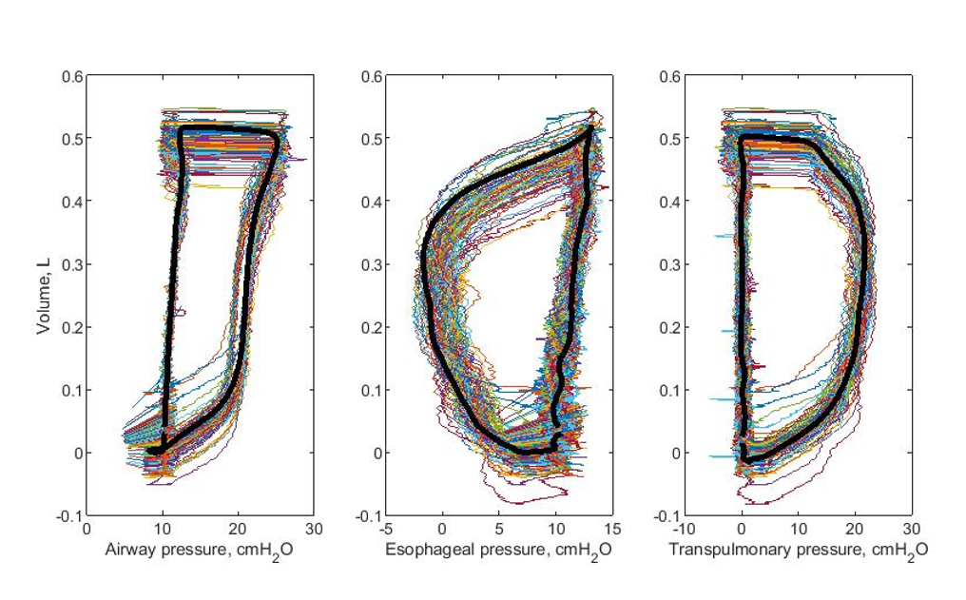
Figure legend: Example of stacked pressure-volume loops to obtain a representative breath from a single hour of recordings in one patient. Y-axes show volume in liters, x-axes show airway pressure, esophageal pressure and transpulmonary pressure, respectively. The transpulmonary mechanical power was calculated as the area enclosed by the P_{L}-volume loop shown on the right, multiplied by the respiratory frequency and 0.098 to convert the unit to J/min.

