Figure E3
A

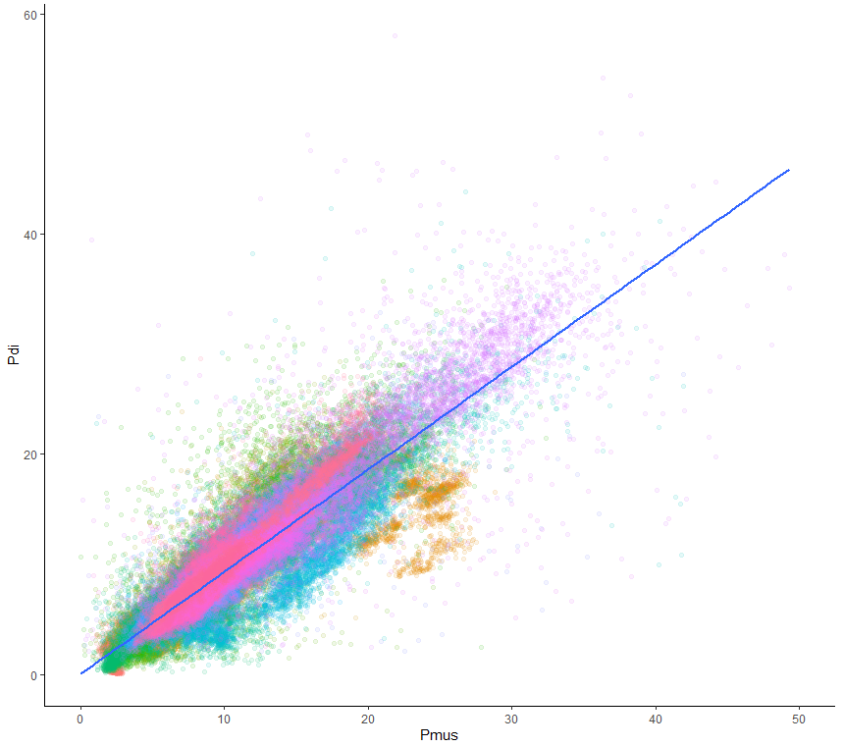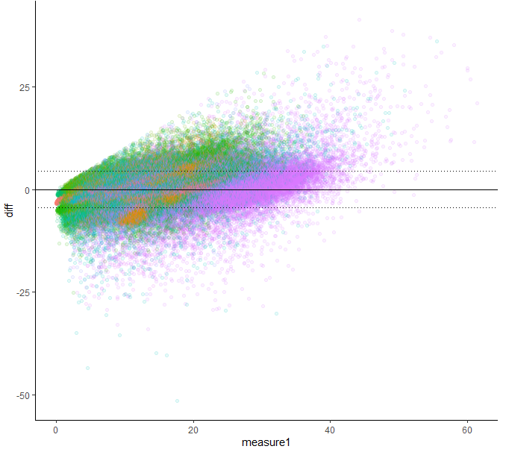
Difference between observed and predicted Pdi
Pdi, cmH₂O
Pdi, cmH₂O
Pdi, cmH₂O
Pmus, cmH₂O
B

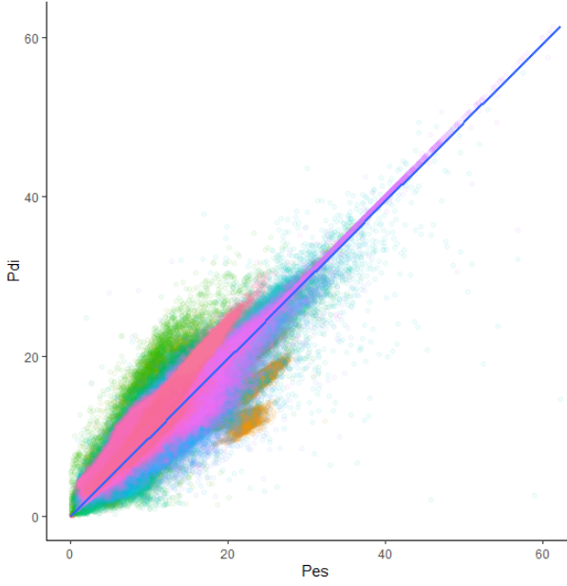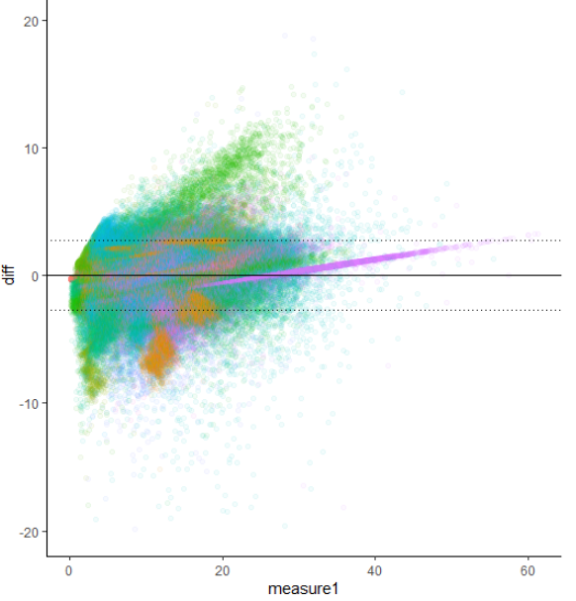
Difference between observed and predicted Pdi
Pdi, cmH₂O
Pdi, cmH₂O
Pes, cmH₂O
Pes, cmH₂O
Figure legend: Correlations between total respiratory muscle pressure (ΔPmus), esophageal pressure (ΔPes) and transdiaphragmatic pressure (ΔPdi). Data includes 840,817 breaths from 38 subjects; 3.9% of breaths had a ΔPdi <3cmH₂O and 36.4 % had a ΔPdi > 12cmH₂O. Each dot represents one breath, each color represents a subject A Left: Correlation ΔPmus with ΔPdi. Right: Bland-Altman plot showing the bias and 95% limits of agreement between ΔPdi and predicted ΔPdi based on ΔPmus (ΔPdi = 0.85*ΔPmus, r² = 0.87, p<0.001). B) Left: A Left: Correlation of ΔPes with ΔPdi. Right: Bland-Altman plot showing the bias and 95% limits of agreement between ΔPdi and predicted ΔPdi based on Pes (ΔPdi = 1.08*ΔPes, r² = 0.92, p<0.001).

