Figure E6

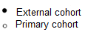
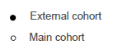
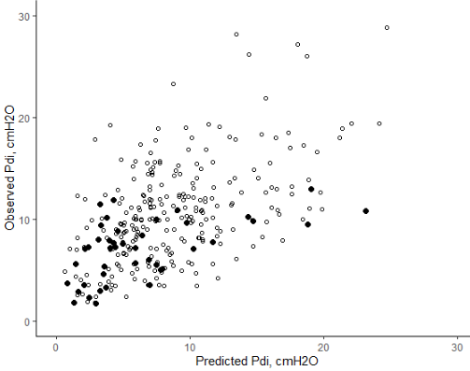
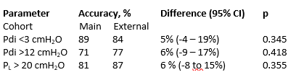
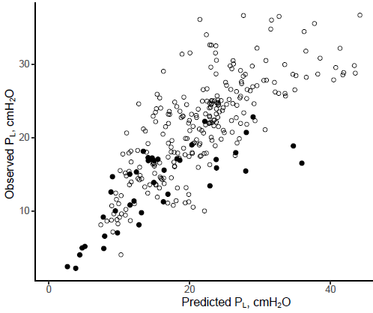
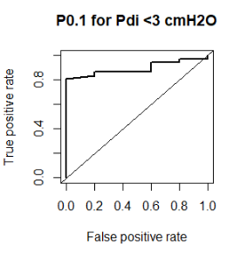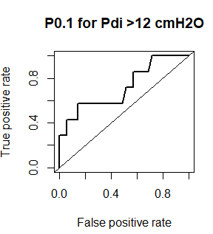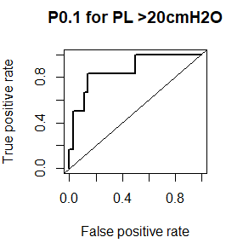
AUC = 0.71
AUC = 0.84
AUC = 0.86
Figure legend: Scatter plot showing the relationship between predicted and observed transdiaphragmatic (ΔPdi) and transpulmonary (ΔP_{L}) pressures based on the airway occlusion pressure at 100ms (P0.1) in the external cohort (solid dots, n = 43) and primary cohort (open dots, n = 282). Bottom graphs show areas under receiver-operator curves of using P0.1 to detect potentially injurious diaphragm effort and lung stress using the cut-offs derived in the main cohort on the data in the external cohort.

