Figure E8
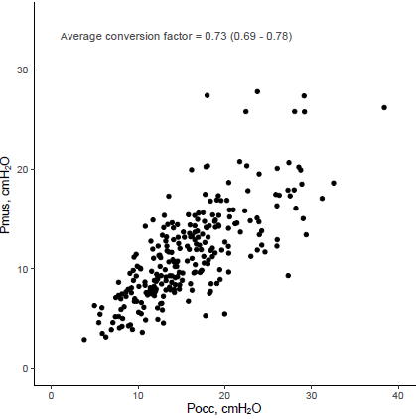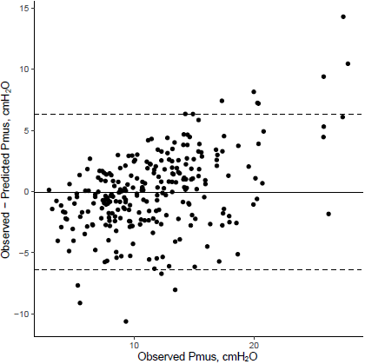
Figure legend: Left) Scatterplot showing the relation between the occluded inspiration pressure (Pocc) and total respiratory muscle pressure (Pmus) in the primary cohort. Each dot is a measurement (n = 282). Right) Bland-Altman plot showing the difference between the observed and predicted Pmus on the y-axis versus the observed Pmus on the x-axis. Dotted horizontal lines show the 95%-limits of agreement.

