Instructions for running SAS code for analyses of data for Table 2
1. Update the SAS code (errata_sas.txt) to indicate the locations of the errata_data.xls file and the location of the bootstrap program (jackboot.sas).
2. Run the SAS code to create the output attached (Table_2_output_3-5-2014.rtf). T-tests for each cost outcome by treatment group and the associated bootstrap analysis.

Cost data
cost_surg_robot: Cost of the day of surgery including the cost of the robot
cost_surg_norobot: Cost of the day of surgery without the cost of the robot
cost_6wk_robot: Cost of full surgical hospitalization and any subsequent hospitalizations within six weeks of surgical date including the cost of the robot
cost_6wk_norobot: Cost of full surgical hospitalization and any subsequent hospitalizations within six weeks of surgical date without the cost of the robot
Costs with the robot were the costs without the robot plus the equivalent annual cost per use and the maintenance cost per use (see below).
To get equivalent annual cost per use we used the following formula (Drummond ME, Stoddard GL, Torrance GW. Methods for the Economic Evaluation of Health Care Programmes. Oxford: Oxford University Press (1992), P. 51):
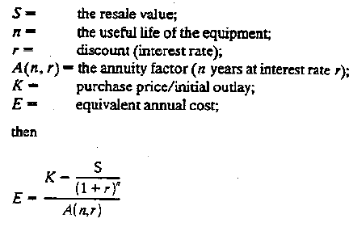
Rate | 0.03
Annuity Factor | 6.2303
Resale Value | 200000
Years of Use | 7
Purchase Price | $1,838,140.00
Equivalent annual cost | $268,931.14
Number of uses per year | 300
Cost per use without upkeep | $ 896.44
Yearly Upkeep | 153000
Cost per use with upkeep | $ 1,406.44

