Supplementary Material

Governing equations for blood flow simulations
The equation of motion for the continuous phase (blood) are the Navier-Stokes equations:
$∇∙u=0$ (1)
$ρ\left( \frac{∂u}{∂t}+u∙∇ u\right)=-∇p+μ∇^{2}u$ (2)
Equation (1) and (2) represents the basic continuity and momentum equations for the fluid in dimensional form. Here, $u$ is the velocity, $p$ is pressure, $ρ$ is the fluid density, and μ is the fluid dynamic viscosity. Blood was modeled as a homogeneous, incompressible, Newtonian fluid with density $ρ$ = 1060 kg/m³ and dynamic viscosity μ = 0.0035 Pa-s to solve the unsteady Navier-Stokes equations.

Model boundary conditions
The Windkessel model solves the following equation for time-varying pressure:
$\frac{P{\left(t\right)}_{i}}{R_{i}}+C_{i}\frac{d P{\left(t\right)}_{i}}{dt}=Q{\left(t\right)}_{i}$ (3)
Where $i$ indicates an outlet (i.e. brachiocephalic, carotid, subclavian and descending aorta) $P{\left(t\right)}_{i}$ represents the time-varying pressure at outlet $i$, $Q{\left(t\right)}_{i}$ is the volume flow rate of blood through outlet $i$, $C_{i}$ is the vascular capacitance in (m³/Pa) and $R$ is the vascular resistance in (Pa-s/m³) for outlet $i$.The various R and C values used for the four outlets are shown in Table- S1.

Table -S 1: Parameters used in the Winkessel model for vascular resistances
Outlet | Resistance R (Pa-s/m³) | Capacitance C (m³/Pa)
Brachiocephalic | 1.852 x 10⁸ | 5.401 x 10⁻¹¹
Common Carotid | 3.901 x 10⁸ | 2.563 x 10⁻¹¹
Left Subclavian | 3.955 x 10⁸ | 2.528 x 10⁻¹¹
Descending Aorta | 5.368 x 10⁷ | 1.863 x 10⁻¹⁰

Particle tracking
The equation of motion of a particle at location $X\left(t\right)$ is at time instant $t$, is:
$\frac{d}{dt}X\left(t\right)=U(X\left(t\right),t)$ (4)
Equation (3) represents the simplified particle dynamics, where the velocity is a function of location, equal to the velocity of the blood surrounding it. The particle location is updated by numerical integration of this equation with sufficiently small time step.

Particle trajectories:
The particle trajectories were constructed from their location at each fluid time step, from particle injection at the outflow graft to particle exit through any of the vessels: brachiocephalic, subclavian, carotid or descending aorta, or to their final positions if they remain in the aortic territory.

Particle residence time (RT)
The particle residence time (RT) was calculated by tracking the time each particle remained in the vascular domain:
$RT_{i}=T_{i}^{entrance}-T_{i}^{exit}$ (5)
Where $i$ is an index for each particle,$T_{i}^{entrance}$ represents the time the particle is injected into the domain, and $T_{i}^{exit}$represents the time the particle trajectory ends.

Particle stress history (SH)
Lagrangian tracking allows for determination of accumulated shear stress on each platelet, as a function of time in the flow, to evaluate the level of SIPA associated with each LVAD outflow graft angle studied:
$SH= \int_{t_{0}}^{t}{τ\left(X\left(t^{'}\right),t^{'}\right)dt^{'}}$ (6)
Where $τ$ is the instantaneous shear stress magnitude at time $t^{'}$ and $X\left(t^{'}\right)$ is the platelet’s location at that time.

Thrombogenic potential (TP) calculation
Please refer to our previously published work *** for details of how thrombogenic potential (TP) was calculated. As mentioned in Section 2, we have modified the TP calculation algorithm to include a probability of occurrence (PO) score. The PO score is obtained by assigning weights based on the % differences for different time ranges for RT and different SH ranges. For RT, higher times were assigned larger weights, indicating their importance to evaluation of the overall thrombogenicity – for example, for the simulations without AV opening, the time range of 0-1 second was assigned a weight of 1 and the time range of 8-9 seconds was assigned a weight of 9. For the simulations with AV opening, the weights were calculated from the % difference in each of the categories of the time ranges. For example, a 10% reduction in the PO of particle RT in the range of 0-1 seconds due to AV opening resulted in a weight of 0.9 assigned to the AV opening case for that time range. A 10% reduction in the particle RT due to AV opening for the time range of 8-9 seconds would lead to a weight of 9 for the no AV opening case and a weight of 8.1 for the AV opening case. A similar procedure was used to assign weights for particle SH. This methodology was developed to elucidate the importance of particles circulating the domain for long periods of time and /or accumulating large SH to evaluation of overall thrombogenicity.

45⁰ configuration
Particles traveling toward the brain in the 45⁰ configuration without AV opening had a median RT of 0.39 s, with 12.7% particles having extreme residence times. In comparison, particles in the AV opening scenario had a very similar median RT of 0.4 s, while only 11.9% particles lingered longer in the domain, a reduction of ~6%. Probability of occurrence (PO) plots that indicate the probability of a randomly chosen particle lingering in the domain for a specific amount of time were similar for RT characteristics for both scenarios. However, there was a ~ 7% reduction in the median SH for particles in the AV opening scenario compared to the case without any AV opening. More importantly, there was a reduction in the probabilities of particles accumulating high shear histories for the case with AV opening. Cumulative probability that a platelet would accumulate a SH higher than 2 Pa-s was over 90% lower for platelets in the AV opening scenario in comparison to the case with AV permanently closed.
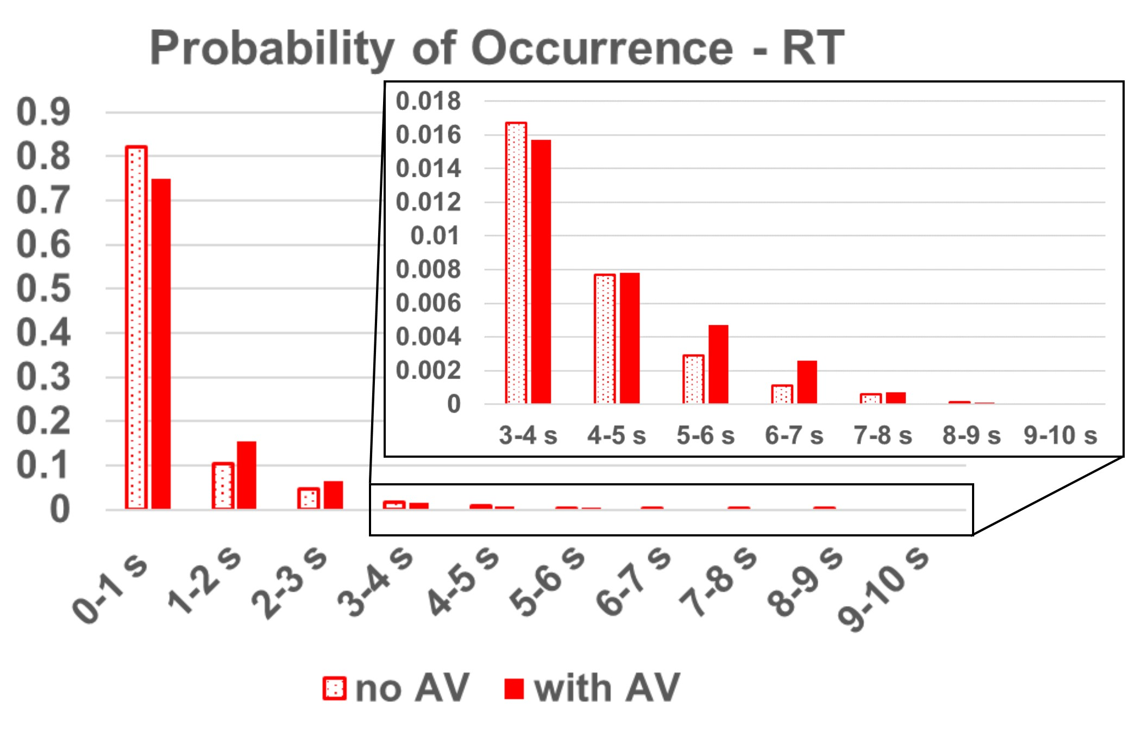
Figure 1: Probability of occurrence of particle RT for the 45⁰ configuration
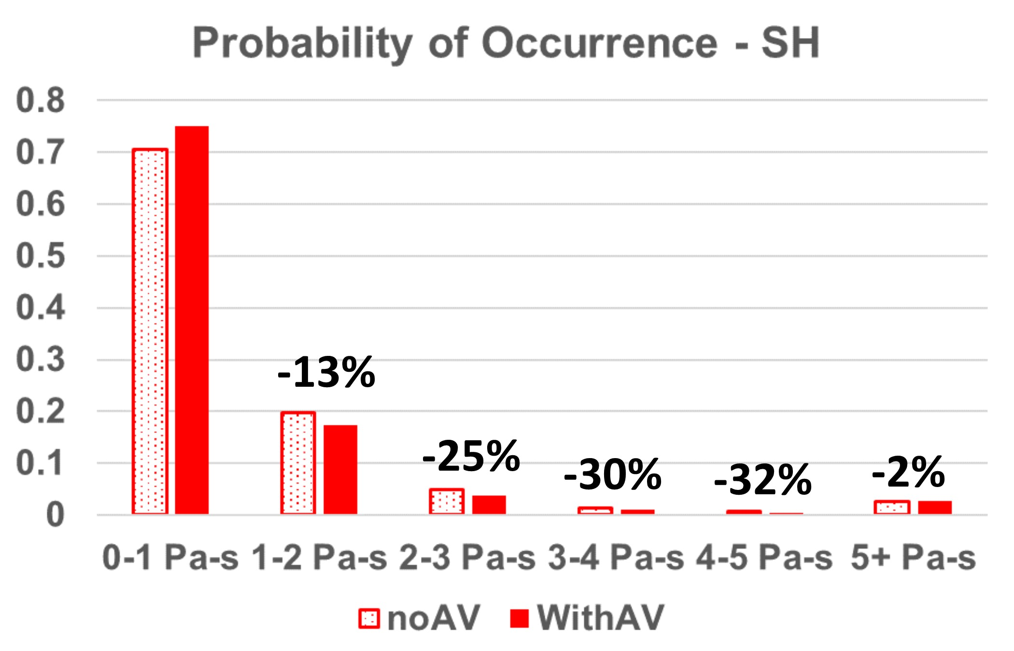
Figure 2: Probability of occurrence of particle SH for the 45⁰ configuration. Note the reduction of particles exposure to high SH for the AV opening scenario.

60⁰ configuration
RT statistics for the 60⁰ configuration were largely similar to the 45⁰ configuration, with a median RT of 0.36 s for the no AV opening case and a median RT of 0.4 s for the case with AV opening. The % of outlier particles that linger for long periods of time in the domain increased by 20% for the case with AV opening. Interestingly, cumulative probabilities of a particle lingering in the domain for more than 7 s reduced by 230%, while the cumulative probabilities of particles exiting the domain at earlier times increased for the case with AV opening, a beneficial result. Particle SH behavior was also similar to RT behavior – the median SH and % of outlier particles increased by about 7% and 14% respectively when the AV opened intermittently. Contrastingly, PO data indicated that the cumulative probability of particles accumulating a SH higher than 2 Pa-s reduced by ~15% for the case with AV opening.
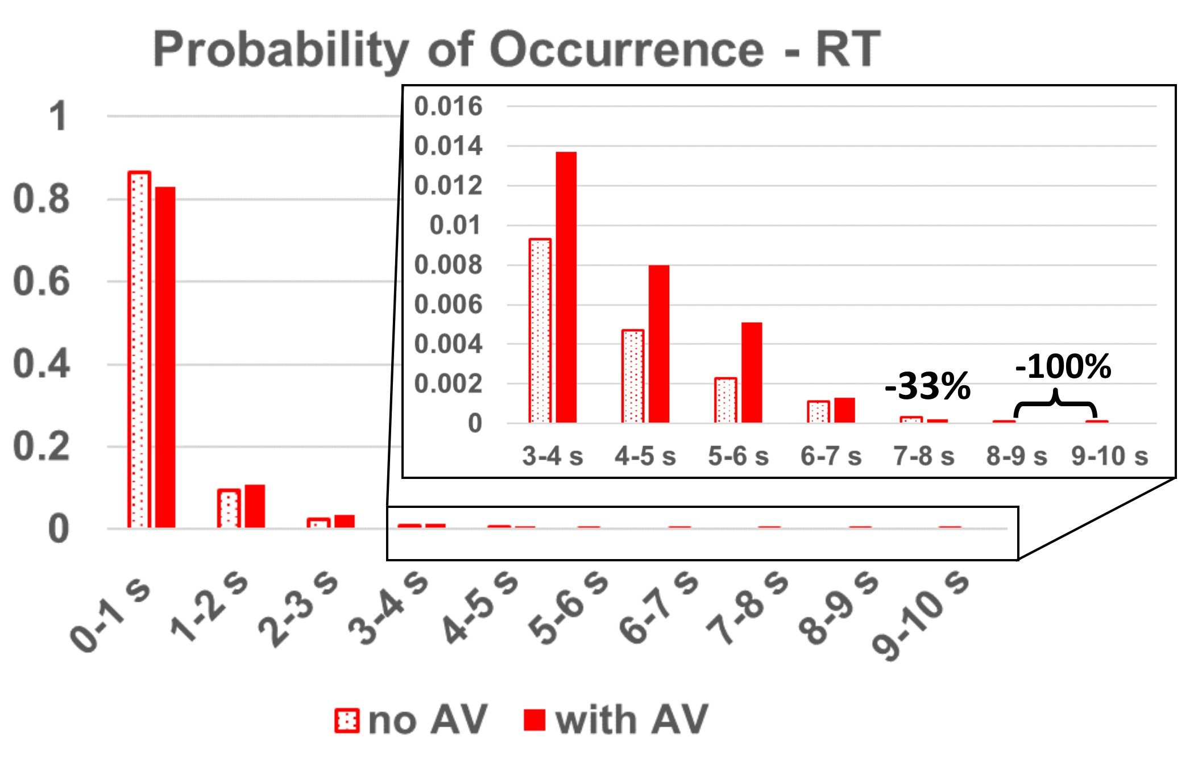
Figure 3: Probability of occurrence of particle RT for the 60⁰ configuration. Note the reduction in particles lingering for long RT for the AV opening scenario.
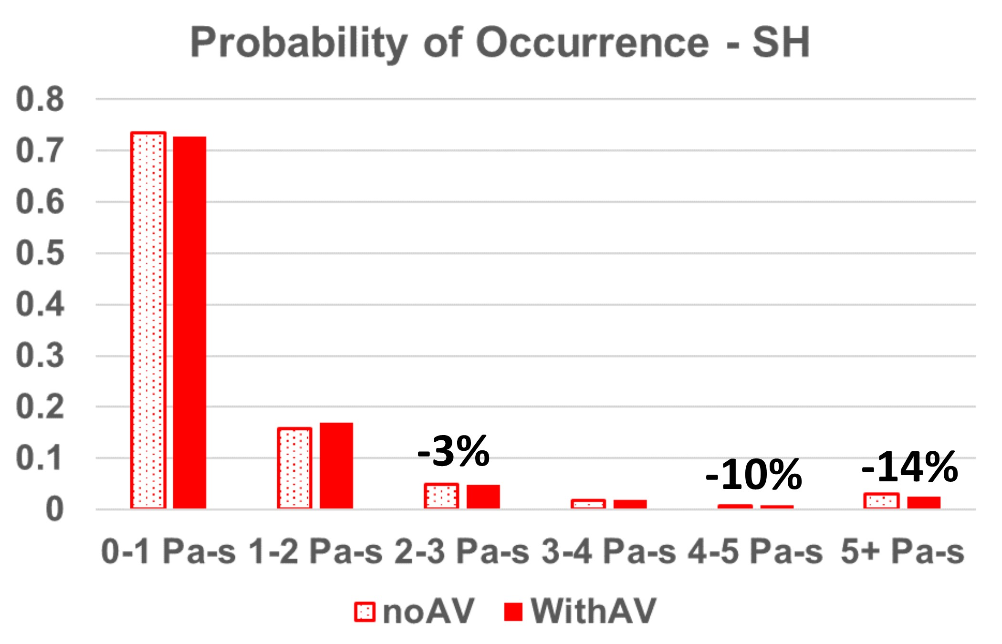
Figure 4: Probability of occurrence of particle SH for the 60⁰ configuration. Note the reduction of particles exposure to high SH for the AV opening scenario.

As LVADs become increasingly more prevalent for long-term therapy for HF patients, it is essential to focus on complications arising from LVAD support. Cerebrovascular events such as stroke remain the most devastating complication of LVAD support, along with pump thrombosis and the development of de novo aortic valve damage and aortic insufficiency, among others.

