Supplementary material

Experimental model
In brief, real time flow and pressure waveforms were captured using TS410 transit-time tubing flow meter (Transonic System, Inc. NY) and an Aespire anaesthesia machine (Datex-Ohmeda, Inc. Madison, WI), respectively. Four different conditions were tested with the MCL, including intact valves, AR, MR, and TR. Baseline variables for all conditions include heart rate (HR) 90, pneumatic left and right ventricular driving pressures of 120 and 40 mmHg respectively, and maintained mean arterial pressure (MAP) of 70mmHg. All experiments were conducted with a 40% glycerol solution (60% water), kept at a set temperature of 37 degrees Celsius by passing the systemic circulation tubing through a water bath to maintain a viscosity analogous to human blood (haematocrit of 34%)⁽¹¹⁾. Pulsatility was provided using the pneumatic SynCardia Companion 2 DriverTM with a heart rate of 90/min, LV pneumatic driving pressure 120mmHg, RV pneumatic driving pressure 40mmHg, ejection duration 280msec, suction set to 0mmHg for LV and RV. These settings were not altered during the series of experiments.
Baseline left atrial pressure (LA) varied (10, 15, 20 and 25mmHg) depending on the Protocol 2 experiment tested. Flows (Flowmeter, RVAD and LVAD) and other hemodynamic pressure such as pulmonary artery (PA) and mean pulmonary artery pressure (MPAP) were not directly controlled, and their initial flows/pressures were dependent on starting right atrial (RA), LA and MAP pressures. Mechanical bi-leaflet valves (27mm On-X Life Technologies Inc. Heart Valve Product Group, Austin, TX) were used for all experiments. The MCL was initially configured to test various hemodynamic flow and pressure waveforms with all valves attached under different LVAD pump speeds (ranging from 2200-4000RPM). To mimic AR, MR and TR, one leaflet was deliberately removed to reliably generate stable, severe regurgitation. To observe hemodynamic consequences of isolated LVAD and continuous flow BiVAD support within these simulated conditions, two different experimental protocols were designed. Protocol 1 examined the impact of pump speed, and Protocol 2 examined the impact of varying preload.
In Protocol 1, LVAD pump speeds were varied between 2200 and 4000RPM as well as with isolated LVAD vs. dual BiVAD support (RVAD pump speed 2400RPM). In Protocol 2, recordings were repeated with starting LA pressures of 10, 15, 20 and 25mmHg with fixed LVAD pump speed 2600RPM and RVAD 2400RPM. The results were then compared between conditions and waveforms analysed to determine whether (i) increased pump speed compensated for regurgitant flow, and (ii) there was a difference between isolated LVAD support compared to BiVAD support across different valvular pathologies, pump speed and preload settings.
Experimental procedure
All experiments began from a simulated state of no VAD support. The outflow graft of the LVAD and RVAD pumps were occluded and the MCL was entirely run by the SynCardia Companion 2 DriverTM. Initial baseline hemodynamics (LA 25mmHg, MAP 70mmHg, and RA 10mmHg for left heart failure and LA 25mmHg, MAP 70mmHg, and RA 25mmHg for biventricular failure – pre-BiVAD) were established and maintained for 5 minutes. Once recorded, the LVAD outflow graft was opened and the LVAD turned on. The SVR and PVR were adjusted until similar MAP parameters were achieved to those seen in clinical patients with isolated LVAD (MAP 85mmHg-95mmHg). We used the control experiment (intact valves) as a reference point and showed that a MAP of 88mmHg produced physiological flows and pressures (LAP, RAP, and MPAP). To remain consistent, a target MAP of 88mmHg was set for AR, MR, and TR experiments. No other changes were made and the new baseline parameters for isolated LVAD were recorded. At the completion of recording the new baseline values (LVAD 2600), the LVAD pump speed was reduced to a minimum 2200RPM by decrements of 200. It was then returned to 2600RPM where it increased to 3200 RPM by increments of 200 again. From 3200RPM pump speed was increased to 3600RPM and then to a maximum speed of 4000RPM. To eliminate the effect of inertia, a steady state period of 2 minutes was allocated following changes to pump speed to allow the system to stabilise before the effects on flow rate and MAP, LA, RA and PA pressures were recorded. Upon completion, the LVAD pump speed was returned to 2600 RPM and the baseline restored. To demonstrate the difference between BiVAD and isolated LVAD, the RVAD was turned on and the outflow graft opened. The SVR and PVR were then adjusted until a MAP of 93mmHg was achieved, based on the same rationale described for isolated LVAD. Baseline parameters at new pump speeds (LVAD 2600, RVAD 2400) were recorded for 5 minutes before increasing LVAD pumps speeds from 2200-4000RPM as previously described, while the RVAD remained constant at 2400RPM. Once completed, baseline parameters were restored, priming the MCL for Protocol 2. No other variables were changed. The experimental protocol flow diagram is shown in the Supplementary Material Figure 1.
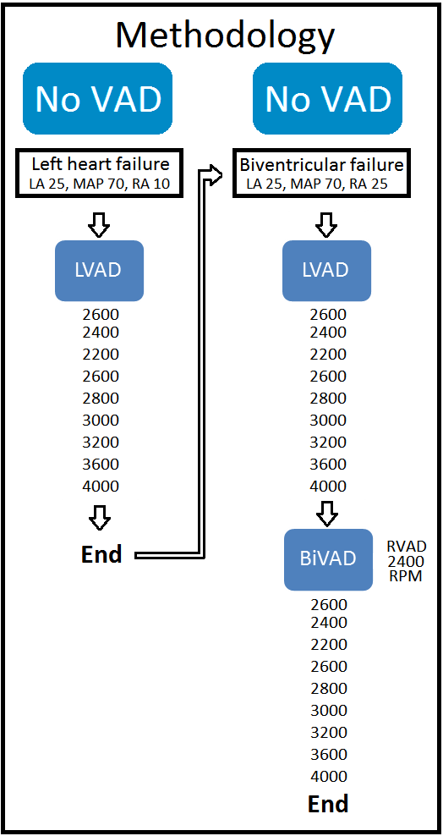
In Protocol 2, LV filling pressure was actively varied at a fixed pump speed. The LA pressure was increased from 10mmHg to 15mmHg and the process previously described in Protocol 1 was repeated. The same was completed for LA pressures of 20mmHg and 25mmHg. The incremental increase of 5mmHg from 10 to 25mmHg at the end of each Protocol 1 experiment was achieved by slight modifications to the SVR and PVR. Contractility, HR, viscosity, haematocrit, LV and RV pressures were not altered. All four valves remained attached to the ventricles during LVAD control. The same test was repeated with one leaflet of the aortic, mitral or tricuspid valve removed during different stages to mimic the respective pathological regurgitant states.
Data Acquisition
Flow and pressure waveforms were recorded using LabChart 7 (ADInstruments Pty Ltd, Bella Vista) and Datex-Ohmeda S/5TM Collect software (GE Healthcare, Finland), respectively. LVAD and RVAD pump parameters were recorded directly from pump controllers onto laptop using proprietary software (continuous digital acquisition system) sampled at 50Hz. All data were analysed using statistical Matlab software (The MathWorks, Inc. Natick MA). All waveforms were smoothed with a low pass filter using Sovitzky-Golay method and were averaged over four cardiac cycles.

