Supplementary Content:
AoP (mmHg) | Heart Failure (HF) (L) | Medium (MED) (L) | Normal Operating conditions (NOC) (L) | P-value HF to MED | P-value HF to NOC
65 | 2.517 +/- 0.043 | 2.611+/- 0.055 | 2.726+/-0.022 | 0.0043 | 0.0022
75 | 2.924+/-0.027 | 2.964+/-0.082 | 3.157+/-0.054 | 0.2403 | 0.0022
85 | 3.221+/-.0072 | 3.391+/-0.069 | 3.459+/-0.096 | 0.0022 | 0.0022
95 | 3.203+/-0.012 | 3.674+/-0.044 | 3.918+/-0.050 | 0.0022 | 0.0022
105 | 2.875+/-0.103 | 3.724+/-0.051 | 4.698+/-0.065 | 0.0022 | 0.0022
115 | 2.917+/-0.029 | 3.423+/-0.031 | 5.403+/-0.055 | 0.0022 | 0.0022

Supplement table 1: Varying afterload (AoP) while recording pulsatility under heart failure conditions (LV LDP of 120 mmHg), medium ventricular pumping force ( LV LDP of 150 mmHg), and normal ventricular pumping force (LV LDP of 180 mmHg). P-values are calculated by comparing HF conditions to MED LV pumping force and HF conditions to NOC LV pumping force.

Preload Variation (mmHg) | Heart Failure (HF) (L) | Medium (MED) (L) | Normal Operating conditions (NOC) (L) | P-value HF to MED | P-value HF to NOC
0 | 4.207+/-0.047 | 4.506+/-0.190 | 5.043+/-0.057 | 0.0022 | 0.0022
5 | 5.522+/-0.035 | 4.733+/-0.071 | 5.015+/-0.072 | 0.0022 | 0.0022
10 | 4.007+/-0.0952 | 5.165+/-0.139 | 5.406+/-0.083 | 0.0022 | 0.0022
15 | 3.867+/-0.117 | 4.941+/-0.230 | 5.673+/-0.051 | 0.0022 | 0.0022
20 | 3.902+/-0.070 | 4.871+/-0.072 | 5.881+/-0.085 | 0.0022 | 0.0022

Supplement Table 2: Varying preload while recording pulsatility under heart failure conditions (LV LDP of 120 mmHg), medium ventricular pumping force (LV LDP of 150 mmHg), and normal ventricular pumping force (LV LDP of 180 mmHg). P-values are calculated by comparing HF conditions to MED LV pumping force and HF conditions to NOC LV pumping force.
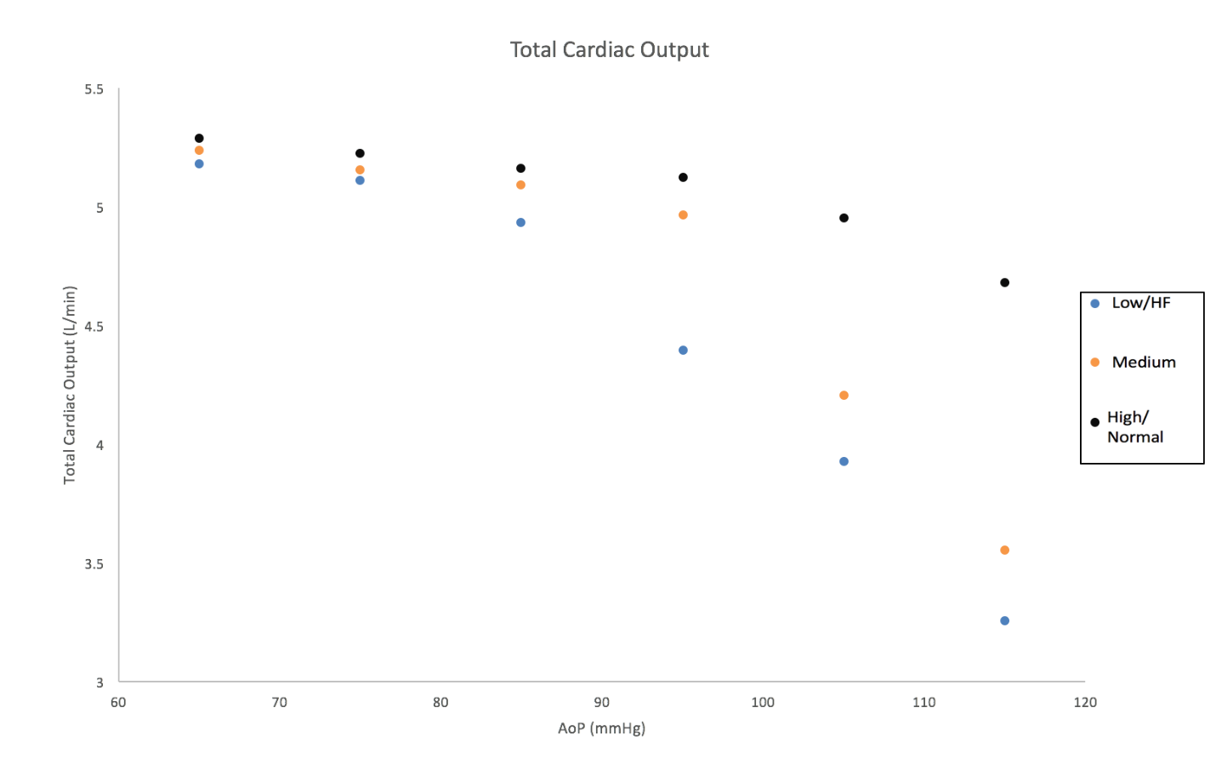
Supplement Figure 1: Total Cardiac Output at low, medium, and normal operating conditions under various afterloads

