**Patient flow**



**Supplementary material**

Follow-up protocol

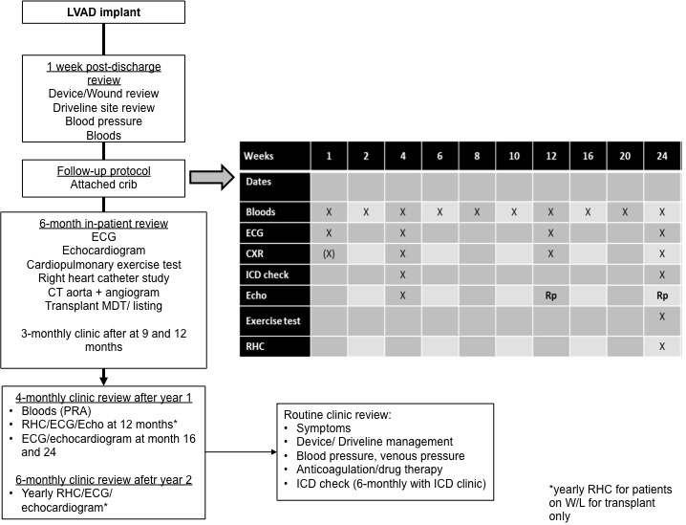

Case 1 – intracerebral bleed

A 60-year-old man with a previous myocardial infarction and coronary bypass graft surgery underwent implantation of a Heartmate 3 LVAD as a bridge to candidacy due to severe pulmonary hypertension and INTERMACS 2 heart failure. Echocardiogram at discharge demonstrated a closed aortic valve with no regurgitation and normal right ventricular function at 5700 RPM. He was readmitted with a homonymous hemianopia at 3 months on warfarin (INR 3.2 at admission) and aspirin (75mg). Doppler blood pressure was 90mmHg. CT head showed intracerebral haemorrhage at the right occipital region [FIGURE 1]. Analysis of LVAD parameters demonstrated no abnormal events. Lactate dehydrogenase (LDH) was 318 IU/L compared to 268 IU/L 4 weeks earlier. Both warfarin and aspirin were withheld for 30 days to minimize the risk of hematoma expansion. Warfarin was reinitiated when subsequent scans showed contraction of the haematoma and oedema. Warfarin but not aspirin was reintroduced with INR 1.5-1.9 for a further 2 weeks. Echocardiogram was unchanged throughout (satisfactory LV unloading). INR was then maintained at 2.0-3.0 and LDH remained stable at 3-month follow-up.

Case 2 – fatal retroperitoneal bleed

A 63-year-old man with a prior surgery for congenital ventricular septal defect and severe LV dysfunction underwent implantation of HM3 LVAD due to progressive deterioration on the waiting list for heart transplantation (bridge-to-transplantation). The HM3 LVAD was implanted via lateral thoracotomy. He recovered well but started to suffer from a recurrence of heart failure. Echocardiogram confirmed progressive deterioration in aortic regurgitation, which led to aortic valve replacement surgery on day 146 post-implant. The surgery was uncomplicated and he was re-established on warfarin and aspirin (75mg) following aortic valve replacement. He developed severe back and abdominal pain on day 21 post-aortic valve surgery with no preceding trauma. CT scan confirmed severe retroperitoneal bleeding [FIGURE 2]. Following extensive discussions with surgeons and interventional radiology, he was treated with repeated embolization but without success.

FIGURE 1: Intracerebral bleed on CT head

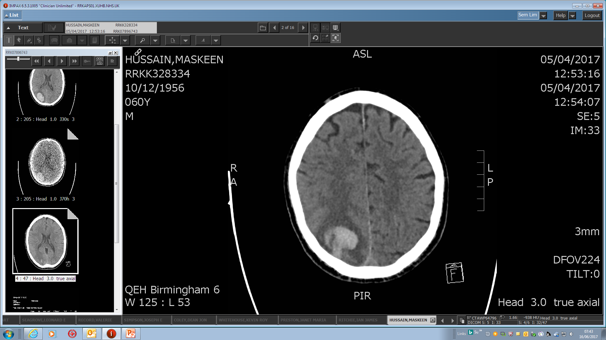

FIGURE 2: Severe retroperitoneal bleed

