Supplementary Material 1 – LPN model, equations, and parameters

Prior to the FSI simulations, a lumped parameter of the entire cardiovascular circulation under VAD support conditions needed to be established to ensure appropriate boundary conditions in the 3-D domains. The structure of the model is shown in Figure 1 and was created based on [1] and [2], which also include the reasoning for the choice of parameter values. The green dashed frame indicates the location of the 3-D FSI model.

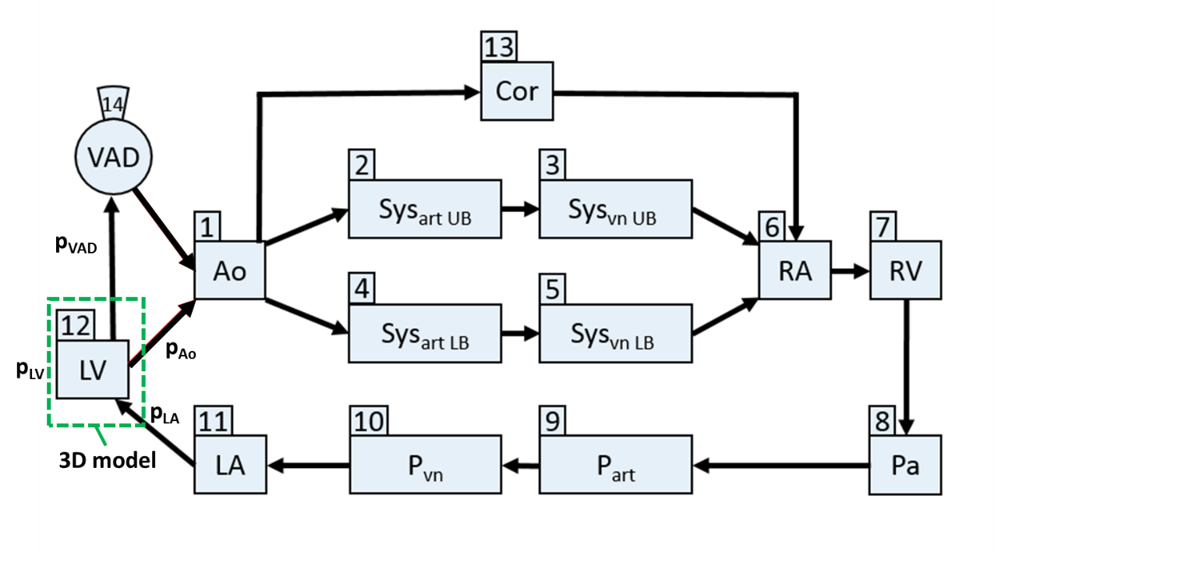
Figure 1: Lumped parameter model of cardiovascular system with VAD support. 1: Aortic arch, 2: Systemic arterial (upper body), 3: Systemic venous (upper body), 4: Systemic arterial (lower body), 5: Systemic venous (lower body), 6: Right atrium, 7: Right ventricle, 8: Pulmonary artery, 9: Pulmonary arterial, 10: Pulmonary venous, 11:Left atrium, 12: Left ventricle, 13:Coronary arteries, 14:VAD
The entire model consisted of 14 compartments which were characterized by pressure-flow or pressure-volume relationships via ordinary differential equations.
The compartments describing the systemic arterial upper and lower body circulation, the systemic venous upper and lower body circulation, the pulmonary artery, the pulmonary arterial circulation, the pulmonary venous circulation, and the VAD inflow cannula were represented as a hydraulic resistance R and a hydraulic compliance C in a parallel circuit yielding the following ODEs (Equations 1a and 1b):
$Q_{out}=\frac{p_{i}-p_{i+1}}{R_{i}}$ (1a) $\frac{{dp}_{i}}{dt}=\frac{Q_{in}-Q_{out}}{C_{i}}$ (1b)
where Q_{in} and Q_{out} are the incoming and outgoing flows into the compartment i (R_{i} and C_{i}); p_{i} and p_{i+1} are the pressures of the corresponding and the downstream compartment, respectively. The ventricles (Equation 2a) and atria (Equation 2b) were modelled as time-varying elastances described by the following equations:
$p_{j}=V_{j}e_{v}\left(t\right)E_{max,j}+(1-e_{v}\left(t\right))(α_{j}{ e}^{κ_{j} V_{j}}+β_{j})$ with j = LV or RV (2a)
$p_{k}=V_{k}{(e}_{a}\left(t\right){(E}_{max,k}-E_{d,k})+E_{d,k})$ with k = LA or RA (2b)
$\frac{dV}{dt}=Q_{in}-Q_{out}$ (3)
where e_{v}(t) and e_{a}(t) are the ventricular and atrial activity functions (analytical formula in Equation 4). E_{max} and E_{d} are the maximal systolic and diastolic elastances. α, β, and κ are parameters quantifying end-diastolic ventricular elastance. T_{s1,v/a} and T_{s2,v/a} are the respective time constants of the ventricular and atrial activity functions. T_{c} is the duration of the cardiac cycle (0.8 s). The short delay between atrial and ventricular activations (approx. 30 ms) was disregarded.
$e_{v/a}=\left\{\begin{aligned}\frac{1-\cos\left(\frac{t}{T_{s1,v/a}}π\right)}{2}, 0≤ &t<T_{s1,v/a} \\ \frac{1+\cos\left(\frac{t-T_{s1,v/a}}{T_{s2,v/a}-T_{s1,v/a}}π\right)}{2}, &T_{s1,v/a}≤t<T_{s2,v/a} \\ 0 ,T_{s2,v/a} ≤ &t<T_{c} \end{aligned}\right.$ (4)
The valves (aortic, tricuspidal, mitral, pulmonary) were described as an ideal diode allowing only forward flow direction and an orifice with a quadratic pressure loss (loss coefficient CQ_{i}), see Equation 5:
$Q_{out}=\sqrt{p_{i}-p_{i+1}}{CQ}_{i}$ (5)
The coronary block included the left ventricular pressure as a squeezing pressure changing Equation 1b to Equation 6.
$\frac{d (p_{cor}-0.75p_{LV)}}{dt}=\frac{Q_{cor,in}-Q_{cor,out}}{C_{cor}}$ (6)
Considering the pressure difference H across the LVAD, the corresponding blood flow through the pump is shown in Equation 7:
$Q_{VAD}=p_{1}H^{4}$+$p_{2}H^{3}{+p}_{3}H^{2}{+p}_{4}H+p_{5}$ (7)
where p_{i} are the coefficients of a fifth-order polynomial that was used to fit a generic HQ curve.

The parameters for the LPN model for the full and partial support conditions are listed in Table 1.The pressures and flows calculated by the LPN model are found in Figures 3 and 4. The pressures (p_{LV} – green, p_{LA} –blue, and p_{Ao} – red) were put as boundary conditions in the 3D model.
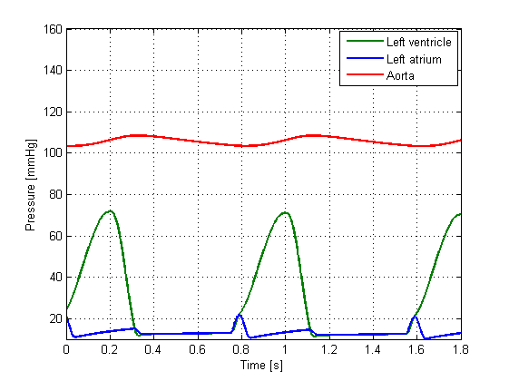 | 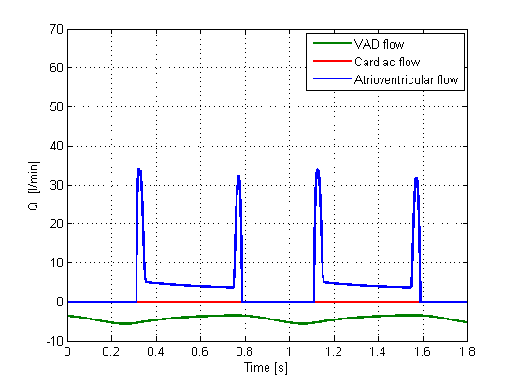
Figure 3: Left: pressure, right: flow. Full VAD support.
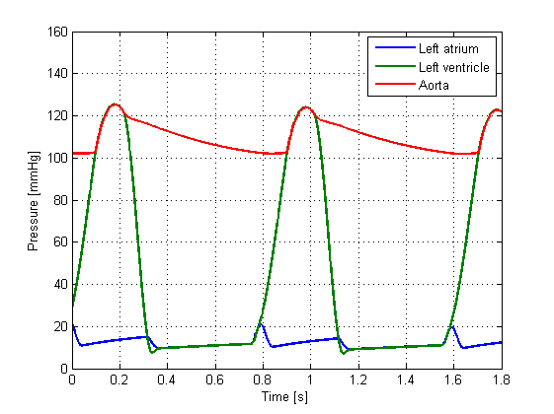 | 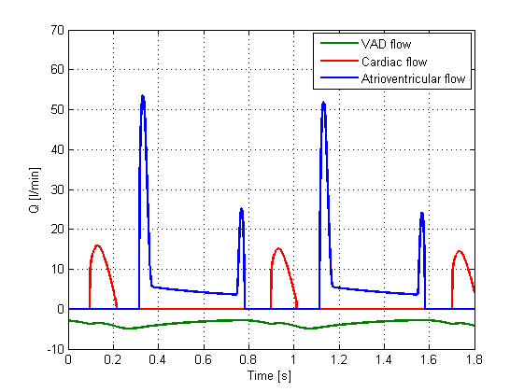
Figure 4: Left: pressure, right: flow. Partial VAD support.

During full support simulations (Figure 7), the mean VAD flow is 4.5 L/min. Left ventricular pressure is in the range between 10 and 70 mmHg. Aortic pressure exhibits very low pulsatility and is higher than LV pressure, yielding full closure of the aortic valve. During partial support simulations the mean blood flow is 5 L/min with 3.5 L/min VAD output and 1.5 L/min cardiac output. LV pressure is increased and the aortic pressure has higher pulsatility than during full support. Systole and diastole are distinguished and clearly recognizable.
These findings are not only used to deliver realistic pressure curves, but can also verify the consistency of the lumped parameter model as the results coincide with findings from in vitro and in vivo studies [3] and [4] as well as common clinical knowledge.

Part | Parameter | Value
Systemic circulation | R_{aorta} [mmHg s/mL] (LPN only) | 0.07
 | C_{aorta} [mL/mmHg] (LPN only) | 0.1
 | R_{sartUB} [mmHg s/mL] | 2.34
 | C_{sartUB} [mL/mmHg] | 1.35
 | R_{svnUB} [mmHg s/mL] | 0.33
 | C_{svnUB} [mL/mmHg] | 4
 | R_{sartLB} [mmHg s/mL] | 1.44
 | C_{sartLB} [mmHg/mL] | 1.95
 | R_{svnLB} [mmHg s/mL] | 0.05
 | C_{svnLB} [mmHg s/mL] | 15
Pulmonary circulation | R_{pa} [mmHg s/mL] | 0.02
 | C_{pa} [mL/mmHg] | 0.18
 | R_{part} [mmHg s/mL] | 0.155
 | C_{part} [mmHg s/mL] | 3.8
 | R_{pvn} [mmHg s/mL] | 0.075
 | C_{pvn} [mL/mmHg] | 20.5
Right heart | CQ_{tri} [mL/s mmHg^{0.5}] | 400
 | CQ_{pul} [mL/s mmHg^{0.5}] | 350
 | E_{maxRA} [mmHg/mL] | 0.225
 | E_{dRA} [mmHg/mL] | 0.1575
 | E_{maxRV} [mmHg/mL] | 0.45
 | α_{RV} [mmHg/mL] | 2.5/2.1**
 | β_{RV} [mmHg/mL] | 0.0336/0.028**
 | κ_{RV} [1/ml] | 0.0564/0.047**
Left heart | CQ_{mi} [mL/s mmHg^{0.5}] | 400
 | CQ_{ao} [mL/s mmHg^{0.5}] | 350
 | E_{maxLA} [mmHg/mL] | 0.45
 | E_{dLA} [mmHg/mL] | 0.2125
 | E_{maxLV} [mmHg/ml] | 2.5/0.6*/2.2**
 | α_{LV} [mmHg/mL] | 3/2.5**
 | β_{LV} [mmHg/mL] | 0.0396/0.033**
 | κ_{LV} [1/mL] | 0.0768/0.064**
Coronaries | R_{cor} [mmHg s/mL] | 12.5
 | C_{cor} [mL/mmHg] | 0.0015
VAD | R_{can,in}[mmHg s/mL] | 0.08
 | C_{can,in} [mmHg s/mL] | 3
Additional parameters | T_{c} [s] | 0.8
 | T_{s1} [s] | 0.26
 | T_{s2} [s] | 0.39
 | T_{sa1} [s] | 0.04
 | T_{sa2} [s] | 0.09
 | Z_{cor} [s] | 0.1
 | Z_{LB} [s] | 0.045
 | Z_{UB} [s] | 0.08
 | C_{can,out} [s] | 0.2
 | C_{ao} [s] | 0.2
Table 1: Parameters of the lumped parameter network. *: parameters changed for HF and LVAD full support, **: parameters changed for LVAD partial support. Bold parameters: most important influence on system behavior.

References:
[1] Korakianitis T, Shi Y: A concentrated parameter model for the human cardiovascular system including heart valve dynamics and atrioventricular interaction. Med Eng Phys 28: 613-628, 2006.
[2] Kung E, Baretta A, Baker C, et al: Predictive modeling of the virtual Hemi-Fontan operation for second stage single ventricle palliation: two patient-specific cases. J Biomech 46(2): 423-429, 2013.
[3] Koenig SC, Pantalos GM, Gillars KJ, Ewert DL, Litwak KN, Etoch SW: Hemodynamic and pressure–volume responses to continuous and pulsatile ventricular assist in an adult mock circulation. ASAIO J 50: 15-24, 2004.

[4] Soucy KG, Giridharan GA, Choi Y, et al: Rotary pump speed modulation for generating pulsatile flow and phasic left ventricular volume unloading in a bovine model of chronic ischemic heart failure. J Heart Lung Transplant 34(1): 122–131, 2015.

