Supplementary material 2 – Preliminary simulations and advanced simulation settings

Meshing
This section shows the mesh independence study for the fluid mesh. Further on, the material parameters for the 4 structural meshes are presented. The meshes used for the fluid and structure simulations are also shown.

Mesh independence
Three unstructured tetrahedral meshes with 3 prismatic boundary layers were created with the following sizes:
coarse – 200k elements
medium – 500k elements
fine – 1.2mio elements

At first a visual comparison of velocity distribution at a transversal plane located in the center of the left ventricle at t=0.4 s of the second cycle was done; see Figure 1:

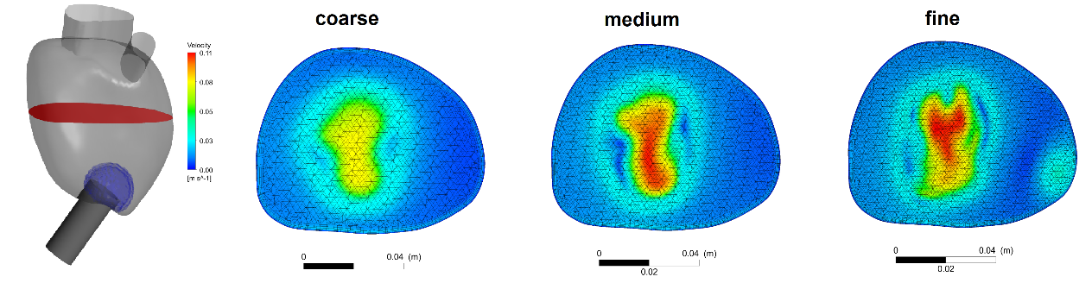
Figure 1: Location of the cut plane (red) and the evaluation region of wall shear stress (blue). Velocity distribution at the plane at t=0.4 s (second cycle) for the coarse, medium, and fine mesh, respectively.
Differences are observable regarding the maximal velocity value and the contours of the velocity distribution. To consider the transient behavior of the simulations and include a more quantitative comparison, the weighted mean relative difference (WMRD) was used. WMRD was calculated by the following formula:

$WMRD= \frac{\sum_{t}{\left|g_{t}-g_{t}^{'}\right|}}{\sum_{t}{\left(g_{t}+g_{t}^{'}\right)/2}}$

It calculated the ratio between the absolute difference to the mean between two (time-dependent) variables g and g’ belonging to two different scenarios (two different mesh sizes). More information can be found in (Duffield et al. 2003).
Comparisons between coarse and medium (mesh 1 vs. mesh 2) and medium and fine (mesh 2 vs. mesh 3) were done. The maximum plane velocity (red plane in Figure 1), the average plane velocity, the kinetic energy (KE) inside the entire ventricle, the maximal wall shear stress (WSS), and the average WSS at the cannula tip (blue region in Figure 1) were evaluated for one cycle. Table 1 shows the results:

Variable of investigation | Mesh 1 | Mesh 2 | Mesh 3
Maximum plane velocity WMRD [%] | 32 | 9 | -
Average plane velocity WMRD [%] | 17 | 7 | -
Left ventricular kinetic energy WMRD [%] | 49 | 12 | -
Maximum cannula tip WSS WMRD [%] | 64 | 21 | -
Average cannula tip WSS WMRD [%] | 51 | 18 | -

Table 1: WMRD values in % for three meshes used in CFD simulations.

There is always a big reduction of WMRD when changing from the coarse to the medium mesh. The coarse mesh shows a large WMRD, with 4 of 5 variables larger than 30%.
Velocity and kinetic energy show mean relative differences of around 10% for the medium mesh. WSS (max and mean) show bigger deviances with WMRD of around 20% for the medium mesh. The full mesh, a cross-section at a coronal plane and an apex close-up of the mesh, is shown in Figure 2:

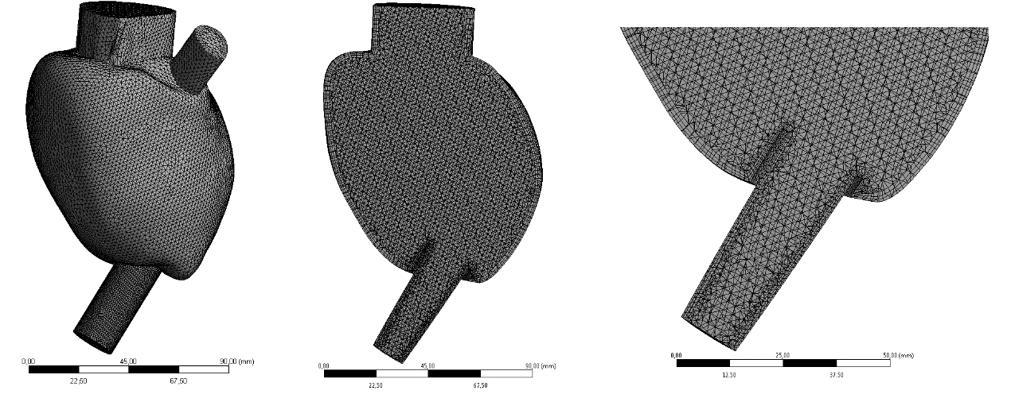
Figure 2: CFD mesh showing the entire LV, a coronal cross-section and a close-up at the apex region of the ventricle.

FEM material parameters and FEM mesh
Table 2 shows the material parameters chosen for the 4 simulation conditions P3 100 VAD, P3 70 VAD, P6 100 VAD, and P6 70VAD. Once again, it should be mentioned that because we were not interested in material stresses, a simple isotropic elastic model was chosen with a Young’s modulus that allows a stable deformation of the model. Thus, low Young’s moduli might result in folding of FEM mesh elements and high Young’s moduli result in very low deformations.

Name | E [MPa] | ν
P3 100 VAD | 1.15 | 0.3
P3 70 VAD | 2.5 | 0.3
P6 100 VAD | 3.5 | 0.3
P6 70 VAD | 7 | 0.3
Table 2: Material parameters (Young’s modulus E and Poisson’s ration ν) chosen for the four simulation scenarios.

A representative FEM mesh for P6 is shown in Figure 3. Shell elements with a thickness of 5 mm were chosen. The full mesh and a cross-section along a coronal plane are shown:
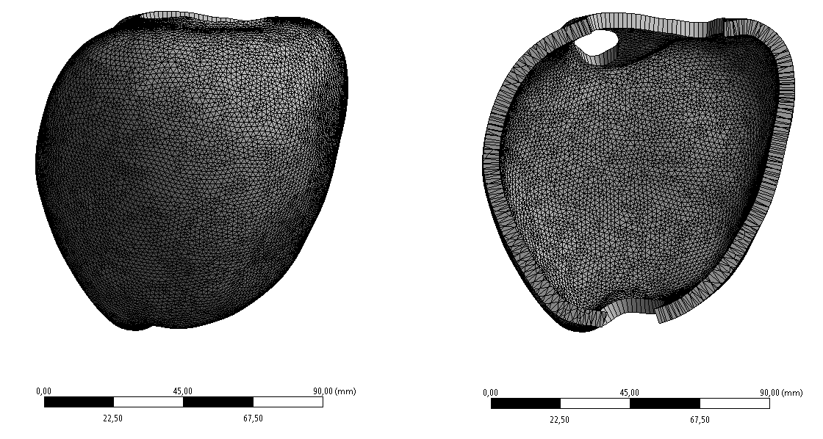
Figure 3: FEM mesh used for the simulations. Full view and cross-section.

Fluid mesh deformation and convergence of FSI simulation

Fluid mesh deformation
The settings in Ansys CFX to achieve one-way fluid structure interaction are shown. More specifically, wall displacement is translated into displacement of the fluid mesh. Thus, an appropriate mesh quality has to be ensured. An approach to maintain high mesh quality is to adapt the mesh stiffness (mesh diffusivity) depending on the size of the finite volumes. The following equation was used: 1[m^5 s^-1]/volcvol. Volcvol is the volume of the finite volumes (mesh elements). Therefore, not only mesh elements that are close at the fluid-structure boundary (LV wall) are deformed but the deformation is also translated (diffused) to mesh elements that are further away from the boundary, resulting in preservation of overall high quality of the mesh.

Convergence plot

Figure 4 shows the convergence as the root mean square (RMS) of mass and momentum for the FSI simulations of P6 100 VAD.

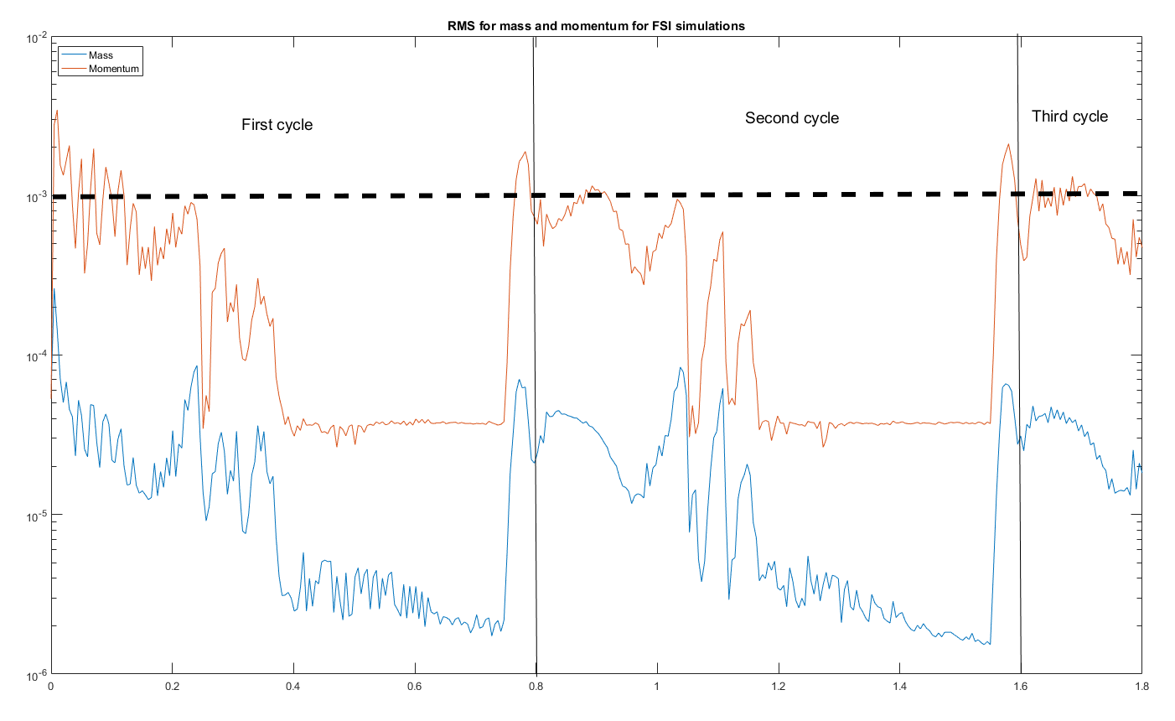
Figure 4: Convergence plot of mass and momentum for FSI simulations of P6 100 VAD. Black dashed line shows the convergence criterion of 1e-3, and the two solid black lines show where the cycles stop and end.
From the figure it can be observed that already during the second cycle the threshold of 1e-3 is exceeded just at minor parts of the time (1.55-1.6 s) and around 0.9-0.95s. The first quarter of the cycle is critical with RMS values close to the threshold of 1e-3. Afterward the values drop to 4e-5. It is seen that the third cycle does not produce significantly better results when compared to the second cycle; thus, the second cycle was chosen for evaluation.
It should be noted that the time of the vortex-cannula interaction (see Figure 7 and Figure 8b of the main manuscript) happens between 0.4 and 0.6 s (1.2s-1.4s for the total time). This timeframe is characterized by very low RMS (4e-5) in Figure 4, so it is appropriate to use the second cycle for evaluation, especially of this timeframe.

