Supplementary Material
Figure Captions

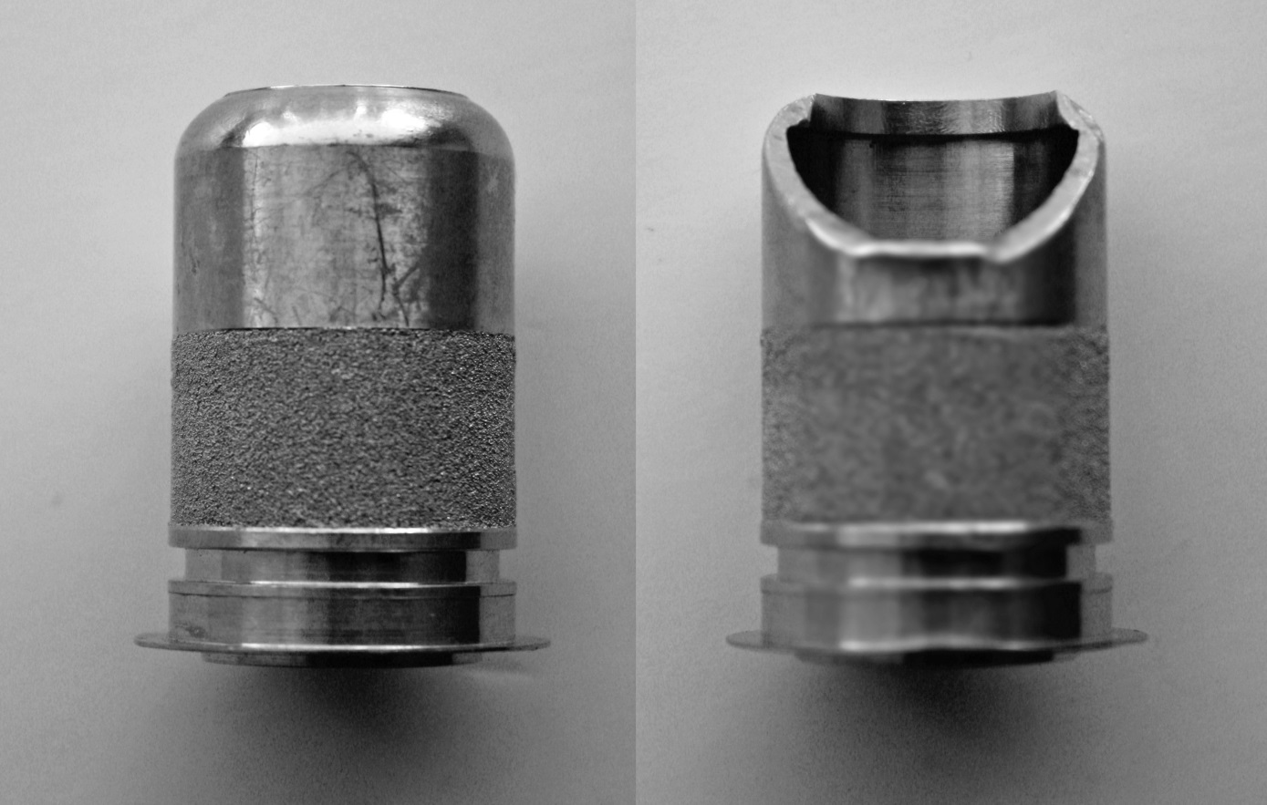

Figure S1. Photo of the HeartWare LVAD cannula that shows both external and internal surfaces.
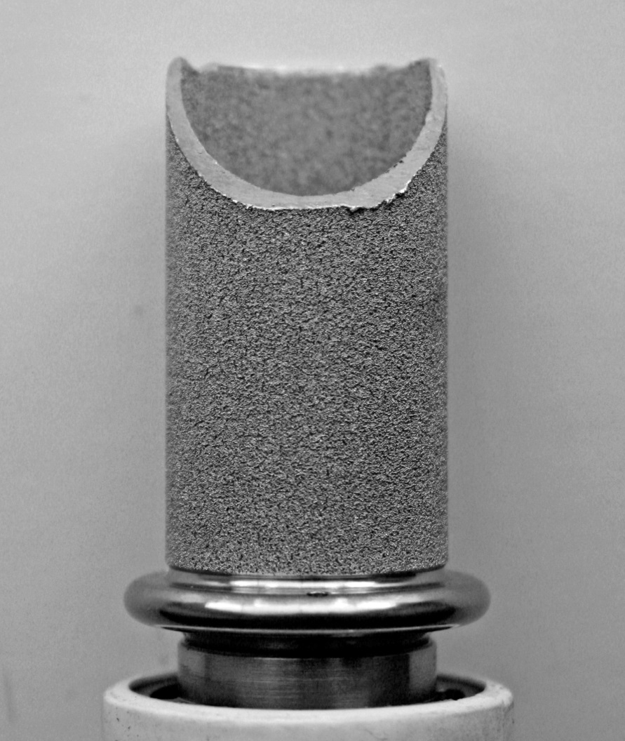
Figure S2. Photo of the HeartMate II inflow cannula that shows both external and internal surfaces.

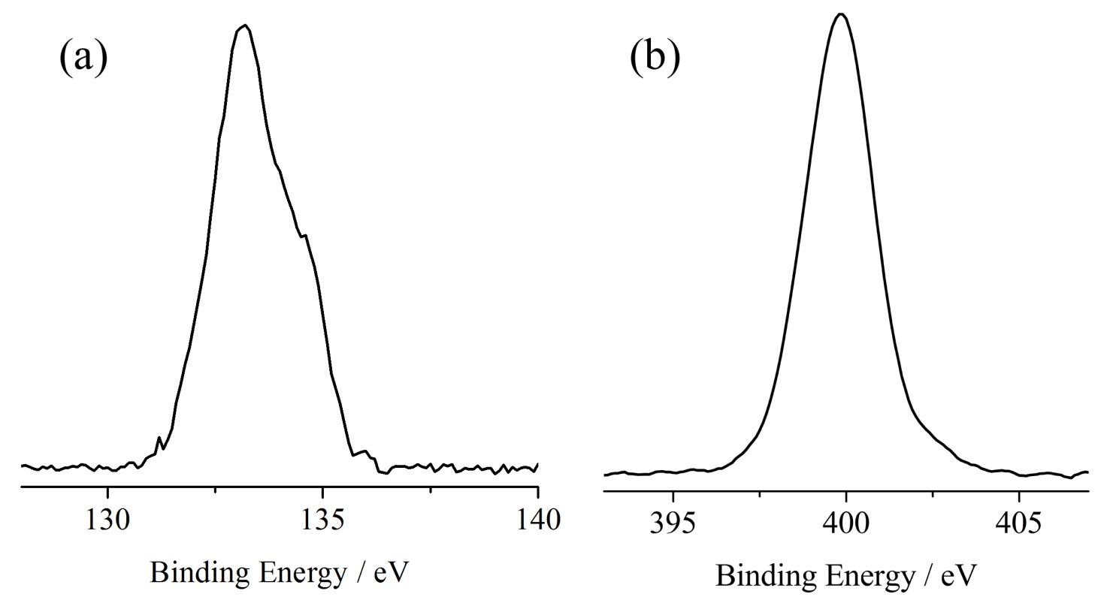
Figure S3. Al Kα excited XPS of inner Jarvik-2000 surface in the: (a) P 2p and (b) N 1s energy regions. Structures due to satellite radiations have been subtracted from the spectra.

