Appendix I
Radiographic measurements used in SMA study. (Upright films used if available).
Anterior Posterior Radiographs
1) Max Coronal Cobb – Largest Cobb angle of largest curve
2) S1-L1 vertical distance – Measure distance (mm) from mid-point of S1 endplate to the midpoint of the superior endplate of L1
3) T12-T1- vertical distance from midpoint of inferior endplate of T12 to the midpoint of the superior endplate of T1
4) Space Available for Lung – See Figure Below from Campbell et al JBJS 2003.[10]
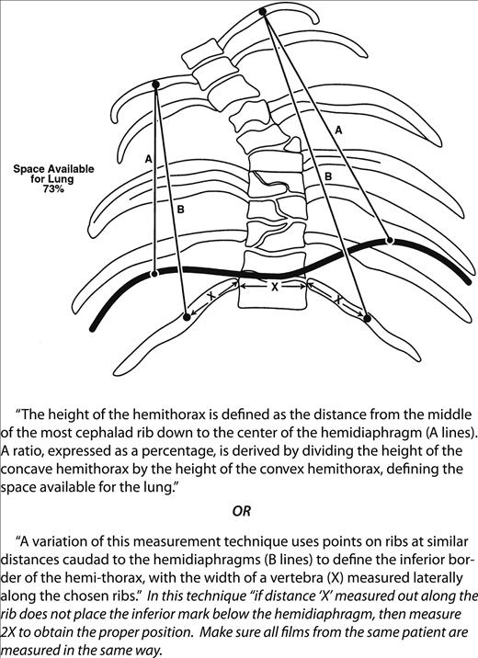

5) Smallest Rib Vertebral Angle (most acute angle) RVA and RVDA, From Corona et al. JBJS 2012; adapted from Mehta JBJS Br. 1972.[23, 24]
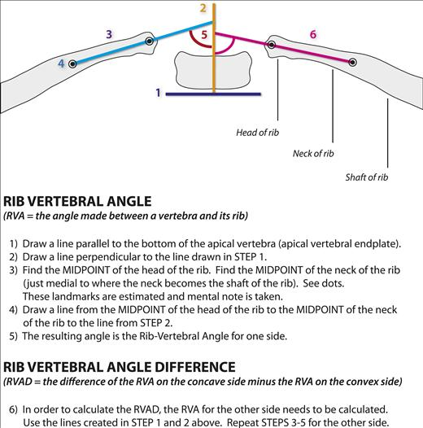

7) Width Chest Cavity -Inner rib to inner rib (measured in (mm) at the widest spot)
8) Pelvic Obliquity – Iliac crest from horizontal (or clavicles if supine).
Lateral Radiograph
- Maximum Chest Depth – distance from posterior aspect of sternum/or rib (anteriorly) with the anterior edge of posterior rib. (widest measurement)
Thoracic Kyphosis – T2-T12, the angle formed between the superior endplate of T2 and the inferior endplate of T12.

