Appendix Table 1: Further outcomes at 12 months follow-up
Outcomes | Decompression  alone (n=85) | Fusion (n=46) | p
NRS, mean (SD) | 2.5 (2.3) | 2.3 (2.4) | 0.662
FT, mean (SD) | 27.1 (25.4) | 23.2 (22.2) | 0.386
EQ-5D-EL sum score, mean (SD) | 84.4 (15.3) | 86.3 (14.4) | 0.478
EQ-5D-EL actual health status, mean (SD) | 77.9 (18.3) | 74.9 (24.7) | 0.439
RMDQ, mean (SD) | 7.0 (6.0) | 6.3 (4.9) | 0.469

FT = Feeling Thermometer; NRS = Numeric Rating Scale (NRS); RMDQ = Roland and Morris Disability Questionnaire

Appendix Figure 1a. Random intercepts and their slopes are displayed against age for the model with SSM symptoms as dependent variable. In general, a decreasing trend is visible, except for older patients aged 80 years and older. For them there seems to be a constant or slightly increasing trend, meaning stable or slightly increasing SSM symptoms values. Black intercepts and slopes are from patients in the decompression group, whereas grey intercepts and slopes are from patients in the fusion group.
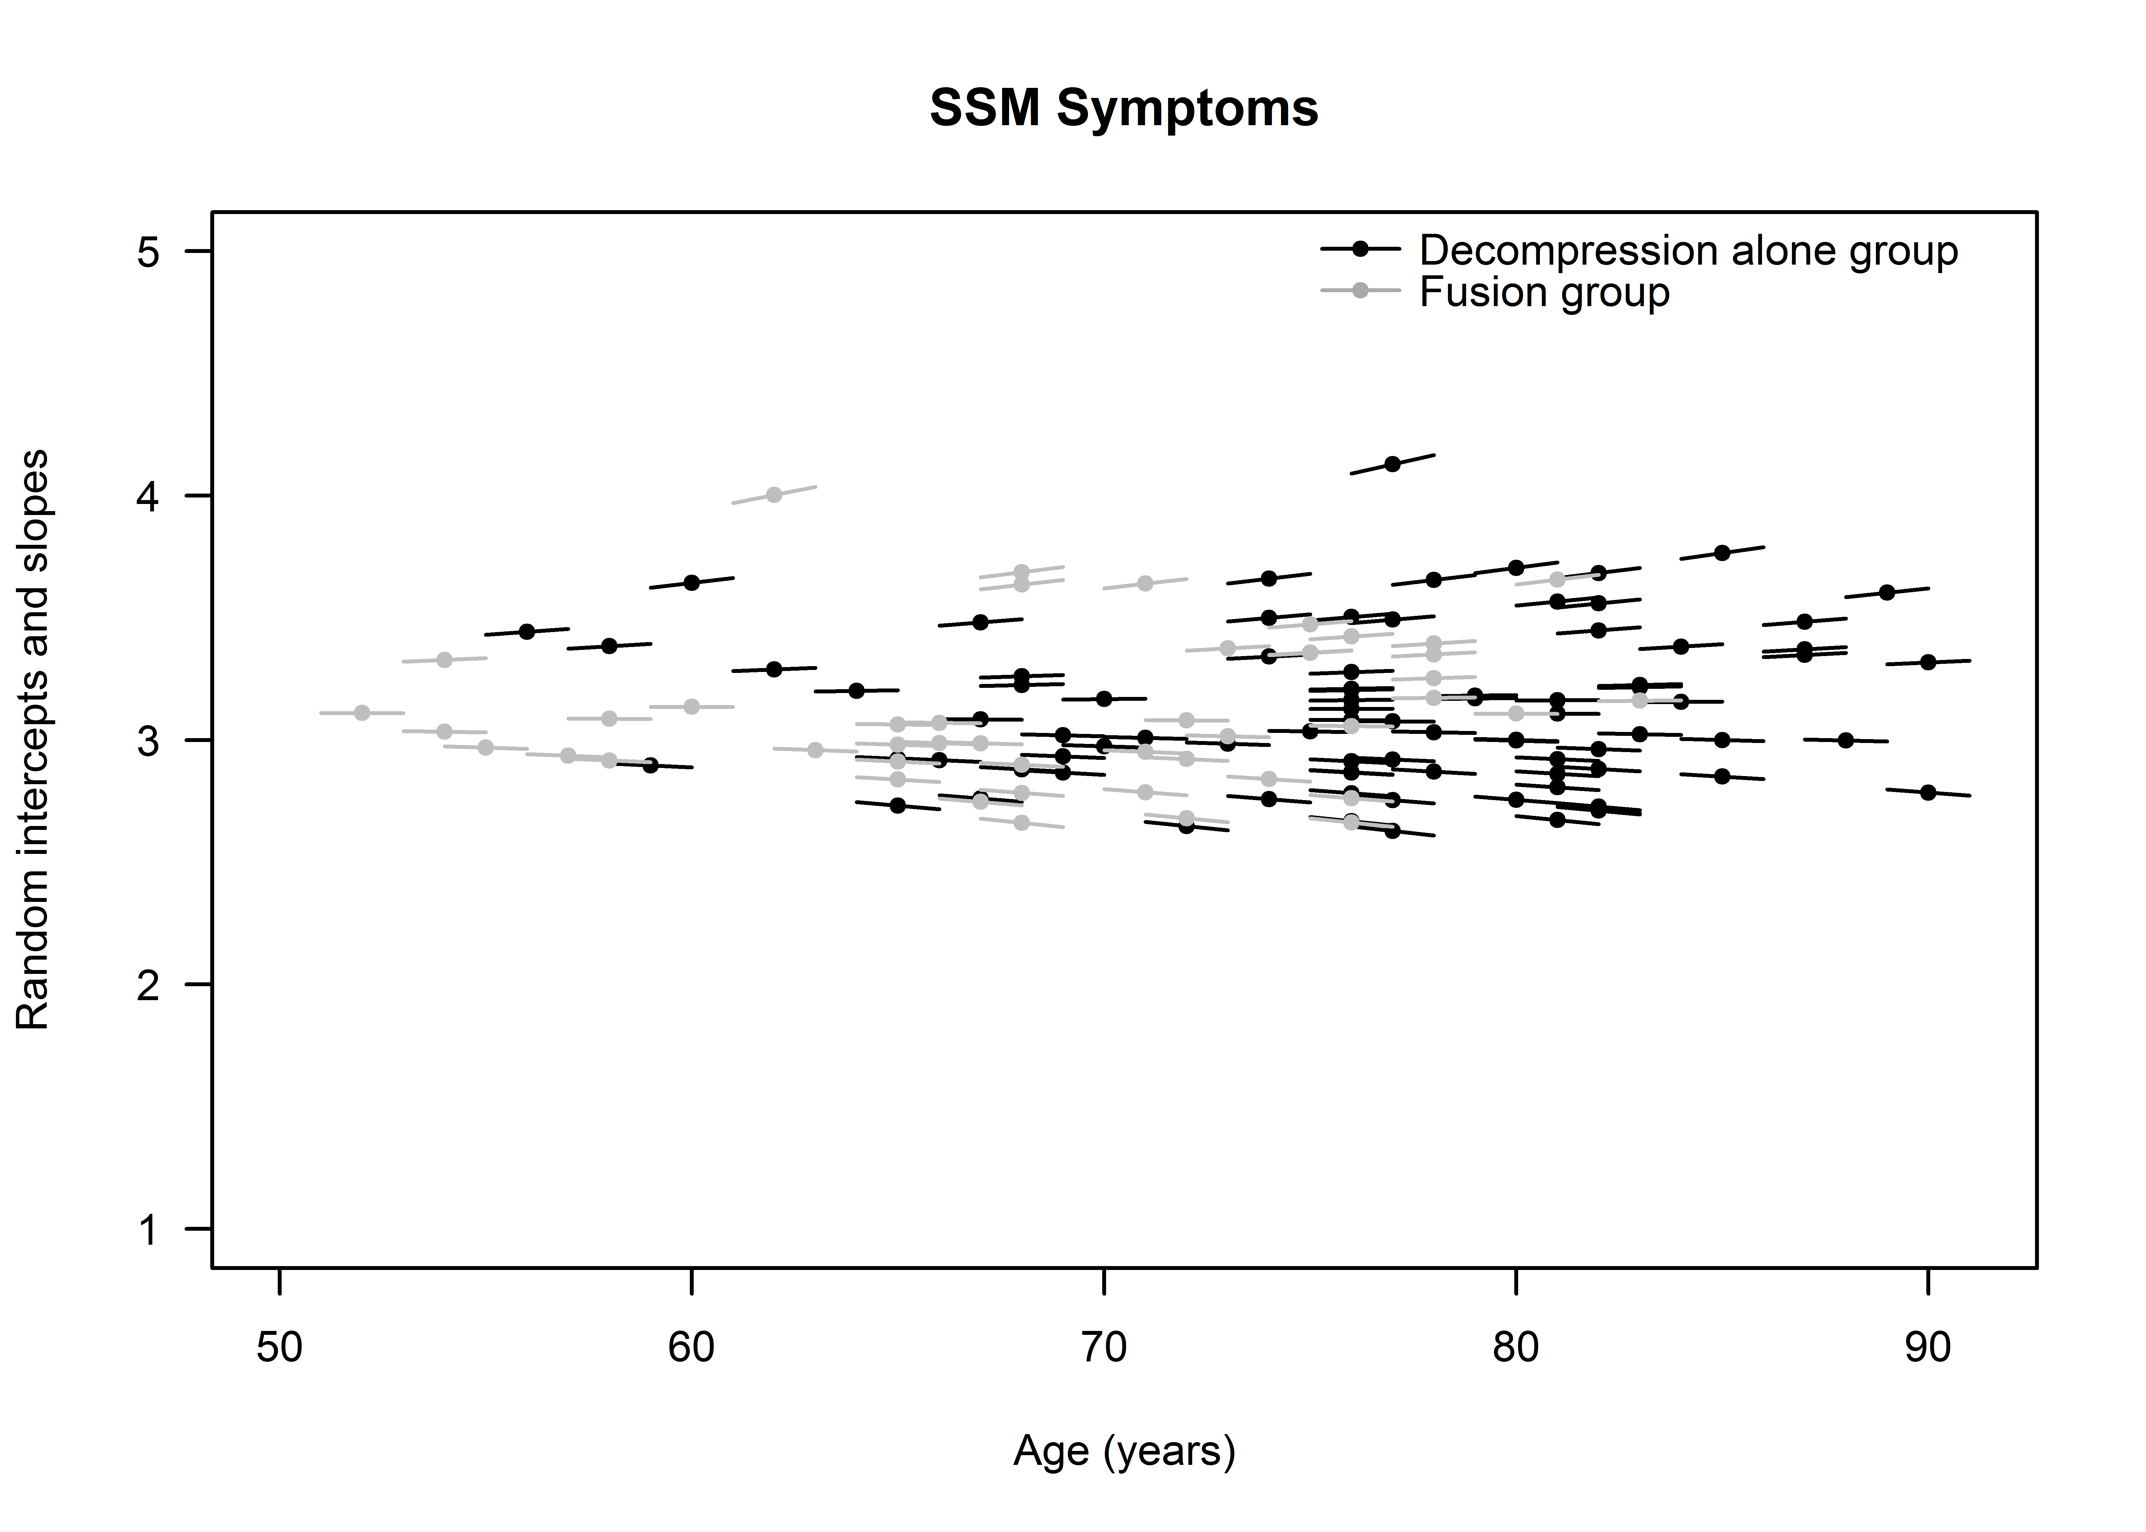

Appendix Figure 1b. Random intercepts and their slopes are displayed against age for the model with SSM function as dependent variable. There is no general trend visible. Black intercepts and slopes are from patients in the decompression group, whereas grey intercepts and slopes are from patients in the fusion group.


