Supplement Figure Legends:

Figure 1. Ultraviolet spectrophotometry profile for simvastatin solution in ethanol at various concentrations (a) with calibration curve used to calculate simvastatin concentrations (b).

Figure 2. Scanning electron microscope of the simvastatin nanoparticles (a) with size particle size distribution in nanometers (b) as well as the size distribution of the particles.

Figure 3. Simvastatin nanoparticles were suspended in PBS at varying concentrations (217μg/mL – 1667 μg/mL) and release was measured at various time points over two weeks. Release efficiency averaged 74.2% over this time frame.

Figure 4. MC3T3 cells were treated with varying concentrations of simvastatin and simvastatin nanoparticles. Viability was assessed using an MTT assay at 48 hours after treatment. No decrease in cell viability was observed at concentrations upto 10⁻⁶ M for simvastatin (a) and up to 16 ug/mL for simvastatin nanoparticles (b).

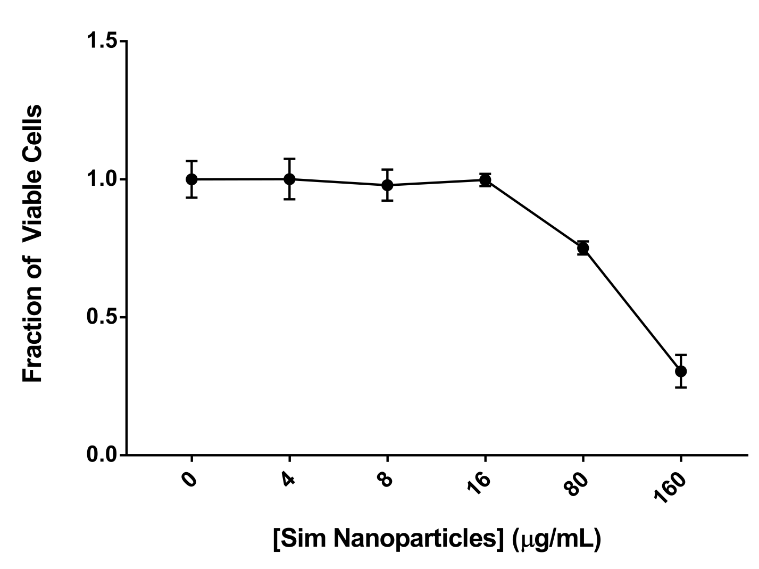

Figure 5. MC3T3 cells were treated with simvastatin nanoparticles (SimNP), blank nanoparticles (BlankNP) or a mineralizing differentiation medium (MIN) for 7 days. SimNP treated cells showed a significant increase in alkaline phosphatase (ALP) activity compared to MIN (a). SimNP treated cells had significantly higher expression of osteocalcin (OCN) (b) and osteopontin (OPN) (c) compared to BlankNP and MIN. SimNP also resulted in higher expression of ALPL (d) and RunX2 (e) but these did not reach statistical significance. *p<0.05

