Supplemental Digital Content Figure 1. Formation of pelvic incidence from 2 lines and hip center of rotation, showing the importance of sacral position inside the pelvis.

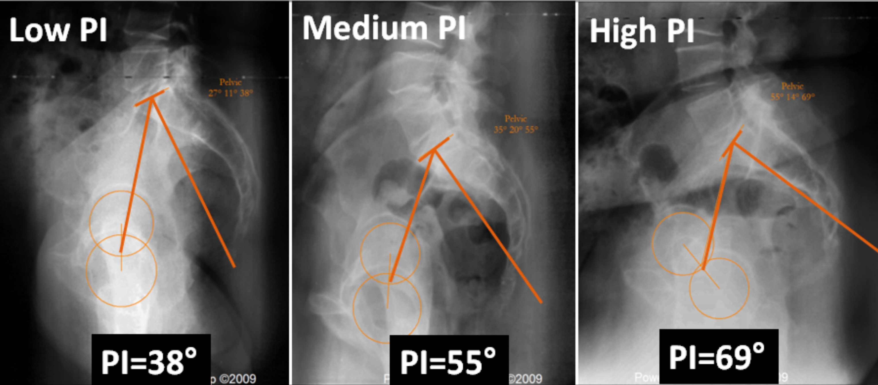

Supplemental Digital Content Figure 2. Spino-pelvic harmony.


