FIGURE 1. Cookie Theft picture description graphic.
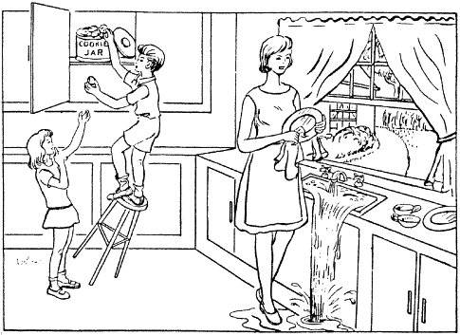

Cookie Theft Picture Description (originally from the Boston Diagnostic Aphasia Examination (BDAE, Goodglass, H., Kaplan, E., & Barresi, 2001) and the National Institutes of Health Stroke Scale (NIHSS, Brott et al., 1989; Lyden et al., 2004)

