Supplemental Material

Table of Contents

Methods: Ventilator-Associated Event (VAE) definitions 2
Methods: VAE incidence rates 4
Methods: Pathogen reporting 5
Results: VAE incidence rates 6
eTable 7
eFigure 8

Methods: Ventilator-Associated Event (VAE) definitions
There are three VAE surveillance definition syndromes. The most inclusive is Ventilator-Associated Condition (VAC); a subset of VAC is Infection-related Ventilator-Associated Complication (IVAC), and a subset of IVAC is Possible Ventilator-Associated Pneumonia (PoVAP) and Probable VAP (PrVAP). In 2015, PoVAP and PrVAP were combined into a single Possible VAP (PVAP) definition (Figure 1). VAC is defined by a ≥2-day period of worsening oxygenation following a ≥2-day period of stability or improvement on the ventilator. Worsening oxygenation is defined as a ≥3 cmH₂O increase in the daily minimum positive end-expiratory pressure (PEEP) or a ≥0.20 increase in the daily minimum fraction of inspired oxygen (FiO₂). Daily minimum PEEP values between 0 and 5 cmH₂O are considered equivalent to a daily minimum value of 5 cmH₂O for the purposes of VAE surveillance, such that a sustained increase in the daily minimum PEEP to 8 cmH₂O is needed to meet the VAC definition. The second syndrome, IVAC, can only be detected in patients with a VAC who also have the following: 1) an abnormal temperature or white blood cell count within a specified time frame around the date of onset of worsening oxygenation; and 2) a new antimicrobial drug started and continued for ≥4 calendar days during the same, specified time frame around the date of onset of worsening oxygenation. The third syndrome in 2014 was composed of the PoVAP and PrVAP surveillance events, which could only be detected in patients with IVAC who also had laboratory evidence of pneumonia (e.g., positive culture of lower respiratory secretions, positive diagnostic test for selected respiratory viruses, objectively-defined purulent lower respiratory secretions, etc.).
The minimum amount of time on a mechanical ventilator required to meet a VAE definition is 4 calendar days. Patients who are not on a mechanical ventilator for some portion of each of 4 consecutive calendar days cannot meet the VAE definitions. The earliest possible date of VAE onset (defined as the first day of the ≥2-day period of worsening oxygenation) is mechanical ventilation day 3, where the day of intubation or initiation of mechanical ventilation is day 1. According to the VAE surveillance protocol (8), pathogens can be reported for PoVAP and PrVAP (PVAP in 2015), but not for VAC or IVAC.

Methods: VAE incidence rates
The VAE definition syndromes potentially appropriate for use in inter-facility rate comparisons are: 1) overall VAE (i.e., all events meeting at least the VAC definition); and 2) IVAC-plus (i.e., all events meeting at least the IVAC definition). The VAC and IVAC definitions are based on objective criteria that are readily-available in mechanically-ventilated patients’ medical records. IVAC-plus events represent those VACs in which there is evidence of infection, not necessarily limited to the respiratory tract (3). Due to variability in diagnostic testing and reporting practices across inpatient locations and facilities, comparisons of PoVAP and PrVAP rates between locations and facilities may not be appropriate (3), and therefore we did not analyze PoVAP or PrVAP rates.

Methods: Pathogen reporting
National Healthcare Safety Network (NHSN) users may report up to three pathogens for each PoVAP or PrVAP event. For selected pathogens, antimicrobial susceptibility data are submitted to NHSN based on the clinical laboratory’s interpretation (e.g., susceptible, intermediate, resistant); minimum inhibitory concentration data are not submitted. Beginning in 2014, the NHSN annual facility survey included a question pertaining to use of revised Clinical and Laboratory Standards Institute carbapenem susceptibility breakpoints for Enterobacteriaceae (for example, see hospital survey, available here: http://www.cdc.gov/nhsn/forms/57.103_pshospsurv_blank.pdf). No information from this 2014 survey item was available for the current analysis.
We tabulated PoVAp and PrVAP pathogens reported in 2014, including proportions of pathogens with selected antimicrobial resistance phenotypes: resistance to methicillin, oxacillin or cefoxitin in Staphylococcus aureus, and carbapenem resistance in selected Enterobacteriaceae and Pseudomonas aeruginosa. We defined carbapenem resistance in Enterobacteriaceae as resistance to imipenem, doripenem, ertapenem, or meropenem, and in P. aeruginosa as intermediate susceptibility or resistance to imipenem, doripenem, or meropenem. For these pathogen/antimicrobial agent combinations, we determined the resistant proportion, defined as the number of resistant isolates divided by the total number of isolates tested.

Results: VAE incidence rates
The final model used to determine additional stratification of VAE rates beyond location type is ln(µ_{i})=β₀+β₁x_{i}+ln(t_{i}), where x_{i} represents the location type strata, using adult step-down units as the referent group, and t_{i} represents the corresponding total number of ventilator days in each stratum. Locations with no VAEs and therefore an incidence rate of zero (rehabilitation and surgical wards) were not included in the model. Final model parameters and estimates are shown in the eTable.

eTable. Final negative binomial regression model parameters and estimates used to inform selection of location type strata used in reporting VAE incidence rates. Adult step-down units were the referent group.

Parameter | Estimate (95%CI) | P-value
Intercept | -5.39 (-5.53, -5.24) | <0.0001
Burn critical care | 0.40 (0.16, 0.65) | 0.001
Medical cardiac critical care | 0.33 (0.17, 0.49) | <0.0001
Surgical cardiothoracic critical care | 0.29 (0.13, 0.44) | 0.0003
Long term acute care critical care | -0.84 (-1.23, -0.46) | <0.0001
Neurologic critical care | 0.64 (0.42, 0.86) | <0.0001
Neurosurgical critical care | 0.59 (0.42, 0.75) | <0.0001
Respiratory critical care | -0.21 (-0.71, 0.28) | 0.398
Trauma critical care | 0.94 (0.78, 1.10) | <0.0001
Oncology medical/surgical critical care | -0.57 (-1.17, 0.04) | 0.068
Medical critical care: major teaching affiliation | 0.59 (0.44, 0.75) | <0.0001
Medical critical care: non-major teaching affiliation | 0.19 (0.03, 0.35) | 0.018
Medical/surgical critical care: major teaching affiliation | 0.51 (0.36, 0.66) | <0.0001
Medical/surgical critical care: non-major teaching affiliation, >15 beds | 0.12 (-0.03, 0.27) | 0.114
Medical/surgical critical care: non-major teaching affiliation, ≤15 beds | -0.04 (-0.19, 0.11) | 0.562
Surgical critical care: major teaching affiliation | 0.65 (0.49, 0.81) | <0.0001
Surgical critical care: non-major teaching affiliation | 0.20 (0.02, 0.37) | 0.031
Long term acute care ward | -1.64 (-1.86, -1.41) | <0.0001
Medical ward | -0.34 (-0.67, -0.01) | 0.043
Medical/surgical ward | -0.60 (-0.93, -0.28) | 0.0003
Pulmonary ward | -0.03 (-0.43, 0.37) | 0.885
Rehabilitation ward | -1.53 (-3.52, 0.45) | 0.130
Hematopoietic stem cell transplant ward | 1.21 (0.64, 1.77) | <0.0001
Adult mixed acuity unit | 0.50 (0.25, 0.75) | <0.0001

eFigure. Ventilator-associated event definitions, 2014.
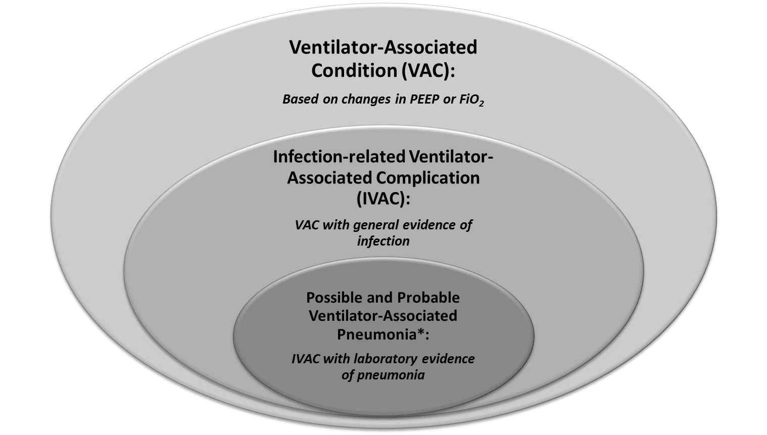
*Possible and Probable VAP replaced in 2015 by single Possible VAP (PVAP) definition.

