Electronic Figure 1. Citation analysis of family-centered care publication from Thomson Web of Science
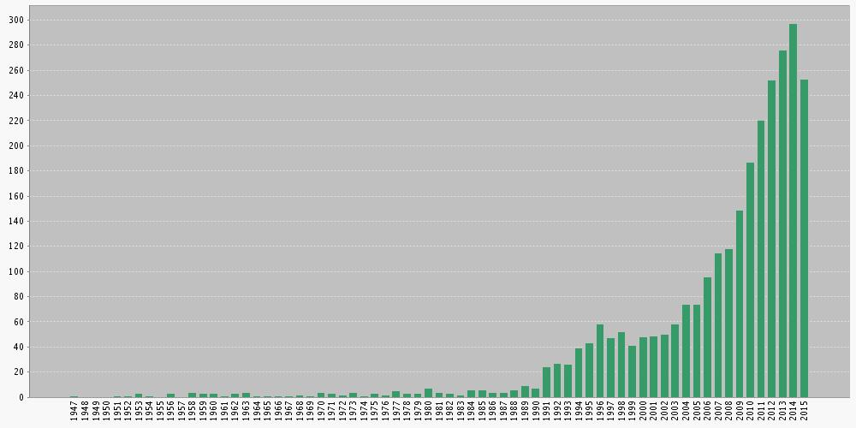

Electronic Figure 2: Prisma Flow Diagram for Systematic Review

Identification
Records identified through database searching PubMed 2437
CINAHL 3051
EMBASE 4313 ( n = 9801 )

Eligibility

Screening
Records after duplicates removed ( n = 4158 )
Additional records identified through alerts & hand search ( n = 76 )
Records screened ( n = 4234 )
Records excluded ( n = 3910 )
Full-text articles assessed as eligible
( n = 324 )
Full-text articles excluded, with reason
( n = 88 )

Included
Studies included (n = 236 )

Adapted from: Moher D, Liberati A, Tetzlaff J, Altman DG, The PRISMA Group (2009). Preferred Reporting Items for Systematic Reviews and Meta- Analyses: The PRISMA Statement. PLoS Med 6(6): e1000097. doi:10.1371/journal.pmed1000097

