Bedside glucose monitoring—is it safe? A new, regulatory-compliant risk assessment evaluation protocol in critically ill patient care settings
Jeffrey DuBois, Robbert Slingerland, Marion Fokkert, Alain Roman, Nam Tran, William Clarke, David Sartori, Tina Palmieri, Andrei Malic, Martha Lyon, Andrew Lyon

SUPPLEMENTAL DIGITAL CONTENT

Application of Monte Carlo Simulation of Clinical Risk to the BGMS Trial Data: This section provides a description of how to overlay published Monte Carlo simulation contour plots of clinical risk in critical care adult patients to the blood glucose monitoring system trial data in critical care adult patients.
Monte Carlo Simulation Contour Plots
The Monte Carlo simulation contour plots of insulin dose error rates previously published by Karon, Boyd and Klee (2010) were utilized to estimate the potential clinical risk associated with the BGMS trial data. In this simulation study, the dose of insulin given to patients was dependent upon the glucose value measured by a point of care glucose meter. Twelve insulin dose categories were utilized that reflect the institutional tight glycemic protocol. The influence of analytical bias and precision on all glucose values was assessed by evaluating if the insulin-dose-category was the same, or changed to ±1, ±2, ±3 dose categories at each pair of bias and precision values. To simulate the effects of analytic precision and bias on the modelled glucose, the initial glucose values were modified using the following equation:
glucose_{m} = glucose_{i} + [n(0,1) x CV x glucose_{i}] + [Bias]x glucose_{i}
Where glucose_{i}= Initial glucose value in mg/dL
- glucose_{m}= modelled value reflecting the effects of analytical imprecision and bias.
- n(0,1) : a random number drawn from a Gaussian distribution with a mean of 0 and SD of 1.
- CV: The coefficient of variation expressed as a fraction.
- Bias: the assay bias expressed as either a positive or negative fraction

The initial glucose and the simulated glucose values were then allotted into the 12 insulin-dose-categories. The contour plots have scales of CV% and Bias% and reflect the percentage of the simulated glucose values allocated to a different insulin-dose-category by ±1 category, ±2 categories or ±3 categories compared to the initial insulin-dose-category.
Overlay of Total Allowable Error boundary lines on Insulin-dose-category error contour plots
Total Allowable Error (TEa) lines reflecting 10%, 15% and 20% TEa were overlaid on each contour graph. TEa was defined as TEa = bias (%) + (1.65 x CV(%)). By overlaying the TEa boundary lines the co-variation of assay imprecision and bias with assay quality (TEa) and percentage of insulin-dose-category error can be visually observed as previously described (Refs: Boyd & Bruns 2001 Clin Chem, Karon, Boyd, Klee 2010 Clin Chem).
Overlay of Blood Glucose Monitoring System Patient Trial Data with Insulin-dose-category error contour plots
Clinical trial data from critical care patients consisted of pairs of glucose results from a reference method (Glucose _{Ref Method}) and a BGMS (Glucose _{BGMS}) and the BGMS device has known precision (e.g. CV = 3.25%). The percentage bias of clinical trial BGMS glucose data can be calculated for pair of patient results: (e.g bias % = 100%x (Glucose _{BGMS} – Glucose _{Ref Method})/Glucose _{Ref})). By using the device CV% and individual patient BGMS Bias%, then the clinical trial data can be overlaid onto the contour plot of insulin-dose-error percentage. The cluster of BGMS trial data on the plot outlines a zone of device performance in the trial and depicts the associated risk of insulin-dose-error rate with the trial BGMS observations. In Figure 3 the contour plot of three or more categories of insulin-dose-errors was superimposed with a random sample of blood glucose trial results (n=200) at a 3.25% CV with BGMS Bias% of the individual observations. The overlay of the contour plot, the TEa lines and clinical trial data was created using STATA software with a jitter function applied to the CV% clinical trial data to slightly disperse the data points at CV= 3.25%. The study BGMS has been shown in a previous publication by Karon et al (Diabetes Technology & Therapeutics, 2008 10 (2)) and by Biljak et al (Diabetologia Croatica 2010 39-3), to have a coefficient of variation (CV) in whole blood and QC control samples ranging from 1.4% to 3.3% depending upon the study site. Consequently the study team chose the higher coefficient of variance to reflect general use.

Application of Stratified Sensitivity and Specificity Analysis to the BGMS Trial Data
This section provides additional information of the method used to calculate the sensitivity and specificity in each stratum presented in figure 2 of the main manuscript. The 1815 paired glucose measurements from the Reference method and the BGMS method were sorted into the 13 categories of the insulin-dose protocol as depicted below. Cross tabulation of the glucose values from the two methods shows the pattern of association. The boxes in green depict values where the Reference method and the BGMS method agree within + or - one insulin-dose category. The boxes in yellow depict values where the methods disagree by more than + or - one category. The sensitivity calculated within each insulin-dose category or stratum is the fraction of BGMS glucose values +/- one BGMS glucose category that agree with the corresponding Reference method glucose value. The specificity calculated within each insulin-dose category or strata is the fraction of BGMS glucose values + or - one Reference method glucose category that agree with the corresponding BGMS method.
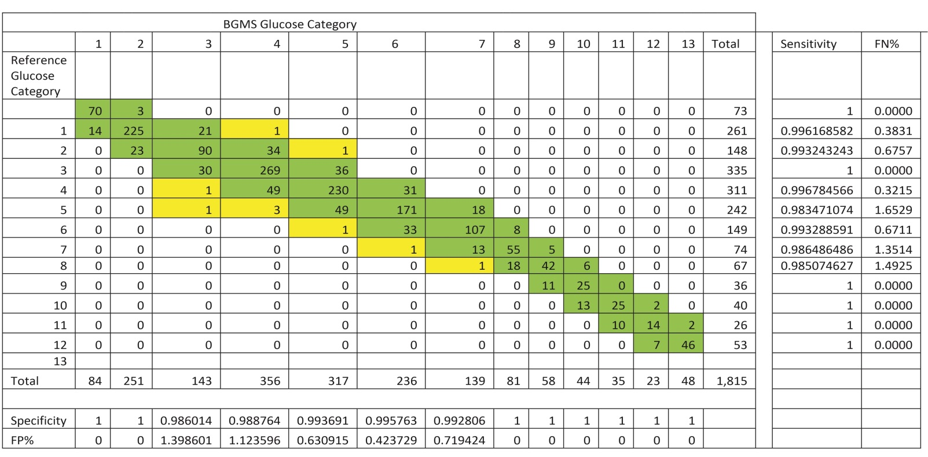

Supplemental Tables
Supplemental Table 1. Alignment and traceability of laboratory reference methods

Site | Laboratory method | Traceability to ID GCMS method | External Quality Assurance verification
A | Hexokinase | Traceability to an in house method using NIST SRM 965a at four reported levels; 1.913 mmol/L, 4.357 mmol/L, 6.717mmol/L, and 16.24 mmol/L) | SKML Dutch Foundation for Quality Assessment in Medical Laboratories
B | Hexokinase | To in house method using NIST SRM 965a at four reported levels; 1.913 mmol/L, 4.357 mmol/L, 6.717mmol/L, and 16.24 mmol/L) | SKML - Dutch Foundation for Quality Assessment in Medical Laboratories
C | Hexokinase | Alignment verified using NIST standard reference materials 965b at four reported levels as provided by NIST and SRM 917c from which 10 glucose levels were prepared across the glucose measuring range | CAP - College of American Pathologists Proficiency Testing
C | Hexokinase | Alignment verified using NIST standard reference materials 965b at four reported levels as provided by NIST and SRM 917c from which 10 glucose levels were prepared across the glucose measuring range | WIV-ISP Belgian External Quality Assessment Program
E | Glucose Oxidase | Alignment verified using NIST standard reference materials 965b at four reported levels as provided by NIST and SRM 917c from which 10 glucose levels were prepared across the glucose measuring range | CAP - College of American Pathologists Proficiency Testing

The information in Table 1 further describes the alignment of the central laboratory glucose methods and the confirmation and verification of method performance based on External Quality Assessment.

Supplemental Table 2: Breakdown of patient age and glucose ranges

Age range | Number | Minimum glucose value (mg/dL) | Maximum glucose value (mg/dL) | Average glucose value (mg/dL)
0 – 6 months | 12 | 86.4 | 475.68 | 188.40
6 months – 1 year | 0
1 -10 years | 0
10 – 19 years | 22 | 73.87 | 378.38 | 162.80
20 – 29 years | 75 | 16.22 | 531.54 | 130.7
30 – 39 | 144 | 28.83 | 553.16 | 150.01
40 - 49 | 116 | 14.41 | 483.00 | 138.74
50 – 59 | 228 | 16.22 | 558.56 | 123.06
60 – 69 | 394 | 12.61 | 515.32 | 133.52
70 – 79 | 432 | 12.61 | 517.12 | 136.48
80 - 89 | 155 | 30.36 | 499.10 | 142.14
90 - 99 | 22 | 57.66 | 390.00 | 139.73
Unknown | 98 | 12.6 | 263.07 | 99.93

Supplemental Table 2 shows a breakdown of the study population number into ten year age spans. The minimum and maximum glucose values obtained within each age range group expressed in mg/dL are listed. The average glucose values are expressed in mg/dL for each age range group.

Supplemental Table 3: Breakdown of Patient medication information by five sites to include 33 different drug classes¹
Patient Drug classes | Site A | Site B | Site C | Site D | Site E
Alcohol  Anti-Infective  Antidote  Anti-Neoplastic  Anti-Psoriatics  Disease Modifying Anti-Rheumatic  Anti-Vertigo  Biologicals  Blood Products  Calcimimetic  Cardiovascular Agents  Cholinergic Muscle Stimulant  Central Nervous System Agent  Coagulation Modifiers  Radiologic Agent  Gastrointestinal agent  Genitourinary Tract Agent  Hemodialysis  Hormonal Agents  Hyperkalemia Agent  Immunologic Agent  Metabolic / Nutritional  Metabolic agent  Nutritional Product  Phosphate Binder  Plasma Expander  Psychotherapeutic Agent  Respiratory Agent  Smoking Cessation Agent  Topical Agent  Topical Anti-Infective | 311  9  2  1  19  7  317  365  285  338  3  1  287  9  23  166  292  30  8  144  280  11  60  3 | 385  1  1  3  1  7  2  588  557  458  458  22  5  385  26  3  320  296  6  3  154  287  19  323 | 62  1  11  2  45  1  59  38  4  52  58  9  12  11  5  10  25  36  3 | 1  166  21  2  1  34  148  207  109  164  123  5  4  58  74  221  73  31  64  1 | 6  6  6  6  6  6  3  5  6  5  1  6  1  6  6
- 963/1698 (56.7%) patients on vasoactive drugs including 603/1698 patients (35.6%) on vasopressors. 540/1698 (31.8%) on more than one vasoactive medication

Supplemental Table 3 shows a breakdown of the study population patient medication. The medication groups are defined by the Medication classification based on the United States Pharmacopeia (reference 24 in the main manuscript text) and 33 different parent drug classes were identified. The numbers within each medication classification are further broken down by study site. In addition, out of the total study population 963/1698 (56.7%) patients received vasoactive drugs including 603/1698 patients (35.6%) on vasopressors and 540/1698 (31.8%) on more than one vasoactive medication.

Supplemental Table 4.
Breakdown of range of physiological and biochemical parameters in patient whole blood samples by five sites
Parameter | Site A | Site B | Site C | Site D | Site E
Hematocrit - % | 14.10 – 70.6 | 17.4 - 64.20 | 27 – 63.4 | 12 - 61.2 | 18.3 – 55.1
pH | 7.02 - 7.58 | 6.87 - 7.77 | 7.11 – 7.54 | 6.80 – 7.63 | 7.19 - 7.5
pCO2 – kPa  pCO2 – mm/Hg | 0.62 -13.90 | 1.03 - 15.30 | Not available | 14.40 -109.50 | 29 – 59
pO2 – kPa  pO2 – mm/Hg | 2.51 – 45 | 2.2 -46 | 22.6-400 | 20.80 – 429.10 | 80 – 417
sO2 - % | 22.9 - 100 | 24.4 - 100.2 |  | 52.8 - 99.20 | 91 – 100
Sodium – mmol/L  Sodium - mEq/L | 119 – 169 | 113 – 161 | 129 - 152 | 116.30 – 156 | 3.4 – 143
Potassium – mmol/L  Potassium – mEq/L | 2.5 – 6.4 | 2.10 - 6.7 | Not available | 2.80 - 7.80 | 2.6 – 11
Calcium – mmol/L  Calcium – mEq/L | 0.70 – 2.03 | 0.64 – 1.90 | Not available | 0.84 – 1.37 | Not available
Lactate – mmol/L | 0.60 – 18 | 0.4 – 19 | Not Available | 4.00 – 154.90 | Not available
Triglycerides – mmol/L | 0.78 – 2.8 | 0.64 – 3.83 | 1.70 – 692 | Not available | Not available

Supplemental Table 4 shows a breakdown of a range of biochemical and physiological factors known to associated with interference of BGMS results. The abnormal ranges reflect the nature of the patient population. In site 1, 2 and 3 results are routinely reported in SI units and in sites 3 and 4 results are routinely reported in US customary units.

Supplemental Table 5.
Supplemental Table 5 provides further background definitions to the test methodology used in the study that is recommended by, and referred to, in international guidelines and standards.

Methodology | Terminology | Definition | Reference
BGMS | Blood Glucose Monitoring system | US FDA description for blood glucose monitoring systems approved for use in hospitals. Also considered to be for Prescription Point-of-Care Use. | Food and Drug Administration: Self-Monitoring Blood Glucose Test Systems for Over-the-Counter Use. Draft Guidance for Industry and FDA Staff. Rockville, MD: 2014
SMBG | Self-Monitoring blood glucose system | US FDA description for glucose meters used by diabetic patients for self -monitoring of glucose. Also considered to be for over-the-counter. | Food and Drug Administration: Blood glucose monitoring test systems for prescription point-of-care use. Draft Guidance for Industry and FDA Staff. Rockville, MD: 2014
ID-GCMS | Isotope Dilution Gas Chromatography Mass Spectrometry | Highest order reference measurement methodology for assessing traceability and alignment of glucose measurement methods | Andreis E, Küllmer K, Appel M, Application of the Reference Method Isotope Dilution Gas Chromatography Mass Spectrometry (ID/GC/MS) to Establish Metrological Traceability for Calibration and Control of Blood Glucose Test Systems. 2014 Journal of Diabetes Science and Technology, Vol. 8(3) 508–515

