ONLINE ONLY SUPPLEMENTAL MATERIAL:
Supplemental data file 1: CORNELL ASSESSMENT OF PEDIATRIC DELIRIUM (CAPD)
Supplemental data file 2: List of participating institutions

Supplemental data file 1:

CORNELL ASSESSMENT OF PEDIATRIC DELIRIUM*
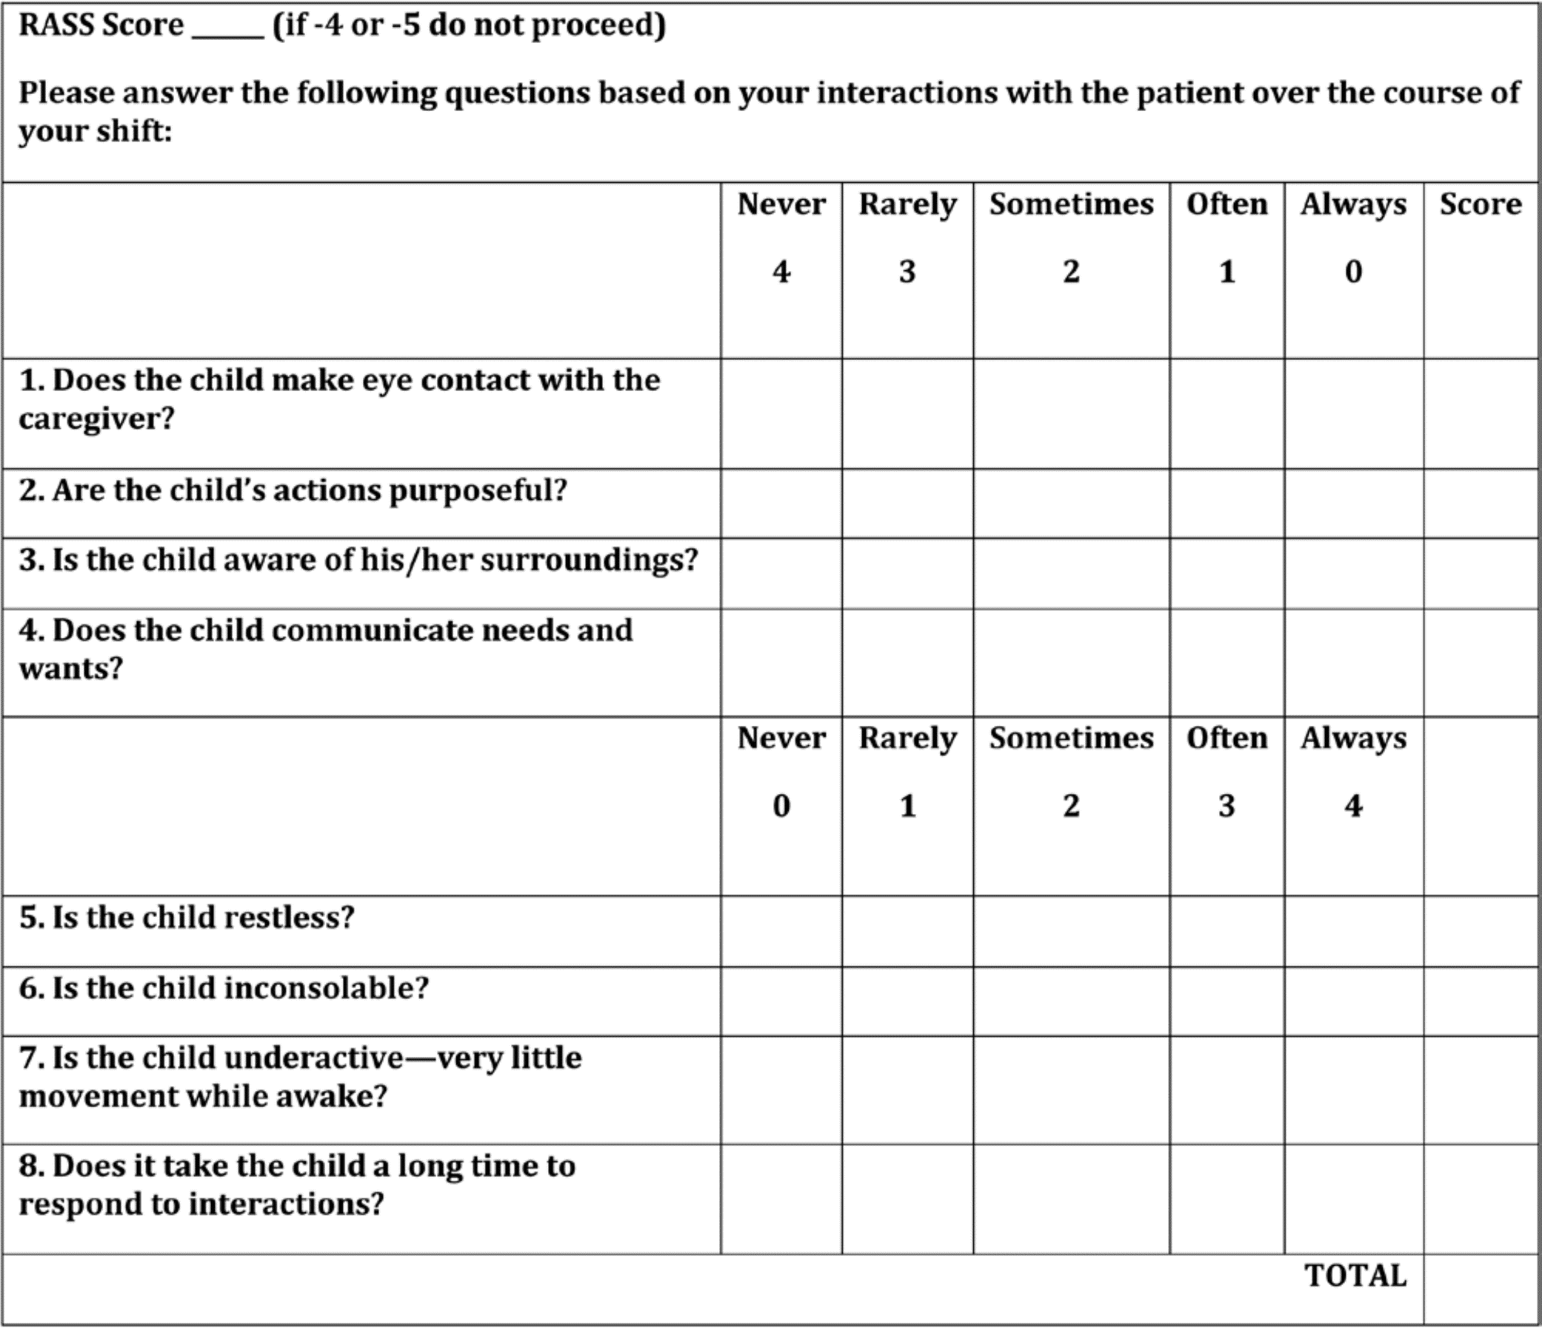
*Cut-off score of >=9 used for delirium classification.
Reproduced from: Traube C, Silver G, Kearney J, Patel A, Atkinson TM, Yoon MJ, et al. Cornell Assessment of Pediatric Delirium: A Valid, Rapid, Observational Tool for Screening Delirium in the PICU. Crit Care Med. 2014 Mar;42(3):656–63.

Supplemental data file 2:
List of participating institutions:
Name of Institution |  | Location | Number of Subjects
Al Hada Armed Forces Hospital |  | Taif, Saudi Arabia | 3
Boston Children’s Hospital |  | Boston, Massachusetts | 53
Children’s Healthcare of Atlanta at Scottish Rite |  | Atlanta, Georgia | 33
Children’s Hospital of Omaha |  | Omaha, Nebraska | 15
Children’s Hospital of Philadelphia |  | Philadelphia, Pennsylvania | 146
Connecticut Children’s Medical Center |  | Hartford, Connecticut | 29
Cook Children's Hospital |  | Fort Worth, Texas | 15
CS Mott Children’s Hospital |  | Ann Arbor, Michigan | 17
Duke Children’s Hospital |  | Durham, North Carolina | 15
Emory University |  | Atlanta, Georgia | 36
Erasmus MC-Sophia Children’s Hospital |  | Rotterdam, The Netherlands | 30
Johns Hopkins University |  | Baltimore, Maryland | 59
Lady Cilento Children’s Hospital |  | Brisbane, Australia | 21
Lurie Children’s Hospital |  | Chicago, Illinois | 98
Massachusetts General Hospital |  | Boston, Massachusetts | 7
Nationwide Children’s Hospital |  | Columbus, Ohio | 81
Phoenix Children’s Hospital |  | Phoenix, Arizona | 59
Seattle Children’s Hospital |  | Seattle, Washington | 65
Starship Children’s Hospital |  | Auckland, New Zealand | 28
University of North Carolina |  | Chapel Hill, North Carolina | 14
University of Pittsburgh |  | Pittsburgh, Pennsylvania | 74
University of Wisconsin |  | Madison, Wisconsin | 10
Virginia Commonwealth |  | Richmond, Virginia | 8
Washington University of St. Louis |  | St. Louis, Washington | 43
Weill Cornell Medical College |  | New York, New York | 35
Total: |  |  | 994

