Supplemental Data File

Supplemental Table 1: Inclusion/Exclusion Criteria
Inclusion Criteria | Exclusion Criteria
Male and female patients | Neurological exam suggested imminent brain death
Age: 14 years and older | Accuracy of neurologic exam was uncertain (e.g., seizure activity)
Non-penetrating severe TBI  (initial GCS score 3-8, motor score ≤5, not following commands after resuscitation and without influence of paralytics or sedation) | Potential secondary oxygenation concerns which would influence results (e.g., evidence of severe chest/lung injury), refractory hypotension; and/or systemic hypoxia
Clinical need for ICP monitoring according to Guidelines for the Management of Severe TBI | Placement of an intracranial monitor was contraindicated
Randomization and ICP monitor placement within 12 hours of injury | Pregnancy
 | Inability to obtain informed consent from legal authorized representative (LAR)
 | Participation in another interventional trial
 | PbtO₂ monitoring before randomization

Supplemental Table 2: Interventions by assignment group
 | ICP Only  (N=62) | ICP + PbtO₂  (N=57)
Total Number of Interventions | 933 | 867
B | 933 | 411
C | --- | 334
D | --- | 122
Add antiepileptic drug (AED) | --- | 9
C | --- | 8
D | --- | 1
Add EEG monitoring | --- | 10
C | --- | 10
D | --- | 0
Adjust head of bed to improve brain oxygenation | --- | 39
C | --- | 39
Adjust head of bed to lower ICP | 104 | 56
B | 104 | 46
D | --- | 10
Adjust sedation and analgesia | 340 | 210
B | 340 | 184
D | --- | 26
Adjust Temperature to 32 – 34.5°C | 1 | 0
B | 1 | 0
D | --- | 0
Adjust temperature to 35 – 37°C | 4 | 6
B | 4 | 4
D | --- | 2
Adjust ventilation to increase PaCO₂ to 45‐50 mmHg | --- | 6
C | --- | 6
Adjust ventilation to lower PaCO₂ to 32‐35 mmHg. | 9 | 6
B | 9 | 6
Adjust ventilation to obtain PaCO₂ between 35‐40 mmHg | 39 | 10
B | 39 | 10
CSF drainage | 169 | 68
B | 169 | 61
D | --- | 7
Decompressive craniectomy | 3 | 0
B | 3 | 0
D | --- | 0
Decrease ICP to < 10mmHg | --- | 11
C | --- | 11
Ensure temperature < 38°C | 98 | 90
B | 98 | 33
C | --- | 42
D | --- | 15
High dose mannitol (>1g/kg), or higher frequency of standard dose | 6 | 6
B | 6 | 6
D | --- | 0
Hypertonic saline | 71 | 35
B | 71 | 28
D | --- | 7
Increase CPP to a maximum of 70mmHg with fluid bolus | --- | 35
C | --- | 27
D | --- | 8
Increase CPP to a maximum of 70mmHg with vasopressors | --- | 6
C | --- | 5
D | --- | 1
Increase PaO₂ by adjusting PEEP | --- | 57
C | --- | 48
D | --- | 9
Increase PaO₂ by increasing FiO₂ to 100% | --- | 38
C | --- | 26
D | --- | 12
Increase PaO₂ by increasing FiO₂ to 60% | --- | 102
C | --- | 83
D | --- | 19
Neuromuscular paralysis | 8 | 3
B | 8 | 2
D | --- | 1
Optimize hemodynamics | --- | 25
C | --- | 25
Pentobarbital coma | 1 | 0
B | 1 | 0
D | --- | 0
Repeat CT – look for increased size of intracranial mass lesions | 14 | 9
B | 14 | 7
D | --- | 2
Standard dose mannitol (0.25 – 1.0 g/kg) | 66 | 24
B | 66 | 23
D | --- | 1
Transfuse packed RBCs to reach Hgb > 10g/dL | --- | 5
C | --- | 4
D | --- | 1
Treat surgically remediable lesions with craniotomy | --- | 1
B | --- | 1
D | --- | 0

Supplemental Table 3: Treatment-related protocol deviations & violations in each study group.
By Number of Patients | Overall | ICP Only | PbtO₂ + ICP | p-value
N | 119 | 62 | 57
Deviation: ICP 20-25 mmHg for >30 min. | 45 (38%) | 25 (40%) | 20 (35%) | .576
Deviation: PbtO₂ 15-19 mmHg for >30 min. | 11 (9%) | --- | 11 (19%) | ---
Violation: ICP >25mmHg for >30 min. | 14 (12%) | 8 (13%) | 6 (11%) | .780
Violation: PbtO₂ <15mmHg for >30 min. | 9 (8%) | --- | 9 (16%) | ---

Supplemental Table 4: Serious Adverse Events.
 | Overall | ICP Only | PbtO₂ + ICP | p-value
Subjects | 119 | 62 | 57
A - Cardio-Vascular | 14 (12%) | 5 (8%) | 9 (16%) | .257
B - Genito-Urinary | 0 (0%) | 0 (0%) | 0 (0%) | ---
C - Gastro-intestinal | 2 (2%) | 1 (2%) | 1 (2%) | 1.000
D - Laboratory abnormalities | 0 (0%) | 0 (0%) | 0 (0%) | ---
E - Metabolic Disorders | 0 (0%) | 0 (0%) | 0 (0%) | ---
F - Musculo-skeletal | 0 (0%) | 0 (0%) | 0 (0%) | ---
G - Neurological | 15 (13%) | 10 (16%) | 5 (9%) | .276
H - Opthamologic | 0 (0%) | 0 (0%) | 0 (0%) | ---
I - Respiratory | 5 (4%) | 1 (2%) | 4 (7%) | .192
J - Skin | 0 (0%) | 0 (0%) | 0 (0%) | ---
K - Other | 25 (21%) | 17 (27%) | 8 (14%) | .114
Death following w/d of medical care | 22 (18%) | 14 (23%) | 8 (14%) | .248
Other* | 3 (3%) | 3 (5%) | 0 (0%) | .245
* "sepsis", "MRSA infection", "self-extubation"

Web Appendix – BOOST-II tiered interventions for each treatment scenario.
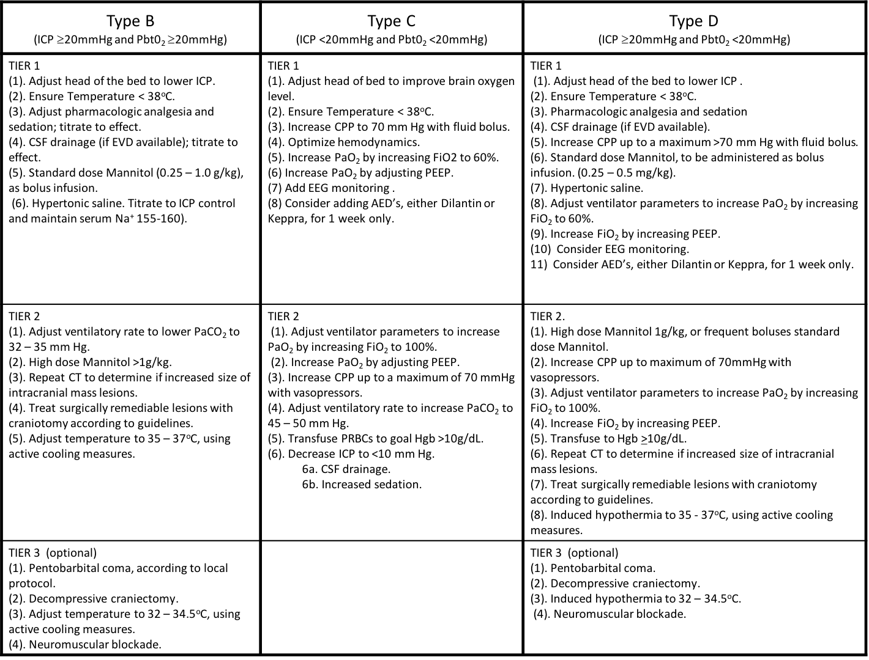

For Type B treatments (ICP ≥ 20 mm Hg), Tier 1 treatment interventions included adjustment of the head of the bed; ensuring body temperature < 38ºC; titration of pharmacologic analgesia and sedation; drainage of CSF if ventriculostomy present; and/or administration of mannitol or hypertonic saline. Tier 2 treatment interventions were initiated when ICP was ≥ 20 mm Hg for >60 minutes despite Tier 1 therapies and included adjustment of ventilator rate (paCO₂ 32-35 mmHg); increased dosage of osmotics; repeat CT scan to determine if intracranial mass lesions increased in volume, with surgery if applicable; optimization of hemodynamics and adjustment of body temperature (35-37ºC). Tier 3 therapies were optional, instituted per attending site physician discretion and included pentobarbital coma, according to local protocol; decompressive craniectomy; hypothermia treatment (32-34.5ºC); and neuromuscular paralysis.
For Type C treatments (ICP normal, pBtO₂ <20 mm Hg), Tier 1 treatment interventions included adjustment of the head of the bed; ensuring body temperature < 38ºC; optimization of hemodynamics with increase cerebral perfusion pressure (CPP) > 70mmHg; optimization of oxygenation (increasing PaO₂ with FiO₂ at 60% and increasing PEEP); considering EEG monitoring and potential additional seizure prophylaxis. Tier 2 treatment interventions were initiated when PbtO₂ was < 20mm Hg for >60 minutes despite Tier 1 therapies and included additional adjustments of ventilator parameters (increasing PaO₂ with FiO₂ at 100% and increasing PEEP; increasing PaCO₂ 45-50mm Hg; ); optimization of hemodynamics to increase CPP to 7-mmHg (with vasopressors, if needed and decrease ICP to <10mmHg by CSF drainage and/or increased sedation) and transfusion of pRBC’s to Hgb >10mmHg.
For Type D treatments (ICP ≥ 20 and PbtO2 < 20 mm Hg), Tier 1 treatment interventions included adjustment of the head of the bed; ensuring body temperature < 38ºC; titration of pharmacologic analgesia and sedation; drainage of CSF if ventriculostomy present; and/or administration of mannitol or hypertonic saline; optimization of hemodynamics to maximum of 70mmHg with fluid bolus; optimization of oxygenation (increasing PaO₂ with FiO₂ at 60% and increasing PEEP); and consideration of EEG monitoring and potential additional seizure prophylaxis. Tier 2 treatment interventions then included adjustment of ventilator rate (increasing PaO₂ with FiO₂ at 100% and increasing PEEP); increased dosage of osmotics; repeat CT scan to determine if intracranial mass lesions increased in volume, with surgery if applicable; optimization of hemodynamics (increase CPP to >70 mmHg and transfusion of pRBC’s to Hgb >10mmHg); adjustment of body temperature (35-37ºC). Tier 3 therapies were optional, instituted per attending site physician discretion and included pentobarbital coma, according to local protocol; decompressive craniectomy; hypothermia treatment (32-34.5ºC); and neuromuscular paralysis.

