Supplemental Digital Content 3
Q1 – ACTH vs random

Quality assessment |  |  |  |  |  |  | Impact | Quality | Importance
№ of studies | Study design | Risk of bias | Inconsistency | Indirectness | Imprecision | Other considerations
Predicting Hemodynamic Instability
1 | randomised trials | serious ¹ | not serious | not serious | serious ² | none | This is based on a single RCT which randomized 60 patients with septic shock to a low dose ACTH (1ug ACTH) test versus a random cortisol to diagnose adrenal insufficiency. Despite the small numbers, the low dose ACTH test was better able to predict those that required a longer duration of vasopressors and those that were steroid responsive as opposed to the random cortisol. This finding is supported by observational studies as well. | ⨁⨁◯◯  LOW | CRITICAL
CI: Confidence interval
- Unblinded study.
- Very small number of patients.

Q2 – High vs low dose ACTH

Quality assessment |  |  |  |  |  |  | Impact | Quality | Importance
№ of studies | Study design | Risk of bias | Inconsistency | Indirectness | Imprecision | Other considerations
Sensitivity/Specificity (assessed with: area under the curve from receiver-operating characteristics)
11 | observational studies ¹ | not serious | not serious | not serious | not serious ² | none | Data is from the Kazlauskaite meta-analysis. In the standard dose (250ug), 30-min cortisol values less than 440nmol/L were highly predictive of CIRCI, and values greater than 833nmol/L ruled out CIRCI. AUC for these categorized test results was 0.82 (95% CI 0.78-0.86). In the low dose (1ug), AUC for these same categorized test results was 0.94 (95% CI 0.90-0.94). | ⨁⨁◯◯  LOW | CRITICAL
CI: Confidence interval
- Data adjusted for type of cortisol assay.
- No overlap in AUC confidence intervals from each test.

Q3 – Salivary cortisol

Quality assessment |  |  |  |  |  |  | Impact | Quality | Importance
№ of studies | Study design | Risk of bias | Inconsistency | Indirectness | Imprecision | Other considerations
Correlation between salivary and serum cortisol
2 | observational studies | not serious | not serious | not serious | serious ¹ | none | Two studies examined the correlation between salivary and serum free cortisol. One was done in the setting of severe sepsis (Estrada-Y-Martin) and the other in liver cirrhosis (Galbois). The correlation coefficient in 38 patients with sepsis was 0.86 (95% CI 0.78-0.92) and in 88 patients with cirrhosis was 0.91. | ⨁◯◯◯  VERY LOW | CRITICAL
Correlation between salivary free & clinical CIRCI - not reported
- | - | - | - | - | - | - |  | - | CRITICAL
CI: Confidence interval
- Small number of patients in only 2 studies.

Q4 – Plasma free vs plasma total

Quality assessment |  |  |  |  |  |  | Impact | Quality | Importance
№ of studies | Study design | Risk of bias | Inconsistency | Indirectness | Imprecision | Other considerations
Ability to predict Illness Severity [multiple]
 | observational studies | not serious | not serious | serious ª | not serious | none | Ho 2006 - free cortisol better able to predict illness severity in patients with sepsis and free cortisol incrementally varied with illness category (sepsis vs septic shock) whereas total did not. Voseger 2003 - free cortisol varied more with CV surgery whereas total did not. Hamrahian 2004 - free cortisol different between critically ill and healthy controls whereas total was not. Even more pronounced in those with hypoproteinemia. Molenaar 2011 - total cortisol closely correlates to free cortisol in critically ill, septic and non-septic patients with suspected CIRCI, even though the biologically active free cortisol fraction depends on binding proteins and free cortisol better parallels severity of disease than total cortisol. | ⨁◯◯◯  VERY LOW | CRITICAL
CI: Confidence interval
a. Varying patient populations.
References

Q5 – Hemodynamic response vs 250mcg ACTH
Forest Plot
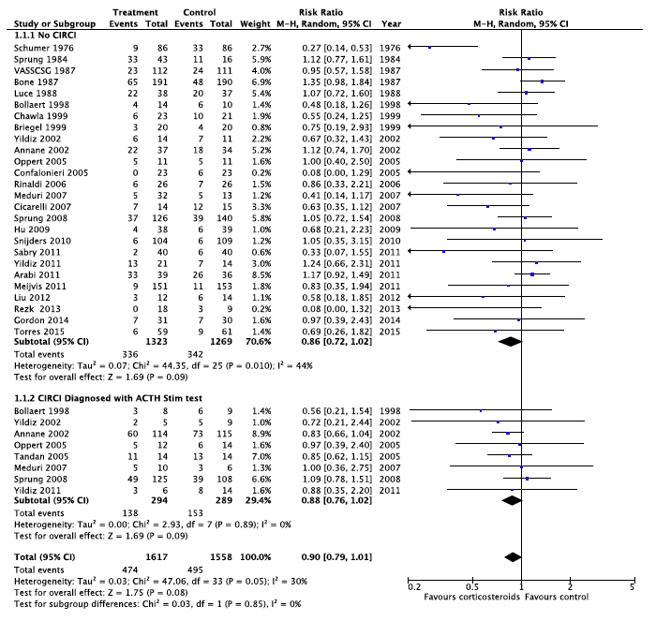

Q6 – Corticotropin vs 250mcg ACTH

No relevant data identified.

