Online Data Supplement: Acute Physiologic Stress and Subsequent Anxiety among Family Members of Intensive Care Unit Patients

Sarah J. Beesley, MD1,2 , Ramona O. Hopkins, PhD1,3,4, Julianne Holt-Lunstad PhD3, Emily L. Wilson, MStat4, Jorie Butler, PhD1,5, Kathryn G. Kuttler, PhD1,6, James Orme, MD1,2,4, Samuel M. Brown, MD, MS1,2, 4* and Eliotte L. Hirshberg, MD, MS1,2,4,7*

1Center for Humanizing Critical Care, Intermountain Healthcare

2Pulmonary and Critical Care Medicine, University of Utah School of Medicine

3Psychology and Neuroscience Center, Brigham Young University

4Pulmonary Division, Intermountain Medical Center

5Geriatrics and Psychology, University of Utah

6Homer Warner Center, Medical informatics, Intermountain Healthcare

7Pediatric Critical Care, University of Utah

*Co-correspondingauthors

**Correspondence**: Samuel M. Brown MD MS or Eliotte L. Hirshberg MD MS, Shock Trauma ICU, Intermountain Medical Center, 5121 S. Cottonwood Street, Murray, UT 84107, O: (801) 507-6529, F: (801) 507-5578

Contributions to manuscript: Conception (SMB, ELH, JO, ROH, KGK), data acquisition (SJB, SMB, EW, KGK, ELH), data analysis (SJB, EW, SMB, JHL), writing manuscript (SMB, SJB, ELH), revising manuscript for important intellectual content (all authors), approval of final copy (all authors)

**Financial Support**: Intermountain Research and Medical Foundation Grant

No author has a conflict of interest.

Contents

Figure E1. Priority for determining which family member to enroll as a participant 2

Figure E2. Example Calculation of Area under the Curve with respect to ground from Pruessner et al1 3

Table E1. Study Participant Information 4

Table E2. ICU Patient Demographic, Medical and Outcome Information 6

## Figure E1. Priority for determining which family member to enroll as a participant

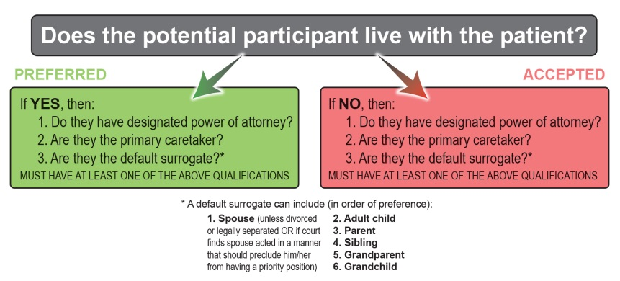

## Figure E2. Example Calculation of Area under the Curve with respect to ground

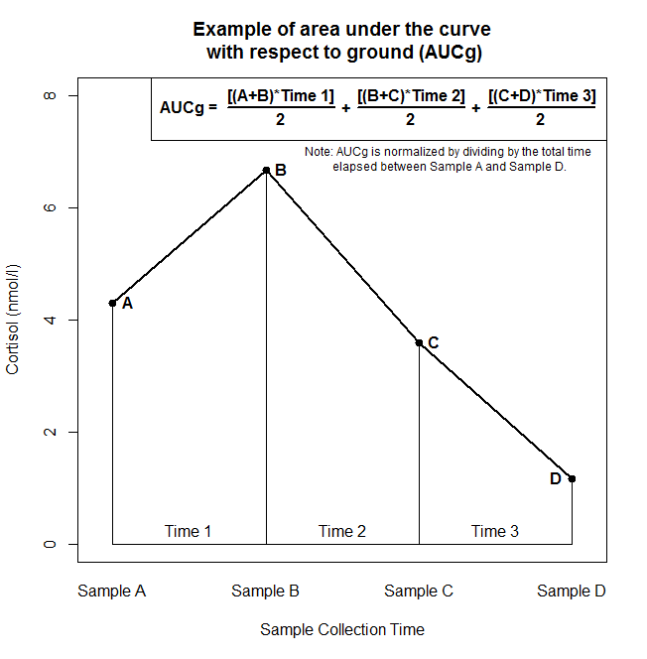

## Table E1. Study Participant Information

|  |  |
| --- | --- |
| Variable | Overall |
| Participant Demographics | |
| Age; mean ± SD | 54 ± 14 |
| Female sex; n (%) | 63 (64%) |
| Race; n (%)  American Indian or Alaskan Native  Asian  Black  Native Hawaiian or Pacific Islander  White  Not reported | 1 (1%)  3 (3%)  2 (2%)  2 (2%)  89 (90%)  2 (2%) |
| Ethnicity; n (%)  Hispanic or Latino  Not Hispanic or Latino  Not reported | 8 (8%)  90 (91%)  1 (1%) |
| Education; n (%)  Some schooling  High school diploma, GED, or equivalent  Associates degree  Bachelor’s degree  Graduate degree (masters, doctorate) | 3 (3%)  48 (49%)  23 (23%)  15 (15%)  10 (10%) |
| Participant Medical History | |
| Ever smoker; n (%) | 37 (37%) |
| Pack years; median (IQR) | 8 (5 – 21) |
| Current smoker; n (%) | 10 (10%) |
| Alcohol frequency; n (%)  Never  Monthly or less  2 to 4 times a month  2 to 3 times a week  4 or more times a week | 56 (57%)  19 (19%)  15 (15%)  7 (7%)  2 (2%) |
| Chronic pain; n (%) | 19 (19%) |
| Sleep disorder; n (%) | 25 (25%) |
| Obese; n (%) | 19 (19%) |
| Participant Medication Usage; n (%) | |
| Anxiety/sleep | 17 (17%) |
| Depression | 26 (26%) |
| Pain | 15 (15%) |
| Birth control | 4 (4%) |

## Table E2. ICU Patient Demographic, Medical and Outcome Information

|  |  |
| --- | --- |
| Patient Demographics | |
| Age; mean ± SD | 60 ± 17 |
| Female sex; n (%) | 50 (51%) |
| Race; n (%)  American Indian or Alaskan Native  Asian  Black  Native Hawaiian or Pacific Islander  White  Not reported | 1 (1%)  3 (3%)  3 (3%)  2 (2%)  88 (89%)  2 (2%) |
| Ethnicity; n (%)  Hispanic or Latino  Not Hispanic or Latino  Not reported | 9 (9%)  89 (90%)  1 (1%) |
| Education; n (%)  Some schooling  High school diploma, GED, or equivalent  Associates degree  Bachelor’s degree  Graduate degree (masters, doctorate) | 14 (14%)  53 (54%)  16 (16%)  10 (10%)  6 (6%) |
| Primary ICU Diagnosis; n (%)  Cardiac  GI/Hepatic  Neurologic  Respiratory  Sepsis  Trauma  Other | 7 (7%)  10 (10%)  4 (4%)  14 (14%)  42 (42%)  18 (18%)  4 (4%) |
| Admission APACHE II; mean ± SD | 30 ± 7 |
| Elixhauser; mean ± SD | 5 ± 3 |
| End stage heart failure; n (%) | 0 (0%) |
| Liver failure; n (%) | 5 (5%) |
| Renal failure; n (%) | 8 (8%) |
| Malignancy; n (%) | 7 (7%) |
| Dementia; n (%) | 1 (1%) |
| Mechanical ventilation (first 24 hours); n (%) | 54 (55%) |
| Mechanical ventilation (ever); n (%) | 63 (64%) |
| Patient Hospitalization History; n (%) | |
| Previous ICU admit (last 5 years) | 47 (47%) |
| Number of ICU Admits (last 5 years)  None  1 other admission  2-5 admissions  >5 admissions | 52 (53%)  17 (17%)  28 (28%)  2 (2%) |
| Patient Outcomes | |
| ICU LOS (days) ; median (IQR) | 3.3 (1.9 – 8.4) |
| Hospital LOS (days) ; median (IQR) | 7.8 (3.8 – 13.6) |
| In-hospital mortality; n (%)  *[Denominator is all participants enrolled (n=99)]* | 21 (21%) |
| 3-month mortality; n (%)  *[Denominator is participants who completed follow up (n=92)]* | 27 (29%) |
| Patient residence at 3 months; n (%)  At their home  In someone else’s home  In a care facility  Other  Deceased  *[Denominator is participants who completed follow up (n=92)]* | 50 (54%)  7 (8%)  6 (7%)  2 (2%)  27 (29%) |