Supplementary Table 1. Search Strategy
Medline | Embase
Biological Markers terms:  - Biological markers  - Biomarkers  - Calcitonin  - Procalcitonin | Biological Markers terms:  - Procalcitonin
ICU Terms and Specific Infection and Sepsis Terms  - Sepsis  - Bacteremia  - Pneumonia, Ventilator-Associated  - Pneumonia  - Shock, Septic  - Intensive Care Units  - Critical Care  - Critical Care Unit  - Critical Illness | ICU Terms and Specific Infection and Sepsis Terms  - Sepsis  - Bacteremia  - Pneumonia, Ventilator-Associated  - Pneumonia  - Shock, Septic  - Intensive Care Units  - Critical Care  - Critical Care Unit  - Critical Illness
Antibiotic Terms  - Antibiotics  - Anti-Bacterial agents | Antibiotic Terms  - Antibiotics

Supplementary Table 2. Characteristics of included studies
Author / Year (Country)  (PCT assay / manufacturer) | N  (PCT / Control) | Design | Setting | PCT algorithm | Overruling | Outcome (PCT vs. control) | Comments
Studies using PCT-guided algorithms for initiation of antibiotic therapy
Jensen, 2011 (Denmark)  (Kryptor PCT / Brahms) | 604 / 596 | P, R, MC, OL | Mixed ICU | - PCT > 1 mcg/L that was not decreasing at least 10% from previous day prompted increase in antimicrobial spectrum and diagnostic efforts | 17.9% (only available for BL PCT) | - 28-day mortality: 31.5% vs. 32 % (p=0.98)  - ICU LOS: 6 vs. 5 days (p=0.004)  - ICU days with MV: 65.5% vs. 60.7% (p<0.001)  - ICU days with at least 3 antimicrobials: 65.5% vs. 57.7% (p<0.001) | - PCT did not improve outcomes, and may have increased ICU LOS, MV use, and antimicrobial use  - Increase morbidity may have been associated with increased use of antimicrobials
Layios, 2012  (Beligum)  (Kryptor PCT / Pasteur Mérieux) | 258 / 251 | P, R, SC, OL | Mixed ICU | - PCT < 0.25 mcg/L: ABX strongly discouraged  - PCT between 0.25 – 0.5 mcg/L: ABX discouraged  - PCT between 0.5 – 1.0 mcg/L: ABX encouraged  - PCT > 1.0 mcg/L: ABX strongly encouraged | PCT > 1 mcg/L: 11.4%  PCT 0.5-1 mcg/L: 23.1%  PCT: 0.25 – 5 mcg/L: 80.9%  PCT: <0.25 mcg/L: 53.7% | - ICU days with ABX use: 62.6 ± 34.4% vs. 57.7 ± 34.4% (p=0.11)  - ICU mortality and LOS similar between groups | - PCT not associated with improvements in outcomes or ABX consumption  - compliance with reserving ABX therapy was poor
Nafaji, 2015 (Iran)  (Kryptor PCT / Brahms) | 30 / 30 | P, R, SC, SB | Mixed ICU | - PCT < 0.5 mcg/L: ABX discouraged, PCT rechecked after 12 hours  - PCT between 0.5-2 mcg/L: ABX held, PCT rechecked after 8 hours  - PCT >2 mcg/L: ABX encouraged  (rechecked PCT > 2 mcg/L: ABX encouraged) | NR | - Total ABX exposure lower with PCT guidance (128 days vs. 320 days, p=0.003)  - ICU LOS: 4 vs. 6days, p=0.01  - Hospital mortality and hospital LOS similar between groups | - PCT associated with decrease ABX use with no worsening of mortality
Studies using PCT-guided algorithms for cessation of antibiotic therapy
Bloos, 2016 (Germany)  (NR) | 552 / 537 | P, R, MC, OL | Mixed ICU | PCT checked at BL; day 4, 7, 10, and 14.  - Day 7-14 PCT < 1 mcg/L or >50% drop from previous PCT: ABX stopped | Day 7: 59%  Day 10: 61% | - No difference in 28d mortality (25.6% vs. 28.2%, p=0.34)  - 4.5% reduction in ABX exposure with PCT guidance | -2x2 factorial study with selenium. Significant interaction detected between PCT and selenium, where selenium administration seemed to harm patients not receiving PCT guidance
De Jong, 2016 (Netherlands)  (Krpytor PCT / Thermo Fisher or Vidas or Roche) | 761 / 785 | P, R, MC, OL | Mixed ICU | - PCT decreased by >80% of peak or absolute value <0.5 mcg/L: ABX stopped | 24h: 56%  48h: 47%  End of study: 3% | - significant difference in ABX use and median ABX duration  - significant decrease in mortality (20% vs. 25%, p=0.012) | - 1 year mortality difference observed in per protocol population (36% vs. 43%, p=0.019)
Deliberato, 2013 (Brazil)  (Vidas PCT / bioMérieux) | 42 / 39 | P, R, SC, OL | Mixed ICU | - BL PCT ≥1 mcg/L, re-evaluation at day 5, and ABX stopped if PCT < 10% of BL level or < 0.25 mcg/L  - BL PCT <1 mcg/L, re-evaluation at day 3 and ABX were stopped if PCT < 0.1 mcg/L | 29% (personal communication) | - ABX duration (per-protocol ): 9 vs. 13 days (p=0.008)  - Hospital mortality: 2.4% vs. 10.3%  - ICU LOS: 3.5 vs. 3 days (p=0.60) | - PCT shortened duration of ABX without worsening mortality  - Majority of patients met criteria for severe sepsis
Hochreiter, 2009 (Germany)  (Brahams PCT / Brahms) | 57 / 53 | P, R, SC, OL | SICU | - PCT < 1 mcg/L or dropped to 25-35% of the BL value over 3 days | NR | - Duration of ABX: 5.9 vs. 7.9 days (p<0.001)  - Hospital mortality: 26.3% vs. 26.4% (p = NS)  ICU LOD: 15.5 vs. 17.7 days (p=0.046) | - PCT shortened duration of ABX without worsening mortality  - Patients met criteria for sepsis
Nobre, 2008  (Switzerland)  (Kryptor PCT / Brahms) | 39 / 40 | P, R, SC, OL | Mixed ICU | - BL PCT ≥1 mcg/L, re-evaluation at day 5, and ABX stopped if PCT < 10% of BL level or < 0.25 mcg/L  - BL PCT <1 mcg/L, re-evaluation at day 3 and ABX were stopped if PCT < 0.1 mcg/L | 19% | - Duration of ABX (all patients) : 6 vs. 9.5 days (p=0.15)  - Duration of ABX (compliant to protocol): 6 vs. 12.5 days (p<0.001)  - 28d mortality: 20.5% vs. 20% (p=0.82)  ICU LOS: 4 vs. 7 days (p=0.02) | - PCT shortened duration of ABX without worsening mortality  - Compliance with protocol led to statistical significant difference in ABX duration
Oliveira, 2013 (Brazil)  (Vidas PCT / bioMérieux) | 49 / 45 | P, R, MC, OL | Mixed ICU | PCT assessed on day 3:  - If < 1 mcg/L, PCT checked daily and ABX stopped when PCT < 0.1 mcg/L  - If >1 mcg/L, PCT checked daily and AB stopped when PCT decrease > 90% | 14% | - no difference in median duration of ABX: 7d vs 6d (p-0.13)  - no difference in end of study mortality | - Control group – C-reactive protein guidance
Schroeder, 2009 (Germany) | 14 / 13 | P, R, SC, OL | SICU | - PCT < 1 mcg/L or decreased to 25-35% of the BL value over 3 days | NR | - Duration of ABX: 6.6 vs. 8.3 days (p<0.001)  - Hospital mortality: 21.4% vs. 23.1% (p = NS)  ICU LOS: 16.4 vs. 16.7 days (p=NS) | - PCT shortened duration of ABX without worsening mortality  - Patients met criteria for severe sepsis / septic shock
Shehabi, 2014 (Australia)  (Brahams PCT / Brahms) | 196 / 196 | P, R, MC, SB | Mixed ICU | - Cease ABX for any of the following:  - PCT < 0.1 mcg/L  - PCT 0.1-0.25 mcg/L and infection is highly unlikely  - PCT level decreased > 90% from initial value | 3% | - median time to ABX cessation: 9 vs. 11days, p=0.58  - No difference detected in ICU or hospital LOS, MV time, or mortality | - PCT did not affect ABX duration  - Protocol was most conservative and allowed for clinician assessment without violation
Stolz, 2009 (Switzerland, United States)  (Kryptor PCT / Brahms) | 51 / 50 | P, R, MC, OL | Mixed ICU | - PCT < 0.25 mcg/L: ABX strongly discouraged  - PCT between 0.25 – 0.5 mcg/L or decrease 80% from BL: ABX - discouraged  - PCT between 0.5 – 1.0 mcg/L: ABX encouraged  - PCT > 1.0 mcg/L: ABX strongly encouraged | 16% | - Day 28 ABX-free days: 13 vs. 9.5 (p=0.038)  - Day 28 MV-free days: 21 vs. 19 (p=0.46)  - Day 28 ICU-free days: 10 vs. 8.5 (p=0.53)  - Day 28 mortality: 16% vs. 24% (p=0.33) | - PCT shortened duration of ABX without worsening mortality  - Patients all met criteria for VAP
Studies using PCT-guided algorithms for both initiation and cessation of antibiotic therapy
Annane, 2013 (France)  (Brahams PCT / Brahms) | 30 / 28 | P, R, MC, OL | Mixed ICU | Medical patients  - PCT < 0.25 mcg/L: ABX not recommended  - PCT between 0.25 – 0.5 mcg/L: ABX strongly discouraged  - PCT between 0.5 – 5.0 mcg/L: ABX recommended  - PCT ≥ 5.0 mcg/L: ABX strongly recommended  Surgical patients  PCT < 4.0 mcg/L: ABX not recommended  - PCT between 4.0 – 9.0 mcg/L: ABX recommended  - PCT ≥ 9.0 mcg/L: ABX strongly encouraged | 19% at 6 hours  17% at day 3  37% at day 5 | - Day 5 ABX use: 67% vs. 81% (p=0.24)  - no difference observed in ICU LOS, hospital LOS, or mortality | - Study terminated prematurely due to low recruitment rate  - compliance was poor among patients with low BL PCT
Bouadma, 2010 (France)  (Kryptor PCT / Brahms) | 307 / 314 | P, R, MC, OL, NI | Mixed ICU | Baseline PCT value to determine whether ABX should be started and serial PCT values to decide if ABX should be stopped  - PCT < 0.25 mcg/L: ABX strongly discouraged  - PCT between 0.25 – 0.5 mcg/L or decrease 80% from BL: ABX - discouraged  - PCT between 0.5 – 1.0 mcg/L: ABX encouraged  - PCT > 1.0 mcg/L: ABX strongly encouraged | 53% | - Day 28 mortality: 21.2% vs. 20.4%, met non-inferiority criteria  - Day 28 ABX-free days: 14.3 vs. 11.6 (p<0.001) | - PCT shortened duration of ABX use  - Non-compliance to protocol was high, and largely due to reluctance to hold initial antibiotics
Ding, 2013 (China)  (Kryptor PCT / Brahms) | 33 / 35 | P, R, MC, OL | Medical ICU | - ABX continued until PCT ≤ 0.5 mcg/L | 0% (patients with protocol violation were removed from study) | - Significant reduction in ABX duration (8.7d vs 14.2d, p<0.001)  - no difference in mortality, duration of MV, or hospital LOS | - Patients with acute exacerbations of IPF

ABX, antibiotics; BL, baseline; D, day; ICU, intensive care unit; IPF, idiopathic pulmonary fibrosis, LOS, length of stay; MC, multi-center; MV, mechanical ventilation; N, number; NI, non-interiority; NR, not reported; NS, not significant; OL, open-label; P, prospective; PCT, procalcitonin; R, randomized; SB, single-blinded; SC, single center; SICU, surgical intensive care unit

Supplementary Figure 1. Risk of Bias Summary
Initiation
Cessation
Mixed
 | Random sequence generation (selection bias) | Allocation concealment (selection bias) | Blinding of participants and personnel (performance bias) | Blinding of outcome assessment (detection bias) | Incomplete outcome data (attrition bias) | Selective reporting (reporting bias) | Other bias | Overall risk of bias
Jensen 2011 | + | + | - | ? | + | + | + | +
Layios 2012 | ? | ? | - | + | + | + | + | +
Nafaji 2015 | + | ? | - | ? | ? | ? | + | -
Bloos 2016 | + | + | - | + | + | + | + | +
de Jong 2016 | + | + | - | ? | + | + | + | +
Deliberato 2013 | ? | ? | - | ? | + | + | + | ?
Hochreiter 2009 | ? | ? | - | ? | + | ? | ? | ?
Nobre 2008 | + | + | - | - | + | + | + | ?
Oliveira 2013 | + | + | - | ? | + | - | + | ?
Schroeder 2009 | ? | ? | - | ? | + | ? | + | ?
Shehabi 2014 | + | + | - | ? | + | + | + | +
Stolz 2009 | + | + | - | ? | + | + | + | +
Annane 2013 | + | + | - | ? | + | + | + | +
Boudama 2010 | + | + | - | + | + | + | + | +
Ding 2013 | + | - | ? | ? | - | + | + | -

Cochrane Collaboration tool for assessing risk of bias for each study. + low risk of bias; - high risk of bias; ? unclear risk of bias.

Supplementary Figure 2. Funnel plot of included studies: short term, all cause mortality
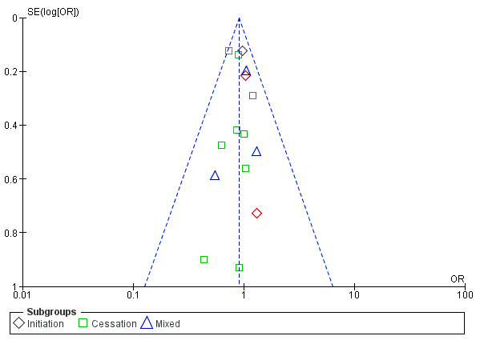

Supplementary Figure 3. Forest plot – long-term mortality (Cessation subgroup only)
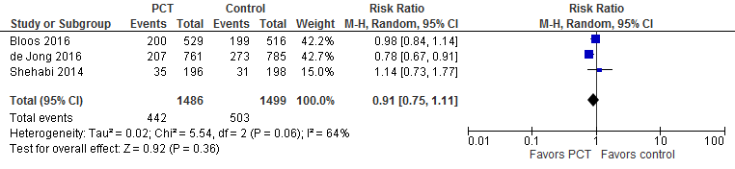

Supplementary Figure 4. Forest plot – hospital length of stay (Cessation Subgroup Only)
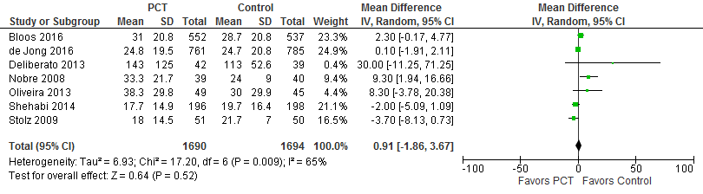

Supplementary Figure 5. Forest plot – ICU length of stay 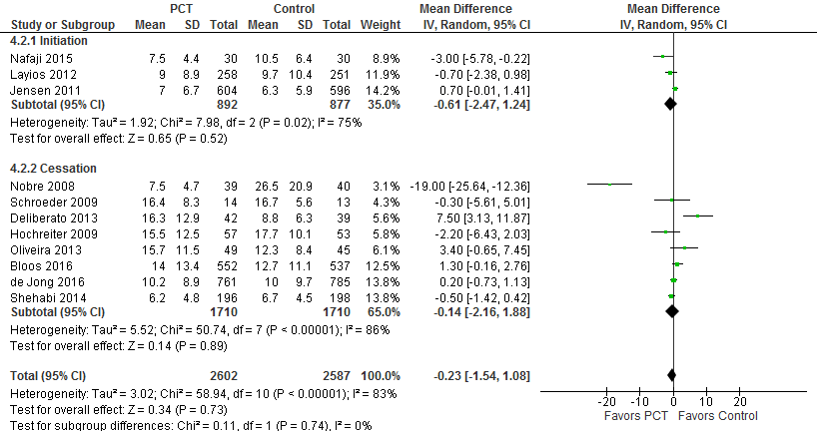
Supplementary Figure 6. Forest plot – Recurrent infections (Cessation subgroup only)
Du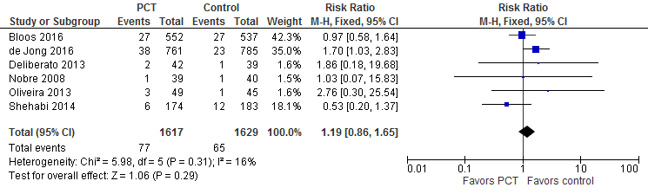

Supplementary Figure 7. Forest Plot - Sensitivity analysis – Short term mortality (28d only)
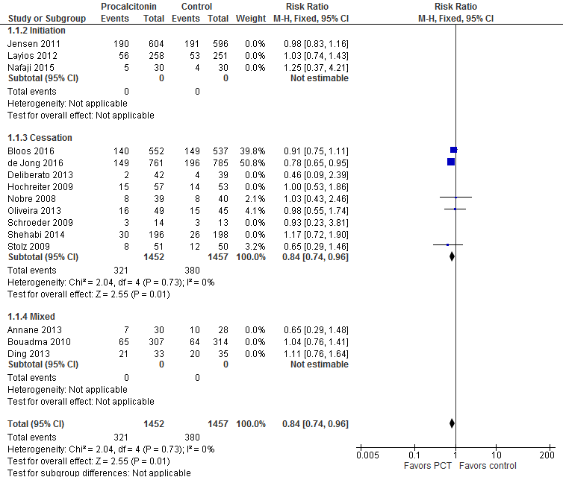
Supplementary Figure 8. Forest Plot - Sensitivity analysis – Short term mortality (Studies with low risk of bias)
