Supplemental Digital Content 1

Mouse experiments: Experimental protocols were approved by the Institutional Review Board (Institutional Animal Care and Use Committee [IACUC]) at the University of Colorado Denver, USA. They were in accordance with the AAALAC regulations, the US Department of Agriculture Animal Welfare Act, and the Guide for the Care and Use of Laboratory Animals of the NIH. Mice were housed in a 14/10-h light-dark cycle and all mouse experiments were conducted at the same time point (ZT3, Zeitgeber Time 3 corresponding to 9AM based on light on at 6AM). To eliminate gender- and age-related variations, we routinely used 12- to 16-week-old, 24g male mice. Mice were bred in the vivarium at Denver for optimal acclimatization and housed in cages of 5 at 21 °C with food (Harlan diets, formulation 2920x, soy free) and water ad libitum. One week before the experiments, the mice were single housed without enrichment and brought to the testing room for one hour daily to acclimate being handled and moved. The testing room had the same conditions as the housing area (e.g. lighting, temperature etc.).

Animals: Per2^{-/-} (C57BL/6J background) and controls (C57BL/6J, wildtype mice) were obtained from the Jackson Laboratories and bred in the animal vivarium in Denver. Characterization and validation were performed as described previously. Homozygous mutant mice are morphologically indistinguishable from their wild-type littermates and both males and females are fertile (1).

Compounds: Sterile 0.9% NaCl (500ml, Baxter, USA), Midazolam (5mg/ml, preservative free, Pfizer, USA, LPS (O111:B4 from E. coli; InvivoGen, USA), Nobiletin (NOB, 2-(3,4-Dimethoxyphenyl)-5,6,7,8-tetramethoxy-4H-1-benzopyran-4-one, 3′,4′,5,6,7,8-Hexamethoxyflavone, > 97%, Sigma, USA), Solutol (Kolliphor® HS 15, Sigma, USA).

Interventions

Experimental groups: Mice were randomly selected for i.p. (intraperitoneal) injections of 1. NaCl 0.9% (0.1ml i.p., control group), 2. Midazolam (0.05 ml of midazolam 5mg/ml i.p. [10mg/kg]; 10 mg/kg was chosen to achieve a visually apparent sedative effect), 3. LPS in NaCl 0.9% (0.1 ml of LPS 24 μg/ml i.p. [100 μg/kg], 4. Midazolam+LPS i.p., 5. Midazolam+NOB i.p. (0.5 ml of nobiletin 48 μg/ml (1 mg/kg) in solutol:NaCl 0.9% [1:100 ratio]), or for 6. 7 days of constant light with 0.5 ml solutol:NaCl 0.9% [1:100 ratio] i.p. (control group), 7. 7 days of constant light with 0.5 ml NOB i.p. (1 mg/kg) in solutol:NaCl 0.9% [1:100 ratio].

Constant light conditions: Mice were exposed to constant light for one week (24/7) using a light box (Uplift Technologies DL930 Day-Light 10,000 Lux SAD, full spectrum) (2-4).

Overview experimental setup

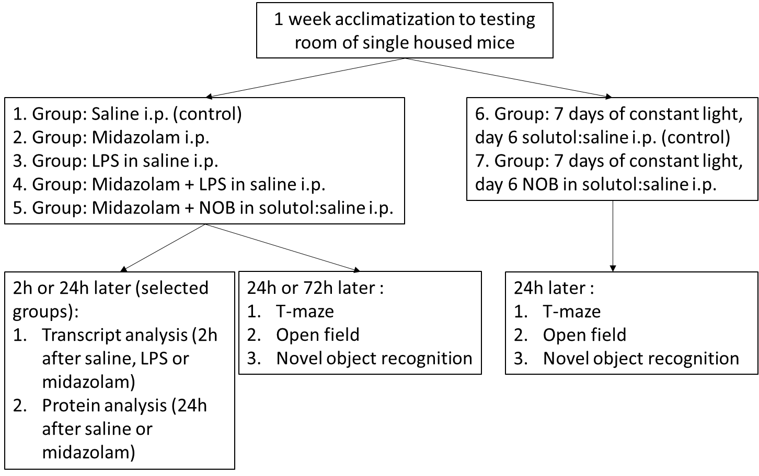
Outcome measures
Transcriptional analysis: Total RNA was isolated from liquid nitrogen shock frozen murine brain tissue 2 hours after saline, midazolam or LPS treatment using the RNeasy Mini Kit (SA-Biosciences, Qiagen, USA). Primer sets for mouse PER2 (Period 2) or ACTB (Beta Actin) were from Invitrogen (PER2: 5´-ACC TGC TCA ACC TCC TTC TG-3´, 5´-ACT ACT GCC TGC CCC ACT TT-3´, ACTB: 5'-CTA GGC ACC AGG GTG TGA T -3', 5'-TGC CAG ATC TTC TCC ATG TC-3'). Primer sets for BMAL1 (Brain and Muscle ARNT-Like 1) were TaqMan primers from Thermo Fisher Scientific (Arntl, Mm00500226_m1). DNA from mRNA was generated using iScript (Bio-Rad) and transcript levels were determined by real-time RT-PCR (iCycler or iCycler IQ; Bio-Rad Laboratories Inc.) as described (1). The PCR reactions contained 1 µM sense and 1 µM antisense oligonucleotides. Each target sequence was amplified using increasing numbers of cycles of 94°C for 1 min, 58°C for 0.5 min, 72°C for 1 min. Data were calculated relative to the ‘housekeeping’ gene ACTB (‘housekeeping’ genes are involved in basic cell maintenance and, therefore, are expected to maintain constant expression levels in all cells and conditions) and were expressed as fold change compared to controls. BMAL1, which is responsible for generating molecular circadian rhythms, was determined to evaluate the effect of midazolam on other core components of the circadian system.
Immunohistochemistry: Brains from saline treated controls or mice subjected to midazolam induced delirium (24h after saline or midazolam treatment) were harvested following perfusion fixation in 4% PFA/0.1 M PB (phosphate buffer without saline) and post fixed in the same fixative overnight, followed by cryoprotection in 20% sucrose in 0.1 M PB pH 7.2 overnight at 4°C. Using a cryostat, 30-μm coronal sections were cut on a sliding frozen microtome and labeled for Per2. The slides underwent three 10-minute washes in 0.1M PB 0.1% TX before incubation in blocking solution (2 Normal Donkey Serum 1:50 for 1 hour [10 ml 0.3% PBT + 200µl Normal Donkey Serum) for 1 hour at room temperature. The samples were then incubated for 48 hours at 4°C in PER2 antibody R39 made in rabbit (from Weaver-box 5-59) 1:1,000 diluted in blocking solution. Following three washes in PBS, samples were incubated for 2 hours at room temperature with Donkey anti-rabbit in 10 ml PB/ 0.3%Tx. The samples were stained with DAB Peroxidase (HRP) Substrate Kit (Vector Laboraties SK-4100) and then mounted on Superfrost Plus slides (Fisher Scientific). Following mounting, the samples were dehydrated in citri-solv and ethanol series and coverslipped with Krystalon. All immunohistochemical staining was performed on serial sections. PER2 staining was performed using a protocol which validated the PER2 antibody (5). Evaluation of the immunohistochemical staining and photographic documentation were performed using an Olympus BX-50 light microscope (Hamburg, Germany. The investigator counting the PER2 positive hippocampal neurons and PER2 positive SCN neurons was blinded to the experimental protocol.

Behavioral testing overview

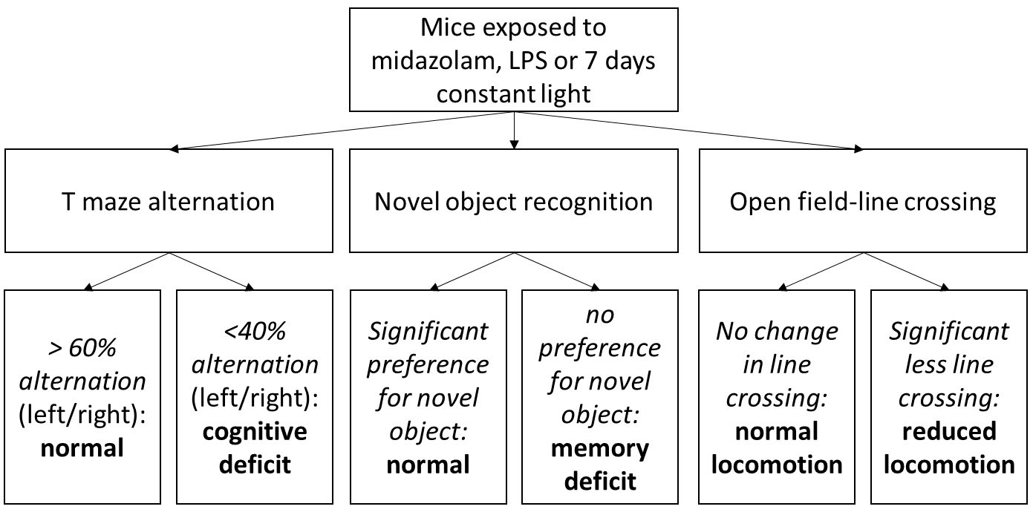

Based on previous work indicating a three-domain model for delirium that includes generalized cognitive impairment, disturbed executive cognition, and behavioral disruption, which are all are under circadian control (6), three behavioral tests were chosen:

1. Spontaneous T-maze alternation to detect cognitive impairment: Because of its simplicity of construction and use, combined with its sensitivity, T-maze alternation has almost universal applicability in detecting cognitive dysfunction. The spontaneous alternation is very sensitive to dysfunction of the hippocampus, but other brain structures are also involved (7).

2. Open field line crossing to detect behavioral disruption: The Open Field Maze is one of the most commonly used platforms to measure behaviors in animal models. The test provides a unique opportunity to assess novel environment exploration, general locomotor activity, and anxiety (8).

3. Novel object recognition to detect short-term/working memory dysfunction (as a part of executive cognitive function): The novel object recognition test doesn’t involve reference memory components (e.g. explicit rule learning), thus it can be considered a “pure” recognition memory test and a valid task to assess working memory. Finally, the test doesn’t involve positive or negative reinforces (e.g. food, electric shocks) and this makes the novel object recognition comparable to memory tests currently used in humans. All these advantages make the novel object recognition test quick and simple to be implemented and, therefore, it has been widely used for assessing mild cognitive impairment in pre-clinical research (9).

Cognitive impairment, behavioral changes and emotional disturbances are key components of delirium (10, 11) which can be evaluated with the above-mentioned tests: 1. Cognitive impairments: poor memory (novel object recognition, T-maze) or disorientation (open field line crossing, T-maze), 2. Behavior changes: being quiet and withdrawn (open field line crossing), slowed movement and lethargy (open field line crossing). Emotional disturbances: anxiety, apathy, depression (open field line crossing).

General setup for behavioral tests

Measures of T-maze alternation, line crosses, or novel object recognitions were obtained with a camera-based computer tracking system on an IBM PC computer with the camera fixed to the ceiling, 2.1 m above the apparatus. Mazes were cleaned between each mouse using 70 % ethyl alcohol and the experimenter did not wear cologne or lotion to avoid olfactory disturbances of animals. Mice were habituated to the experimenter before the procedure. Therefore, the experimenter put their hands into the cage and slowly accustomed the animals to touch, without picking them up. This was done daily, several times at 5 min intervals starting one week prior to behavior testing.

T maze alternation: The T-maze was made of ABS plastic acrylic. Animals started from the base (long arm) of the T and allowed to choose one of the goal arms abutting the other end of the stem. Using a plastic panel, the mouse was blocked in the chosen arm for 30 seconds. The panel was removed, and the mouse was again placed in the long arm of the T. In ten trials in quick succession, the rodent’s choice was recorded (‘continuous trial procedure of spontaneous alternation’). If the mouse did not choose an arm within 15 minutes, the experiment was considered failed and over. With repeated trials, the animals should show less of a tendency to enter a previously visited arm. The percentage of alternation (number of turns in each goal arm) and total trial duration are recorded. This test is used to quantify cognitive deficits in transgenic strains of mice and evaluate chemical entities for their effects on cognition. Normal alternation result in alternation rates of 60-70%. Reduction of alternation below 50% indicates cognitive impairment (7).

Open field – line crossing: The open field maze was made of ABS plastic acrylic. Mice were randomly placed into one of the four corners of the open field and allowed to explore the apparatus for 10 minutes. Line crossing was determined by the frequency with which the mice crossed one of the grid lines with all four paws. The numbers of squares crossed over 10 minutes were counted and given as absolute numbers. A reduction in line crossing indicates reduced locomotor activity. This can be a result of general behavioral changes or anxiety (8).

Novel object recognition: The test consisted of 2 days of habituation, 1 training day followed by the testing day. On the training day, two of the same objects (either two 50 mL falcon tissue culture flasks filled with sand or two towers of Lego bricks) were placed in the arena and the mice could explore them for 10 minutes. On the testing day one familiar object was replaced by a novel object (tower of Lego bricks or a 50-mL falcon tissue culture flask filled with sand) and mice were placed in the arena for 10 minutes. The use of either a falcon tissue culture flask or Lego brick tower on training day was randomized. The time spent with the old or the novel object for 10 minutes was determined and the preference for the novel object were given in % (time spent with old object/total time and time spent with novel object/total time; the sum of the % preference to the old and novel object is 100%). The preference to the old and the novel object from each mouse was compared using a paired t-test. Based on the curiosity of mice a significant preference to the novel object is expected. A non-significant preference to the novel object indicates deficits in working memory (9).

While these behavioral tests in mice are widely accepted to study e.g. the effects of LPS on cognitive function as model for delirium (12-15), it needs to be pointed out that each component of the delirium-like murine behavior can also be explained by causes other than delirium such as general illness or pain.
Data analysis: An a priori sample size analysis for T-maze, open-field and novel-object-recognition revealed a biologically relevant difference of at least 10 %, 20 squares and 10% between control and experimental groups, respectively. Thus, five animals per group were necessary to obtain statistically significant results with an α error of 0.05 and β error of 0.1. Based on this analysis we minimized the number of animals used and their suffering. All data were tested for normality using the Shapiro Wilk test, which confirmed normality. For multiple comparisons, one-way analysis of variance with Bonferroni adjustment was performed, and for single comparison, the unpaired or paired Student t-test was applied. Comparison of two groups using the unpaired student t test was performed for transcriptional and translational analysis (Figure 1). Comparison of two groups using a paired Student t test were performed for the novel object recognition test (Figure 3, 4 and 5). For multiple group comparisons comparing the treated groups to the controls group a one-way analysis of variance with a Dunnette’s post hoc test was performed (Figure 2, 3 and 5). For multiple group comparisons comparing all treated groups one-way analysis of variance with Bonferroni adjustment was performed (Figure 4). For multiple comparisons not reaching statistical significance, T-tests on relevant 2-grop comparisons were performed and are explicitly marked in the figure legends. Values are expressed as mean (SD). P<0.05 was considered statistically significant. For all statistical analysis, GraphPad Prism 5.0 software was used.

References
1. Eckle T, Hartmann K, Bonney S, et al. Adora2b-elicited Per2 stabilization promotes a HIF-dependent metabolic switch crucial for myocardial adaptation to ischemia. Nat Med 2012;18(5):774-782.
2. Bartman CM, Oyama Y, Brodsky K, et al. Intense light-elicited upregulation of miR-21 facilitates glycolysis and cardioprotection through Per2-dependent mechanisms. PLoS One 2017;12(4):e0176243.
3. Fonken LK, Finy MS, Walton JC, et al. Influence of light at night on murine anxiety- and depressive-like responses. Behav Brain Res 2009;205(2):349-354.
4. Fujioka A, Fujioka T, Tsuruta R, et al. Effects of a constant light environment on hippocampal neurogenesis and memory in mice. Neurosci Lett 2011;488(1):41-44.
5. LeSauter J, Lambert CM, Robotham MR, et al. Antibodies for assessing circadian clock proteins in the rodent suprachiasmatic nucleus. PLoS One 2012;7(4):e35938.
6. Fitzgerald JM, Adamis D, Trzepacz PT, et al. Delirium: a disturbance of circadian integrity? Med Hypotheses 2013;81(4):568-576.
7. Deacon RM, Rawlins JN. T-maze alternation in the rodent. Nat Protoc 2006;1(1):7-12.
8. Seibenhener ML, Wooten MC. Use of the Open Field Maze to measure locomotor and anxiety-like behavior in mice. J Vis Exp 2015(96):e52434.
9. Antunes M, Biala G. The novel object recognition memory: neurobiology, test procedure, and its modifications. Cogn Process 2012;13(2):93-110.
10. Meagher DJ, Moran M, Raju B, et al. Phenomenology of delirium. Assessment of 100 adult cases using standardised measures. Br J Psychiatry 2007;190:135-141.
11. Meagher DJ, Moran M, Raju B, et al. Motor symptoms in 100 patients with delirium versus control subjects: comparison of subtyping methods. Psychosomatics 2008;49(4):300-308.
12. Hennessy E, Gormley S, Lopez-Rodriguez AB, et al. Systemic TNF-alpha produces acute cognitive dysfunction and exaggerated sickness behavior when superimposed upon progressive neurodegeneration. Brain Behav Immun 2017;59:233-244.
13. Griffin EW, Skelly DT, Murray CL, et al. Cyclooxygenase-1-dependent prostaglandins mediate susceptibility to systemic inflammation-induced acute cognitive dysfunction. J Neurosci 2013;33(38):15248-15258.
14. Field RH, Gossen A, Cunningham C. Prior pathology in the basal forebrain cholinergic system predisposes to inflammation-induced working memory deficits: reconciling inflammatory and cholinergic hypotheses of delirium. J Neurosci 2012;32(18):6288-6294.
15. Murray C, Sanderson DJ, Barkus C, et al. Systemic inflammation induces acute working memory deficits in the primed brain: relevance for delirium. Neurobiol Aging 2012;33(3):603-616 e603.

