ONLINE DATA SUPPLEMENT

TABLE OF CONTENTS | Page
Supplemental Methods | 2
Supplemental Results | 5
Supplemental Figure 1 | 6
Supplemental Figure 2 | 7
Supplemental References | 10

SUPPLEMENTAL METHODS

On June 30, 2014, Massachusetts General Law c. 111, § 231, “An Act relative to patient limits in all hospital intensive care units” was signed into law.(1) The law established that (1) “in all intensive care units the patient assignment for the registered nurse shall be 1:1 or 1:2” and (2) that this determination should be based “on the stability of the patient as assessed by [an] acuity tool and by the staff nurses in the unit.” Regulations governing the implementation and operation of the law were unanimously approved as 958 CMR 8.00(2) on June 10, 2015. Academic medical centers, as defined by the Center for Health Information and Analysis(3), were given a compliance date of March 31, 2016. All other hospitals were required to comply with mandate requirements by January 31, 2017. Hospitals were required to report on four associated ICU quality measures, including central line-associated bloodstream infections, catheter-associated urinary tract infections, hospital-acquired pressure ulcers, and patient falls with injury.

Data source
We conducted a retrospective cohort study using a difference-in-difference (DD) design that included patients admitted to ICUs at more than 250 academic medical centers and affiliated hospitals in the United States. Data were abstracted from Vizient, Inc. (Clinical Data Base/Resource Manager and Action-OI databases), a collection of administrative claims and billing information from the largest network of healthcare systems in the United States. Patients from hospitals that submitted data for all time periods of interest were included in analyses; hospitals missing data from one or more period were excluded. Using data from hospital encounter files, we identified patients between ages 18-99 years old who were admitted to ICUs. Further, we also identified a subpopulation of mechanically ventilated patients within this group using International Classification of Diseases, 9th and 10th Revision Procedure codes (ICD-9: 96.7, 96.70, 96.71; ICD-10: 5A1935Z,5A1945Z, 5A1955Z).

Intervention and Comparator Cohorts
In primary analysis, we defined three time periods relative to the nurse staffing compliance date for academic hospitals: a “Baseline” period from April 1, 2014 to March 31, 2015, a “Preparation” period from April 1, 2015 to March 31, 2016, and a “Post-mandate” period from April 1, 2016 to March 31, 2017 (Figure 1). We identified ICU hospitalizations from academic non-Massachusetts comparator hospitals from the United States during the same time periods for the difference-in-difference analysis. Thus, the difference-in-difference approach was analogous to an intention-to-treat design evaluating patient outcomes associated with the Massachusetts nurse staffing regulations requiring 1:1 or 2:1 patient:nurse ratios guided by patient acuity tools.

Outcomes
The primary outcome was the change in risk-standardized mortality ratio (SMR) during the Baseline and Post-mandate periods for patients hospitalized within Massachusetts academic ICUs, as compared with patients hospitalized in non-Massachusetts, academic ICUs. Risk-standardized hospital mortality was calculated by Vizient 2016 Mortality Risk Adjustment Models, which used stepwise logistic regression to generate models for 3M-MS-DRG groupings.(4) All models have a minimum concordance index of 0.70 and include clinical conditions at the time of admission, but exclude iatrogenic conditions acquired during the time of stay.(4) To contextualize changes in standardized mortality ratios, we also reported changes in the component unadjusted and expected mortality rates.

We evaluated two secondary outcomes associated with ICU staffing in prior studies. First, we examined a composite in-hospital complication rate composed of four complications for which reporting was mandated (central line-associated bloodstream infections, catheter-associated urinary tract infections, hospital-acquired pressure ulcers, and patient falls with injury).(5-7) Second, we examined rates of do-not-resuscitate (DNR) orders; prior studies have shown associations between higher ICU staffing and increased DNR rates that may influence mortality.(8)

Statistical analysis
Difference-in-difference approaches can be used to evaluate effects of policy interventions introduced at a specific point in time. In settings in which temporal trends are the same within the intervention and comparison groups in the absence of intervention (despite differences in group characteristics), difference-in-difference designs can achieve unbiased effect estimates.(9) The change in outcome in an unexposed group is considered the effect of background secular trends. When this change is compared to the change in outcome in the exposed group (i.e., the “difference in differences”), the result is an estimate of the causal effect associated with the exposure of interest. By comparing before-after changes in Massachusetts to secular changes occurring outside of Massachusetts, we estimated the effect of legislation mandating minimum nursing ratios on patient mortality and rate of complications.

In order to evaluate if statewide legislation had the intended effect of increasing nurse staffing, we assessed nurse staffing prior to and after the mandate compliance date. We performed an analysis of nurse staffing among three Massachusetts hospitals (11 ICUs) and 33 hospitals (88 ICUs) outside of Massachusetts that had reported staffing data during both the Baseline and Post-mandate period. We calculated the ratio of total patient-days to the total nurse-days worked by licensed nurses to yield patient-to-nurse ratios for the Baseline and Post-mandate period and compared the change in staffing using staffing using t-tests.

After establishing parallel baseline trends in mortality between Massachusetts and non-Massachusetts hospitals in the two years preceding the compliance date (p for difference in trends = 0.58), we investigated the effects of the nurse staffing mandate for risk-standardized mortality using generalized linear models with a Poisson distribution and the natural log of expected mortality as an offset variable(10). The difference-in-difference estimate of standardized mortality was represented by the interaction term between standardized mortality ratio, the Baseline vs. Post-mandate time frames, and hospital location of Massachusetts vs. non-Massachusetts(10). Difference-in-difference estimates were evaluated using similar methods for unadjusted hospital mortality, expected mortality, complications, and DNR orders.

Sensitivity and Subgroup analysis
We performed four sensitivity and subgroup analyses. First, we used a controlled interrupted time series approach(11, 12) to evaluate the change in unadjusted mortality after implementation of the nursing mandate among academic hospitals in Massachusetts as compared to those outside of Massachusetts. The controlled interrupted time series design allowed an alternative approach to assess changes to mortality at the date of mandate implementation that did not depend on risk-adjustment. We assessed the difference in monthly mortality rates for MA and non-MA hospitals in the two years before and one year after the legislation compliance date. Due to the presence of first order autocorrelation (Durbin-Watson test=1.5, p=0.026) we used an exact maximum likelihood to account for autocorrelated errors and seasonality. Models included independent variables for time (i.e., number of months from start of follow up), the onset of the policy intervention (i.e. pre- vs. post- implementation), and time after the policy intervention.(13) Polynomial models were also explored for best fit.

Second, as prior analyses have shown that nurse staffing and nursing intensity can vary between academic and non-academic medical centers,(14) and that state nursing mandates may affect hospitals differentially depending on pre-legislation staffing levels,(15, 16) we conducted a difference-in-difference analysis for risk-standardized and unadjusted mortality in non-academic medical centers. Non-academic acute hospitals were required to comply with mandate requirements by a later January 31, 2017 date; for these hospitals, two time periods were compared: February 1, 2015 to June 30, 2015 and February 1, 2017 to June 30, 2017 for Massachusetts and non-Massachusetts comparator non-academic hospitals.

Third, we examined the effect of the nurse staffing mandate in the subgroup of mechanically ventilated patients (using ICD-9 and ICD-10 procedure codes).(17) The presence of mechanical ventilation accounts for a significant increase in acuity score on a tool such as the Therapeutic Intervention Scoring System-76 (TISS-76),(18) and therefore, patients requiring mechanical ventilation may be more likely to have increased nurse staffing assigned as a result of the mandate.

Fourth, we performed a post hoc exploratory analysis to evaluate changes in patient outcomes within Massachusetts alone using interrupted time series analysis.(11, 12) This analysis was conducted to evaluate whether the changes in nurse staffing after implementation of state regulations were associated with changes in patient outcome, without relying on assumptions that Massachusetts was comparable to other states. Due to the presence of first order autocorrelation (Durbin-Watson test=1.4, p=0.01) we used an exact maximum likelihood to account for autocorrelated errors and seasonality. As with our controlled time series approach, models included independent variables for time, the onset of the policy intervention and time after the policy intervention;(13) polynomial models were explored for best fit.

All statistical testing was two-tailed and performed with α= 0.05. A sample size of 7,000 was required to detect a 10% relative change in mortality with α = 0.05 and power of 0.90. A sample size of 10,000 was required to detect a 25% relative change in complications with α = 0.05 and power of 0.90. Results were generated with the use of SAS software, version 9.4 of the SAS system. This study of de-identified composite hospital date was deemed exempt from review by the Boston University Medical Campus Institutional Review Board.

SUPPLEMENTAL RESULTS

The rate of complications among community hospitals was stable between the Baseline period and the Post-mandate period in Massachusetts (0.24% to 0.36%, p = 0.17) as well as outside of Massachusetts (0.39% to 0.39%, p = 0.88), with no significant difference in trends (p = 0.21). The proportion of ICU patients with a DNR status increased in Massachusetts (18.1% to 19.8%, p =0.007) as well as outside of Massachusetts (13.9% to 15.7%, p<.001), without a significant difference-in-difference (p = 0.49).

Supplemental Figure 1. Controlled interrupted time series analysis of differences in unadjusted mortality rates between hospitals in Massachusetts and outside of Massachusetts.

Panel A. Linear regression accounting for 1st and 12th order (seasonality) autocorrelation (Durbin-Watson test after accounting for autocorrelation = 1.89, p = 0.20) also found no significant change in difference in mortality between MA and Non-MA hospitals after implementation of nurse staffing legislation (change in mortality difference after implementation: β = -0.53, SE = 0.66, p = 0.43; trend prior to implementation: β = -0.01, SE = 0.03, p = 0.69; change in trend in mortality difference after implementation: β = 0.06, SE = 0.09, p = 0.50).

Panel B. Quadratic polynomial regression accounting for 1st and 12th order autocorrelation (Durbin-Watson test = 1.92, p = 0.17) also found no significant change in difference in mortality between MA and Non-MA hospitals; however, there was a significant increase in difference in mortality trend after implementation (change in mortality difference after implementation:

β = -0.54, SE = 0.59, p = 0.37; trend prior to implementation: β = 0.20, SE = 0.09, p = 0.04; change in trend in mortality difference after implementation: β = 0.43, SE = 0.14, p = 0.007).

A.
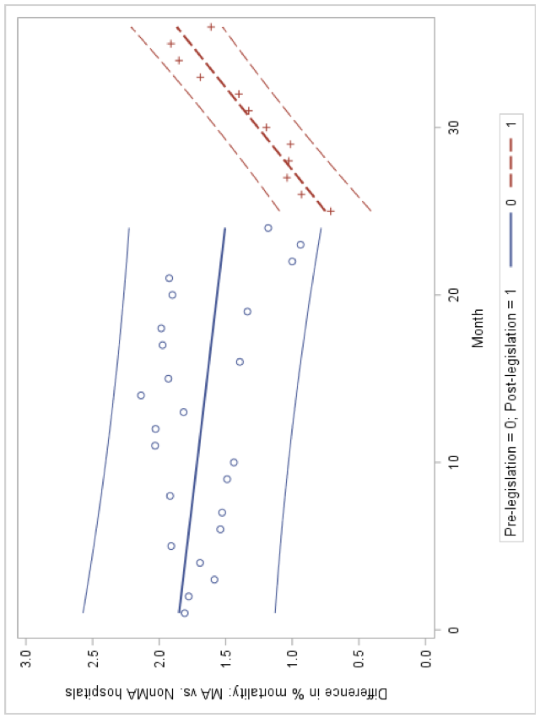

B.

Supplemental Figure 2. Interrupted time series analysis of effect of increased nurse staffing on observed mortality in Massachusetts.

Panel A. Linear regression accounting for 1st and 12th order (seasonality) autocorrelation (Durbin-Watson test after accounting for autocorrelation = 1.89, p = 0.20) found no significant improvement in mortality in MA associated with increase in nurse staffing (change in mortality after implementation: β = -1.13, SE = 0.83, p = 0.18; trend prior to implementation: β = 0.006, SE = 0.04, p = 0.86; change in mortality trend after implementation: β = 0.13, SE = 0.11, p = 0.23).

Panel B. Quadratic polynomial regression accounting for 1st and 12th order autocorrelation (Durbin-Watson test = 1.92, p = 0.17 also found no significant improvement in mortality in MA associated with increase in nurse staffing; however, there was a significant increase in mortality trend after implementation (change in mortality after implementation: β = -0.55, SE = 0.77, p = 0.48; trend prior to implementation: β = 0.26, SE = 0.10, p = 0.02; change in mortality trend after implementation: β = 0.50, SE = 0.14, p = 0.002).

A.

B.

SUPPLEMENT REFERENCES
1. Limitation on patient assignments per nurse in intensive care units; development and certification of acuity tool, (2014).
2. Patient Assignment Limits for Registered Nurses in Intensive Care Units in Acute Hospitals, (2015).
3. Center for Health Information and Analysis. Massachusetts Hospital Profiles, Technical Appendix. Massachusetts2015.
4. Vizient. 2016 Risk Adjustment Methodology 2016 [Available from: https://amc.vizientinc.com/docs/5555-6-15580_RiskAdjustmentMethodology2016.pdf.
5. Needleman J, Buerhaus P, Mattke S, Stewart M, Zelevinsky K. Nurse-staffing levels and the quality of care in hospitals. N Engl J Med. 2002;346(22):1715-22.
6. Stone PW, Mooney-Kane C, Larson EL, Horan T, Glance LG, Zwanziger J, et al. Nurse working conditions and patient safety outcomes. Med Care. 2007;45(6):571-8.
7. Lake ET, Shang J, Klaus S, Dunton NE. Patient falls: Association with hospital Magnet status and nursing unit staffing. Res Nurs Health. 2010;33(5):413-25.
8. Kerlin MP, Harhay MO, Kahn JM, Halpern SD. Nighttime intensivist staffing, mortality, and limits on life support: a retrospective cohort study. Chest. 2015;147(4):951-8.
9. Health CUMSoP. Population Health Methods: Difference-in-Difference Estimation [Available from: https://www.mailman.columbia.edu/research/population-health-methods/difference-difference-estimation.
10. Warton EM, Parker MM, Karter AJ, editors. How D-I-D you do that? Basic Difference-in-Differences Models in SAS®. Proceedings of the Western Users of SAS Software 2016 Conference; September 2016.
11. Lopez Bernal J, Cummins S, Gasparrini A. Interrupted time series regression for the evaluation of public health interventions: a tutorial. Int J Epidemiol. 2016.
12. Penfold RB, Zhang F. Use of interrupted time series analysis in evaluating health care quality improvements. Acad Pediatr. 2013;13(6 Suppl):S38-44.
13. Wagner AK, Soumerai SB, Zhang F, Ross-Degnan D. Segmented regression analysis of interrupted time series studies in medication use research. J Clin Pharm Ther. 2002;27(4):299-309.
14. Welton JM, Unruh L, Halloran EJ. Nurse staffing, nursing intensity, staff mix, and direct nursing care costs across Massachusetts hospitals. J Nurs Adm. 2006;36(9):416-25.
15. Mark BA, Harless DW, Spetz J, Reiter KL, Pink GH. California's minimum nurse staffing legislation: results from a natural experiment. Health Serv Res. 2013;48(2 Pt 1):435-54.
16. McHugh MD, Brooks Carthon M, Sloane DM, Wu E, Kelly L, Aiken LH. Impact of nurse staffing mandates on safety-net hospitals: lessons from California. Milbank Q. 2012;90(1):160-86.
17. Kerlin MP, Weissman GE, Wonneberger KA, Kent S, Madden V, Liu VX, et al. Validation of Administrative Definitions of Invasive Mechanical Ventilation across 30 Intensive Care Units. Am J Respir Crit Care Med. 2016;194(12):1548-52.
18. Keene AR, Cullen DJ. Therapeutic Intervention Scoring System: update 1983. Crit Care Med. 1983;11(1):1-3.

