Supplemental Electronic Material

1) Search strategy for MEDLINE (Ovid SP)
2) Individual Study risk of bias assessment
3) Forest plot for ICU length of stay
4) Forest plot for hospital length of stay
5) Forest plot for Shock reversal at day 7
6) Forest plot for SOFA score at day 7
7) Forest plot for adverse events
8) Meta-regression for short-term mortality outcome by control group mortality
9) Meta-regression for long-term mortality outcome by control group mortality
10) Meta-regression for short-term mortality outcome by year of study publication
11) Funnel plot for short-term mortality
12) Funnel plot for shock reversal at day 7
13) Funnel plot for SOFA score at day 7
14) Funnel plot for hyperglycemia
15) Table of Egger test p-values
16) Sensitivity analysis for short-term mortality – 2 most recent studies
17) Sensitivity analysis for short-term mortality – excluding short course and high dose corticosteroids
18) Sensitivity analysis for short-term mortality – excluding high risk or probably high risk of bias studies
19) Metaregression results (p-values for interaction) for subgroup analysis

1) Supplemental Material. Search strategy for MEDLINE (Ovid SP)

1. exp Sepsis/
2. exp Shock, Septic/
3. (sepsis or septic shock).mp.
4. 1 or 2 or 3
5. exp Adrenal Cortex Hormones/
6. (corticosteroid* or steroid*).mp.
7. 6 or 5
8. 4 and 7
9. ((randomized controlled trial or controlled clinical trial).pt. or randomized.ab. or placebo.ab. or clinical trials as topic.sh. or randomly.
ab. or trial.ti.) not (animals not (humans and animals)).sh.
10. 8 and 9

2) Supplemental Table 1. Individual Study risk of bias assessment.
Study  (author, year) | Randomization Generation | Allocation Concealment | Blinding | Incomplete Data | Selective Reporting | Other | Overall ROB
Annane 2002 | low | low | low | low | low | low | low
Annane 2018 | low | low | low | low | low | low | low
Arabi 2011 | low | low | low | probably low | probably low | low | probably low
Bollaert 1998 | low | low | low | low | low | probably high | probably high
Bone 1987 | low | low | low | low | probably low | probably low | probably low
Branco 2014 | probably low | probably low | probably low | probably low | probably high | high | high
Briegel 1999 | Low | low | low | low | probably low | low | probably low
Chawla 1999 | low | low | low | low | low | low | low
Cicarelli 2007 | probably high | low | low | probably low | probably low | probably low | probably high
Confalonieri 2005 | low | low | low | high | low | high | high
CSG 1963 | probably low | probably low | probably low | low | probably high | probably low | probably high
DeGraaf 2014 | probably low | probably low | probably high | probably high | probably low | low | probably high
El-Nawawy 2016 | low | low | low | probably high | probably high | low | probably high
Gordon 2014 | low | low | probably low | probably low | low | low | probably low
Gordon 2016 | low | low | low | low | low | low | low
Hu 2009 | probably low | probably low | probably high | low | probably low | probably low | probably high
Keh 2016 | low | low | low | low | low | low | low
Liu 2012 | low | probably low | probably low | probably low | probably low | probably low | probably low
Luce 1988 | low | low | low | probably high | probably low | low | probably high
Lv 2017 | low | high | low | low | low | low | high
Meduri 2007 | low | low | probably low | low | probably low | low | probably low
Meduri 2009 | low | low | low | low | low | low | low
Meijvis 2011 | low | low | low | low | low | low | low
Menon 2017 | low | low | low | low | low | low | low
Mirea 2014 | probably high | probably high | probably high | probably high | high | probably high | high
Oppert 2005 | probably low | probably low | probably low | probably high | probably low | low | probably high
Rezk 2003 | probably high | probably high | high | low | probably high | low | high
Rianldi 2006 | probably low | probably high | high | low | low | low | high
Sabry 2011 | probably low | probably high | probably low | low | low | low | probably high
Schumer 1976 | probably low | high | probably low | low | low | low | high
Slusher 1996 | probably high | probably high | probably low | low | low | low | probably high
Snijders 2010 | low | low | probably low | low | low | low | probably low
Sprung 1984 | probably high | probably high | high | low | low | low | high
Sprung 2008 | low | low | low | low | low | low | low
Tandan 2005 | low | low | low | probably high | probably high | probably low | probably high
Tongyoo 2016 | low | low | low | low | low | low | low
Torres 2015 | low | low | low | low | low | low | low
Valoor 2009 | low | probably low | high | low | low | high | probably high
VASSCSG 1987 | probably low | probably low | probably low | low | low | low | probably low
Venkatesh 2017 | low | low | low | low | low | low | low
Yildiz 2002 | probably low | probably low | probably low | low | low | low | probably low
Yildiz 2011 | probably low | probably low | probably low | low | low | low | probably low

3) Forest plot for ICU length of Stay
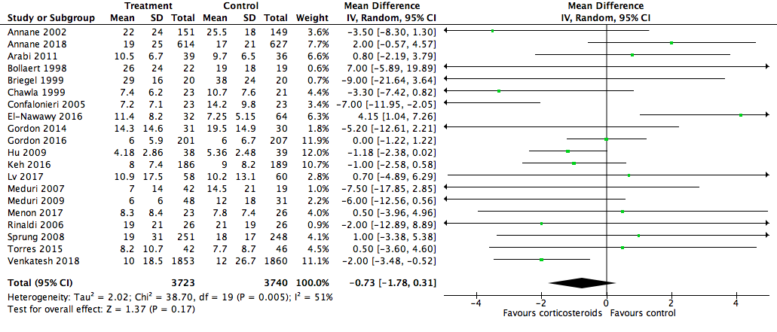

4) Forest plot for hospital length of stay
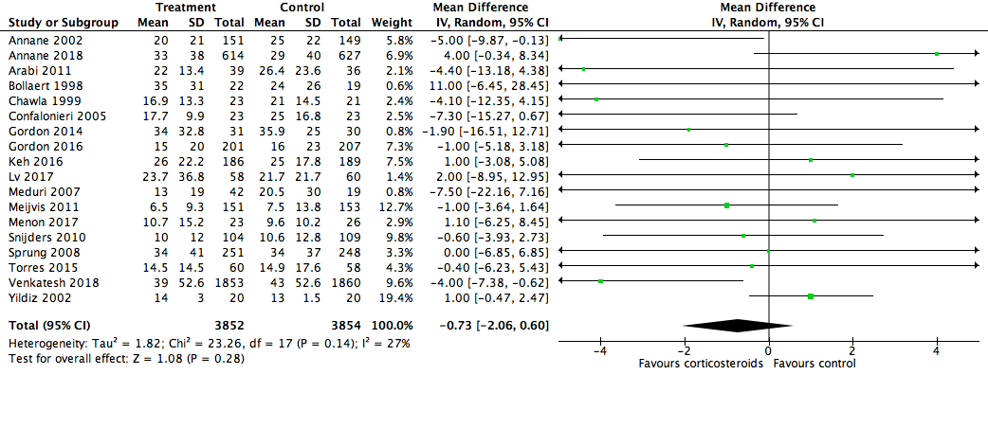

5) Forest plot for shock reversal at day 7
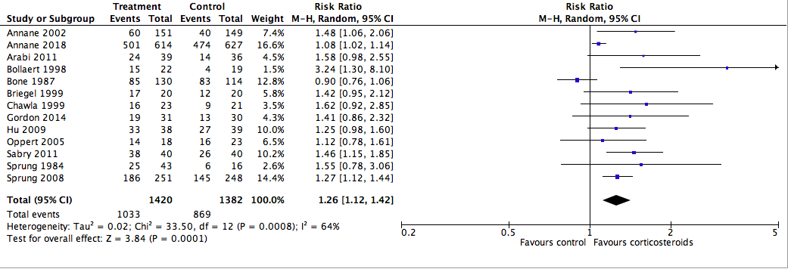

6) Forest plot for SOFA score at day 7
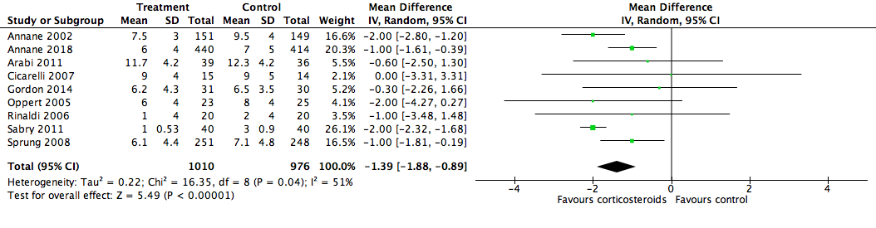
7) Forest plot for adverse events
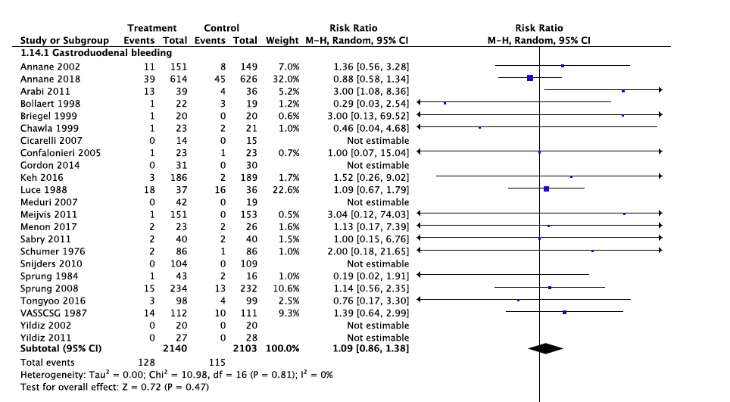

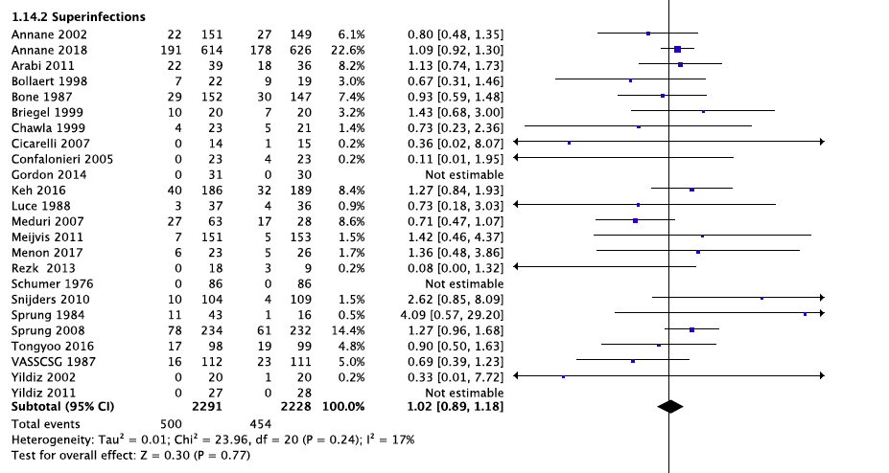
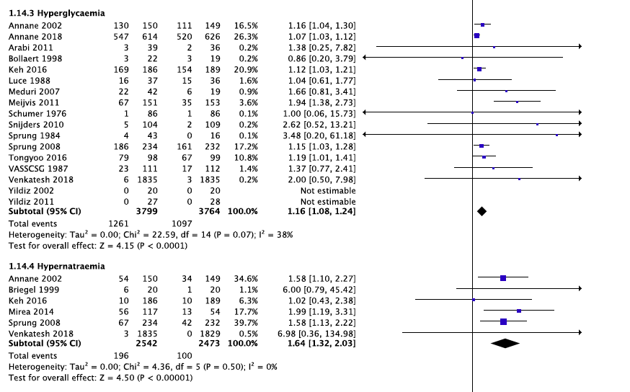
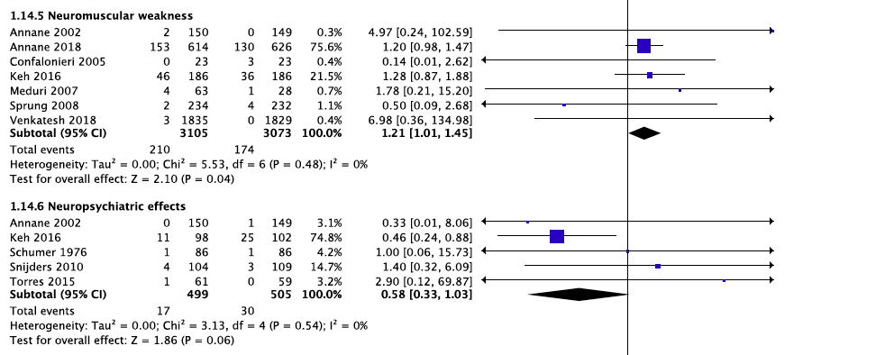
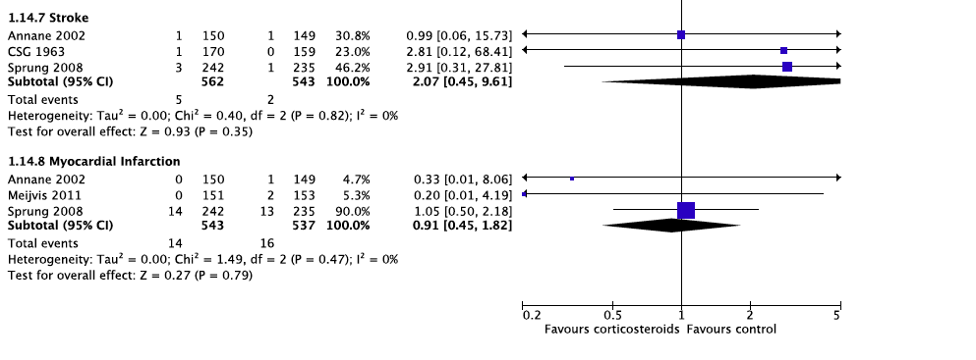

8) Meta-regression for short-term mortality by control group mortality
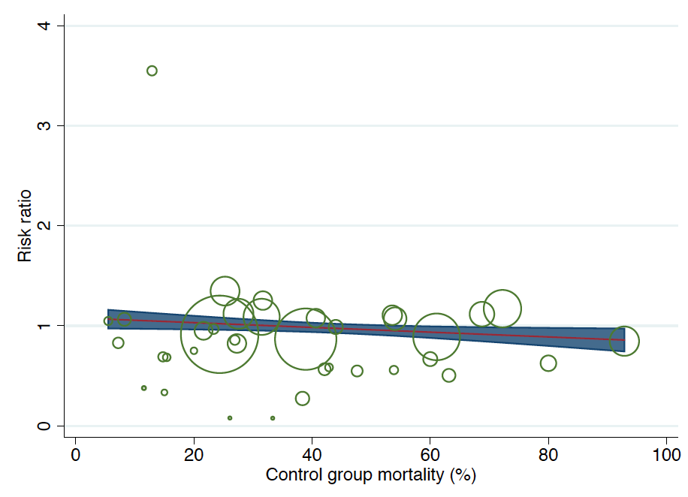

9) Meta-regression for long-term mortality outcome by control group mortality
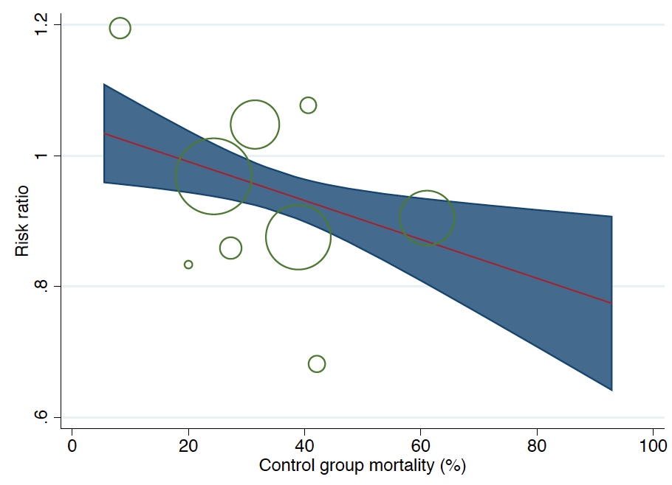

10) Meta-regression for short-term mortality outcome by year of study publication
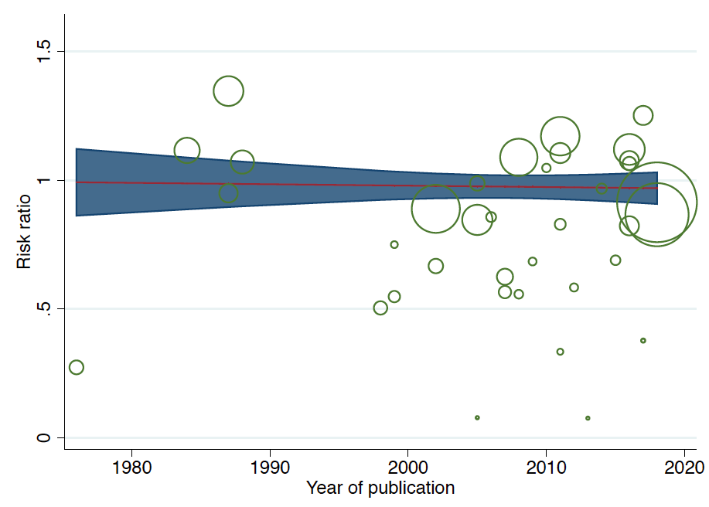

11) Funnel plot for short-term mortality
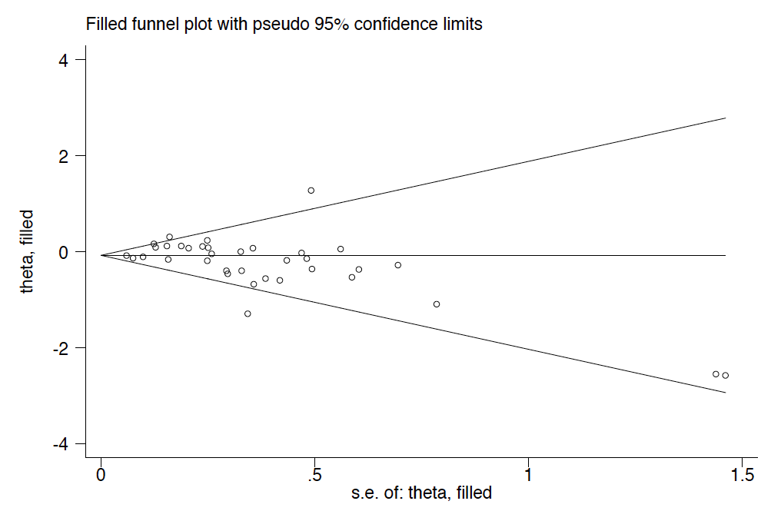

12) Funnel plot for shock reversal at day 7
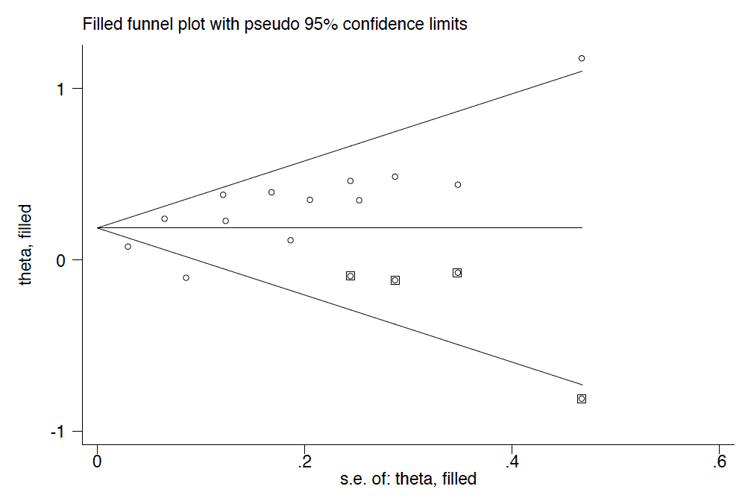

13) Funnel plot for SOFA score at day 7
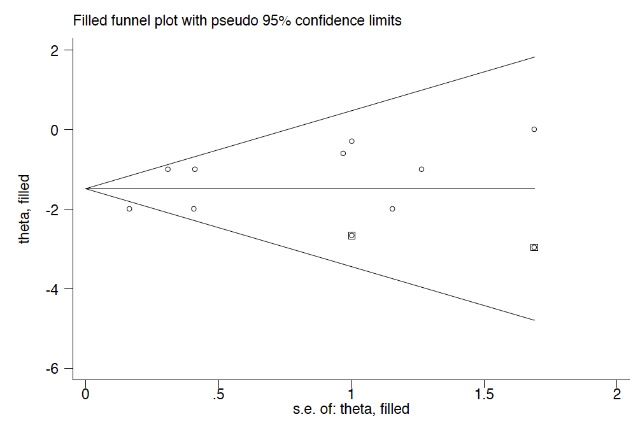

14) Funnel plot for hyperglycemia
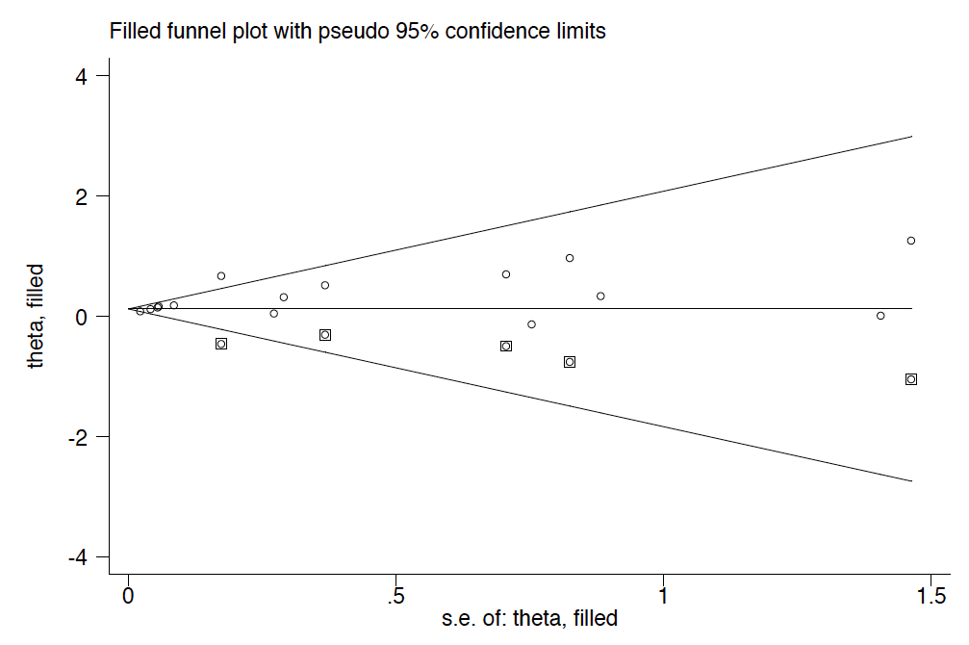

15) Egger test p-values

Outcome | Egger test p-value
Short-term mortality | 0.111
Long-term mortality | 0.940
Shock Reversal at day 7 | 0.010
SOFA score at day 7 | 0.082
ICU Length of Stay | 0.554
Hospital Length of Stay | 0.214
Hyperglycemia | 0.013
Superinfection | 0.166

16) Sensitivity analysis for short-term mortality – 2 most recent studies

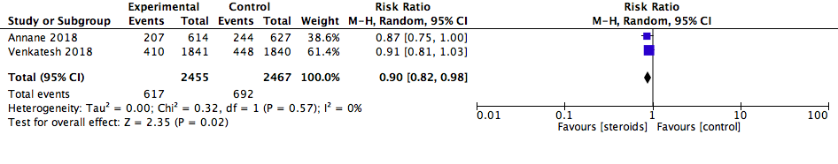

17) Sensitivity Analysis short-term mortality – excluding short course and high dose corticosteroids

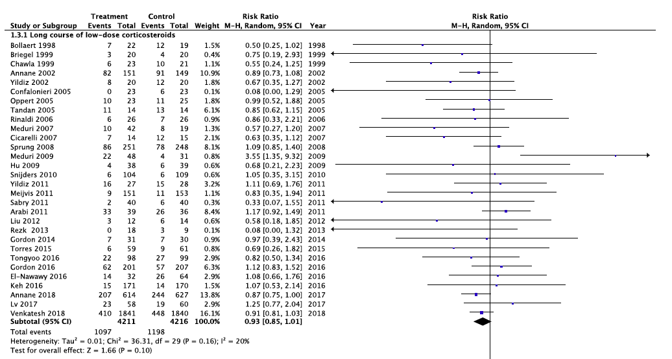

18) Sensitivity analysis for short-term mortality – excluding high risk or probably high risk of bias studies

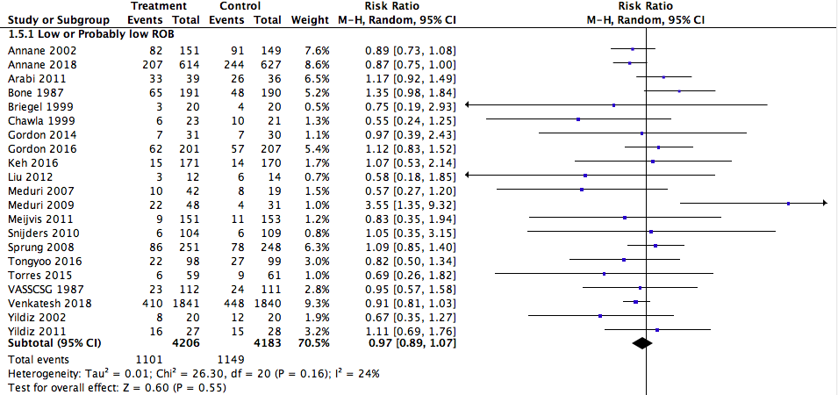

19) Meta-regression results (p-value for interaction) for subgroup analysis.

Outcome | RoB | Control Group mort | Sepsis w/o shock vs all others | Shock vs all others | ARDS vs all others | CAP vs all others | Sepsis vs shock | ARDS vs shock | CAP vs shock | Pulm vs non-pulm | Duration/Dose | HC vs all others | HC+FC vs all others | MP vs all others
Short-term Mortality | 0.336 | 0.262 | 0.070 | 0.556 | 0.203 | 0.427 | 0.102 | 0.249 | 0.474 | 0.130 | 0.219 | 0.344 | 0.183 | 0.638
Long-term mortality | N/A | 0.188 | 0.189 | 0.972 | 0.294 | N/A | 0.202 | 0.315 | N/A | 0.294 | N/A | 0.063 | 0.183 | 0.274
SOFA on day 7 | 0.104 | 0.617 | 0.754 | 0.099 | N/A | 0.087 | 0.865 | N/A | 0.087 | 0.087 | N/A | 0.988 | 0.780 | N/A
Shock reversal at day 7 | 0.320 | 0.085 | N/A | 0.302 | N/A | N/A | N/A | N/A | N/A | N/A | N/A | 0.098 | 0.564 | 0.150
Length of ICU Stay | 0.600 | 0.248 | 0.800 | 0.190 | N/A | 0.255 | 0.661 | N/A | 0.233 | 0.128 | N/A | 0.700 | 0.588 | 0.912
Length of Hospital Stay | 0.686 | 0.922 | 0.054 | 0.496 | N/A | 0.610 | 0.150 | N/A | 0.995 | 0.491 | N/A | 0.269 | 0.732 | 0.331
Superinfection | 0.871 | 0.492 | 0.644 | 0.488 | 0.200 | 0.803 | 0.856 | 0.219 | 0.764 | 0.187 | 0.699 | 0.378 | 0.451 | 0.785
Hyperglycemia | 0.594 | 0.201 | 0.414 | 0.251 | 0.884 | <0.001 | 0.899 | 0.267 | <0.001 | 0.018 | 0.922 | 0.313 | 0.271 | 0.416
RoB = risk of bias, mort = mortality, vs = versus, ARDS = acute respiratory distress syndrome, CAP = community acquired pneumonia, pulm = pulmonary, HC = hydrocortisone, FC = fludrocortisone, MP = methylprednisone, methylprednisolone or prednisone, SOFA = sequential organ failure assessment score, ICU = intensive care unit

