Non-linear relationship between objective sedation monitor (BIS) and subjective sedation scale (SAS) in a single patient as sedation level fluctuated (Adapted from Fraser GL, Riker RR. Bispectral index monitoring in the intensive care unit provides more signal than noise. Pharmacotherapy 2005; 25(5 Pt 2):19S-27S.) [1]

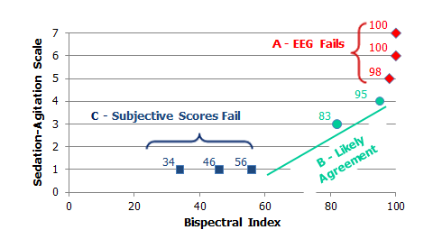

1. Fraser GL, Riker RR: Bispectral index monitoring in the intensive care unit provides more signal than noise. Pharmacotherapy 2005, 25(5 Pt 2):19S-27S.

