**Haloperidol Delirium Treatment, Patients with Delirium**

**Duration of Delirium (days)**

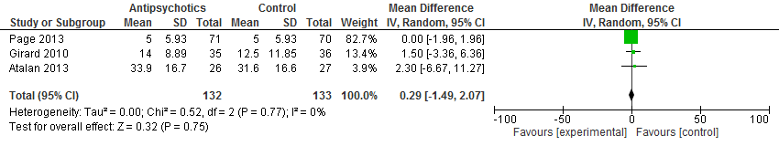

**Page [1], Girard [2], Atalan [3]**

**Haloperidol Delirium Treatment, Patients with Delirium**

**Duration of Mechnical Ventilation (days)**

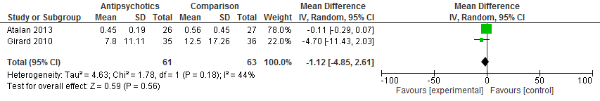

**Atalan [3], Girard [4]**

**Haloperidol Delirium Treatment, Patients with Delirium**

**ICU Mortality**

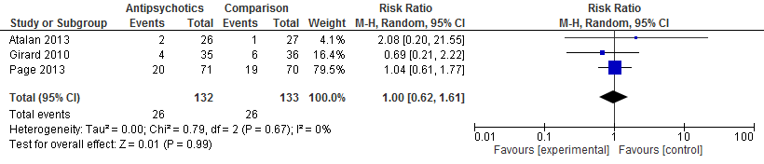

**Atalan [3], Girard [5], Page [1]**

**Atypical Antisychotic Delirium Treatment, Patients with Delirium**

**Duration of Delirium (days)**

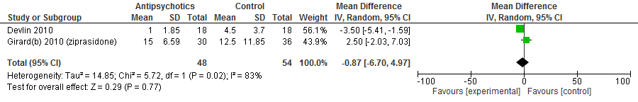

**Devlin [6], Girard [5]**

**Atypical Antipsychotic Delirium Treatment, Patients with Delirium**

**Duration of Mechanical Ventilation (days)**

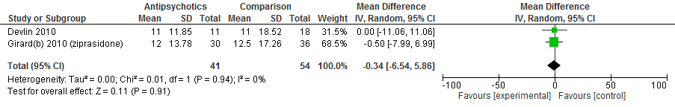

**Devlin [6], Girard [5]**

**Atypical Antipsychotic Delirium Treatment, Patients with Delirium**

**Length of ICU Stay (days)**

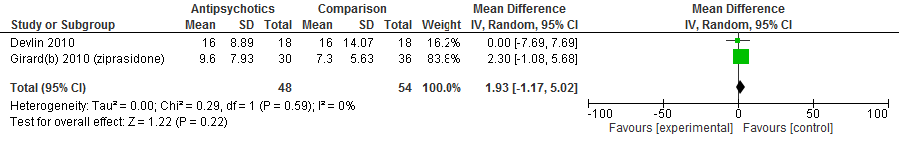

**Devlin [6], Girard [5]**

**Atypical Antipsychotic Delirium Treatment, Patients with Delirium**

**ICU Mortality**

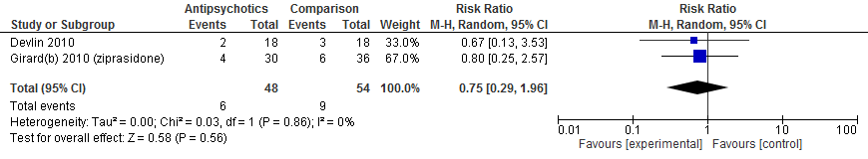

**Devlin [6], Girard [5]**

**Single intervention nonpharmacologic -Bright light therapy, Patients without Delirium**

***Delirium incidence***

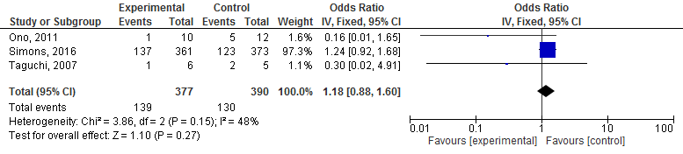

**Ono [7], Simons [8], Taguchi [9]**

**Single intervention non pharmacologic Bright light therapy, Patients without Delirium**

***ICU length of Stay***

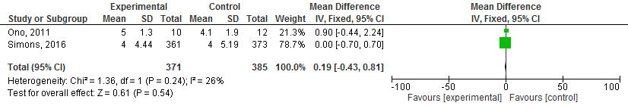

**Ono [7], Simons [8]**

**References**

1. Page VJ, Ely EW, Gates S, Zhao XB, Alce T, Shintani A, Jackson J, Perkins GD, McAuley DF: Effect of intravenous haloperidol on the duration of delirium and coma in critically ill patients (Hope-ICU): A randomised, double-blind, placebo-controlled trial. *The Lancet Respiratory Medicine* 2013, 1(7):515-523.

2. Girard TD, Pandharipande PP, Carson SS, Schmidt GA, Wright PE, Canonico AE, Pun BT, Thompson JL, Shintani AK, Meltzer HY *et al*: Feasibility, efficacy, and safety of antipsychotics for intensive care unit delirium: the MIND randomized, placebo-controlled trial. *Crit Care Med* 2010, 38(2):428-437.

3. Atalan N, Sevim ME: Postoperative delirium associated with prolonged decline in cognitive function and sleep disturbances after cardiac surgery. *Turk Gogus Kalp Dama* 2013, 21:358-363.

4. Girard TD, Jackson JC, Pandharipande PP, Pun BT, Thompson JL, Shintani AK, Gordon SM, Canonico AE, Dittus RS, Bernard GR *et al*: Delirium as a predictor of long-term cognitive impairment in survivors of critical illness. *Crit Care Med* 2010, 38(7):1513-1520.

5. Girard TD, Kress JP, Fuchs BD, Thomason JW, Schweickert WD, Pun BT, Taichman DB, Dunn JG, Pohlman AS, Kinniry PA *et al*: Efficacy and safety of a paired sedation and ventilator weaning protocol for mechanically ventilated patients in intensive care (Awakening and Breathing Controlled trial): a randomised controlled trial. *Lancet* 2008, 371(9607):126-134.

6. Devlin JW, Roberts RJ, Fong JJ, Skrobik Y, Riker RR, Hill NS, Robbins T, Garpestad E: Efficacy and safety of quetiapine in critically ill patients with delirium: a prospective, multicenter, randomized, double-blind, placebo-controlled pilot study. *Crit Care Med* 2010, 38(2):419-427.

7. Ono H, Taguchi T, Kido Y, Fujino Y, Doki Y: The usefulness of bright light therapy for patients after oesophagectomy. *Intensive Crit Care Nurs* 2011, 27(3):158-166.

8. Simons KS, Laheij RJF, van den Boogaard M, Moviat MAM, Paling AJ, Polderman FN, Rozendaal FW, Salet GAM, van der Hoeven JG, Pickkers P *et al*: Dynamic light application therapy to reduce the incidence and duration of delirium in intensive-care patients: A randomised controlled trial. *The Lancet Respiratory Medicine* 2016, 4(3):194-202.

9. Taguchi T, Yano M, Kido Y: Influence of bright light therapy on postoperative patients: a pilot study. *Intensive Crit Care Nurs* 2007, 23(5):289-297.