Hospital Mortality (13 RCTs, 1421 patients)
ICU mortality

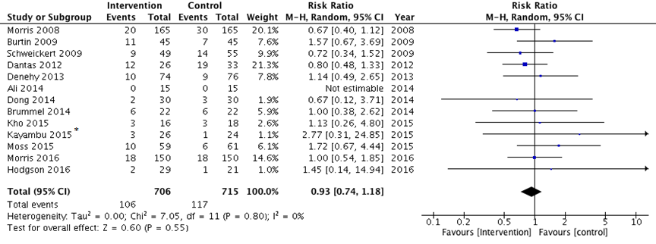
Morris [1], Burtin [2], Schweickert [3], Dantas [4], Denehy [5], Ali [6], Dong [7], Brummel [8], Kho [9], Kayambu [10], Moss [11], Morris 2016 [12], Hodgson [13]
Muscle Strength (MRC) at ICU discharge (6 RCTs, 304 Patients)
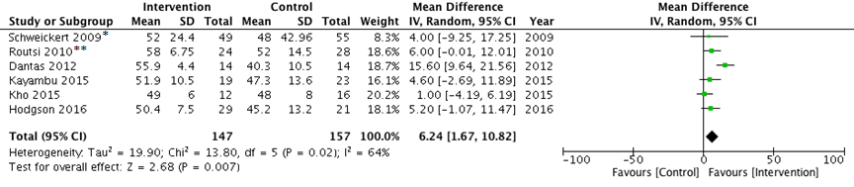
* At hospital discharge
** At ICU awakening
Schweickert [3], Routsi [14], Dantas [4], Kayambu [10], Kho [9], Hodgson [13]

Quality of Life (SF-36 Physical Function) within 2 months (4 RCTs, 303 patients)
Burtin [2], Ali [6], Moss [11], Morris [12]

PFIT at ICU Discharge (3 RCTs, 209 patients)
Denehy [5], Kayambu [10], Hodgson [13]

TUG at Hospital Discharge (one study was at 28 days [3 RCTs, 172 patients])
Denehy [5], Brummel [8], Moss[12]
Duration of Mechanical Ventilation (11 RCTs, 1128 patients)
Yosef-Braner [15], Patman [16], Morris 2008 [17], Schweickert [3], Routsi [14], Denehy [5], Dong [7], Kho [9], Kayambu [10], Moss [11], Hodgson [13]
References
1. Morris PE, Goad A, Thompson C, Taylor K, Harry B, Passmore L, Ross A, Anderson L, Baker S, Sanchez M et al: Early intensive care unit mobility therapy in the treatment of acute respiratory failure. Crit Care Med 2008, 36(8):2238-2243.
2. Burtin C, Clerckx B, Robbeets C, Ferdinande P, Langer D, Troosters T, Hermans G, Decramer M, Gosselink R: Early exercise in critically ill patients enhances short-term functional recovery. Crit Care Med 2009, 37(9):2499-2505.
3. Schweickert WD, Pohlman MC, Pohlman AS, Nigos C, Pawlik AJ, Esbrook CL, Spears L, Miller M, Franczyk M, Deprizio D et al: Early physical and occupational therapy in mechanically ventilated, critically ill patients: a randomised controlled trial. Lancet 2009, 373(9678):1874-1882.
4. Dantas CM, Silva PFDS, Siqueira FHTd, Pinto RMF, Matias S, Maciel C, Oliveira MCd, Albuquerque CGd, Andrade FMD, Ramos FF et al: Influence of early mobilization on respiratory and peripheral muscle strength in critically ill patients. Rev Bras Ter Intensiva 2012, 24(2):173-178.
5. Denehy L, Skinner EH, Edbrooke L, Haines K, Warrillow S, Hawthorne G, Gough K, Hoorn SV, Morris ME, Berney S: Exercise rehabilitation for patients with critical illness: a randomized controlled trial with 12 months of follow-up. Crit Care 2013, 17(4):R156.
6. Ali MS, Talwar D, Jain SK: The effect of a short-term pulmonary rehabilitation on exercise capacity and quality of life in patients hospitalised with acute exacerbation of chronic obstructive pulmonary disease. Indian J Chest Dis Allied Sci 2014, 56(1):13-19.
7. Dong Z-H, Yu B-X, Sun Y-B, Fang W, Li L: Effects of early rehabilitation therapy on patients with mechanical ventilation. World J Emerg Med 2014, 5(1):48-52.
8. Brummel NE, Girard TD, Ely EW, Pandharipande PP, Morandi A, Hughes CG, Graves AJ, Shintani A, Murphy E, Work B et al: Feasibility and safety of early combined cognitive and physical therapy for critically ill medical and surgical patients: the Activity and Cognitive Therapy in ICU (ACT-ICU) trial. Intensive Care Med 2014, 40(3):370-379.
9. Kho ME, Martin RA, Toonstra AL, Zanni JM, Mantheiy EC, Nelliot A, Needham DM: Feasibility and safety of in-bed cycling for physical rehabilitation in the intensive care unit. J Crit Care 2015, 30(6):1419.e1411-1415.
10. Kayambu G, Boots R, Paratz J: Early physical rehabilitation in intensive care patients with sepsis syndromes: a pilot randomised controlled trial. Intensive Care Med 2015, 41(5):865-874.
11. Moss M, Nordon-Craft A, Malone D, Van Pelt D, Frankel SK, Warner ML, Kriekels W, McNulty M, Fairclough DL, Schenkman M: A Randomized Trial of an Intensive Physical Therapy Program for Patients with Acute Respiratory Failure. Am J Respir Crit Care Med 2016, 193(10):1101-1110.
12. Morris PE, Berry MJ, Files DC, Thompson JC, Hauser J, Flores L, Dhar S, Chmelo E, Lovato J, Case LD et al: Standardized rehabilitation and hospital length of stay among patients with acute respiratory failure a randomized clinical trial. JAMA - Journal of the American Medical Association 2016, 315(24):2694-2702.
13. Hodgson CL, Bailey M, Bellomo R, Berney S, Buhr H, Denehy L, Gabbe B, Harrold M, Higgins A, Iwashyna TJ et al: A Binational Multicenter Pilot Feasibility Randomized Controlled Trial of Early Goal-Directed Mobilization in the ICU. Crit Care Med 2016, 44(6):1145-1152.
14. Routsi C, Gerovasili V, Vasileiadis I, Karatzanos E, Pitsolis T, Tripodaki E, Markaki V, Zervakis D, Nanas S: Electrical muscle stimulation prevents critical illness polyneuromyopathy: a randomized parallel intervention trial. Crit Care 2010, 14(2):R74.
15. Yosef-Brauner O, Adi N, Ben Shahar T, Yehezkel E, Carmeli E: Effect of physical therapy on muscle strength, respiratory muscles and functional parameters in patients with intensive care unit-acquired weakness. Clin Respir J 2015, 9(1):1-6.
16. Patman S, Sanderson D, Blackmore M: Physiotherapy following cardiac surgery: is it necessary during the intubation period? Aust J Physiother 2001, 47(1):7-16.
17. Morris PE, Goad A, Thompson C, Taylor K, Harry B, Passmore L, Ross A, Anderson L, Baker S, Sanchez M et al: Early intensive care unit mobility therapy in the treatment of acute respiratory failure. Crit Care Med 2008, 36(8):2238-2243.

