Non Pharmacologic – Assist Control
Sleep Efficiency
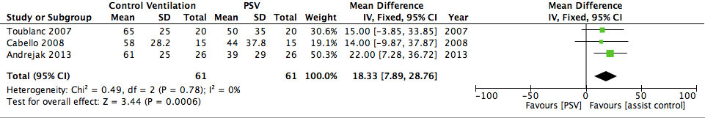
Toublanc [1], Cabello [2], Andrejak [3]

Non Pharmacologic – Assist Control
Stage 1 Sleep
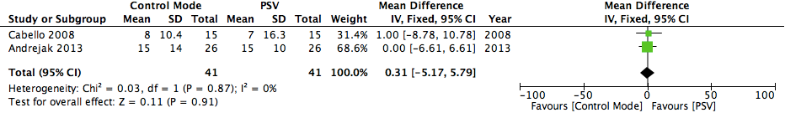
Cabello [2], Andrejak [3]

Non Pharmacologic – Assist Control

Stage 2 Sleep
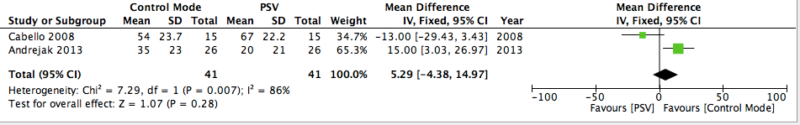
Cabello [2], Andrejak [3]

Non Pharmacologic – Assist Control

REM Sleep
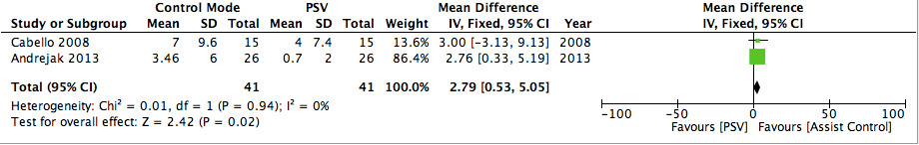
Cabello [2], Andrejak [3]

Non Pharmacologic – Adaptive Ventilation

Sleep Efficiency

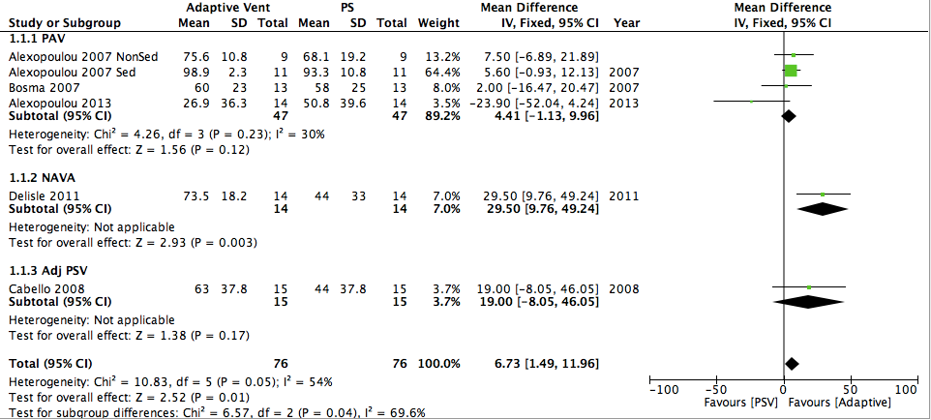
Alexopoulou 2007 [4], Bosma [5], Alexopoulou 2013 [6], Delisle [7], Cabello [2]

Non Pharmacologic – Adaptive Ventilation
Sleep Fragmentation
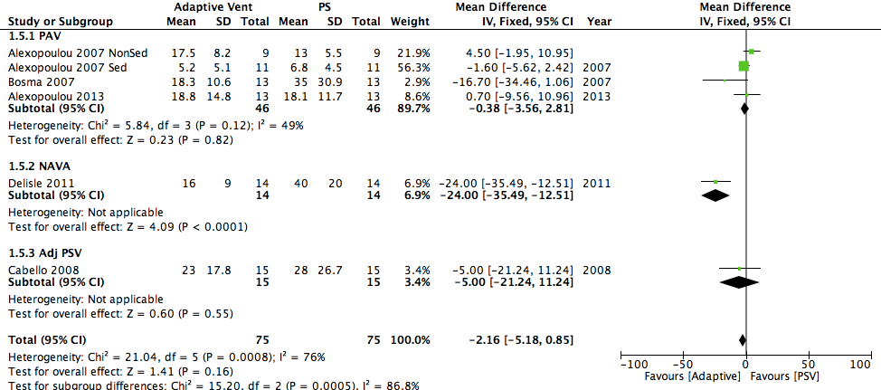
Alexopoulou 2007 [4], Bosma [5], Alexopoulou 2013 [6], Delisle [7], Cabello [2]

Non Pharmacologic – Adaptive Ventilation
Stage 1 Sleep
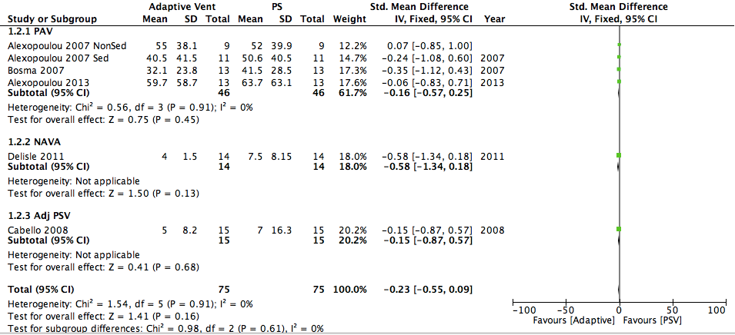
Alexopoulou 2007 [4], Bosma [5], Alexopoulou 2013 [6], Delisle [7], Cabello [2]

Non Pharmacologic– Adaptive Ventilation
Stage 2 Sleep
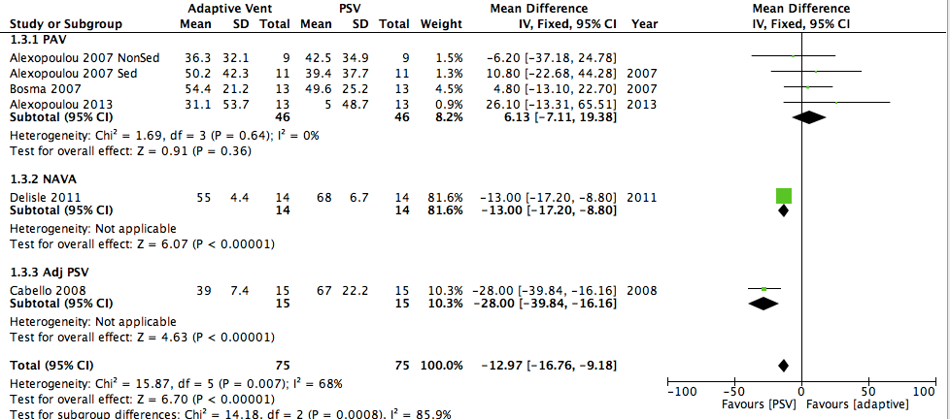
Alexopoulou 2007 [4], Bosma [5], Alexopoulou 2013 [6], Delisle [7], Cabello [2]

Non Pharmacologic– Adaptive Ventilation
REM Sleep
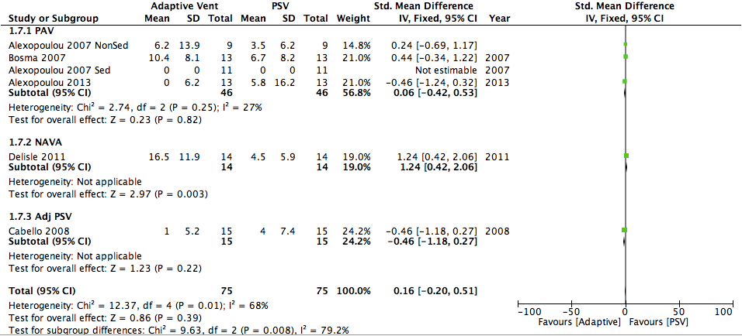
Alexopoulou 2007 [4], Bosma [5], Alexopoulou 2013 [6], Delisle [7], Cabello [2]

Non Pharmacologic – Adaptive Ventilation

Apneas/hour

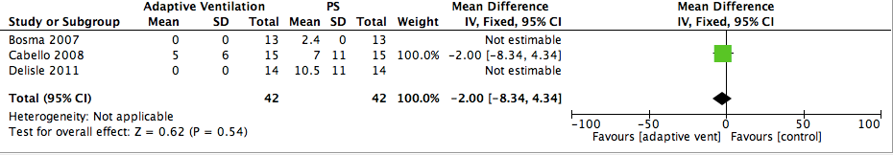
Bosma [5], Cabello [2], Delisle [7]

Non Pharmacologic – Aromatherapy

Self-Reported Sleep

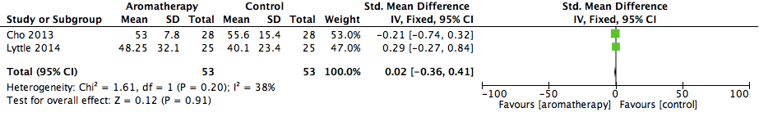Cho [8], Little 2012 [9]
Pharmacologic – Dexmedetomdine
Sleep Fragmentation
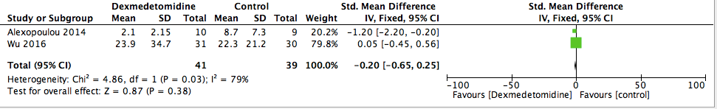
Alexopoulou [10], Wu [11]
Pharmacological Dexmedetomidine

Stage 1 Sleep

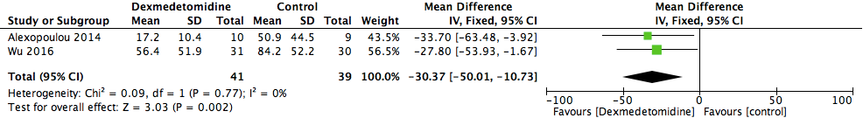
Alexopoulou [10], Wu [11]
Pharmacological Dexmedetomidine

Stage 2 Sleep
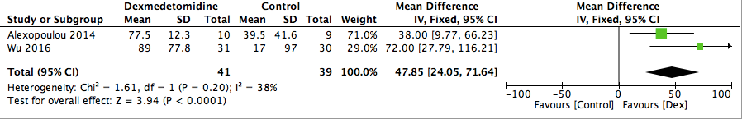
Alexopoulou [10], Wu [11]
Multicomponent Sleep Protocol

Daytime Sleepiness
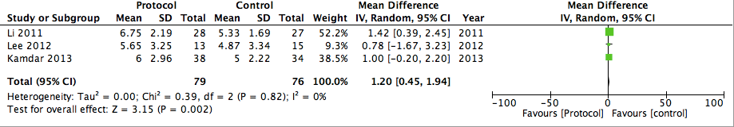
Li [12], Lee [13], Kamdar [14]

Multicomponent Sleep Protocol

Delirium
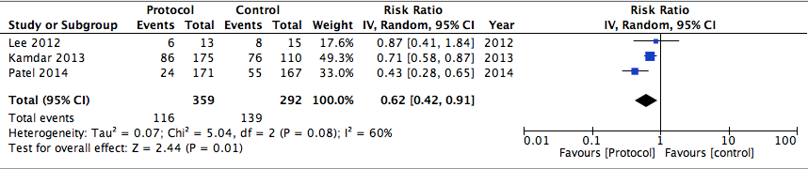
Lee [13], Kamdar [14], Patel [15]

References
1. Toublanc B, Rose D, Glérant J-C, Francois G, Mayeux I, Rodenstein D, Jounieaux V: Assist-control ventilation vs. low levels of pressure support ventilation on sleep quality in intubated ICU patients. Intensive Care Med 2007, 33(7):1148-1154.
2. Cabello B, Thille AW, Drouot X, Galia F, Mancebo J, d'Ortho M-P, Brochard L: Sleep quality in mechanically ventilated patients: comparison of three ventilatory modes. Crit Care Med 2008, 36(6):1749-1755.
3. Andréjak C, Monconduit J, Rose D, Toublanc B, Mayeux I, Rodenstein D, Jounieaux V: Does using pressure-controlled ventilation to rest respiratory muscles improve sleep in ICU patients? Respir Med 2013, 107(4):534-541.
4. Alexopoulou C, Kondili E, Vakouti E, Klimathianaki M, Prinianakis G, Georgopoulos D: Sleep during proportional-assist ventilation with load-adjustable gain factors in critically ill patients. Intensive Care Med 2007, 33(7):1139-1147.
5. Bosma K, Ferreyra G, Ambrogio C, Pasero D, Mirabella L, Braghiroli A, Appendini L, Mascia L, Ranieri VM: Patient-ventilator interaction and sleep in mechanically ventilated patients: pressure support versus proportional assist ventilation. Crit Care Med 2007, 35(4):1048-1054.
6. Alexopoulou C, Kondili E, Plataki M, Georgopoulos D: Patient-ventilator synchrony and sleep quality with proportional assist and pressure support ventilation. Intensive Care Med 2013, 39(6):1040-1047.
7. Delisle S, Ouellet P, Bellemare P, Tétrault J-P, Arsenault P: Sleep quality in mechanically ventilated patients: comparison between NAVA and PSV modes. Ann Intensive Care 2011, 1(1):42.
8. Cho M-Y, Min ES, Hur M-H, Lee MS: Effects of aromatherapy on the anxiety, vital signs, and sleep quality of percutaneous coronary intervention patients in intensive care units. Evid Based Complement Alternat Med 2013, 2013:381381.
9. Little A, Ethier C, Ayas N, Thanachayanont T, Jiang D, Mehta S: A patient survey of sleep quality in the Intensive Care Unit. Minerva Anestesiol 2012, 78(4):406-414.
10. Alexopoulou C, Kondili E, Diamantaki E, Psarologakis C, Kokkini S, Bolaki M, Georgopoulos D: Effects of dexmedetomidine on sleep quality in critically ill patients: a pilot study. Anesthesiology 2014, 121(4):801-807.
11. Wu X-H, Cui F, Zhang C, Meng Z-T, Wang D-X, Ma J, Wang G-F, Zhu S-N, Ma D: Low-dose Dexmedetomidine Improves Sleep Quality Pattern in Elderly Patients after Noncardiac Surgery in the Intensive Care Unit: A Pilot Randomized Controlled Trial. Anesthesiology 2016, 125(5):979-991.
12. Li SY, Wang TJ, Vivienne Wu SF, Liang SY, Tung HH: Efficacy of controlling night-time noise and activities to improve patients' sleep quality in a surgical intensive care unit. Journal of clinical nursing 2011, 20(3-4):396-407.
13. Nam LE, Lim CJ, Ri KM, Ju LE, Hui LY, Ju CE, Ran LH: The Effects of Sleep Improvement Intervention on the Sleep Quality and Incidence of Delirium in the Intensive Care Unit Patients. Journal of Korean Critical Care Nursing 2012, 5(1).
14. Kamdar BB, King LM, Collop NA, Sakamuri S, Colantuoni E, Neufeld KJ, Bienvenu OJ, Rowden AM, Touradji P, Brower RG et al: The effect of a quality improvement intervention on perceived sleep quality and cognition in a medical ICU. Crit Care Med 2013, 41(3):800-809.
15. Patel J, Baldwin J, Bunting P, Laha S: The effect of a multicomponent multidisciplinary bundle of interventions on sleep and delirium in medical and surgical intensive care patients. Anaesthesia 2014, 69(6):540-549.

