SUPPLEMENTARY MATERIAL

Table of Contents

Australian and New Zealand Intensive Care Society Centre for Outcome and Resource Evaluation 3
Supplementary methods 4
Post-hoc analyses of temperature-related variables 4
Additional details of physiological data collected 5
Additional details about the adjusted analyses 5
Additional details of segmented regression analyses 6
Supplementary tables 7
Table S1. Illness severity and physiological data for patients in the Pre-TTM trial cohort* and Post-TTM trial cohort† 7
Table S2. Characteristics of patients in the extended pre-TTM cohort* 8
Table S3. Illness severity and physiological data for patients in the extended Pre-TTM trial cohort* 9
Table S4. Temperature data and clinical outcomes in the extended Pre-TTM trial cohort* 10
Table S5. Additional temperature variables 11
Table S6. Subgroup analyses 12
Table S7. Adjusted analyses for length of stay variables 13
Table S8. Discharge destination 14
Supplementary Figures 15
Figure S1. Percentage of patients with a lowest temperature <34°C in the first 24 hours in ICU by month 15
Figure S2. In-hospital mortality by month for the subset of ICUs where the average lowest temperature in the first 24 hours in ICU increased between the pre-TTM period and the post TTM period 16
Figure S3. Local weighted regression plot of average hospital mortality per month 17
Figure S4. Percentage of patients discharged home by month 18
Figure S5. Percentage of survivors discharged home by month 19
Figure S6. Percentage of survivors discharged to rehabilitation facilities by month 20

Australian and New Zealand Intensive Care Society Centre for Outcome and Resource Evaluation

The members of the Australian and New Zealand Intensive Care Society Centre for Outcome and Resource Evaluation (ANZICS-CORE) management committee are: Chair – Peter Hicks; Manager – Sue Huckson, ANZICS CORE; Clinical lead Australian and New Zealand Intensive Care Society Adult Patient Database (ANZICS APD) – David Pilcher; Clinical lead ANZ Paediatric Intensive Care Registry – Johnny Millar; Clinical lead ANZ Critical Care Resources Registry – Edward Litton; Deputy Clinical lead ANZICS APD – Alastair McGeorge.

The authors and the ANZICS CORE management committee would like to thank clinicians, data collectors and researchers at the following contributing sites: Albury Base Hospital ICU; Alfred Hospital ICU; Alice Springs Hospital ICU; Allamanda Private Hospital ICU; Armadale Health Service ICU; Armidale Rural Referral Hospital ICU; Ashford Community Hospital ICU; Auckland City Hospital CV ICU; Auckland City Hospital DCCM; Austin Hospital ICU; Ballarat Health; Services ICU; Bankstown-Lidcombe Hospital ICU; Bathurst Base Hospital ICU; Bendigo Health Care Group ICU; Blacktown Hospital ICU; Box Hill Hospital ICU; Brisbane Private Hospital ICU; Brisbane Waters Private Hospital ICU; Bunbury Regional Hospital ICU; Bundaberg Base Hospital ICU; Caboolture Hospital ICU; Cabrini Hospital ICU; Cairns Base Hospital ICU; Calvary Hospital (Canberra) ICU; Calvary John James Hospital ICU; Calvary Mater Newcastle ICU; Calvary North Adelaide Hospital ICU, Calvary; Wakefield Hospital (Adelaide) ICU; Campbelltown Hospital ICU; Canberra Hospital ICU; Central Gippsland Health Service ICU; Christchurch Hospital ICU; Coffs Harbour Health Campus ICU; Concord Hospital (Sydney) ICU; Dandenong Hospital ICU, Dubbo Base Hospital ICU; Dunedin Hospital ICU; Epworth Eastern Private Hospital ICU; Epworth Freemasons Hospital ICU; Epworth Hospital (Richmond) ICU; FigTree Private Hospital ICU; Fiona Stanley ICU; Flinders Medical Centre ICU; Flinders Private Hospital ICU; Footscray Hospital ICU; Frankston Hospital ICU; Fremantle Hospital ICU; Geelong Hospital ICU; Gold Coast University Hospital ICU; Gosford Hospital ICU; Gosford Private Hospital ICU; Goulburn Valley Health ICU; Grafton Base Hospital ICU; Greenslopes Private Hospital ICU; Griffith Base Hospital ICU; Hawkes Bay Hospital ICU; Hervey Bay Hospital ICU; Hollywood Private Hospital ICU; Holy Spirit Northside Hospital ICU; Hornsby Ku-ring-gai Hospital ICU; Hutt Hospital ICU; Ipswich Hospital ICU; John Fawkner Hospital ICU; John Flynn Private Hospital ICU; John Hunter Hospital ICU; Joondalup Health Campus ICU; Knox Private Hospital ICU; Latrobe Regional Hospital ICU; Launceston General Hospital ICU; Lismore Base Hospital ICU; Liverpool Hospital ICU; Logan Hospital ICU; Lyell McEwin Hospital ICU; Mackay Base Hospital ICU; Macquarie University Private Hospital ICU; Manly Hospital & Community Health ICU; Manning Rural Referral Hospital ICU; Maroondah Hospital ICU; Mater Adults Hospital (Brisbane) ICU; Mater Private Hospital (Brisbane) ICU;
Mater Private Hospital (Sydney) ICU; Mater Private Hospital (Townsville) ICU; Melbourne Private Hospital ICU; Mersey Community Hospital ICU; Middlemore Hospital ICU; Mildura Base Hospital ICU; Modbury Public Hospital ICU; Monash Medical Centre-Clayton Campus ICU; Mount Hospital ICU; Mount Isa Hospital ICU; Nambour General Hospital ICU; National Capital Private Hospital ICU; Nelson Hospital ICU; Nepean Hospital ICU; Newcastle Private Hospital ICU; Noosa Hospital ICU; North Shore Hospital ICU; North Shore Private Hospital ICU; North West Regional Hospital (Burnie) ICU; Northeast Health Wangaratta ICU; Norwest Private Hospital ICU; Orange Base Hospital ICU; Peninsula Private Hospital ICU; Peter MacCallum Cancer Institute ICU; Pindara Private Hospital ICU; Port Macquarie Base Hospital ICU; Prince of Wales Hospital (Sydney) ICU; Prince of Wales Private Hospital (Sydney) ICU; Princess Alexandra Hospital ICU; Queen Elizabeth II Jubilee Hospital ICU; Redcliffe Hospital ICU; Repatriation General Hospital (Adelaide) ICU; Robina Hospital ICU; Rockhampton Hospital ICU; Rockingham General Hospital ICU; Rotorua Hospital ICU; Royal Adelaide Hospital ICU; Royal Brisbane and Women's Hospital ICU; Royal Darwin Hospital ICU; Royal Hobart Hospital ICU; Royal Melbourne Hospital ICU; Royal North Shore Hospital ICU; Royal Perth Hospital ICU; Royal Prince Alfred Hospital ICU; Shoalhaven Hospital ICU; Sir Charles Gairdner Hospital ICU; South West Healthcare (Warrnambool) ICU; St Andrew's Hospital (Adelaide) ICU; St Andrew's Hospital Toowoomba ICU; St Andrew's War Memorial Hospital ICU; St George Hospital (Sydney) ICU; St George Hospital (Sydney) CICU; St George Private Hospital (Sydney) ICU; St John Of God Health Care (Subiaco) ICU; St John Of God Hospital (Geelong) ICU; St John Of God Hospital (Murdoch) ICU; St Vincent's Hospital (Toowoomba) ICU; St Vincent's Hospital (Melbourne) ICU; St Vincent's Hospital (Sydney) ICU; St Vincent's Private Hospital (Sydney) ICU; St Vincent's Private Hospital Fitzroy ICU; Sunnybank Hospital ICU; Sunshine Hospital ICU; Sutherland Hospital & Community Health Services ICU; Sydney Adventist Hospital ICU; Tamworth Base Hospital ICU; Taranaki Health ICU; Tauranga Hospital ICU; The Northern Hospital ICU; The Prince Charles Hospital ICU; The Queen Elizabeth (Adelaide) ICU; The Sunshine Coast Private Hospital ICU; The Townsville Hospital ICU; The Valley Private Hospital ICU; The Wesley Hospital ICU; Timaru Hospital ICU; Toowoomba Hospital ICU; Tweed Heads District Hospital ICU; Wagga Wagga Base Hospital & District Health ICU; Waikato Hospital ICU; Warringal Private Hospital ICU; Wellington Hospital ICU; Western District Health Service (Hamilton) ICU; Westmead Hospital ICU; Westmead Private Hospital ICU; Whangarei Area Hospital, Northland Health Ltd ICU; Wimmera Health Care Group (Horsham) ICU; Wollongong Hospital ICU; and Wyong Hospital ICU.

Supplementary methods

Post-hoc analyses of temperature-related variables
The following temperature-related variables were reported on a post-hoc basis to provide readers with a better understanding of temperature management that occurred:
- Average temperature in the first 24 hours in ICU (min+max)/2
- Proportion of patients with a lowest temperature of 32-34°C in the first 24 hours in ICU
- Proportion of patients with a lowest temperature of 35.5 to 36.5°C in the first 24 hours in ICU
- Proportion of patients with a lowest temp<32°C in the first 24 hours in ICU
- Proportion with a lowest temp<33°C in the first 24 hours in ICU
- Proportion with a lowest temp<34°C in the first 24 hours in ICU
- Proportion with a lowest temp<35°C in the first 24 hours in ICU
- Proportion with a lowest temp<36°C in the first 24 hours in ICU
- Proportion with a lowest temp<37°C in the first 24 hours in ICU
- Proportion with a highest temp >37°C in the first 24 hours in ICU
- Proportion with a highest temp >37.5°C in the first 24 hours in ICU
- Proportion with a highest temp>38.5°C in the first 24 hours in ICU

We compared these variables for the pre-TTM trial patients compared to the post-TTM trial patients in the same manner as we did for the pre-planned analyses. In addition we performed a segmented regression analysis evaluating the proportion of the patients with a lowest temperature <34°C by month with a breakpoint of December 2013.

Additional details of physiological data collected
Physiological data included from the first 24 hours in ICU were the highest and lowest heart rate, the highest and lowest systolic blood pressure, the highest and lowest diastolic blood pressure, the highest and lowest mean arterial pressure, the highest and lowest temperature, the highest and lowest respiratory rate, the worst arterial oxygen partial pressure, the highest and lowest haematocrit, the highest and lowest haemoglobin, the highest and lowest platelet count, the highest and lowest white blood cell count, the highest and lowest serum creatinine, the urine output, the most deranged serum urea, the highest and lowest serum sodium, the highest and lowest serum potassium, the most deranged serum albumin, the most deranged serum bilirubin, the highest and lowest glucose, the highest and lowest serum bicarbonate, the worst pH, and the best Glasgow Coma Score.

Additional details about the adjusted analyses
ANZROD is a mortality prediction model developed specifically for ANZ ICUs. The data that contribute to the model include age, chronic health conditions, and physiological data required to calculate the acute physiology score of Acute Physiology And Chronic Health Evaluation (APACHE) - III. The acute physiology score is based on the worst measurement for 16 physiologic components on ICU day 1. Additional variables included in the risk prediction model include whether treatment limitations are in place, hospital source of admission, time between hospital admission and ICU admission, and whether ICU admission is elective or emergency.

As shown in Table 1 of the main manuscript we observed some statistically significant demographic differences between groups. Namely, differences in patient age, country of admission, ICU type, chronic cardiac disease, and the time between hospital admission and ICU admission. No additional adjusted analyses were necessary to account for these differences because:
- Our hierarchical analysis with patients nested with sites accounts for differences between country and ICU type, and
- Time between hospital admission and ICU admission, patient age, and chronic comorbidities are components of the ANZROD equation.

Additional details of segmented regression analyses
For segmented regression analyses autocorrelation between consecutive months was tested for by a Durban Watson test and where there was evidence of significant autocorrelation (P<0.05), auto regressive techniques were used instead of linear regression. To further quantify the relationship between temperature management and mortality, an additional sensitivity analysis was performed evaluating temporal trends in the subset of ICUs where an increase in average lowest temperature in pre-TTM vs. post-TTM cohorts was observed.

ICU and hospital length of stay were log-transformed and analysed using hierarchical mixed linear modelling with the same three models outlined above. To further account for the competing risks of death and discharge alive these variables were stratified by survival status. Results are presented as geometric means (99%CI).

Supplementary tables

Table S1. Illness severity and physiological data for patients in the Pre-TTM trial cohort* and Post-TTM trial cohort†
 | Pre-TTM trial cohort |  | Post-TTM trial cohort
Characteristic | (n=4450) |  | (n=5184) |  | P value
Illness severity, mean (SD), % risk of death
ANZ ROD | 53.4 (25.5) |  | 51.2 (26.2) |  | <0.001
ANZ ROD (temp. removed)‡ | 52.0 (25.5) |  | 51.8 (26) |  | 0.70
ANZ ROD (temp. affected variables removed)§ | 51.5 (24.2) |  | 51.3 (24.1) |  | 0.65
Physiological data¶
Highest heart rate, mean (SD), bpm | 103 (25) |  | 106 (24.9) |  | <0.001
Lowest heart rate, mean (SD), bpm | 61.8 (19.4) |  | 67 (19.4) |  | <0.001
Highest MAP, mean (SD), mm Hg | 101 (20.2) |  | 101 (19.9) |  | 0.94
Lowest MAP, mean (SD), mm Hg | 63.8 (12.5) |  | 63.6 (12.7) |  | 0.38
Highest respiratory rate, mean (SD), RR | 21.4 (7.6) |  | 22.8 (8.0) |  | <0.001
Lowest respiratory rate, mean (SD), RR | 12.9 (3.6) |  | 13 (4.0) |  | 0.29
Urine output , mean (SD), mL | 1823 (1378) |  | 1686 (1262) |  | <0.001
Highest serum creatinine, median [IQR], μmol/L | 112.3 [67.2-164.5] |  | 119.4 [69.0-168.9] |  | 0.06
Worst pH, mean (SD) | 7.22 (0.15) |  | 7.24 (0.15) |  | <0.001
Worst PaO₂, median [IQR], kPa | 14.8 [10.5-24.5] |  | 14.0 [10.1-22.8] |  | <0.001
Worst PaCO₂, mean (SD), kPa | 6.39 (2.19) |  | 6.23 (2.01) |  | <0.001
Highest HCO₃⁻, median [IQR], mmol/L | 22 [19-24] |  | 22 [19-24] |  | 0.02
Lowest HCO₃ median [IQR], mmol/L | 18.2 [15-21] |  | 19 [15-21.9] |  | 0.02
Abbreviations: ANZ ROD: Australia and New Zealand Risk of Death score; bpm: beats per minute; HCO₃⁻: bicarbonate; ICU: intensive care unit; IQR: interquartile range; MAP: mean arterial blood pressure; mmHg: millimetres of mercury; PaO₂: partial pressure of oxygen; PaCO₂: partial pressure of carbon dioxide; SD: standard deviation; TTM: targeted temperature management; RR: respiratory rate
* The Pre-TTM trial cohort includes patients admitted to ICU between the 1st of January 2011 and the 31st of December 2013
† The Post-TTM trial cohort includes patients admitted to the ICU between the 1st of January 2014 and the 31st of December 2016
‡ The ANZ ROD (temp. removed) was the calculated ANZ ROD with the temperature components of the score removed.
§ The ANZ ROD (temp. affected variables removed) was the ANZ ROD with temperature, respiratory rate, heart rate, urine output, pH and PaO2 components of the score removed.
¶ All physiological data will be from the first 24 hours in the ICU.

Table S2. Characteristics of patients in the extended pre-TTM cohort*
 | Extended Pre-TTM trial cohort
Characteristic | (n=11068)
Age, median [IQR], yr | 62.3 [49.0-73.3]
Male sex – no. (%) | 7604 (68.7)
Height, mean (SD), cm | 172 (12.3)
Weight, median [IQR], kg | 80 [70-94]
Co-morbid conditions – no. (%)
Chronic pulmonary disease | 720 (6.5)
Chronic cardiac disease | 1477 (13.3)
End stage renal failure | 358 (3.2)
Liver cirrhosis | 128 (1.2)
Country of admission – no. (%)
Australia | 9804 (88.6)
New Zealand | 1264 (11.4)
Type of ICU admitted to – no. (%)
Tertiary | 6970 (63)
Metropolitan | 2599 (23.5)
Rural | 1320 (11.9)
Private | 179 (1.6)
Time between hospital admission and intensive care admission, mean (SD), hrs | 3.03 (3.13)
Abbreviations: ICU: Intensive Care Unit; TTM: Targeted Temperature Management
*The Extended Pre-TTM trial cohort includes patients admitted to ICU between the 1st of January 2005 and the 31st of December 2013

Table S3. Illness severity and physiological data for patients in the extended Pre-TTM trial cohort*
 | Extended pre-TTM trial cohort
Characteristic | (n=11068)
Illness severity, mean (SD), % risk of death
ANZ ROD | 53 (25.6)
ANZ ROD (temp. removed†) | 51.8 (25.6)
ANZ ROD (temp. affected variables removed)‡ | 51.6 (24.3)
Physiological data§
Highest heart rate, mean (SD), bpm | 104 (25.5)
Lowest heart rate, mean (SD), bpm | 63.6 (20.4)
Highest MAP, mean (SD), mm Hg | 101.0 (20.7)
Lowest MAP, mean (SD), mm Hg | 64.6 (13.6)
Highest respiratory rate, mean (SD), RR | 21.5 (8.2)
Lowest respiratory rate, mean (SD), RR | 12.8 (3.9)
Urine output , mean (SD), mL | 1859 (1417)
Highest serum creatinine, median [IQR], μmol/L | 114.9 [84.9-166.2]
Worst pH, mean (SD) | 7.23 (0.15)
Worst PaO₂, median [IQR], kPa | 14.9 [10.7-25.1]
Worst PaCO₂, mean (SD), kPa | 6.33 (2.20)
Highest HCO₃⁻, median [IQR], mmol/L | 22.0 [19.0-24.1]
Lowest HCO₃⁻, median [IQR], mmol/L | 19.0 [15.0-21.9]
Abbreviations: ANZ ROD: Australia and New Zealand Risk of Death score; bpm: beats per minute; HCO₃⁻: Bicarbonate; ICU: Intensive Care Unit; IQR: Interquartile Range; MAP: Mean arterial blood pressure; mmHg: millimetres of mercury; PaO₂: Partial pressure of oxygen; PaCO₂: Partial pressure of carbon dioxide; SD: Standard Deviation; TTM: Targeted Temperature Management
* The extended Pre-TTM trial cohort includes patients admitted to ICU between the 1st of January 2005 and the 31st of December 2013
† The ANZ ROD (temp. removed) is the calculated ANZ ROD with the temperature components of the score removed.
‡ The ANZ ROD (temp. affected variables removed) is the ANZ ROD with temperature, respiratory rate, heart rate, urine output, pH and PaO2 components of the score removed.
§ All physiological data are from the first 24 hours in the ICU.

Table S4. Temperature data and clinical outcomes in the extended Pre-TTM trial cohort*
 | Extended Pre-TTM trial cohort
Characteristic | (n=11068)
Temperature data
Lowest temp in 1st 24 hours in ICU, mean (SD), °C | 33.9 (1.78)
Highest temp in 1st 24 hours in ICU, mean (SD), °C | 36.6 (1.63)
Highest minus lowest temp. in 1st 24 hours, mean (SD), °C | 2.69 (1.71)
Proportion with fever (highest temp>38°C) – no. (%) | 1589 (14.4)
In hospital mortality – no. (%) | 6138 (55.5)
ICU length of stay, geometric mean (99% CI), days
Overall
Unadjusted | 2.74 (2.67 to 2.82)
Adjusted for ANZ ROD | 2.64 (2.51 to 2.77)
Adjusted for ANZ ROD, temp. removed† | 2.62 (2.47 to 2.78)
Adjusted for ANZ ROD, temp. affected removed‡ | 2.62 (2.46 to 2.78)
Survivors
Unadjusted | 4.12 (4.00 to 4.25)
Adjusted for ANZ ROD | 4.15 (3.93 to 4.38)
Adjusted for ANZ ROD, temp. removed† | 4.17 (3.89 to 4.47)
Adjusted for ANZ ROD, temp. affected removed‡ | 4.18 (3.9 to 4.48)
Non-survivors
Unadjusted | 1.76 (1.69 to 1.83)
Adjusted for ANZ ROD | 1.69 (1.60 to 1.79)
Adjusted for ANZ ROD, temp. removed† | 1.67 (1.56 to 1.8)
Adjusted for ANZ ROD, temp. affected removed‡ | 1.68 (1.56 to 1.8)
Hospital length of stay, geometric mean (99% CI)
Overall
Unadjusted | 5.12 (4.95 to 5.29)
Adjusted for ANZ ROD | 4.70 (4.45 to 4.97)
Adjusted for ANZ ROD, temp. removed† | 4.66 (4.35 to 4.99)
Adjusted for ANZ ROD, temp. affected removed‡ | 4.65 (4.33 to 4.99)
Survivors only
Unadjusted | 12.70 (12.30 to 13.12)
Adjusted for ANZ ROD | 11.64 (11.04 to 12.28)
Adjusted for ANZ ROD, temp. removed† | 11.72 (10.93 to 12.57)
Adjusted for ANZ ROD, temp. affected removed‡ | 11.76 (10.97 to 12.60)
Non-survivors only
Unadjusted | 2.25 (2.16 to 2.34)
Adjusted for ANZ ROD | 2.13 (2.01 to 2.26)
Adjusted for ANZ ROD, temp. removed† | 2.12 (1.97 to 2.27)
Adjusted for ANZ ROD, temp. affected removed‡ | 2.13 (1.98 to 2.28)
Abbreviations: ICU: Intensive care unit; ANZ ROD: Australia and New Zealand Risk of Death score; temp. removed: The ANZ ROD was calculated with the temperature component removed; temp. affected removed: The ANZ ROD was calculated with variables affected by temperature removed (temperature, respiratory rate, heart rate, urine output, pH and PaO₂).
* The Extended Pre-TTM cohort includes patients admitted to ICU between the 1st of January 2005 and the 31st of December 2013
† The ANZ ROD (temp. removed) will be the calculated ANZ ROD with the temperature components of the score removed.
‡ The ANZ ROD (temp. affected variables removed) will be the ANZ ROD with temperature, respiratory rate, heart rate, urine output, pH and PaO₂ components of the score removed.

Table S5. Additional temperature variables
 | Pre-TTM trial cohort* |  | Post-TTM trial cohort† | Point  estimate‡ | P value
Characteristic | (n=4450) |  | (n=5184) | (99% CI)
Percentage of patients with a lowest temperature of 32-34°C in the first 24 hours in ICU, % (99%CI) |  | 45.9  (43.8-47.9) | 24.6  (23.0-26.2) | -21.2  (-23.8 to -18.7) | <0.001
Percentage of patients with a lowest temperature of 35.5 to 36.5°C in the first 24 hours in ICU, % (99%CI) |  | 16.6  (15.1-18.1) | 27.4  (25.8-29.1) | 10.9  (8.6 to 13.1) | <0.001
Percentage of patients with a lowest temp<32°C in the first 24 hours in ICU, % (99%CI) |  | 13.0  (11.7-14.4) | 2.9  (2.2-3.5) | -10.2  (-11.7 to -8.7) | <0.001
Percentage of patients with a lowest temp<33°C in the first 24 hours in ICU, % (99%CI) |  | 38.5%  (36.5-40.5%) | 10.8%  (9.6-11.9%) | -27.7%  (-30% to -25.4%) | <0.001
Percentage of patients with a lowest temp<35°C in the first 24 hours in ICU, % (99%CI) |  | 70.4%  (68.6-72.3%) | 50.5%  (48.6-52.3%) | -20.0%  (-22.6% to -17.3%) | <0.001
Percentage of patients with a lowest temp<36°C in the first 24 hours in ICU, % (99%CI) |  | 85.3%  (83.8-86.7%) | 80.2%  (78.8-81.7%) | -5.0%  (-7.1% to -3.0%) | <0.001
Percentage of patients with a lowest temp<37°C in the first 24 hours in ICU, % (99%CI) |  | 97.3%  (96.6-97.9%) | 96.9%  (96.3-97.6%) | -0.3%  (-1.2% to 0.6%) | 0.39
Percentage of patients with a highest temp >37°C in the first 24 hours in ICU, % (99%CI) |  | 37%  (35-38.9%) | 52.5%  (50.7-54.4%) | 15.6%  (12.9% to 18.2%) | <0.001
Percentage of patients with a highest temp >37.5°C in the first 24 hours in ICU, % (99%CI) |  | 24.3%  (22.6-26%) | 33.3%  (31.5-35%) | 9.0%  (6.5% to 11.4%) | <0.001
Percentage of patients with a highest temp>38.5°C in the first 24 hours in ICU, % (99%CI) |  | 6.9%  (5.9-7.9%) | 7.7%  (6.8-8.7%) | 0.9%  (-0.6% to 2.3%) | 0.12
Abbreviations: ICU: Intensive care unit; ANZ ROD: Australia and New Zealand Risk of Death score
* The Pre-TTM trial cohort includes patients admitted to ICU between the 1st of January 2011 and the 31st of December 2013
† The Post-TTM trial cohort includes patients admitted to the ICU between the 1st of January 2014 and the 31st of December 2016
‡ The point estimates for comparisons of proportions are odd ratio post TTM trial vs. pre TTM trial (99% CI). The point estimates for comparisons for means are expressed as difference in mean post TTM trial minus pre-TTM trial (99%CI).

Table S6. Subgroup analyses
 | Pre-TTM trial cohort  (n=4450) |  | Post-TTM trial cohort  (n=5184) | Estimate of difference  (99% CI) | P value for
 |  |  |  |  | Point estimate | Interaction
Lowest temperature in the first 24 hours, mean (SD), °C
Country of admission |  |  |  |  |  | <0.001
Australia | 33.88 (1.76) |  | 34.79 (1.42) | 0.91  (0.81 to 1.00) | <0.001
New Zealand | 33.14 (1.47) |  | 34.53 (1.32) | 1.39  (1.19 to 1.58) | <0.001
Type of intensive care |  |  |  |  |  | 0.22
Tertiary | 33.72 (1.77) |  | 34.70 (1.39) | 0.98  (0.87 to 1.08) | <0.001
Metropolitan | 33.68 (1.67) |  | 34.65 (1.42) | 0.98  (0.79 to 1.16) | <0.001
Rural | 34.08 (1.70) |  | 35.15 (1.46) | 1.07  (0.82 to 1.32) | <0.001
Private | 34.56 (1.71) |  | 34.95 (0.97) | 0.39  (-0.34 to 1.12) | 0.17
Patient age |  |  |  |  |  | 0.28
<60 years | 33.77 (1.79) |  | 34.78 (1.42) | 1.01  (0.89 to 1.14) | <0.001
≥60 years | 33.77 (1.70) |  | 34.71 (1.39) | 0.94  (0.82 to 1.06) | <0.001
In-hospital mortality, n/N (%)
Country of admission |  |  |  |  |  | 0.54
Australia | 2041/3846  (53.1) |  | 2387/4383  (54.5) | 1.07  (0.95 to 1.20) | 0.13
New Zealand | 290/604  (48.0) |  | 382/801  (47.7) | 0.99  (0.75 to 1.31) | 0.94
Type of intensive care |  |  |  |  |  | 0.07
Tertiary | 1397/2834  (49.3) |  | 1811/3484  (52.0) | 1.13  (0.99 to 1.28) | 0.02
Metropolitan | 595/1033  (57.6) |  | 636/1087  (58.5) | 1.04  (0.82 to 1.31) | 0.70
Rural | 309/530  (58.3) |  | 299/566  (52.8) | 0.80  (0.59 to 1.10) | 0.07
Private | 30/53  (56.6) |  | 23/47  (48.9) | 0.74  (0.25 to 2.17) | 0.46
Patient age |  |  |  |  |  | 0.61
<60 years | 1030/2106  (48.9) |  | 1348/2658  (50.7) | 1.08  (0.93 to 1.26) | 0.20
≥60 years | 1301/2344  (55.5) |  | 1421/2526  (56.3) | 1.04  (0.90 to 1.21) | 0.48
The point estimates for comparisons of proportions are odd ratio post TTM trial vs. pre TTM trial (99% CI). The point estimates for comparisons for means are expressed as difference in mean post TTM trial minus pre-TTM trial (99%CI).

Table S7. Adjusted analyses for length of stay variables
 | Pre-TTM trial cohort* | Post-TTM trial cohort† |  | Ratio of geometric means | P value
Characteristic | (n=4450) | (n=5184) |  | (99% CI)
ICU length of stay, geometric mean (99% CI), days
Overall
Adjusted for ANZ ROD | 2.91  (2.75 to 3.07) | 2.64  (2.50 to 2.78) |  | 0.91  (0.86 to 0.96) | <0.001
Adjusted for ANZ ROD, temp. removed‡ | 2.87  (2.68 to 3.07) | 2.68  (2.50 to 2.87) |  | 0.93  (0.88 to 0.99) | 0.002
Adjusted for ANZ ROD, temp. affected removed§ | 2.87  (2.67 to 3.07) | 2.68  (2.5 to 2.86) |  | 0.93  (0.88 to 0.99) | 0.002
Survivors
Adjusted for ANZ ROD | 4.23  (3.98 to 4.49) | 4.06  (3.83 to 4.31) |  | 0.96  (0.90 to 1.02) | 0.09
Adjusted for ANZ ROD, temp. removed‡ | 4.30  (3.98 to 4.65) | 3.99  (3.70 to 4.30) |  | 0.93  (0.87 to 0.98) | 0.001
Adjusted for ANZ ROD, temp. affected removed§ | 4.31  (3.99 to 4.66) | 3.98  (3.69 to 4.29) |  | 0.92  (0.87 to 0.98) | <0.001
Non-survivors
Adjusted for ANZ ROD | 1.92  (1.79 to 2.05) | 1.79  (1.68 to 1.91) |  | 0.93  (0.86 to 1.02) | 0.04
Adjusted for ANZ ROD, temp. removed‡ | 1.87  (1.72 to 2.04) | 1.84  (1.70 to 2.00) |  | 0.98  (0.90 to 1.07) | 0.63
Adjusted for ANZ ROD, temp. affected removed§ | 1.88  (1.72 to 2.04) | 1.84  (1.69 to 1.99) |  | 0.98  (0.90 to 1.07) | 0.55
Hospital length of stay, geometric mean (99% CI), days
Overall
Adjusted for ANZ ROD | 5.05  (4.75 to 5.37) | 4.69  (4.42 to 4.97) |  | 0.93  (0.87 to 0.99) | 0.003
Adjusted for ANZ ROD, temp. removed‡ | 4.91  (4.54 to 5.31) | 4.84  (4.49 to 5.22) |  | 0.99  (0.92 to 1.05) | 0.57
Adjusted for ANZ ROD, temp. affected removed§ | 4.91  (4.54 to 5.31) | 4.83  (4.48 to 5.21) |  | 0.98  (0.92 to 1.05) | 0.51
Survivors only
Adjusted for ANZ ROD | 11.14  (10.51 to 11.82) | 11.54  (10.91 to 12.22) |  | 1.04  (0.97 to 1.10) | 0.16
Adjusted for ANZ ROD, temp. removed‡ | 11.35  (10.51 to 12.25) | 11.30  (10.49 to 12.18) |  | 1.00  (0.93 to 1.06) | 0.87
Adjusted for ANZ ROD, temp. affected removed§ | 11.41  (10.57 to 12.31) | 11.28  (10.48 to 12.15) |  | 0.99  (0.93 to 1.05) | 0.67
Non-survivors only
Adjusted for ANZ ROD | 2.26 (2.1-2.42) | 2.35 (2.2-2.51) |  | 1.04 (0.96 to 1.13) | 0.21
Adjusted for ANZ ROD, temp. removed‡ | 2.2 (2.06-2.36) | 2.41 (2.26-2.57) |  | 1.09 (1.01 to 1.19) | 0.005
Adjusted for ANZ ROD, temp. affected removed§ | 2.21 (2.07-2.37) |  | 2.4 (2.25-2.55) | 1.08 (1.10 to 1.18) | 0.01
Abbreviations: ICU: Intensive care unit; ANZ ROD: Australia and New Zealand Risk of Death score
The ratios of geometric means are expressed of post TTM trial over pre TTM trial (99%CI).
* The Pre-TTM trial cohort includes patients admitted to ICU between the 1st of January 2011 and the 31st of December 2013
† The Post-TTM trial cohort includes patients admitted to the ICU between the 1st of January 2014 and the 31st of December 2016
‡ The ANZ ROD (temp. removed) is the calculated ANZ ROD with the temperature components of the score removed.
§ The ANZ ROD (temp. affected variables removed) is the ANZ ROD with temperature, respiratory rate, heart rate, urine output, pH and PaO2 components of the score removed.

Table S8. Discharge destination
 | Pre-TTM trial cohort* |  | Post-TTM trial cohort† | Odds Ratio | P value
Characteristic |  |  |  | (99% CI)
Proportion discharged home, n/N (%)
Unadjusted |  | 1375/4450 (30.9) | 1651/5184  (31.8) | 1.05 (0.93 to 1.17) | 0.32
Adjusted for ANZ ROD |  |  |  | 0.90 (0.80 to 1.02) | 0.03
Adjusted for ANZ ROD, temp. removed‡ |  |  |  | 1.04 (0.92 to 1.17) | 0.42
Adjusted for ANZ ROD, temp. affected removed§ |  |  |  | 1.04 (0.92 to 1.18) | 0.37
Proportion of survivors discharged home, n/N (%)
Unadjusted |  | 1375/2119  (64.9) | 1651/2415  (68.4) | 1.17 (0.99 to 1.38) | 0.01
Adjusted for ANZ ROD |  |  |  | 1.11 (0.94 to 1.30) | 0.11
Adjusted for ANZ ROD, temp. removed‡ |  |  |  | 1.16 (0.98 to 1.36) | 0.02
Adjusted for ANZ ROD, temp. affected removed§ |  |  |  | 1.16 (0.99 to 1.37) | 0.02
Proportion of survivors discharged to rehabilitation, n/N (%)
Unadjusted |  | 307/2119  (14.5) | 300/2415  (12.4) | 0.84 (0.67 to 1.05) | 0.04
Adjusted for ANZ ROD |  |  |  | 0.91 (0.73 to 1.15) | 0.30
Adjusted for ANZ ROD, temp. removed‡ |  |  |  | 0.85 (0.68 to 1.07) | 0.07
Adjusted for ANZ ROD, temp. affected removed§ |  |  |  | 0.84 (0.67 to 1.06) | 0.05
Abbreviations: ICU: Intensive care unit; ANZ ROD: Australia and New Zealand Risk of Death score
The ratios of geometric means are expressed of post TTM trial over pre TTM trial (99%CI).
* The Pre-TTM trial cohort includes patients admitted to ICU between the 1st of January 2011 and the 31st of December 2013
† The Post-TTM trial cohort includes patients admitted to the ICU between the 1st of January 2014 and the 31st of December 2016
‡ The ANZ ROD (temp. removed) is the calculated ANZ ROD with the temperature components of the score removed.
§ The ANZ ROD (temp. affected variables removed) is the ANZ ROD with temperature, respiratory rate, heart rate, urine output, pH and PaO₂ components of the score removed.

Supplementary Figures

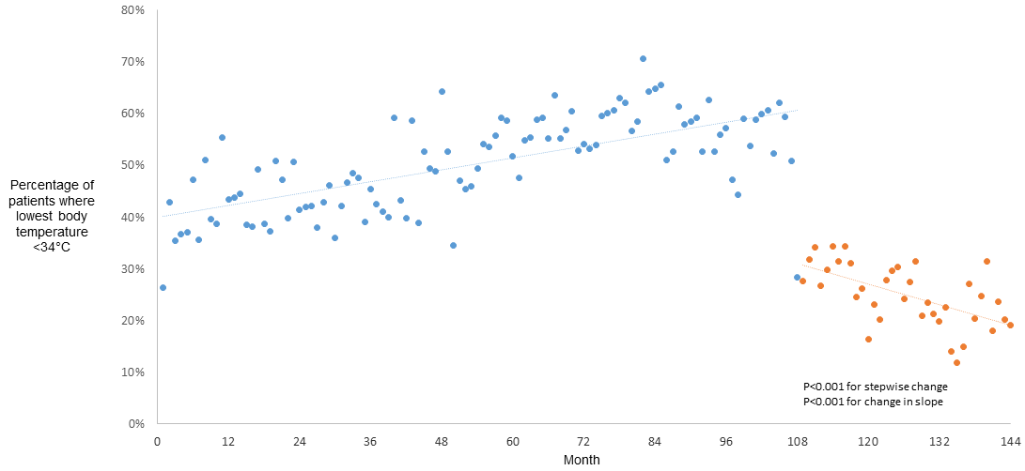
Figure S1. Percentage of patients with a lowest temperature <34°C in the first 24 hours in ICU by month*
* Data points represent the percentage of patients by month where the lowest temperature was <34°C in the first 24 hours in ICU. The shaded area and blue dots include the months from January 2005 until December 2013 inclusive; the unshaded area and orange dots include the months from January 2014 until December 2016 inclusive. The Targeted Temperature Management (TTM) study was published online on the 17th of November 2013 and was published in print on the 5th of December 2013.

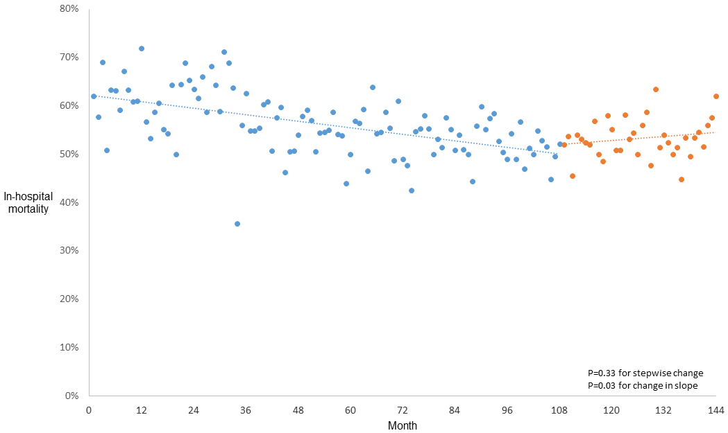
Figure S2. In-hospital mortality by month for the subset of ICUs where the average lowest temperature in the first 24 hours in ICU increased between the pre-TTM period and the post TTM period*
* Data points represent the in-hospital mortality for eligible patients by month limited to the 93 ICUs where average lowest temperature increased between periods. The shaded area and blue dots includes the months from January 2005 until December 2013 inclusive; the unshaded area and orange dots include the months from January 2014 until December 2016 inclusive. The Targeted Temperature Management (TTM) study was published online on the 17th of November 2013 and was published in print on the 5th of December 2013.

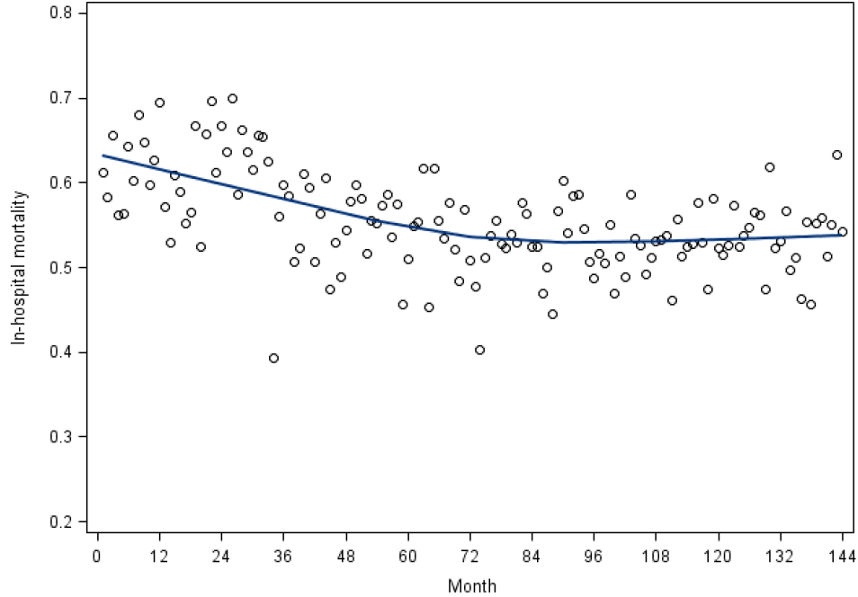
Figure S3. Local weighted regression plot of average hospital mortality per month*
* Data points represent the in-hospital mortality for eligible patients by month. The shaded area includes the months from January 2005 until December 2013 inclusive; the unshaded area includes the months from January 2014 until December 2016 inclusive. The Targeted Temperature Management (TTM) study was published online on the 17th of November 2013 and was published in print on the 5th of December 2013.

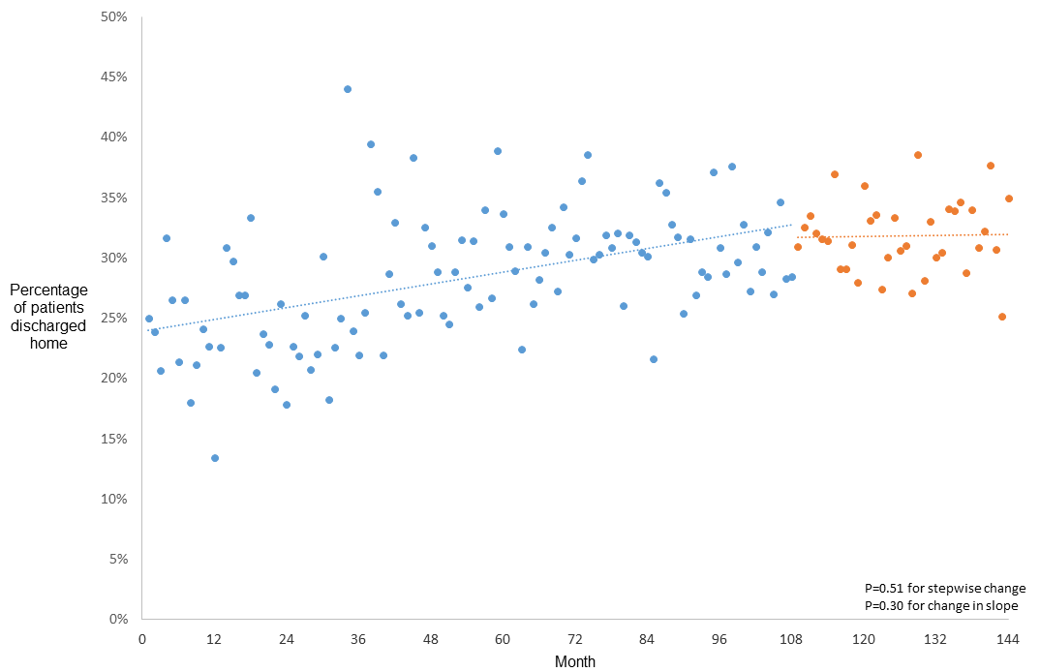
Figure S4. Percentage of patients discharged home by month*
* Data points represent the percentage of patients discharged home by month. The shaded area and blue dots include the months from January 2005 until December 2013 inclusive; the unshaded area and orange dots includes the months from January 2014 until December 2016 inclusive. The Targeted Temperature Management (TTM) study was published online on the 17th of November 2013 and was published in print on the 5th of December 2013.
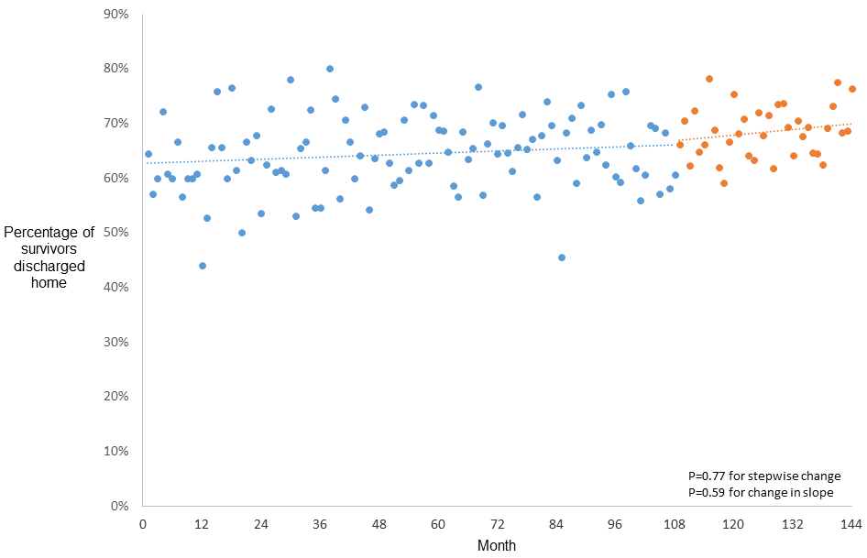
Figure S5. Percentage of survivors discharged home by month*
* Data points represent the percentage of survivors discharged home by month. The shaded area and blue dots include the months from January 2005 until December 2013 inclusive; the unshaded area and orange dots includes the months from January 2014 until December 2016 inclusive. The Targeted Temperature Management (TTM) study was published online on the 17th of November 2013 and was published in print on the 5th of December 2013.
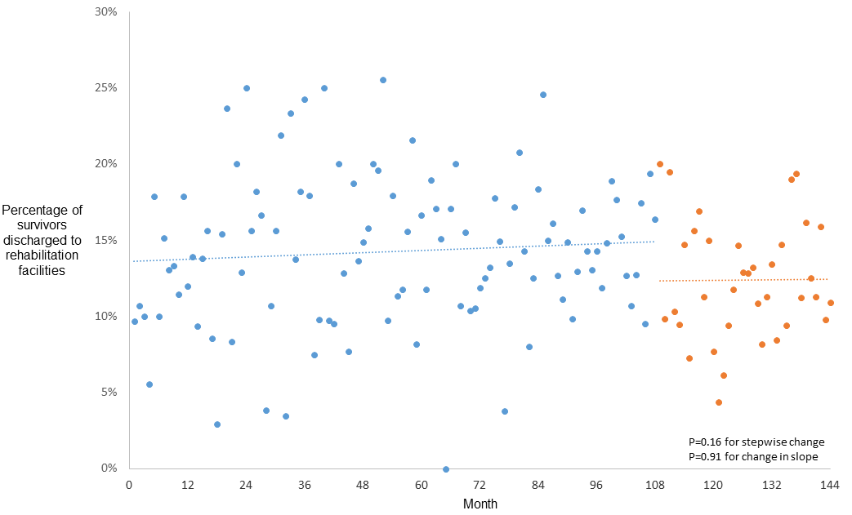
Figure S6. Percentage of survivors discharged to rehabilitation facilities by month*
* Data points represent the percentage of survivors discharged to rehabilitation facilities by month. The shaded area and blue dots include the months from January 2005 until December 2013 inclusive; the unshaded area and orange includes the months from January 2014 until December 2016 inclusive. The Targeted Temperature Management (TTM) study was published online on the 17th of November 2013 and was published in print on the 5th of December 2013.

