Online Supplement
Sepsis Surveillance Using Adult Sepsis Events Simplified eSOFA Criteria versus Sepsis-3 SOFA Criteria

Table of Contents

eMethods – Detailed Description of SOFA Score Implementation (page 2)

eTable 1. International Classification of Diseases, Ninth Revision, Clinical Modification Codes Used to Identify Infectious Syndromes (page 5)

eTable 2. Frequency of Missing Variables for SOFA and eSOFA (page 5)

eTable 3. Comparison of Findings in Primary and Independent Datasets (page 6)

eFigure 1. Overlap of presumed infection, sepsis defined by the SOFA score (Sepsis-3), and sepsis defined by eSOFA (CDC Adult Sepsis Event) (page 7)

eFigure 2. Frequency of SOFA organ dysfunctions in sepsis patients defined by increase in SOFA by ≥2 points (Sepsis-3) (page 8)

eFigure 3. Frequency of eSOFA organ dysfunctions in sepsis patients defined by ≥1 eSOFA criteria (CDC Adult Sepsis Event) (page 8)

eFigure 4. Frequency of eSOFA organ dysfunction criteria in eSOFA+/SOFA- sepsis patients (page 9)

eFigure 5. Frequency of SOFA organ dysfunctions contributing ≥2 points in SOFA+/eSOFA- sepsis patients (page 9)

eFigure 6. Frequency of organ dysfunctions contributing ≥2 SOFA points and ≥1
eSOFA criteria in SOFA+/eSOFA+ sepsis patients (page 10)

eMethods – Detailed Description of SOFA Score Implementation

Overview: For sepsis defined by the SOFA score (i.e., Sepsis-3), we required that at least one day within the +/-2 day window surrounding the blood culture day had a SOFA score ≥2 points higher than the baseline SOFA score. The baseline SOFA score for patients with infection present-on-admission was assumed to be the lowest SOFA score during hospitalization (unless they died within 3 days, in which case it was assumed to be zero), or the lowest score within the prior 7 days for hospital-onset sepsis. This approach differed slightly from that used in the Sepsis-3 analyses (which assumed a baseline score of zero) but we felt it gave a better approximation of a patient’s true baseline organ function. If SOFA components were missing on a given day, we carried over data from adjacent days (see below). For sepsis defined by eSOFA (i.e., CDC Adult Sepsis Event), we required any of the organ dysfunction criteria to be met within the +/-2 day window period around the blood culture day. Missing data for eSOFA were assumed to be normal.

- SOFA Organ Dysfunction Specific Notes

SOFA scores were calculated on a daily basis, using the worst value each day for each individual system. Notes specific to implementing each SOFA organ dysfunction system are detailed below, including the handling of missing data.

- Neurologic SOFA - the lowest Glasgow Coma Scale (GCS) value in a given day was used to calculate the Neurologic SOFA score. That GCS value was carried forward until a new value was present on another day. If there were no other values during the hospitalization, that value was carried forward until the end of the encounter. If the first GCS score occurred several days into a hospitalization, a missing value was assigned to the GCS score (which functions as a score of 0) for each day leading up to that day. For encounters with no GCS scores, a missing value was assigned for each day.

- Cardiovascular SOFA - mean arterial pressures (MAPs) were used if directly recorded in the data. Otherwise, MAPSs were calculated from simultaneous systolic blood pressure (SBP) and diastolic blood pressure (DBP) readings using the formula: MAP = (SBP + 2xDBP)/3

- Respiratory SOFA - ICD-9 or CPT codes for mechanical ventilation were used to identify mechanical ventilation (ICD-9 codes: 96.7, 96.70, 96.71, 96.72; CPT codes 94002, 94003, 94004, 94656, 94657). Calculating PaO2/FiO2 ratios can be challenging since patients may not have both values available simultaneously. The following algorithm was used:
- PaO2 and FiO2 values drawn from a simultaneous blood gas (i.e. same timestamp) were used preferentially, if available. The lowest PaO2/FiO2 value for a given day was used to calculate the SOFA score.
- If no simultaneous PaO2/FiO2 ratios were available, but there were separate PaO2 and FiO2 values on a given day, the lowest PaO2 value and the lowest FiO2 value on that day were used.
- If the above was not available, simultaneous SaO2/FiO2 ratios were used, if available, and the lowest value for a given day was used to calculate the SOFA score. If no simultaneous SaO2/FiO2 ratios were available, but there were separate SaO2 and FiO2 values on a given day, the lowest SaO2 value and the lowest FiO2 value on a given day were used.
- If none of the above criteria were met, the last PaO2/FiO2 ratio (or if simultaneous values unavailable, lowest PaO2 / lowest FIO2 ratio on the same day) obtained during the period of continuous mechanical ventilation was used if the patient was still mechanically ventilated on the day of interest (i.e., “vent episode”, which is the continuous period where a patient is vented each day), using a “look-back period” of up to 5 days. If no PaO2/FiO2 ratio was available, the SaO2/FiO2 ratio was used using the same logic (i.e., first looking for simultaneous values, then if not available, using the lowest SaO2 / lowest FiO2 on a given day). If there was no prior PaO2/FiO2 ratio or SaO2/FiO2 ratio during the vent episode, the closest PaO2/FiO2 ratio (looking forward, up to 5 days) during the same vent episode was used (or SaO2/FiO2 ratio if PaO2/FiO2 unavailable). If no PaO2/FiO2 or SaO2/FiO2 data were available during a vent episode, a missing value was assigned for respiratory SOFA points.

For days where the patient was mechanically ventilated, a FiO2 of 35% was imputed if no FiO2 data was available. For non-ventilated days, a FiO2 of 21% was imputed if no FiO2 data was available. If the patient was not mechanically ventilated and there were no PaO2 (or SaO2) values that day, a missing value was assigned for respiratory SOFA points.

FiO2 values for nonintubated patients receiving supplemental oxygen were estimated assuming each 1 liter/minute of oxygen flow rate increased FiO2 by 4% over room air (1 L = 24% FiO2, 2 L = 28%, 3 L = 32%, etc.)

- Renal / Hepatic / Coagulation SOFA - for creatinine, total bilirubin, and platelets, the worst value per day (highest creatinine, highest bilirubin, lowest platelets) was used to calculate the SOFA score. If there was a missing value on a given day, the closest value within +/-5 days was imputed. If there is tie for which is the closest day (i.e., for day 3, there was a bilirubin on day 1 and a bilirubin on day 5), the worst value was used. If there was no value within +/- 5 days, then a missing value was assigned.

- Handling Missing Scores - for purposes of calculating a daily score, missing scores were counted as zero points for that organ system.

- Calculating “Baseline” SOFA Scores

- Infection Present-On-Admission (blood culture or first antibiotic on hospital day 1 or 2) - the baseline SOFA score was defined as the lowest SOFA score during hospitalization for patients with infection present-on-admission, as we reasoned that most patients that survive a hospitalization have a return in their organ function to close to their healthy state prior to discharge. However, the baseline SOFA score only incorporated the neurologic, renal, hepatic, and coagulation components of the SOFA score; thus, any cardiovascular or respiratory SOFA points were always counted as “new” (since hypotension and hypoxemia typically indicate an acute process, whereas dementia, kidney or hepatic disease, or thrombocytopenia are often chronic). For patients that died or were discharged to hospice within 3 days of hospital admission, however, the baseline SOFA score was considered to be zero (since these patients would not return to their normal “healthy” state of organ function).

- Hospital-Onset Infection (blood culture day and first antibiotic on or after calendar day 3) - the baseline SOFA score was defined as the lowest SOFA score in the 7 days prior to the blood culture day.

eTable 1. International Classification of Diseases, Ninth Revision, Clinical Modification Codes Used to Identify Infectious Syndromes

Infectious Syndrome | ICD-9-CM Codes
Pneumonia | 480.0-480.9, 481, 482.0-482.9, 483.0-483.8, 484.1-484.8, 485, 486
Urinary Tract Infections | 590.00, 590.01, 590.10, 590.11, 590.2, 590.3, 590.80, 590.81, 590.9, 595.0, 595.2, 595.3, 595.4, 595.89, 595.9, 597.0, 597.80, 597.89, 598.00, 598.01, 599.0
Intra-abdominal Infections | 008.45, 009.0–009.3, 540.0–540.9, 541, 542, 543.9, 562.01, 562.03, 562.11, 562.13, 567.0–567.9, 569.5, 569.61, 569.71, 569.83, 572.0–572.8, 574.00–574.91,  575.0–575.9, 576.0–576.9, 614.0–614.9
Skin/Soft Tissue Infections | 680-686, 035, 376.01, 728.86
Septicemia/Bacteremia | 038.0-038.9, 790.7

eTable 2. Frequency of Missing Variables for SOFA and eSOFA

SOFA or eSOFA component | Number of 1st presumed infection episodes missing each component  (Total N=104,903)
Lactate (eSOFA) | 65,405 (62.3%)
PaO2/FiO2 or SaO2/FiO2 (SOFA) | 29,912 (28.5%)
Total Bilirubin(SOFA and eSOFA) | 21,239 (20.2%)
Glasgow Coma Scale (SOFA) | 20,952 (20.0%)
Blood Pressure (SOFA) | 5,557 (5.3%)
Platelet Count (SOFA and eSOFA) | 3,815 (3.6%)
Creatinine (SOFA and eSOFA) | 2,891 (2.8%)

This table indicates the number of presumed infection episodes that were missing at least one reading necessary to compute the SOFA score within the 2-day window surrounding the blood culture day. For hospitalizations with multiple presumed infection episodes, only the first episode was analyzed.

eTable 3. Comparison of Findings in Primary and Independent Datasets

 | Cerner HealthFacts  (Total N=942,360) | Emory Dataset  (Total N= 213,173)
Sepsis Prevalence  SOFA  eSOFA | 57,242 (6.1%)  41,618 (4.4%) | 12,983 (6.1%)  13,843 (6.5%)
Sepsis Mortality  SOFA  eSOFA | 8,221 (14.4%)  7,131 (17.1%) | 1,395 (10.8%)  1,585 (11.5%)
Overlap of Sepsis Patients  Sensitivity of eSOFA vs SOFA  PPV of eSOFA vs SOFA | 59.7%  82.1% | 74.0%  69.4%
AUROC for in-hospital death  SOFA [95% CI]  eSOFA [95% CI]  p-value | 0.759 [0.751-0.764]  0.774 [0.770-0.779]  <0.001 | 0.717 [0.705-0.728]  0.755 [0.745-0.766]  <0.001

eFigure 1. Overlap of presumed infection, sepsis defined by the SOFA score (Sepsis-3), and sepsis defined by eSOFA (CDC Adult Sepsis Event)

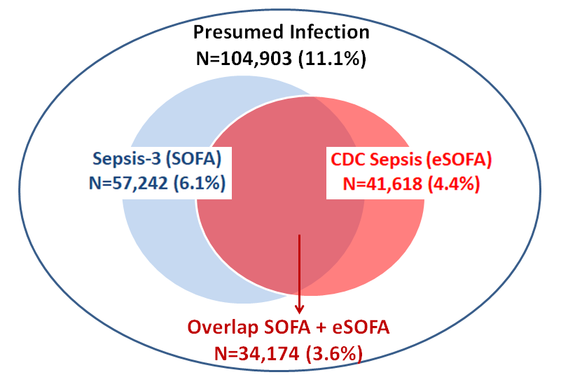

eFigure 2. Frequency of SOFA organ dysfunctions in sepsis patients defined by increase in SOFA by ≥2 points (Sepsis-3)

Each bar represents the percentage of sepsis patients who had ≥2 SOFA points in each organ dysfunction category.

eFigure 3. Frequency of eSOFA organ dysfunctions in sepsis patients defined by ≥1 eSOFA criteria (CDC Adult Sepsis Event)

eFigure 4. Frequency of eSOFA organ dysfunction criteria in eSOFA+/SOFA- sepsis patients

eFigure 5. Frequency of SOFA organ dysfunctions contributing ≥2 points in SOFA+/eSOFA- sepsis patients

eFigure 6. Frequency of organ dysfunctions contributing ≥2 SOFA points and ≥1 eSOFA criteria in SOFA+/eSOFA+ sepsis patients

This figure shows the distribution of dysfunctional organs in patients meeting both CDC Adult Sepsis Event and Sepsis-3 criteria. The blue bars indicate the frequency of ≥2 SOFA points for each organ dysfunction category for sepsis patients, while the blue bar indicates the frequency of ≥1 eSOFA criteria in each category. The far right column (“Neurologic or Lactate”) refers to the Neurologic SOFA criteria or the Lactate ≥2.0 mmol/L eSOFA criteria.
The other corresponding eSOFA criteria are: vasopressor initiation (cardiovascular), mechanical ventilation initiation (respiratory), doubling in creatinine (renal), doubling in bilirubin to ≥2.0 mg/dL (hepatic), and decrease in platelets by ≥50% to <100 cells/µL (coagulation).

