Supplementary Data

Table of Contents
Search strategy 2
Supplementary Table 1 Characteristics of included studies 3
Supplementary Table 2 Risk of Bias Assessment for Randomized Controlled Trials 4
Supplementary Table 3 Risk of Bias Assessment for Cohort Studies 5
Supplementary Table 4 Excluded Studies 6
Supplementary Figures 1-5 Forest Plots of Results 7
Supplementary Figure 6 Funnel Plot: Primary Outcome PTSD 10

Search strategy
Database | PubMed
Date Searched | 7/12/17
Search Terms | ((((ICU OR intensive care OR intensive care unit OR critical care OR critical illness OR sepsis OR shock OR septic shock OR acute respiratory failure OR ARDS OR mechanical ventilation OR artificial ventilation))) AND ((PTSD OR posttraumatic stress OR post traumatic stress disorder OR anxiety OR anxiety disorder OR depression OR psychological OR psychology OR mental health OR quality of life))) AND ((diary OR diaries OR narrative OR narration))
Results Returned | 891

Database | EMBASE
Date Searched | 9/12/17
Search Terms | 'intensive care unit'/exp OR 'intensive care unit' OR 'intensive care'/exp OR 'intensive care' OR 'critical illness'/exp OR 'critical illness' OR 'critically ill patient'/exp OR 'critically ill patient' OR 'sepsis'/exp OR 'sepsis' OR 'adult respiratory distress syndrome'/exp OR 'adult respiratory distress syndrome' OR 'acute respiratory failure'/exp OR 'acute respiratory failure' OR 'artificial ventilation'/exp OR 'artificial ventilation' AND ('posttraumatic stress disorder'/exp OR 'posttraumatic stress disorder' OR 'anxiety disorder'/exp OR 'anxiety disorder' OR 'depression'/exp OR 'depression' OR 'anxiety'/exp OR 'anxiety' OR ‘quality of life’) AND ('diary'/exp OR diary OR narrative)
Results Returned | 457

Database | PsycINFO
Date Searched | 13/12/17
Search Terms | ((((ICU OR intensive care OR intensive care unit OR critical care OR critical illness OR sepsis OR shock OR septic shock OR acute respiratory failure OR ARDS OR mechanical ventilation OR artificial ventilation))) AND ((PTSD OR posttraumatic stress OR post traumatic stress disorder OR anxiety OR anxiety disorder OR depression OR psychological OR psychology OR mental health OR quality of life))) AND ((diary OR diaries OR narrative OR narration))
Results Returned | 717

Database | CENTRAL
Date Searched | 13/12/17
Search Terms | ((((ICU OR intensive care OR intensive care unit OR critical care OR critical illness OR sepsis OR shock OR septic shock OR acute respiratory failure OR ARDS OR mechanical ventilation OR artificial ventilation))) AND ((PTSD OR posttraumatic stress OR post traumatic stress disorder OR anxiety OR anxiety disorder OR depression OR psychological OR psychology OR mental health OR quality of life))) AND ((diary OR diaries OR narrative OR narration))  Limited to Trials
Results Returned | 102

Supplementary Table 1 Characteristics of included studies
Study | Setting | Methodology |  |  |  | Patients |  |  |  |  |  | Outcomes
 |  | Study Design | Inclusion/ exclusion criteria | Recruitment | Details of Intervention | Total number in final analysis | Intervention | Control | ICU diagnosis |  |  | Outcome measured (tool) | Length of follow up | Assessment method
 |  |  |  |  |  |  |  |  | Intervention |  | Control
Knowles 2009 | 1 hospital in UK | Randomized controlled trial | I: Expected ICU stay >48 hrs. E: <18 or >85 yrs, current psychological symptoms, history of dementia or other organic memory problems | All patients had a diary written for them. The experimental group was offered the diary intervention in between the two assessment points, while the control group received the diary after the end of the trial | Diary kept at bedside and written in by staff members. Standardized headings – patient’s appearance and condition, events on the ward, details of treatments or procedures in everyday language, names of visitors. | 36 | 18 | 18 | 50% medical, 50% surgical |  | 56% medical, 44% surgical | Anxiety, depression (HADS) | 1 month | a range of self-report and interview measures
Bäckman 2010 | 8 bed ICU in Sweden | Prospective observational | I: ICU stay >24 h and who were alive 6 months after discharge. E: <17years, repeat admissions | ICU diaries kept for the most severely ill – ICU stay > 3 days or likely to need mechanical ventilation. Diary given at follow up visit 2-8 weeks post discharge, with contents explained | Notebook kept at bedside, started with a summary of admission to ICU, initial events in ICU and current status of patient. Family summarized events before admission. Anyone involved with care of patient including staff and family could contribute. Photographs of patient included. Emphasis on everyday language used. | 262 | 38 | 224 | Resp 37%, gastro 18%, sepsis 5%, other 24%, trauma 16% |  | Resp 17%, gastro 22%, sepsis 6%, other 48%, trauma 7% | Quality of life (SF-36) | 6, 12, 24 and 36 months | Structured questionnaire was mailed to the participants
Jones 2010 | 12 ICUs in 6 European countries | Randomized controlled trial | I: in ICU and ventilated. E: ICU stay <72 hours, ventilated <24 hours, too confused/ unable to consent, prior psychotic illness or PTSD | All patients received an ICU diary. Patients were then randomized to either receive their diary immediately (intervention) or after the final follow-up questionnaires (controls) | The diary was a daily record of the patients’ ICU stay in everyday language, with photographs. Guidelines provided to standardize entries | 322 | 162 | 160 | Resp failure 18%, sepsis 12%, circulatory failure 12%, multi-organ failure 16%, GI 8%, neuro 3%, trauma 16%, other 2% |  | Resp failure 23%, sepsis 20%, circulatory failure 11%, multi-organ failure 11%, GI 5%, neuro 3%, Trauma 15%, other 2% | PTSD (PTSS-14) | 3 months | Patients completed questionnaires
Garrouste-Orgeas 2012 | 10-bed ICU in France | Prospective open study comparing a diary period and the pre- diary and postdiary periods | I: ICU stay >4 days E: death on day 4, family unwilling/ not present, not fluent in French, and dementia in the patient | All patients during the intervention period received a diary, those recruited before and after did not | Standardized entry including purpose of diary, organisation and equipment of ICU. Entries by family and staff, everyday language used | 143 | 49 | pre-diary group 48/ post-diary group 46 | 81.6% medical, 10.2% unscheduled surgery, 8.2% scheduled surgery |  | 72.9/ 76.1% medical, 16.7/ 13% unscheduled surgery, 10.4/ 10.9% scheduled surgery | PTSD (IES-R) anxiety, depression (HADS) | 3 months and 12 months | Follow up data collected over the phone
Jones 2012 | 2 hospitals, one in UK, one in Sweden | Randomized controlled trial | I: in ICU and ventilated. E: ICU <72 hours, ventilated <24 hours, too confused/ unable to consent, prior psychotic illness or PTSD | Next of kin recruited as part of Jones 2010. Relatives encouraged to write in diary | The diary was a daily record of the patients’ ICU stay in everyday language, with photographs. Guidelines provided to standardize entries | 30 | 15 | 15 | Resp failure 27%, sepsis 7%, circulatory failure 13%, multi-organ failure 20%, GI 13%, neuro 13%, trauma 7% |  | Resp failure 33%, sepsis 33%, circulatory failure 0, multi-organ failure 13%, GI 7%, neuro 0, trauma 27% | PTSD (PTSS-14) | 3 months | Questionnaire
Svenningsen 2013 | 3 ICUs in Denmark | Prospective observational design investigating the effect of delirium on QoL | I: ICU stay >48 hours, age >17 years and ability to communicate in Danish. E: severe brain damage restricting communication | Patients consecutively recruited. Diary use recorded | No details provided | 279 | 44 | 235 | Total cohort: 41% medical, 59% surgical. Individual groups not reported |  |  | Quality of Life (SF-36, Barthel Index) | 1 week, 2 months and 6 months | Telephone interview
Glimelius-Petersson 2015 | 9 bed ICU in Sweden | Descriptive/ observational | I: >18, ICU stay >3 days. E: not stated | Diary kept if ICU stay likely to be >or = 3 days | Standardized guidelines - purpose and aim of the diary and a list of the most common medical terms explained. Start with summary of reasons for admission, notes about here and now including daily cares, sleep, visitors | 96 | 52 | 44 | Not reported |  |  | PTSD (PTSS-14) | 2 months | Questionnaires mailed
Fukuda 2015 | 8 bed ICU in Japan | Prospective, observational, time series | I: ≥20 years, ICU stay ≥3 days. E: mental illness, higher brain dysfunction. | Period of standard ICU care (control group), followed by a period of ICU diary plus standard care | Diaries written primarily by bedside nurses according to guidelines, with focus on daily activities. No photos | 40 | 17 | 23 | Cardiovascular 35%, GI 29%, sepsis 12%, others 18%, Neurosurgical 6% | Cardiovascular 48%, GI 17%, sepsis 9%, others 17%, Neurosurgical 9% |  | Anxiety, depression (HADS) | Before hospital discharge | Interview on the ward

Abbreviations: ICU = intensive care unit, PTSD = post-traumatic stress disorder, QoL = quality of life, GI = gastrointestinal, HADS = Hospital Anxiety and Depression Scale, SF-36 = Short Form -36, IES-R = Impact of Events Scale – Revised, PTSS-14 = Post-traumatic stress syndrome 14

Supplementary Table 2 Risk of Bias Assessment for Randomized Controlled Trials
Study | Random Sequence Generation | Allocation Concealment | Blinding of Participants and Personnel | Blinding of Outcome Assessment | Incomplete Outcome Data | Selective Reporting | Other Bias
Knowles 2009 | Unclear | Unclear | High | High | Low | High | Unclear
Jones 2010 | Low | Low | High | Low | Low | Low | Low
Jones 2012 | Low | Low | Unclear | Low | Low | Low | Low

Supplementary Table 3 Risk of Bias Assessment for Cohort Studies
 | Risk of Bias Assessment- Selection |  |  |  | Risk of Bias Assessment- Comparability | Risk of Bias Assessment- Outcome
Authors | Selection- Representativeness of exposed cohort | Selection- of controls | Ascertainment of exposure | Demonstration that outcome of interest was not present at start of study | Comparability of cohorts on the basis of design or analysis | Assessment of outcome | Was follow up long enough for outcomes to occur | Adequacy of follow up of cohorts | Total Number of Stars (Max = 9)
Bäckman 2010 | * | * | * |  | ** |  | * |  | 6
Garrouste-Orgeas 2012 | * | * | * | * | ** | * | * |  | 8
Svenningsen 2013 | * | * | * |  |  | * | * |  | 5
Glimelius Petersson 2015 | * | * | * | * |  | * |  | * | 6
Fukuda 2015 | * | * | * | * |  | * |  | * | 6

Supplementary Table 4 Excluded Studies
Title | Authors | Citation | Reason for Exclusion
Effect of a Family-Maintained Progress Journal on anxiety of families of critically ill patients. | Kloos JA, Daly BJ. | Crit Care Nurs Q. 2008 Apr-Jun;31(2):96-107; quiz 108-9. | ICU stay only 1-2 days
Lost days--diaries for military intensive care patients. | Thomas J, Bell E. | J R Nav Med Serv. 2011;97(1):11-5. | No original data
The effect of narrative writing on maternal stress in neonatal intensive care settings. | Kadivar M, Seyedfatemi N, Akbari N, Haghani H. | J Matern Fetal Neonatal Med. 2015 May;28(8):938-43. | No follow up post ICU
The ICU-Diary study: prospective, multicenter comparative study of the impact of an ICU diary on the wellbeing of patients and families in French ICUs. | Garrouste-Orgeas M, Flahault C, Fasse L, et al. | Trials. 2017 Nov 15;18(1):542. | Ongoing trial
The meaning of follow-up in intensive care: Patients’ perspective. | Storli, Sissel L. | Scand J Caring Sci. 2009 Mar;23(1):45-56 | No control group
The use of patient diaries in an intensive care unit. | Combe D. | Nurs Crit Care. 2005 Jan-Feb;10(1):31-4. | No control group
Use of a personal diary written on the ICU during critical illness. | Bäckman CG, Walther SM. | Intensive Care Med. 2001 Feb;27(2):426-9. | No control group

Forest Plots of Results

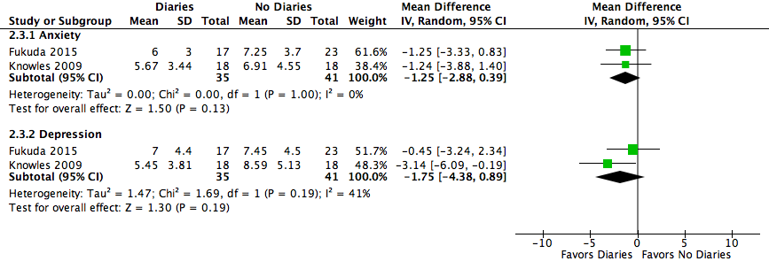
Supplementary Figure 1 Hospital Anxiety and Depression Scores

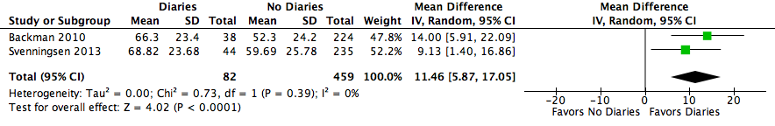
Supplementary Figure 2 Health-Related Quality of Life: SF-36: GH

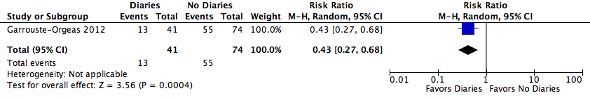
Supplementary Figure 3 PTSD - Families

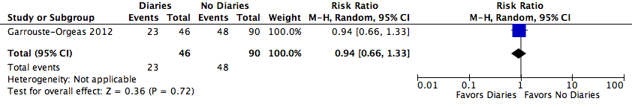
Supplementary Figure 4 Anxiety - Families

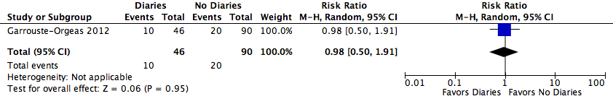
Supplementary Figure 5 Depression - Families

Supplementary Figure 6 Funnel Plot: Primary Outcome PTSD
