SUPPLEMENTAL DIGITAL CONTENT
Renal Klotho is reduced in septic patients and pretreatment with recombinant Klotho attenuates organ injury in LPS-challenged mice
Daniela Jou-Valencia BSc^{1,2}; Grietje Molema PhD²; Eliane Popa PhD²; Adnan Aslan MD^{1,2}; Fransien van Dijk MSc²; Rik Mencke MD³; Jan-Luuk Hillebrands PhD³; Peter Heeringa PhD²; Joost G. Hoenderop PhD⁴; Jan G. Zijlstra MD, PhD¹; Matijs van Meurs MD, PhD^{1,2}; Jill Moser PhD^{1,2}

^{1.} Department of Critical Care, University of Groningen, University Medical Center Groningen, Groningen, The Netherlands.
^{2.} Department of Pathology and Medical Biology, Medical Biology section, University of Groningen, University Medical Center Groningen, Groningen, The Netherlands.
^{3.} Department of Pathology and Medical Biology, Pathology section, University of Groningen, University Medical Center Groningen, Groningen, The Netherlands.
^{4.} Department of Physiology, Radboud University Medical Center, Nijmegen, The Netherlands

Key Words: Sepsis, Acute Kidney Injury, Delirium, Endotoxemia, Klotho, Inflammation, Microvasculature, Endothelial activation

Supplemental digital content 1 – Methods

Gene expression analysis by RT-qPCR
Total RNA was isolated from mouse kidney and brain cryosections using a RNAeasy Mini Plus Kit (Qiagen, Leusden, The Netherlands), according to the manufacturer’s instructions. RNA integrity was analyzed using gel electrophoresis and RNA concentration (OD260) and purity (OD260/280) were measured by Nanodrop ND-1000UV-Vis spectrophotometer (NanoDrop Technologies, Rockland, DE, USA). cDNA was synthesized as previously described (37). RT-qPCR was performed using the ViiA 7 system (Applied Biosystems/ThermoFisher Scientific). Duplicate real-time PCR analyses were executed for each sample, and the obtained threshold cycle (C_{T}) values were averaged. Gene expression was normalized to the expression of housekeeping gene (GAPDH) resulting in the ΔC_{T} value. The relative mRNA level was calculated by 2^{- ΔCT}. Assay on demand primers from Applied Biosystems (Nieuwerkerk aan de IJssel, The Netherlands) included GADPH (Glyceraldehyde-3-phosphate dehydrogenase, assay ID Mm99999915_g1/ Hs99999905_m1), Klotho (assay ID Mm00502002_m1/ Hs00183100_m1), NGAL/LCN2 (Neutrophil gelatinase-associated lipocalin/Lipocalin-2, assay ID Mm01324470_m1/ Hs01008571_m1), KIM-1/ HAVCR1 (Kidney Injury Molecule-1/ Hepatitis A virus cellular receptor-1, assay ID Mm00516023_m1/ Hs03054855_g1), Ddx58/RIG-I (DExD/H-Box Helicase 58, assay ID Mm01216853_m1), E-selectin (assay ID Mm00441248_m1/ Hs00174057), VCAM-1 (vascular cell adhesion molecule-1, assay ID Mm00449197_m1/ Hs00365486_m1), ICAM-1 (intracellular adhesion molecule-1, assay ID Mm00441242_m1/ Hs00164932_m1), IL-6 (Interleukin-6, assay ID Mm00446190_m1), IL-8 (Interleukin-8, assay ID Mm00433859_m1), MCP-1 (Monocyte chemotactic protein-1, assay ID Mm00441242_m1), TNFα (Tumor necrosis factor alpha, assay ID Mm00443258_m1), IL-1β (Interleukin-1β, assay ID Mm00434228_m1).

Immunohistochemistry
Immunochemical staining of Klotho protein was performed on formalin-fixed paraffin-embedded human kidney, and mouse kidney and brain tissue. Tissue sections were deparaffinized, rehydrated, and antigens retrieved by boiling the sections for 15 minutes in 1mM EDTA (pH 8). The endogenous peroxidase activity was blocked by 10 minutes incubation with Peroxidase Block (EnVision + System-HRP, DAKO, Carpentaria, CA, USA). After washing with PBS, the slides were incubated with rat-anti-Klotho (clone KM2076, TransGenic Inc. Kobe, Japan) in 5% BSA solution for 1 hour at room temperature (RT). After washing, the secondary antibody rabbit anti-rat (Vector Laboratories Inc, Burlingame, CA, USA) was added for 45 minutes. Sections were then rinsed and incubated with HRP-labeled anti-rabbit polymer (EnVision + System-HRP-AEC) for 30 minutes. After washing, the peroxidase activity was detected with 3-amino-9-ethylcarbazole (AEC; Envision kit, DAKO) and sections counterstained with Mayer’s hematoxylin (Merck Millipore, Darmstadt, Germany). Sections were mounted with Kaiser’s glycerol gelatin (Merck Millipore).

Immunohistochemical staining of endothelial adhesion molecules and leukocyte infiltration was performed on 5 µm mouse kidney tissue cryosections. Tissue was fixed in acetone for 10 minutes and rehydrated in PBS. Endogenous peroxidase activity was blocked as described above. Non-specific binding was blocked by 1% BSA and 2% FCS in PBS for 30 minutes at RT. Primary antibodies included rat-anti-Ly6G (lymphocyte antigen 6 complex-locus G, BD Biosciences), rat-anti-VCAM-1 (clone M/K-1.9, ATCC, Manassas VA, USA), rat-anti-E-Selectin (clone MES-1, kindly provided by Derek Brown, UCB Celltech, Brussels, Belgium). Antibodies were diluted in 1% BSA with 2%FCS in PBS and incubated for 1 hour at RT. Subsequent steps were performed as described above.

ELISA
NGAL and MPO protein levels were determined in mouse renal tissue lysates by ELISA (NGAL: HK210, R&D Systems, Minneapolis, Minnesota, USA; MPO: HK210, Hycult Biotech). NGAL plasma levels were determined using the same NGAL ELISA kit. Plasma IL-6 levels were determined using the LEGEND MAX™ Mouse IL-6 ELISA Kit (Biolegend, San Diego, CA, USA). All ELISA analyses were performed according to the manufacturers’ instructions.

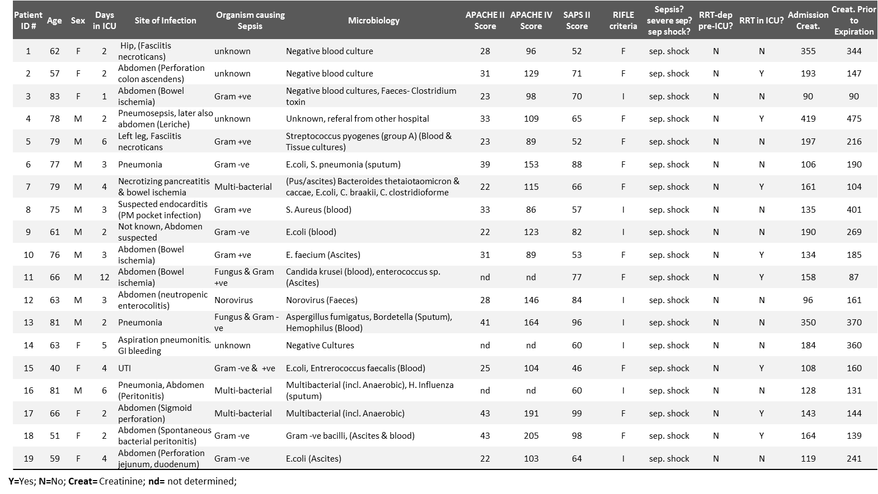

Supplemental Table 1. Septic patients: clinical, laboratory and renal function details

Supplemental Table 2. Control patients: clinical, laboratory and renal function details
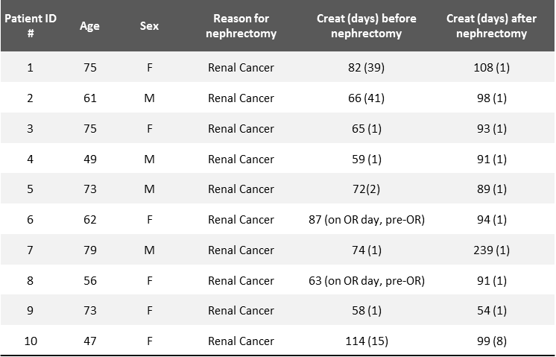

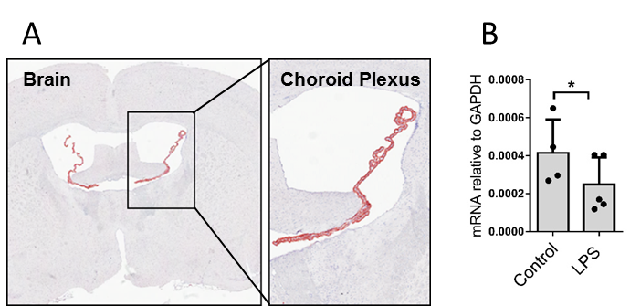

Supplemental Figure 1. Klotho levels are reduced in the brain of endotoxemic mice and are rescued by recombinant Klotho administration prior to LPS challenge. (A) Representative immunohistochemical staining of Klotho (red) in the brain of healthy C57Bl/6 mice. Original magnification 400x. (B) mRNA expression of Klotho in the brain of control and LPS challenged (0.5mg/kg) mice at 8h after LPS administration. Klotho mRNA expression levels were determined by RT-qPCR using GAPDH as the housekeeping gene. Each dot represents an individual mouse. Bars represent the mean ± SD. * p< 0.05.

Supplemental Figure 2. Renal Klotho levels are reduced in critically-ill patients with sepsis. (A) Representative immunohistochemical staining of Klotho (red) in post-mortem kidney biopsy of a sepsis-AKI patient compared to Control tissue, Original magnification 400x. (B) Morphometric quantification of Klotho staining in kidney biopsies from control (n=9) and sepsis-AKI (n=19) subjects. (C) Klotho mRNA expression was determined in the renal biopsies from control individuals (Black dots, R²= 0.3564, p= 0.0684) and in patients who died of sepsis (Red dots, R²= 0.0000017, p= 0.9958).
(D) Sepsis-AKI patients (n=19) were categorized by the extent of renal failure, RIFLE criteria. Graphs represent the total number of positive pixels per μm2. Each dot represents an individual subject and the bars represent the mean ± SD. *, p< 0.05.

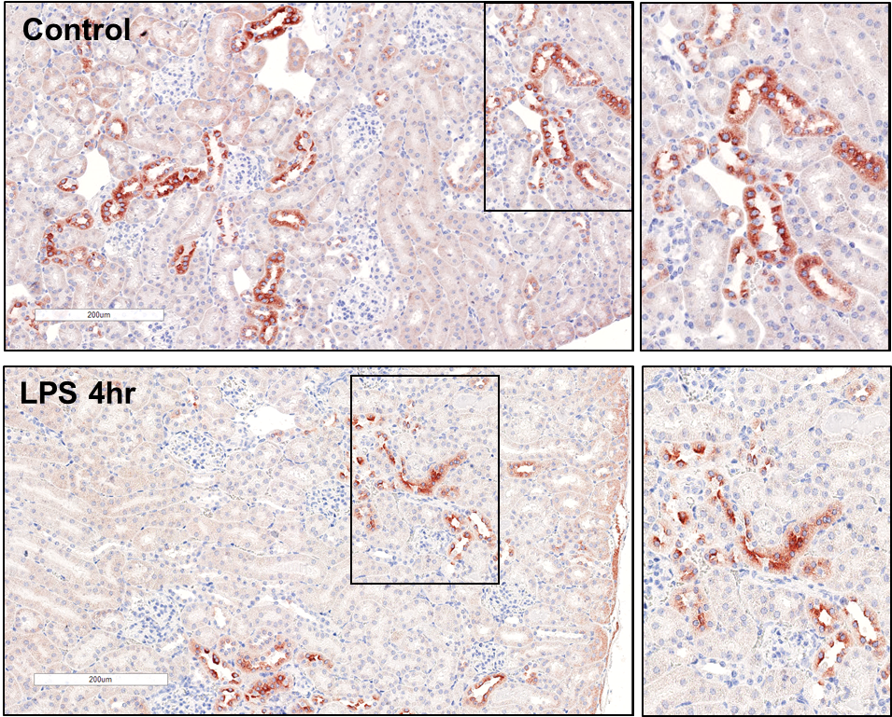

Supplemental Figure 3. Reduced Klotho protein levels at 4hr after LPS administration. Representative immunohistochemical staining of Klotho (red) in the kidney of control mice (vehicle treated) and mice challenged with LPS (1 mg/kg) and sacrificed 4 hr later. Original magnification 400x.

Supplemental Figure 4. Klotho haploinsufficient (Klotho^{+/-}) mice display signs of renal inflammation, damage and endothelial activation. Renal mRNA expression of Klotho, NGAL, KIM-1, RIG-I, E-selectin, VCAM-1 and ICAM-1 in Klotho haploinsufficient mice (Kl^{+/-}) (n=5) or wild type (WT) (n=5) mice as determined by RT-qPCR using GAPDH as a housekeeping gene. Each dot represents an individual mouse. Bars represent the mean ± SD. *p< 0.05, ** p< 0.005.

Supplemental Figure 5. Recombinant Klotho protein administration protects against LPS-mediated kidney damage and inflammation in vivo. Plasma (A) urea nitrogen, (B) NGAL and (C) IL-6 levels were determined in the plasma of control vehicle-treated mice (n=5) or LPS (1mg/kg) challenged mice (LPS; n=8), or LPS (1mg/kg) challenged mice that received recombinant Klotho (0.05mg/kg) 30 minutes prior to LPS injection (rKL + LPS; n=8). (D) Renal NGAL protein levels in control, LPS and rKL + LPS mice were determined by ELISA analysis of renal tissue lysates. All mice were sacrificed 4 hours after LPS or vehicle injection. Each dot represents an individual mouse. Bars represent the mean ± SD. * p< 0.05, ** p< 0.005, *** p< 0.001.

Supplemental Figure 6. Recombinant Klotho protein administration attenuates LPS-mediated endothelial activation and neutrophil infiltration into the kidney. (A) Representative immunohistochemical staining of E-selectin and VCAM-1 protein (red) in the kidney of control vehicle-treated mice or LPS (1mg/kg) challenged mice (LPS; n=8), or LPS (1mg/kg) challenged mice that received recombinant Klotho (0.05mg/kg) 30 minutes prior to LPS injection (rKL + LPS; n=8). Original magnification 400x. (B) Morphometric analyses of E-selectin and VCAM-1 staining in the kidney of control, LPS, and rKL + LPS mice. Graphs represents the total number of positive red pixels per μm2. (C) Representative immunohistochemical staining of neutrophil marker Ly6G (red) in the kidney of control, LPS, and rKL + LPS mice. Original magnification 400x. (D) Mean neutrophils per glomerulus was determined by quantifying positive cells in glomeruli (see Materials and Methods for details) (E) Renal Myeloperoxidase (MPO) protein levels in control, LPS and rKL + LPS mice were determined by ELISA analysis of renal tissue lysates. Each dot represents an individual mouse. Bars represent the mean ± SD. ** p< 0.005, *** p< 0.001.

