A pilot study identifying brain-targeting adaptive immunity in pediatric Extracorporeal Membrane Oxygenation (ECMO) patients with acquired brain injury

Sterling B. Ortega, Ph.D.*,¹ Poornima Pandiyan, M.D.*,² Jana Windsor, M.Sc., ¹ Vanessa O. Torres, B.S.,¹ Uma M. Selvaraj, M.Tech.,¹ Amy Lee, M.D.,² Michael Morriss, M.D.,² Fenghua Tian, Ph.D.,³ Lakshmi Raman, M.D.*,² and Ann M. Stowe, Ph.D.*,^{1,4}

¹Departments of Neurology and Neurotherapeutics, and ²Department of Pediatrics, UT Southwestern Medical Center, 6000 Harry Hines Blvd., Dallas TX 75390-9072, USA; ³Department of Bioengineering, UT Arlington, 500 UTA Blvd, Arlington, TX 76019, USA;⁴Department of Neurology, University of Kentucky, 741 S. Limestone St., Lexington, KY, 40536.*contributed equally

Supplemental Digital Content

Corresponding author:
Ann Marie Stowe, PhD
Ann.Stowe@uky.edu
Department of Neurology
University of Kentucky College of Medicine
741 S. Limestone St., BBSRB 363
Lexington, KY, 40536
Phone: 001-314-623-4648

SUPPLEMENTAL METHODS

Peripheral blood mononuclear cells (PBMC): Venous blood samples were collected from the ECMO circuit at day 1 (10-23 hours), day 3, day 7, weekly thereafter and prior to coming off ECMO. For controls, blood samples were collected from indwelling venous or arterial lines. Samples were anticoagulated in Acid-Citrate-Dextrose (ACD) vacutainer tubes (BD biosciences). Peripheral blood mononuclear cells (PBMC) were obtained by Ficoll separation and an aliquot used to perform the ex vivo leukocyte survey panel (see Supplemental Methods, Online Resource #1). Remaining cells were cryogenically frozen until autoreactivity proliferation assay could be performed. PBMC cellularity was quantified by hemocytometer counts and viability assessed by trypan blue exclusion, >99% viability. Remaining cells were cryogenically stored by placing 20x10⁶ cells/mL in 40% human serum-containing media (40% Human serum, 0.43% 1M Hepex Buffer, 0.7% L-Glutamine, 10% DMSO) and placed in a 10K Cryostorage System, (Cryoscience), until downstream assays could be performed.

CFSE Proliferation Assay: As previously described [1], cells were incubated with carboxyfluoresceine succinimidyl ester (CFSE) at a 0.18uM concentration for 6 days with no antigen (stimulation control), myelin oligodendrocyte protein (MOG), myelin basic protein (MBP), human proteolipid protein (PLP), (synthesized by UT Southwestern Protein Chemistry Core), human peptide pools of NMDA receptor subunit (GluN2A) mix or microtubule associated protein (MAP-2) mix (Biosynthesis; Supplemental Table 3). Cells were labeled with fluorescent stained antibodies-CD3-v450, CD4-PerCp, CD19-PE-Cy7, CD25-APC47, CD8-APC. Flow cytometric data was obtained by use of LSR Fortessa (BD Biosciences) and data were analyzed using Flow Jo software (Tree Star). Antigen-specific responses were considered positive when the delta proliferation factor (ΔPF, test condition-non-stimulated condition) exceeded 1% and the stimulation index (SI, test condition/non-stimulation condition) was greater than X2 [1].

Leukocyte survey assay: PMBCs were washed with FACS buffer (PBS with 1% bovine serum albumin and 0.1% Na-Azide) and nonspecific antibody binding was blocked with FcR blocking reagent (Miltenyi Biotec, Germany). Fluorescent flow cytometry antibodies –CD3-FITC, CD4-PerCp5.5, CD19-PE-Cy7, CD45-APC-Cy7, CD161-PE, CD11c-APC, CD66b-BV421, CD14-Alexa 700, CD11b-PECF594, CD8-BV510 were used to survey the leukocyte subpopulations according to gating strategy (Supplemental Figure 1). Cells were incubated with antibodies for 30 minutes at 4° C, followed by FACS buffer wash and fixed with 1%Parafolmadehyde (PFA). All flow cytometry was performed on a FACS LSR Fortessa Special Order (BD biosciences, San Jose, CA) using FACS Diva 8.0 at Children’s Medical Center Research Institute at UT Southwestern and data analyzed using FlowJo (V9.0) software. Absolute counts were extrapolated by use of hemocytometer counts and percentages of specific leukocyte population [2].

ELISA-based cytokine analysis: Collected blood was centrifuged at 1600rpm at 27°C for 10 minutes to separate plasma which was aliquoted and stored at -80°C until analysis. The plasma was thawed for analysis and diluted plasma specimens were prepared for analysis in a 96-well plate using the Bio-Plex Human Cytokine 10-Plex assay (Bio-Rad Laboratories, Hercules, CA, USA) according to the manufacturers’ instructions. The 10-plex assay contains beads conjugated with monoclonal antibodies to granulocyte colony stimulating factor (GM-CSF), interferon (IFN)-γ, IL-1β, IL-2, IL-4, IL-5, IL-6, IL-8, IL-10, tumor necrosis factor-alpha (TNF-α). Analyses were quantified using a Magpix analytical instrument which utilizes xMAP technology (Luminex Corp., Austin, TX, USA) and xPONENT 4.2 software (Luminex Corp.). Concentrations of cytokines (pg/ml) were determined based on the fit of a standard curve for mean fluorescence intensity versus pg/ml. The multiplex cytokine assays were performed by the microarray and genomics core at University of Texas, Southwestern, Dallas [3].

Plasma modulation and intracellular cytokine analysis: Samples were processed as previously described [4]. Blood samples collected in ACD blood tubes were centrifuged and plasma collected and stored at -80. Samples were then thawed out and used to make plasma-containing media (RPMI 1640 supplemented with penicillin, streptomycin, L-glutamine and 20% patient plasma). Target cells were isolated from healthy individuals, Ficoll separated and cryogenically stored. Upon experimental setup, cells were washed twice with H5 media, counted and aliquoted out at a concentration of 1x10⁶/ml. Cells were resuspended with plasma-containing media and cultured for seven days at 37C and 5% CO2. Next, cells were stimulated and protein production retained with Cell Stimulation Cocktail (Tonbo) for 6 hours. Cells were then washed twice with PBS and using BD Fixation/Permeabilization kit (as per manufacturer’s instructions), cells were washed, surfaced stained with CD19, CD4 and CD3 flow antibodies, permeabilized and fixed. Flow cytometric data was obtained by use of LSR Fortessa (BD biosciences, San Jose, CA) and data was analyzed using Flow Jo software [4].

Autoregulation and neuroimaging scores: Cerebral tissue oxygenation (surrogate for cerebral blood flow) was measure on the forehead using a cerebral oximeter (INVOS 5100-5100, Somanetics). Autoregulation index was calculated using the surrogate cerebral tissue oxygen saturation measured using near infrared spectroscopy monitor and bedside mean arterial pressures with prior established methods [5]. The degree of disrupted autoregulation can be quantified using wavelet transform coherence (WTC), which is an unbiased assessment of coherence between the spontaneous fluctuations of systemic mean arterial pressure (MAP) and cerebral tissue oxygen saturation (SctO2), as determined by NIRS [5, 6].
In our patient population, 13 of our patients were simultaneously enrolled in an observational study to monitor continuous changes in cerebral autoregulation over the course of ECMO (Table 1). This includes 6 ECMO patients without brain injury, and 7 with acquired brain injury. Taking the value for disrupted cerebral autoregulation per patient, based on WTC analysis for the entire duration of monitoring while on ECMO [44-46], we used linear regression analysis to determine correlations between disturbed cerebral autoregulation and circulating adaptive immune cells for either percent representation or total cellularity (Table 4; Supplemental Figs. 2-4; correlation data not graphed). Neuroimaging score was evaluated for the patients with CT or MRI brain images obtained as part of post-ECMO protocol or for clinical indications using a 1.5 or 3 T MRI (Achieva and Intera, Philips Healthcare, Best, the Netherlands). The scores were evaluated by a neuro-radiologist who was blinded to the patients’ clinical status using prior established methods [7].

Supplemental Figures
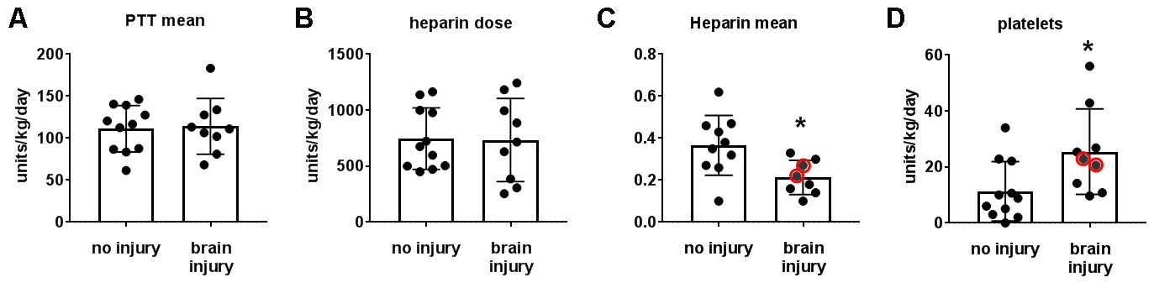

Supplemental Fig. 1 Anti-coagulation goals for ECMO patients
Data for patient treatment show no significant difference in the (A) PTT levels between patients with and without brain injury, nor (B) any difference in the amount of heparin infusion in units/kg/day between patients with and without brain injury. Patients with brain injury did exhibit (C) lower anti xa levels and (D) received more platelets compared to patients without brain injury. Please note that the two patients that presented with hemorrhagic and not ischemic stroke are identified by red circles in the group and fall close to the group mean. *p<0.05 compared to ECMO patients without brain injury, as determined by non-parametric Mann Whitney.

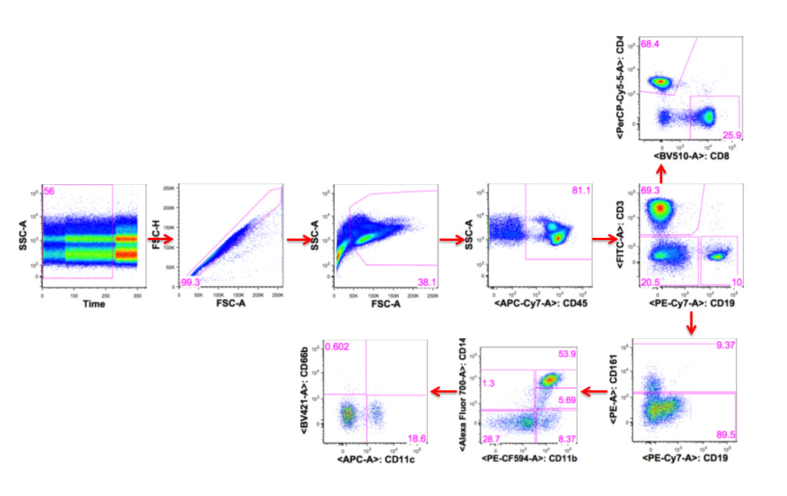
Supplemental Fig. 2 Gating strategy for PBMC enumeration by flow cytometry
Gating strategy shows side scatter (SSC) vs. time for leukocyte populations (far left panel), and subsequent gating following the arrows to the right by forward scatter (FSC). CD45⁺ leukocytes are then gated for CD19⁺ B cells and CD3⁺ T cells. CD3⁺ T cells are further subdivided into cytotoxic T cells (CD8⁺), helper T cells (CD4⁺; top panel), and natural killer (NK) T cells (CD3⁺NK1.1⁺). Innate populations (CD3⁻CD19⁻) are gating into monocytes (CD14⁺CD11b⁺), macrophages (CD14^{hi} CD11b⁺), granulocytes (CD66b⁺), dendritic cells (CD14⁻CD11c⁺) and natural killer cells (CD161⁺).

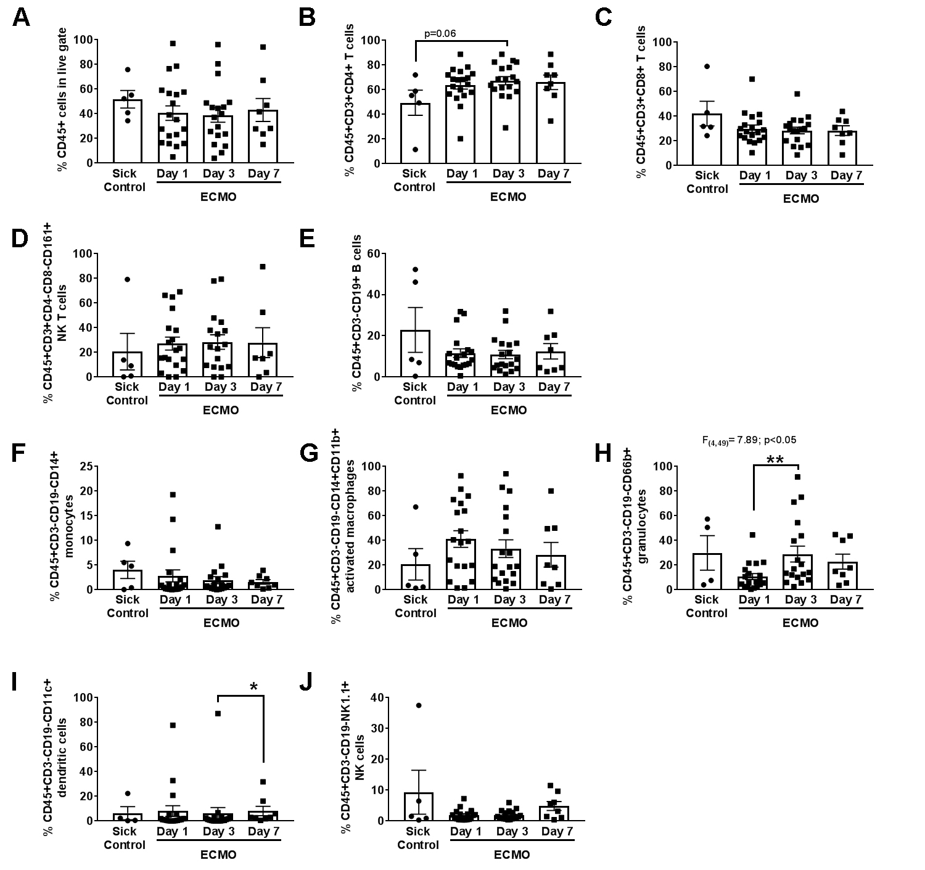

Supplemental Figure 3. ECMO patients exhibit elevated helper T cells when analyzed as a group. Panels show the percent representation for adaptive and innate immune cell subsets, with parent gate located on y axis. Graphs show grouped data for all ECMO patients (n=20; squares) compared to PELOD-matched sick patients (n=5; circles). Non-parametric Kruskal-Wallis ANOVA vs. sick controls analyzed (A) general leukocytes, (B) helper T cells, (C) cytotoxic T cells, (D) NK T cells, (E) B cells, (F) monocytes, (G) activated macrophages, (H) granulocytes, (I) dendritic cells, and (J) NK cell populations. All adaptive populations were predominantly unaffected by ECMO for grouped data, with only increases in (H) granulocytes at day 3 on ECMO vs. day 1 of ECMO, but not versus sick controls. *p<0.05, **p<0.01between groups as indicated by brackets.

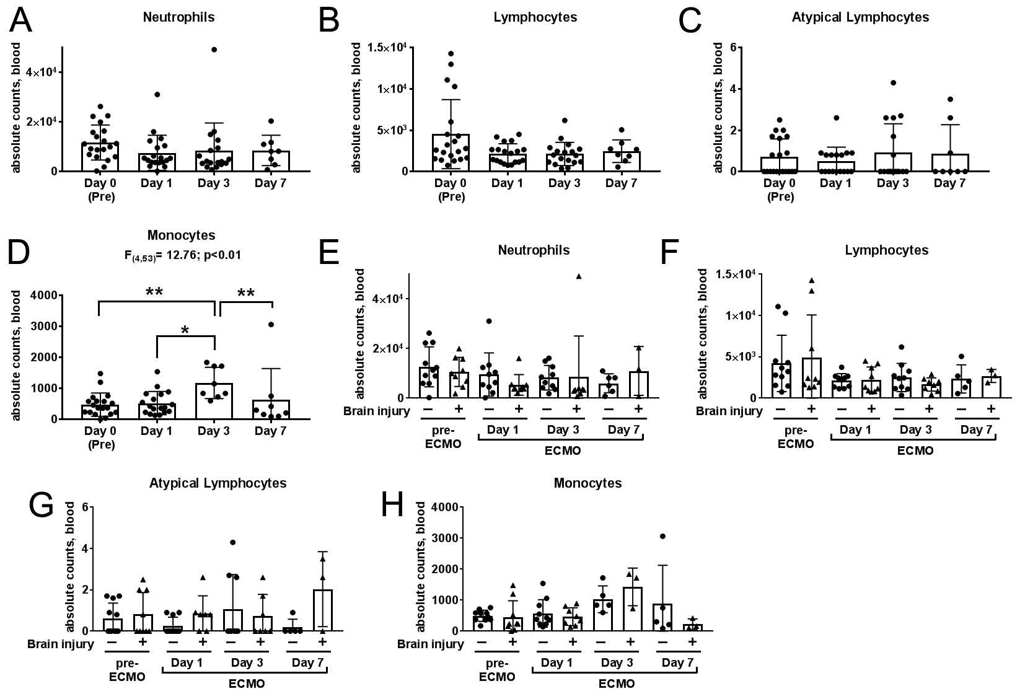

Supplemental Figure 4. Monocyte counts are elevated on Day 3 of ECMO. Panels show the differential counts analyzed by Kruskal-Wallis one-way ANOVA between days for (A) neutrophils, (B) lymphocytes, (C) atypical lymphocytes and (D) monocytes. Only monocytes were elevated on day 3 of ECMO.(E-H) ECMO differential count data parsed into uninjured (n=11, “-“, circles) and acquired brain injury (n=9, “+”, triangles) patients across days and analyzed by two-way ANOVA with Fisher’s LSD showed no effect of brain injury on circulating general leukocyte populations.*p<0.05, **p<0.01between groups as indicated by brackets.

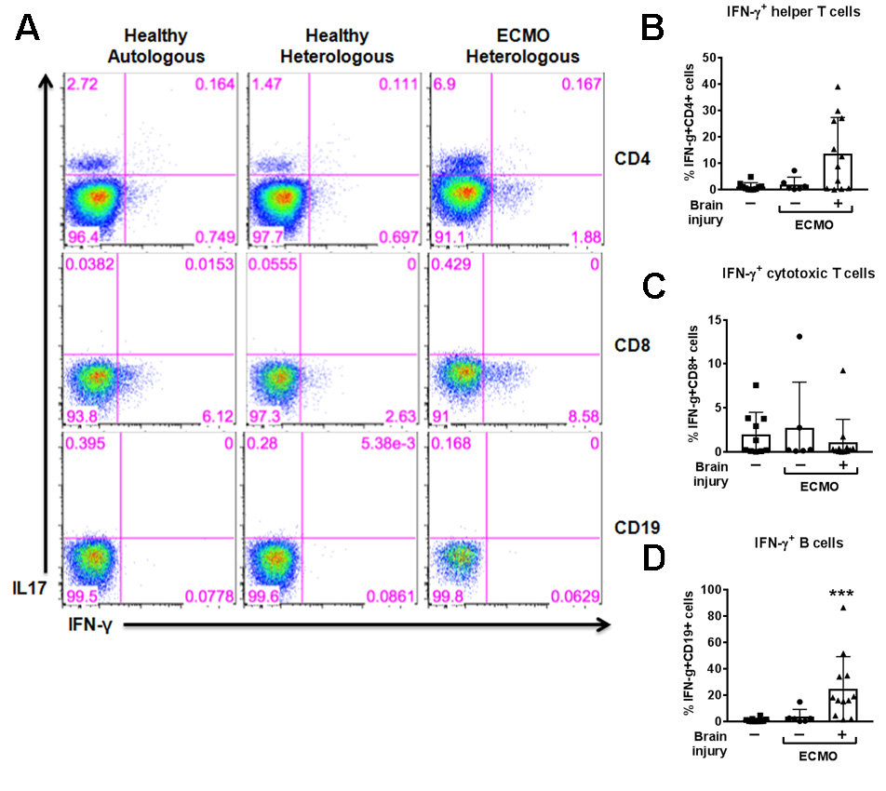
Supplemental Fig. 5 Plasma from ECMO patients with brain injury promotes a pro-inflammatory adaptive cell phenotype
(A) Representative flow cytometry plots show IL-17 (y axis) and IFN-γ (x axis) production from healthy (top row) CD4⁺ helper T cells, (middle row) CD8⁺ cytotoxic T cells, and (bottom row) CD19⁺ B cells after exposure to healthy plasma-containing media (left columns), or ECMO patient-derived plasma-containing media (without brain injury, middle columns; with brain injury, right columns). Numbers show percent from parent gate. (B-D) Black bar graphs show non-parametric Kruskal-Wallis ANOVA results for triplicate experiments of IFN-γ⁺ lymphocytes (as indicated) co-cultured with healthy plasma (squares), ECMO non-brain injury plasma (circles) and ECMO patients with brain injury plasma (triangles). Values are mean ± SD and significance between groups on an individual day is shown as ***p<0.001 vs. healthy plasma.

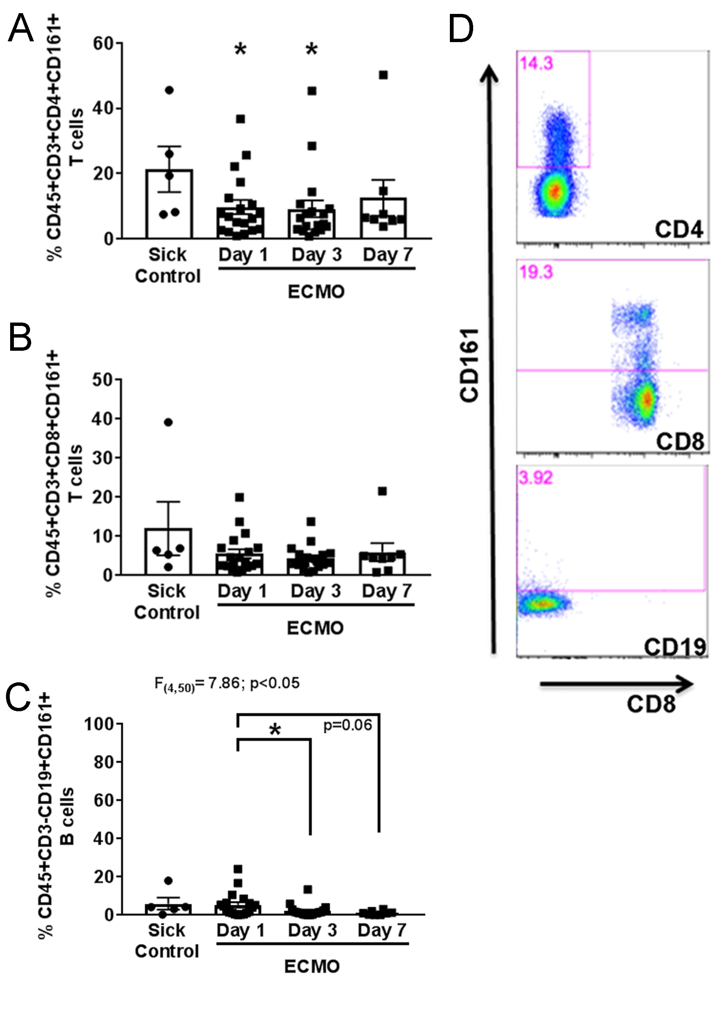

Supplemental Fig. 6 ECMO patients exhibit decreased CD161⁺ helper T cell populations
Panels show the percent representation for activated immune cell subsets as identified in title, with parent gate located on y axis. Graphs show grouped data for all ECMO patients (n=20, black squares) compared to PELOD-matched sick patients (n=5, black circles). Non-parametric Kruskal-Wallis ANOVA vs. sick controls identified decreases in (A) activated helper T cells at days 1 and 3 on ECMO, but not (B) cytotoxic T cells. (C) While not elevated above sick controls, CD161+ B cells decreased on days 3 and 7 of ECMO vs. day 1. (D) Representative flow cytometry data showing corresponding CD161⁺ populations.*p<0.05 vs sick control unless otherwise indicated by brackets..

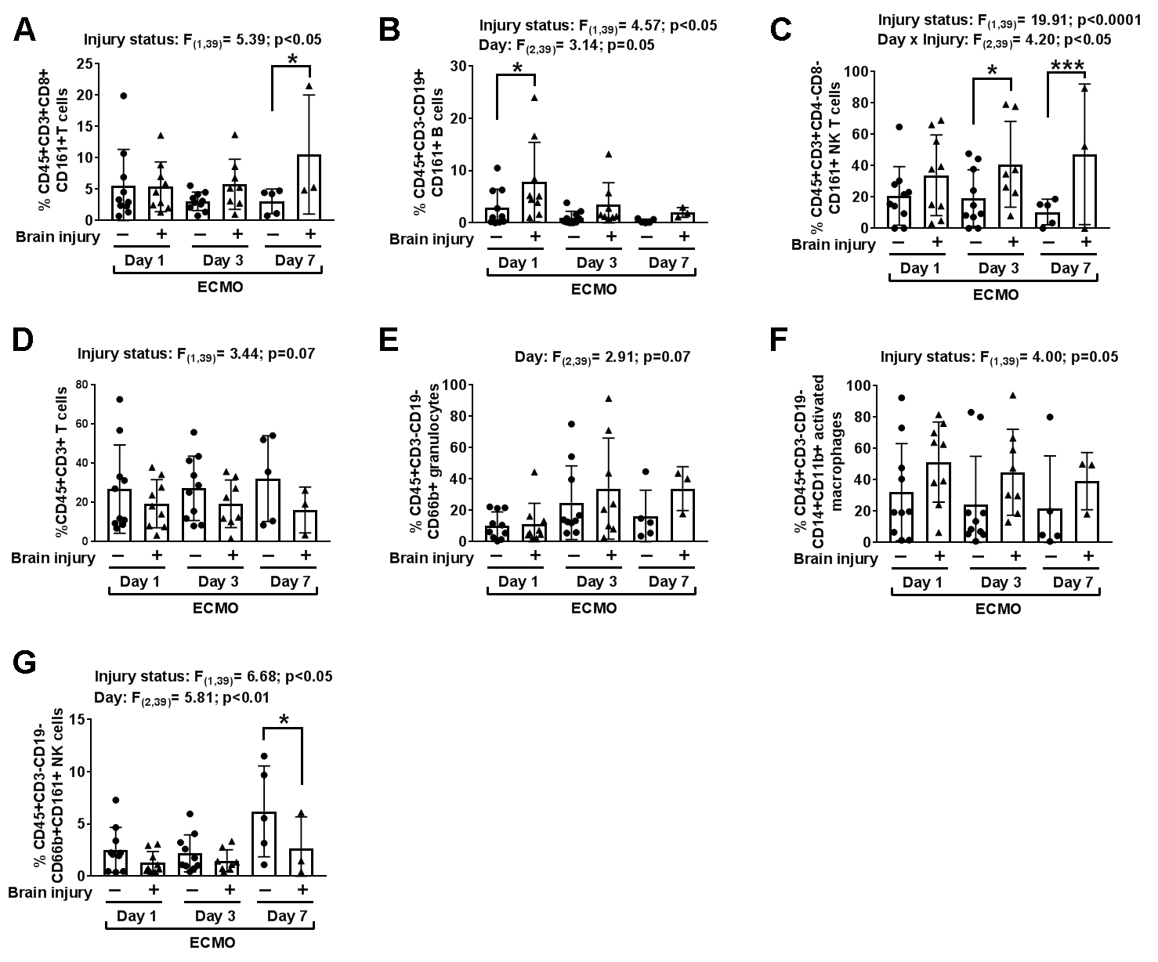

Supplemental Fig. 7 ECMO patients with brain injury exhibit elevated levels of activated adaptive and innate cell subsets
Panels show the percent representation for adaptive immune cell subsets as identified with parent gate on the y axis. Graphs in each cell type show the ECMO data parsed into uninjured (n=11, “-“, circles) and acquired brain injury (n=9, “+”, triangles) patients across days. Two-way ANOVA with Fisher’s LSD showed (A) activated cytotoxic T cells, (B) activated B cells, (C) activated NK T cells, (D) general T cell populations, (E) neutrophils, (F) activated macrophages, and (G) activated NK cells. Significant ANOVA values are shown above the respective graphs. Values are mean ± SD and significance between groups on an individual day is shown as *p<0.05, ***p<0.001, as denoted by brackets.
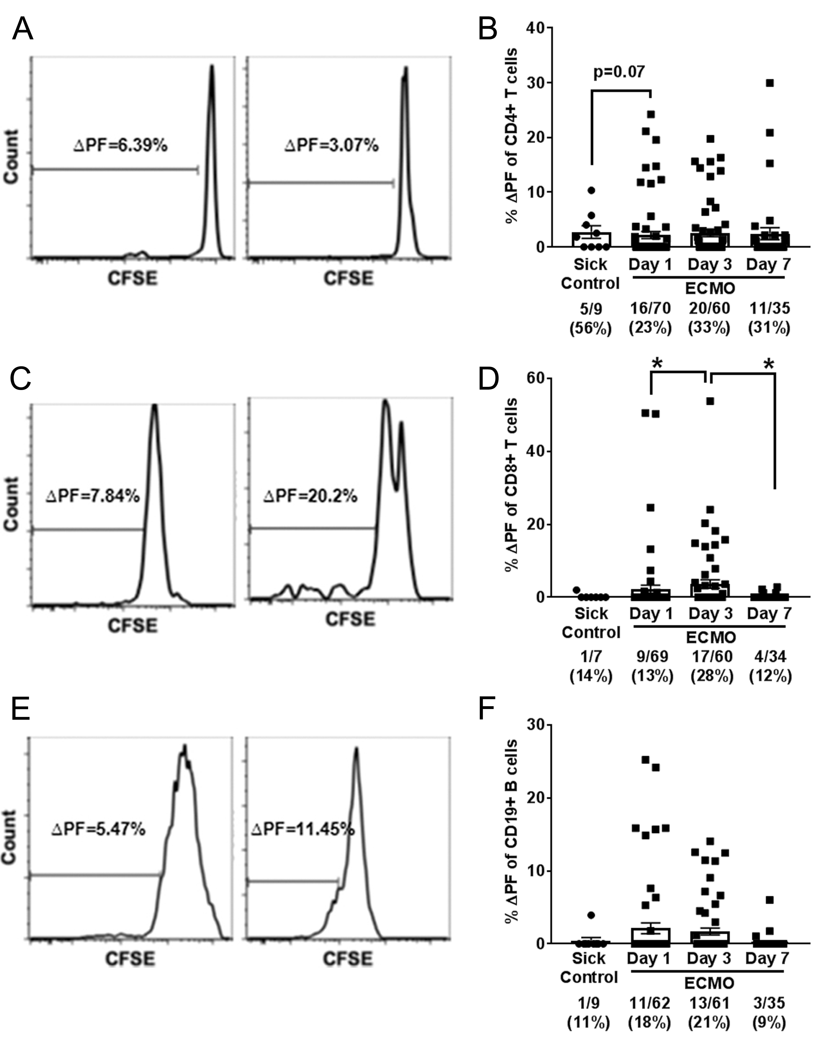

Supplemental Fig. 8 ECMO support coincides with T-cell autoreactivity to CNS antigens
(A, C, E) Representative histograms of CFSE-based autoreactivity assays with y axis showing delta proliferation fraction (%Δ PF, stimulated minus non-stimulated condition) and the x axis indicates intensity of CFSE responses to neuronal and myelin antigens for (A) CD4+ helper T cells, (C) CD8+ cytotoxic T cells, and (E) CD19+ B cells. (B, D, F) Dot plot graphs show cumulative data for all patients, with total responses for all wells used in the assay (#/#) and corresponding % indicated below graph. Non-parametric Kruskal-Wallis ANOVA with uncorrected Dunn’s identified a (B) trend for increased helper T cell CNS-directed autoreactivity in grouped data for ECMO patients (n=15, black squares) compared to PELOD-matched sick patients (n=4, black circles). (D) Cytotoxic T cell autoreactivity peaked on day 3 vs. days 1 and 7 (p<0.05). P values between groups identified by brackets, and *= p<0.05.

Supplemental Tables

Supplemental Table 1. Patient demographics for the ECMO cohort
ECMO Patient | Age/Sex | ECMO type | Diagnosis | Duration in days | Survival | Neurological injury | Autoregulation data
1 | 2y/F | VA | Septic Shock | 5 | Yes | N/A | Yes (2.26)
2* | 3mo/F | VA | Septic Shock | 7 | Yes | N/A | No
3 | 1mo/M | VV to VA | Respiratory Failure | 14 | Yes | Subdural hemorrhage (4) | Yes (1.08)
4 | 6y/F | VA | Cardiogenic Shock | 4 | Yes | N/A | No
5* | 2d/M | VA | PPHN | 2 | Yes | Restricted diffusion, right occipital lobe (10) | No
6* | 6y/M | VA | Septic Shock | 6 | Yes | Bilateral cerebral infarctions (17) | Yes (14.43)
7 | 1d/F | VA | Congenital Diaphragmatic Hernia | 2 | No | N/A | No
8 | 1d/F | VA | Meconium Aspiration | 4 | Yes | Left cerebral infarcts (9) | Yes (0.59)
9* | 3mo/F | VA | Septic Shock | 2 | No | Bilateral cerebral infarcts (9) | Yes (8.35)
10 | 2d/F | VV | PPHN | 3 | Yes | Small focus hemorrhage left centrum semiovale (1) | Yes (1.21)
11* | 3y/M | VA | Shock | 4 | Yes | N/A | Yes (0.86)
12* | 8mo/F | VA | Respiratory Failure | 6 | Yes | White matter paucity secondary to prematurity | Yes (1.94)
13* | 13y/M | VV | Respiratory Failure | 3 | Yes | No injury | Yes (2.93)
14* | 1d/F | VA | PPHN | 6 | Yes | Left cerebral hemisphere and basal ganglia infarction (10) | Yes (1.41)
15* | 1mo/M | VA | Shock/ Respiratory Failure | 15 | Yes | Known infarcts pre-ECMO (18) | Yes (1.76)
16* | 9mo/F | VA | Cardiac arrest/ Shock | 1 | No | Right cerebral infarct with midline shift (9) | No
17* | 7mo/F | VA | Myocarditis/ Cardiogenic Shock | 4 | Yes | N/A | No
18* | 19mo/F | VV | Respiratory Failure | 10 | Yes | White matter paucity secondary to prematurity (2) | No
19 | 14y/F | VV | Respiratory Failure | 12 | Yes | N/A | Yes (1.50)
20* | 13mo/M | VV | Respiratory Failure | 22 | Yes | White matter paucity secondary to prematurity (2) | Yes (8.10)
* = indicates glucocorticoid treatment, VV=veno-venous, VA=veno-arterial, y=years, mo=months, d=days, PPHN=persistent pulmonary hypertension, ARDS =acute respiratory distress syndrome. N/A=not available as images not obtained; (Numbers) denote brain injury; Italicized brain injury was not included in acquired injury cohort

Supplemental Table 2. Disease control patient characteristics
Control patient | Age/Sex | Diagnosis | Survival
1 | 7y/M | Respiratory failure | Yes
2* | 10y/F | Septic Shock | Yes
3 | 2y/F | Respiratory Failure/ ARDS | Yes
4 | 16y/M | Septic shock | Yes
5 | 14y/F | Septic shock | Yes
* = indicates glucocorticoid treatment, y=years, ARDS =acute respiratory distress syndrome

Supplemental Table 3. Myelin and neuronal peptide sequences
Name | Peptide ID | Sequence
Myelin Oligodendrocyte Glycoproteindrocyte Glycoprotein | MOG35-55 | MEVGWYRSPFSRVVHLYRNGK
Myelin Basic Protein | MBP (Ac1-11) | ASQKRPSQRSK
Proteolipid Lipoprotein | PLP178-191 | NTWTTCQSIAFPSK
Microtubule Associated Protein-2 | MAP2 Mix | QVQIVTKKIDLSHVT, LKNIRHRPGGGRVKI, GSLDNAHHVPGGGNV, GGGNVKIDSQKLNFR, PRRLSNVSSSGSINL
N-Methyl-D-Aspartic Acid (NMDA) Receptor | Glun2A Mix | VFGDDTDQEAVAQML, PILGIHGGASMIMAD, MADKDPTSTFFQFGA, RSLGLTGYDFFWIVP

Supplemental Table 4. Correlation of adaptive immune responses to disruption of cerebral autoregulation while on ECMO
(significance designated by *, bolded, and in red)
 | All ECMO patients
 | % (R²)
Leukocyte population | D1 | D3 | D7
General leukocytes | 0.36* | 0.28 | 0.56
T cells | (-) 0.14 | (-) 0.04 | (-) 0.06
B cells | (-) 0.004 | 0.001 | (-) 0.18
Activated B cells | (-) 0.06 | (-) 0.50** | (-) 0.02
Helper T cells | (-) 0.44* | (-) 0.24 | (-) 0.51
Activated helper T cells | 0.42* | 0.33* | 0.68*
Cytotoxic T cells | 0.50* | 0.25 | 0.37
Activated cytotoxic T cells | 0.006 | 0.20 | 0.72*
Natural Killer T cells | 0.44* | 0.17 | 0.48
Monocytes | (-) 0.07 | (-) 0.06 | 0.001
Activated macrophages | 0.10 | 0.13 | 0.001
Dendritic cells | (-) 0.02 | (-) 0.03 | (-) 0.16
NK cells | (-) 0.08 | (-) 0.08 | (-) 0.15
Granulocytes | (-) 0.15 | (-) 0.03 | (-) 0.004
Patient number | (n=12) | (n=13) | (n=6)
R2= R square goodness of fit, linear regression; D, day; %, percent immune population; (-) negative slope in correlation; *p<0.05; **p<0.01

Supplemental References

1. Ortega SB, Noorbhai I, Poinsatte K, Kong X, Anderson A, Monson NL, Stowe AM: Stroke induces a rapid adaptive autoimmune response to novel neuronal antigens. Discov Med 2015, 19(106):381-392.
2. Monson NL, Ireland SJ, Ligocki AJ, Chen D, Rounds WH, Li M, Huebinger RM, Munro Cullum C, Greenberg BM, Stowe AM et al: Elevated CNS inflammation in patients with preclinical Alzheimer&apos;s disease. In: J Cereb Blood Flow Metab. vol. 34; 2014: 30-33.
3. Zhu H, Mi W, Luo H, Chen T, Liu S, Raman I, Zuo X, Li QZ: Whole-genome transcription and DNA methylation analysis of peripheral blood mononuclear cells identified aberrant gene regulation pathways in systemic lupus erythematosus. Arthritis Res Ther 2016, 18:162.
4. Stowe AM, Ireland SJ, Ortega SB, Chen D, Huebinger RM, Tarumi T, Harris TS, Cullum CM, Rosenberg R, Monson NL et al: Adaptive lymphocyte profiles correlate to brain Abeta burden in patients with mild cognitive impairment. Journal of neuroinflammation 2017, 14(1):149.
5. Tian F, Morriss MC, Chalak L, Venkataraman R, Ahn C, Liu H, Raman L: Impairment of cerebral autoregulation in pediatric extracorporeal membrane oxygenation associated with neuroimaging abnormalities. Neurophotonics 2017, 4(4):041410.
6. Tian F, Tarumi T, Liu H, Zhang R, Chalak L: Wavelet coherence analysis of dynamic cerebral autoregulation in neonatal hypoxic-ischemic encephalopathy. NeuroImage Clinical 2016, 11:124-132.
7. Taylor GA, Fitz CR, Miller MK, Garin DB, Catena LM, Short BL: Intracranial abnormalities in infants treated with extracorporeal membrane oxygenation: imaging with US and CT. Radiology 1987, 165(3):675-678.

