Supplemental Digital Content

- Materials and Methods Page 2-6

- Supplementary figures Page 7-11

- Supplementary tables Page 12-13

- References Supplemental Digital Content Page 14

Materials and Methods
Experimental human endotoxemia
On both endotoxin challenge days, subjects were admitted at the Intensive Care Unit of the Radboud university medical center for 10 hours. Subjects had to refrain from alcohol and caffeine (24 hours), and food and drinks (12 hours) before the administration of endotoxin. Subjects were weighted to determine the total dose of endotoxin to be administered (4 ng/kg bodyweight). An intravenous cannula was placed in an antebrachial vein to administrate fluids and endotoxin. A radial artery catheter (BD Infusion Therapy Systems, Sandy, USA) was placed to withdraw blood and continuously monitor blood pressure. During the hour before endotoxin administration, prehydration fluid (1.5 L 2.5% glucose/0.45% NaCl) was administered to prevent vasovagal responses (1). Hereafter, a bolus of 1 ng/kg endotoxin (lipopolysaccharide [LPS], E. Coli Type O113, Lot no. 94332B4; List Biological Laboratories, Campbell, USA) was administered, followed by continuous administration of 1 ng/kg/hr endotoxin for three hours, analogous to our previous study (2). Hydration fluid (2.5% glucose/0.45% NaCl) was administered at a rate of 150 mL/hr from start of endotoxin administration until discharge from the hospital.

Cytokine measurements
After withdrawal, ethylenediaminetetraacetic acid (EDTA-)anticoagulated blood was centrifuged (10 min, 2000g, 4ºC), and plasma was stored at -80ºC until analysis. Concentrations of Tumor Necrosis Factor (TNF)α, Interleukin (IL)-1 receptor antagonist (RA), IL-1β, IL-4, IL-6, IL-8, IL-10, IL-13, Macrophage Inflammatory Protein (MIP)-1α, MIP-1β, and Monocyte Chemoattractant Protein (MCP)-1 were determined batchwise using a simultaneous luminex assay (Milliplex, Millipore, Billerica, USA).

HLA-DR expression on monocytes
HLA-DR expression on monocytes was determined in EDTA-anticoagulated whole blood before and six hours after both endotoxin challenges using the Anti-HLA-DR/Anti-Monocyte Quantibrite assay (BD Biosciences, San Jose, USA) on a CytoFLEX flow cytometer (Beckman Coulter, Indianapolis, USA). Flow data were analyzed using Kaluza Software (Beckman Coulter, Indianapolis, USA). Antibodies bound per cell were calculated by standardizing HLA-DR arithmetic mean fluorescence intensity (MFI) of monocytes to BD Quantibrite phycoerythrin (PE) beads (BD Biosciences, San Jose, USA).

Prostaglandins
Urine was collected in containers placed on ice and thoroughly mixed at the end of the specified intervals, after which samples were taken and stored at -80ºC until analysis. Because plasma thromboxane A₂ is rapidly hydrolyzed to thromboxane B₂, we measured the stable urinary metabolite 11-dehydro-thromboxane B₂ (11-dehydro-TXB₂) to confirm therapy compliance and acetylsalicylic acid (ASA) efficacy using enzyme-linked immunosorbent assay (ELISA, Cayman Chemical, Ann Arbor, USA). Prostaglandin E₂ production was assessed by measuring urinary Prostaglandin E metabolites (PGE-M) using ELISA (Cayman Chemical, Ann Arbor, USA). Urinary 11-dehydro-TXB₂ and PGE-M values were corrected for urinary creatinine content, determined using a Cobas C8000 analyzer (Roche Diagnostics Operations, Indianapolis, USA) at the Department of Laboratory Medicine of the Radboud university medical center.

Oxidative stress
Lipid peroxidation was determined by measuring levels of malondialdehyde (MDA) in EDTA plasma using the Thiobarbituric Acid Reactive Substances (TBARS) Parameter Assay Kit (R&D Systems, Abingdon, UK) according to the manufacturer’s instructions.
Hematological parameters
Platelet and leukocyte counts and differentiation were determined in EDTA-anticoagulated blood by the Department of Laboratory Medicine of the Radboud university medical center (Sysmex XE-5000, Sysmex Nederland B.V., Etten-Leur, the Netherlands).

Clinical parameters
During hospitalization, heart rate and intra-arterial blood pressure were monitored using a 4-lead electrocardiogram (M50 Monitor, Philips, Eindhoven, the Netherlands), and a pressure transducer (Edward Lifesciences, Irvine, USA) connected to the Philips monitor, respectively. Hemodynamic data were sampled every 30 seconds using in-house developed software. Every 30 minutes, core temperature was measured with a tympanic thermometer (FirstTemp Genius 2, Covidien, Dublin, Ireland) and flu-like symptoms (headache, nausea, cold shivers, muscle and back pain) were scored using a numeric six-point scale (0 = no symptoms, 5 = worst ever experienced) with addition of 3 points in case of vomiting, resulting in a total symptom score ranging from 0 to 28.

Ex vivo monocyte stimulation experiments
Peripheral blood mononuclear cells of sepsis patients (n=4) were isolated from EDTA anti-coagulated blood using Ficoll-Paque (GE Healthcare, Chicago, Illinois, USA) as described previously (3). Subsequently, (unlabeled) monocytes were obtained by magnetic beads depletion using a Pan monocyte isolation kit (MACS, Miltenyi Biotec, Bergisch Gladbach, Germany) according to the manufacturer’s instructions. Purity of the monocyte fraction (>95% monocytes of leukocytes for all samples) was determined using a hematology analyzer (Sysmex XN450, Hamburg, Germany) prior to stimulation. Washed platelets (WP) obtained from healthy donors (n=3) were isolated from citrated blood as described previously (4) and pre-incubated with 10 µM ASA (Sigma, St. Louis, Missouri, USA) for 30 minutes and subsequently washed to remove ASA. The ASA concentration used reflects the levels observed in vivo after repeated oral intake of 80mg ASA, and predominantly results in acetylation of platelet-derived cyclooxygenase (COX)-1, and not of COX-2 (5, 6). Thereafter, monocytes (5*10⁴ cells) were incubated with WP (1:100 monocyte to platelet ratio) and stimulated with E. coli LPS (10 ng/ml; serotype 055:B5, Sigma, St. Louis, Missouri, USA) and Trombin Receptor Activator Peptide 6 (TRAP; 50 uM, Sigma, St. Louis, Missouri, USA). After 24 hours, supernatants were collected and stored at -20°C. TNFα and IL-10 concentrations were measured using ELISA according to the manufacturer’s instructions (R&D systems, Minneapolis, Minnesota, USA). To assess the immune status of the patients, mHLA-DR expression was determined as described above.
Statistical analysis
In a previously performed experiment by our group using continuous endotoxin administration, the standard deviation of the area under the TNFα concentration time curve in the placebo group was 40% of the mean (2). Using an α of 0.05, a power of 80% (β of 0.2), and an expected detectable difference of 50% between placebo and ASA groups in an unpaired design, 10 subjects per group were required. Normally distributed data, according to D’Agostino & Pearson omnibus normality test, are presented as mean ± standard error (SEM), and non-parametric data as median [interquartile range]. Significant outliers in normally distributed datasets were detected using the Grubbs’ test and excluded accordingly with a maximum of one exclusion per group. The area under the curve (AUC) was used as an integrated measure of responses over time. In the text, percentage difference in AUC are reported to illustrate differences in responses and, in case of paired measurements, the SEM is provided. One-way analysis of variance (ANOVA) was performed to compare baseline characteristics between groups, and repeated measures one-way ANOVA followed by Dunnett’s post-hoc test to analyze within-group changes over time. Repeated measures two-way ANOVA (interaction term) was used to compare data of the three groups over time within the same endotoxin challenge day. Differences in peak PGE-M levels between both endotoxin challenge days were tested using paired Student’s t-tests. Differences in ex vivo monocytic cytokine production were tested using paired Student’s t-test on log-transformed data. A two-tailed p-value <0.05 was considered statistically significant. All statistical analyses were performed using GraphPad Prism version 5.03 (GraphPad Software, San Diego, USA).

Supplementary figures
Figure S1. Urinary 11-dehydro-thromboxane (TX) B₂ levels at baseline and prior to the first and second endotoxin challenge. Data are depicted as bar (mean) and scatter plots. ** p < 0.01 and *** p < 0.001 compared with baseline (calculated using repeated measures one-way ANOVA with Dunnett’s post-hoc tests). ASA = acetylsalicylic acid.

Figure S2. Plasma concentrations of (A) Monocyte Chemoattractant Protein (MCP)-1, (B) Macrophage Inflammatory Protein (MIP)-1α, and (C) MIP-1β upon the first and second endotoxin challenge. Cytokine concentrations over time are depicted as mean and SEM. The grey area indicates the three-hour endotoxin administration period. p-values represent the interaction term of repeated measures two-way ANOVA. ASA = acetylsalicylic acid.

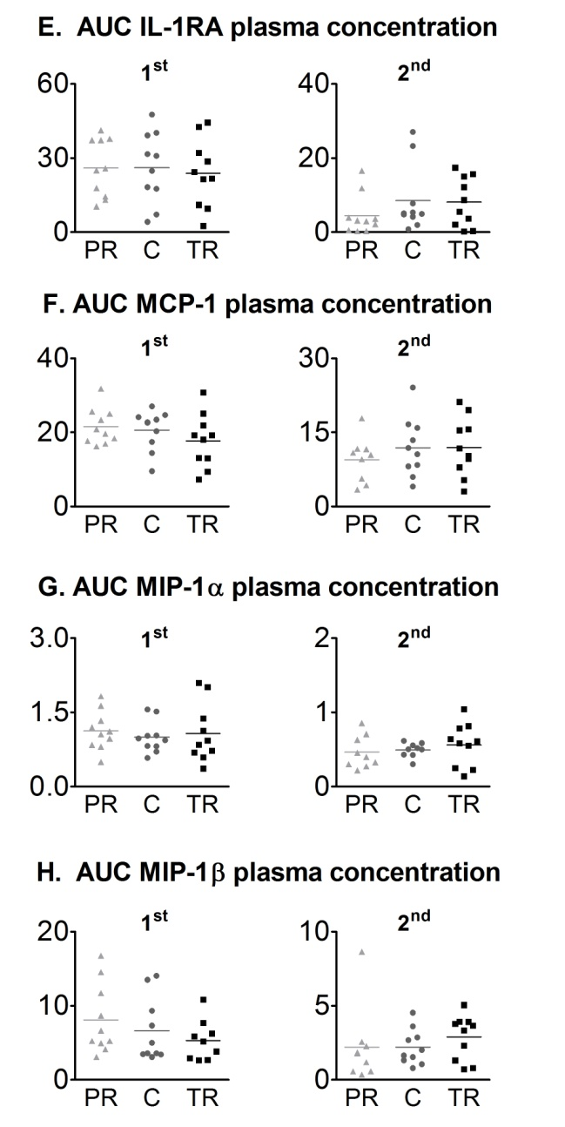
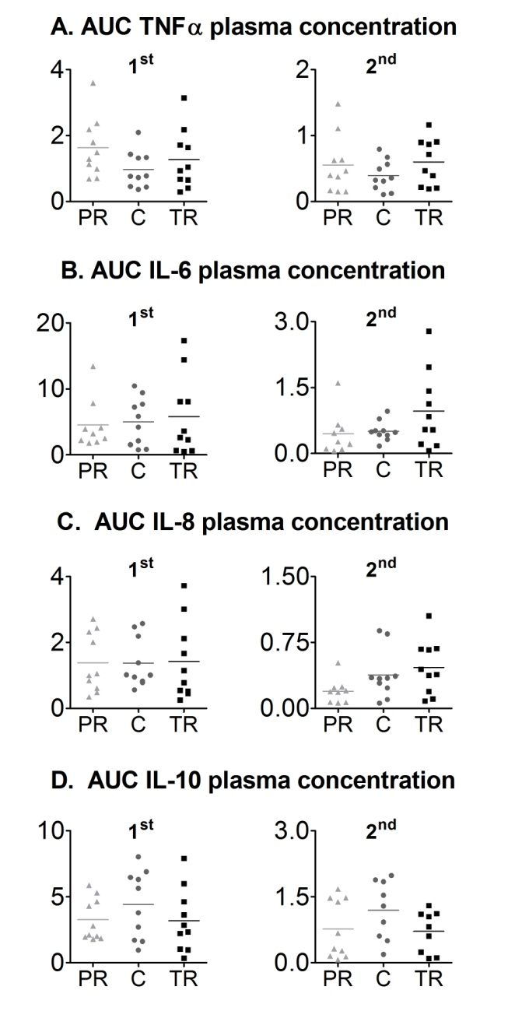
Figure S3. Area under the time-concentration curves (AUC) of (A) Tumor Necrosis Factor (TNF)α, (B) Interleukin (IL)-6, (C) IL-8, and (D) IL-10, (E) IL-1 receptor antagonist (RA), (F) Monocyte Chemoattractant Protein (MCP)-1, (G) Macrophage Inflammatory Protein (MIP)-1α, and (H) MIP-1β upon the first (1st) and second (2nd) endotoxin challenge. Data are depicted as scatter plots with the horizontal line indicating the mean value, and expressed as µg * h/mL. ASA = acetylsalicylic acid; PR = ASA-prophylaxis; C = control; TR = ASA-treatment.
Figure S4. (A) Neutrophil, (B) monocyte, and (C) lymphocyte counts upon the first and second endotoxin challenge (mean and SEM). The grey area indicates the three-hour endotoxin administration period. p-values represent the interaction term of repeated measures two-way ANOVA. ASA = acetylsalicylic acid.

Figure S5. (A) Temperature, (B) symptom score, (C) heart rate, and (D) mean arterial pressure upon the first and second endotoxin challenge (mean and SEM). The grey area indicates the three-hour endotoxin administration period. p-values represent the interaction term of repeated measures two-way ANOVA. ASA = acetylsalicylic acid.

Supplementary Tables

Supplementary Table 1. Baseline characteristics of the healthy volunteers enrolled in the endotoxemia experiments
Parameters | Control  (n=10) | ASA-treatment (n=10) | ASA-prophylaxis (n=10) | p-value between groups
Age, yr | 22 ± 2 | 23 ± 3 | 22 ± 3 | 0.84
Height, cm | 184 ± 5 | 182 ± 6 | 183 ± 6 | 0.71
Weight, kg | 79 ± 7 | 85 ± 9 | 80 ± 11 | 0.29
BMI, kg/m² | 23 ± 2 | 26 ± 2 | 24 ± 3 | 0.08
HR, bpm | 68 ± 10 | 64 ± 6 | 72 ± 9 | 0.12
MAP, mmHg | 97 ± 6 | 94 ± 9 | 98 ± 4 | 0.35

Data are presented as (mean ± SD). p-values were calculated using one-way ANOVA.
ASA = acetylsalicylic acid; BMI = body mass index; HR = heart rate; MAP = mean arterial pressure.
Supplementary Table 2. Characteristics of septic patients included in the ex vivo stimulation experiments.
 | Patient 1 | Patient 2 | Patient 3 | Patient 4
Age | 72 | 46 | 29 | 68
Gender | M | M | M | M
BMI | 27.3 | 22.9 | 25.0 | 23.7
Focus sepsis | Pneunomia | Pneunomia | Pneunomia | Pneunomia
Noradrenaline dosage (µg/kg/min) | 0.02 | 0.125 | 0.05 | 0
Highest noradrenaline dosage (µg/kg/min) | 0.04 | 0.125 | 0.133 | 0
HLA-DR  (antibodies/cell) | 11068 | 4285 | 32367 | 11980

BMI = body mass index; HLA-DR = Human Leukocyte Antigen – DR isotype.
Supplementary References
1. van Eijk LT, Pickkers P, Smits P, et al: Severe vagal response after endotoxin administration in humans. Intensive Care Med 2004; 30:2279-2281
2. Kiers D, van der Heijden WA, van Ede L, et al: A randomised trial on the effect of anti-platelet therapy on the systemic inflammatory response in human endotoxaemia. Thromb Haemost 2017; 117:1798-1807
3. Ter Horst R, Jaeger M, Smeekens SP, et al: Host and Environmental Factors Influencing Individual Human Cytokine Responses. Cell 2016; 167:1111-1124.e1113
4. Tunjungputri RN, van der Ven AJ, Riksen N, et al: Differential effects of platelets and platelet inhibition by ticagrelor on TLR2- and TLR4-mediated inflammatory responses. Thromb Haemost 2015; 113:1035-1045
5. Sharma NP, Dong L, Yuan C, et al: Asymmetric Acetylation of the Cyclooxygenase-2 Homodimer by Aspirin and Its Effects on the Oxygenation of Arachidonic, Eicosapentaenoic, and Docosahexaenoic Acids. Molecular Pharmacology 2010; 77:979-986
6. Dovizio M, Bruno A, Tacconelli S, et al: Mode of action of aspirin as a chemopreventive agent. Recent Results Cancer Res 2013; 191:39-65

