**Supplementary Content**

**Figure S1**

Workflow diagram for NGS diagnostics in context with clinical microbiology results.

**Data S2**

Overview of patients, groups, samples and results in this study.

**Figure S3**

Decision tree for species hit inclusion following SIQ score calculation.

**Figure S4**

Questionnaire for the expert evaluation.

**Figure S5**

cfDNA concentrations are displayed for the groups of septic (S) and postoperative (P) patients, for individual time points.

**Figure S6**

Sequencing, mapping and classifying statistics of the sequences study samples divided by septic (S) and postoperative (P) patients.

**Figure S7**

Normalized read distribution for the top ten species identified by BC or NGS

**Figure S8**

Species comparison between positive BC and SIQ results and contingency table.

**Figure S9**

Results of the expert evaluation on plausibility and therapy change based on NGS findings.

**Figure S10**

Inter-rater agreement statistics calculated by Fleiss’s Kappa for the expert evaluation.

**Figure S11**

Heat map of integrated NGS and clinical microbiology results for patient S3 over the course of the study.

**Table S1**

Complete list of species, SIQ scores, normalized abundance of reads sorted by patient and time point after application of the decision tree exclusion of species.

**Table S2**

Complete list of species found by NGS in the dataset of sequenced samples after decision tree filtering.

**Table S3**

Clinical data for patients with appropriate antibiosis (group1, n=24) or inappropriate antibiosis (group 2, n=14), based on the expert evaluation

**Table S4**

Detailed overview of samples ruled as implausible by expert evaluation.

**Figure S1. Workflow diagram for NGS diagnostics in context with clinical microbiology results.**



**Data S2. Overview of patients, groups, samples and results in this study.**

1. **Study cohort**

|  |  |  |  |
| --- | --- | --- | --- |
| **Group** | **Number of patients** | **Timepoints** | **Total number of samples** |
| Septic Patients (S) | 48 | T0, T1, T2, T3, T4, T5, T6 | 256 |
| Postoperative Controls (P) | 17 | T0, T1, T2 | 51 |

Group S:

Originally **50** septic patients were included in a previously published, prospective observational clinical study of our workgroup (see Methods). Two of them had to be excluded retrospectively from this secondary analysis due to technical reasons. Therefore, 48 patients with up to 7 timepoints were part of this secondary study = 256 blood samples for blood culture, for 239 plasma samples NGS after QC (see Figurebelow).

Group P:

Originally, **20** patients scheduled for elective surgery were included in the study, 3 were retrospectively excluded so that 17 patients with elective major abdominal surgery with up to 3 time points remained in the study (see Figurebelow) = 51 samples, for NGS after QC 34 samples (see Figurebelow).

1. **Samples before and after QC for NGS**

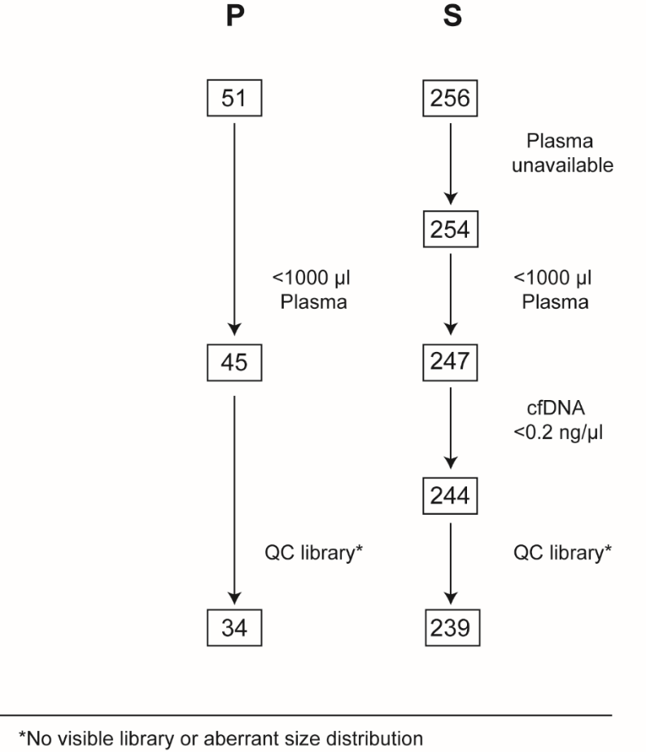

Initial and final samples of the two groups of septic patients (S) and postoperative patients (P). The exclusion of samples according to different quality control steps in the work flow is illustrated in this chart. The number of samples still available of the total samples of this group after the respective quality control step are shown in boxes.

1. **Contingency tables and evaluation statistics**

Contingency table of BC and NGS positive results

|  |  |  |  |
| --- | --- | --- | --- |
|  | **BC +** | **BC -** | **Σ** |
| **SIQ +** | 17 | 152 | 169 |
| **SIQ -** | 10 | 60 | 70 |
| **SIQ n.d.** | 2 | 15 | 17 |
| **Σ** | 27 / 29 | 212 / 226 | 239 / 256 |

|  |  |
| --- | --- |
| **Statistic** | **Value [%]** |
| Sensitivity | 62.96 |
| Specificity | 27.83 |
| PPV | 10.00 |
| NPV | 85.51 |

BC positivity: 29 out of 256 = 11%

NGS positivity 169 out of 239 = 71%

Out of 29 total positive BCs, 2 were excluded from further comparisons because the corresponding NGS sample failed QC, leading to 27 positive BC samples with a corresponding NGS sample. 17 of these were likewise positive by BC and NGS (7/17 CoNS or Propionibacteria by BC). 10 were only positive by BC and negative by NGS (6/10 CoNS or Propionibacteria by BC).

Contingency table of BC and NGS positive results without BC contaminants*

|  |  |  |  |
| --- | --- | --- | --- |
|  | **BC +** | **BC -** | **Σ** |
| **SIQ +** | 10 | 159 | 169 |
| **SIQ -** | 4 | 66 | 70 |
| **SIQ n.d.** | 2 | 15 | 17 |
| **Σ** | 14 / 29 | 225 / 240 | 239 / 256 |

|  |  |
| --- | --- |
| **Statistic** | **Value [%]** |
| Sensitivity | 71.43 |
| Specificity | 28.89 |
| PPV | 5.88 |
| NPV | 94.20 |

* BC results for frequent contaminants as CoNS and Propionibacteria were counted as BC negative in this calculation.

**Figure S3. Decision tree for species hit inclusion following SIQ score calculation.**

The decision tree was exercised for each species found in the dataset. The squares contain the questions “The species is/has…”. If the answer is “no”, the diamond shape contains the action “exclude”. If the answer to the question is “yes”, the action is to proceed to the next step in the tree, with the final result of inclusion, if the tested species passed all filters.

**Figure S4. Questionnaire for the expert evaluation.**

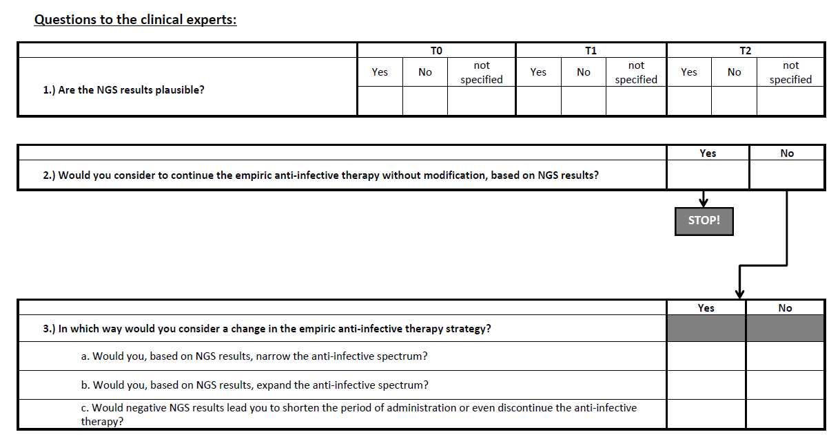

The questionnaire was answered individually by each reviewer and patient-wise. The answers to question one were divided by time point, with the option of yes, no or neither (“not specified”). If question two was answered with “yes”, question three was omitted. If the answer to question two was “no”, question three with sub-questions a-c was asked. Only unambiguous answers were included in the analysis. A majority decision for “yes” was reached, when votes for “yes” exceeded votes for “no” and at least two votes for “yes” were recorded. Decisions for “no” were likewise reached. If votes for “yes” or “no” were equal, no majority was reached. Majority votes were recorded for „yes“, „no“, „not specified“, and regarding change in antibiotic therapy. If the majority vote for question 1 (Figure S3) was „not specified“, the patients/time points were excluded.

**Figure S5. cfDNA concentrations are displayed for the groups of septic (S) and postoperative (P) patients, for individual time points.**



Median cfDNA levels in control patients before elective surgery were low (P T0=11.4ng/ml). Major abdominal surgery in the control cohort resulted in a four-fold increase in cfDNA levels (P T1-T2= 43.74 ng/ml). In contrast, cfDNA levels were considerably increased in septic patients (S=90.62 ng/ml), especially at sepsis onset (S T0=119.10 ng/ml and T1=123.6 ng/ml). Additionally, the median PCT concentration is plotted in orange as a dynamic surrogate marker for severity of infection.

**Figure S6. Sequencing, mapping and classifying statistics of the sequences study samples divided by septic (S) and postoperative (P) patients.**

The group of septic patients is further subdivided by the seven time points (T0 to T6) and the group of postoperative patients is subdivided by the three sampled time points (T0-T2). The right column contains the average library size of each subgroup and the bars indicate the percentage of mapped human reads (grey), unmapped reads (blue) and reads classified to any taxonomic order other than human by Kraken (orange).

**Figure S7. Normalized read distribution for the top ten species identified by BC or NGS**

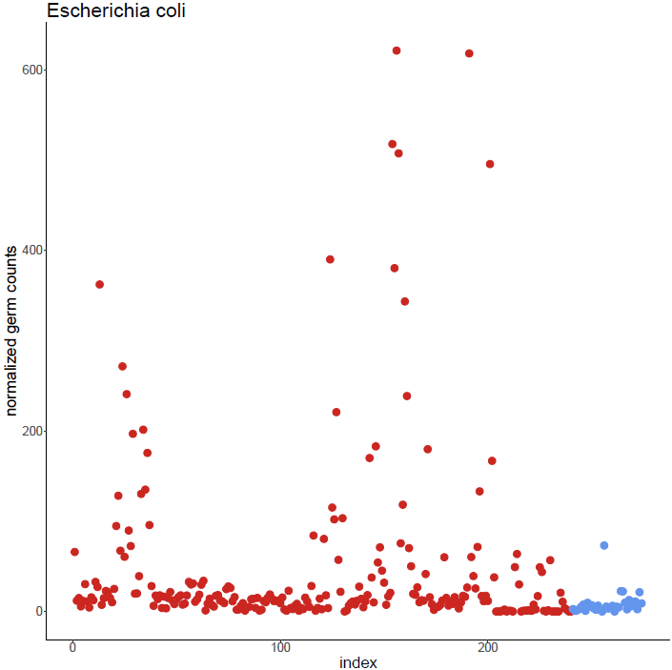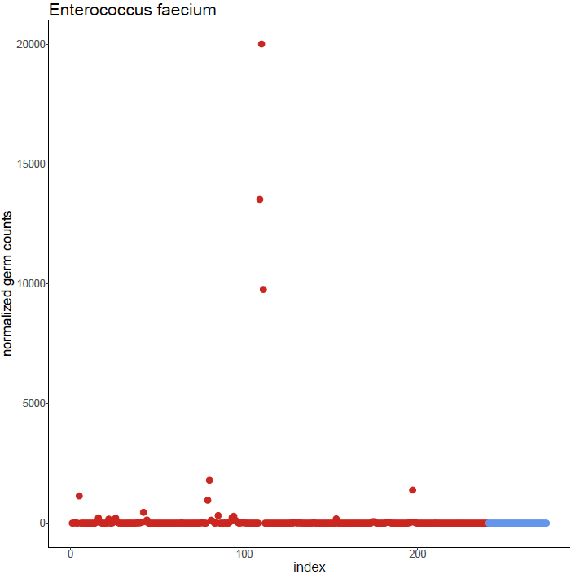 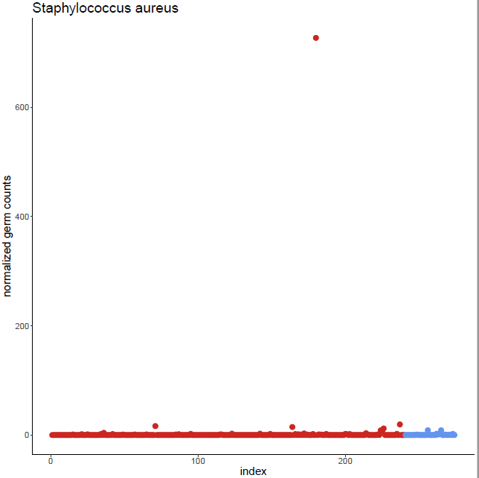 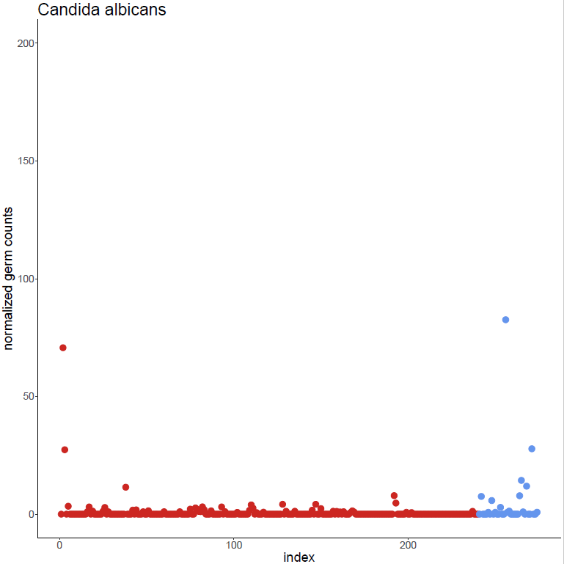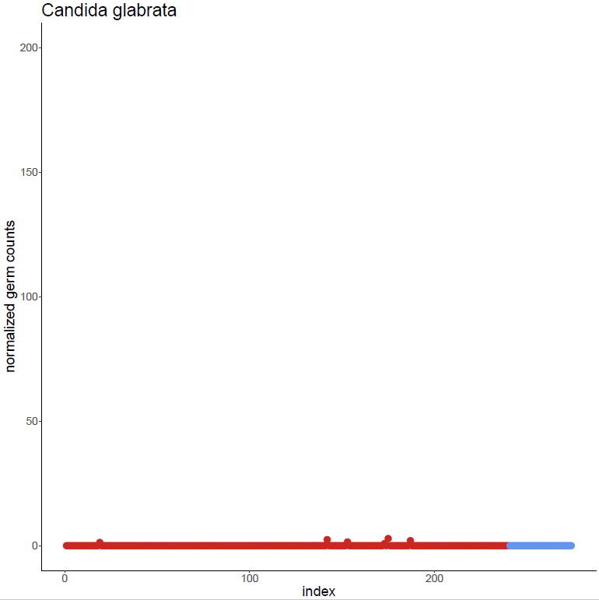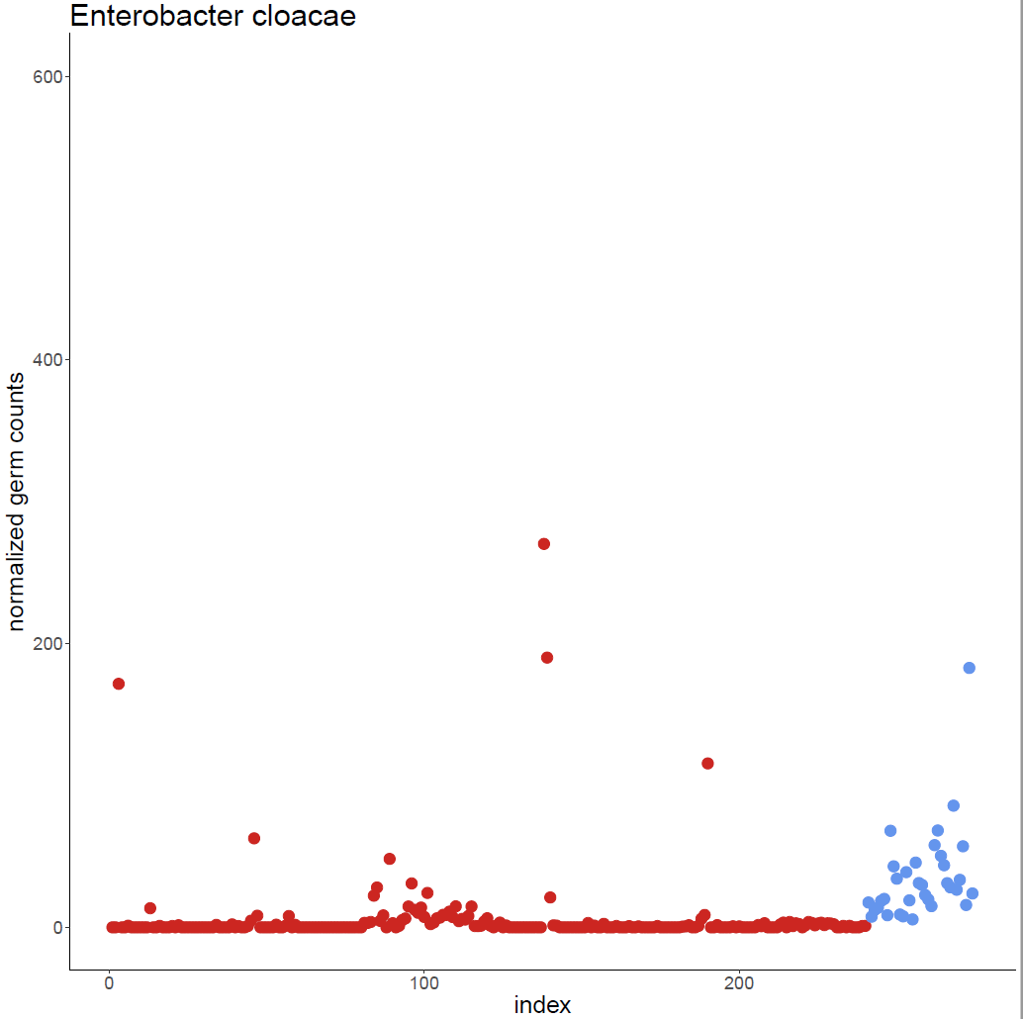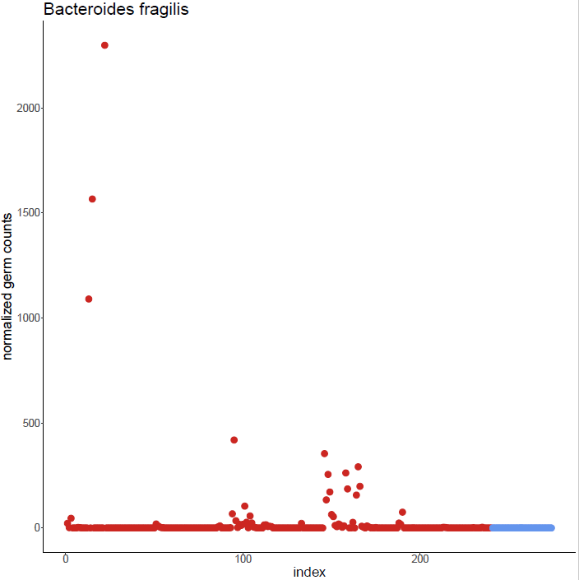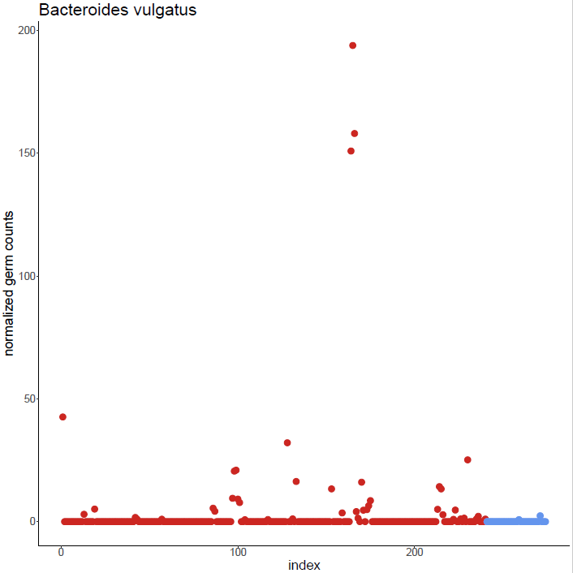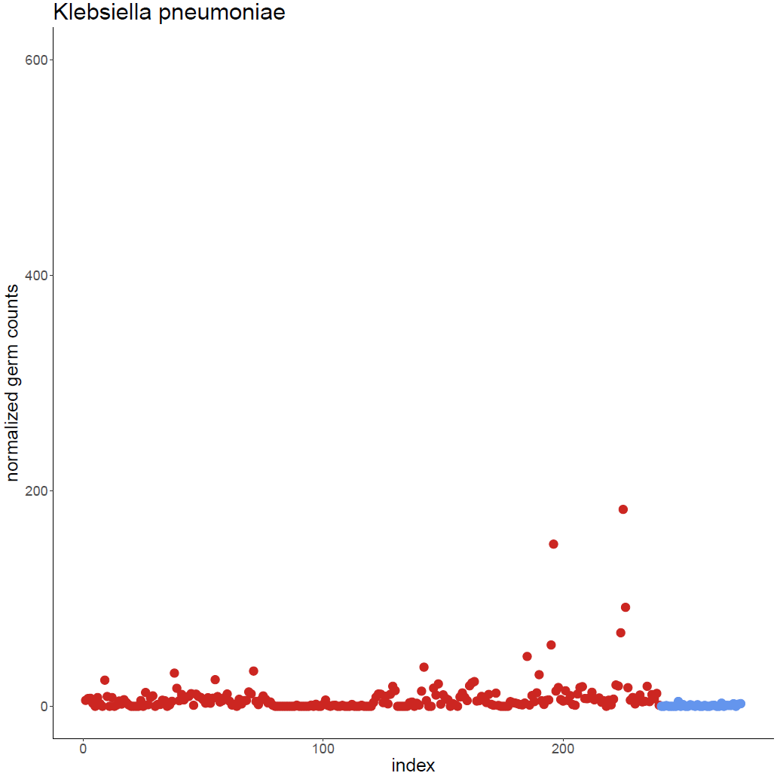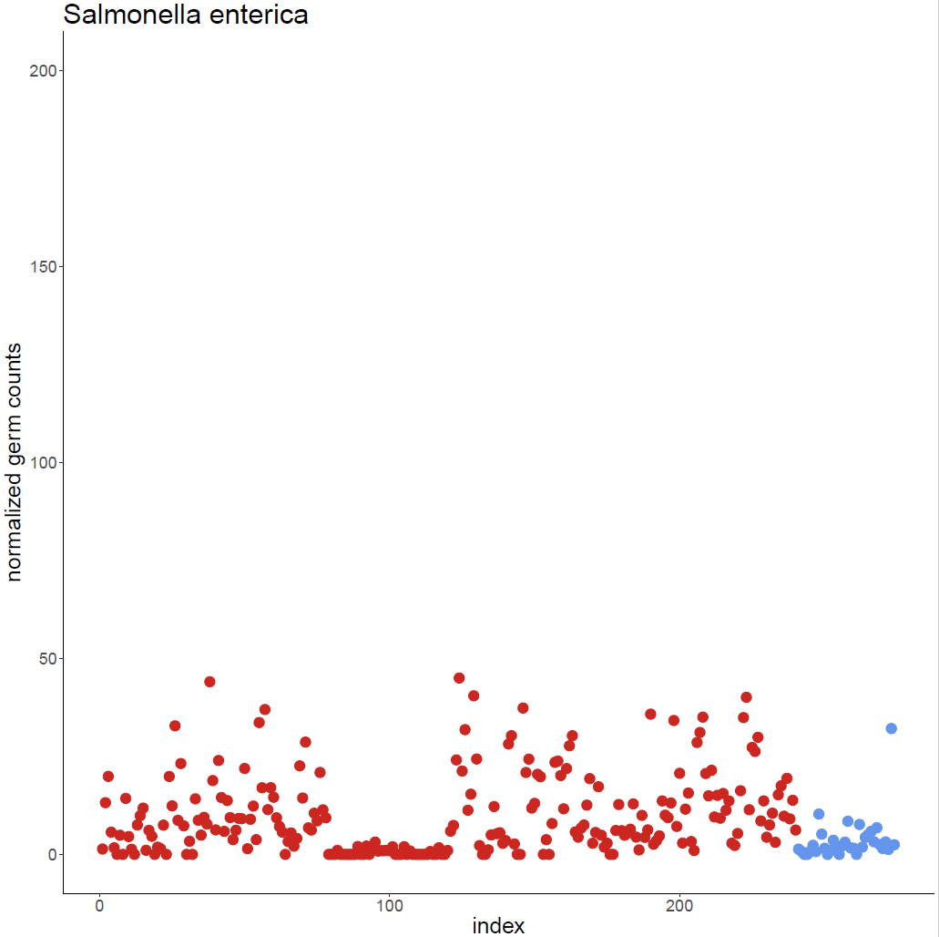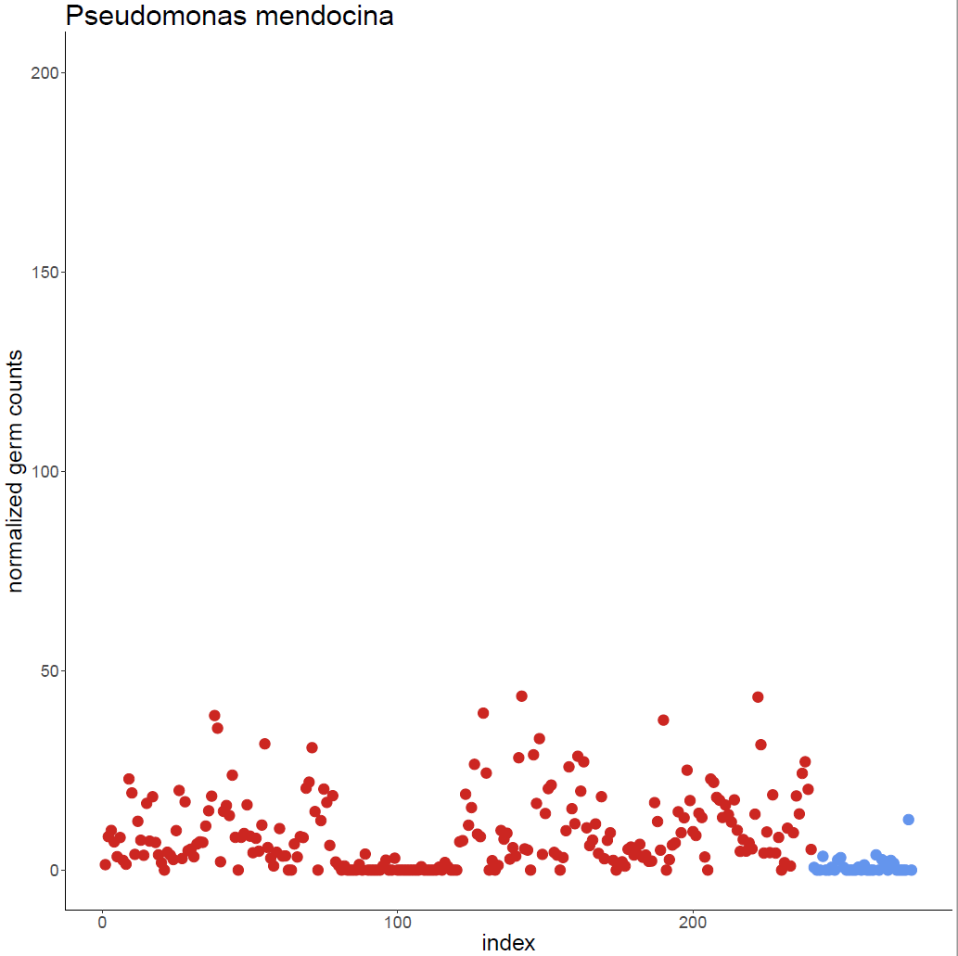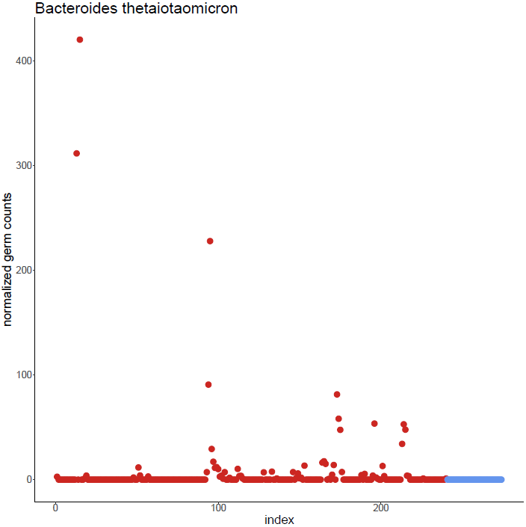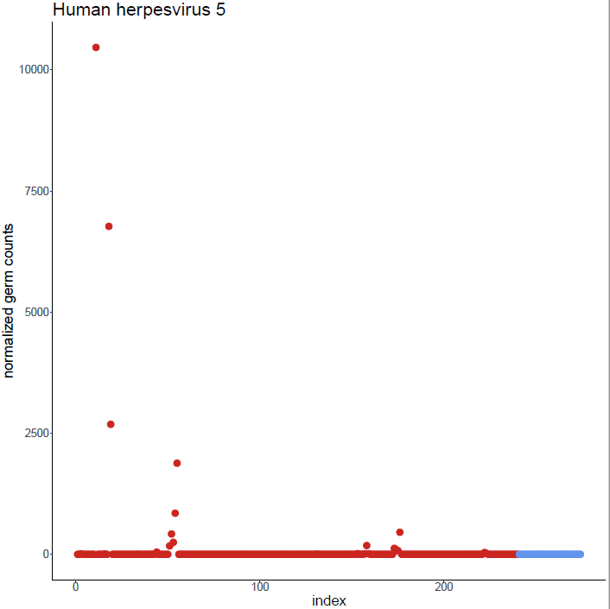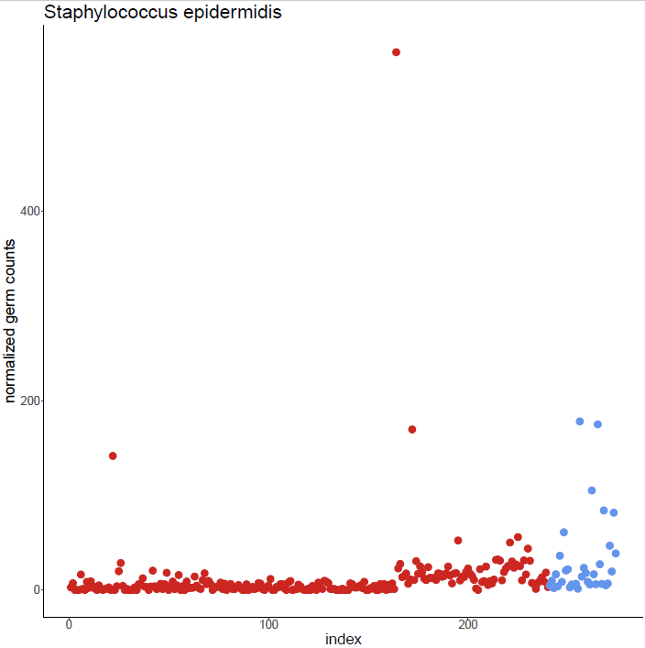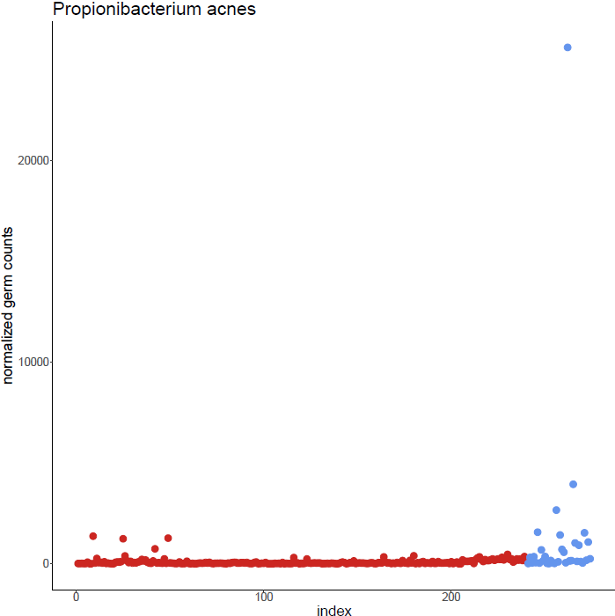

Normalized read counts are shown here for individual species for the patients (red dots) and the postoperative controls (blue dots).

**Figure S8. Species comparison between positive BC and SIQ results and contingency table.**



(**A**) Sample-wise comparison of species detected by BC and NGS. Species detected in BC are surrounded by a blue square, potential skin contaminants are displayed in grey. Species with a relevant SIQ score are surrounded by an orange square and the shared overlap between both methods is displayed in the middle. (**B**) Table displaying positive, negative and total results from BC and NGS (SIQ). Two positive and 15 negative BC results had to be excluded from the comparison, as the corresponding plasma samples did not pass quality control thresholds for NGS analysis.

**Figure S9. Results of the expert evaluation on plausibility and therapy change based on NGS findings.**



Positive SIQ results are abbreviated as SIQ+, whereas negative SIQ results are abbreviated as SIQ-.

**Figure S10. Inter-rater agreement statistics calculated by Fleiss’s Kappa for the expert evaluation.**



Inter-rater agreement statistics regarding the expert’s votings (Raters, n=8) for all patients (n=45) calculated for the individual questions of the questionnaire by Fleiss’s Kappa.

**Figure S11.** **Heat map of integrated NGS and clinical microbiology results for patient S3 over the course of the study.**

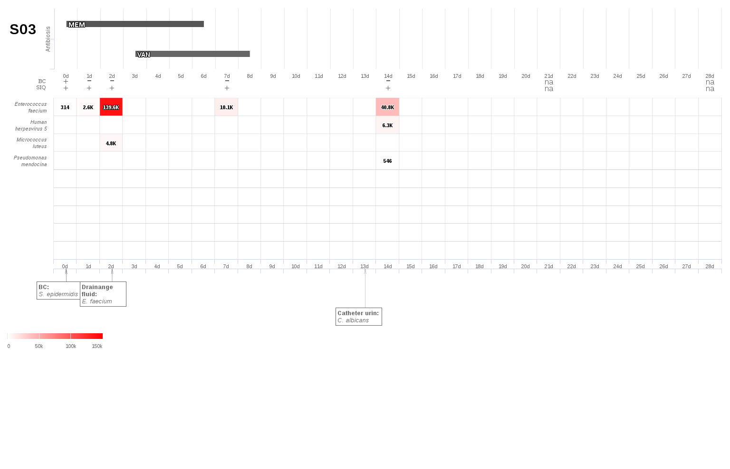

A 71-year-old male patient underwent gastric resection and cholecystectomy for a gastric cancer. The patient recovered and was discharged from the hospital 19 days after the initial operation. Two months later the patient was readmitted to the hospital with a septic arrosion hemorrhage of the splenic artery. He underwent an immediate surgical focus control but subsequently worsened to septic shock. Meropenem was used as an empiric antibiotic monotherapy. Apart from *Staphylococcus epidermidis*,which was defined as a potential contamination, no further pathogens were found by culture-based microbiological testings at sepsis onset. Two days later, the patient underwent another surgical revision, and fresh drainage fluid revealed cultural growth of *Enterococcus faecium* as the only pathogen. Accordingly, vancomycin was added to meropenem in terms of a targeted therapy at day three following sepsis onset. However, NGS-based diagnostics could have led to this antibiotic adjustment three days earlier, since *Enterococcus faecium* was identified already at sepsis onset. Furthermore, blood cultures remained negative for *Enterococcus faecium* or any other pathogenat all time points. The patient recovered well and antibiotic therapy was stopped on day 6 (meropenem) and day 8 (vancomycin) after sepsis onset. Concerning further microbiological findings, *Candida albicans* could be isolated from urine 13 days after sepsis onset. Since no further cultural growth of *Candida* spp. could be observed after removal of the still indwelling urine catheter, this finding was defined to be fungal colonization; accordingly no antifungals were administered. The patient was discharged from the ICU in stable condition at 21 days after sepsis onset and was able to leave the hospital in healthy condition at 58 days after sepsis onset.

**Table S1. Complete list of species, SIQ scores, normalized abundance of reads sorted by patient and time point after application of the decision tree exclusion of species.**

|  |  |  |  |  |  |
| --- | --- | --- | --- | --- | --- |
| **Remark** | **Patient** | **Species** | **SIQ score** | **Normalized Reads** | **P-value** |
| a, b | S01_T1 | *Pseudomonas stutzeri* | 25919 | 266 | 4.79E-98 |
| a, b | S01_T3 | *Escherichia coli* | 561 | 39 | 4.68E-15 |
| a, b | S01_T4 | *Escherichia coli* | 13534 | 130 | 1.41E-104 |
| a, b | S01_T5 | *Escherichia coli* | 39384 | 202 | 3.50E-196 |
| a, b | S01_T6 | *Escherichia coli* | 14837 | 135 | 1.45E-110 |
| b | S01_T6 | *Gordonia bronchialis* | 883 | 28 | 5.42E-32 |
| a, b | S02_T2 | *Escherichia coli* | 28193 | 176 | 3.92E-161 |
| a, b | S02_T3 | *Escherichia coli* | 6173 | 96 | 3.69E-65 |
| b | S02_T5 | *Bordetella petrii* | 518 | 18 | 4.10E-30 |
|  | S02_T5 | *Candida albicans* | 27 | 11 | 4.55E-03 |
| b | S02_T5 | *Klebsiella pneumoniae* | 1183 | 31 | 4.02E-39 |
| a, b | S02_T5 | *Micrococcus luteus* | 5391 | 89 | 2.44E-61 |
| a, b | S02_T5 | *Pseudomonas mendocina* | 1730 | 39 | 2.24E-45 |
| a, b | S02_T5 | *Salmonella enterica* | 1428 | 44 | 3.79E-33 |
| a | S02_T6 | *Corynebacterium jeikeium* | 1246 | 24 | 1.57E-52 |
| a, b | S02_T6 | *Pseudomonas mendocina* | 1425 | 36 | 8.43E-41 |
|  | S03_T0 | *Enterococcus faecium* | 314 | 13 | 7.05E-26 |
|  | S03_T1 | *Enterococcus faecium* | 2605 | 33 | 2.55E-79 |
|  | S03_T2 | *Enterococcus faecium* | 139591 | 454 | 0.00E+00 |
| a, b | S03_T2 | *Micrococcus luteus* | 4761 | 84 | 4.07E-57 |
|  | S03_T3 | *Enterococcus faecium* | 10111 | 63 | 2.39E-162 |
|  | S03_T4 | *Enterococcus faecium* | 40838 | 133 | 0.00E+00 |
|  | S03_T4 | *Human herpesvirus 5* | 6336 | 47 | 1.98E-136 |
| a, b | S03_T4 | *Pseudomonas mendocina* | 546 | 24 | 1.13E-23 |
|  | S05_T0 | *Bacteroides fragilis* | 911 | 19 | 5.72E-49 |
|  | S05_T0 | *Bacteroides thetaiotaomicron* | 3575 | 12 | 0.00E+00 |
|  | S05_T0 | *Human herpesvirus 5* | 53612 | 174 | 0.00E+00 |
|  | S05_T1 | *Anaerococcus prevotii* | 416 | 14 | 1.54E-30 |
|  | S05_T1 | *Human herpesvirus 5* | 129282 | 420 | 0.00E+00 |
|  | S05_T2 | *Human herpesvirus 1* | 12534 | 41 | 0.00E+00 |
|  | S05_T2 | *Human herpesvirus 5* | 76070 | 247 | 0.00E+00 |
|  | S05_T3 | *Human herpesvirus 5* | 261357 | 850 | 0.00E+00 |
| b | S05_T4 | *Bordetella petrii* | 994 | 24 | 1.33E-42 |
|  | S05_T4 | *Human herpesvirus 5* | 579015 | 1882 | 0.00E+00 |
| b | S05_T4 | *Klebsiella pneumoniae* | 713 | 25 | 1.38E-29 |
| a, b | S05_T4 | *Pseudomonas mendocina* | 1081 | 32 | 7.22E-35 |
| a, b | S05_T4 | *Salmonella enterica* | 705 | 34 | 1.09E-21 |
|  | S06_T0 | *Raoultella ornithinolytica* | 47496 | 161 | 4.78E-296 |
|  | S06_T1 | *Raoultella ornithinolytica* | 15585 | 98 | 5.48E-160 |
| a, b | S06_T1 | *Salmonella enterica* | 885 | 37 | 1.11E-24 |
| a | S07_T2 | *Streptococcus intermedius* | 5350 | 51 | 1.56E-105 |
|  | S07_T2 | *Veillonella parvula* | 415 | 22 | 8.14E-20 |
| b | S08_T6 | *Klebsiella pneumoniae* | 1364 | 33 | 2.05E-42 |
| a, b | S08_T6 | *Pseudomonas mendocina* | 1003 | 31 | 2.04E-33 |
|  | S08_T6 | *Staphylococcus aureus* | 270 | 16 | 3.24E-17 |
|  | S09_T4 | *Enterococcus faecium* | 1225 | 24 | 7.53E-53 |
|  | S10_T0 | *Enterococcus faecium* | 349453 | 1136 | 0.00E+00 |
|  | S10_T1 | *Enterococcus faecium* | 294390 | 957 | 0.00E+00 |
|  | S10_T2 | *Enterococcus faecium* | 552735 | 1797 | 0.00E+00 |
|  | S10_T3 | *Enterococcus faecium* | 38260 | 124 | 0.00E+00 |
|  | S10_T4 | *Enterococcus faecium* | 13443 | 71 | 1.89E-189 |
|  | S11_T2 | *Enterococcus faecium* | 267 | 12 | 1.39E-23 |
|  | S11_T3 | *Enterococcus faecium* | 97630 | 317 | 0.00E+00 |
|  | S12_T0 | *Bacteroides fragilis* | 1323 | 22 | 7.45E-61 |
|  | S12_T0 | *Bacteroides vulgatus* | 4135 | 43 | 9.74E-98 |
| a, b | S12_T0 | *Escherichia coli* | 2312 | 66 | 9.27E-36 |
|  | S12_T0 | *Faecalibacterium prausnitzii* | 303 | 11 | 3.14E-28 |
|  | S12_T2 | *Human herpesvirus 6B* | 179 | 13 | 7.16E-15 |
|  | S12_T6 | *Enterococcus faecium* | 207 | 10 | 2.51E-21 |
|  | S13_T2 | *Enterococcus faecium* | 11470 | 66 | 2.49E-174 |
|  | S13_T3 | *Enterococcus faecium* | 72000 | 234 | 0.00E+00 |
|  | S13_T3 | *Human herpesvirus 1* | 5030 | 16 | 0.00E+00 |
|  | S13_T4 | *Bacteroides fragilis* | 14007 | 67 | 1.31E-208 |
|  | S13_T4 | *Bacteroides thetaiotaomicron* | 27916 | 91 | 0.00E+00 |
|  | S13_T4 | *Enterococcus faecium* | 88444 | 287 | 0.00E+00 |
|  | S13_T4 | *Parabacteroides distasonis* | 4147 | 13 | 0.00E+00 |
|  | S13_T5 | *Acidaminococcus intestini* | 3553 | 12 | 0.00E+00 |
|  | S13_T5 | *Bacteroides fragilis* | 128870 | 419 | 0.00E+00 |
|  | S13_T5 | *Bacteroides thetaiotaomicron* | 70086 | 228 | 0.00E+00 |
|  | S13_T5 | *Enterococcus faecium* | 36820 | 120 | 0.00E+00 |
|  | S13_T6 | *Bacteroides fragilis* | 3342 | 34 | 3.96E-98 |
|  | S13_T6 | *Bacteroides thetaiotaomicron* | 9011 | 29 | 0.00E+00 |
|  | S13_T6 | *Enterococcus faecium* | 3554 | 38 | 4.68E-93 |
|  | S14_T0 | *Bacteroides thetaiotaomicron* | 5267 | 17 | 0.00E+00 |
|  | S14_T0 | *Klebsiella oxytoca* | 3368 | 49 | 3.56E-70 |
|  | S14_T1 | *Bacteroides fragilis* | 714 | 17 | 3.72E-43 |
|  | S14_T1 | *Bacteroides thetaiotaomicron* | 3452 | 11 | 0.00E+00 |
|  | S14_T1 | *Bacteroides vulgatus* | 850 | 21 | 4.69E-42 |
|  | S14_T1 | *Klebsiella oxytoca* | 47290 | 157 | 8.73E-302 |
|  | S14_T2 | *Bacteroides fragilis* | 340 | 12 | 4.34E-29 |
|  | S14_T2 | *Bacteroides thetaiotaomicron* | 3686 | 12 | 0.00E+00 |
|  | S14_T2 | *Bacteroides vulgatus* | 866 | 21 | 4.69E-42 |
|  | S14_T2 | *Enterococcus faecium* | 749 | 19 | 3.03E-40 |
|  | S14_T2 | *Klebsiella oxytoca* | 21598 | 111 | 1.13E-195 |
|  | S14_T3 | *Bacteroides fragilis* | 790 | 17 | 4.73E-46 |
|  | S14_T3 | *Bacteroides thetaiotaomicron* | 3101 | 10 | 0.00E+00 |
|  | S14_T3 | *Enterococcus faecium* | 571 | 17 | 2.36E-35 |
|  | S14_T3 | *Klebsiella oxytoca* | 4014 | 52 | 1.53E-77 |
|  | S14_T4 | *Bacteroides fragilis* | 31950 | 104 | 0.00E+00 |
|  | S14_T4 | *Odoribacter splanchnicus* | 3883 | 13 | 0.00E+00 |
|  | S14_T5 | *Bacteroides fragilis* | 2054 | 27 | 4.01E-76 |
|  | S15_T0 | *Bacteroides fragilis* | 9903 | 57 | 3.43E-174 |
|  | S15_T0 | *Klebsiella oxytoca* | 422 | 20 | 5.20E-22 |
|  | S15_T1 | *Bacteroides fragilis* | 1491 | 24 | 7.12E-64 |
|  | S15_T2 | *Human herpesvirus 1* | 7894 | 26 | 0.00E+00 |
|  | S15_T3 | *Human herpesvirus 1* | 30313 | 99 | 0.00E+00 |
|  | S16_T0 | *Enterococcus casseliflavus* | 4080 | 40 | 6.03E-104 |
|  | S16_T0 | *Enterococcus faecalis* | 3411 | 37 | 1.21E-92 |
|  | S16_T0 | *Enterococcus faecium* | 4158304 | 13516 | 0.00E+00 |
|  | S16_T1 | *Citrobacter koseri* | 3711 | 41 | 3.34E-90 |
|  | S16_T1 | *Enterococcus casseliflavus* | 7786 | 53 | 9.48E-147 |
|  | S16_T1 | *Enterococcus faecalis* | 8295 | 56 | 4.03E-148 |
|  | S16_T1 | *Enterococcus faecium* | 6154524 | 20005 | 0.00E+00 |
|  | S16_T2 | *Enterococcus casseliflavus* | 915 | 20 | 8.94E-47 |
|  | S16_T2 | *Enterococcus faecalis* | 1146 | 22 | 1.02E-51 |
|  | S16_T2 | *Enterococcus faecium* | 3001395 | 9756 | 0.00E+00 |
|  | S16_T3 | *Enterococcus faecium* | 67127 | 218 | 0.00E+00 |
|  | S16_T4 | *Candida albicans* | 3897 | 71 | 7.50E-56 |
|  | S16_T5 | *Enterococcus faecium* | 2649 | 34 | 2.55E-79 |
|  | S16_T6 | *Bacteroides fragilis* | 6281 | 46 | 3.36E-137 |
|  | S16_T6 | *Candida albicans* | 335 | 27 | 5.72E-13 |
| a | S16_T6 | *Enterobacter cloacae* | 10417 | 172 | 2.06E-61 |
|  | S17_T0 | *Bacteroides fragilis* | 533 | 15 | 1.92E-37 |
|  | S17_T0 | *Bacteroides thetaiotaomicron* | 3153 | 10 | 0.00E+00 |
|  | S17_T0 | *Prevotella denticola* | 263 | 13 | 3.32E-21 |
|  | S17_T1 | *Bacteroides fragilis* | 596 | 15 | 2.75E-40 |
| a, b | S17_T4 | *Escherichia coli* | 4471 | 84 | 7.88E-54 |
| a, b | S20_T3 | *Escherichia coli* | 3953 | 80 | 7.38E-50 |
| a, b | S21_T0 | *Escherichia coli* | 120058 | 390 | 0.00E+00 |
|  | S21_T0 | *Klebsiella oxytoca* | 94 | 10 | 4.78E-10 |
| a, b | S21_T0 | *Salmonella enterica* | 1458 | 45 | 3.79E-33 |
| a, b | S21_T1 | *Escherichia coli* | 9957 | 115 | 4.09E-87 |
| a | S21_T1 | *Methylobacterium radiotolerans* | 8477 | 57 | 2.92E-149 |
| a, b | S21_T2 | *Escherichia coli* | 7343 | 102 | 1.17E-72 |
| a, b | S21_T2 | *Pseudomonas mendocina* | 717 | 27 | 9.33E-28 |
| a, b | S21_T2 | *Salmonella enterica* | 605 | 32 | 9.37E-20 |
| a, b | S21_T3 | *Escherichia coli* | 49057 | 221 | 1.00E-222 |
|  | S21_T4 | *Bacteroides vulgatus* | 2276 | 32 | 1.28E-71 |
|  | S21_T4 | *Bacteroides xylanisolvens* | 8347 | 53 | 4.57E-158 |
| a | S21_T4 | *Enterobacter aerogenes* | 68717 | 223 | 0.00E+00 |
| a, b | S21_T4 | *Escherichia coli* | 1608 | 57 | 8.05E-29 |
| a, b | S21_T5 | *Acinetobacter baumannii* | 836 | 63 | 6.46E-14 |
|  | S21_T5 | *Enterococcus faecium* | 2489 | 33 | 1.31E-76 |
| a, b | S21_T5 | *Pseudomonas mendocina* | 1818 | 39 | 6.35E-47 |
| a, b | S21_T5 | *Salmonella enterica* | 1137 | 40 | 7.87E-29 |
| a, b | S21_T6 | *Escherichia coli* | 7552 | 103 | 9.59E-74 |
| a, b | S21_T6 | *Pseudomonas mendocina* | 591 | 24 | 5.10E-25 |
|  | S22_T1 | *Enterococcus faecium* | 271 | 12 | 1.39E-23 |
|  | S23_T0 | *Bacteroides fragilis* | 1246 | 22 | 7.47E-58 |
|  | S23_T0 | *Bacteroides vulgatus* | 524 | 16 | 8.70E-33 |
|  | S23_T0 | *Bacteroides xylanisolvens* | 343494 | 1117 | 0.00E+00 |
|  | S23_T0 | *Odoribacter splanchnicus* | 5369 | 17 | 0.00E+00 |
|  | S23_T0 | *Tannerella forsythia* | 270 | 12 | 2.99E-23 |
|  | S23_T1 | *Bacteroides xylanisolvens* | 26438 | 92 | 2.72E-289 |
|  | S23_T2 | *Bacteroides xylanisolvens* | 326 | 12 | 1.61E-28 |
| a | S24_T0 | *Enterobacter cloacae* | 37753 | 270 | 2.14E-140 |
| a | S24_T2 | *Enterobacter cloacae* | 14122 | 190 | 5.32E-75 |
|  | S24_T3 | *Enterococcus faecium* | 991 | 21 | 9.49E-48 |
| b | S25_T0 | *Klebsiella pneumoniae* | 701 | 24 | 1.38E-29 |
|  | S25_T0 | *Lactobacillus gasseri* | 504 | 14 | 5.03E-36 |
| b | S25_T2 | *Bordetella petrii* | 795 | 21 | 2.32E-38 |
| a, b | S25_T2 | *Pseudomonas mendocina* | 840 | 28 | 1.48E-30 |
| b | S25_T3 | *Bordetella petrii* | 1067 | 24 | 9.42E-45 |
| a, b | S25_T3 | *Comamonas testosteroni* | 563 | 45 | 2.69E-13 |
| b | S25_T3 | *Gordonia bronchialis* | 618 | 24 | 3.00E-26 |
| b | S25_T3 | *Klebsiella pneumoniae* | 1760 | 36 | 3.73E-49 |
|  | S25_T3 | *Lactobacillus gasseri* | 2477 | 30 | 1.54E-82 |
| a, b | S25_T3 | *Pseudomonas mendocina* | 2289 | 44 | 3.23E-53 |
| a, b | S25_T3 | *Salmonella enterica* | 548 | 30 | 8.29E-19 |
| a, b | S26_T0 | *Escherichia coli* | 26174 | 170 | 1.41E-154 |
|  | S26_T1 | *Human herpesvirus 6B* | 114 | 10 | 4.90E-12 |
|  | S27_T0 | *Bacteroides fragilis* | 108909 | 354 | 0.00E+00 |
| a, b | S27_T0 | *Escherichia coli* | 31301 | 183 | 9.45E-172 |
| a, b | S27_T0 | *Pseudomonas mendocina* | 862 | 29 | 1.48E-30 |
| a, b | S27_T0 | *Salmonella enterica* | 932 | 37 | 1.06E-25 |
|  | S27_T1 | *Bacteroides fragilis* | 41127 | 134 | 0.00E+00 |
| a, b | S27_T1 | *Escherichia coli* | 1391 | 54 | 2.45E-26 |
|  | S27_T2 | *Bacteroides fragilis* | 78458 | 255 | 0.00E+00 |
| a, b | S27_T2 | *Escherichia coli* | 2882 | 71 | 3.07E-41 |
| a, b | S27_T2 | *Pseudomonas mendocina* | 1174 | 33 | 2.48E-36 |
|  | S27_T2 | *Staphylococcus haemolyticus* | 85 | 10 | 6.69E-09 |
|  | S27_T3 | *Bacteroides fragilis* | 52692 | 171 | 0.00E+00 |
| a, b | S27_T3 | *Escherichia coli* | 842 | 45 | 2.53E-19 |
|  | S27_T4 | *Bacteroides fragilis* | 12389 | 64 | 9.25E-195 |
|  | S27_T5 | *Bacteroides fragilis* | 8607 | 54 | 1.26E-160 |
|  | S27_T6 | *Bacteroides fragilis* | 379 | 12 | 7.66E-32 |
|  | S29_T0 | *Bacteroides thetaiotaomicron* | 4101 | 13 | 0.00E+00 |
|  | S29_T0 | *Bacteroides vulgatus* | 338 | 13 | 4.30E-26 |
|  | S29_T0 | *Bacteroides xylanisolvens* | 329 | 12 | 1.61E-28 |
|  | S29_T0 | *Enterococcus faecium* | 55134 | 179 | 0.00E+00 |
|  | S29_T0 | *Human herpesvirus 5* | 540 | 15 | 3.38E-37 |
|  | S29_T0 | *Parabacteroides distasonis* | 10479 | 34 | 0.00E+00 |
|  | S30_T0 | *Bacteroides fragilis* | 906 | 19 | 5.72E-49 |
| a, b | S30_T0 | *Escherichia coli* | 159398 | 518 | 0.00E+00 |
|  | S30_T1 | *Bacteroides fragilis* | 450 | 13 | 1.26E-34 |
| a, b | S30_T1 | *Escherichia coli* | 117077 | 381 | 0.00E+00 |
| a, b | S30_T2 | *Escherichia coli* | 191274 | 622 | 0.00E+00 |
| a, b | S30_T3 | *Escherichia coli* | 156229 | 508 | 0.00E+00 |
|  | S30_T4 | *Bacteroides fragilis* | 80580 | 262 | 0.00E+00 |
| a, b | S30_T4 | *Escherichia coli* | 3347 | 76 | 5.16E-45 |
|  | S30_T4 | *Human herpesvirus 5* | 55737 | 181 | 0.00E+00 |
| a, b | S30_T4 | *Pseudomonas mendocina* | 664 | 26 | 2.22E-26 |
|  | S30_T5 | *Bacteroides fragilis* | 57177 | 186 | 0.00E+00 |
| a, b | S30_T5 | *Escherichia coli* | 10632 | 118 | 1.53E-90 |
|  | S30_T5 | *Human herpesvirus 5* | 333 | 12 | 6.83E-29 |
| a, b | S32_T0 | *Escherichia coli* | 105725 | 344 | 0.00E+00 |
| a, b | S32_T1 | *Escherichia coli* | 59177 | 239 | 1.59E-248 |
| a, b | S32_T1 | *Pseudomonas mendocina* | 851 | 29 | 1.48E-30 |
|  | S32_T2 | *Bacteroides fragilis* | 1931 | 27 | 4.90E-73 |
| a, b | S32_T2 | *Escherichia coli* | 2781 | 70 | 2.60E-40 |
| b | S32_T2 | *Klebsiella pneumoniae* | 529 | 22 | 4.83E-25 |
| a, b | S32_T3 | *Escherichia coli* | 1123 | 50 | 3.90E-23 |
| b | S32_T3 | *Klebsiella pneumoniae* | 593 | 23 | 1.54E-26 |
| a, b | S32_T3 | *Pseudomonas mendocina* | 772 | 27 | 3.78E-29 |
| a, b | S32_T3 | *Salmonella enterica* | 548 | 30 | 8.29E-19 |
|  | S33_T0 | *Akkermansia muciniphila* | 233619 | 759 | 0.00E+00 |
|  | S33_T0 | *Alistipes finegoldii* | 9093 | 62 | 2.07E-147 |
|  | S33_T0 | *Bacteroides fragilis* | 48178 | 157 | 0.00E+00 |
|  | S33_T0 | *Bacteroides thetaiotaomicron* | 5018 | 16 | 0.00E+00 |
|  | S33_T0 | *Bacteroides vulgatus* | 46422 | 151 | 0.00E+00 |
|  | S33_T0 | *Bacteroides xylanisolvens* | 31116 | 101 | 0.00E+00 |
|  | S33_T0 | *Bifidobacterium adolescentis* | 79045 | 257 | 0.00E+00 |
|  | S33_T0 | *Bifidobacterium bifidum* | 36888 | 120 | 0.00E+00 |
|  | S33_T0 | *Bifidobacterium longum* | 12725 | 77 | 6.14E-165 |
|  | S33_T0 | *Clostridium saccharolyticum* | 5270 | 17 | 0.00E+00 |
|  | S33_T0 | *Faecalibacterium prausnitzii* | 1288 | 22 | 3.31E-59 |
|  | S33_T0 | *Parabacteroides distasonis* | 38143 | 124 | 0.00E+00 |
|  | S33_T0 | *Roseburia hominis* | 6775 | 22 | 0.00E+00 |
|  | S33_T0 | *Staphylococcus aureus* | 204 | 15 | 1.37E-14 |
| b | S33_T0 | *Staphylococcus epidermidis* | 174901 | 569 | 0.00E+00 |
|  | S33_T0 | *Staphylococcus haemolyticus* | 127 | 12 | 3.91E-11 |
|  | S33_T1 | *Akkermansia muciniphila* | 340575 | 1107 | 0.00E+00 |
|  | S33_T1 | *Alistipes finegoldii* | 21244 | 91 | 1.36E-233 |
|  | S33_T1 | *Bacteroides fragilis* | 89598 | 291 | 0.00E+00 |
|  | S33_T1 | *Bacteroides thetaiotaomicron* | 5396 | 18 | 0.00E+00 |
|  | S33_T1 | *Bacteroides vulgatus* | 59642 | 194 | 0.00E+00 |
|  | S33_T1 | *Bacteroides xylanisolvens* | 36432 | 118 | 0.00E+00 |
|  | S33_T1 | *Bifidobacterium adolescentis* | 124409 | 404 | 0.00E+00 |
|  | S33_T1 | *Bifidobacterium bifidum* | 60721 | 197 | 0.00E+00 |
|  | S33_T1 | *Bifidobacterium longum* | 46686 | 152 | 0.00E+00 |
|  | S33_T1 | *Candidatus Methanomassiliicoccus intestinalis* | 6208 | 20 | 0.00E+00 |
|  | S33_T1 | *Clostridium saccharolyticum* | 5938 | 19 | 0.00E+00 |
|  | S33_T1 | *Eggerthella lenta* | 4316 | 14 | 0.00E+00 |
|  | S33_T1 | *Faecalibacterium prausnitzii* | 864 | 18 | 1.31E-47 |
|  | S33_T1 | *Parabacteroides distasonis* | 70166 | 228 | 0.00E+00 |
|  | S33_T1 | *Roseburia hominis* | 11875 | 39 | 0.00E+00 |
|  | S33_T2 | *Akkermansia muciniphila* | 333868 | 1085 | 0.00E+00 |
|  | S33_T2 | *Alistipes finegoldii* | 4743 | 46 | 7.11E-104 |
|  | S33_T2 | *Bacteroides fragilis* | 60961 | 198 | 0.00E+00 |
|  | S33_T2 | *Bacteroides thetaiotaomicron* | 4630 | 15 | 0.00E+00 |
|  | S33_T2 | *Bacteroides vulgatus* | 48615 | 158 | 0.00E+00 |
|  | S33_T2 | *Bacteroides xylanisolvens* | 26297 | 91 | 2.72E-289 |
|  | S33_T2 | *Bifidobacterium adolescentis* | 117806 | 383 | 0.00E+00 |
|  | S33_T2 | *Bifidobacterium bifidum* | 76907 | 250 | 0.00E+00 |
|  | S33_T2 | *Bifidobacterium longum* | 48098 | 156 | 0.00E+00 |
|  | S33_T2 | *Candidatus Methanomassiliicoccus intestinalis* | 4372 | 14 | 0.00E+00 |
|  | S33_T2 | *Clostridium saccharolyticum* | 3344 | 11 | 0.00E+00 |
|  | S33_T2 | *Eggerthella lenta* | 4889 | 16 | 0.00E+00 |
|  | S33_T2 | *Faecalibacterium prausnitzii* | 440 | 13 | 1.26E-33 |
|  | S33_T2 | *Parabacteroides distasonis* | 64047 | 208 | 0.00E+00 |
|  | S33_T2 | *Roseburia hominis* | 10802 | 35 | 0.00E+00 |
|  | S33_T3 | *Akkermansia muciniphila* | 8171 | 27 | 0.00E+00 |
|  | S33_T3 | *Bifidobacterium adolescentis* | 4914 | 41 | 5.37E-121 |
|  | S33_T3 | *Bifidobacterium longum* | 368 | 16 | 3.31E-24 |
|  | S33_T3 | *Human herpesvirus 1* | 7541 | 25 | 0.00E+00 |
|  | S33_T4 | *Human herpesvirus 1* | 46166 | 150 | 0.00E+00 |
| a, b | S33_T4 | *Micrococcus luteus* | 538 | 38 | 5.29E-15 |
|  | S34_T0 | *Bacteroides vulgatus* | 515 | 16 | 8.70E-33 |
| a, b | S34_T0 | *Escherichia coli* | 653 | 42 | 1.94E-16 |
|  | S34_T0 | *Parabacteroides distasonis* | 3486 | 11 | 0.00E+00 |
|  | S34_T3 | *Bacteroides thetaiotaomicron* | 4301 | 14 | 0.00E+00 |
|  | S34_T3 | *Eggerthella lenta* | 3153 | 10 | 0.00E+00 |
| a, b | S34_T3 | *Escherichia coli* | 29804 | 180 | 2.01E-166 |
|  | S34_T3 | *Parabacteroides distasonis* | 9463 | 31 | 0.00E+00 |
| b | S34_T4 | *Staphylococcus epidermidis* | 11125 | 170 | 2.76E-66 |
|  | S35_T0 | *Bacteroides thetaiotaomicron* | 25034 | 81 | 0.00E+00 |
|  | S35_T0 | *Enterococcus faecalis* | 451 | 15 | 1.73E-31 |
|  | S35_T0 | *Faecalibacterium prausnitzii* | 1700 | 25 | 4.20E-68 |
|  | S35_T0 | *Human herpesvirus 5* | 38054 | 124 | 0.00E+00 |
|  | S35_T1 | *Bacteroides thetaiotaomicron* | 17890 | 58 | 0.00E+00 |
|  | S35_T1 | *Enterococcus faecalis* | 7700 | 54 | 3.91E-142 |
|  | S35_T1 | *Enterococcus faecium* | 10143 | 63 | 2.39E-162 |
|  | S35_T1 | *Faecalibacterium prausnitzii* | 964 | 19 | 1.77E-50 |
|  | S35_T1 | *Human herpesvirus 5* | 29355 | 96 | 1.53E-306 |
|  | S35_T1 | *Lactococcus lactis* | 50 | 15 | 3.93E-04 |
|  | S35_T2 | *Bacteroides thetaiotaomicron* | 14629 | 48 | 0.00E+00 |
|  | S35_T2 | *Enterococcus faecalis* | 6530 | 50 | 2.96E-130 |
|  | S35_T2 | *Enterococcus faecium* | 9807 | 62 | 2.28E-159 |
|  | S35_T2 | *Faecalibacterium prausnitzii* | 373 | 12 | 6.53E-31 |
|  | S35_T2 | *Human herpesvirus 5* | 16669 | 73 | 2.34E-228 |
|  | S35_T3 | *Human herpesvirus 5* | 140139 | 456 | 0.00E+00 |
|  | S35_T4 | *Haemophilus influenzae* | 416 | 14 | 1.60E-29 |
|  | S35_T4 | *Human herpesvirus 5* | 3219364 | 10464 | 0.00E+00 |
|  | S35_T4 | *Rothia dentocariosa* | 78728 | 256 | 0.00E+00 |
|  | S35_T4 | *Rothia mucilaginosa* | 90 | 12 | 2.22E-08 |
|  | S35_T4 | *Staphylococcus lugdunensis* | 304 | 13 | 6.55E-24 |
|  | S35_T5 | *Human herpesvirus 5* | 2083021 | 6771 | 0.00E+00 |
|  | S35_T6 | *Human herpesvirus 5* | 825789 | 2684 | 0.00E+00 |
| a, b | S35_T6 | *Pseudomonas aeruginosa* | 5328 | 271 | 2.04E-20 |
| a, b | S37_T1 | *Escherichia coli* | 1843 | 60 | 2.27E-31 |
|  | S37_T2 | *Haemophilus parainfluenzae* | 810 | 26 | 2.10E-31 |
|  | S37_T2 | *Lactobacillus brevis* | 8820 | 29 | 0.00E+00 |
|  | S37_T2 | *Lactobacillus delbrueckii* | 3706288 | 12047 | 0.00E+00 |
|  | S37_T2 | *Lactobacillus plantarum* | 1986 | 38 | 2.49E-52 |
|  | S37_T2 | *Lactococcus lactis* | 711961 | 2314 | 0.00E+00 |
|  | S37_T2 | *Rothia mucilaginosa* | 1698 | 39 | 5.41E-44 |
|  | S37_T2 | *Staphylococcus aureus* | 223780 | 727 | 0.00E+00 |
|  | S37_T2 | *Staphylococcus pasteuri* | 192 | 15 | 1.96E-13 |
| a | S37_T2 | *Streptococcus mitis* | 1892 | 32 | 2.03E-60 |
|  | S37_T3 | *Acidianus bottle-shaped virus* | 589 | 24 | 1.08E-25 |
|  | S38_T1 | *Enterococcus faecium* | 2800 | 34 | 4.81E-82 |
|  | S38_T2 | *Enterococcus faecium* | 5603 | 48 | 1.87E-118 |
|  | S38_T3 | *Enterococcus faecium* | 645 | 17 | 8.69E-38 |
| b | S38_T4 | *Klebsiella pneumoniae* | 3057 | 46 | 8.91E-67 |
|  | S39_T0 | *Bacteroides fragilis* | 335455 | 1090 | 0.00E+00 |
|  | S39_T0 | *Bacteroides thetaiotaomicron* | 95843 | 312 | 0.00E+00 |
|  | S39_T0 | *Bacteroides xylanisolvens* | 41933 | 136 | 0.00E+00 |
| a, b | S39_T0 | *Escherichia coli* | 111512 | 362 | 0.00E+00 |
|  | S39_T0 | *Odoribacter splanchnicus* | 3224 | 10 | 0.00E+00 |
| a, b | S39_T0 | *Pseudomonas aeruginosa* | 9583 | 309 | 8.73E-32 |
|  | S39_T1 | *Bacteroides fragilis* | 1482 | 23 | 7.12E-64 |
| a, b | S39_T1 | *Pseudomonas aeruginosa* | 20780 | 375 | 3.44E-56 |
|  | S39_T2 | *Bacteroides fragilis* | 794 | 18 | 4.73E-46 |
| a, b | S39_T2 | *Pseudomonas aeruginosa* | 30966 | 418 | 7.44E-75 |
| a, b | S39_T3 | *Acinetobacter baumannii* | 752 | 61 | 5.84E-13 |
|  | S39_T3 | *Bacteroides fragilis* | 17738 | 75 | 1.32E-236 |
| b | S39_T3 | *Bordetella petrii* | 576 | 18 | 3.83E-32 |
| a, b | S39_T3 | *Burkholderia multivorans* | 501 | 17 | 1.74E-29 |
| a | S39_T3 | *Enterobacter cloacae* | 3047 | 116 | 4.30E-27 |
| b | S39_T3 | *Klebsiella pneumoniae* | 1079 | 29 | 1.70E-37 |
| a, b | S39_T3 | *Pseudomonas mendocina* | 1621 | 38 | 7.71E-44 |
| a, b | S39_T3 | *Salmonella enterica* | 821 | 36 | 1.14E-23 |
|  | S41_T0 | *Acidianus bottle-shaped virus* | 137 | 13 | 2.54E-11 |
| a, b | S41_T0 | *Escherichia coli* | 190280 | 618 | 0.00E+00 |
| a, b | S41_T1 | *Escherichia coli* | 1850 | 60 | 2.27E-31 |
|  | S41_T1 | *Human herpesvirus 1* | 4846 | 16 | 0.00E+00 |
| a, b | S41_T2 | *Escherichia coli* | 563 | 39 | 4.68E-15 |
|  | S41_T2 | *Human herpesvirus 1* | 20785 | 68 | 0.00E+00 |
|  | S41_T3 | *Human herpesvirus 1* | 40890 | 133 | 0.00E+00 |
|  | S42_T0 | *Bifidobacterium animalis* | 6156 | 20 | 0.00E+00 |
|  | S42_T0 | *Enterococcus faecium* | 496 | 15 | 6.08E-33 |
| a, b | S42_T0 | *Escherichia coli* | 2899 | 72 | 3.07E-41 |
| b | S42_T0 | *Klebsiella pneumoniae* | 4817 | 57 | 2.56E-85 |
|  | S42_T0 | *Lactobacillus fermentum* | 453 | 13 | 2.26E-35 |
|  | S42_T0 | *Staphylococcus warneri* | 93 | 10 | 5.33E-10 |
|  | S42_T1 | *Bacteroides thetaiotaomicron* | 16469 | 54 | 0.00E+00 |
|  | S42_T1 | *Bifidobacterium animalis* | 21822 | 71 | 0.00E+00 |
|  | S42_T1 | *Enterococcus faecium* | 3755 | 39 | 7.74E-96 |
| a, b | S42_T1 | *Escherichia coli* | 14306 | 133 | 3.68E-108 |
| b | S42_T1 | *Klebsiella pneumoniae* | 42996 | 151 | 2.67E-286 |
|  | S42_T1 | *Lactobacillus fermentum* | 330 | 11 | 1.00E-29 |
|  | S42_T1 | *Veillonella parvula* | 615 | 25 | 6.40E-25 |
|  | S42_T3 | *Bifidobacterium animalis* | 32885 | 107 | 0.00E+00 |
|  | S42_T3 | *Enterococcus faecium* | 425641 | 1384 | 0.00E+00 |
| b | S42_T4 | *Bordetella petrii* | 572 | 18 | 3.83E-32 |
|  | S42_T4 | *Enterococcus faecium* | 4203 | 42 | 1.97E-101 |
| a, b | S42_T4 | *Pseudomonas mendocina* | 643 | 25 | 2.22E-26 |
| a, b | S42_T4 | *Salmonella enterica* | 749 | 34 | 1.13E-22 |
|  | S42_T6 | *Rothia dentocariosa* | 58 | 12 | 2.18E-05 |
|  | S43_T0 | *Bacteroides thetaiotaomicron* | 4003 | 13 | 0.00E+00 |
| a, b | S43_T0 | *Escherichia coli* | 152571 | 496 | 0.00E+00 |
| a, b | S43_T1 | *Escherichia coli* | 24822 | 167 | 2.24E-149 |
|  | S43_T2 | *Acidianus bottle-shaped virus* | 328 | 18 | 8.09E-19 |
|  | S44_T0 | *Haemophilus influenzae* | 157201 | 511 | 0.00E+00 |
|  | S44_T0 | *Haemophilus parainfluenzae* | 450 | 21 | 1.46E-22 |
|  | S44_T1 | *Haemophilus influenzae* | 807579 | 2625 | 0.00E+00 |
|  | S44_T1 | *Haemophilus parainfluenzae* | 10283 | 80 | 9.80E-129 |
|  | S44_T2 | *Haemophilus influenzae* | 1336769 | 4345 | 0.00E+00 |
|  | S44_T2 | *Haemophilus parainfluenzae* | 1301 | 32 | 8.07E-41 |
| a, b | S44_T3 | *Escherichia coli* | 6006 | 95 | 4.17E-64 |
|  | S44_T3 | *Haemophilus influenzae* | 19691 | 86 | 1.21E-229 |
|  | S44_T4 | *Bacteroides fragilis* | 707306 | 2299 | 0.00E+00 |
|  | S44_T4 | *Enterococcus faecium* | 52326 | 170 | 0.00E+00 |
| a, b | S44_T4 | *Escherichia coli* | 13019 | 128 | 3.34E-102 |
|  | S44_T4 | *Haemophilus influenzae* | 5462 | 48 | 3.97E-115 |
| b | S44_T4 | *Staphylococcus epidermidis* | 6534 | 142 | 7.96E-47 |
|  | S44_T6 | *Bacteroides fragilis* | 481962 | 1567 | 0.00E+00 |
|  | S44_T6 | *Bacteroides thetaiotaomicron* | 129269 | 420 | 0.00E+00 |
|  | S44_T6 | *Enterococcus faecium* | 4380 | 42 | 3.03E-104 |
|  | S44_T6 | *Haemophilus influenzae* | 7552 | 55 | 9.16E-138 |
|  | S44_T6 | *Human herpesvirus 1* | 42687 | 139 | 0.00E+00 |
| a, b | S45_T1 | *Salmonella enterica* | 592 | 31 | 9.37E-20 |
| a, b | S45_T2 | *Salmonella enterica* | 803 | 35 | 1.14E-23 |
|  | S45_T3 | *Serratia liquefaciens* | 392 | 14 | 7.27E-28 |
| a, b | S46_T2 | *Escherichia coli* | 2483 | 67 | 1.46E-37 |
| a, b | S46_T3 | *Escherichia coli* | 80579 | 272 | 2.54E-297 |
|  | S46_T3 | *Lactococcus lactis* | 25 | 12 | 8.13E-03 |
|  | S46_T4 | *Enterococcus faecium* | 43013 | 140 | 0.00E+00 |
| a, b | S46_T4 | *Escherichia coli* | 1858 | 61 | 2.27E-31 |
|  | S46_T5 | *Enterococcus faecium* | 63592 | 207 | 0.00E+00 |
| a, b | S46_T5 | *Escherichia coli* | 60399 | 241 | 1.99E-251 |
| b | S46_T5 | *Gordonia bronchialis* | 4175 | 56 | 8.27E-76 |
| a, b | S46_T5 | *Salmonella enterica* | 655 | 33 | 1.03E-20 |
|  | S46_T6 | *Achromobacter xylosoxidans* | 19 | 14 | 4.96E-02 |
|  | S46_T6 | *Enterococcus faecium* | 3372 | 38 | 2.76E-90 |
| a, b | S46_T6 | *Escherichia coli* | 5224 | 90 | 6.58E-59 |
|  | S46_T6 | *Gardnerella vaginalis* | 3496 | 46 | 3.58E-76 |
| a | S46_T6 | *Kocuria rhizophila* | 16202 | 101 | 1.47E-160 |
| a, b | S46_T6 | *Micrococcus luteus* | 99793 | 324 | 0.00E+00 |
|  | S47_T0 | *Bacteroides thetaiotaomicron* | 10503 | 34 | 0.00E+00 |
| a, b | S47_T0 | *Escherichia coli* | 1064 | 49 | 2.35E-22 |
|  | S47_T0 | *Serratia liquefaciens* | 382 | 14 | 7.27E-28 |
|  | S47_T1 | *Akkermansia muciniphila* | 5418 | 18 | 0.00E+00 |
|  | S47_T1 | *Bacteroides thetaiotaomicron* | 16256 | 53 | 0.00E+00 |
|  | S47_T1 | *Bacteroides vulgatus* | 393 | 14 | 2.69E-28 |
| a, b | S47_T1 | *Escherichia coli* | 2120 | 64 | 5.53E-34 |
|  | S47_T1 | *Serratia liquefaciens* | 188 | 10 | 2.36E-19 |
|  | S47_T2 | *Akkermansia muciniphila* | 5467 | 18 | 0.00E+00 |
|  | S47_T2 | *Bacteroides thetaiotaomicron* | 14687 | 48 | 0.00E+00 |
|  | S47_T2 | *Bacteroides vulgatus* | 338 | 13 | 4.30E-26 |
| a | S48_T0 | *Enterobacter aerogenes* | 5081 | 48 | 1.37E-105 |
|  | S48_T3 | *Serratia liquefaciens* | 192 | 10 | 2.36E-19 |
| a, b | S48_T4 | *Acinetobacter baumannii* | 1031 | 68 | 6.59E-16 |
| b | S48_T4 | *Bordetella petrii* | 663 | 20 | 3.40E-34 |
| a | S48_T4 | *Enterobacter aerogenes* | 705 | 20 | 2.55E-36 |
|  | S48_T4 | *Human herpesvirus 5* | 4013 | 38 | 3.96E-107 |
| a, b | S48_T4 | *Pseudomonas mendocina* | 2277 | 43 | 3.23E-53 |
| a, b | S48_T4 | *Salmonella enterica* | 766 | 35 | 1.13E-22 |
| a, b | S48_T5 | *Salmonella enterica* | 1185 | 41 | 2.3E-29 |
| a, b | S48_T5 | *Acinetobacter baumannii* | 507 | 56 | 8.9E-10 |
|  | S48_T5 | *Human herpesvirus 5* | 1086 | 20 | 2.6E-54 |
| a, b | S48_T5 | *Pseudomonas mendocina* | 1141 | 32 | 6.9E-36 |
|  | S49_T0 | *Klebsiella oxytoca* | 170 | 13 | 1.3E-13 |
| b | S49_T0 | *Klebsiella pneumoniae* | 7810 | 70 | 1.5E-111 |
| a, b | S49_T1 | *Escherichia coli* | 1106 | 51 | 1.5E-22 |
|  | S49_T1 | *Klebsiella oxytoca* | 3672 | 51 | 3.6E-73 |
| b | S49_T1 | *Klebsiella pneumoniae* | 58051 | 189 | 0.0E+00 |
| a, b | S49_T2 | *Escherichia coli* | 817 | 45 | 8.3E-19 |
|  | S49_T2 | *Klebsiella oxytoca* | 4325 | 54 | 1.5E-80 |
| b | S49_T2 | *Klebsiella pneumoniae* | 15155 | 95 | 1.6E-160 |
|  | S49_T2 | *Serratia liquefaciens* | 460 | 16 | 7.6E-30 |
|  | S49_T2 | *Staphylococcus aureus* | 139 | 12 | 6.6E-12 |
| a | S49_T2 | *Streptococcus anginosus* | 1493 | 26 | 3.2E-58 |
| b | S49_T3 | *Klebsiella pneumoniae* | 511 | 21 | 9.6E-25 |
| a, b | S49_T3 | *Pseudomonas mendocina* | 525 | 23 | 2.3E-23 |
| a, b | S49_T3 | *Salmonella enterica* | 863 | 37 | 3.2E-24 |
|  | S50_T0 | *Bacteroides vulgatus* | 1606 | 28 | 1.3E-58 |
| a, b | S50_T0 | *Escherichia coli* | 1984 | 63 | 2.3E-32 |
|  | S50_T0 | *Proteus mirabilis* | 3710 | 12 | 0.0E+00 |
|  | S51_T0 | *Proteus mirabilis* | 4166 | 14 | 0.0E+00 |
|  | S51_T1 | *Proteus mirabilis* | 6538 | 21 | 0.0E+00 |
|  | S52_T0 | *Alistipes finegoldii* | 327 | 13 | 2.50E-25 |
|  | S52_T0 | *Methanosaeta concilii* | 232 | 10 | 6.4E-23 |
|  | S52_T2 | *Staphylococcus aureus* | 308 | 18 | 2.49E-18 |
|  | S52_T3 | *Human herpesvirus 1* | 323583 | 1052 | 0.0E+00 |
| a, b | S52_T3 | *Pseudomonas mendocina* | 641 | 25 | 4.9E-26 |
| a, b | S53_T2 | *Escherichia coli* | 3176 | 75 | 3.8E-43 |
| a, b | S53_T3 | *Escherichia coli* | 37137 | 197 | 2.5E-189 |

**Table S2. Complete list of species found by NGS in the dataset of sequenced samples after decision tree filtering.**

**.**

NGS analysis of the complete dataset including the postoperative controls yielded 712 species. By stringent decision processes and filtering we extracted 169 samples with positive SIQ scores. In these 169 samples, 438 organisms were identified comprising 90.9% (n= 398) bacteria, 14.3% viruses (n=34), 0.7% archae (n=3) and fungi 0.7% (n=3). The 438 organisms contained 74 unique species. Most of them (n=67) were bacteria and viruses (n=4), but also archae (n=2) and the fungus *Candida albicans* (n=1). Of the bacteria, 52% were gram-negative and 48% gram—positive and the predominant phyla were Firmicutes and Proteobacteria, as for BC (36% and 31%, respectively).

**Table S3. Clinical data for patients with inappropriate antimicrobial therapy (group1, n=24) or appropriate antimicrobial therapy (group 2, n=17), based on the expert evaluation.**

|  |  |  |  |  |
| --- | --- | --- | --- | --- |
|  | All patients (n=41) | Group 1 (n=24) | Group 2 (n=17) | p-value (*<0.05) |
| Gender male [n] | 31 (75.6%) | 19 (79.2%) | 12 (70.6%) | 0.394 |
| Age [years] | 66 (59-74) | 65.5 (56.3-73.3) | 66 (64-74) | 0.751 |
| BMI [kg/m2] | 26.9 (24.3-30.9) | 26.5 (22.7-31.8) | 27.3 (24.3-30.9) | 0.832 |
| Postoperatively peritonitis | 27 (65.9%) | 20 (83.3%) | 7 (41.2%) | **0.007\*** |
| **Intial operation** |  |  |  |  |
| Kidney [n] | 2 (4.9%) | 0 (0%) | 2 (11.8%) | 0.166 |
| Liver [n] | 9 (21.9%) | 6 (25%) | 3 (17.6%) | 0.435 |
| Pancreas [n] | 2 (4.9%) | 1 (4.2%) | 1 (5.9%) | 0.663 |
| GIT [n] | 32 (78%) | 20 (83.3%) | 13 (70.6%) | 0.276 |
| VAS [n] | 2 (4.9%) | 0 (0%) | 2 (11.8%) | 0.166 |
| Others [n] | 10 (24.4%) | 6 (25%) | 4 (23.5%) | 0.606 |
| ≥ 48 h after hospital admission [n] | 18 (46.1%) | 12 (50%) | 6 (35.3%) | 0.283 |
| NYHA 0-I [n] | 33 (80.5%) | 19 (79.2%) | 14 (82.4%) | 0.563 |
| Diabetes mellitus [n] | 13 (31.7%) | 10 (41.7%) | 3 (17.6%) | 0.098 |
| Arterial hypertension [n] | 26 (63.4%) | 13 (54.1%) | 13 (76.5%) | 0.129 |
| Coronary heart disease [n] | 6 (14.6%) | 2 (8.3%) | 4 (23.5%) | 0.182 |
| Chronic obstructive lung disease [n] | 9 (21.9%) | 4 (16.7%) | 5 (29.4%) | 0.276 |
| Renal insufficiency [n] | 7 (17.1%) | 5 (20.4%) | 2 (11.8%) | 0.374 |
| Renal replacement therapy [n] | 14 (34.1%) | 11 (45.8%) | 3 (17.6%) | 0.060 |
| Liver cirrhosis [n] | 10 (24.4%) | 5 (20.8%) | 5 (29.4%) | 0.394 |
| Oncological disease [n] | 26 (63.4%) | 16 (66.7%) | 10 (58.8%) | 0.425 |
| APACHE II | 30 (28-35) | 30 (28.8-35.3) | 29 (25-32) | 0.282 |
| SOFA | 11 (10-14) | 12.5 (10-14) | 11 (9-12) | 0.357 |
| SAPS | 60 (48-72) | 61 (50.3-70.5) | 59 (41-73) | 0.569 |
| Cumulative APACHE* | 25.7 (22.2-30.3) | 26.9 (22.3-32) | 23.8 (10-29) | 0.131 |
| Cumulative SOFA* | 10 (7.6-12) | 10.7 (9.3-12) | 9 (7.4-11.25) | 0.244 |
| Cumulative SAPS | 54.5 (42-64.7) | 55 (43.8-65.1) | 51 (39.8-63.5) | 0.517 |
| Duration of mechanical ventilation [h] | 146 (69-475) | 188 (76-506.3) | 145 (53-390) | 0.412 |
| Acute kidney failure [n] | 21 (12-46) | 22.5 (12.8-46) | 20 (12-46) | 0.605 |
| ARDS [n] | 51 (26-73) | 57 (28.3-78.5) | 43 (24-70) | 0.321 |
| ICU length of stay [d] | 26 (63.4%) | 15 (62.5%) | 11 (64.7%) | 0.575 |
| Hosptial length of stay [d] | 24 (58.5%) | 16 (66.7%) | 8 (47.1%) | 0.175 |
| Tracheotomy [n] | 13 (31.7%) | 9 (37.5%) | 4 (23.5%) | 0.274 |
| Anastomosis leakage [n] | 20 (48.8%) | 12 (50%) | 8 (47.1%) | 0.552 |
| Fascia dehiscence [n] | 11 (26.8%) | 8 (33.3%) | 3 (17.6%) | 0.226 |
| 90-day mortality [n] | 13 (31.7%) | 9 (37.5%) | 4 (23.5%) | 0.285 |
| 28-day mortality [n] | 8 (19.5%) | 6 (25%) | 2 (11.8%) | 0.261 |
| **Septic focus** |  |  |  |  |
| Abdomen [n] | 37 (90.2%) | 24 (100%) | 13 (76.5%) | **0.024\*** |
| Lung [n] | 3 (7.3%) | 0 (0%) | 3 (17,6%) | 0.064 |
| UGI [n] | 1 (2.5%) | 0 (0%) | 1 (5.9%) | 0.415 |
| Cumulative Antimicrobials ** | 25 (15-38) | 30 (20-43.5) | 19 (9-25.5) | **0.020\*** |
| VRE [n] | 4 (9.8%) | 3 (12.5%) | 1 (5.9%) | 0.445 |
| 4-MRGN *Enterobacter cloacae* [n] | 1 (2.4%) | 1 (4.2%) | 0 (0%) | 0.585 |
| 4-MRGN *Pseudomonas aeruginosa* [n] | 1 (2.4%) | 1 (4.2%) | 0 (0%) | 0.585 |

Legend: BMI, Body mass index; NYHA, New York heart association classification; APACHE II, Acute Physiology and Chronic Health Evaluation II – Score; SOFA, Sepsis-related Organ Failure Assessment score; SAPS, Simplified Acute Physiology Score;* mortality associated cumulative Score over the period of 28 days; ARDS, acute respiratory distress syndrome; UGI, urogenitary infections; ** cumulated daily therapies of prescribed antimicrobials over the period of 28 days (Calculated by adding up the days a patient received at least one antibiotic drug. In patients receiving more than one antibiotic drug, the cumulative duration of use was calculated for each single antibiotic drug and then added up), VRE, vancomycin-resistant *Enterococcus faecium*; 4-MRGN, multi-resistant gram-negative bacteria with resistance against four main antibiotic drug classes; Concerning symbolism and higher orders of significance: * p < 0.05:

**Table S4. Detailed overview of samples ruled as implausible by expert evaluation.**

There were11 NGS negative and 2 NGS positive samples that were ruled implausible by majority vote by the clinical experts:

|  |  |  |  |  |
| --- | --- | --- | --- | --- |
| Sample | NGS | BC | BC result | Comment |
| S04 T0 | negative | positive | *E. cloacae* | Reads identified for *E. cloacae* for all three samples, filtered out due to threshold settings |
| S04 T1 | negative | negative |  |
| S04 T2 | negative | negative |  |
| S08 T0 | negative | positive | *S. epidermidis* | Repetitive identification of *S. epidermidis* also in other specimens, no significant read counts for *S. epidermidis* in the plasma samples. |
| S08 T1 | negative | negative |  |
| S08 T2 | negative | negative |  |
| S22 T0 | negative | positive | *E. faecium* | Reads identified for E*. faecium*, filtered out due to threshold settings; patient died 2 days after study inclusion |
| S26 T2 | negative | negative |  | Reads were found in this sample for *E. coli* and *Human herpesvirus 6B*, consistent with results for this patient for the previous samples. These species were however not called due to filter settings. The patient died 3 days after study inclusion. |
| S38 T0 | negative | negative |  | The following samples of this patient were positive for *E. faecium*, however no reads for *E. faecium* were identified at onset. |
| S45 T1 | positive | negative |  | For this patient, (low) read counts identified *S. enterica*, which seemed unlikely in the clinical context. There were however no results of BC or any other clinical specimens available up to day 4 after sepsis onset to compare the NGS results to. |
| S45 T2 | positive | negative |  |
| S53 T0 | negative | positive | *E. faecium, E. coli, C. albicans* | No reads for *E. faecium* or *C. albicans*, reads below filter settings for *E. coli*. Later time points T2 and T3 for this patient positive by NGS for *E. coli*. |
| S53 T1 | negative | negative |  |

In summary, most of the samples were also negative by BC, in many cases there were also no further clinical specimens available. The expert’s votes were independent from each other and we can only assume that the votes of “implausibly negative” might reflect the feeling that the patients were severely ill and had signs of infection and that therefore a negative result of any test does not seem to accurately reflect the patient’s health state.