Supplemental Data File 2: Heat map for each patient with timecourse, antibiosis and all clinical microbiology and NGS results over the study period. The heat maps are headed by a brief summary of the patient’s condition.
S1: Pneumonia following proctocolectomy due to colon cancer.
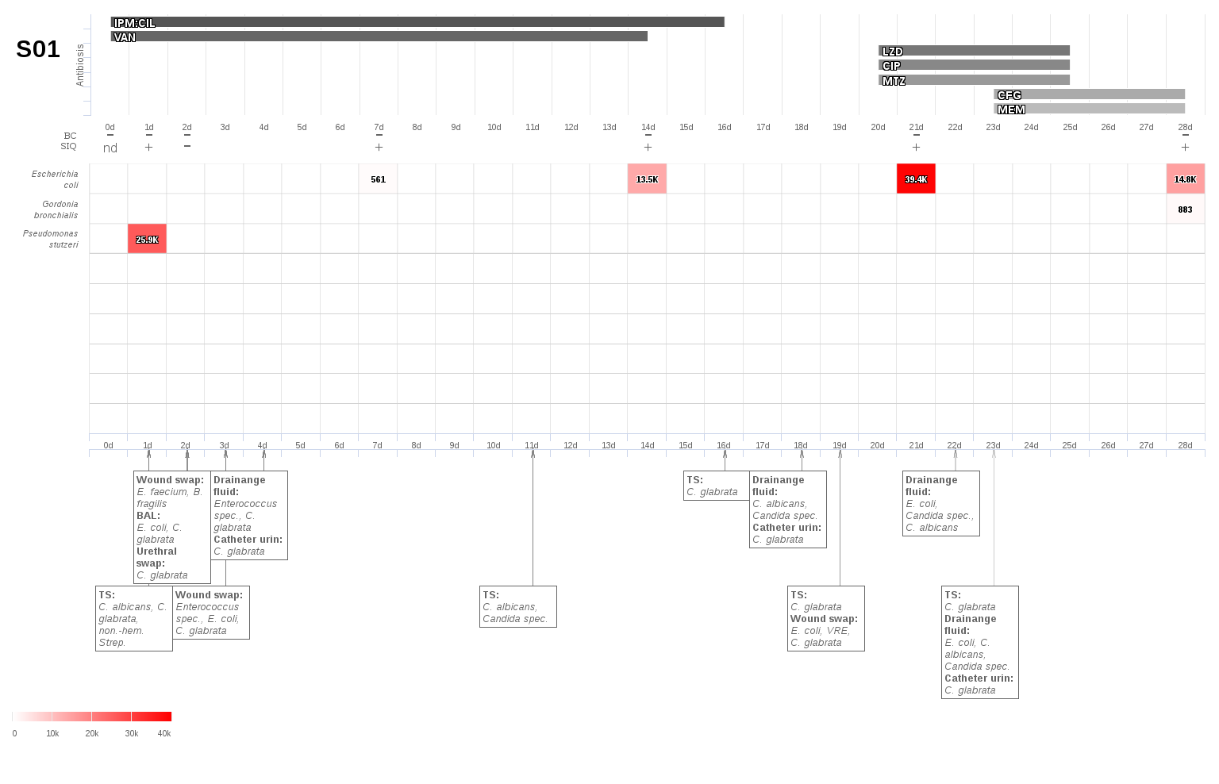
S2: Multiple intraabdominal abscesses due to colon necrosis following untwisting of a volvulus.
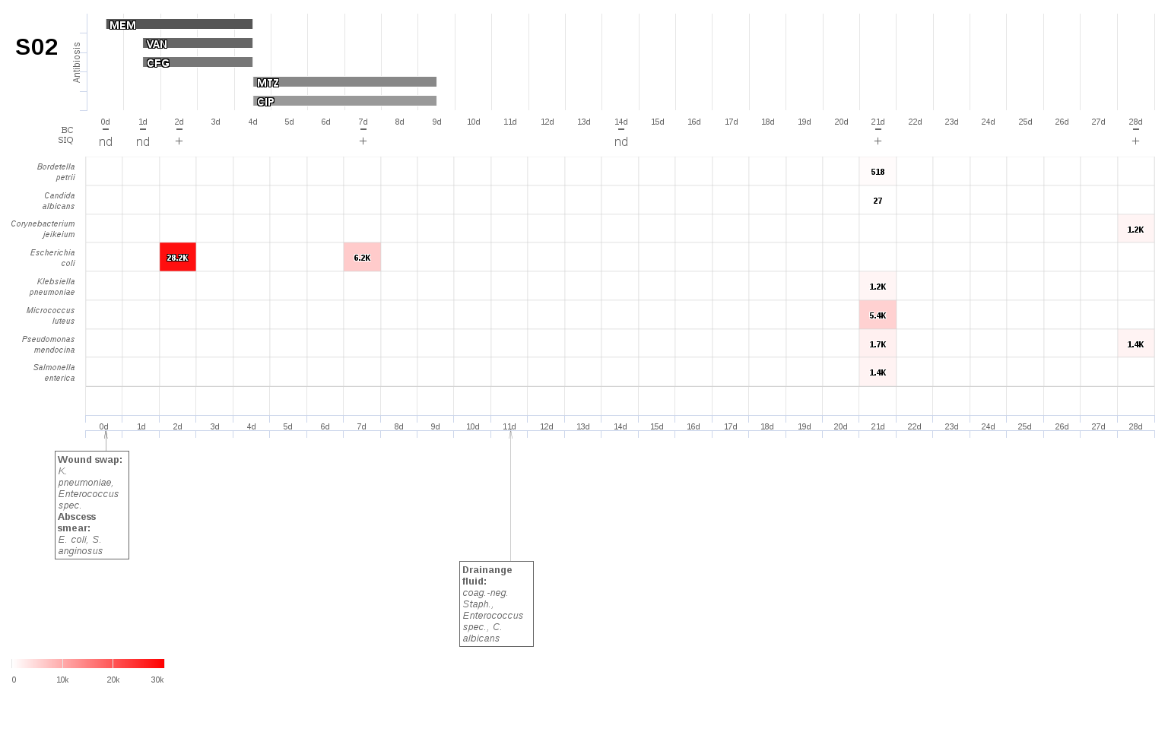
S3: Anastomotic insufficiency and infected hematoma following gastrectomy.
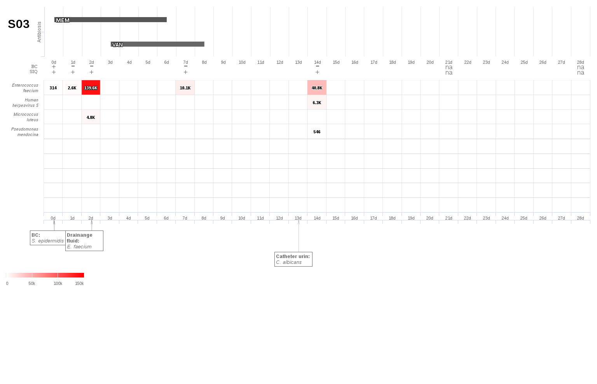
S4: Pneumonia following adhesiolysis of an obstructive ileus.
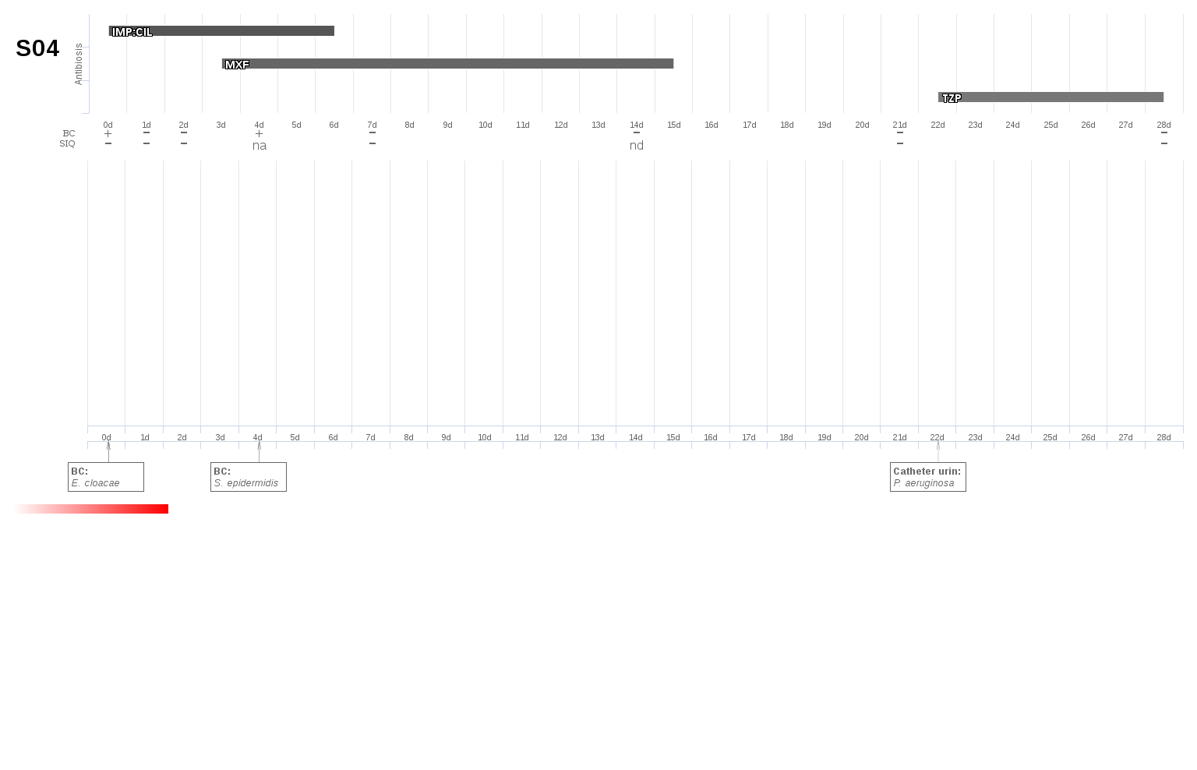
S5: Diffuse peritonitis with multiple abscesses following perforation of a sigmoid diverticulitis.
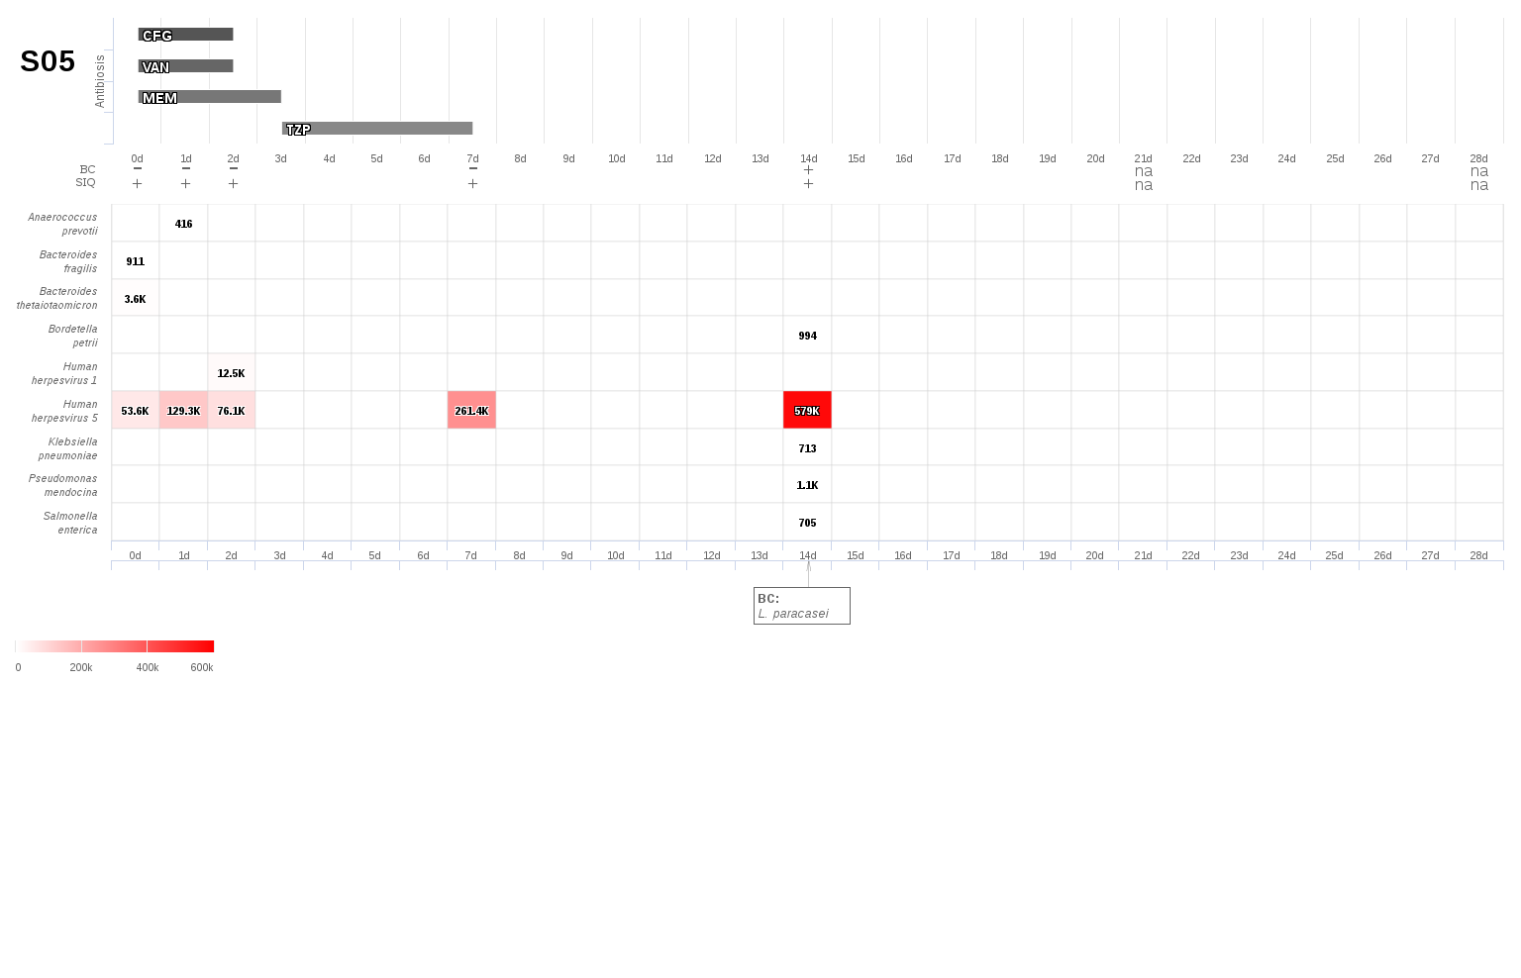
S6: Anastomotic insufficiency of the pancreaticojejunostomia with diffuse peritonitis following partial pancreaticoduodenectomy due to a cholangiocarcinoma.
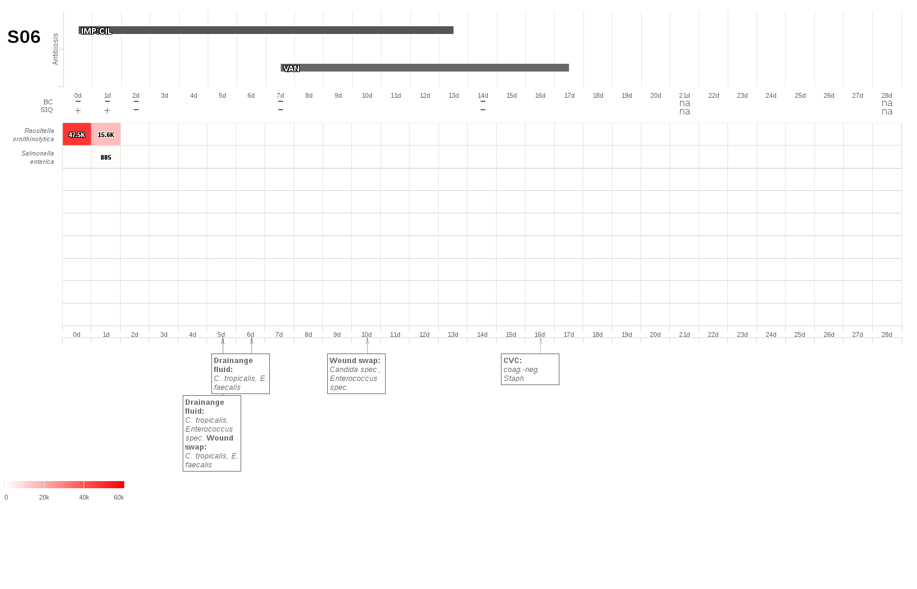
S7: Insufficiency of the esophagojejunostomia following total gastrectomy due to gastric cancer.
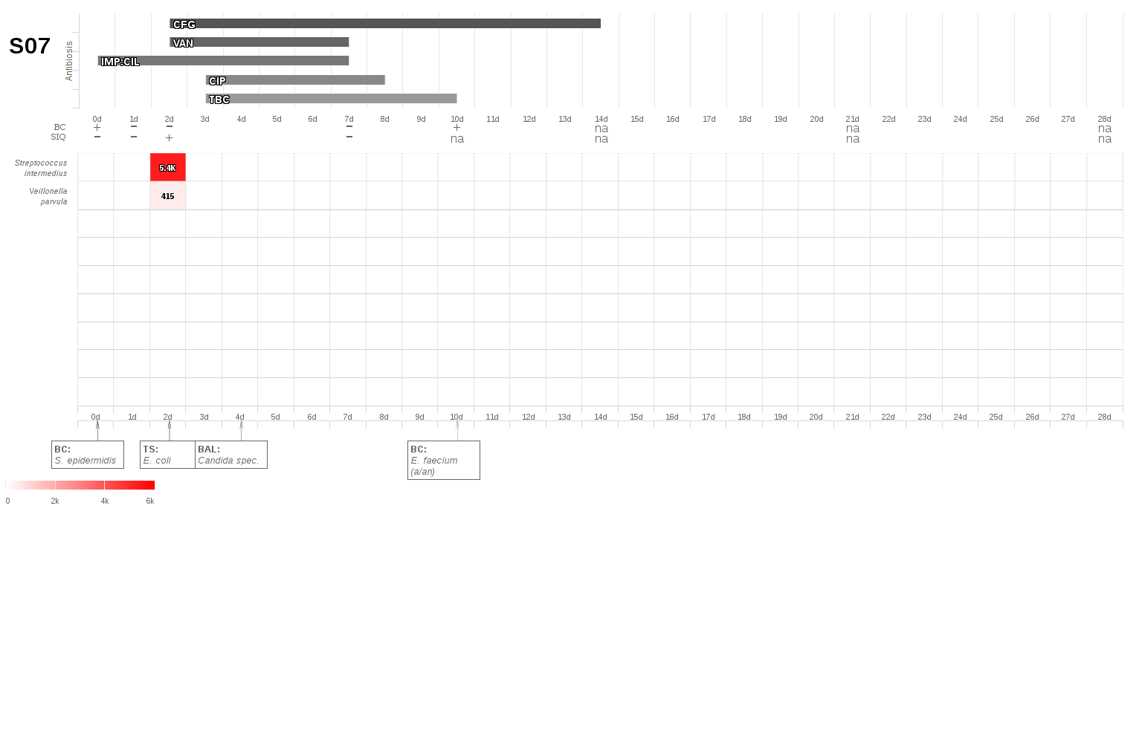
S8: Anastomotic insufficiency following esophagectomy due to esophageal cancer.
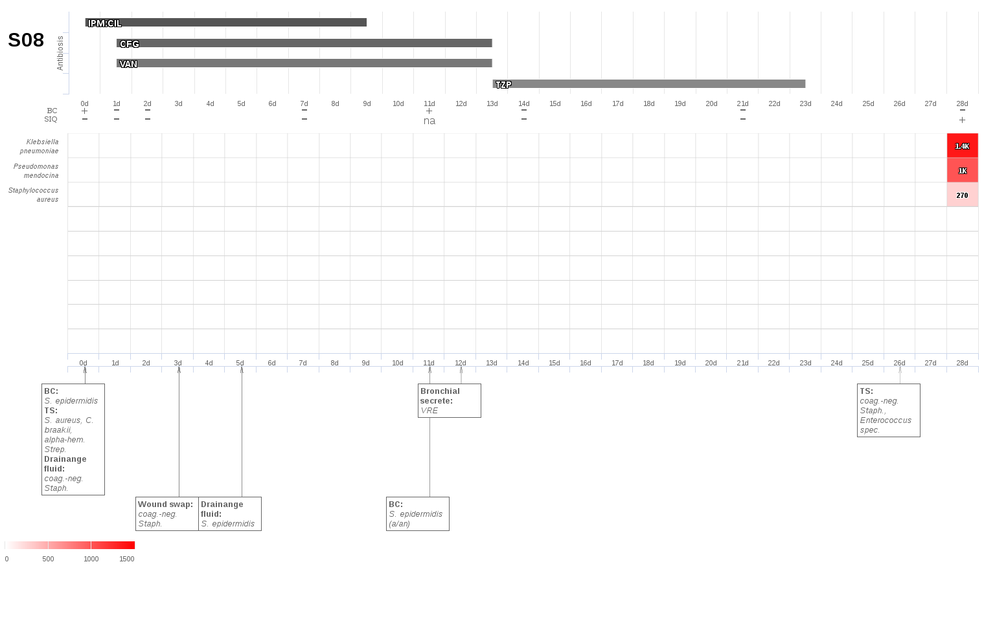
S9: Infected bilioma due to a biliary leakage following liver resection.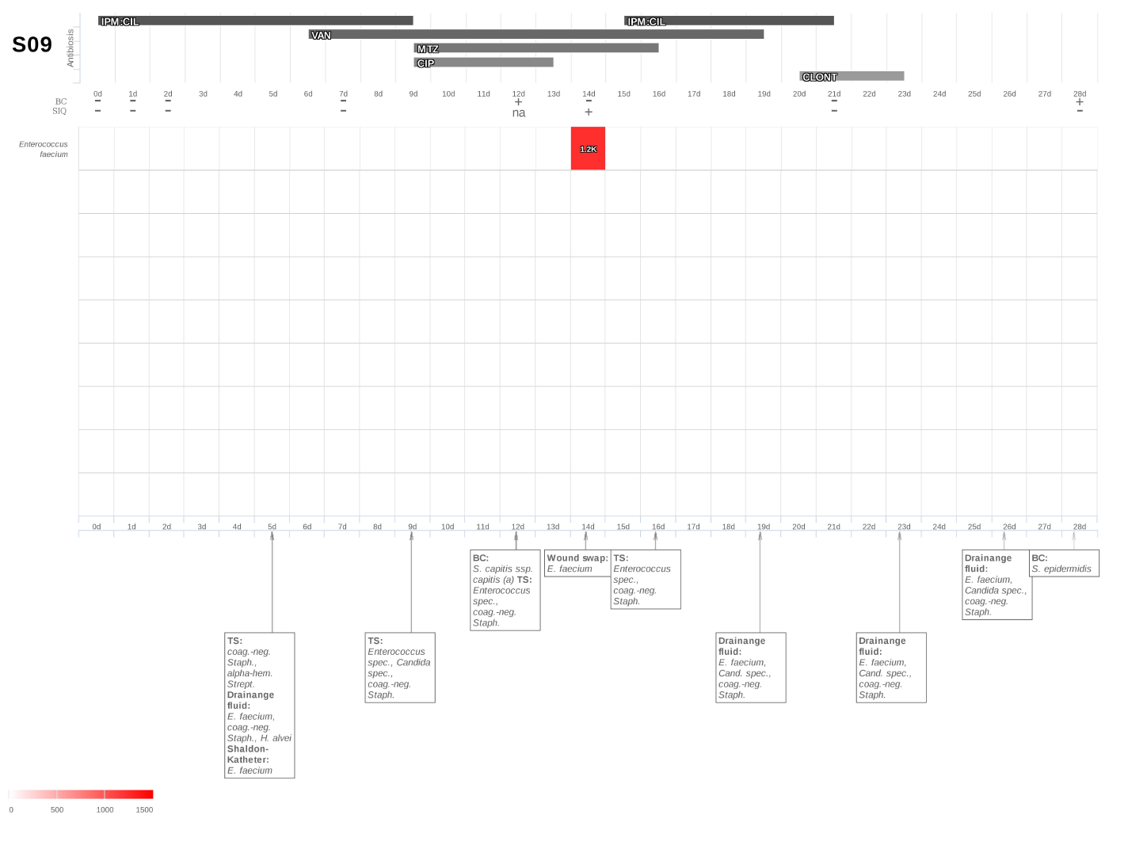
S10: Leakage of an ileostomy with accompanying diffuse peritonitis following bowel resection due to a liposarcoma
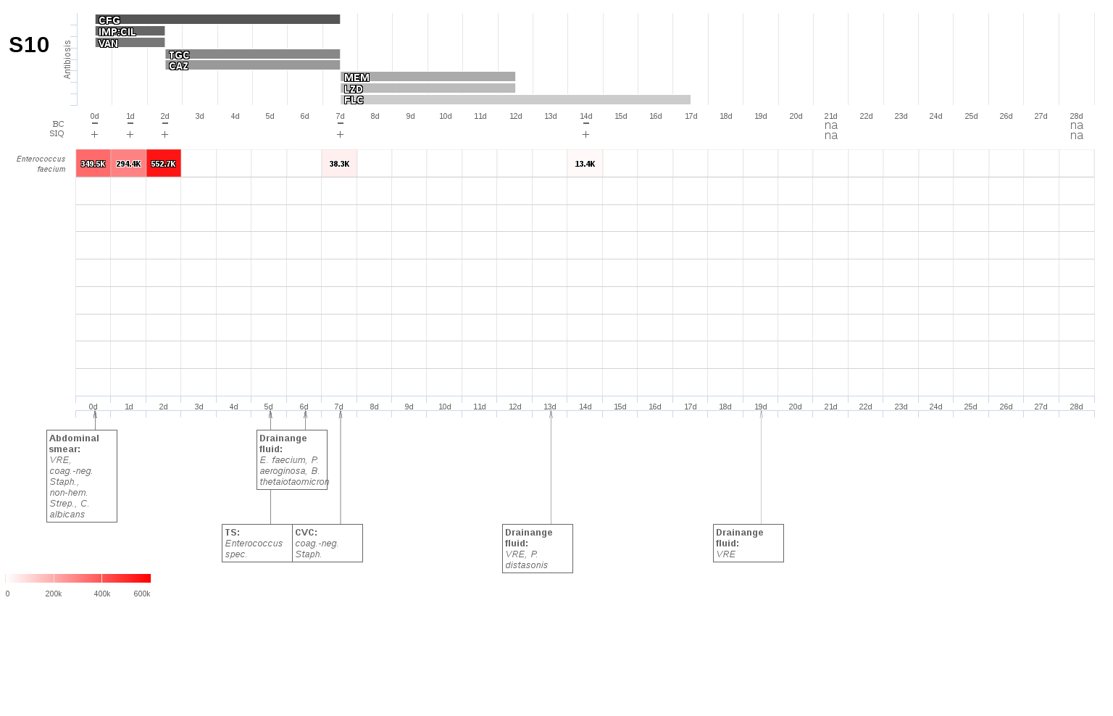
S11: Anastomotic insufficiency following pylorus-preserving pancreatoduodenectomy due to pancreatic cancer.
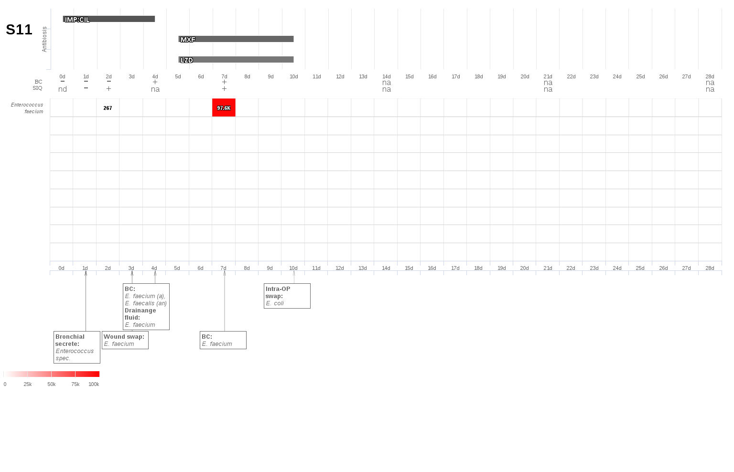
S12: Cecal perforation following liver resection due to a hepatocellular cancer
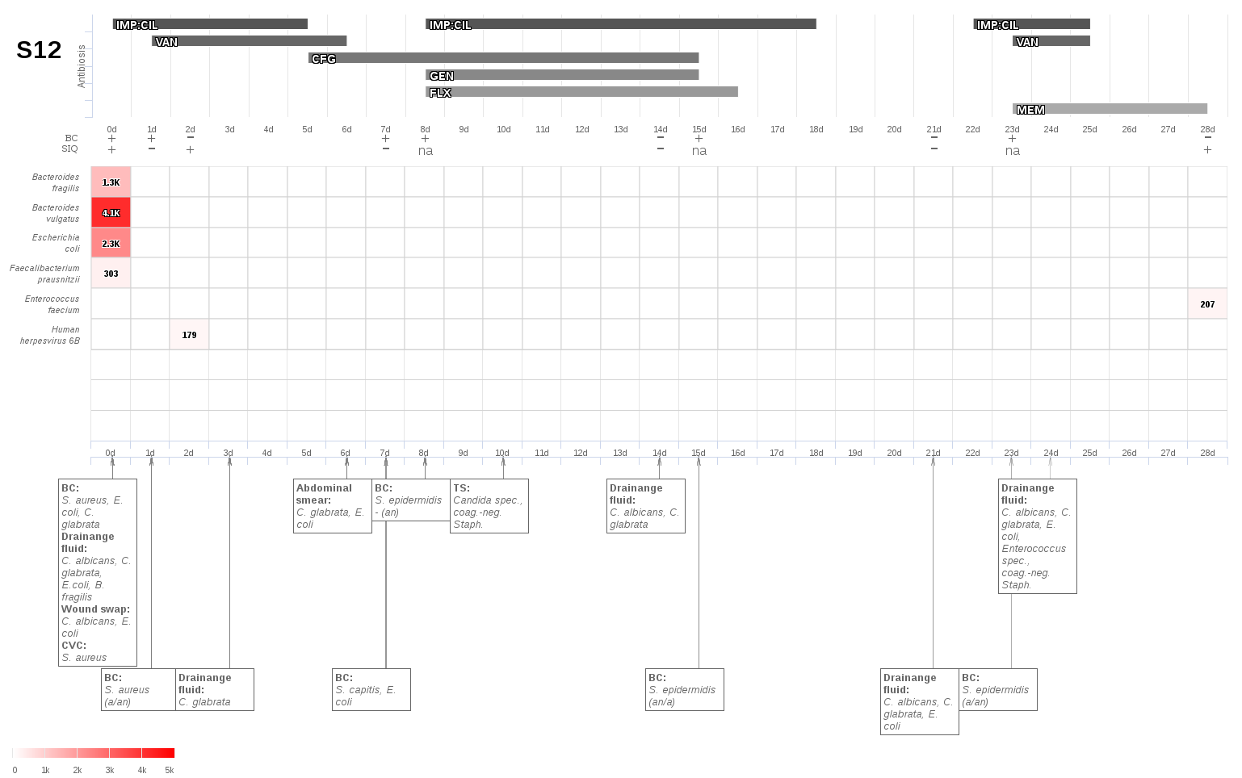
S13: Anastomotic insufficiency following sigma resection.
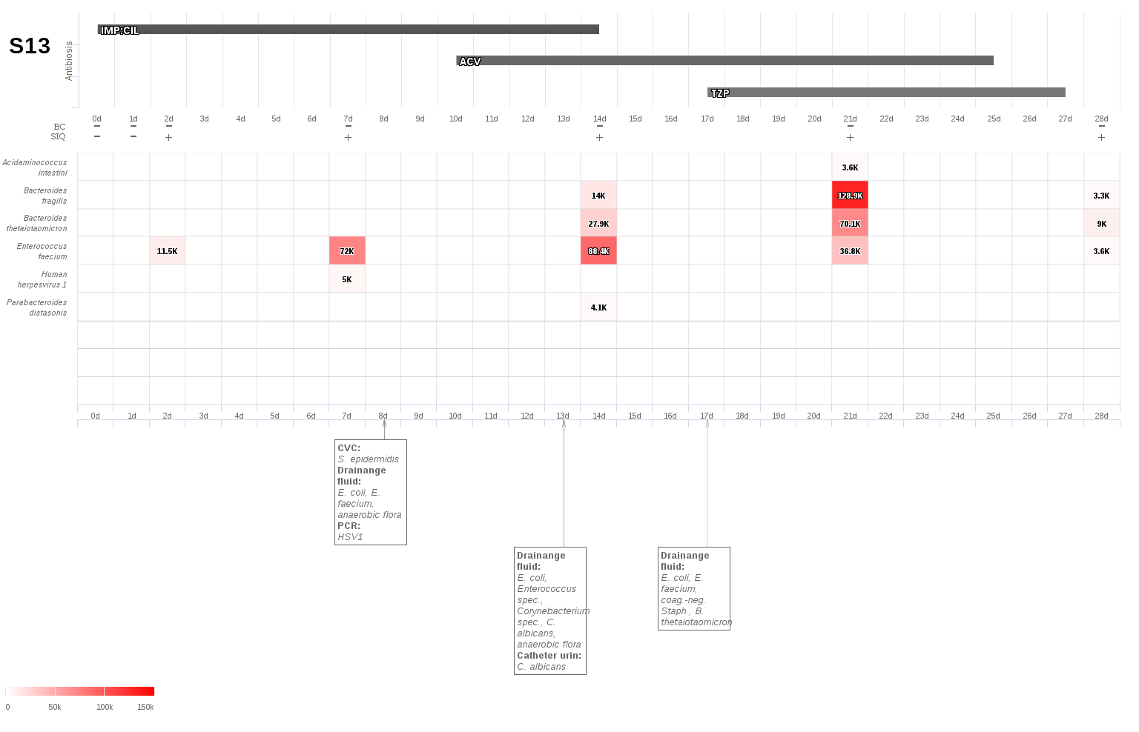
S14: Small bowel perforation following liver resection.
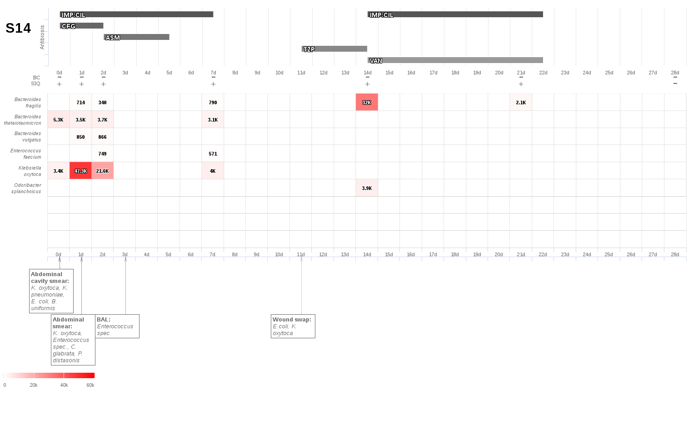
S15: Small bowel ischemia due to a volvulus.
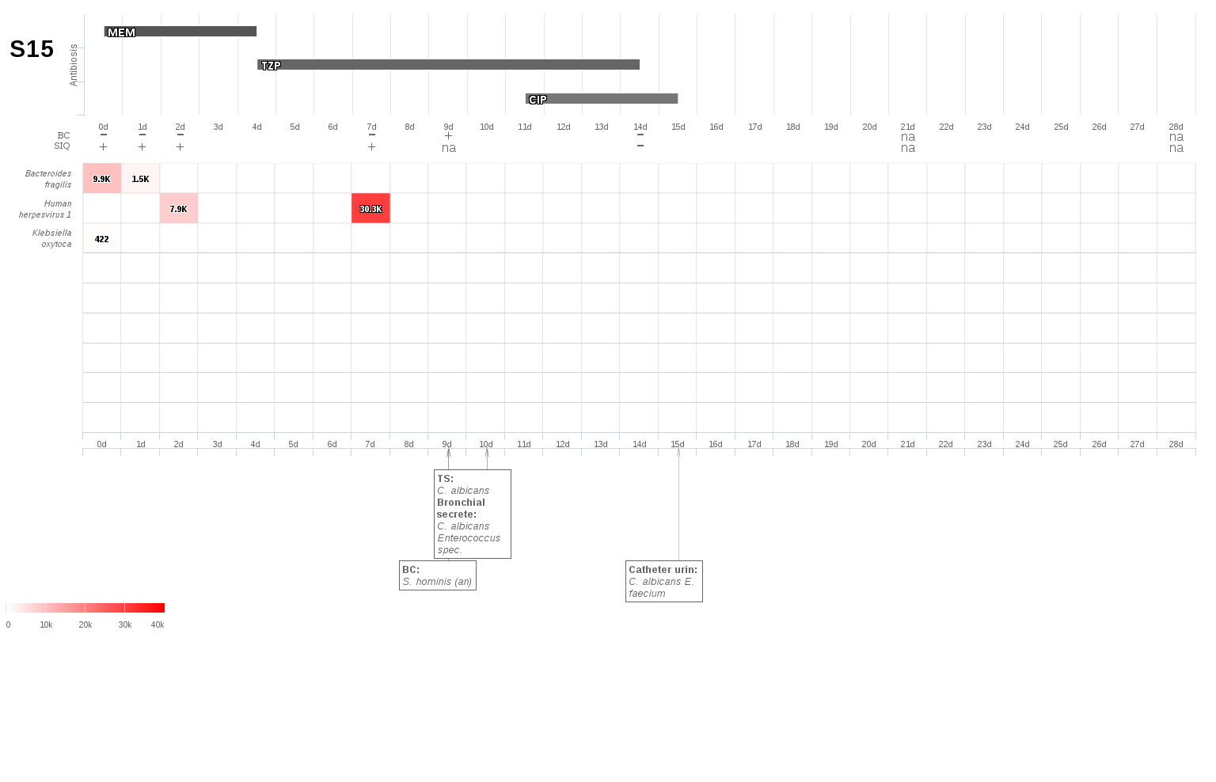
S16: Duodenal ulcer perforation following choledochotomy and total gastrectomy due to cholangiocarcinoma.
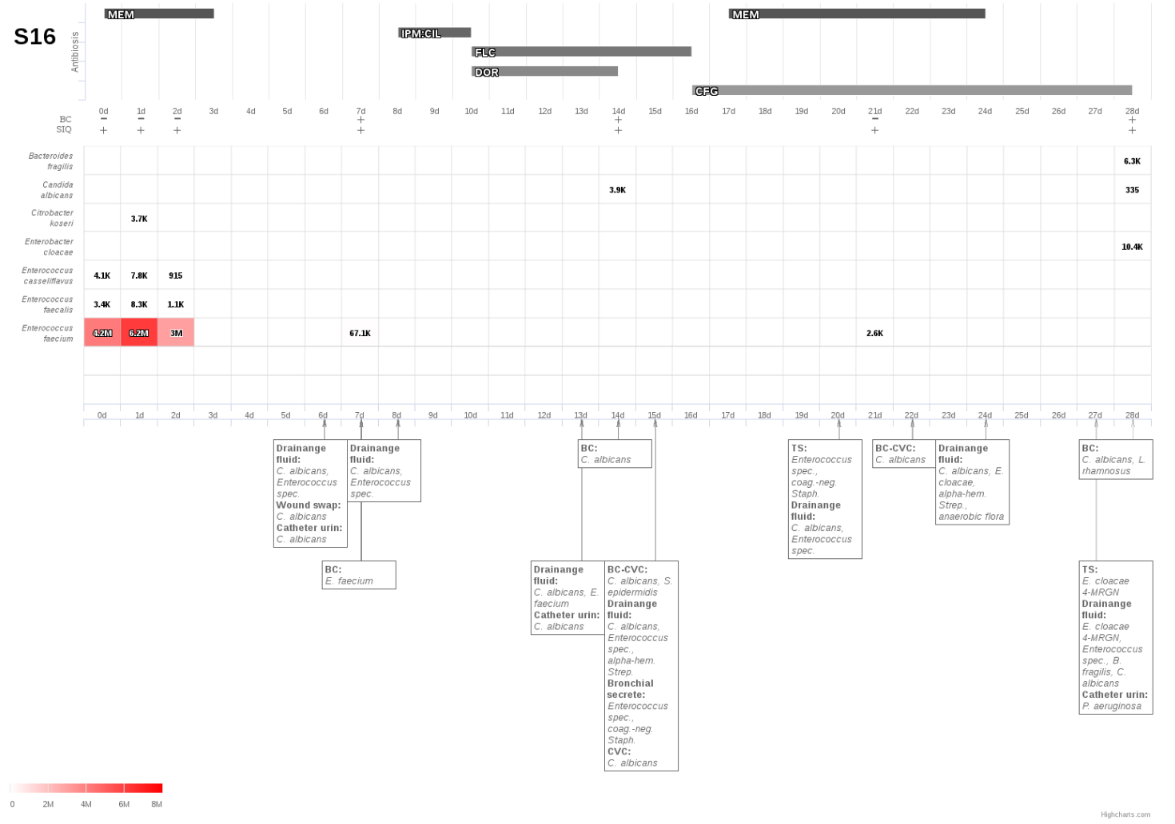
S17: Sigmoid perforation due to sigmoid diverticulitis.
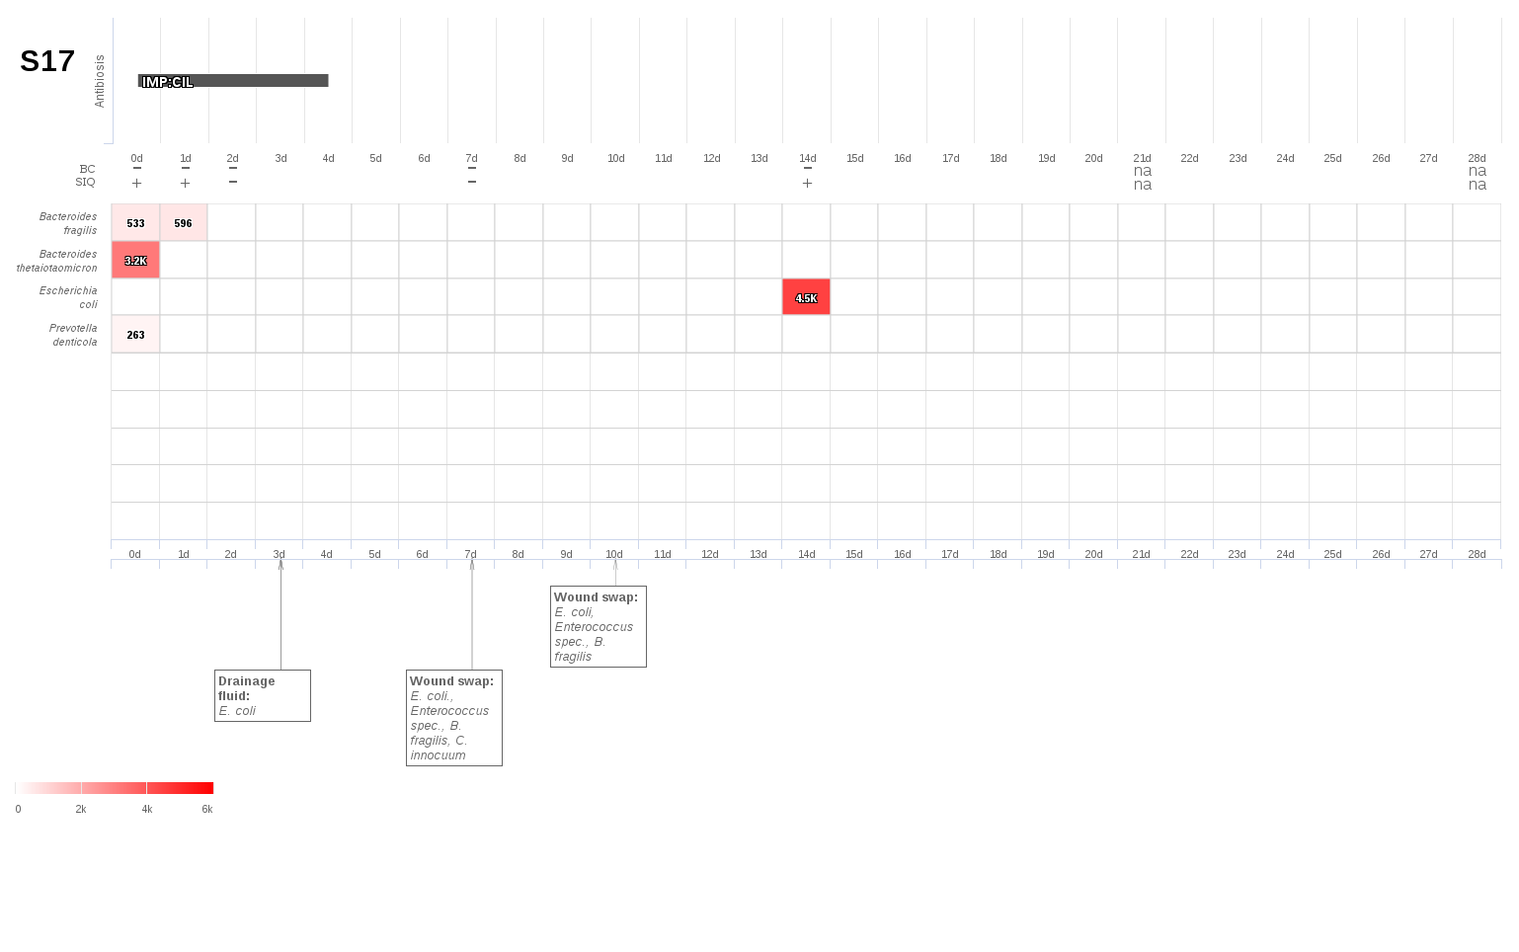
S19: Toxic megacolon with perforation due to a pseudomembranous colitis.
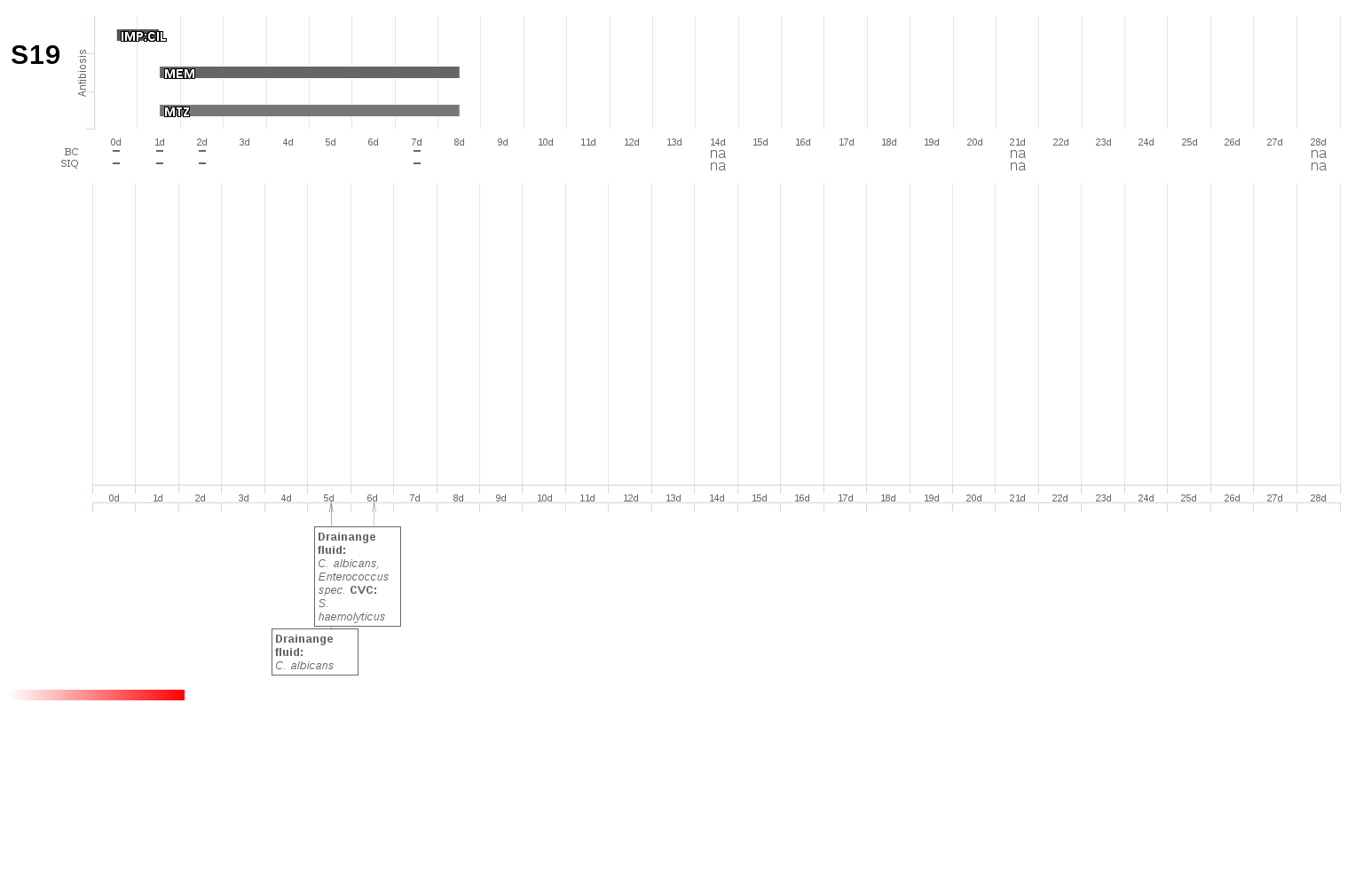
S20: Urosepsis due to ureteral calculus.
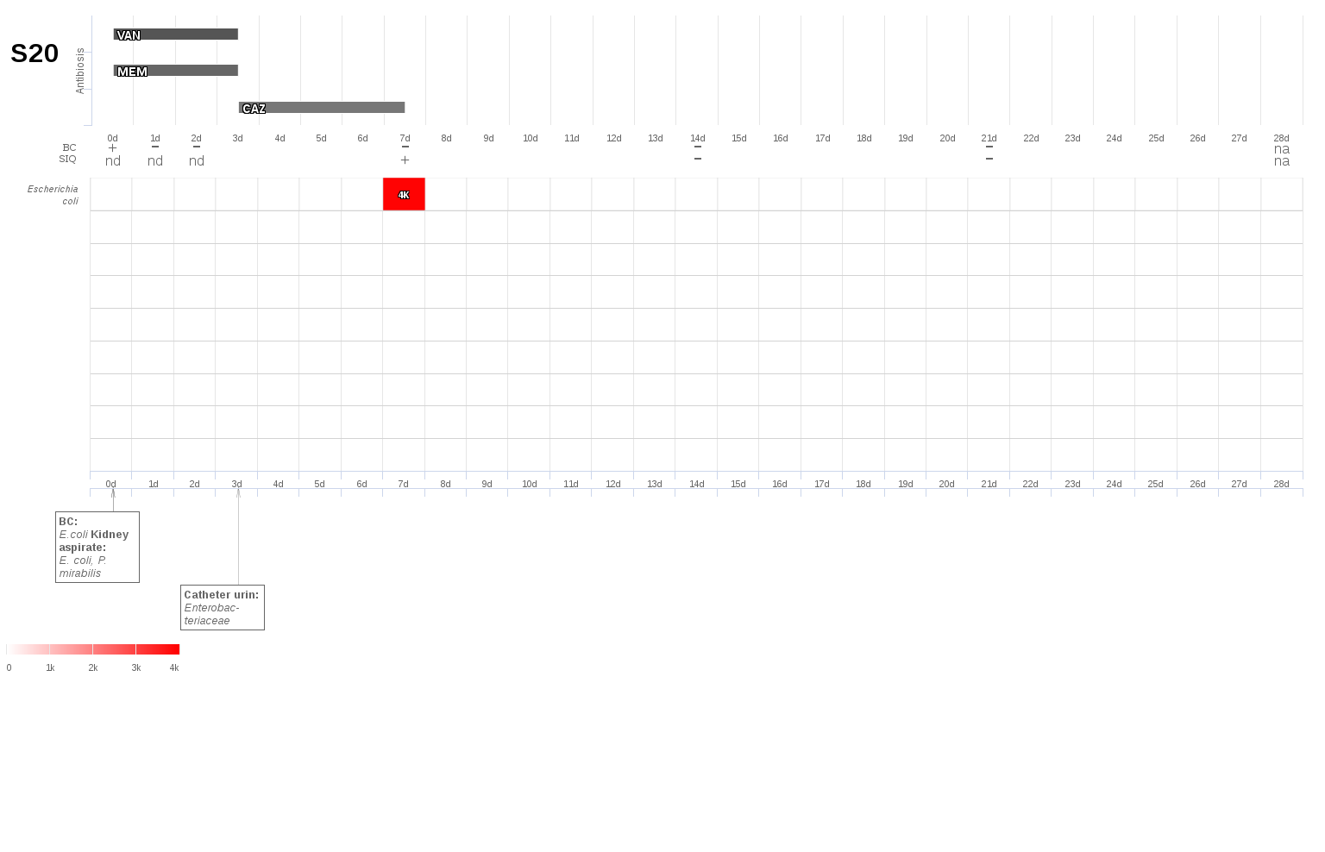
S21: Jejunal perforation due to a mechanical ileus.
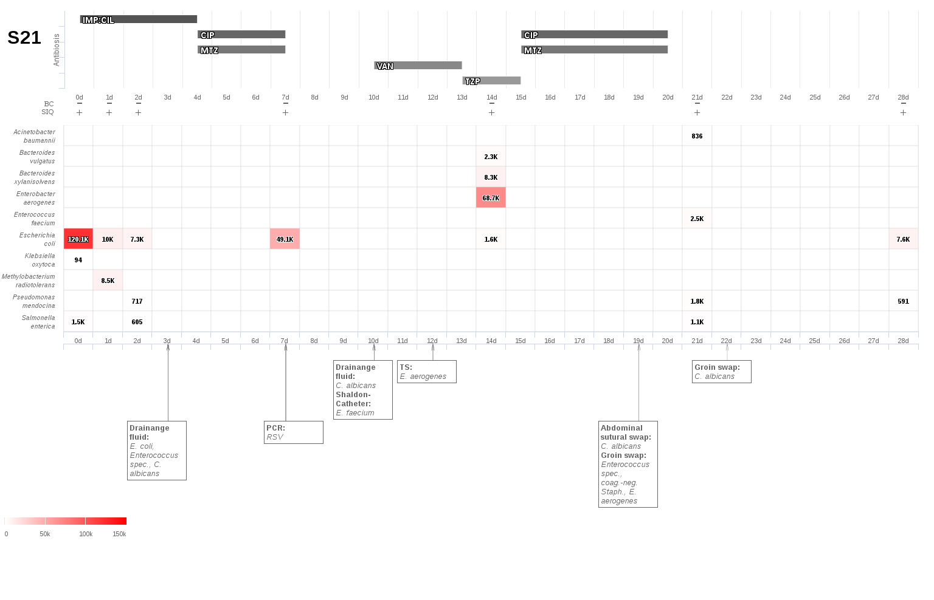
S22: Anastomotic insufficiency with diffuse peritonitis following hemicolectomy with ileotransversostomy
S23: Cecal perforation with diffuse peritonitis and acute cholecystitis.
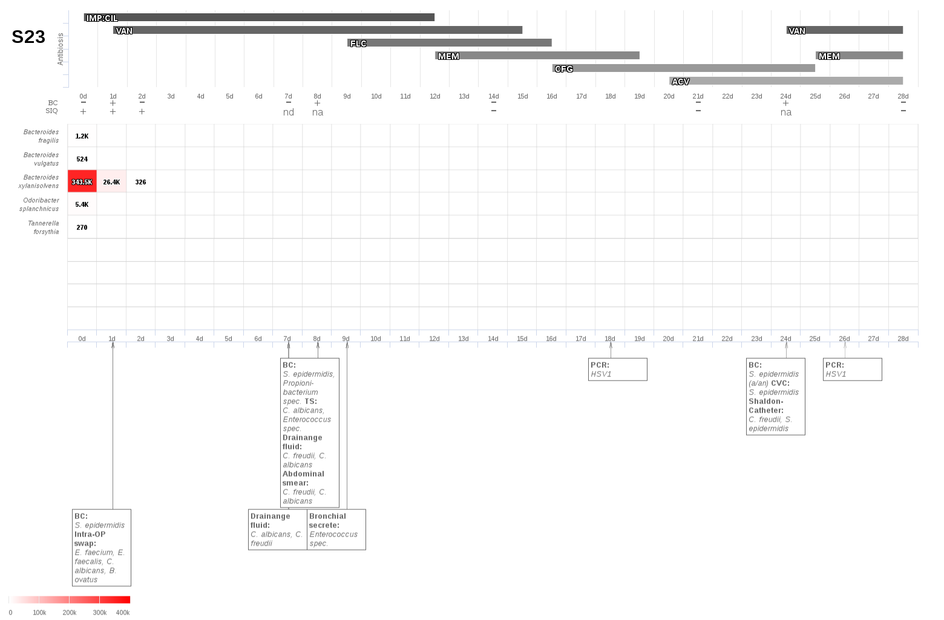
S24: Torsion of the intestines following a gastric bypass.
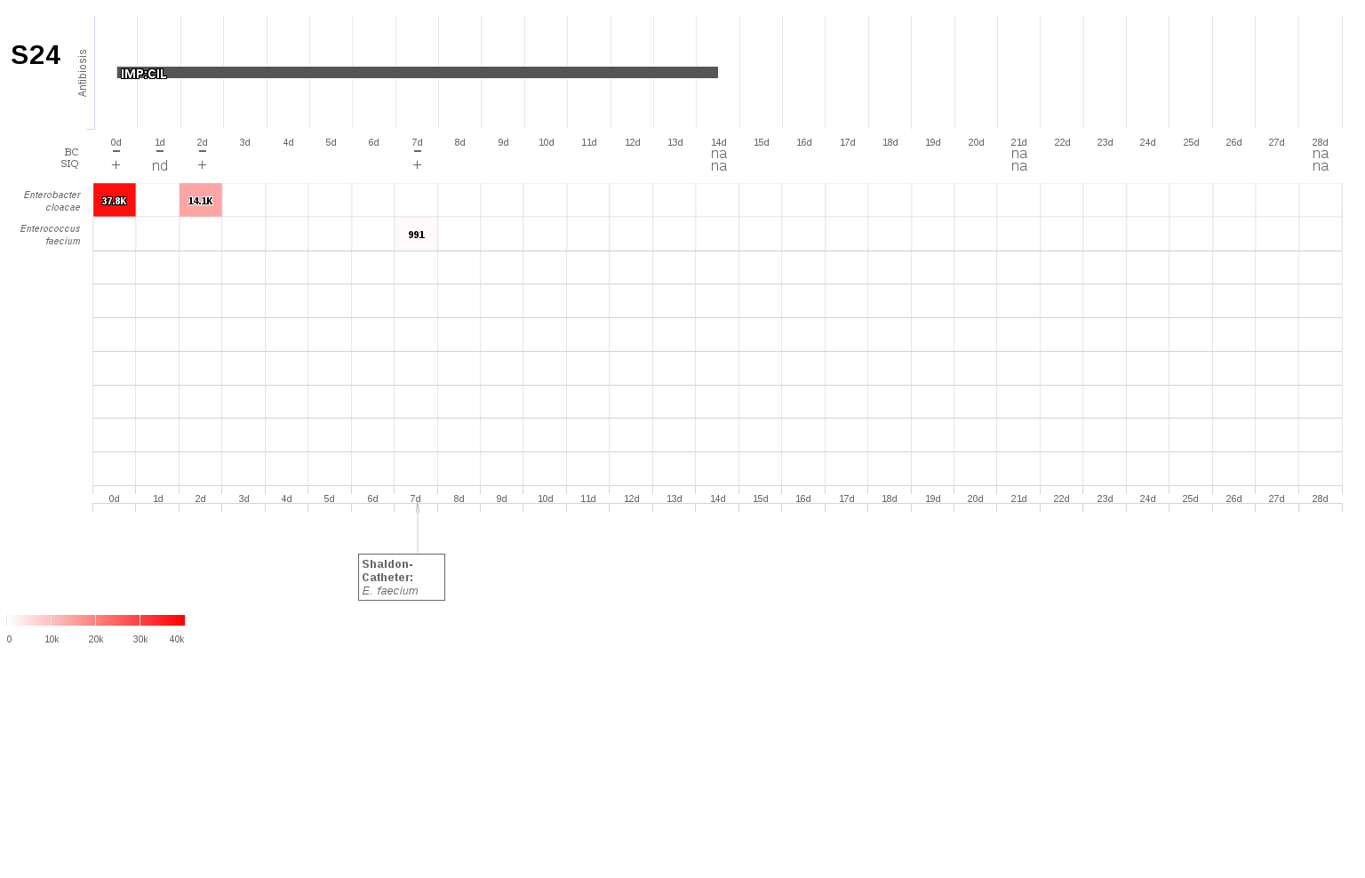
S25: Pleural empyema following liver resection due to a hilar cholangiocarcinoma (Klatskin tumor).
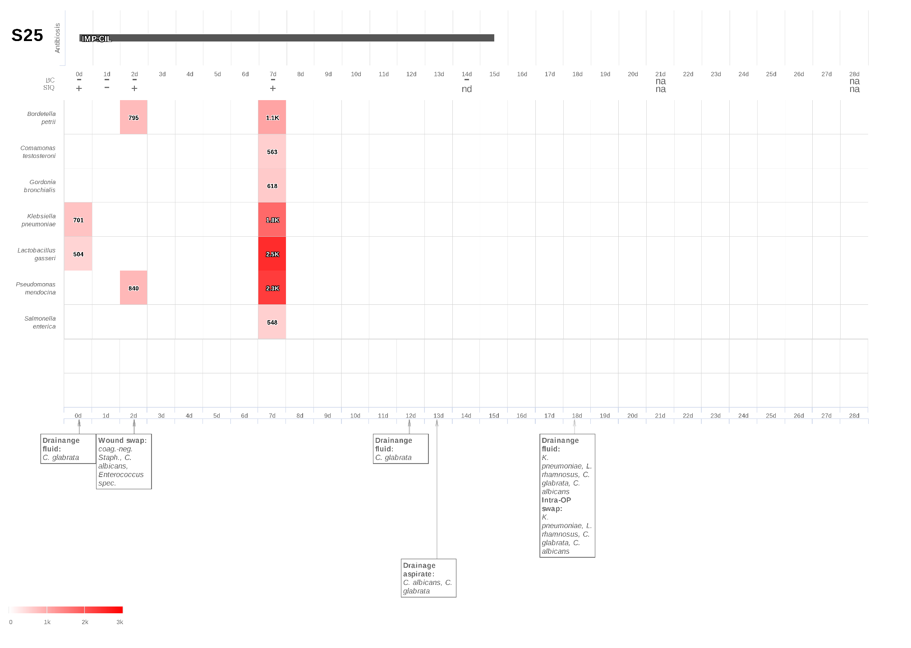
S26: Colon and small bowel ischemia.
S27: Anastomotic insufficiency with diffuse peritonitis following proctocelectomy due to colitis ulcerosa.
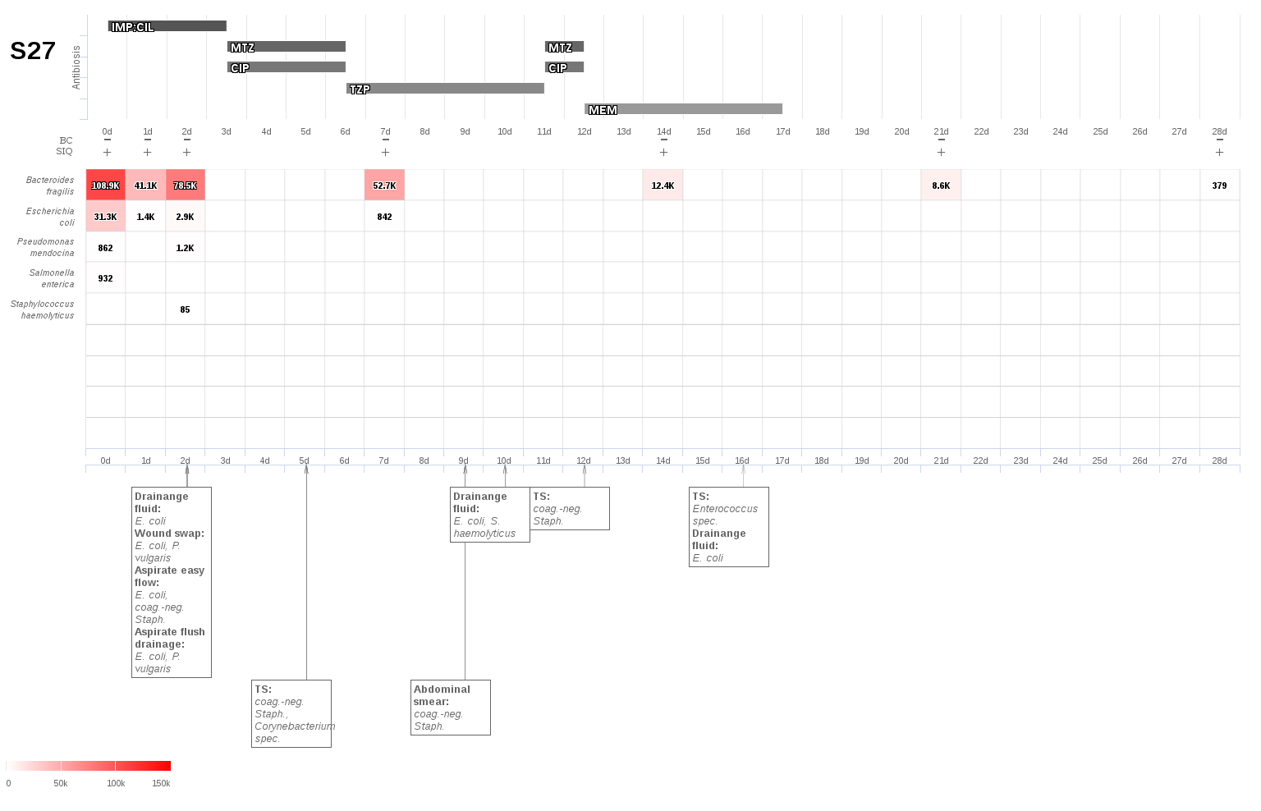
S29: Cecal perforation with diffuse peritonitis.
S30: Necrotizing pancreatitis following pancreatoduodenectomy.
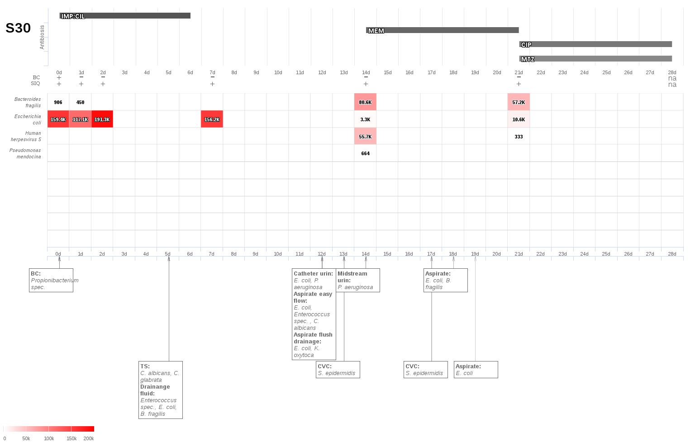
S32: Infected bilioma and biliary leakage following cholecystectomy due to a hepatic metastatic pancreatic cancer.
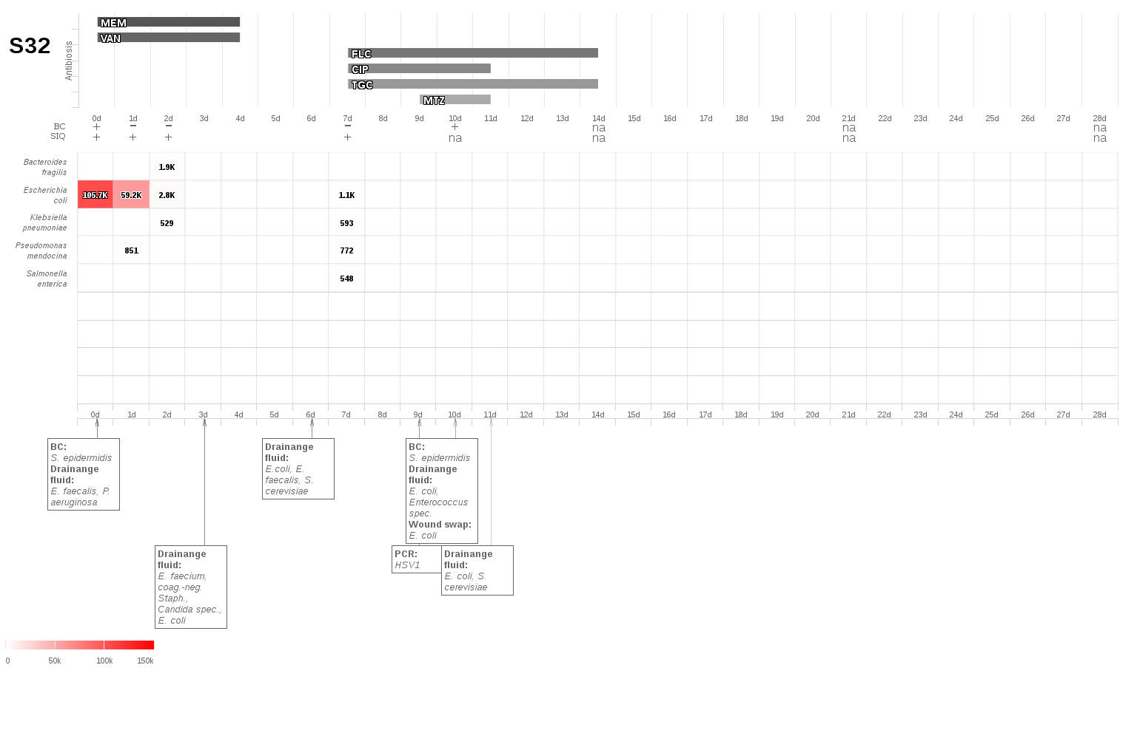
S33: Megacolon with perforation and diffuse peritonitis.
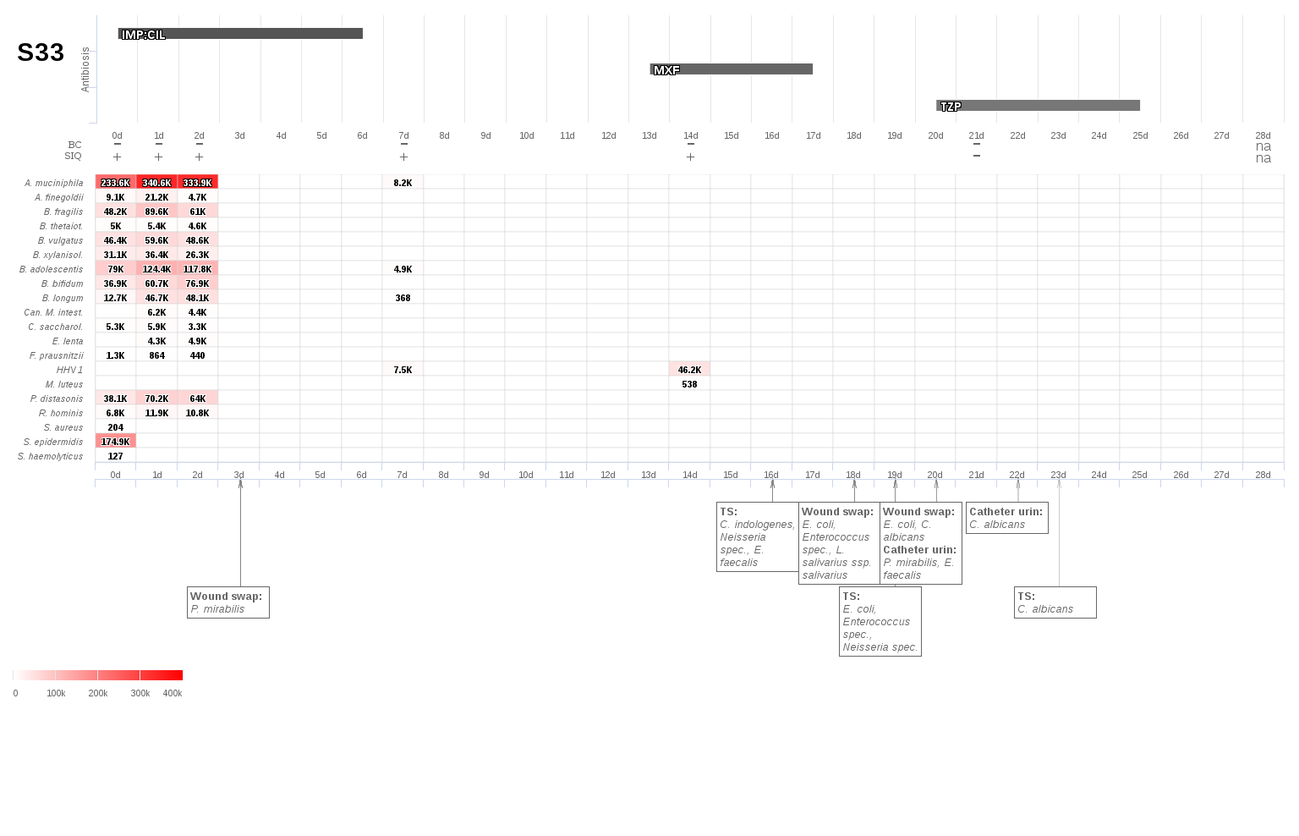
S34: Anastomotic insufficiency with diffuse peritonitis following hemicolectomy due to colon cancer.
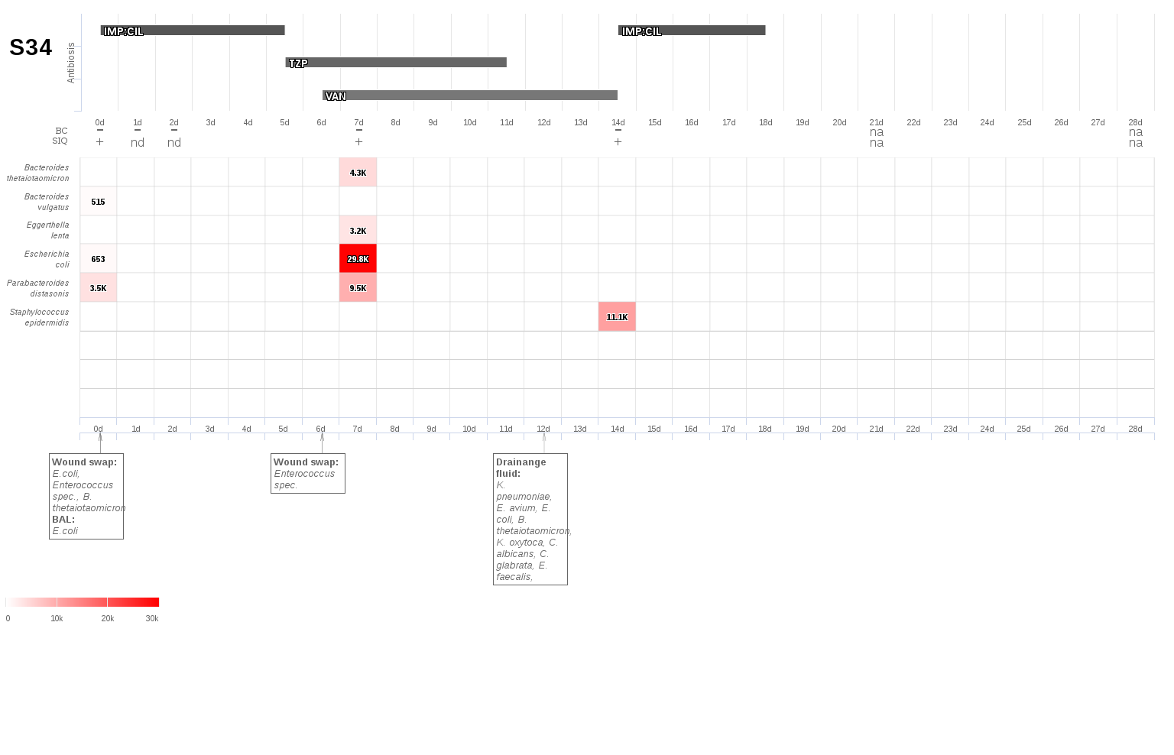
S35: Perforation of the colon following resection of the lower lobe of the right lung due to a liver abscess.
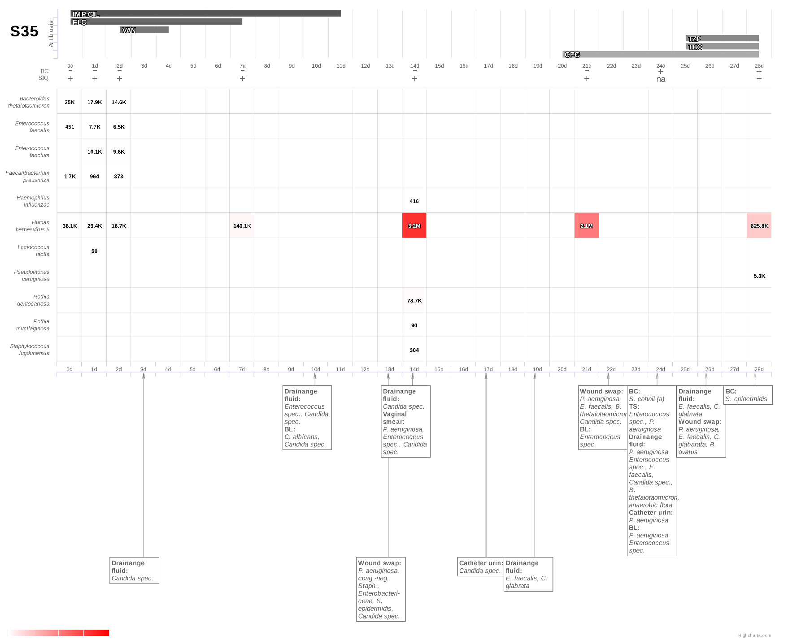
S37: Pneumonia and anastomotic insufficiency following distal esophagectomy due to a gastric cancer.
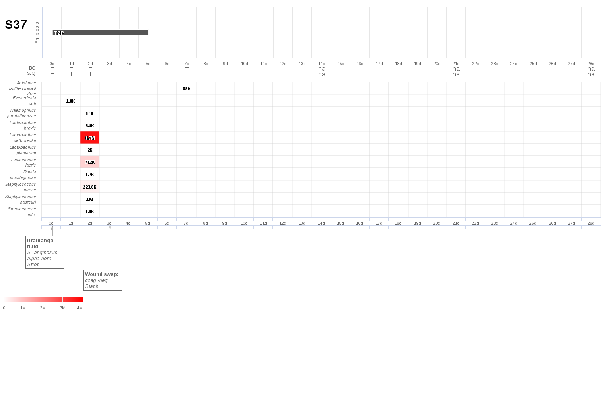
S38: Anastomotic insufficiency of the biliodigestive anastomosis following liver resection due to a hilar cholangiocarcinoma (klatskin tumor).
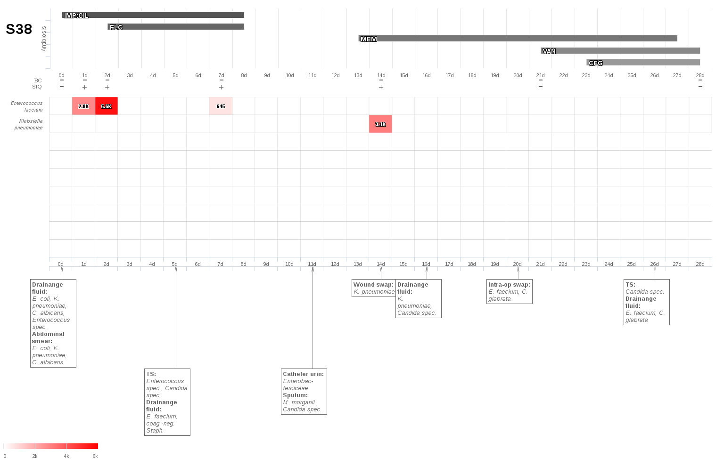
S39: Anastomotic insufficiency following anterior rectum resection.
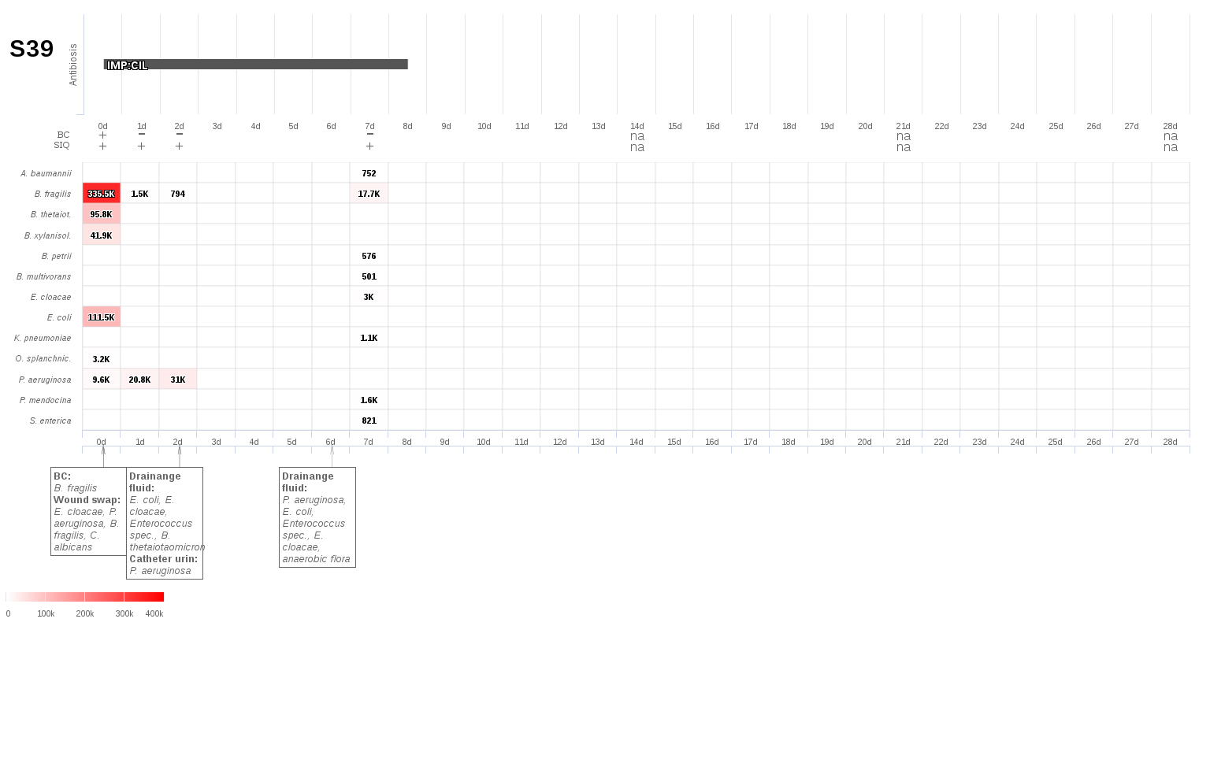
S41: Perforation of the colon due to multiple desmoids.
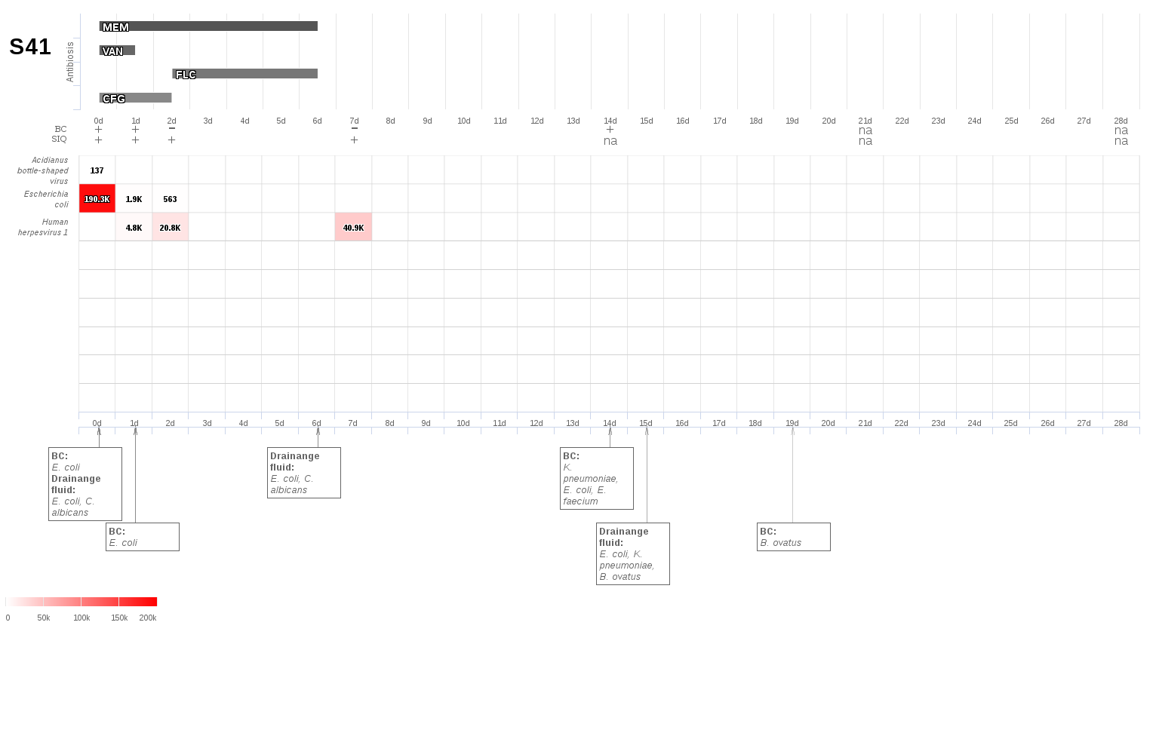
S42: Small bowel perforation due to a mechanical ileus with aspiration pneumonia.
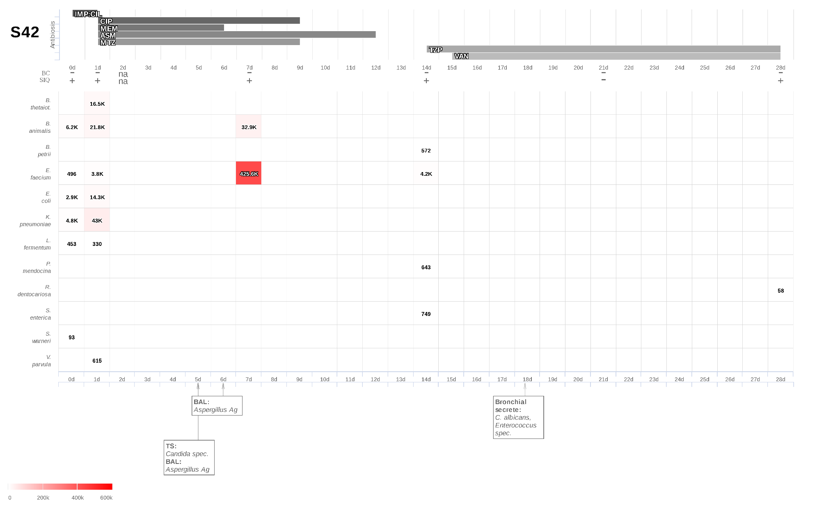
S43: Aspiration pneumonia due to a postoperative ileus.
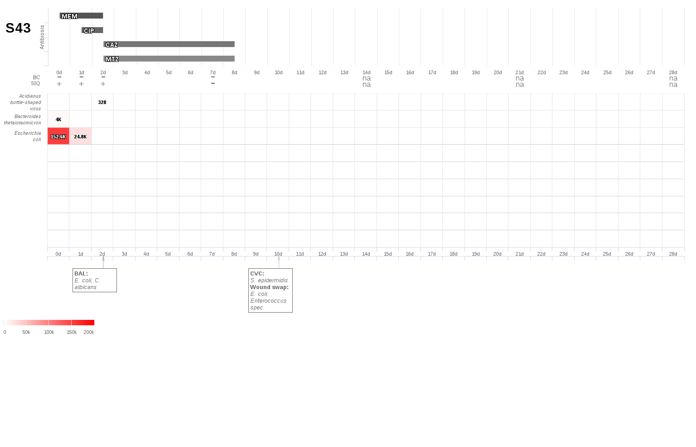
S44: Anastomotic insufficiency following duodenectomy due to a duodenal adenomatosis.
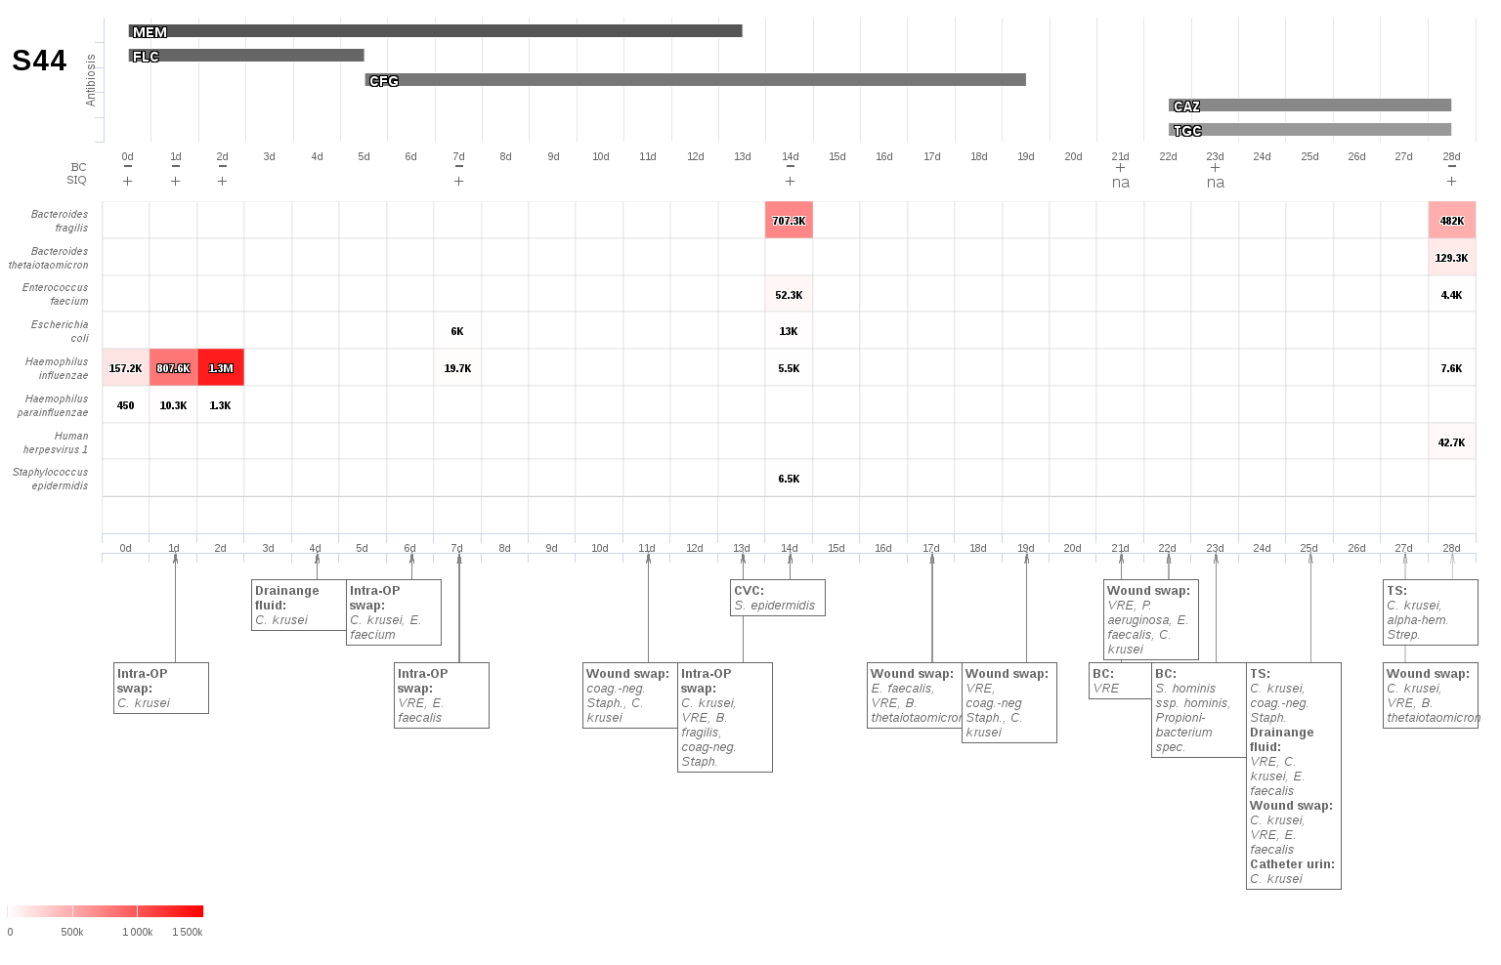
S45: Pneumonia following hernia repair.
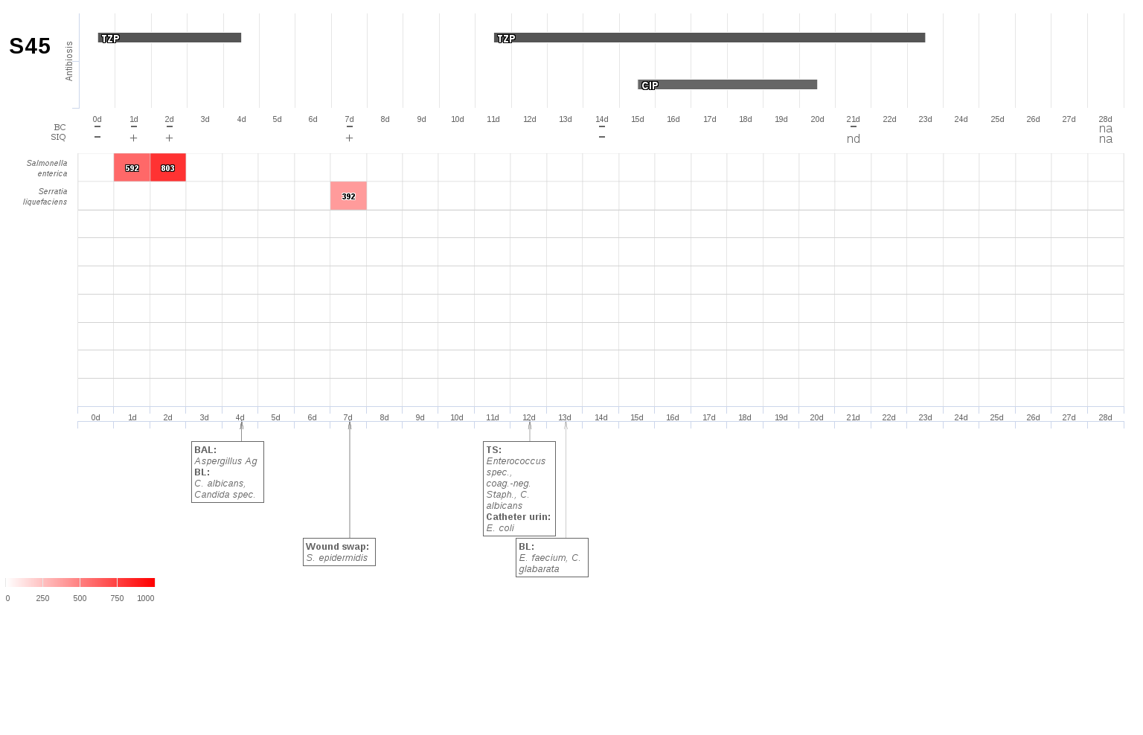
S46: Biliary leakage with peritonitis following thrombectomy of the inferior vena cava due to advanced renal cell cancer.
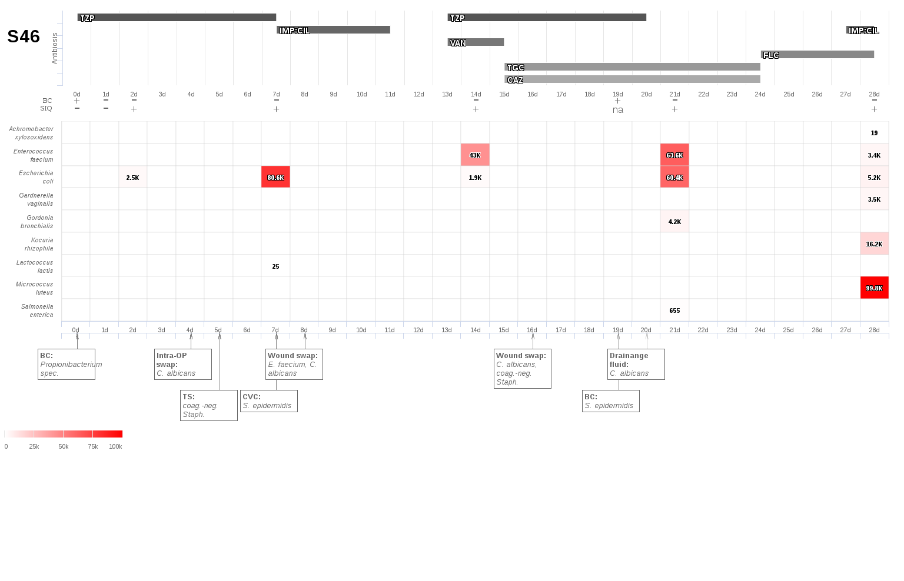
S47: Perforation of the colon ascendens due to colon cancer.
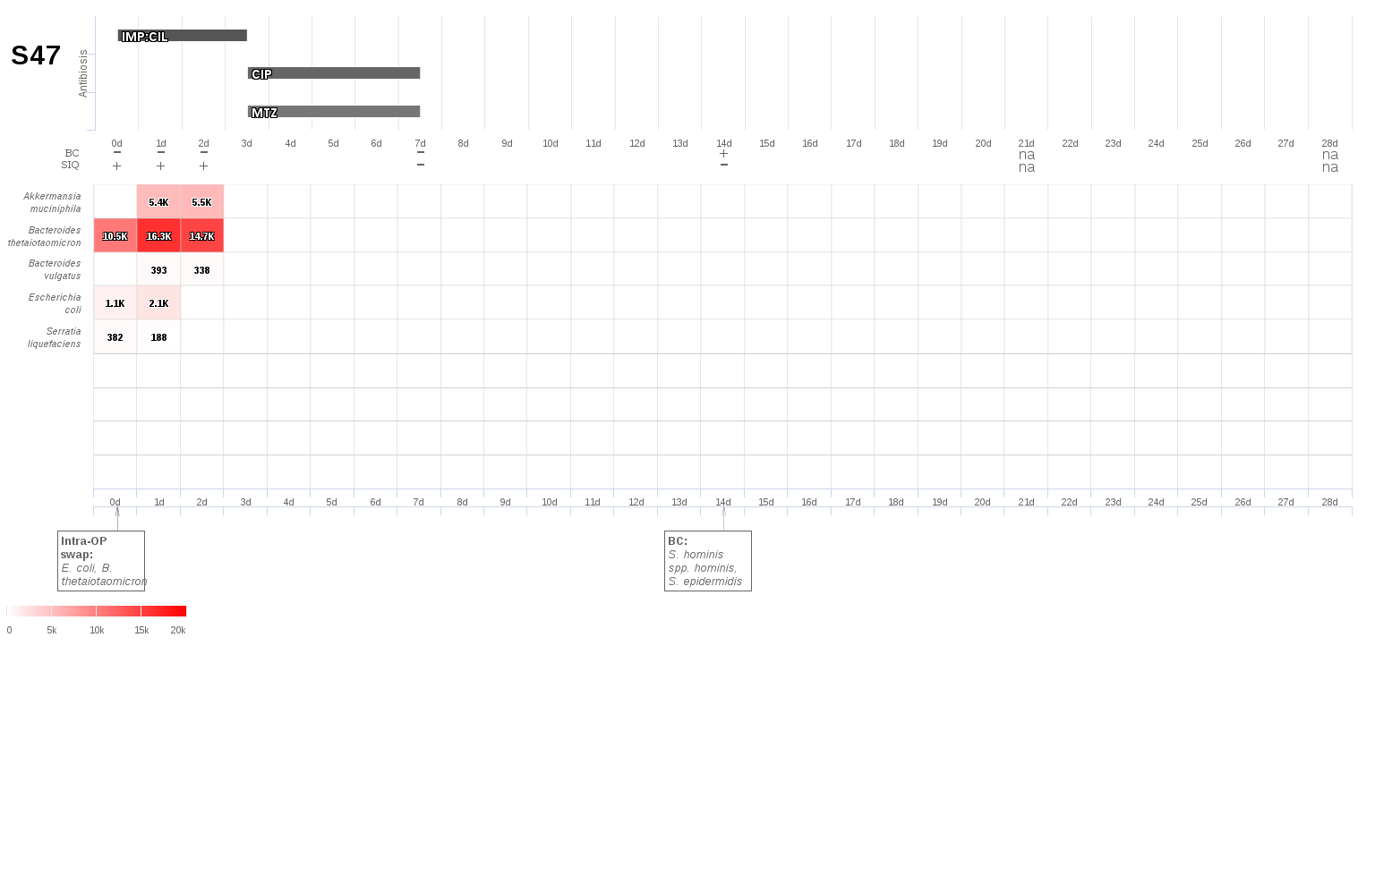
S48: Aspiration pneumonia following total gastrectomy.
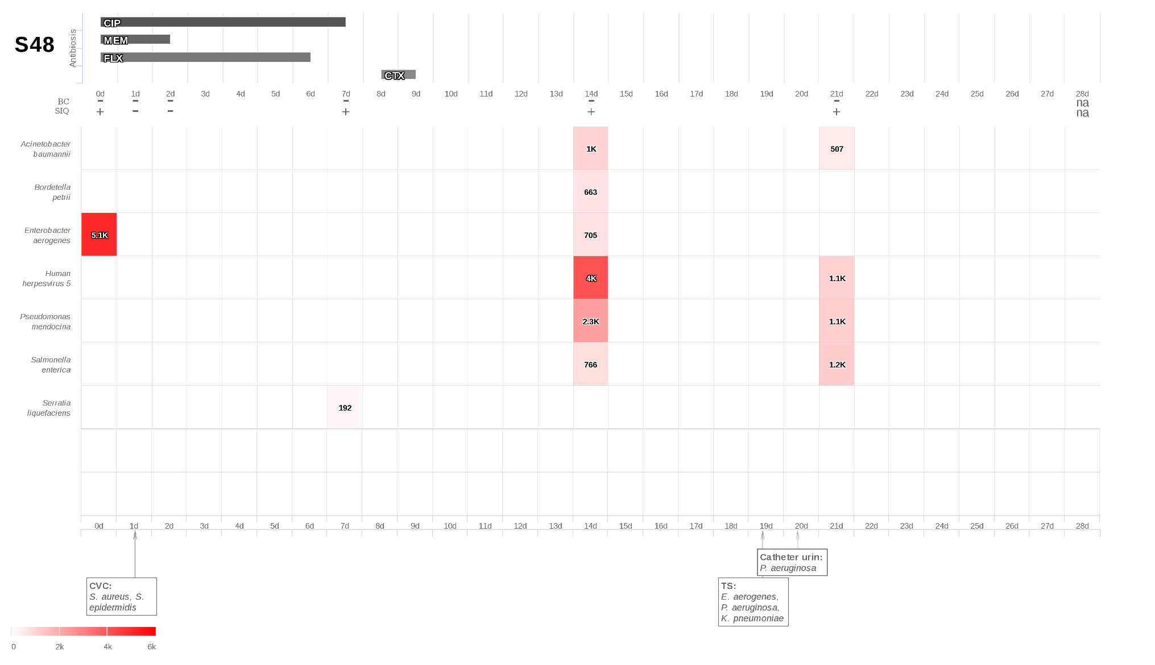

S49: Aspiration pneumonia due to acute necrotizing pancreatitis.
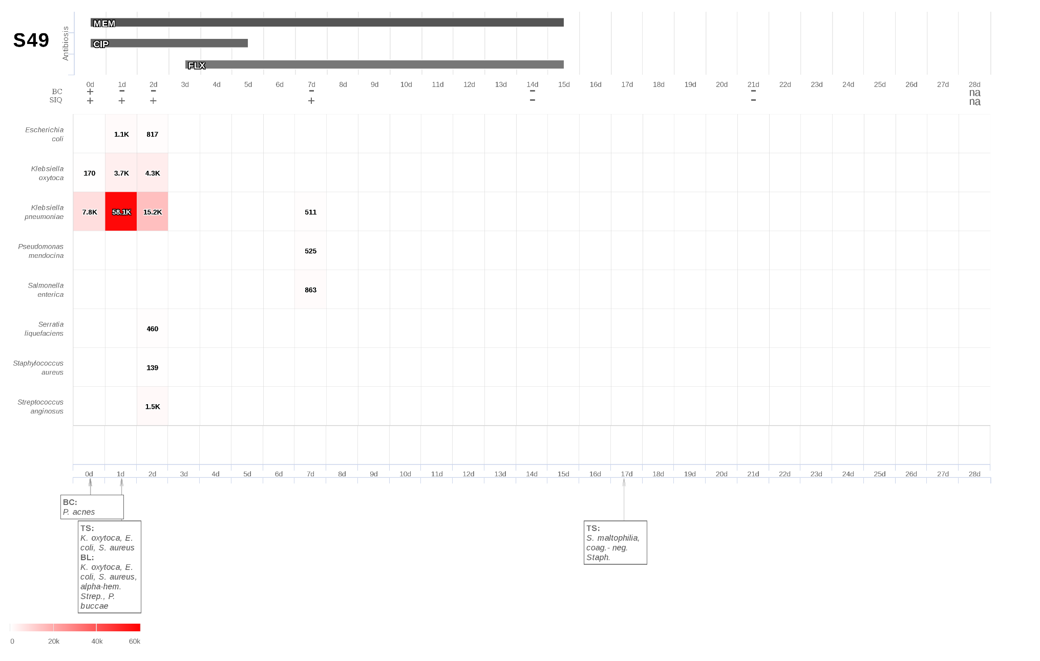
S50: Anastomotic insufficiency following anterior rectum resection.

S51: Perforation of the small bowels following hysterectomy.
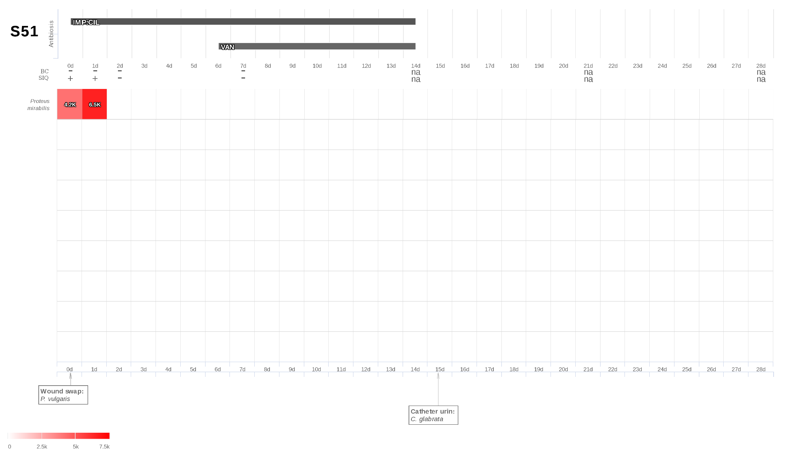

S52: Aspiration pneumonia due to a mechanical ileus
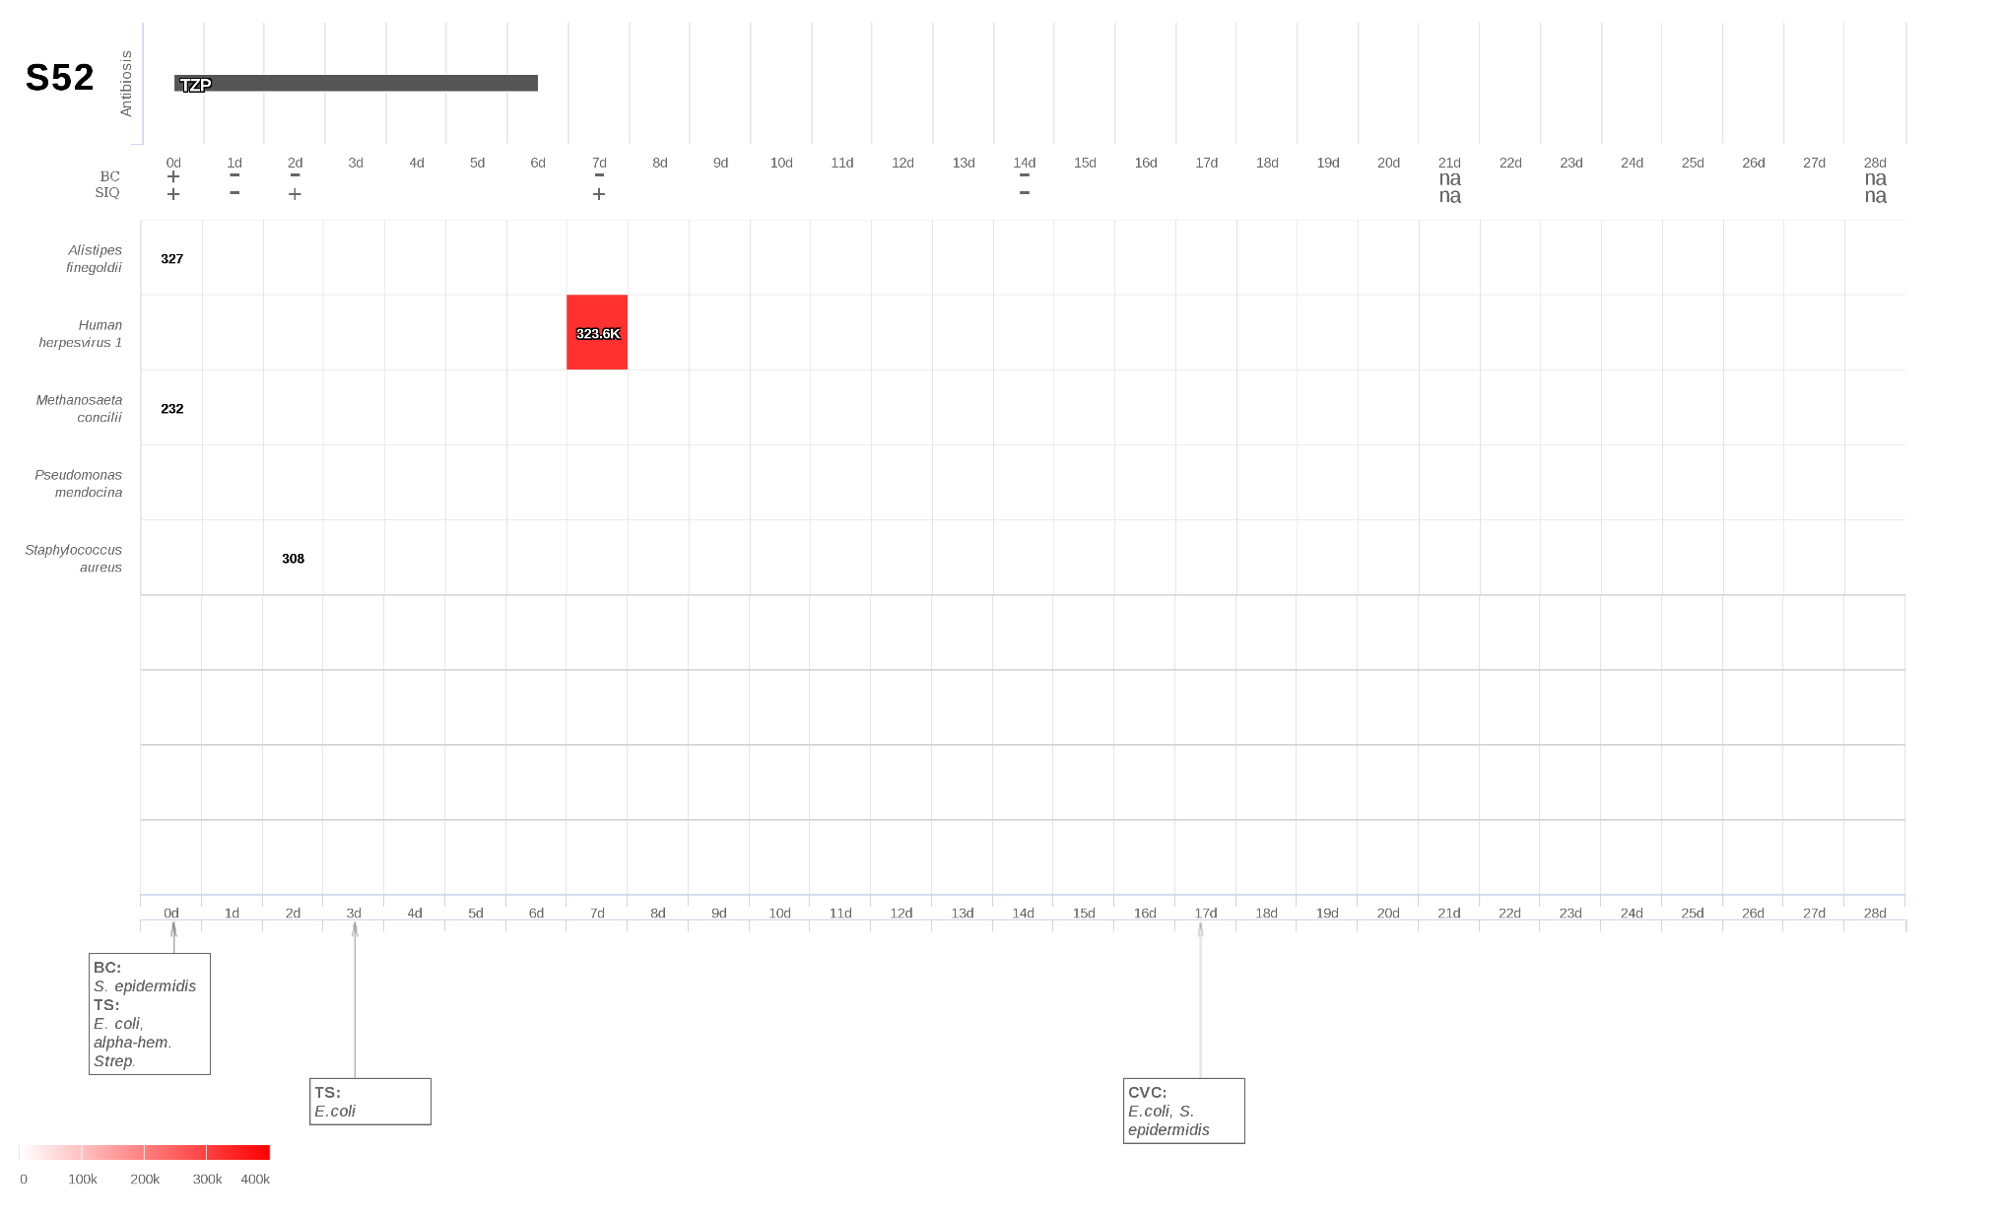

S53: Retroperitoneal abscess and necrotizing fasciitis due to sigmoid perforation.
