Online Data Supplement

Effects of Mesenchymal Stem Cell Treatment on Systemic Cytokine Levels in a Phase 1 Dose Escalation Safety Trial of Septic Shock Patients

Authors:
Kenny Schlosser¹, Jia-Pey Wang¹, Claudia dos Santos^{2,3}, Keith R. Walley⁴, John Marshall³, Dean A. Fergusson⁵, Brent W. Winston⁶, John Granton², Irene Watpool⁷, Duncan J. Stewart^{1,8#}, Lauralyn A. McIntyre^{7#}, Shirley H. J. Mei¹*# on behalf of the Canadian Critical Care Trials Group and the Canadian Critical Care Translational Biology Group

Affiliations:
1. Sinclair Centre for Regenerative Medicine, Ottawa Hospital Research Institute, Ottawa, Ontario, Canada
2. Department of Medicine, University of Toronto, Toronto, Ontario, Canada
3. Department of Surgery and Critical Care Medicine, Keenan Research Centre of the Li Ka Shing Knowledge Institute, St. Michael’s Hospital, The University of Toronto, Toronto, Ontario, Canada
4. Centre for Heart Lung Innovation, University of British Columbia, British Columbia, Canada
5. Department of Epidemiology and Community Medicine, University of Ottawa
6. Department of Critical Care Medicine, Biochemistry and Molecular Biology, Cumming School of Medicine, University of Calgary, Calgary, Alberta, Canada
7. Department of Medicine (Division of Critical Care), University of Ottawa, Ottawa, Ontario, Canada
8. Department of Cell and Molecular Medicine, University of Ottawa, Ottawa, Ontario, Canada

Running Title: Effects of MSCs on Plasma Cytokines in Septic Shock

# Denotes co-senior authors.

* Corresponding Author: Dr. Shirley HJ Mei, smei@ohri.ca, 501 Smyth Rd, Ottawa, ON K1H 8L6, Phone: +1-613-737-8899 x73278

Methods
CISS Cohorts and healthy normal subjects
The CISS trial was approved by Health Canada and the Ottawa Health Sciences Network Research Ethics Board (OHSN-REB #: 20140809-01H). Details on trial design and rationale, participant recruitment, MSC source and preparation, and trial outcomes have been described previously (1). Briefly, the observational cohort consisted of 21 septic shock participants who met CISS eligibility criteria but did not receive MSCs (collected from January 2013 to May 2014), and the interventional cohort (n=9; collected from April 2015 to June 2016) comprised three MSC dose cohorts of three septic shock participants each receiving 0.3 (low dose), 1.0 (mid dose), or 3.0 (high dose) million cells per kg to a maximum of 300 million cells. The allogeneic freshly cultured MSCs were prepared from the bone marrow of one healthy donor, and served as the source of MSCs for all 9 participants in the interventional cohort. Actual MSC numbers delivered to patients ranged from 19-30 million (low dose), 80-86 million (mid dose) and 132-250 million cells (high dose). Of note, one patient in the high dose group received an incomplete dose due to manufacturing issues (i.e., 250 of 300 million cells), as previously reported (1). Peripheral blood samples from apparently healthy normal participants were obtained with written informed consent from 2011–2018 at a single center, in accordance with protocols, guidelines, and regulations approved by the Ottawa Health Sciences Network Research Ethics Board (OHSN-REB #:2011470-01H). Healthy participants were non-smokers (or had quit smoking 6 months prior to screening) and had no history of diabetes mellitus requiring medication (oral hypoglycemics or insulin), systemic hypertension requiring medication, hypercholesterolemia requiring medication, chronic asthma or chronic obstructive pulmonary disorders, scarring or fibrosis of the lung, or cancer in the previous five years (excluding superficial skin cancer).

Plasma specimen collection
Whole blood from CISS patients was collected in BD Vacutainers (blue top; citrate) and plasma was subsequently isolated by centrifugation at 1700 x g for 10 min at 4˚C. Plasma samples were collected at study baseline (t=0 h) just prior to MSC infusion (and within 30 h of admission to the intensive care unit) and 1 h, 4 h, 12 h, 24 h and 72 h after MSC infusion and/or trial enrollment. Complete plasma sampling could not be obtained at all time points. In the observational cohort, 116 of 126 possible plasma specimens (92%) were available with sample sizes ranging from n=15-21 (0 h, n=21; 1 h, n=21; 4 h, n=20; 12 h, n=19; 24 h, n=20; 72 h, n=15). In the interventional cohort, 52 of 54 (96%) possible plasma specimens were available, with sample sizes ranging from n=8-9 (0 h, n=9; 4 h, n=8; 12 h, n=8; 24 h, n=9; 72 h, n=9). Whole blood from healthy subjects was collected by venipuncture with BD blue top citrate Vacutainers, and plasma was isolated using two successive centrifugations steps comprised of i) 1700 x g, 10 min at 4˚C and ii) 11,000 x g, 5 min at 4˚C. All plasma specimens were stored at -70 to -80˚C until assayed.

Single and Multi-Analyte Immunoassays
All samples for the CISS interventional and observational groups were run on a single plate for a given time point, but different time points were run on separate plates if necessary due to space restrictions. For CISS patient specimens, all assay plates for a given analyte were prepared on the same day using the same lot of reagents, and run on the same day. The coefficient of variation between interplate control assays prepared with the same lot of reagents and run on the same day was 9% (IQR; 5-16%). In some cases, healthy subjects were assayed on a separate day with a different lot of reagents compared to CISS patients. The coefficient of variation between inter-plate control assays under these circumstances was 39% (IQR; 18-70%). The coefficient of variation between duplicate technical replicates (run in parallel on the same plate) was 5% (IQR; 2-10%). Forty analytes were assayed using 4x diluted plasma with the Bio-Plex Pro Human Chemokine 40-plex Assay (Biorad; catalog# 171AK99MR2). A 5-plex including ANGPT1, ANGPT2, RAGE, IL-18 and vWF-A2 (2x diluted plasma), a 2-plex including PCT and IL-1ra (100x diluted plasma), and Cystatin C (100x diluted plasma) were measured using separate Magnetic Luminex assays from R&D systems Bio-Techne (catalog#LXSAHM). LL-37 was measured using 20x diluted plasma with a human ELISA kit (HycultBiotech; catalog# HK321-02). All assays were performed according to manufacturer recommendations. Data acquisition was conducted on a Bioplex 200 system (Biorad) or Polarstar Omega plate reader (BMG Labtech). Data were fit to an optimized six- or seven-point standard curve generated using five parameter logistic regression with applicable Bioplex manager or Omega Polarstar software. Extrapolated values were used for samples that exhibited fluorescent signals above background (i.e., above blank samples) but below the standard curve range. Samples that exhibited signals below the standard curve range and below background levels of fluorescence were set to the lowest extrapolated value observed among all samples in a given analyte and assay run, or the manufacturer defined minimum detectable concentration, whichever was lower. Where applicable, immunoassays were confirmed to work within manufacturer’s specifications, as evidenced by positive internal quality control standards run in parallel with biologic samples (Biorad). Plasma samples used for 45 analytes were limited to 1-2 freeze-thaw cycles at the time of measurement. Plasma samples used for PCT, IL-1ra, Cystatin C and LL-37 were subject to 4-6 freeze-thaw cycles at time of measurement.

Data Analysis and Statistics
To minimize potential biases, cytokine data that were unavailable due to missing plasma samples were not imputed and no patients were excluded from analysis. Data are presented as concentrations (pg/mL), fold change to study baseline time 0 h (calculated as paired measurements over time), or fold change of MSC-treated participants to median of observational cohort (after normalization of data to study baseline time 0 h) with medians and interquartile ranges unless otherwise specified in figure legends. Descriptive and inferential statistics were performed with Graphpad Prism V7.0 or Partek V7.0, and specific details are reported in each figure legend. In some cases, no formal statistical tests were conducted due to limited sample sizes. To mitigate potential type II (false negative) errors, all changes in plasma analyte levels were quantified and reported (irrespective of statistical significance level) in the manuscript or online data supplement. Principal Component Analysis (PCA) and hierarchical clustering (Euclidean distance and average linkage method) was performed with Partek Genomics Suite V7.0.

Abbreviations and alternate names
ANGPT1: Angiopoietin-1
ANGPT2: Angiopoietin-2
BCA-1 / CXCL13: B cell-attracting chemokine 1/ chemokine (C-X-C motif) ligand 13
6Ckine/ CCL21: Chemokine (C-C motif) ligand 21
CTACK / CCL27: Cutaneou T-cell-attracting chemokine/ Chemokine (C-C motif) ligand 27
Cystatin C
ENA-78 / CXCL5: Epithelial-derived neutrophil activating peptide 78/C-X-C motif chemokine 5
Eotaxin: eosinophil chemotactic protein
Eotaxin-2 / CCL24: eosinophil chemotactic protein 2/ Chemokine (C-C motif) ligand 24
Eotaxin-3 / CCL26: eosinophil chemotactic protein 3/ Chemokine (C-C motif) ligand 26
Fractalkine / CX3CL1: Chemokine (C-X3-C motif) ligand 1
GCP-2 / CXCL6: Granulocyte chemotactic protein 2/ Chemokine (C-X-C motif) ligand 6
GM-CSF: Granulocyte-macrophage colony-stimulating factor
Gro-α/CXCL1: Chemokine (C-X-C motif) ligand 1
Gro-ß / CXCL2: Growth-regulated protein beta/ Chemokine (C-X-C motif) ligand 2
I-309 / CCL1: Chemokine (C-C motif) ligand 1
IFN-ɣ: Interferon gamma
IL-10: Interleukin 10
IL-16: Interleukin 16
IL-18: Interleukin 18
IL-1β: Interleukin 1 beta
IL-1ra: Interleukin 1 receptor antagonist
IL-2: Interleukin 2
IL-4: Interleukin 4
IL-6: Interleukin 6
IL-8/ CXCL8: Interleukin 8/ Chemokine (C-X-C motif) ligand 8
IP-10/ CXCL10: Interferon gamma-induced protein 10/ Chemokine (C-X-C motif) ligand 10
I-TAC / CXCL11: Interferon-inducible T-cell alpha chemoattractant/ Chemokine (C-X-C motif) ligand 11
LL-37
MCP-1/ CCL2: Monocyte chemoattractant protein 1 / Chemokine (C-C motif) ligand 2
MCP-2 / CCL8: Monocyte chemoattractant protein 2 / Chemokine (C-C motif) ligand 8
MCP-3 / CCL7: Monocyte chemoattractant protein 3 / Chemokine (C-C motif) ligand 7
MCP-4 / CCL13: Monocyte chemoattractant protein 4 / Chemokine (C-C motif) ligand 13
MDC / CCL22: Macrophage-derived chemokine/ Chemokine (C-C motif) ligand 22
MIF: Macrophage migration inhibitory factor
MIG / CXCL9: Monokine induced by gamma/ Chemokine (C-X-C motif) ligand 9
MIP-1α/ CCL3: Macrophage inflammatory protein 1 alpha/ Chemokine (C-C motif) ligand 3
MIP-1δ / CCL15: Macrophage inflammatory protein 1 delta/ Chemokine (C-C motif) ligand 15
MIP-3a / CCL20: Macrophage inflammatory protein 3 alpha/ Chemokine (C-C motif) ligand 20
MIP-3ß / CCL19: Macrophage inflammatory protein 3 beta/ Chemokine (C-C motif) ligand 19
MPIF-1 / CCL23: Myeloid progenitor inhibitory factor 1/ Chemokine (C-C motif) ligand 23
PCT: Procalcitonin
RAGE: Receptor for Advanced Glycation-End-products
SCYB16 / CXCL16: Small inducible cytokine B16/ Chemokine (C-X-C motif) ligand 16
SDF-1a+ß / CXCL12: Stromal cell-derived factor-1 alpha and beta/ Chemokine (C-X-C motif) ligand 12
TARC / CCL17: Thymus- and activation-regulated chemokine/ Chemokine (C-C motif) ligand 17
TECK / CCL25: Thymus-expressed chemokine/ Chemokine (C-C motif) ligand 25
TNF-α: Tumor necrosis factor alpha
vWF-A2: Von Willebrand factor A2 domain

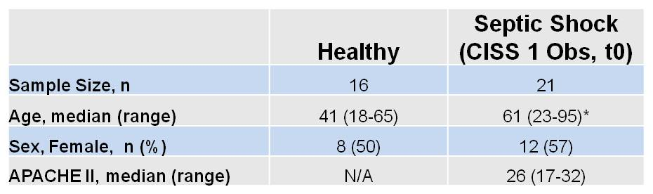

Supplementary Table 1. Characteristics of Healthy and Septic Shock Subjects. Participants in the septic shock group are from the CISS1 trial observational arm at study baseline (t=0). Additional patient characteristics have been previously reported (McIntyre et al. AJRCCM. 2018). Plasma samples from healthy donors were collected on an ad hoc basis independent of the CISS 1 trial. Age was significantly different between groups (* P=0.003; Unpaired 2-sided t-test).

Supplementary Table 2.

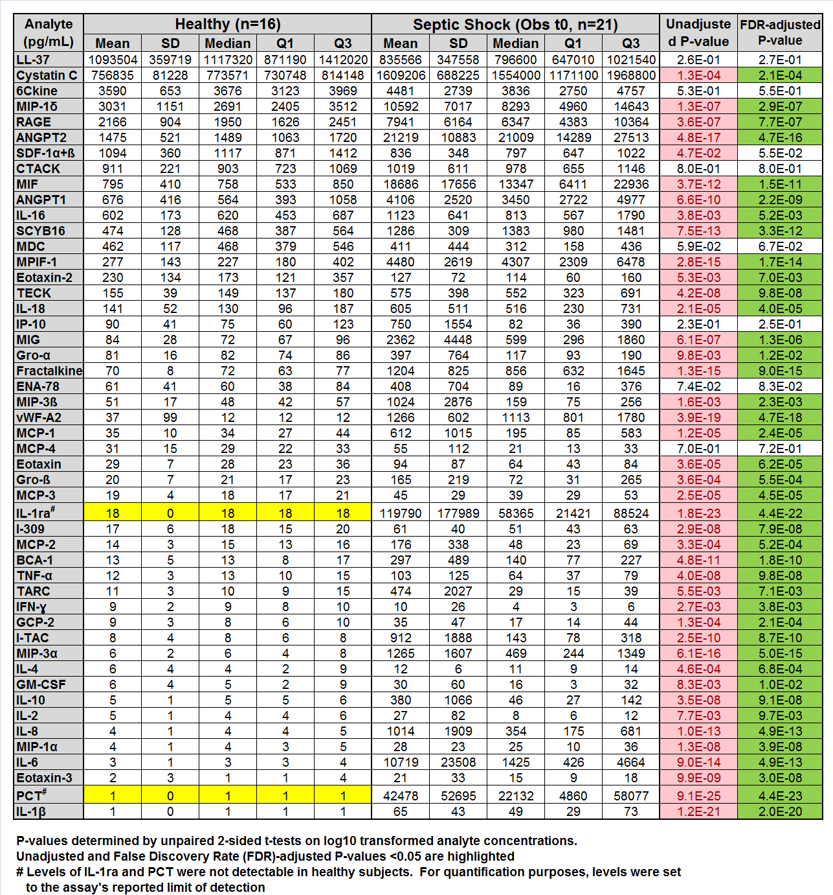

Supplementary Table 3.
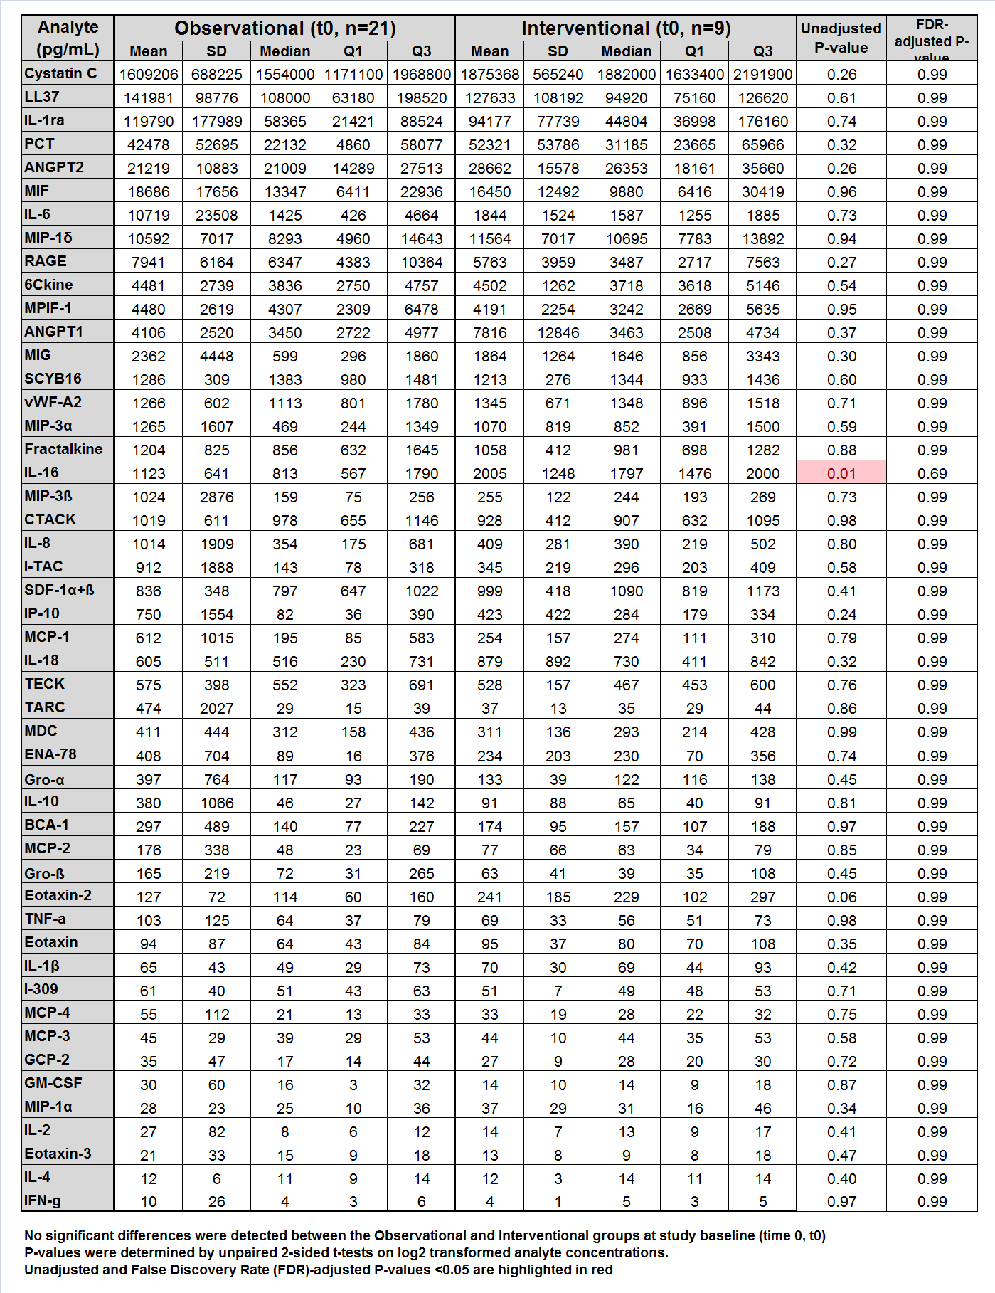

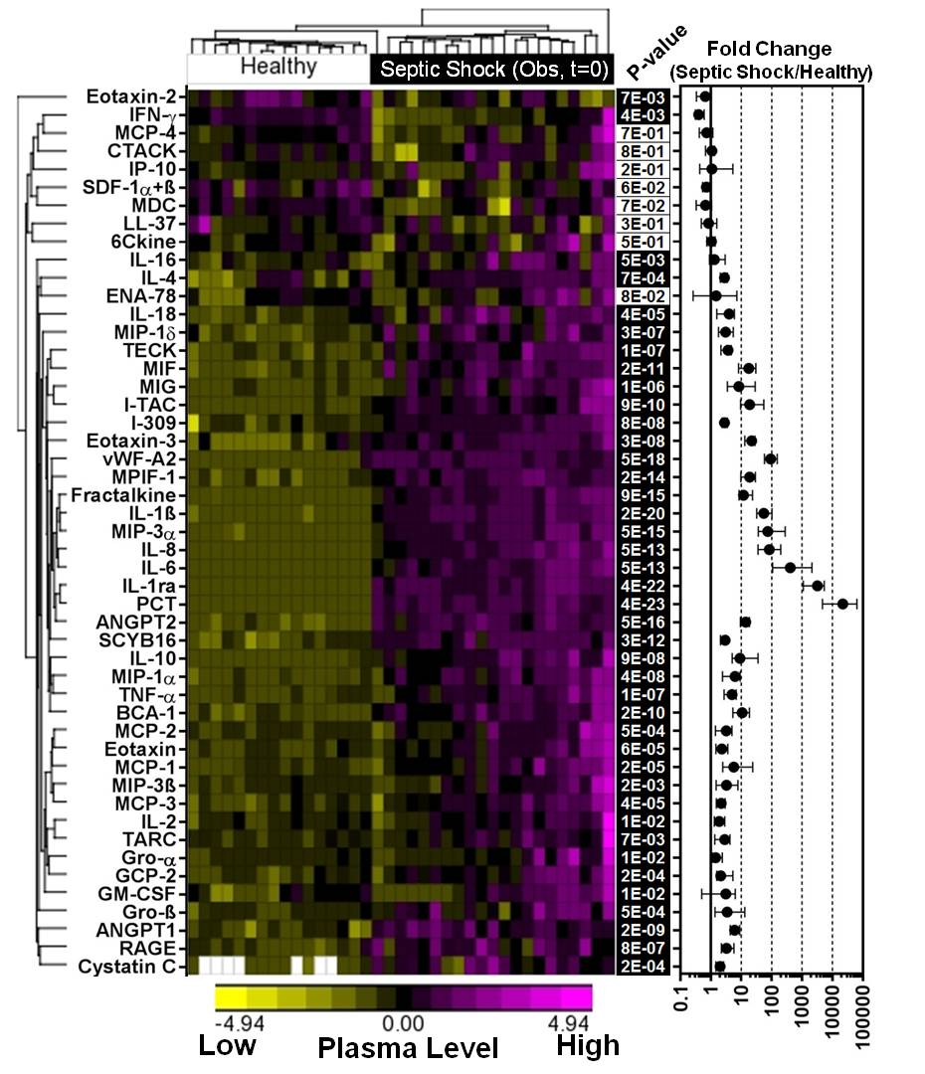

Supplementary Figure 1. Majority of assessed analytes are altered in plasma of septic shock patients versus healthy subjects. Hierarchical clustering and heatmap of 49 cytokine/biomarkers in healthy subjects (n=16) and septic shock patients in the CISS 1 observational (Obs) cohort at study baseline time 0 (n=21). Columns denote subjects and rows denote analytes (i.e., cytokines and biomarkers). White cells denote unavailable specimens. Log10 transformed analyte concentrations were shifted to mean 0 and scaled to standard deviation of 1 for hierarchical clustering and heatmap construction. P-values were determined by two-sided Student’s t-test on log transformed concentrations, and adjusted for multiple comparisons using the false discovery rate (FDR) method (Benjamin-Hochberg). Forty-one analytes with FDR<0.05 are highlighted with dark shading. Right panel graph shows magnitude of fold change in analyte levels (median, IQR) in septic shock patients relative to healthy subjects.

Supplementary Figure 2. Septic shock patients show significant alterations in plasma cytokine levels within 72 h of trial enrollment in the absence of MSC treatment. Time course profiles for 22 analytes that showed significant alterations in plasma in the (non-MSC treated) observational cohort of septic shock patients over time (n=15-21/time point). Non-transformed cytokine concentrations are presented as median and interquartile range. * P<0.05, ** P<0.01, *** P<0.001, **** P<0.0001 vs. time 0. P-values were determined by non-parametric Kruskal-Wallis and Dunn’s multiple comparison test vs. time 0.

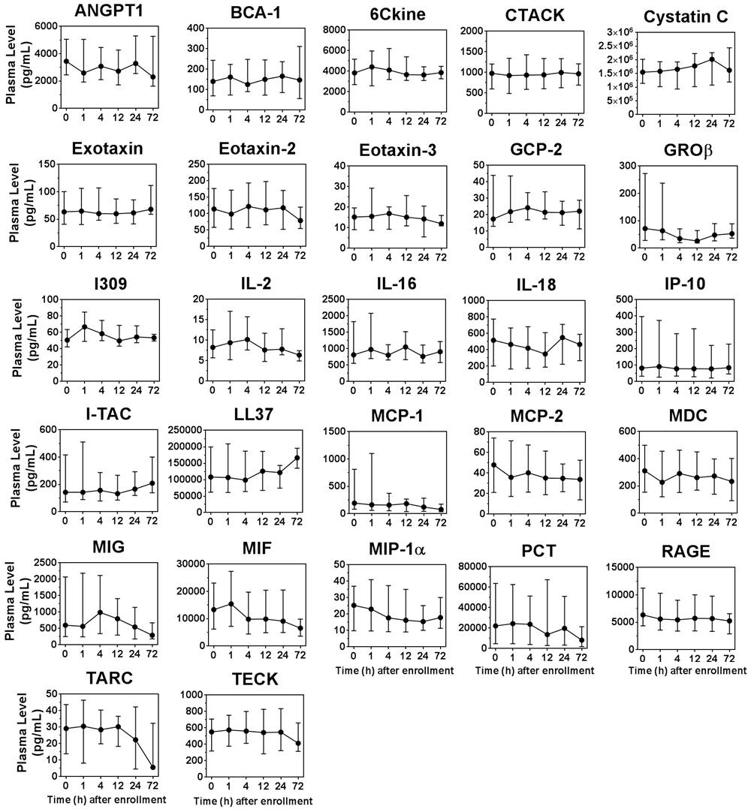

Supplementary Figure 3. Cytokines/biomarkers that did not show significant changes in plasma levels within the first 72 h of trial enrollment in the observational cohort of septic shock patients (n=15-21/ time point). Data are presented as median and interquartile range.

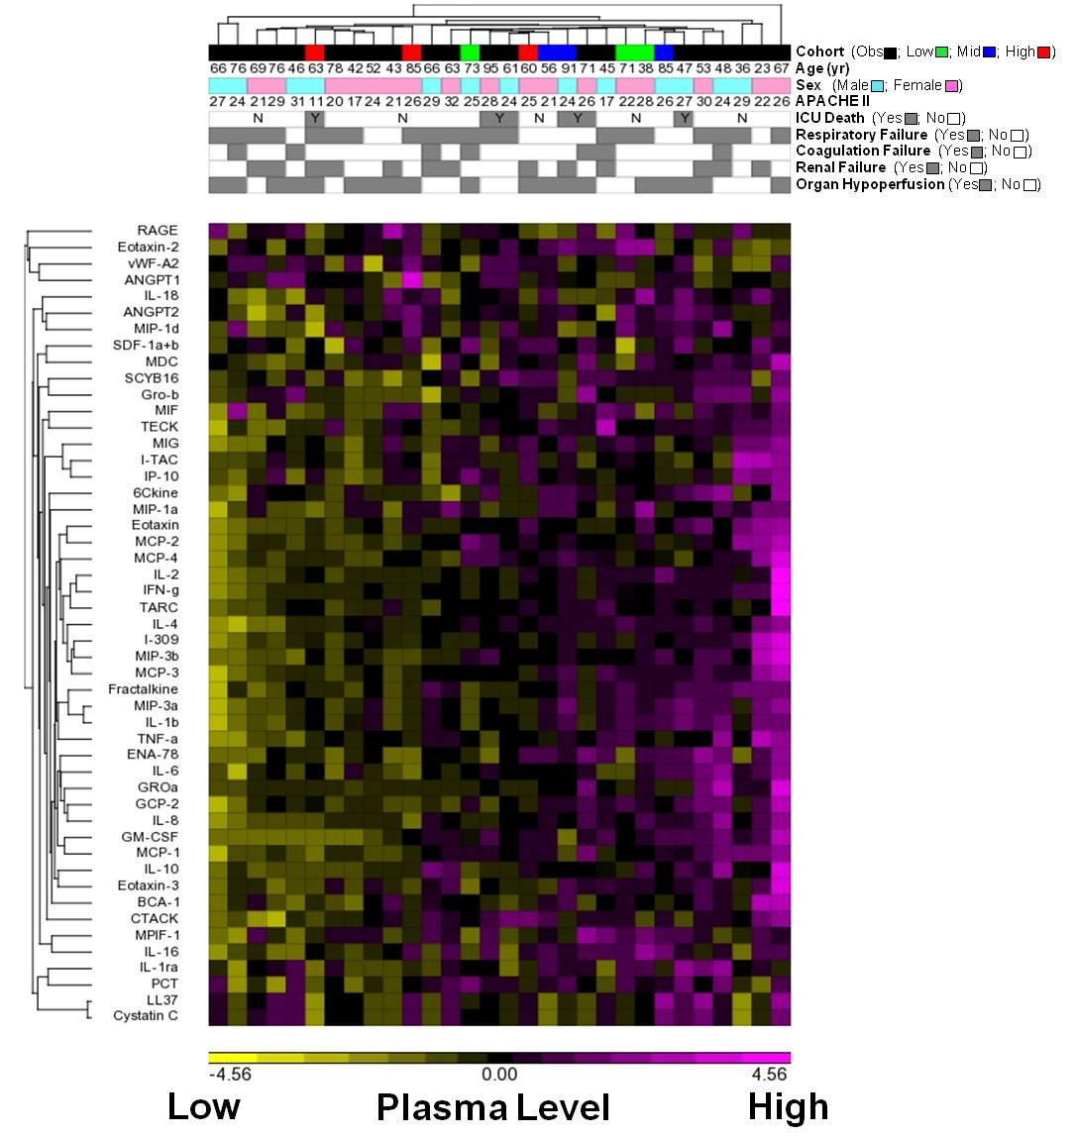

Supplementary Figure 4. Hierarchical clustering and heatmap of 49 cytokine/biomarkers at study baseline (time 0, prior to MSC infusion) in the observational and interventional cohorts. Columns denote subjects and rows denote analytes. Log2 transformed plasma analyte concentrations of subjects were shifted to mean 0 and scaled to standard deviation of 1 for hierarchical clustering and heatmap construction. Subject characteristics including age, sex, APACHE II score, ICU death and qualifying organ failure are shown. The interventional cohort is categorized by low, mid or high MSC dose (n=3/group).

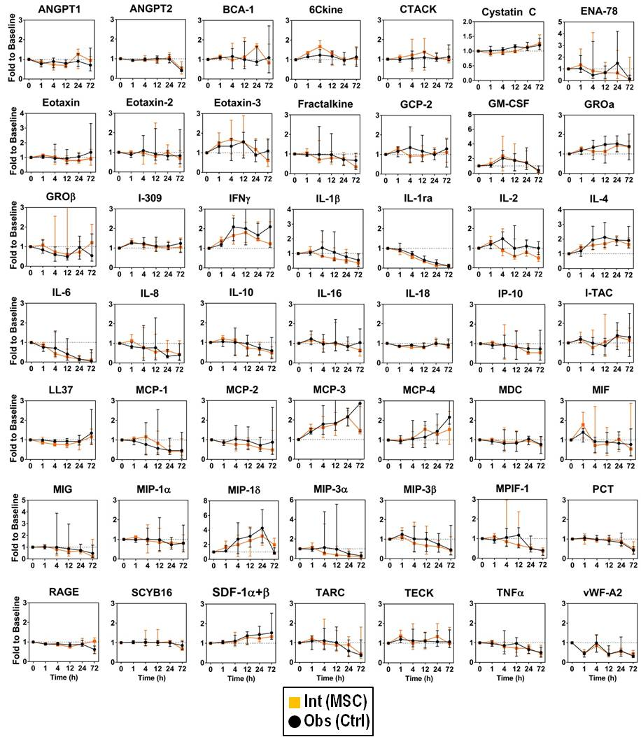

Supplementary Figure 5. No significant differences in plasma cytokine/biomarker levels were detected between the observational and interventional cohorts of septic shock patients. Data for 49 assessed analytes are presented as fold change to study baseline (t=0) with median and interquartile ranges shown. Black circles denote the observational group (n=15-21/ time point), and orange squares denote the MSC-treated interventional group (n=8-9/time point). No significant differences between groups over time were detected by Two-way ANOVA and Sidak’s multiple comparison test.

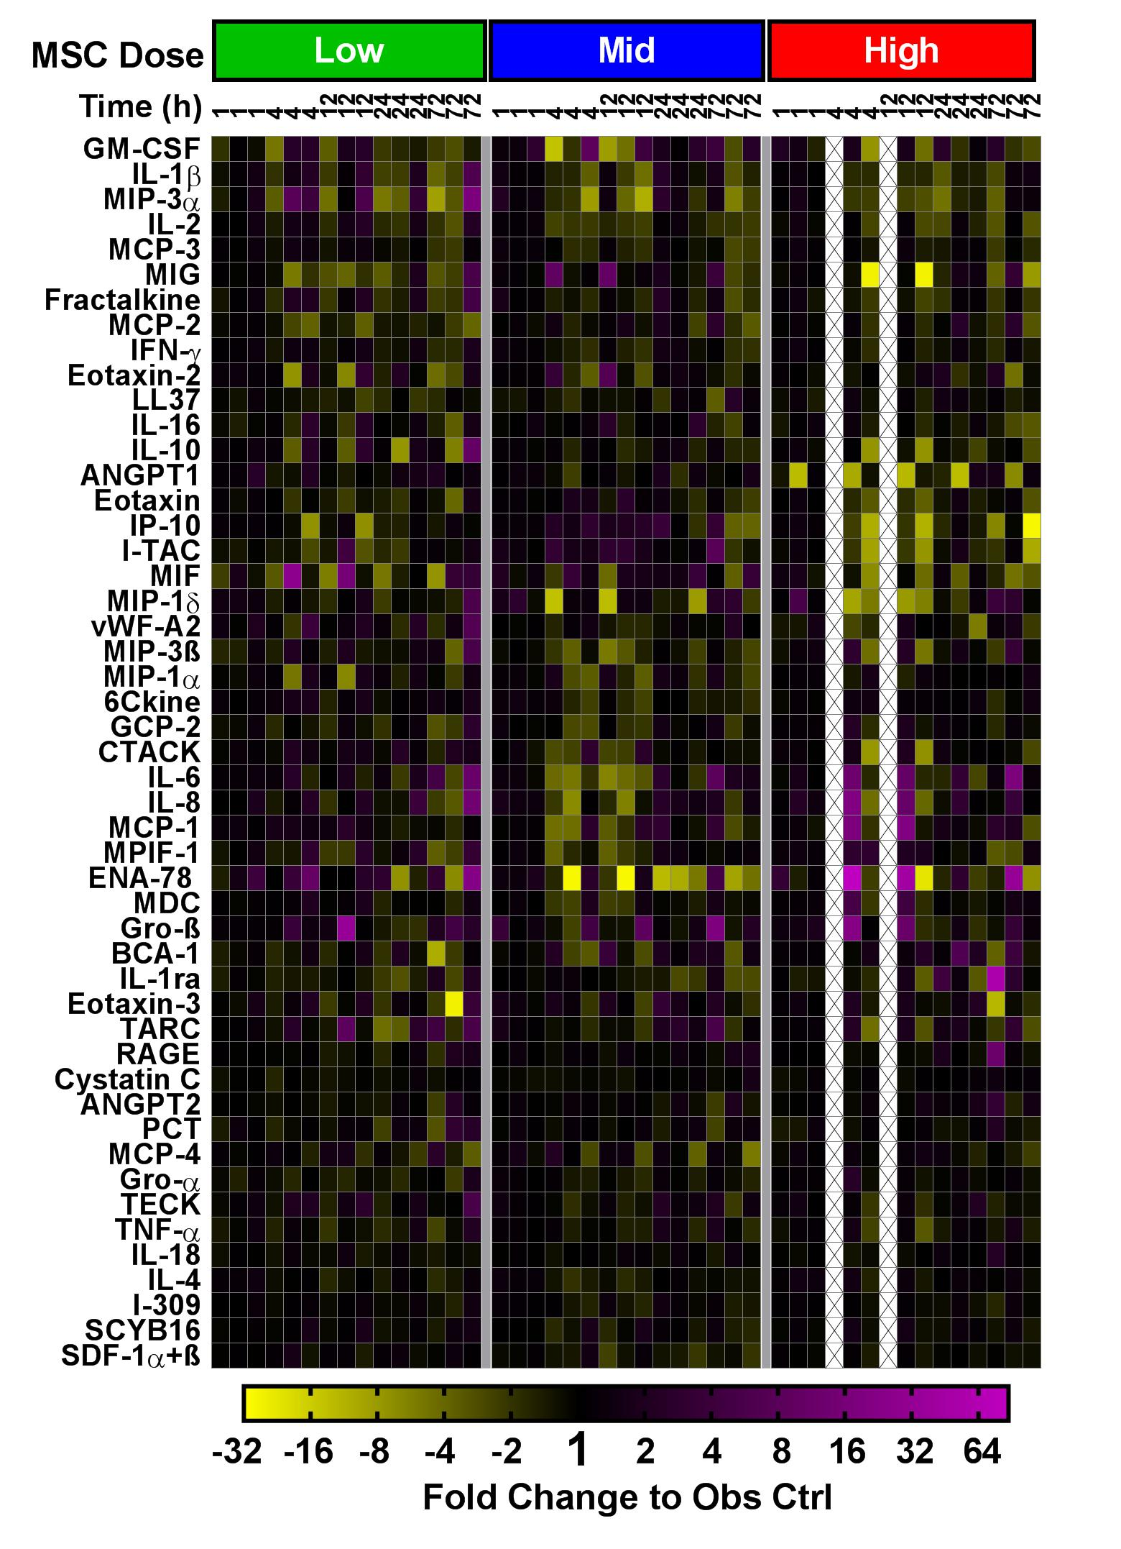
Supplementary Figure 6. Heatmap showing changes in plasma levels of 49 analytes (rows) for each MSC-treated patient stratified by dose and time (columns; n=2-3 subjects/MSC dose/time point). Analyte levels are presented as fold change (log 2 scale) to the observational control (Obs; n=15-21 subjects/time point) after normalization to study baseline (time 0). Missing plasma specimens are denoted by an X.

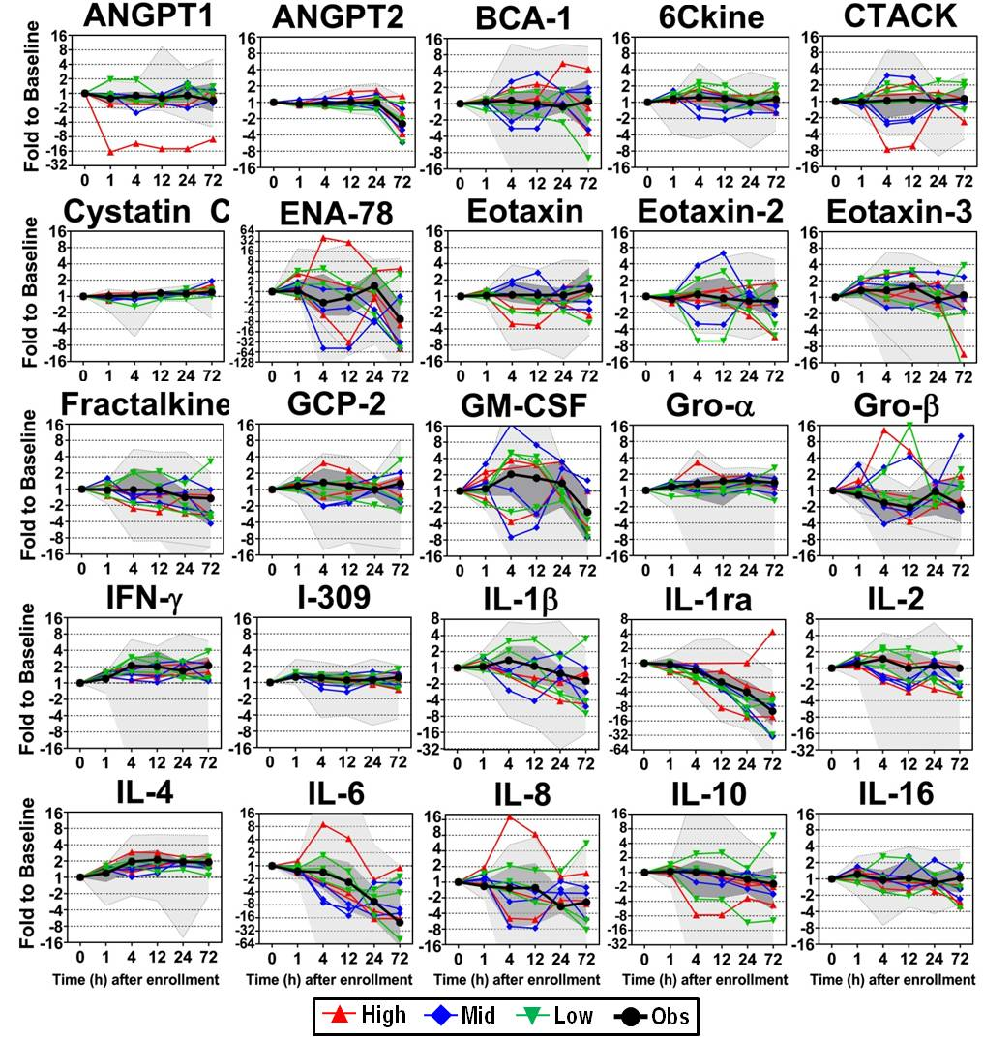

Supplementary Figure 7. Time course of changes in plasma cytokine/biomarker levels in septic shock patients treated with and without MSCs. Data are presented as fold change to study baseline t0. Individual MSC-treated patients are shown color-coded by low, mid and high dose (n=2-3 subjects/dose/time point). Median levels of the observational group (n=15-21 subjects/time point) are shown with the interquartile range (dark grey shaded region) and min-max range (light grey shaded region). For clarity, the observational group range is clipped at the axis limit in some graphs. Additional graphs are shown on the next page.

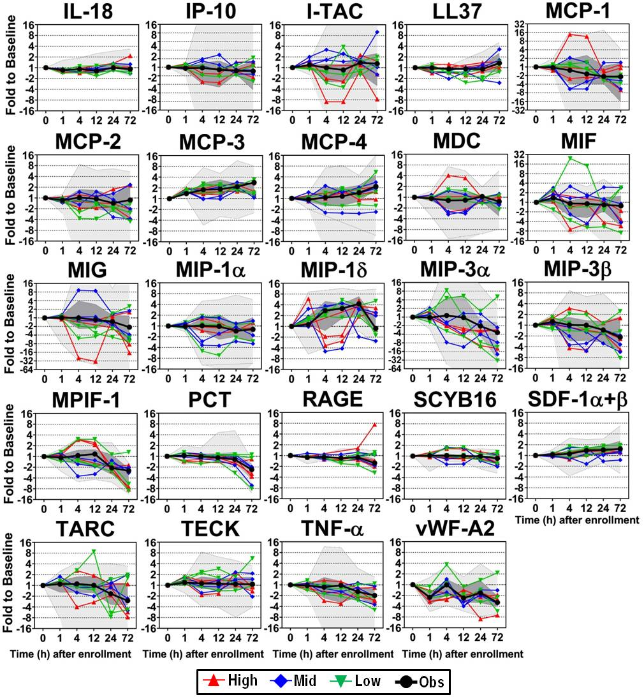

Supplementary Figure 7 cont'd. Time course of changes in plasma cytokine/biomarker levels in septic shock patients treated with and without MSCs. Data are presented as fold change to study baseline t0. Individual MSC-treated patients are shown color-coded by low, mid and high dose (n=2-3 subjects/dose/time point). Median levels of the observational group (n=15-21 subjects/time point) are shown with the interquartile range (dark grey shaded region) and min-max range (light grey shaded region). For clarity, the error range of the observational group is clipped at the axis limit in some graphs.

References

1. McIntyre LA, Stewart DJ, Mei SHJ, Courtman D, Watpool I, Granton J, Marshall J, Dos Santos C, Walley KR, Winston BW, et al. Cellular immunotherapy for septic shock. A phase i clinical trial. Am J Respir Crit Care Med 2018;197:337-347.

