Supplementary information

Location of clinical sites and the number of participants enrolled at each site

- Emory University Hospital, Atlanta, GA (1 participant)
- Grady Memorial Hospital, Atlanta, GA (2 participants)
- Ohio State University, Columbus, OH (3 participants)
- University of Florida College of Medicine, Gainesville, FL (2 participants)
- University of Michigan, Ann Arbor, MI (2 participants)
- University of Pittsburgh Medical Center, Pittsburgh, PA (4 participants)
- Washington University School of Medicine, St Louis, MO (11 participants)

Study exclusion criteria

- Target disease exceptions

- Previous episode of sepsis with intensive care unit (ICU) admission during the current hospitalization or previous episode of septic shock with ICU admission during the current hospitalization
- Presence of an advanced directive to withhold or withdraw life-sustaining treatment, or a do not resuscitate (DNR) order, or a comfort measures only (CMO) order
- Participant’s family, treating physician, or both were not in favor of aggressive support of the participant

- Medical history and concurrent diseases

- Active autoimmune disease or documented history of autoimmune disease. (Note: possible exceptions to this exclusion were participants with a medical history of such entities as vitiligo, resolved childhood asthma, atopic disease, or childhood arthralgias where the clinical suspicion of autoimmune disease was low. In addition, transient autoimmune manifestations of an acute infectious disease that resolved upon treatment of the infectious agent, e.g. acute Lyme arthritis, were exceptions to this exclusion)
- History of solid organ or bone marrow transplant
- History of cancer diagnosis within 6 months prior to study drug administration or history of cancer treatment within 6 months prior to study drug administration. (Note: cancers that were apparently cured, such as basal or squamous cell skin cancer, superficial bladder cancer or carcinoma in situ of the cervix or breast, or localized prostate cancer, were not exclusions)
- Known history of uveitis (e.g. iritis, endophthalmitis, scleritis, or retinitis)
- Known history of retinal detachment in the past 90 days
- Known history of ocular surgery in the past 90 days
- Known history of penetrating trauma of the eye in the past 90 days
- Known permanent, complete loss of vision in one eye
- Note: known history of self-limited conjunctivitis, blepharitis, or hordeolum (stye) were not exclusions
- Known history of infection with human immunodeficiency virus (HIV) and not on antiretroviral therapy prior to the current hospitalization OR cluster of differentiation (CD)4 ≤200 cells/mm³ OR acquired immune deficiency syndrome (AIDS)-defining illness in the past year
- Known history of infection with hepatitis C virus (HCV) and was undergoing treatment for HCV infection at the time OR had detectable HCV RNA at the time
- Apparent active or latent tuberculosis infection as indicated by 1 of the 2 criteria below:
- Known history of purified protein derivative (PPD) test recently converted to positive OR
- Known history of recently positive interferon-gamma release assay (IGRA) test
- Known active illicit drug use disorder (illicit drug use on ≥5 days in the past 30 days) OR known active alcohol use disorder (drinking ≥5 alcoholic drinks on the same occasion on ≥5 days in the past 30 days)

- Physical and laboratory test findings

- Weight <40 kg
- Ocular opacity (e.g. corneal opacity, lens opacity, vitreous opacity) that precluded high quality fundus photographs
- Positive blood screen for hepatitis B surface antigen

- Allergies and adverse drug reaction

- History of severe hypersensitivity reactions to monoclonal antibodies or related compounds

- Other exclusion criteria

- Concurrent participation in another interventional clinical trial of an investigational drug
- Prisoners or participants who were involuntarily incarcerated
- Participants who were compulsorily detained for treatment of either a psychiatric or physical (e.g. infectious disease) illness
- Any other sound medical, psychiatric and/or social reason as determined by the Investigator

Prohibited and/or restricted treatments

Prohibited and/or restricted medications taken before study drug administration are described below. Medications taken ≤2 weeks before study drug administration were required to be recorded on the Case Report Form (CRF).

- Prior exposure to BMS-936559 or to an anti-PD-1, anti-PD-L1, or anti-CTLA-4 antibody, or any other agent that targets T-cell co-stimulation, was prohibited
- Exposure to any other investigational agent within 28 days or 5 half-lives of the agent (whichever was longer) before enrollment was prohibited
- Use of any immunosuppressive medication within 28 days or 5 half-lives of the medication (whichever was longer) before enrollment was prohibited, except those cleared by the Bristol-Myers Squibb (BMS) Medical Monitor or those used to treat a drug-related adverse event during the study
- Use of immunosuppressive doses of systemic or absorbable topical corticosteroids (doses >50 mg/day of prednisone or equivalent) within 28 days or 5 half-lives of the medication (whichever was longer) before enrollment was prohibited, except those cleared by the BMS Medical Monitor or those used to treat a drug-related adverse event during the study
  - Note: Inhaled or intranasal corticosteroids, with minimal systemic absorption, were not prohibited
  - Note: Non-absorbed topical or intra-articular steroid injections were not prohibited
  - Note: Hydrocortisone at doses ≤300 mg/day for the treatment of septic shock was not prohibited

Definition of adverse events

An adverse event (AE) was defined as any new untoward medical occurrence or worsening of a pre-existing medical condition in a clinical investigation subject administered study drug and that did not necessarily have a causal relationship with this treatment. An AE could therefore have been any unfavorable and unintended sign (such as an abnormal laboratory finding), symptom, or disease temporally associated with the use of study drug, whether or not considered related to the study drug. The causal relationship to study drug was determined by a physician and was to be used to assess all AEs. The causal relationship could be one of the following:

- Related: There was a reasonable causal relationship between study drug administration and the AE.
- Not related: There was not a reasonable causal relationship between study drug administration and the AE.

The term "reasonable causal relationship" meant there was evidence to suggest a causal
relationship.

AEs could be spontaneously reported or elicited during open-ended questioning, examination, or evaluation of a participant. (In order to prevent reporting bias, participants were not to be questioned regarding the specific occurrence of one or more AEs.)

A participant’s pre-existing conditions, such as sepsis, organ failure, and associated signs and symptoms were not to be reported as AEs unless these pre-existing conditions worsen after dosing. Pre-existing conditions were to be carefully recorded in the medical history or diagnosis pages of the CRF.

Serious adverse events

A serious adverse event (SAE) was any untoward medical occurrence that at any dose:
- Resulted in death.
- Was life-threatening (defined as an event in which the participant was at risk of death at the time of the event; it does not refer to an event which hypothetically might have caused death if it were more severe).
- Required inpatient hospitalization or caused prolongation of existing hospitalization (see NOTE below).
- Resulted in persistent or significant disability/incapacity.
- Was a congenital anomaly/birth defect.
- Was an important medical event (defined as a medical event(s) that may not be immediately life-threatening or result in death or hospitalization but, based upon appropriate medical and scientific judgment, may jeopardize the participant or may require intervention [e.g. medical, surgical] to prevent one of the other serious outcomes listed in the definition above.) Examples of such events included, but were not limited to, intensive treatment in an emergency room or at home for allergic bronchospasm; blood dyscrasias or convulsions that did not result in hospitalization. Potential drug induced liver injury (DILI) was also considered an important medical event.

Suspected transmission of an infectious agent (e.g. pathogenic or nonpathogenic) via the study drug was an SAE.

Although pregnancy, overdose, cancer, and potential DILI are not always serious by regulatory definition, these events were required to be handled as SAEs.

In this study, the following events were study endpoints; they were excluded from being reported as an SAE, UNLESS the events were related to study drug:
- Death.
- Hospitalization prolongation.
- Re-hospitalization.
- ICU admission.
- Ventilator use.
- Vasopressor use.
- Dialysis use.
- Viral reactivation.

These events were recorded on other CRF pages instead of the SAE pages.

Any component of a study endpoint that was considered related to study therapy was to be reported as an SAE (e.g. death is an endpoint; if death occurred due to anaphylaxis, anaphylaxis was reported).

NOTE: The following hospitalizations were not considered SAEs:
- A visit to the emergency room or other hospital department <24 hours that did not result in admission (unless considered an important medical or life-threatening event).
- Elective surgery, planned prior to signing consent.
- Admissions as per protocol for a planned medical/surgical procedure.
- Routine health assessment requiring admission for baseline/trending of health status (e.g. routine colonoscopy).
- Medical/surgical admission other than to remedy ill health and planned prior to entry into the study. Appropriate documentation was required in these cases.
- Admission encountered for another life circumstance that carried no bearing on health status and required no medical/surgical intervention (e.g. lack of housing, economic inadequacy, caregiver respite, family circumstances, administrative reason).

Study stopping rules

If, at any time during the study, the perceived risk/benefit of treatment changed, the BMS Medical Monitor and BMS Medical Surveillance Team Lead or the independent Data Monitoring Committee (DMC) had the authority to determine whether the study should stop or be modified.

Enrollment would be paused to allow review of blinded safety data in the event of the following observations in the same dose cohort:

- Mortality that was unusual for the study population as determined by the BMS team and Investigators
- ≥2 participants experienced the same SAE, and the event was not expected either for the study population or for BMS-936559, and was considered study drug related (as determined by the BMS team and Investigators)
- ≥2 participants experienced the same retinal lesion in the macula and the lesion was not expected for the study population, and was considered study drug-related (as determined by the BMS team and the investigators)

In parallel, the independent DMC reviewed unblinded study treatment and safety data to adjudicate study drug-relatedness and appropriateness of resuming enrollment with or without study modifications.

Protocol changes

Important protocol changes after study commencement were: removal of systemic inflammatory response syndrome (SIRS) criteria to determine study eligibility (because they are not adequately specific for sepsis diagnosis [Kaukonen KM, Bailey M, Pilcher D et al. Systemic inflammatory response syndrome criteria in defining severe sepsis. New Engl J Med 2015;372:1629-1638]); and inclusion of lactate and Acute Physiology And Chronic Health Evaluation (APACHE) II score collection at enrollment (to characterize participant baseline characteristics).

Supplementary Table S1. Summary of all-cause deaths on treatment

Participant (age / sex / race / treatment group) | Days from dose date | Primary cause of death | Treatment-related?*
64y / female / Caucasian /  BMS-936559 30 mg | 2 | Acute liver failure, GI bleed | No
71y / female / Caucasian /  BMS-936559 30 mg | 7 | Ischemic bowel with sepsis | No
69y / male / Asian /  BMS-936559 300 mg | 36 | Chronic systolic heart failure | No
61y / female / Black or African American / BMS-936559 10 mg | 46 | Hemorrhagic shock, upper GI bleed, non-alcoholic steatohepatitis, cirrhosis | No
71y / male / Caucasian /  BMS-936559 100 mg | 49 | Unknown | No
57y / female / Caucasian /  BMS-936559 10 mg | 52 | CVA and ischemic colitis | No

*As considered by the investigator.
CVA, cerebrovascular accident; GI, gastrointestinal.
Supplementary Table S2. Summary of serious adverse events on treatment

Participant (age / sex / race / treatment group) | Reported term (severity) | Onset (study day) | Duration | Treatment-related?*
61y / female / Black or African American / BMS-936559 10 mg | Worsening hypotension  (Grade 3) | 9 | 3 days | No
76y / female / Caucasian / BMS-936559 30 mg | Respiratory distress  (Grade 3)  Ileus (Grade 2) | 35  38 | 31.7 hours  24.5 hours | No  No
64y / male / Caucasian / BMS-936559 900 mg | Dehiscence of fascia  (Grade 4)  Hypotension  (Grade 4) | 1  14 | 45 days  17.0 hours | No  No
39y / male / Caucasian / Placebo | Pulseless electrical activity arrest  (Grade 4) | 33 | 15.8 hours | No

*As considered by the investigator.

Pharmacokinetic findings

Mean serum concentration–time profiles for BMS-936559 are presented in Supplementary Figure S2.
Mean terminal half-life ranged from 29.3 (10 mg) to 189 hours (300 mg), with greater variability seen at the higher doses (% coefficient of variation [CV] 5.8–63.7%) (Supplementary Table S3). Mean maximum observed serum drug concentration (C_{max}) ranged from 2.04 (10 mg) to 140 µg/mL (900 mg), with moderate variability across doses (%CV 24.5‒51.9%). Mean total body clearance (CLT) values were between 31.2 (300 mg) and 83.0 mL/h (900 mg); mean volume of distribution at steady state (V_{ss}) ranged from 3.88 to 15.8 L. A higher degree of variability was also seen at the higher doses for both CLT and V_{ss}. Mean area under the serum concentration–time curve from time 0 to the time of the last measurable concentration after drug administration (AUC_{(0‒T)}) ranged from 58.5 (10 mg) to 10,800 μg•h/mL (300 mg) (%CV 28.0‒92.7%), and mean AUC from time 0 extrapolated to infinity (AUC_{(INF)}) from 148 (10 mg) to 11,700 μg•h/mL (900 mg) (%CV 19.2‒43.9%). Dose-normalized exposures generally increased in a dose-proportional manner, except for the 300 mg dose group (Supplementary Table S4).
Using the power model, dose proportionality criteria for AUC(0‒T) and AUC(INF) were not met. However, when the 300 mg dose was excluded, AUC(INF) demonstrated dose proportionality. Conversely, C_{max} demonstrated dose proportionality when all doses were included; but, when the 300 mg dose was excluded, dose proportionality was no longer present (Supplementary Table S5).

Interpretation of pharmacokinetic findings

Terminal half-life, CLT, and V_{ss} parameters were variable, with variability appearing to be greater at higher doses; half-life also appeared to increase with dose. However, these findings should be interpreted with caution due to the high variability and limited sample size. In general, CLT values for BMS-936559 (mean 31.2‒83.0 mL/h) were higher than those previously reported (8.9 mL/h) (Bristol-Myers Squibb. Anti-PD-L1 monoclonal antibody BMS-936559 Investigator Brochure, Version No. 8.0. Document Control Number 930039988. 2016). Similarly, V_{ss} values (mean 3.73‒15.8 L) were generally higher than those previously reported (5.8 L) (Bristol-Myers Squibb. Anti-PD-L1 monoclonal antibody BMS-936559 Investigator Brochure, Version No. 8.0. Document Control Number 930039988. 2016), indicating that drug distribution is mostly limited to the intravascular space. C_{max} and AUC were moderately variable and, with the exclusion of the 300 mg dose, generally demonstrated dose-dependent increases. The power model also showed that removing the 300 mg dose affected dose-proportionality; it is not immediately clear why this would be the case, because there is no clear difference in baseline characteristics between the 300 mg dose group and the other groups. However, disease-related pathophysiologic alterations could have impacted the PK in the 300 mg group. For example, sepsis can induce hypoalbuminemia, which could have altered the volume of distribution of BMS-936559 (De Paepe P, Belpaire FM, Buylaert WA. Pharmacokinetic and pharmacodynamic considerations when treating patients with sepsis and septic shock. Clin Pharmacokinet 2002;41:1135-1151). However, because individual clinical information on the relative severity of sepsis in each dose group is not available, assessing the potential impact of disease status on the PK is difficult. It is also not understood why dose-proportionality for AUC(INF) was seen when the 300 mg dose was excluded, and was seen for C_{max} only when the 300 mg dose was included. Again, disease-related pathophysiologic alterations might play a role. However, anti-PD-L1 exhibited nonlinear PK and target-mediated drug disposition, which is common for monoclonal antibodies (Dua P, Hawkins E, van der Graaf PH, CPT Pharmacometrics Syst Pharmacol 2015;4:324-337). Coupled with the small participant numbers, it is important to reiterate that, for these reasons, these findings should be interpreted with caution.

Supplementary Table S3. Pharmacokinetic parameters for BMS-936559 10‒900 mg

Parameter | BMS-936559
 | 10 mg |  | 30 mg |  | 100 mg |  | 300 mg |  |  | 900 mg
 | N | Mean (SD)  [% CV] | N | Mean (SD)  [% CV] | N | Mean (SD)  [% CV] | N | Mean (SD)  [% CV] | N |  | Mean (SD)  [% CV]
AUC_{(INF)} (µg•h/mL) | 1 | 148 (NC) [NC] | 2 | 468 (89.8) [19.2] | 4 | 1290 (335) [26.0] | 4 | 11,000 (4850) [43.9] | 3 |  | 11,700 (4310) [36.8]
fext (%) | 3 | 31.5 (12.9) [41.1] | 2 | 10.3 (4.45) [43.1] | 4 | 2.58 (3.17) [122.8] | 4 | 2.13 (2.18) [102.4] | 4 |  | 9.95 (12.8) [128.9]
AUC_{(0‒T)}  (µg•h/mL) | 3 | 58.5 (54.3) [92.7] | 3 | 321 (188) [58.5] | 4 | 1260 (353) [28.0] | 4 | 10,800 (4880) [45.0] | 4 |  | 10,600 (4010) [37.7]
CLT (mL/h) | 1 | 67.7 (NC) [NC] | 2 | 65.3 (12.5) [19.2] | 4 | 82.5 (25.4) [30.7] | 4 | 31.2 (12.6) [40.3] | 3 |  | 83.0 (25.4) [30.6]
C_{max} (µg/mL) | 4 | 2.04 (1.06) [51.9] | 3 | 8.50 (2.08) [24.5] | 4 | 15.8 (3.97) [25.0] | 4 | 80.7 (29.0) [35.9] | 4 |  | 140 (46.4) [33.2]
T_{max} (h)ª | 4 | 1.56  (1.48‒1.75) | 3 | 1.57  (1.55‒8.03) | 4 | 1.56  (1.53‒1.65) | 4 | 2.63  (1.58‒3.87) | 4 |  | 1.62  (1.28‒4.00)
T-HALF (h) | 3 | 29.3 (11.0) [37.7] | 2 | 41.1 (8.20) [19.9] | 4 | 45.6 (2.66) [5.8] | 4 | 189 (117) [61.5] | 4 |  | 147 (93.5) [63.7]
Kel (1/h) | 3 | 0.0261 (0.00996) [38.1] | 2 | 0.0172 (0.00343) [19.9] | 4 | 0.0152 (0.000855) [5.6] | 4 | 0.00539 (0.00414) [76.9] | 4 |  | 0.00637 (0.00393) [61.7]
V_{ss} (L) | 1 | 3.88 (NC) [NC] | 2 | 3.73 (0.143) [3.8] | 4 | 6.20 (1.16) [18.8] | 4 | 6.73 (2.03) [30.1] | 3 |  | 15.8 (10.8) [67.9]
V_{z} (L) | 1 | 3.99 (NC) [NC] | 2 | 3.80 (0.0297) [0.8] | 4 | 5.38 (1.42) [26.4] | 4 | 6.94 (2.03) [29.2] | 3 |  | 18.5 (16.8) [91.0]

ªMedian range.

AUC_{(0‒T)}, area under the serum concentration–time curve from time 0 to the time of the last measurable concentration after drug administration; AUC_{(INF)}, area under the serum concentration–time curve from time 0 extrapolated to infinity; CLT, total body clearance, calculated as Dose/AUC_{(INF)}; C_{max}, maximum observed serum drug concentration; CV, coefficient of variation; fext, percent of area under the serum concentration–time curve extrapolated to infinity; Kel, apparent first-order terminal rate constant; N, sample size; NC, not calculated; SD, standard deviation; T-HALF, terminal half-life, calculated as 0.693/Kel; T_{max}, time of maximum observed serum drug concentration; V_{ss}, volume of distribution at steady state; V_{z}, volume of distribution based on the terminal phase.

Supplementary Table S4. Dose-normalized AUC_{(INF)}, AUC_{(0-T)}, and C_{max} summary statistics following intravenous infusion of BMS-936559 in participants with sepsis (stratified by dose group)

Dose (mg) | Variable | N | Mean | SD | Min | Median | Max | %CV | Geometric mean
10 | AUC_{(INF)}/Dose µg•h/mL/mg) | 1 | 14.8 | NC | 14.8 | 14.8 | 14.8 | NC | 14.8
 | AUC_{(0-T)}/Dose (µg•h/mL/mg) | 4 | 4.51 | 5.18 | 0.497 | 2.74 | 12.1 | 114.7 | 2.56
 | C_{max}/Dose (µg/mL/mg) | 4 | 0.204 | 0.106 | 0.0891 | 0.190 | 0.345 | 51.9 | 0.183
30 | AUC_{(INF)}/Dose µg•h/mL/mg) | 2 | 15.6 | 2.99 | 13.5 | 15.6 | 17.7 | 19.2 | 15.5
 | AUC_{(0-T)}/Dose (µg•h/mL/mg) | 3 | 10.7 | 6.27 | 4.02 | 11.7 | 16.4 | 58.5 | 9.17
 | C_{max}/Dose (µg/mL/mg) | 3 | 0.283 | 0.0693 | 0.203 | 0.323 | 0.323 | 24.5 | 0.277
100 | AUC_{(INF)}/Dose µg•h/mL/mg) | 4 | 12.9 | 3.35 | 8.44 | 13.5 | 16.0 | 26.0 | 12.5
 | AUC_{(0-T)}/Dose (µg•h/mL/mg) | 4 | 12.6 | 3.53 | 7.82 | 13.4 | 15.8 | 28.0 | 12.2
 | C_{max}/Dose (µg/mL/mg) | 4 | 0.158 | 0.0397 | 0.112 | 0.163 | 0.197 | 25.0 | 0.155
300 | AUC_{(INF)}/Dose µg•h/mL/mg) | 4 | 36.8 | 16.2 | 22.3 | 33.6 | 57.9 | 43.9 | 34.3
 | AUC_{(0-T)}/Dose (µg•h/mL/mg) | 4 | 36.1 | 16.3 | 22.3 | 32.3 | 57.6 | 45.0 | 33.6
 | C_{max}/Dose (µg/mL/mg) | 4 | 0.269 | 0.0965 | 0.154 | 0.278 | 0.366 | 35.9 | 0.255
900 | AUC_{(INF)}/Dose µg•h/mL/mg) | 3 | 13.0 | 4.79 | 9.91 | 10.6 | 18.5 | 36.8 | 12.5
 | AUC_{(0-T)}/Dose (µg•h/mL/mg) | 4 | 11.8 | 4.45 | 9.30 | 9.76 | 18.5 | 37.7 | 11.3
 | C_{max}/Dose (µg/mL/mg) | 4 | 0.155 | 0.0516 | 0.115 | 0.138 | 0.230 | 33.2 | 0.150
AUC_{(0‒T)}, area under the serum concentration–time curve from time 0 to the time of the last measurable concentration after drug administration; AUC_{(INF)}, area under the serum concentration–time curve from time 0 extrapolated to infinity; C_{max}, maximum observed serum drug concentration; CV, coefficient of variation; N, sample size; SD, standard deviation.
Supplementary Table S5. Dose proportionality assessment results for BMS-936559 10‒900 mg

PK parameter | Point estimate | Lower confidence limit | Upper confidence limit
Including 300 mg dose group
C_{max} | 0.9636 | 0.85794 | 1.0692
AUC_{(0‒T)} | 1.2696 | 1.0815 | 1.4576
AUC_{(INF)} | 1.0591 | 0.86118 | 1.257
Excluding 300 mg dose group
C_{max} | 0.9244 | 0.81715 | 1.0316
AUC_{(0‒T)} | 1.1746 | 1.0059 | 1.3432
AUC_{(INF)} | 0.95471 | 0.85107 | 1.0584

The criteria limits calculated for assessment of dose proportionality were determined using the values of θ_{L} = 0.5 and θ_{H} = 2.0, where θ_{L} and θ_{H} are the lower and upper limits for the ratio of dose-normalized geometric mean values. To meet the dose proportionality criteria, the calculated point estimate for the exponent of the power function and associated upper and lower confidence limits must be contained wholly within the calculated CI criteria limits. Because the highest administered dose was 900 mg and the lowest administered dose was 10 mg, the CI criteria limits based on θ_{L} = 0.5 and θ_{H} = 2.0 were 0.84596 and 1.154, respectively.
AUC_{(0‒T)}, area under the serum concentration–time curve from time 0 to the time of the last measurable concentration after drug administration; AUC_{(INF)}, area under the serum concentration–time curve from time 0 extrapolated to infinity; CI, confidence interval; C_{max}, maximum observed serum drug concentration.

Supplementary Figure S1. Study participant flow chart

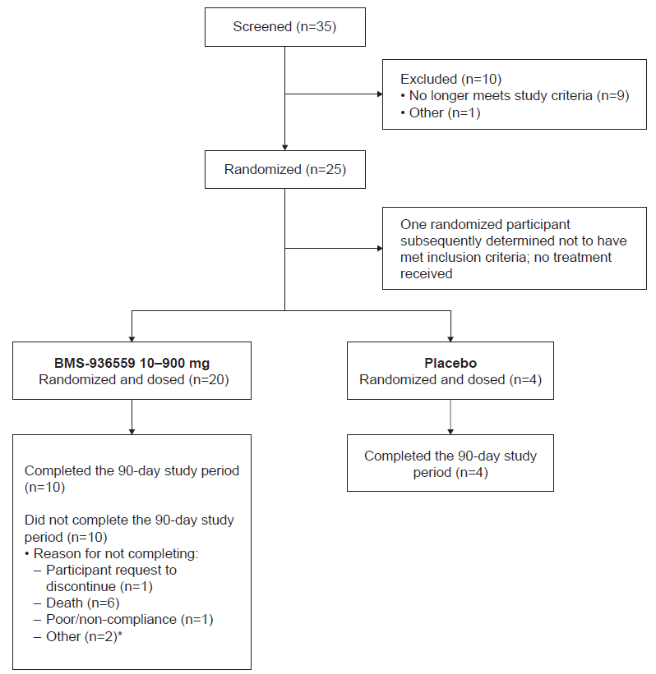
*One of the two participants listed as ‘other’ completed Day 90 but the Case Report Form did not record this status.

Supplementary Figure S2. Mean (SD) overlay plots of BMS-936559 serum concentration–time profiles following intravenous infusion of BMS-936559 in participants with sepsis-associated immunosuppression
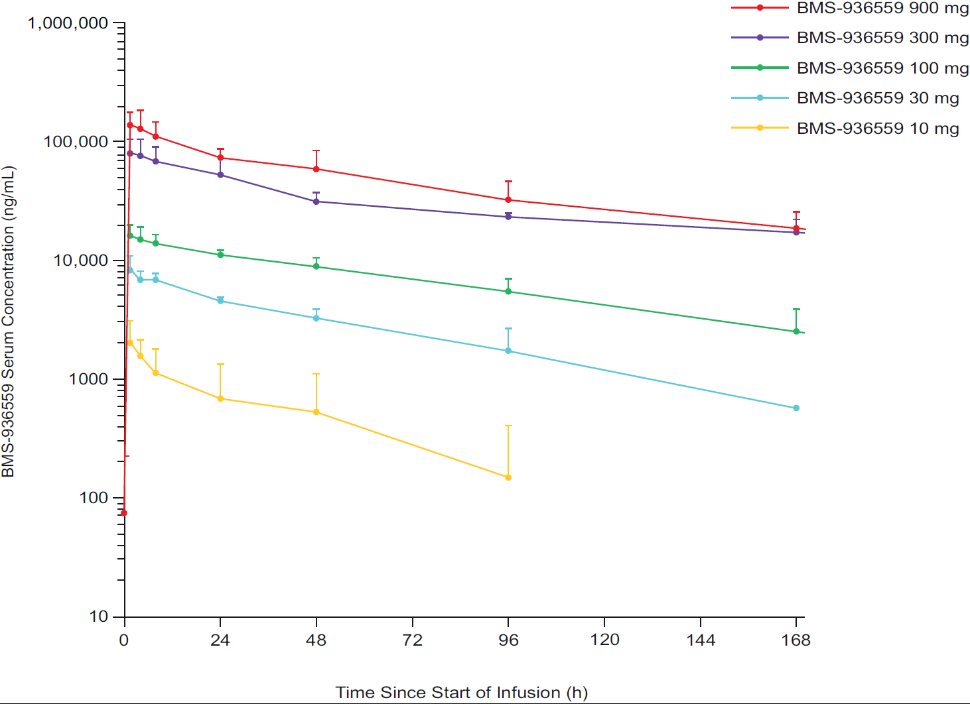
SD, standard deviation.

Supplementary Figure S3. Interleukin-6 levels over time (semi-log plot)
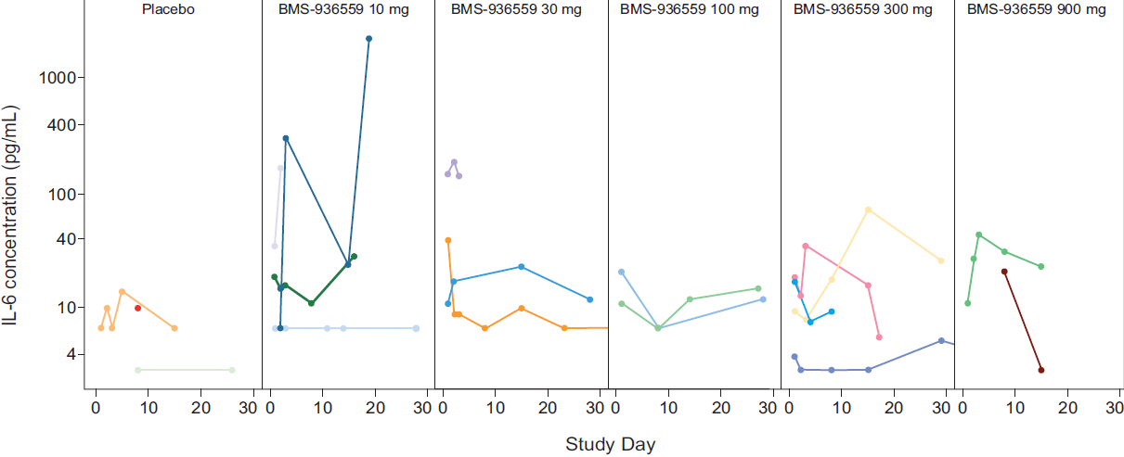
Separate colors represent individual participants.
IL, interleukin.

Supplementary Figure S4. Interleukin-8 levels over time (semi-log plot)
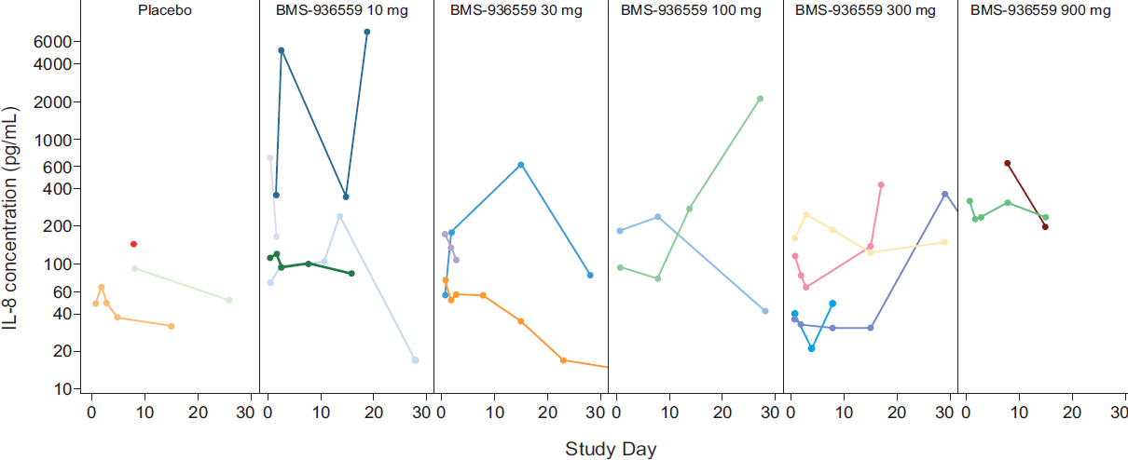
Separate colors represent individual participants.
IL, interleukin.

Supplementary Figure S5. Interleukin-10 levels over time (semi-log plot)
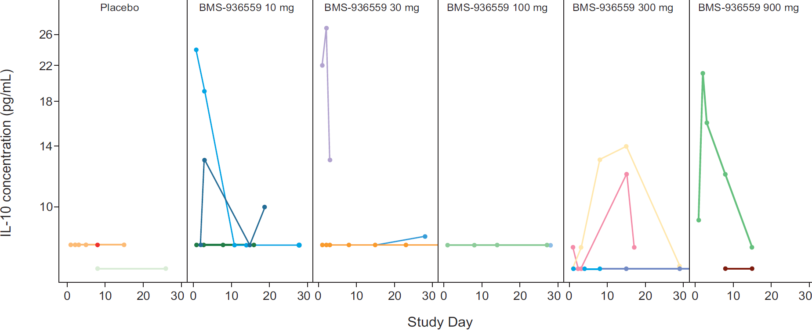
Separate colors represent individual participants.
IL, interleukin.

