**Supplemental Digital Content**

This appendix has been provided to give readers additional information about the study.

**Supplemental Appendix**

**Staged implementation of ABCDE bundle improves patient outcomes and reduces hospital costs**

S. Jean Hsieh M.D.1, Olufisayo Otusanya M.D.2, Hayley B. Gershengorn M.D.3, Aluko A. Hope M.D. M.S.4, Christopher Dayton M.D.5, Daniela Levi M.D.4, Melba Garcia6, David Prince M.D.7 , Michele Mills8, Dan Fein M.D.8, Silvie Colman PhD10, Michelle Ng Gong M.D. M.S.4,11

**Institutional Affiliations:**

1 Division of Pulmonary, Critical Care, and Sleep Medicine, Department of Medicine, Icahn School of Medicine at Mount Sinai

2 Division of Pulmonary Diseases, Critical Care, and Environmental Medicine, Department of Medicine, Tulane University School of Medicine

3Division of Pulmonary, Allergy, Critical Care, and Sleep Medicine, University of Miami, Miller School of Medicine

4 Division of Critical Care Medicine, Department of Medicine, Montefiore Medical Center, Albert Einstein College of Medicine

5 Division of Pulmonary Diseases and Critical Care, Department of Medicine, University of Texas Health Sciences Center at San Antonio

6 Department of Nursing, Montefiore Healthcare Center

7 Department of Physical Medicine and Rehabilitation, Montefiore Medical Center, Albert Einstein College of Medicine

8 Occupational Therapy Assistant Program, LaGuardia Community College

9 Division of Pulmonary Medicine, Department of Medicine, Montefiore Medical Center, Albert Einstein College of Medicine

10 Network Performance Group, Montefiore Medical Center

11 Department of Epidemiology and Population Health, Albert Einstein College of Medicine

**Table of Contents**

1. Methods
   1. Details about study design and setting
   2. Details about cohort for clinical outcomes and cost analyses
   3. Details about implementation stages
   4. Details about clinical data collection
   5. Details about process of care evaluation
   6. Details about clinical and cost outcome evaluation
   7. Details about DiD model assumptions
2. Results
   1. **Table S1.** Startup cost for early Mobilization program in mobilization ICU
   2. **Table S2.** Model to assess assumption of parallel trend for clinical and cost outcomes in full (B-AD-EC) vs partial (B-AD) bundle ICUsa
   3. **Table S3.** Sensitivity analysis of difference-in-differences estimates of change including patients with >90 day LOS
   4. **Figure S1.** Cohorts for clinical outcomes, cost, process of care, and quality indicators
   5. **Figure S2.** Process of care evaluation in full bundle ICU *only*
   6. **Figure S4.** Rehabilitation Protocol
3. References

**Methods Online Supplement**

Study Design and Setting

Both ICUs are staffed with board-certified critical care attending physicians and fellows from the Division of Critical Care Medicine at Montefiore Medical Center. Both ICU’s contain 14 beds and have similar staff to patient ratios (1 nurse: 2 patients; 1 respiratory therapist: 8 patients) and staffing structures (attending and fellow physician, nurses, respiratory therapist, pharmacist), with the exception of the full bundle ICU (B-AD-EC) being staffed by medical residents and the partial bundle ICU (B-AD) being staffed by physician assistants.

Cohort for clinical outcomes and cost analyses

Our primary cohort consisted of all MV adults (≥18 years) admitted to the ICUs for ≥24

hours from July 1, 2011 to June 30, 2014. (Figure S1) To ensure estimates were reflective of the implemented bundles and meet the no spillover assumption for DiD estimates, patients who were transferred between the two ICU’s or who had ICU stays that were not fully confined within one implementation period were excluded. To ensure estimates were reflective of events associated with the index ICU admission, patients were excluded if they were hospitalized for >3 days before ICU admission or if the time between ICU admission and hospital discharge was >90 days.

Implementation Stages

*Baseline: Spontaneous Breathing (B) Trials (both ICU’s)*

At baseline, orders for sedation vacation and Spontaneous Breathing trials (B) were included in the mechanical ventilation order sets in both ICU’s. (Figure 1) However, these orders did not include any guidance on the performance of these interventions, level of consciousness assessments, sedation management, nor coordination of sedation vacation with spontaneous breathing trials.

*Awakening and Delirium Monitoring/Management (AD) (both ICU’s)*

An interdisciplinary team of critical care nursing and physician leadership, pharmacists, and champions developed and disseminated hospital system-wide ICU sedation and delirium screening protocols and policies, added documentation of RASS and CAM-ICU into electronic medical records, and updated sedation order sets to include default RASS of 0. Beginning in January 2012, the (A)wakening from sedation and (D)elirium monitoring/management (AD) bundles were implemented in both ICU’s. These were driven by system-wide ICU policies and protocols which included determination of a target level of consciousness by ICU physicians (i.e., targeted sedation) using the Richmond Agitation and Sedation Scale (RASS) with a default target of awake and calm (RASS 0) (1), RASS assessments every 2 to 4 hours by ICU nurses, sedation titration guidelines to achieve target level of consciousness for nurses and physicians, twice daily delirium assessments using the Confusion Assessment Method-ICU (CAM-ICU) by ICU nurses (1, 2), and recommendations for non-pharmacologic treatment of delirium for nurses and physicians (e.g., re-orientation, timely removal of catheters and restraints, minimization of unnecessary noise / stimulation). Nurses in both ICU’s received educational modules consisting of a 10-minute lecture to introduce the RASS and CAM-ICU followed by observed performances of the RASS and CAM-ICU in multiple ICU patients with immediate feedback provided by the physician or nursing educator. Compliance was assessed by auditing electronic medical records for the frequency of nursing documentation of RASS and CAM-ICU. To account for time required to adopt these practice changes across interdisciplinary providers, the AD bundles were considered fully implemented by July 1, 2012.

*Early Mobilization and Coordination of Bundle Components (EC) (full bundle ICU only)*

An interdisciplinary team of ICU nursing, physician, respiratory therapy, and rehabilitation leaders and champions developed an early mobilization protocol, interdisciplinary simulation training exercises, and database, and obtained funding from hospital administration for dedicated rehabilitation staffing and startup costs. (Table S1) On July 1, 2013, the (E)arly mobilization and structured (C)oordination of ABCDE bundle components (EC) were implemented in the full bundle ICU only (B-AD-EC). This included the addition of a dedicated full-time physical therapist, a dedicated full-time occupational therapist, and 2 rehabilitation technicians who began working in full bundle ICU on July 1, 2013. Because of resource and staffing limitations, the partial bundle ICU (B-AD) did not receive any additional staffing or interventions. All patients were evaluated by physical and occupational therapy at ICU admission and received daily rehabilitation (unless the patient was determined to be clinically unstable for mobilization by the attending intensivist). Rehabilitation treatments were guided by a staged protocol modeled after prior studies in which patients advanced from passive range of motion exercises to independent ambulation.(3, 4) (Figure S3) Treatments were titrated to the patient’s level of consciousness and physical ability, with the goal of achieving the patient’s maximum functional milestone during each treatment. The (C)oordination component of the bundle consisted of daily nursing-led structured interdisciplinary rounds to coordinate spontaneous (B)reathing trials with (A)wakening from sedation, diagnostic tests and procedures to ensure patients were awake and available for mobilization. These brief, focused rounds took place in the morning before bedside rounds and were attended by ICU nurses, respiratory therapists, and rehabilitation staff. They were not meant to replace the more comprehensive interdisciplinary rounds in which more holistic patient care was discussed.

Clinical data collection

Demographic and administrative data for all patients in both ICUs were extracted from electronic medical records using a health care surveillance software (Clinical Looking GlassTM; Emerging Health Information Technology, Yonkers, NY).(5) This included self-identified race and ethnicity, pre-hospital residence, comorbidities (Charlson Comorbidity Index) (6, 7), primary admitting diagnosis, ICU and hospital lengths of stay (LOS), duration of invasive mechanical ventilation (MV), in-hospital mortality, and discharge location. Severity of illness was measured using the APACHE IV score.(8)

Process of care evaluation

We examined processes of care metrics to determine if practices changed after ICU-wide implementation of bundle components. Due to limited resources, these measurements were made in several time periods and were limited to the full bundle ICU only (B-AD-EC). Specifically, sedation and delirium processes of care were compared in consecutive MV and non-MV patients during the summers of baseline, period 1 and period 2 in the full bundle ICU only (n=451, Figures 1 in main manuscript and S1). Rehabilitation processes of care were compared in MV patients in the B-AD and B-AD-EC periods in the mobilization ICU only (n=426).

*Sedative use and delirium/coma prevalence*

Continuous-infusion sedative use was abstracted from electronic medical records in the mobilization ICU only. Level of consciousness was assessed on a daily basis by trained research team members, or (on weekends or holidays) by bedside nurses using the RASS. Patients with a RASS score of -4 or -5 were considered comatose and not assessable for delirium. Patients with a RASS score of -3 or greater were assessed for delirium using the CAM-ICU. The personnel performing delirium assessments did not participate in the quality improvement implementation.

*ICU Mobility*

Rehabilitation staff recorded all exercises performed per session, the highest level of mobility achieved, the reason for no rehabilitation (e.g., lack of staff, clinical instability as determined by the attending intensivist), and serious adverse events that occurred during rehabilitation in the mobilization ICU (e.g., line or tube dislodgement, fall, unplanned extubation, persistent hemodynamic instability or hypoxemia).

Outcomes

*Clinical Outcomes*

The primary outcome of interest was the hospital LOS after completion of the ABCDE bundle. Hospital LOS was defined as the time to hospital discharge from the index ICU admission (i.e., ICU LOS + post-ICU LOS). Secondary outcomes included ICU LOS for the index admission, duration of mechanical ventilation during index ICU stay, in-hospital mortality, and discharge location.

*Cost outcomes*

Total hospital cost, total ICU cost, and average daily ICU cost (i.e., total cost divided by ICU LOS) were also measured as secondary outcomes. Costs were determined from charges using cost-to-charge ratios unique to Montefiore Medical Center. Cost to charge ratios are defined as the ratio between cost required to operate a hospital (e.g., wages, supplies, utility costs) and revenue (the amount billed for the inpatient stay), and are used estimate cost of resource use during inpatient hospital stays. Because cost to charge ratios are consistent across campuses but differ from calendar year to calendar year, the cohort used for the cost analyses was limited to patients with hospitalizations that ended between January 1, 2012 and December 31, 2013. Costs were calculated as the sum of daily direct variable costs from cost centers related to inpatient, non-operative care (e.g., respiratory support, room and board, laboratory, medications) as previously described.(9) Because cost data were date but not time-stamped, ICU costs refer to the total cost of healthcare utilization in the hospital on the calendar days of a patient’s ICU stay.

Statistical Analysis

*DiD Model Assumptions*

Validity of the DiD estimation is predicated on 4 assumptions. In addition to testing the assumption for parallel trend (as detailed in the main manuscript, Table S2), we met the 3 additional assumptions using the following methods: 1) no spillover effect: patients who were transferred between the two ICU’s or who had ICU stays that were not fully confined within one implementation period were excluded; 2) stable composition of intervention and comparison groups: adjustment of patient level characteristics in model, 3) Intervention not determined by baseline outcome: mobilization and bundle coordination was provided to all ICU patients; their provision was not determined by duration of MV, ICU LOS nor cost.

**Supplement Table S1.** Startup cost for early mobilization program in the full bundle ICU

|  |  |
| --- | --- |
| **Cost element** | **Cost** |
| Recurring cost |  |
| Physical therapist salary | $80,000 |
| Occupational therapist salary | $80,000 |
| Technician x 2 salary | $80,000 |
| One-time cost |  |
| Training | $3,000 |
| Equipmenta | $44,135 |
| **Total** | **$287,135** |

aEquipment included in-bed stationary bicycle, transfer and mobility device, stretcher chair, portable suction, dynamometer, patient weights

**Supplement Table S2.** Model to assess assumption of parallel trend for clinical and cost outcomes in full vs partial bundle ICUsa

|  |  |  |  |  |
| --- | --- | --- | --- | --- |
|  | **Baseline Period** b | | **Period 1** c | |
| **Outcome Measure** | **% change (95% CI)** | **p-value** | **% change (95% CI)** | **p-value** |
| Clinical Outcomes |  |  |  |  |
| Duration of mechanical ventilation | -0.03% (-0.28%, 0.21%) | 0.331 | 0.04% (-0.15%, 0.23%) | 0.235 |
| ICU length of stay | 0.00% (-0.13%, 0.14%) | 0.729 | 0.06% (-0.02%, 0.14%) | 0.068 |
| Hospital length of stayd | 0.02% (-0.06%, 0.11%) | 0.176 | 0.17% (0.10%, 0.24%) | 0.022 |
| Cost Outcomes |  |  |  |  |
| Average daily ICU cost | -0.06% (-0.15%, 0.02%) | 0.138 | -0.08% (-0.20%, 0.04%) | 0.196 |
| Total ICU cost | 0.08% (-0.26%, 0.43%) | 0.644 | -0.05% (-0.40%, 0.30%) | 0.770 |
| Total Hospital cost | 0.17% (-0.17%, 0.52%) | 0.328 | -0.03% (-0.37%, 0.32%) | 0.882 |

Parallel trend is the most important assumption that needs to be met for difference-in-differences estimate validity. Specifically, temporal changes in outcomes for both ICUs should be similar prior to interventions. To assess for this assumption, we constructed models for each outcome in the periods before AD implementation (Baseline) and before EC implementation (Period 1).

a Models were adjusted for age, race, ethnicity, pre-hospital residence, admission location, Charlson Comorbidity Index, primary admitting diagnosis, APACHE IV. Interpretive example: 1) % change per calendar day in duration of mechanical ventilation did not differ between full and partial bundle ICU’s before EC was implemented in the full bundle ICU (Period 1, p=0.235)

b At Baseline, spontaneous **(B)**reathing trials were ongoing in *both* full and partial bundle ICU’s

c In Period 1, **(A)**wakening and **(D)**elirium monitoring/management were implemented in *both*ICU’s

d Defined as index ICU LOS + post-ICU LOS

**Supplement Table S3.** Sensitivity analysis of difference-in-differences estimates of change including patients with >90 day LOS (n=1882)a

|  |  |  |  |  |
| --- | --- | --- | --- | --- |
|  | **Full bundle ICU minus Partial bundle ICU** | | | |
| **Outcome Measure** | **Baseline vs Period 1**  **% change (95% CI)**  **(B minus B-AD)** | **p-value** | **Period 1 vs Period 2**  **% change (95% CI)**  **(B-AD minus B-AD-EC)** | **p-value** |
| Duration of mechanical ventilation | 8.2% (-1.6%,18.9%) | 0.061 | -23.0% (-24.3%,-21.8%) | <0.001 |
| ICU length of stay | 4.1% (-4.7%,13.6%) | 0.11 | -11.5% (-17.7%,-4.7%) | 0.03 |
| Hospital length of stayb | 9.6% (5.3%,14.2%) | 0.022 | -9.6% (-11.8%,-7.3%) | 0.012 |

*Definition of abbreviations:*A = awakening; B = spontaneous breathing trial; C = coordination of bundle components; D = delirium monitoring and management; E = early mobilization; APACHE IV = Acute Physiology and Chronic Health Evaluation IV; CCI=Charlson Comorbidity Index

Baseline vs Period 1 compares trends in clinical and cost outcomes after AD was implemented in *both* full and partial bundle ICU’s. Period 1 vs Period 2 compares clinical and cost outcomes in full bundle vs partial bundle ICU’s after EC was implemented in full bundle ICU *only*.

a Both models are adjusted for age, race, ethnicity, pre-hospital residence, admission location, Charlson Comorbidity Index, primary admitting diagnosis, APACHE IV

b Defined as index ICU admission to hospital discharge

**Figure S1**. Cohorts for clinical outcomes, cost, process of care, and quality indicators



aAdmitted to ICU >24 hours; Excludes patients with transfers between ICUs, ICU stay crossing two periods, admitted >3 days before ICU admission, hospital length of stay >90 days

**Figure S2.** Process of care evaluation in full bundle ICU *only*

**A.**

**B.**

1. The proportion of patients receiving continuous sedation decreased across three periods (midazolam and fentanyl, p<0.001; propofol p=0.006); the largest decrease occurred after AD implementation
2. The proportion of patients with ICU delirium and/or coma decreased across all 3 periods (p<0.02); the largest decrease occurred after AD implementation

**Figure S3.** Rehabilitation Protocol

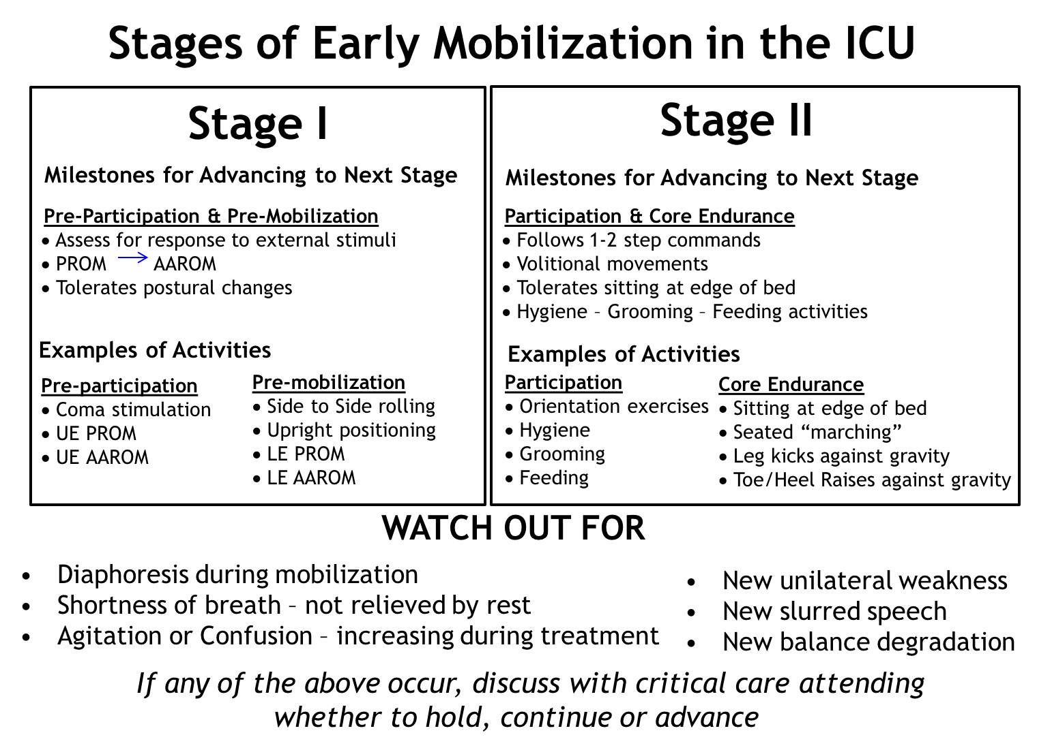

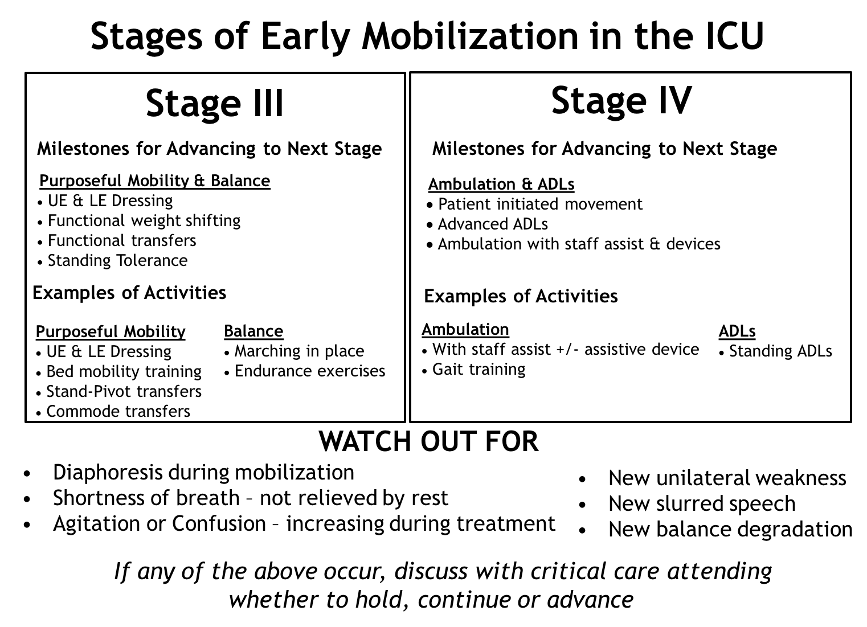

**REFERENCES**

1. Ely EW, Truman B, Shintani A, Thomason JW, Wheeler AP, Gordon S, Francis J, Speroff T, Gautam S, Margolin R, Sessler CN, Dittus RS, Bernard GR. Monitoring sedation status over time in ICU patients: reliability and validity of the Richmond Agitation-Sedation Scale (RASS). *JAMA* 2003; 289: 2983-2991.

2. Ely EW, Inouye SK, Bernard GR, Gordon S, Francis J, May L, Truman B, Speroff T, Gautam S, Margolin R, Hart RP, Dittus R. Delirium in mechanically ventilated patients: validity and reliability of the confusion assessment method for the intensive care unit (CAM-ICU). *JAMA* 2001; 286: 2703-2710.

3. Morris PE, Goad A, Thompson C, Taylor K, Harry B, Passmore L, Ross A, Anderson L, Baker S, Sanchez M, Penley L, Howard A, Dixon L, Leach S, Small R, Hite RD, Haponik E. Early intensive care unit mobility therapy in the treatment of acute respiratory failure. *Crit Care Med* 2008; 36: 2238-2243.

4. Schweickert WD, Pohlman MC, Pohlman AS, Nigos C, Pawlik AJ, Esbrook CL, Spears L, Miller M, Franczyk M, Deprizio D, Schmidt GA, Bowman A, Barr R, McCallister KE, Hall JB, Kress JP. Early physical and occupational therapy in mechanically ventilated, critically ill patients: a randomised controlled trial. *Lancet* 2009; 373: 1874-1882.

5. Bellin E, Fletcher DD, Geberer N, Islam S, Srivastava N. Democratizing information creation from health care data for quality improvement, research, and education-the Montefiore Medical Center Experience. *Acad Med* 2010; 85: 1362-1368.

6. Charlson ME, Pompei P, Ales KL, MacKenzie CR. A new method of classifying prognostic comorbidity in longitudinal studies: development and validation. *J Chronic Dis* 1987; 40: 373-383.

7. Daubin C, Chevalier S, Seguin A, Gaillard C, Valette X, Prevost F, Terzi N, Ramakers M, Parienti JJ, du Cheyron D, Charbonneau P. Predictors of mortality and short-term physical and cognitive dependence in critically ill persons 75 years and older: a prospective cohort study. *Health and quality of life outcomes* 2011; 9: 35.

8. Zimmerman JE, Kramer AA, McNair DS, Malila FM. Acute Physiology and Chronic Health Evaluation (APACHE) IV: hospital mortality assessment for today's critically ill patients. *Crit Care Med* 2006; 34: 1297-1310.

9. Gershengorn HB, Garland A, Gong MN. Patterns of Daily Costs Differ for Medical and Surgical Intensive Care Unit Patients. *Annals of the American Thoracic Society* 2015.