**SUPPLEMENTAL DIGITAL CONTENT**

**Early and late mortality following discharge from the ICU: a multicenter prospective cohort study**

**Table of contents:**

|  |  |
| --- | --- |
| **Supplemental Digital Content** | **Page** |
| Collaborators | 2 |
| Supplemental Figure 1. Participant flow diagram | 3 |
| Supplemental Figure 2. Geographical distribution of participating centers | 4 |
| Supplemental Figure 3. Causes of infectious deaths. | 5 |
| Supplemental Table 1. Univariable analysis of factors associated with early mortality | 6 |
| Supplemental Table 2. Univariable analysis of factors associated with late mortality | 9 |
| Supplemental Figure 4. Schoenfeld test for the early mortality multivariable regression model | 12 |
| Supplemental Figure 5. Schoenfeld test for the late mortality multivariable regression model | 13 |
| Supplemental Figure 6. Martingale test for the association between risk of death at ICU admission and mortality | 14 |
| Supplemental Table 3. Sensitivity analysis 1: factors associated with early and late mortality considering the effect of continuous variables | 15 |
| Supplemental Table 4. Sensitivity analysis 2: factors associated with early and late mortality excluding age as a determinant of risk of death at ICU admission | 16 |
| Supplemental Table 5. Sensitivity analysis 3: factors associated with early and late mortality with adjustment for treatment limitation in place at the moment of ICU discharge | 17 |
| Supplemental Figure 7. Contribution of subtypes of ICU-acquired infections for the hazard of death over time | 18 |
| Supplemental Table 6. Exploratory analysis: multivariable analysis of factors associated with early and late infectious mortality | 19 |

**Collaborators *(by state and hospital center)***

**Bahia**

*Hospital Geral Clériston Andrade*: Lúcio Couto de Oliveira Júnior, Daniela Cunha de Oliveira, Eduardo da Silva Oliveira, Gabriel Silva da Rocha.

**Goiás**

*Hospital de Urgências de Goiânia*: José Mario Meira Teles, Alexandre Amaral, Ana Paula Menezes Silveira, Giuliano Gardenghi.

**Pará**

*Hospital Regional do Baixo Amazonas*: Lívia Correa e Castro, Marli Sarmento da Silva, Luan Silva de Souza, Neyton Souza dos Santos.

**Rio Grande do Sul**

*Hospital Ernesto Dornelles*: André Sant’Ana Machado, Juliana Mara Stormosvski de Andrade, Tanara Carrera Meus Figueredo, Luciana Tagliari.

*Hospital de Clínicas de Porto Alegre*: Silvia Regina Rios Vieira, Paula Pinheiro Berto, Paulo Ricardo Cerveira Cardoso, Fernanda Caleffe Moreira.

*Hospital Moinhos de Vento*: Roselaine Pinheiro de Oliveira, Juçara Gasparetto Maccari, Patrícia Balzano, Aline Maria Ascoli.

*Hospital Nossa Senhora da Conceição*: Wagner Nedel, Cesar Alencar, Michelle Carneiro Teixeira.

*Hospital Santa Clara:* Rodrigo Boldo, Juliana Rezende Cardoso, Fernanda Gehm, Cláudia da Rocha Cabral.

*Pavilhão Pereira Filho*: Daniella Cunha Birriel, Mariana Nunes Gamboa.

**São Paulo**

*Hospital do Coração*: Alexandre Biasi Cavalcanti, Cinthia Mucci Ribeiro, Rafael Trevizoli Neves, Renata de Andrade Gomes.

**Supplemental Figure 1.** Participant flow diagram.

Figure%201.pdf

ICU, intensive care unit.

* No available telephone contact, patient was not found in the ward after five attempts, or screening failure.

**Supplemental Figure 2.** Geographical distribution of participating centers.

Figure%20S1.pdf

**Supplemental Figure 3.** Causes of infectious deaths.

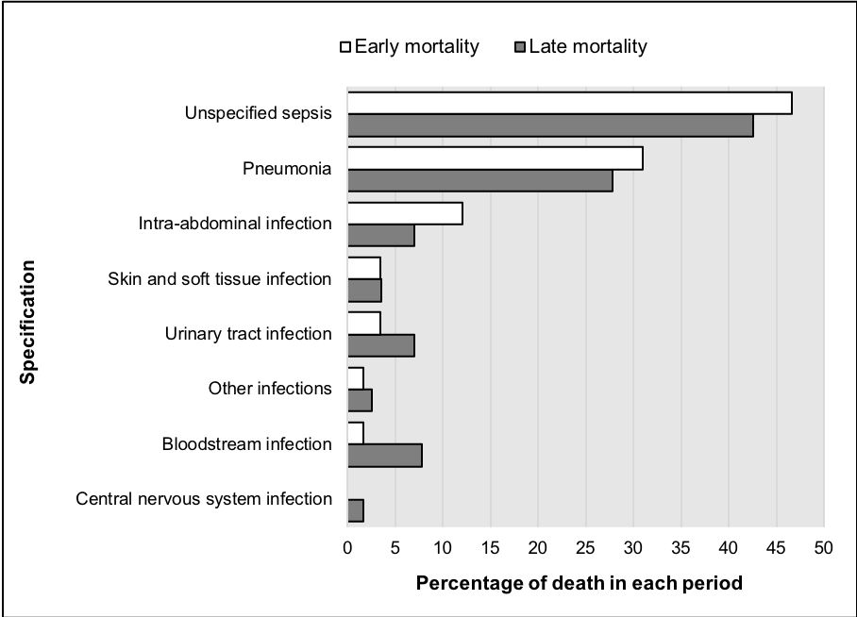

**Supplemental Table 1.** Univariable analysis of factors associated with early mortality.

|  |  |  |  |  |
| --- | --- | --- | --- | --- |
| **Characteristic** | **Post-ICU death** | | **Hazard ratio**  **(95%CI)** | ***P*-value** |
| **Yes**  **(no.=123)** | **No**  **(no.=1431)** |
| Hospitals  Public – no./total no. (%)  Academic – no./total no. (%)  ICU-to-hospital bed ratio, % | 32/123 (26.0)  46/123 (37.4)  6.5 (6.5-6.6) | 359/1431 (25.1)  436/1431 (30.5)  6.6 (6.5-6.6) | 1.04 (0.63-1.72)  1.36 (0.94-1.96)  0.97 (0.89-1.05) | 0.89  0.10  0.44 |
| Patients  Sociodemographic |  |  |  |  |
| Age, years – median (IQR) | 74.0 (60.0-83.0) | 66.0 (53.5-77.0) | 1.03 (1.01-1.04) | <0.001 |
| Age ≥65 years – no./total no. (%) | 85/123 (69.1) | 767/1431 (53.6) | 2.04 (1.38-3.00) | <0.001 |
| Female sex – no./total no. (%) | 58/123 (47.2) | 683/1431 (47.7) | 0.99 (0.69-1.41) | 0.94 |
| Education attainment, years – median (IQR) | 8 (4-11) | 10.5 (5-11) | 0.94 (0.90-0.97) | <0.001 |
| Higher education – no./total no. (%) | 19/121 (15.7) | 324/1426 (22.7) | 0.64 (0.39-1.04) | 0.07 |
| *Per capita* household incomea, USD – median (IQR) | 448 (321-844) | 574 (345-1482) | 1.001 (0.988-1.013) | 0.91 |
| Pre-ICU state of health |  |  |  |  |
| Charlson comorbidity index – median (IQR) | 3.0 (1.0-5.0) | 2.0 (0-3.0) | 1.16 (1.09-1.23) | <0.001 |
| High comorbidityb – no./total no. (%) | 87/123 (70.7) | 781/1431 (54.6) | 1.96 (1.33-2.88) | 0.001 |
| Barthel index – median (IQR) | 90.0 (60.0-100.0) | 100 (85-100) | 0.93 (0.91-0.95) | <0.001 |
| Physical dependencec – no./total no. (%) | 48/122 (39.3) | 264/1430 (18.5) | 2.78 (1.93-4.01) | <0.001 |
| Critical illness |  |  |  |  |
| ICU admission type |  |  |  |  |
| Medical – no./total no. (%) | 89/123 (72.4) | 1006/1431 (70.3) | reference | - |
| Postoperative, elective – no./total no. (%) | 22/123 (17.9) | 253/1431 (17.7) | 0.97 (0.61-1.55) | 0.90 |
| Postoperative, emergency – no./total no. (%) | 12/123 (9.8) | 172/1431 (12.0) | 0.79 (0.43-1.45) | 0.45 |
| Risk of death at ICU admissiond, % – median (IQR) | 23.5 (14.6-46.0) | 17.1 (11.3-35.5) | 1.011 (1.003-1.019) | 0.005 |
| Severe sepsis or septic shock at ICU admission – no./total no. (%) | 46/123 (37.4) | 46/123 (37.4) | 1.17 (0.80-1.69) | 0.42 |
| ARDS at ICU admission – no./total no. (%) | 4/123 (3.3) | 73/1431 (5.1) | 0.64 (0.23-1.73) | 0.37 |
| Organ dysfunctions during ICU stay |  |  |  |  |
| No. of organ dysfunctions – median (IQR) | 2.0 (1.0-3.0) | 2.0 (0-3.0) | 1.13 (0.99-1.28) | 0.06 |
| Delirium – no./total no (%) | 40/123 (32.5) | 360/1431 (25.2) | 1.41 (0.96-2.05) | 0.07 |
| Need of invasive mechanical ventilation – no./total no. (%) | 65/123 (52.8) | 702/1431 (49.1) | 1.13 (0.79-1.62) | 0.49 |
| Need of vasopressor – no./total no. (%) | 74/123 (60.2) | 771/1431 (53.9) | 1.27 (0.89-1.83) | 0.19 |
| Need of renal replacement therapy – no./total no. (%) | 19/123 (15.4) | 172/1431 (12.0) | 1.30 (0.80-2.12) | 0.29 |
| Need of blood or blood products transfusion – no./total no. (%) | 22/123 (17.9) | 256/1431 (17.9) | 0.97 (0.61-1.54) | 0.88 |
| Need of parenteral nutrition – no./total no. (%) | 10/123 (8.1) | 74/1431 (5.2) | 1.62 (0.85-3.10) | 0.14 |
| Length of ICU stay, days – median (IQR) | 8.0 (5.2-14.0) | 6.0 (4.0-11.0) | 1.02 (1.01-1.04) | 0.03 |
| Any-ICU acquired infectionse – no./total no. (%) | 30/123 (24.4) | 185/1431 (12.9) | 2.07 (1.37-3.13) | 0.001 |
| Pneumonia – no./total no. (%) | 23/123 (18.7) | 160/1431 (11.2) | 1.75 (1.11-2.76) | 0.01 |
| Bloodstream infection – no./total no. (%) | 9/123 (7.3) | 34/1431 (2.4) | 2.85 (1.44-5.62) | 0.003 |
| Urinary tract infection – no./total no. (%) | 3/123 (2.4) | 23/1431 (1.6) | 1.43 (0.45-4.51) | 0.54 |
| ICU readmission – no./total no. (%) | 36/123 (29.3) | 123/1431 (8.6) | 3.90 (2.64-5.75) | <0.001 |
| Length of hospital stay, days – median (IQR) | 33.0 (21.0-44.5) | 25.0 (16.0-45.8) | 1.001 (1.001-1.002) | 0.02 |

ARDS, acute respiratory distress syndrome; CI, confidence interval; ICU, intensive care unit; IQR, interquartile range (p25-p75).

a Using the purchasing power parity conversion (BRL to USD). Purchasing power parities are the rates of currency conversion that equalize the purchasing power of different currencies by eliminating the differences in price levels between countries.

b Charlson comorbidity index ≥2.

c Barthel index <75.

d The risk of death was calculated using established prediction equations for hospital death according to the Acute Physiology and Chronic Health Evaluation II score15 or the Simplified Acute Physiology Score-316.

e Pneumonia, bloodstream infection, or urinary tract infection according to the European Centre for Disease Prevention and Control criteria.

**Supplemental Table 2.** Univariable analysis of factors associated with late mortality.

|  |  |  |  |  |
| --- | --- | --- | --- | --- |
|  | **Mortality group**  **(no.=316)** | **Survival group**  **(no.=1102)** | **Hazard ratio**  **(95%CI)** | ***P*-value** |
| Hospitals  Public – no./total no. (%)  Academic – no./total no. (%)  ICU-to-hospital bed ratio, % | 85/316 (26.9)  103/316 (32.6)  6.6 (6.3-6.6) | 268/1102 (24.3)  327/1102 (29.7)  6.6 (6.5-6.6) | 1.06 (0.72-1.55)  1.00 (0.69-1.47)  0.99 (0.94-1.05) | 0.77  0.99  0.81 |
| Patients |  |  |  |  |
| Sociodemographic |  |  |  |  |
| Age, years – median (IQR) | 71 (58-80) | 65 (51-76) | 1.02 (1.01-1.03) | <0.001 |
| Age ≥65 years – no./total no. (%) | 199/316 (63) | 561/1102 (50.9) | 1.66 (1.31-2.09) | <0.001 |
| Female sex – no./total no. (%) | 141/316 (44.6) | 535/1102 (48.5) | 0.86 (0.69-1.08) | 0.19 |
| Education attainment, years – median (IQR) | 8.0 (5.0-11.0) | 11 (5-11) | 0.98 (0.95-0.99) | 0.03 |
| Higher education – no./total no. (%) | 62/315 (19.7) | 262/1098 (23.9) | 0.90 (0.67-1.19) | 0.46 |
| *Per capita* household incomea, USD – median (IQR) | 494.1 (273.3-988.1) | 617.6 (370.6-1607.7) | 0.98 (0.97-0.99) | 0.003 |
| Pre-ICU state of health |  |  |  |  |
| Charlson comorbidity index – median (IQR) | 2.0 (1.0-5.0) | 1.0 (0-3.0) | 1.18 (1.14-1.23) | <0.001 |
| High comorbidityb – no./total no. (%) | 235/316 (74.4) | 540/1102 (49.0) | 2.67 (2.08-3.44) | <0.001 |
| Barthel index – median (IQR) | 90.0 (70.0-100.0) | 100 (90-100) | 0.94 (0.93-0.96) | <0.001 |
| Physical dependencec – no./total no. (%) | 98/316 (31.0) | 164/1101 (14.9) | 2.28 (1.79-2.9) | <0.001 |
| Critical illness |  |  |  |  |
| ICU admission type |  |  |  |  |
| Medical – no./total no. (%) | 235/316 (74.4) | 763/1102 (69.2) | reference | - |
| Postoperative, elective – no./total no. (%) | 51/316 (16.1) | 200/1102 (18.1) | 0.82 (0.61-1.12) | 0.22 |
| Postoperative, emergency – no./total no. (%) | 30/316 (9.5) | 139/1102 (12.6) | 0.72 (0.49-1.06) | 0.09 |
| Risk of death at ICU admissiond, % – median (IQR) | 22.9 (12.9-49.7) | 16.5 (11.3-30.8) | 1.013 (1.008-1.018) | <0.001 |
| Severe sepsis or septic shock at ICU admission – no./total no. (%) | 125/316 (39.6) | 340/1102 (30.9) | 1.32 (1.04-1.66) | 0.02 |
| ARDS at ICU admission – no./total no. (%) | 11/316 (3.5) | 60/1102 (5.4) | 0.63 (0.35-1.16) | 0.14 |
| Organ dysfunctions during ICU stay |  |  |  |  |
| No. of organ dysfunctions – median (IQR) | 2.0 (1.0-3.0) | 2 (0-2.0) | 1.06 (0.98-1.15) | 0.16 |
| Delirium – no./total no (%) | 94/316 (29.7) | 262/1102 (23.8) | 1.29 (1.01-1.64) | 0.04 |
| Need of invasive mechanical ventilation – no./total no. (%) | 152/316 (48.1) | 545/1102 (49.5) | 0.91 (0.73-1.14) | 0.42 |
| Need of vasopressor – no./total no. (%) | 181/316 (57.3) | 582/1102 (52.8) | 1.15 (0.92-1.43) | 0.23 |
| Need of renal replacement therapy – no./total no. (%) | 46/316 (14.6) | 126/1102 (11.4) | 1.24 (0.9-1.69) | 0.18 |
| Need of blood or blood products transfusion – no./total no. (%) | 70/316 (22.2) | 184/1102 (16.7) | 1.32 (1.01-1.74) | 0.04 |
| Need of parenteral nutrition – no./total no. (%) | 11/316 (3.5) | 63/1102 (5.7) | 0.64 (0.35-1.17) | 0.14 |
| Length of ICU stay – median (IQR) | 7.0 (4.0 to 10.0) | 6.0 (4.0 to11.0) | 1.00 (0.99-1.02) | 0.56 |
| Any-ICU acquired infectionse – no./total no. (%) | 45/316 (14.2) | 139/1102 (12.6) | 1.09 (0.79-1.51) | 0.58 |
| Pneumonia – no./total no. (%) | 40/316 (12.7) | 119/1102 (10.8) | 1.14 (0.81-1.60) | 0.44 |
| Bloodstream infection – no./total no. (%) | 8/316 (2.5) | 26/1102 (2.4) | 1.00 (0.49-2.00) | 0.97 |
| Urinary tract infection – no./total no. (%) | 5/316 (1.6) | 18/1102 (1.6) | 0.99 (0.37-2.17) | 0.80 |
| ICU readmissionf  Mortality 31 to 60 days after ICU discharge  Mortality 61 to 90 days after ICU discharge  Mortality 91 to 365 days after ICU discharge | 22/78 (28.2)  14/54 (25.9)  21/184 (11.4) | 100/1340 (7.5)  86/1286 (6.7)  65/1095 (5.9) | 4.58 (2.79-7.52)  4.60 (2.50-8.49)  1.90 (1.21-3.00) | <0.001  <0.001  0.006 |
| Length of hospital stay, days – median (IQR) | 38.0 (22.0-60.0) | 22.0 (14.0-39.0) | 1.009 (1.007-1.012) | <0.001 |

ARDS, acute respiratory distress syndrome; CI, confidence interval; ICU, intensive care unit; IQR, interquartile range (p25-p75).

a Using the purchasing power parity conversion (BRL to USD). Purchasing power parities are the rates of currency conversion that equalize the purchasing power of different currencies by eliminating the differences in price levels between countries.

b Charlson comorbidity index ≥2.

c Barthel index <75

d The risk of death was calculated using established prediction equations for hospital death according to the Acute Physiology and Chronic Health Evaluation II score15 or the Simplified Acute Physiology Score-316.

e Pneumonia, bloodstream infection, or urinary tract infection according to the European Centre for Disease Prevention and Control criteria.

f The time period for assessing late mortality was partitioned into 3 strata to satisfy the proportional hazards assumption.

**Supplemental Figure 4.** Schoenfeld residuals for the early mortality multivariable regression model.

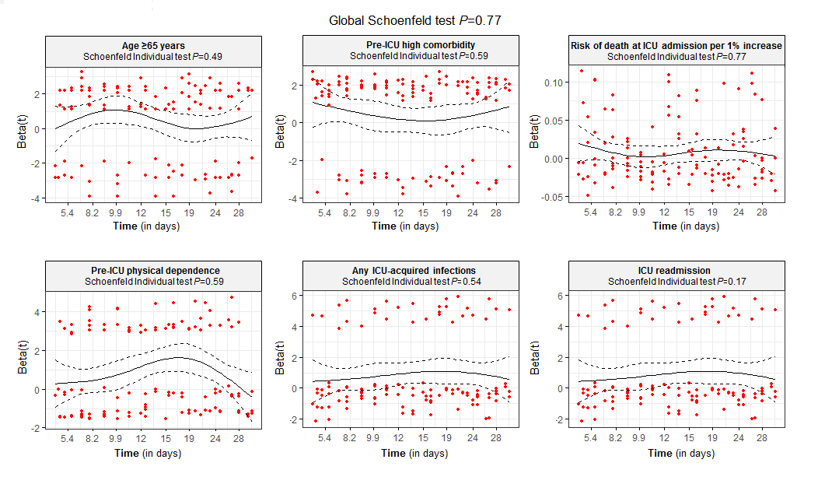

The proportionality assumption was assessed by testing the independence between residuals and time using the Schoenfeld test. A *P*≥0.05 for the test based on Schoenfeld residuals indicates that the proportional hazards assumption has not been violated.

**Supplemental Figure 5.** Schoenfeld residuals for the late mortality multivariable regression model.

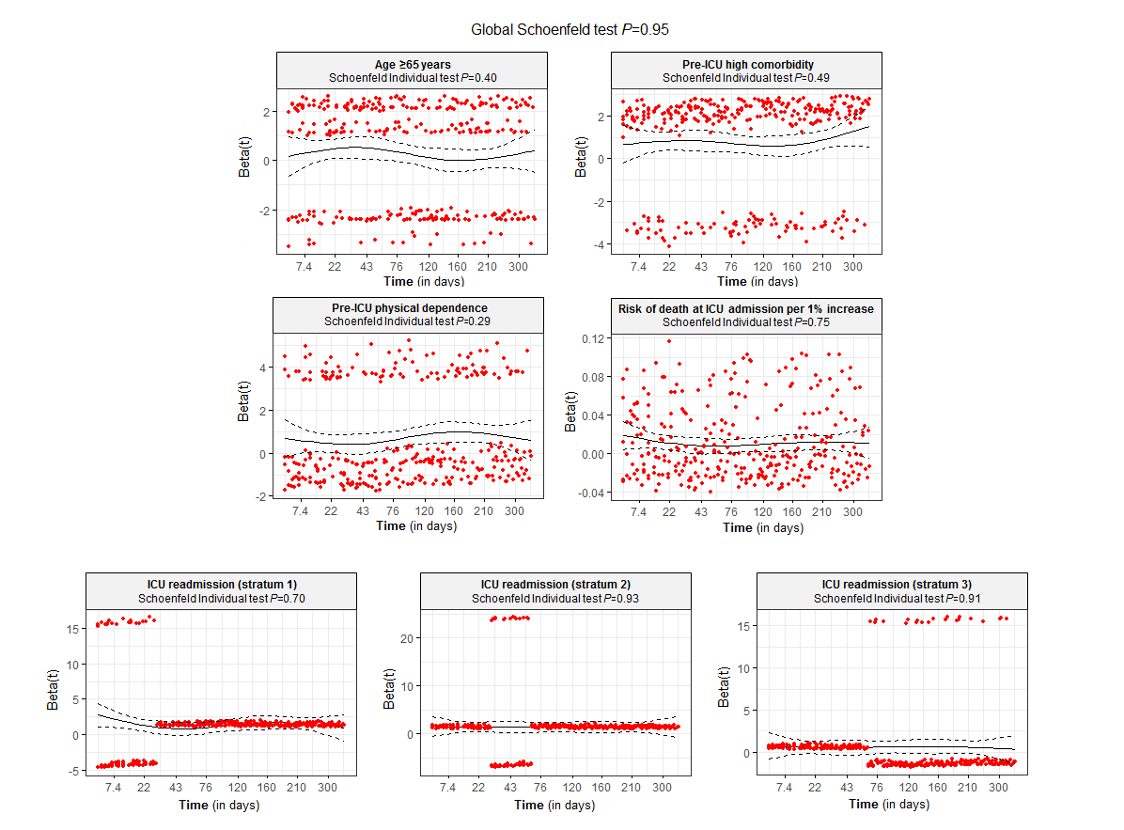

The proportionality assumption was assessed by testing the independence between residuals and time using the Schoenfeld test. A *P*≥0.05 for the test based on Schoenfeld residuals indicates that the proportional hazards assumption has not been violated.

Stratum 1, mortality between 31 and 60 days; Stratum 2, mortality between 61 and 90 days; Stratum 3, mortality between 91 and 365 days.

**Supplemental Figure 6.** Martingale residuals for the association between risk of death at ICU admission and mortality.

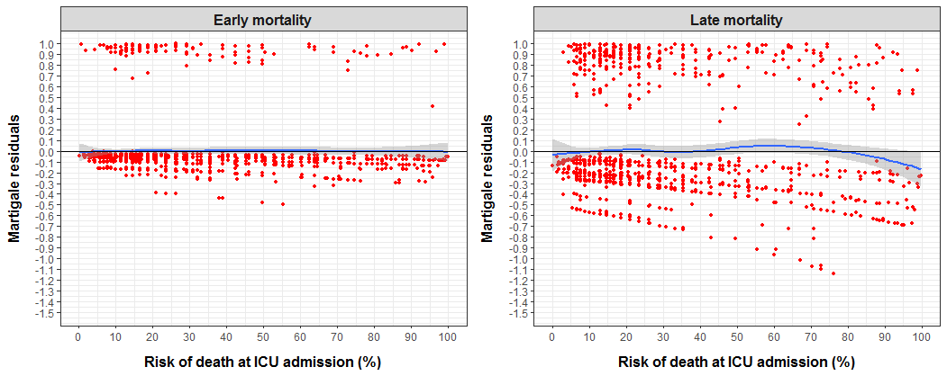

The assumption of linear association between the risk of death at ICU admission and early and late post-ICU mortality was verified by plotting Martingale residuals for the Cox regression model. In order to satisfy the assumption of linearity, the locally weighted scatterplot smoothing (LOWESS) line of residuals against the continuous variable should not show any specific pattern.

**Supplemental Table 3.** Sensitivity analysis 1a: factors associated with early and late mortality considering the effect of continuous variables.

|  |  |  |
| --- | --- | --- |
|  | **Hazard ratio**  **(95% confidence interval)** | ***P*-value** |
| Early mortality (within 30 days) |  |  |
| Age per 1 year increase | 1.018 (1.007-1.030) | 0.002 |
| Pre-ICU Charlson comorbidity index per 1 point increase | 1.13 (1.05-1.21) | 0.001 |
| Pre-ICU Barthel index per 1 point increase | 0.94 (0.92-0.97) | <0.001 |
| Risk of deathb at ICU admission per 1% increase | 1.007 (1.001-1.015) | 0.04 |
| Any ICU-acquired infectionc  ICU readmission | 2.29 (1.50-3.51)  3.66 (2.48-5.42) | <0.001  <0.001 |
| Late mortality (31 to 365 days) |  |  |
| Age per 1 year increase | 1.014 (1.007-1.021) | <0.001 |
| Pre-ICU Charlson comorbidity index per 1 point increase | 1.16 (1.12-1.21) | <0.001 |
| Pre-ICU Barthel index per 1 point increase | 0.95 (0.93-0.97) | <0.001 |
| Risk of deathb at ICU admission per 1% increase  ICU readmissiond  Mortality 31 to 60 days after ICU discharge  Mortality 61 to 90 days after ICU discharge  Mortality 91 to 365 days after ICU discharge | 1.011 (1.007-1.015)  3.96 (2.40-6.53)  4.09 (2.23-7.48)  1.78 (1.13-2.81) | <0.001  <0.001  <0.001  <0.001 |

ICU, intensive care unit.

a In this sensitivity analysis, age, comorbidity (Charlson comorbidity index) and physical dependence (Barthel index) were included in the multivariate Cox regression model as continuous variables.

b The risk of death was calculated using established prediction equations for hospital death according to the Acute Physiology and Chronic Health Evaluation II score15 or the Simplified Acute Physiology Score-316.

c Pneumonia, bloodstream infection, or urinary tract infection according to the European Centre for Disease Prevention and Control criteria.

e The time period for assessing late mortality was partitioned into 3 strata to satisfy the proportional hazards assumption.

**Supplemental Table 4.** Sensitivity analysis 2a: factors associated with early and late mortality excluding age as a determinant of risk of death at ICU admission.

|  |  |  |
| --- | --- | --- |
|  | **Hazard ratio**  **(95% confidence interval)** | ***P*-value** |
| Early mortality (within 30 days) |  |  |
| Age ≥65 years | 1.79 (1.20-2.69) | 0.005 |
| Pre-ICU high comorbidityb | 1.64 (1.11-2.44) | 0.01 |
| Pre-ICU physical dependencec | 2.29 (1.57-3.33) | <0.001 |
| Risk of deathd at ICU admission per 1% increase | 1.009 (1.001-1.017) | 0.04 |
| Any ICU-acquired infectione | 2.23 (1.46-3.41) | <0.001 |
| ICU readmission | 3.70 (2.51 – 5.47) | <0.001 |
| Late mortality (31 to 365 days) |  |  |
| Age ≥65 years | 1.41 (1.11-1.80) | 0.006 |
| Pre-ICU high comorbidityb | 2.34 (1.81-3.03) | <0.001 |
| Pre-ICU physical dependencec | 2.00 (1.56-2.56) | <0.001 |
| Risk of deathd at ICU admission per 1% increase | 1.011 (1.006-1.016) | 0.001 |
| ICU readmissionf |  |  |
| Mortality 30 to 60 days after ICU discharge | 4.11 (2.48-6.80) | <0.001 |
| Mortality 60 to 90 days after ICU discharge | 4.15 (2.25-7.66) | <0.001 |
| Mortality After 90 days at ICU discharge | 1.80 (1.14-2.82) | 0.01 |

ICU, intensive care unit.

a In this sensitivity analysis, the risk of death at ICU admission was included in the multivariate Cox regression model without the effect of age in order to avoid collinearity between this variable and age ≥65 years.

b Charlson comorbidity index ≥2.

c Barthel index ≤75.

d The risk of death was calculated using established prediction equations for hospital death according to the Acute Physiology and Chronic Health Evaluation II score15 or the Simplified Acute Physiology Score-316.

e Pneumonia, bloodstream infection, or urinary tract infection according to the European Centre for Disease Prevention and Control criteria.

f The time period for assessing late mortality was partitioned into 3 strata to satisfy the proportional hazards assumption.

**Supplemental Table 5.** Sensitivity analysis 3a: factors associated with early and late mortality with adjustment for treatment limitation in place at the moment of ICU discharge.

|  |  |  |
| --- | --- | --- |
|  | **Hazard ratio**  **(95% confidence interval)** | ***P*-value** |
| Early mortality (within 30 days) |  |  |
| Age ≥65 years | 1.70 (1.14-2.53) | 0.01 |
| Pre-ICU high comorbidityb | 1.58 (1.06-2.34) | 0.02 |
| Pre-ICU physical dependencec | 1.95 (1.32-2.88) | 0.001 |
| Risk of deathd at ICU admission per 1% increase | 1.008 (1.001-1.015) | 0.03 |
| Any ICU-acquired infectione  ICU readmission | 2.30 (1.50-3.51)  3.85 (2.60-5.70) | 0.001  <0.001 |
| Late mortality (31 to 365 days) |  |  |
| Age ≥65 years | 1.30 (1.03-1.65) | 0.02 |
| Pre-ICU high comorbidityb | 2.24 (1.73-2.91) | <0.001 |
| Pre-ICU physical dependencec | 1.93 (1.50-2.48) | <0.001 |
| ICU readmissionf |  |  |
| Mortality 30 to 60 days after ICU discharge | 4.06 (2.45-6.74) | <0.001 |
| Mortality 60 to 90 days after ICU discharge | 4.09 (2.22-7.54) | <0.001 |
| Mortality After 90 days at ICU discharge | 1.80 (1.15-2.84) | 0.01 |

ICU, intensive care unit.

a In this sensitivity analysis, the multivariate Cox regression model was adjusted by treatment limitation in place at the moment of ICU discharge.

b Charlson comorbidity index ≥2.

c Barthel index ≤75.

d The risk of death was calculated using established prediction equations for hospital death according to the Acute Physiology and Chronic Health Evaluation II score15 or the Simplified Acute Physiology Score-316.

e Pneumonia, bloodstream infection, or urinary tract infection according to the European Centre for Disease Prevention and Control criteria.

f The time period for assessing late mortality was partitioned into 3 strata to satisfy the proportional hazards assumption.

**Supplemental Figure 7.** Contribution of subtypes of ICU-acquired infections for the hazard of death over time.

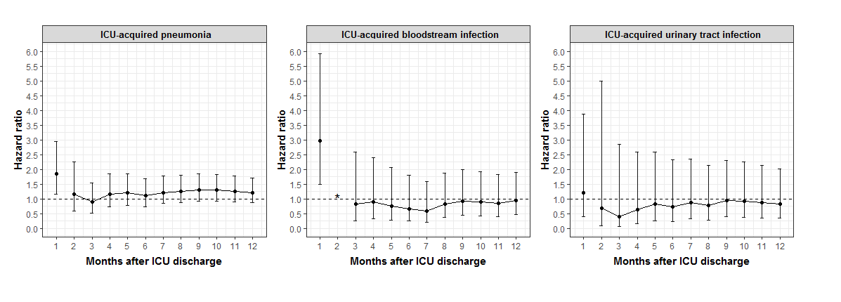

ICU, intensive care unit.

Figure shows the hazard of death over time for patients with specific types of ICU-acquired infection (pneumonia, bloodstream infection, or urinary tract infection) according to the European Centre for Disease Prevention and Control criteria. All analyses were adjusted by age, comorbidities, degree of physical dependence, and risk of death at ICU admission.

* Hazard ratio not displayed because there were no events at this time point.

Whiskers indicate 95% confidence intervals.

**Supplemental Table 6.** Exploratory analysisa: Multivariable analysis of factors associated with early and late infectious mortality.

|  |  |  |
| --- | --- | --- |
|  | **Hazard ratio**  **(95% confidence interval)** | ***P*-value** |
| Early mortality (within 30 days) |  |  |
| Pre-ICU physical dependenceb | 3.26 (1.93-5.50) | <0.001 |
| Any ICU-acquired infectionc | 2.47 (1.37-4.46) | 0.003 |
| ICU readmission | 6.75 (4.01-11.37) | <0.001 |
| Pre-ICU immunosuppressiond | 2.09 (1.25-3.51) | 0.005 |
| Late mortality (31 to 365 days) |  |  |
| Age ≥65 years | 1.80 (1.18-2.76) | 0.007 |
| Pre-ICU high comorbiditye | 1.96 (1.28-3.01) | 0.002 |
| Pre-ICU physical dependenceb | 2.45 (1.64-3.66) | <0.001 |
| Risk of deathf at ICU admission per 1% increase | 1.017 (1.014-1.024) | <0.001 |
| Any ICU-acquired infectionc | 1.79 (1.11-2.87) | 0.02 |
| ICU readmissiong |  |  |
| 30 to 60 days after ICU discharge | 5.71 (2.86-11.42) | <0.001 |
| 60 to 90 days after ICU discharge | 7.38 (2.69-20.28) | <0.001 |
| After 90 days at ICU discharge  Pre-ICU immunosuppressiond | 2.21 (1.05-4.66)  1.14 (0.77-1.69) | 0.01  0.49 |

ICU, intensive care unit.

a There were 58 deaths by infection in the early period, and 115 in the late period.

b Barthel index ≤75. Charlson comorbidity index ≥2.

c Pneumonia, bloodstream infection, or urinary tract infection according to the European Centre for Disease Prevention and Control criteria.

d HIV infection, hematologic or solid malignancies, treatment with corticosteroids (>3 mo), and treatment with other immunosuppressive drugs.

e Charlson comorbidity index ≥2.

f The risk of death was calculated using established prediction equations for hospital death according to the Acute Physiology and Chronic Health Evaluation II score15 or the Simplified Acute Physiology Score-316.

g The time period for assessing late mortality was partitioned into 3 strata to satisfy the proportional hazards assumption.