Trajectory of Mortality and Health Related Quality of Life Morbidity
Following Community-Acquired Pediatric Septic Shock

Supplemental On-Line Electronic Data Table of Contents

Item | Description | Pages
eFigure 1 | Investigation Performance Sites | 2
eText 1 | LAPSE Inclusion and Exclusion Criteria | 3
eText 2 | Methodology for Assignment to PMCA Categories | 4
eText 3 | Immunodeficiency States | 5
eText 4 | Methodology for Serial Functional Status and HRQL Assessments | 6-9
eText 5 | Sample Size Estimations | 10
eText 5 | Methodology for Imputation of Missing Data | 11
eTable 1 | HRQL Survey Follow-up and Completion Rates | 12
eFigure 2 | Cumulative LAPSE Enrollment and Hospital Survival | 13
eTable 2 | Infectious Disease Characteristics for the Study Cohort | 14
eTable 3 | Infectious Disease Organisms for the Study Cohort | 15
eTable 4 | Detail of PCPC and POPC Categories Over Time | 16
eTable 5 | Detail of Functional Status Scale Categories Over Time | 17-18
eTable 6 | Percent of Patients Failing to Return to Baseline PedsQLTM Over Time | 19
eFigure 3 | Longitudinal PedsQLTM, Additional Graphical Analyses | 20
eTable 7 | Percent of Patients Failing to Return to Baseline FSII-R Over Time | 21
eFigure 4 | Longitudinal FSII-R, Additional Graphical Analyses | 22
eTable 8 | Critical Illness Variables by Survey Completion Status at Month 3 | 23
eFigure 5 | Longitudinal PedsQLTM Detail With Imputation of Missing Data | 24
eFigure 6 | Longitudinal FSII-R Detail With Imputation of Missing Data | 25
References 26-28
eFigure 1. Investigation Performance Sites

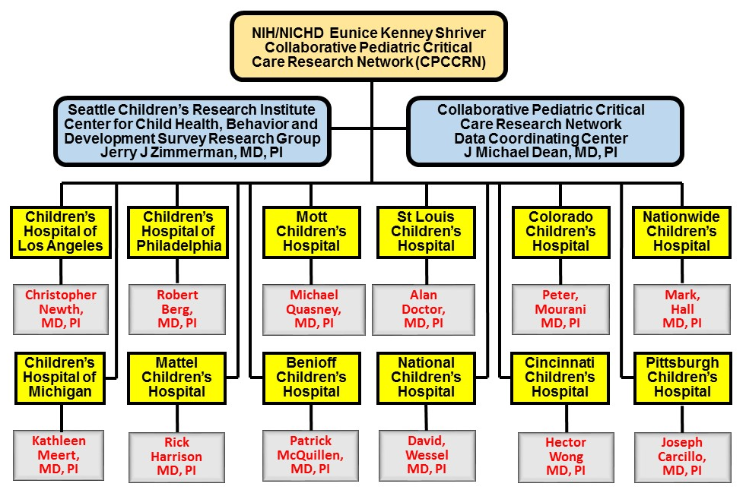

eText 1. LAPSE Inclusion and Exclusion Criteria

Inclusion Criteria

Age: 44 weeks gestation and < 18 years; AND
Suspicion of sepsis or infection; AND
Systemic inflammatory response syndrome (SIRS) (at least 2 of 4 criteria); AND
Community acquired infection or sepsis (diagnosis within 48 hours of hospital admission); AND
Cardiovascular organ dysfunction (requiring vasoactive inotropic infusion); AND
Pulmonary organ dysfunction (requirement for invasive or non-invasive pressure support or mechanical ventilation).

At least one of the SIRS criteria must involve the patient’s white blood cell count (leukocytosis or neutropenia or 10% immature neutrophils) OR the patient’s body temperature (fever or hypothermia).

Exclusion Criteria

Thermal or electrical burn as primary reason for admission; OR
Lack of commitment to aggressive intensive care as indicated by do not resuscitate orders or other limitations of care; OR
Parents or guardians unable to speak English or Spanish; OR
Patient is ward of the state; OR
Patient is unable to participate in long term follow up; OR
Patient was previously enrolled in this study; OR
Patient was not able to be enrolled within 48 hours of PICU admission.

eText 2. Methodology for Assignment to Pediatric Medical Complexity Category Categories

Each LAPSE performance site provided an updated list of study identification numbers, hospital admission and discharge dates, and PHIS (Pediatric Health Information System) (1) identification number (medical record number, MRN) for enrolled patients to Seattle Children’s Research Institute (SCRI) semi-annually. SCRI personnel used the PHIS MRN and admission date provided by each participating performance site to obtain all hospital encounters and associated diagnosis codes (ICD-9, ICD-10) for 3 years up to and including the index admission from PHIS for each enrolled patient. Pediatric Medical Complexity Algorithm (PMCA) designations (2) were determined based on the PMCA algorithm, programmed in SAS: a) excluding the index admission and b) including the index admission.

Two sites (UCLA, UPMC) did not provide PHIS identification numbers to SCRI. These sites provided a list of diagnosis codes (ICD-9, ICD-10), with separate encounters identified either by admission date or by other de-identified means, for each enrolled patient identified by the LAPSE study identification number. These sites were responsible for accurately selecting encounters 3 years prior to and including the index admission, and for identifying the index admission. PMCA designations were provided to the investigation Data Coordination Center, to be linked with study data via study identification number and index admission date.

eText 3. Immunodeficiency States

Immunodeficiency States
- Congenital immunodeficiency
- Bone marrow or stem cell transplantation
- Graft versus host disease
- Solid organ transplantation
- Malnutrition, severe
- Malignancy
- Chemotherapy or radiotherapy within last 3 months
- Human immunodeficiency virus
- Rheumatologic disease
- Neutropenia (absolute neutrophil count <1000)
- Sickle Cell Disease
- Systemic steroid use, chronic or acute
- Other immunosuppression description

eText 4. Methodology for Serial Functional Status and HRQL Assessments

Functional status was assessed utilizing the Pediatric Cerebral Performance Category/Pediatric Overall Performance Category (3) and the Functional Status Scale (4, 5). Two instruments were utilized to generate serial parent proxy-reports of health-related quality of life (HRQL) assessments for their children. The preferred instrument, the Pediatric Quality of Life Inventory (PedsQLTM) (6-12), has been utilized as a primary outcome measure for interventional trials, and has been thoroughly validated, including its use in the PICU (13). Inclusion of the PedsQLTM Infant Scales (10), allowed assessment of HRQL using this instrument across the entire childhood age spectrum. Reference normal values of PedsQLTM for healthy children are 81.3 ± 15.9 (n=10,070) (8).

Based on experience of the Seattle Children’s Hospital Outcomes Assessment Program, some parents of children with severe developmental disability, report that many of the questions in the PedsQLTM instrument do not pertain to their children and do not provide an adequate assessment of their child’s situation. Accordingly, an alternative instrument, the Stein-Jessop Functional Status II (R) (14) was employed to accommodate this need. The short form, 14-item, double element version of FS II-R uses a common core of items across the entire age span. Internal consistency estimates (alphas) for the factor-based and 14-item versions are all greater than 0.80. At each age, long and short versions of this tool behave similarly in a wide range of tests of discriminant, construct, and content validity. The FS II-R has excellent psychometric properties and provides concise measures of health status of children spanning the entire childhood age range from 0 to 16 years. Normative data for this instrument are 96.1 ± 8.2 for healthy children and 86.8 ± 15.7 for chronically ill children (14). Although the name, FSII-R, suggests this instrument is primarily a functional status measure, in fact, it is generally regarded as a validated measure of general health status for children of all ages (15). Particularly for children with severe developmental delay, some parents related that this tool was more meaningful in describing their child’s situation. FSII-R, with questions related to eating, sleeping, play behavior, and emotional health, assesses four HRQL domains: physical, psychological, cognitive, and social functioning, and the overlap with PedsQLTM quite similar. Accordingly, in order to include children with severe developmental disability, and record meaningful parent-proxy survey information, we offered use of either tool. Trajectories of failure to recover HRQL following pediatric septic shock are presented separately for the two instruments in Figure 4 and are remarkably similar. Severity of HRQL morbidity is reported for multiples of the minimal clinically important difference (MCID, 4.5 points) for PedsQLTM and in multiples of 4.5 point (not claimed to be MCID) for FSII-R to provide some consistency of approach even though MCID has not been reported for FSII-R. Both PedsQLTM and FSII-R instruments utilize a 0-100 scale.

Baseline assessment of HRQL, utilizing either instrument was conducted after septic shock resuscitation when the patient’s hemodynamic status had been stabilized, and the parents indicated their ability to focus on this initial survey. Following brief review of both instruments, parents chose which instrument seemed most applicable for their child. The same instrument was utilized for all subsequent HRQL assessments. Parents and research coordinators typically collaborated in the Baseline and Day 7 assessments, while the patient remained in the PICU. Accordingly, families were familiar with the survey tool for the subsequent web-based or telephone interview follow-up assessments. Complete change from baseline data, signifies that adequate portions of both the baseline and follow-up HRQL surveys were completed to permit determination of absolute number of points changed from baseline status or alternatively percent change from baseline status, namely [(baseline-follow-up)/baseline] x 100. Accordingly, each patient served as their own control.
An overview of the survey instruments utilized in the investigation is provided in the table below:
Survey  Instrument | Common Abbreviation | Scale  Range | Minimal Clinically Important Difference
Pediatric Risk of Mortality, Version IV | PRISM IV | 0-74 | ~3
Pediatric Logistic Organ Dysfunction, Version 2 | PELOD-2 | 0-33 | ~3
Pediatric Cerebral Performance Category (3) | PCPC | 1-6 | 1
Pediatric Overall Performance Category (3) | POPC | 1-6 | 1
Functional Status  Scale (4) | FSS | 6-15 | 2
Pediatric Quality of  Life Inventory (16) | PedsQLTM | 0-100 | 4.5
Pediatric Quality of Life Inventory, Infant Scale (10) | PedsQLTM, Infant | 0-100 | 4.5
Stein-Jessop Functional Status Scale (14) | FSII-R | 0-100 | Not  Reported

These assessments were facilitated by on-site performance site research personnel while patients remained hospitalized and by the Seattle Children’s Research Institute (SCRI) following patient l discharge from the hospital.

A variety of strategies have been suggested and evaluated to maximize subject research participation retention (17) including financial incentives for participants, that were employed in this investigation. In respect of their time required for survey participation, and as a token of appreciation, families received gift cards following survey completion.

Families were contacted by e-mail, text messaging or telephone to notify them of an impending survey. Most surveys were conducted using a web-based system, but families could also complete the surveys by text messaging or telephone interview. Increased use of texting to maintain contact with families, employed during the latter phases of LAPSE, seemed a preferable communication modality, with perhaps less risk for disregard as compared to e-mail or telephone notifications.

Because many subjects were developmentally disabled, frequently tracheally intubated, and nearly always receiving analgesic and sedative medications during PICU stay, parent proxy-reporting was the standard approach for assessing HRQL for all time points. Child self-report was also encouraged, but infrequently completed.

Follow-up functional status and HRQL assessments involved cooperation between the performance site research coordinators (RCs) and SCRI. For the Month 1, 3, 6, and 12 follow-up surveys, site RCs were responsible for contacting families and filling out a vital status review form about a week before the open survey period began. This assessment ascertained the child’s vital and general health status and whether or not the family was interested in continued participation in the study. RCs had the option of conducting the survey with the family during this first contact. Most families preferred to be contacted by e-mail or text message to prompt them to fill out the survey, but some preferred phone contact. Phone contacts were also scheduled if, after two weeks, the family had still not completed the follow-up survey. The SCRI team was responsible for the phone contact for all study sites, for all families who were home. RCs were responsible for contacting families who might be still or again in the hospital.

Daily, SCRI personnel monitored the DatStat Research Management System (RMS) for surveys that were currently due. Before calling the family, follow-up research personnel insured that a vital status review had been completed, and that the status indicated the family was at home and agreeable to be contacted. SCRI personnel contacted families up to three times a week, and up to ten times during the time the survey was open. After that, incomplete surveys were considered final or incomplete. SCRI personnel were also responsible for sending gift cards after successful completion of the surveys.

eText 5. Sample Size Estimations

Estimations of required sample size were based on PedsQLTM 4.0 database information (n=13,878) previously generated by co-investigator James Varni, et al (9). For reference a PedsQLTM change of 4.5 is considered a minimally clinically important difference (MICD) (18) among previously healthy children. One standard deviation below the healthy population mean score, per parent proxy-report, is considered at risk status for impaired HRQL (8). With preliminary data generated at Seattle Children’s Hospital, the investigators anticipated approximate serial PedsQLTM scores as summarized in the table, assuming that children eventually assessed with the FSII-R instrument would be in the group of children with chronic, comorbid conditions.

Population | Baseline  PedsQLTM | PICU Day 7  PedsQLTM | 1 Month PedsQLTM
Previously Healthy  Children (~72%) | 82.5  ± 14.9 | 52.7  2 SD or ~36%↓ | 67.6  1 SD or ~18%↓
Children With Chronic Comorbidity (~28%) | 71.8  ± 18.4 | 35.0  2 SD or ~51%↓ | 53.4  1 SD or ~26%↓

Based on sepsis admissions numbers within the Collaborative Pediatric Critical Care Research Network [https://www.cpccrn.org/], the investigators assumed 500 evaluable LAPSE subjects at baseline and PICU discharge, 475 at 1 month, and 400 at 12 months. Conservatively assuming SDs of 25 points in the septic population for observations and change scores (i.e., within subject correlation of 0.50), 95% CIs would estimate PedsQLTM as observed mean ± 1.55/1.60/1.74 SD at baseline/1month/12 months respectively. Corresponding subgroup precisions are ± 1.84/1.89/2.06 SD for healthy children and ± 2.98/3.06/3.34 SD for children with comorbidities.
In the entire LAPSE cohort, the investigators estimated 90% power (via two-sided paired t-test with α=0.05) to detect significant change between baseline and follow-up if the true change was more than 3.6, 3.8, or 4.1 points at discharge/1 month/12 month respectively. Power is ≥ 95% to detect a change of 4.5 points at all time points for the entire cohort, and ≥ 85% for previously healthy children. Additional calculations indicated 80% power to detect changes of 6-7 points among children with comorbidities. If 50% of evaluable patients recovered to within 10% of baseline HRQL by 12 months, 95% CIs for true recovery rate would be the observed % ± 5.0% (overall), ± 6.0% (for previously healthy subjects), ± 9.5% (for subjects with comorbid conditions), with greater precision if recovery varies from 50%. All of these estimates are clinically meaningful.
eText 6. Methodology for Imputation of Missing Data
Primary reporting of LAPSE results focuses on subjects with completed survey information. Availability of the primary HRQL outcome measures, PedsQLTM and FSII-R, were dependent on parent/guardian survey completion, and as is evident from the consort diagram, significant loss to follow-up occurred. In order to address potential bias by not including all subjects in the analyses, an alternative assessment of the outcome data utilized imputation for missing data. Multiple imputation methods were implemented to maintain all subjects surviving to hospital discharge with a completed baseline HRQL measure. Detailed methods for imputing and analyzing data sets with missing data have been described (19-23). A sequence of regression models was used to generate 10 imputed data sets. Each imputed data set contained the observed data along with data drawn from a posterior predictive distribution replacing missing values. Each imputed data set was analyzed separately and results were combined using the MIANALYSE procedure in SAS software (version 9.4, SAS Institute Inc., Cary, NC).

eTable 1. HRQL Survey Follow-up and Completion Rates

HRQL Survey Follow-up and Completion Rates
 |  | Enrolled |  | Died  Prior | Withdrew  Prior | Home  Coma | Expected Survey | Started HRQL | Evaluable  HRQL | Followed Rate | Completion  Rate
Time point
Baseline |  | 389 |  | 0 | 1 | 0 | 389 | 360 | 358 | 93% | 92%
Day 7 |  | 389 |  | 18 | 4 | 0 | 373 | 305 | 297 | 82% | 80%
1 Month |  | 389 |  | 30 | 13 | 0 | 353 | 240 | 237 | 68% | 67%
3 Months |  | 389 |  | 43 | 13 | 3 | 337 | 205 | 205 | 61% | 61%
6 Months |  | 389 |  | 47 | 13 | 2 | 332 | 179 | 180 | 54% | 54%
12 Months |  | 389 |  | 51 | 14 | 5 | 327 | 169 | 169 | 52% | 52%
Enrolled: Patients with a PICU admission date entered and meeting inclusion/exclusion criteria.
Died Prior: The number of patients who died prior or within the survey window.
Withdrew Prior: The number of patients who withdrew prior to the start of survey window.
Home Coma: The number of patients who were at home but in a coma (subsequent surveys not
completed).
Expected Survey: The number of patients with the follow conditions:
1. The patient was enrolled and survey information was collected OR
2. The patient did not die, withdraw from the study, and was not at home with coma within the study time
window
Started HRQL: The number of expected surveys where a PedsQLTM or FSII-R assessment was started.
Evaluable HRQL: The number of surveys with sufficient data to evaluate HRQL. Subjects at home with a coma where assigned a HRQL score of 0.
Followed Rate: The number of started surveys divided by the number of expected surveys x 100.
Completed Rate: The number evaluable HRQL surveys divided by the number of expected surveys x 100.

eFigure 2. Cumulative Study Enrollment and Hospital Survival

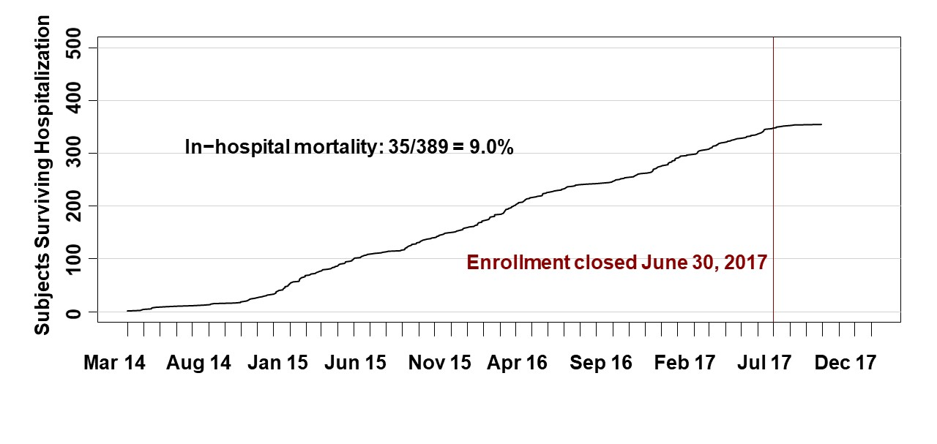

eTable 2. Infectious Disease Characteristics for the Study Cohort
Infectious Disease Status of the Study Cohort
 | Overall (n = 389)
Overall Infection Status
Bacterial Positive Culture | 192 (49.4%)
Viral Positive Polymerase Chain Reaction | 173 (44.5%)
No Documented Infection | 123 (31.6%)
Combined Bacterial and Viral Infection | 79 (20.3%)
Combined Bacterial and Fungal Infection | 13 (3.3%)
Combined Viral and Fungal Infection | 6 (1.5%)
Detail of Infectious Agents
Gram positive | 136 (35.0%)
Gram negative | 93 (23.9%)
Gram variable | 6 (1.5%)
Viruses | 173 (44.5%)
Fungi | 14 (3.6%)
Parasitic | 0 (0%)
 | Abstractions (n = 569)
Sites of Biosamples for Infection Assessment
Nasopharyngeal | 183 (32.2%)
Blood | 127 (22.3%)
Sputum | 86 (15.1%)
Urine | 30 (5.3%)
Vascular catheter | 16 (2.8%)
Bronchoalveolar lavage | 15 (2.6%)
Wound (non-surgical) | 14 (2.5%)
Stool / Rectal | 13 (2.3%)
Surgical site | 9 (1.6%)
Pleural fluid | 7 (1.2%)
Peritoneal fluid | 6 (1.1%)
Abscess | 5 (0.9%)
Skin | 5 (0.9%)
Bronchial brush | 4 (0.7%)
Spinal fluid | 2 (0.4%)
Other | 47 (8.3%)

Abbreviations: ETT, endotracheal tube
Biosamples for culture were obtained on the day of admission to the PICU and/or the following day.

eTable 3. Infectious Disease Organisms for the Study Cohort
Infectious Disease Organisms for the Study Cohort (N = 389 Subjects)
 | Count
Gram Positive Bacteria
Methicillin Sensitive Staphylococcus aureus | 42
Methicillin Resistant Staphylococcus aureus | 21
Other Staphylococcus Species | 15
Group A Streptococcus | 14
Streptococcus pneumoniae | 13
Other Streptococcal Species | 9
Enterococcus Species | 7
Bacillus Species | 6
Lactobacillus Species | 3
Other Gram Positive Bacteria | 6
Gram Negative Bacteria
Pseudomonas aeroginosa | 23
Escherichia coli | 16
Hemophilus Species | 11
Klebsiella Species | 11
Enterobacter Species | 9
Moraxella Species | 7
Clostridia Species | 6
Proteus mirabilis | 5
Mycoplasma pneumoniae | 4
Other Gram Negative Bacteria | 17
Fungal Organisms
Candida Species | 8
Pneumocystis jirovecii | 2
Other Fungi | 7
Viral Organisms
Rhinovirus/Enterovirus | 74
Respiratory Syncytial Virus | 32
Influenza Species | 32
Adenovirus | 15
Parainfluenza | 13
Coronavirus | 11
Metapneumovirus | 9
Epstein Barr Virus | 8
Other Viruses | 16

Biosamples for culture were obtained on the day of admission to the PICU and/or the following day.

eTable 4. Detail of PCPC and POPC Categories Over Time
Distribution of PCPC and POPC Scores Over Time (n = 389)
 | Baseline |  | Day 7 |  | Day 28/Discharge
 | PCPC | POPC | PCPC | POPC | PCPC | POPC
Normal/Good | 195 (50%) | 149 (38%) | 85 (22%) | 33 (8%) | 135 (35%) | 71 (18%)
Mild disability | 56 (14%) | 75 (19%) | 68 (17%) | 70 (18%) | 69 (18%) | 94 (24%)
Moderate disability | 59 (15%) | 72 (19%) | 42 (11%) | 57 (15%) | 52 (13%) | 76 (20%)
Severe disability | 75 (19%) | 89 (23%) | 129 (33%) | 167 (43%) | 91 (23%) | 106 (27%)
Coma/vegetative | 4 (1%) | 4 (1%) | 52 (13%) | 49 (13%) | 13 (3%) | 13 (3%)
Death | 0 (0%) | 0 (0%) | 11 (3%) | 11 (3%) | 24 (6%) | 24 (6%)
Unknown | 0 (0%) | 0 (0%) | 2 (1%) | 2 (1%) | 5 (1%) | 5 (1%)
Abbreviations PCPC, Pediatric Cerebral Performance Category; POPC, Pediatric Overall Performance Category; Baseline, status in the month preceding PICU admission for the septic shock event; Discharge, assessment at Day 28 or Hospital Discharge, which ever occurred first. PCPC reports 'Normal' whereas POPC reports 'Good'. These have been combined and are reported as 'Normal/Good'.

eTable 5. Detail of Functional Status Scale Categories Over Time

Functional Status Scale (FSS) Scores Over Time, Detail

 | Baseline  Status | Day 7 /  Discharge | Day 28 /  Discharge
Normal (6-7) | 56% | 17% | 37%
Mildly abnormal (8−9) | 9% | 10% | 14%
Moderately abnormal (10−15) | 22% | 26% | 27%
Severely abnormal (16−21) | 11% | 28% | 16%
Very severely abnormal (> 22) | 2% | 18% | 6%

Discharge refers to discharge from the hospital in relation to Day 7 or Day 28, whichever occurred first.

Distribution of Functional Status Scale Score Over Time | Overall  (N = 389)
Baseline
N | 389
Mean (SD) | 9.2 (4.5)
Min, Max | 6.0, 28.0
Median [Q1, Q3] | 6.0 [6.0, 12.0]
Day 7
N | 374
Mean (SD) | 15.1 (6.78)
Min, Max | 6.0, 30.0
Median [Q1, Q3] | 15.0 [9.0, 19.0]
Day 28/ Discharge
N | 359
Mean (SD) | 11.1 (5.55)
Min, Max | 6.0, 30.0
Median [Q1, Q3] | 9.0 [6.0, 15.0]

Mean change in FSS, comparing Baseline and Day 28 or Hospital Discharge was 1.8 ± 4.2, 0 [0; 2], p <.001, with an increase in score reflecting worsening functional status.

Distribution of FSS categorical sub-scores
 | FSS Baseline | FSS Day 7 | FSS Day 28
Communication
Normal | 254/389 (65.3%) | 133/377 (35.3%) | 197/360 (54.7%)
Mild dysfunction | 96/389 (24.7%) | 126/377 (33.4%) | 107/360 (29.7%)
Moderate dysfunction | 30/389 (7.7%) | 54/377 (14.3%) | 30/360 (8.3%)
Severe dysfunction | 4/389 (1.0%) | 22/377 (5.8%) | 12/360 (3.3%)
Very severe dysfunction | 5/389 (1.3%) | 42/377 (11.1%) | 14/360 (3.9%)
Feeding
Normal | 251/389 (64.5%) | 90/376 (23.9%) | 170/360 (47.2%)
Mild dysfunction | 25/389 (6.4%) | 21/376 (5.6%) | 18/360 (5.0%)
Moderate dysfunction | 94/389 (24.2%) | 149/376 (39.6%) | 126/360 (35.0%)
Severe dysfunction | 16/389 (4.1%) | 50/376 (13.3%) | 25/360 (6.9%)
Very severe dysfunction | 3/389 (0.8%) | 66/376 (17.6%) | 21/360 (5.8%)
Mental status
Normal | 289/389 (74.3%) | 139/375 (37.1%) | 225/360 (62.5%)
Mild dysfunction | 61/389 (15.7%) | 107/375 (28.5%) | 79/360 (21.9%)
Moderate dysfunction | 17/389 (4.4%) | 35/375 (9.3%) | 20/360 (5.6%)
Severe dysfunction | 19/389 (4.9%) | 66/375 (17.6%) | 26/360 (7.2%)
Very severe dysfunction | 3/389 (0.8%) | 28/375 (7.5%) | 10/360 (2.8%)
Motor function
Normal | 248/389 (63.8%) | 130/377 (34.5%) | 161/360 (44.7%)
Mild dysfunction | 18/389 (4.6%) | 36/377 (9.5%) | 36/360 (10.0%)
Moderate dysfunction | 80/389 (20.6%) | 108/377 (28.6%) | 99/360 (27.5%)
Severe dysfunction | 26/389 (6.7%) | 49/377 (13.0%) | 35/360 (9.7%)
Very severe dysfunction | 17/389 (4.4%) | 54/377 (14.3%) | 29/360 (8.1%)
Respiratory
Normal | 306/389 (78.7%) | 114/377 (30.2%) | 241/359 (67.1%)
Mild dysfunction | 35/389 (9.0%) | 60/377 (15.9%) | 42/359 (11.7%)
Moderate dysfunction | 8/389 (2.1%) | 5/377 (1.3%) | 5/359 (1.4%)
Severe dysfunction | 21/389 (5.4%) | 35/377 (9.3%) | 34/359 (9.5%)
Very severe dysfunction | 19/389 (4.9%) | 163/377 (43.2%) | 37/359 (10.3%)
Sensory
Normal | 310/389 (79.7%) | 249/377 (66.0%) | 270/360 (75.0%)
Mild dysfunction | 51/389 (13.1%) | 46/377 (12.2%) | 52/360 (14.4%)
Moderate dysfunction | 19/389 (4.9%) | 35/377 (9.3%) | 20/360 (5.6%)
Severe dysfunction | 6/389 (1.5%) | 26/377 (6.9%) | 10/360 (2.8%)
Very severe dysfunction | 3/389 (0.8%) | 21/377 (5.6%) | 8/360 (2.2%)

*Percentages in this table ignore missing values. Denominators of non-missing values are shown and may be slightly higher than Ns in the previous table, because calculating a total FSS score requires that all sub-category scores be available. Baseline, reflects status in the month before admission for sepsis; Day 7, assessment on Day 7 after PICU admission or hospital discharge whichever occurred first; Discharge, assessment at hospital discharge or Day 28 which ever occurred first.

eTable 6. Patients Failing to Return to Baseline PedsQLTM Over Time

 | Day 7  (n=178) | Month 1  (n=140) | Month 3  (n=122) | Month 6  (n=102) | Month 12  (n=103)
Failure to return within  4.5 points from baseline | 124 (70%) | 79 (56%) | 50 (41%) | 33 (32%) | 39 (38%)
Failure to return within  9.0 points from baseline | 111 (62%) | 71 (51%) | 37 (30%) | 26 (25%) | 30 (29%)
Failure to return within  13.5 points from baseline | 100 (56%) | 62 (44%) | 28 (23%) | 21 (21%) | 21 (20%)
Failure to return within  18.0 points from baseline | 81 (46%) | 56 (40%) | 19 (16%) | 15 (15%) | 18 (17%)

Failure to return to baseline is depicted in multiples of the minimal clinically important difference (MCID, 4.5 points) for the PedsQLTM instrument. Data is presented as number of patients (percent).

eFigure 3. Changes In PedsQLTM Scores Over Time

Changes in Absolute PedsQLTM Scores Over Time

●
●
●
●
●
0
20
40
60
80
100
Baseline
(n = 222)
Day 7
(n = 180)
Day 28
(n = 142)
Month 3
(n = 123)
Month 6
(n = 104)
Month 12
(n = 105)

For each time point, median [Q1, Q3] is displayed as a box, with 95% confidence intervals as dashed lines above and below each box.

PedsQLTM Scores, Percent Change From Baseline Over Time

●
●
●
●
●
●
●
●
●
●
●
●
●
●
●
●
●
−100
−50
0
50
100
Day 7
(n = 178)

Day 28
(n = 140)
Month 3
(n = 122)
Month 6
(n = 102)
Month 12
(n = 103)

For each time point, median [Q1, Q3] is displayed as a box, with 95% confidence intervals as dashed lines above and below the box.

eTable 7. Patients Failing to Return to Baseline FSII-R Over Time

 | Day 7  (n = 113) | Day 28  (n = 92) | Month 3  (n = 81) | Month 6  (n = 75) | Month 12  (n = 64)
Failure to return within  4.5 points from baseline | 66 (58%) | 36 (39%) | 26 (32%) | 20 (27%) | 20 (31%)
Failure to return within  9.0 points from baseline | 61 (54%) | 28 (30%) | 20 (25%) | 14 (19%) | 18 (28%)
Failure to return within  13.5 points from baseline | 52 (46%) | 18 (20%) | 16 (20%) | 9 (12%) | 15 (23%)
Failure to return within  18.0 points from baseline | 41 (36%) | 13 (14%) | 11 (14%) | 7 (9%) | 12 (19%)

Failure to return to baseline is depicted in multiples of 4.5 points for the FSII-R instrument. Data is presented as number of patients (percent).

eFigure 4. Changes In FSII-R Scores Over Time

Changes in Absolute FSII-R Scores Over Time

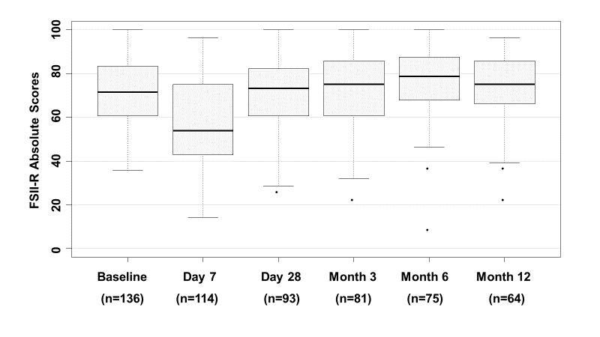
For each time point, median [Q1, Q3] is displayed as a box, with Q1 – (1.5*IQR) and Q3 + (1.5*IQR) as dashed lines below and above each box.

FSII-R Scores, Percent Change From Baseline Over Time
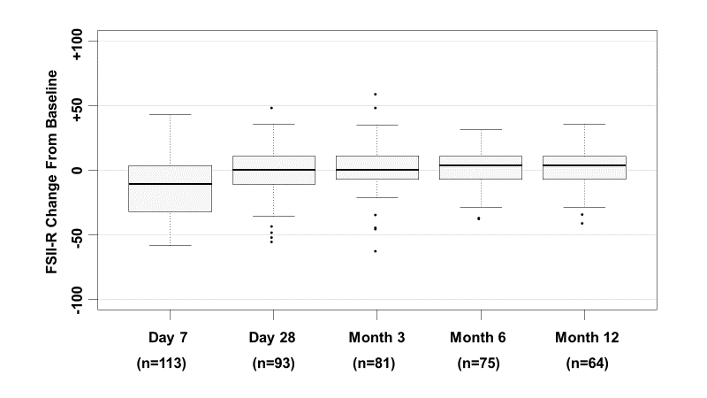 For each time point, median [Q1, Q3] is displayed as a box, with Q1 – (1.5*IQR) and Q3 + (1.5*IQR) as dashed lines below and above each box.

eTable 8. PICU Resource Utilization Among Patients With and Without a Month 3 Survey

eTable 8. PICU Resource Utilization Among Patients With and Without a Month 3 Survey
 |  | HRQL Survey Status at Month 3
 | Overall  Cohort  (n = 389) | Survey  Completed  (n = 203) | Survey  Not Completed  (n = 186)
PRISM-IV¹ | 11.0 [6.0, 17.0] | 11.0 [6.0, 16.0] | 11.0 [6.0, 19.0]
PELOD-2, First Day² | 8.0 [6.0, 11.0] | 8.0 [5.0, 11.0] | 9.0 [6.0, 11.0]
Sum of PELOD³ | 57.0 [32.0, 94.0] | 52.0 [29.0, 83.0] | 68.0 [34.0, 105.0]
Subjects Receiving VIS | 368 (94.6%) | 186 (91.6%) | 182 (97.8%)
VIS Days⁴ | 3.0 [2.0, 6.0] | 3.0 [2.0, 5.0] | 3.0 [2.0, 7.0]
VIS Free Days⁵ | 25.0 [22.0, 26.0] | 25.0 [24.0, 27.0] | 25.0 [18.0, 26.0]
Subjects Receiving Mechanical Ventilation | 380 (97.7%) | 198 (97.5%) | 182 (97.8%)
Mechanical Ventilation Days⁴ | 8.0 [5.0, 14.0] | 8.0 [5.0, 12.0] | 9.0 [5.0, 15.0]
Mechanical Ventilation Free Days⁵ | 20.0 [12.0, 23.0] | 20.0 [16.0, 24.0] | 18.0 [5.0, 23.0]
Subjects Receiving RRT | 38 (9.8%) | 14 (6.9%) | 24 (12.9%)
RRT Duration (Days)⁵ | 8.0 [5.0, 17.0] | 5.5 [3.0, 9.0] | 9.0 [7.0, 19.5]
Subjects Receiving ECLS | 27 (6.9%) | 7 (3.4%) | 20 (10.8%)
ECLS Duration (Days)⁵ | 8.0 [4.0, 16.0] | 8.0 [3.0, 10.0] | 9.0 [4.5, 17.5]
PICU Duration of Stay (Days) | 9.4 [5.6, 15.4] | 9.1 [5.2, 14.9] | 9.9 [5.8, 17.2]
Hospital Duration of Stay (Days) | 15.7 [9.2, 26.0] | 16.1 [9.7, 25.8] | 15.4 [8.8, 26.8]
Abbreviations: PRISM-IV, Pediatric Risk of Mortality, version IV; PELOD-2, Pediatric Logistic Organ Dysfunction score, version 2; VIS, vasoactive-inotropic support; PICU, pediatric intensive care unit; RRT, renal replacement (dialytic) therapy; ECLS, extracorporeal life support.
Results are presented as median [Q1, Q3] or number of patients (%)
¹ PRISM data were collected during a modified period of 2 hours prior to PICU admission through 4 hours post PICU admission.
²PELOD-2, First Day, time from PICU admission to 0000, the following day
³Summation of daily PELOD scores during PICU admission
⁴ The number of calendar days from PICU admission to study day 28 that the therapy was administered. Subjects never receiving the therapy have values of 0 and are excluded from these summaries.
⁵ The number of calendar days from PICU admission through study day 28 that the patient did NOT receive the therapy. If the patient died before study day 28, then values were set to zero.

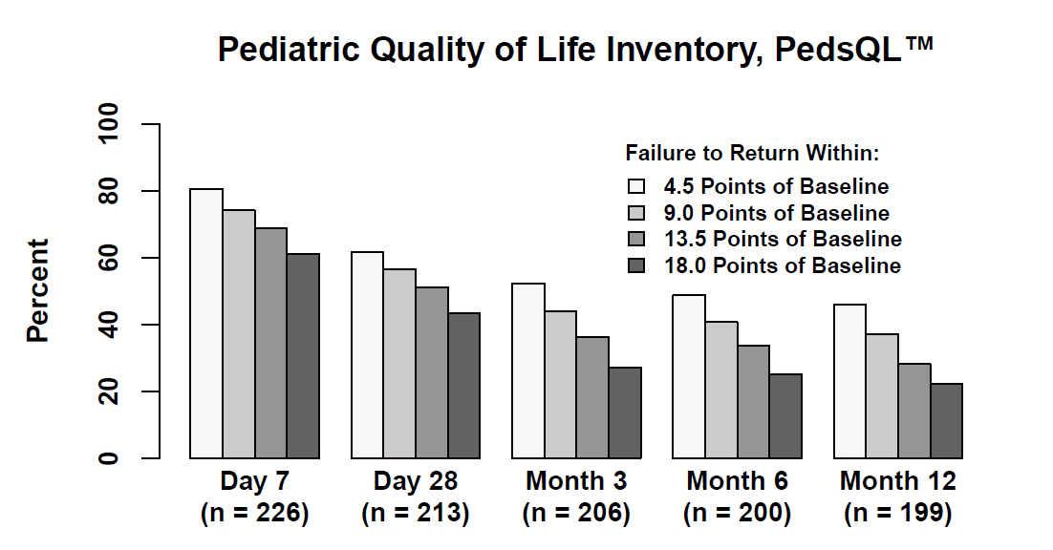
eFigure 5. Longitudinal PedsQLTM Detail With Imputation of Missing Data

 | Day 7  (n=226) | Day 28  (n=213) | Month 3  (n=206) | Month 6  (n=200) | Month 12  (n=199)
Failure to return within  4.5 points from baseline | 81% | 61% | 51% | 48% | 46%
Failure to return within  9.0 points from baseline | 75% | 56% | 42% | 40% | 37%
Failure to return within  13.5 points from baseline | 70% | 51% | 35% | 33% | 28%
Failure to return within  18.0 points from baseline | 62% | 44% | 26% | 25% | 21%

eFigure 6. Longitudinal FSII-R Detail With Imputation of Missing Data
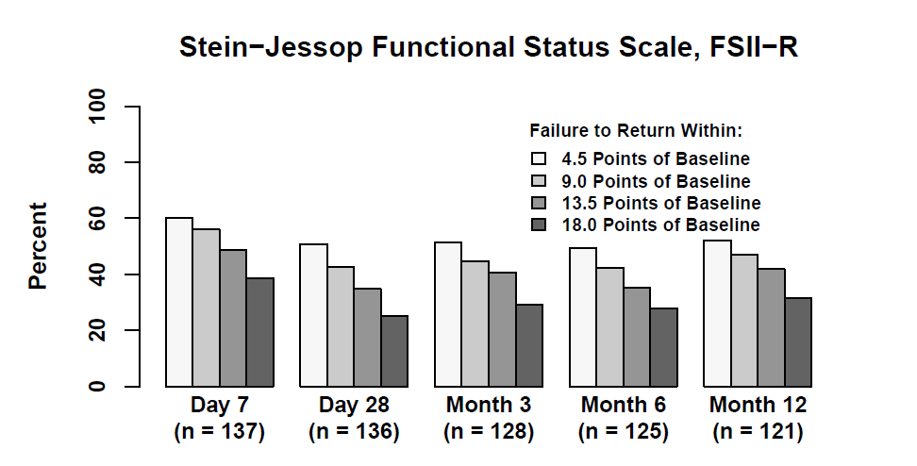

 | Day 7  (n=137) | Day 28  (n=136) | Month 3  (n=128) | Month 6  (n=125) | Month 12  (n=121)
Failure to return within  4.5 points from baseline | 61% | 51% | 50% | 50% | 53%
Failure to return within  9.0 points from baseline | 57% | 42% | 44% | 43% | 48%
Failure to return within  13.5 points from baseline | 49% | 34% | 40% | 36% | 42%
Failure to return within  18.0 points from baseline | 39% | 24% | 30% | 29% | 33%

References
1. Association CsH. Pediatric Health Information System, PHIS.
2. Simon TD, Cawthon ML, Stanford S, Popalisky J, Lyons D, Woodcox P, et al. Pediatric medical complexity algorithm: a new method to stratify children by medical complexity. Pediatrics. 2014;133(6):e1647-54.
3. Fiser DH, Long N, Roberson PK, Hefley G, Zolten K, Brodie-Fowler M. Relationship of pediatric overall performance category and pediatric cerebral performance category scores at pediatric intensive care unit discharge with outcome measures collected at hospital discharge and 1- and 6-month follow-up assessments. Crit Care Med. 2000;28(7):2616-20.
4. Pollack MM, Holubkov R, Glass P, Dean JM, Meert KL, Zimmerman J, et al. Functional Status Scale: new pediatric outcome measure. Pediatrics. 2009;124(1):e18-28.
5. Pollack MM, Holubkov R, Funai T, Clark A, Moler F, Shanley T, et al. Relationship between the functional status scale and the pediatric overall performance category and pediatric cerebral performance category scales. JAMA pediatrics. 2014;168(7):671-6.
6. Varni JW, Limbers, C.A. The Pediatric Quality of Life Inventory: Measureing pediatric health-related quality of life from the perspective of children and their parents. Pediat Clin N Am. 2009;56:843-63.
7. Varni JW, Limbers, C.A., Newman, D.W. Factorial invariance of the PedsQL 4.0 Generic Core Scales child self-report across gender: A multigroup confirmatory factor analysis with 11,356 children ages 5 to 18. Appl Res Qual Lif 2008;3:137-48.
8. Varni JW, Burwinkle TM, Seid M, Skarr D. The PedsQL 4.0 as a pediatric population health measure: feasibility, reliability, and validity. Ambul Pediatr. 2003;3(6):329-41.
9. Varni JW, Limbers CA, Burwinkle TM. Parent proxy-report of their children's health-related quality of life: an analysis of 13,878 parents' reliability and validity across age subgroups using the PedsQL 4.0 Generic Core Scales. Health Qual Life Outcomes. 2007;5:2.
10. Varni JW, Limbers CA, Neighbors K, Schulz K, Lieu JE, Heffer RW, et al. The PedsQL Infant Scales: feasibility, internal consistency reliability, and validity in healthy and ill infants. Qual Life Res. 2011;20(1):45-55.
11. Varni JW, Limbers CA, Newman DA, Seid M. Longitudinal factorial invariance of the PedsQL 4.0 Generic Core Scales child self-report Version: one year prospective evidence from the California State Children's Health Insurance Program (SCHIP). Qual Life Res. 2008;17(9):1153-62.
12. Varni JW, Seid M, Kurtin PS. PedsQL 4.0: reliability and validity of the Pediatric Quality of Life Inventory version 4.0 generic core scales in healthy and patient populations. Med Care. 2001;39(8):800-12.
13. Aspesberro F, Fesinmeyer MD, Zhou C, Zimmerman JJ, Mangione-Smith R. Construct Validity and Responsiveness of the Pediatric Quality of Life Inventory 4.0 Generic Core Scales and Infant Scales in the PICU. Pediatr Crit Care Med. 2016;17(6):e272-9.
14. Stein RE, Jessop DJ. Functional status II(R). A measure of child health status. Med Care. 1990;28(11):1041-55.
15. Keenan HT, Runyan DK, Nocera M. Longitudinal follow-up of families and young children with traumatic brain injury. Pediatrics. 2006;117(4):1291-7.
16. Bhat SR, Goodwin TL, Burwinkle TM, Lansdale MF, Dahl GV, Huhn SL, et al. Profile of daily life in children with brain tumors: an assessment of health-related quality of life. J Clin Oncol. 2005;23(24):5493-500.
17. Group JHUOACISO. Cohort retention tools. In: Needham DM, editor.
18. Jaeschke R, Singer J, Guyatt GH. Measurement of health status. Ascertaining the minimal clinically important difference. Control Clin Trials. 1989;10(4):407-15.
19. Pigott TD. A review of methods for missing data. Educational Research and Evaluation. 2001;7(4):353-83.
20. Sterne JA, White IR, Carlin JB, Spratt M, Royston P, Kenward MG, et al. Multiple imputation for missing data in epidemiological and clinical research: potential and pitfalls. BMJ. 2009;338:b2393.
21. Pampaka M, Hutcheson G, Williams J. Handling missing data: analysis of a challenging data set using multiple imputation. International Journal of Research & Method in Education. 2016;39(1):19-37.
22. Rubin DB. Multiple Imputation for Nonresponse in Surveys. New York: Wiley; 1987.
23. Raghunathan TE, Lepkowski, J. M., Van Hoewyk, J., Solenberger, P. . A Multivariate Technique for Multiply Imputing Missing Values Using a Sequence of Regression Models. Survey Methodology. 2001;27(1).

