Supplementary materials
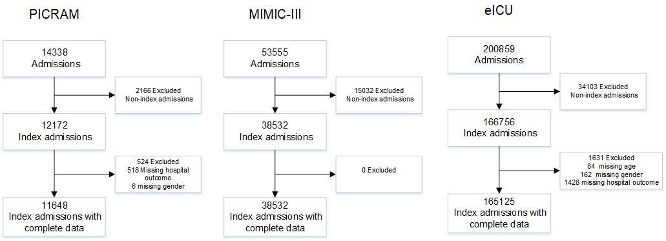
Supplementary Figure 1: Flow chart of inclusion/exclusion criteria for PICRAM, MIMIC-III and eICU

Supplementary Table 1: Conditional survival (survival to hospital discharge from this point in time) as percentage for three ICU populations, unselected and then dichotomised by age. *Indicates fewer than 50 patients in cohort
 | PICRAM |  |  | MIMIC-III |  |  | eICU
Cohort (years) | All | < 75 | ≥ 75 | All | < 75 | ≥ 75 | All | < 75 | ≥ 75
All patients | 81.5 | 84.4 | 71.8 | 88.9 | 91.7 | 82.7 | 91.0 | 92.8 | 86.4
>4 days | 73.8 | 77.1 | 61.4 | 81.6 | 84.8 | 75 | 84.2 | 85.9 | 79.7
>9 days | 74.2 | 78.0 | 56.3 | 78.8 | 83.1 | 68 | 78.8 | 81.2 | 70.6
>14 days | 75.2 | 79.2 | 52.3 | 78.4 | 82.8 | 66.9 | 78.6 | 80.7 | 70.2
>19 days | 76.2 | 80.2 | 52.9 | 79.8 | 83.7 | 69.4 | 79.4 | 80.6 | 73.4
>24 days | 78.2 | 81.0 | * | 79.9 | 83.7 | 69.5 | 78.8 | 80.9 | 69.5
>29 days | 79.2 | 81.1 | * | 79.9 | 85.6 | 64.1 | 77.8 | 80.1 | 66.7
>34 days | 77.5 | 80.2 | * | 79.3 | 85.2 | 63.7 | 77.1 | 79.2 | *
>39 days | 75.8 | 80.0 | * | 76.2 | 82.2 | 62.5 | 76.6 | 77.6 | *

