Echo Report Proforma
Study Number: …………..
Ventilation N/A Spont SIMV Mandatory Ventilation Mode
Inotropes ...................................................................................................................
LV function: Normal Or Impaired Mild Moderate Severe
Pericardial Effusion: Absent Or Present ……….mm
RV:LV size ration: Normal (LV>RV in A4c view) or Abnormal (RV>LV in A4C view)
Valves:
Mitral Normal or only mildly impaired. Aortic Normal or only mildly impaired.
Or Or
Mod-Severe Regurgitation Mod-Severe Regurgitation
Mod-Severe Stenosis Mod-Severe Stenosis
Tricuspid Normal or only mildly impaired. Pulmonary Normal or only mildly impaired.
Or Or
Mod-Severe Regurgitation Mod-Severe Regurgitation
Mod-Severe Stenosis Mod-Severe Stenosis
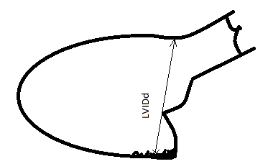
PLAX Measures
LVIDd .............cm
Normal: M = 4.2-5.9 F = 3.9-5.3 cm
Measure from inflection point of Septum and LVOT
Past leaflet tips of mitral valve
To LV free wall excluding trabeculations and valve apparatus
Inner edge to inner edge

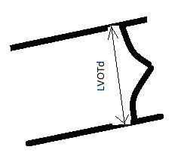
LVOT Diameter ............cm
Normal: 2.0 - 2.2 cm (varies with body size, large males may be bigger)
Zoomed in view of LVOT
Measure inner edge to inner edge
Measure just left of leaflet tip insertions
Do NOT measure within valve or leaflet insertion points
Should not be more than 5mm subvalvular
Should be perpendicular to direction of blood flow

A4C Measures
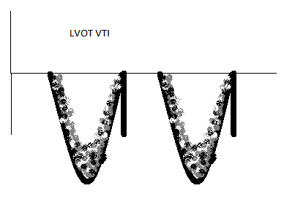
LVOT VTI Record three measure and their average
cm | cm | cm | Average: | cm
Normal: > 15 cm
Pulse Wave Doppler in LVOT (A5C)
Ensure cursor angle aligned with blood flow through LVOT
Gate should be subvalvular
Trace should show closing but not opening click
Trace should be hollow
Measure “chin not beard” ie avoid spectral broadening
TAPSE ....................mm Normal : > 15mm
M mode through lateral tricuspid annulus
Measure one continuous line
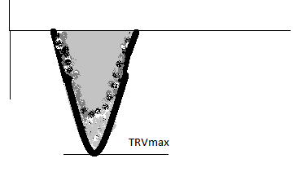
Use Calculation Tool
TR Vmax ...................cm/s Normal: < 260cm/s
Continuous wave Doppler through TR jet
Aim to get highest velocity jet in all views
Ie obtain loops of 2D, colour and spectral doppler of PLAX, PSAX, A4C and S4C
Record only highest reading
Do not average readings
Align cursor with TR jet

Subcostal Measures
IVC Diameter Expiration ...........................mm
IVC Diameter Inspiration ...........................mm
Measure with M mode
Measure 1cm inferior (left ) to hepatic vein entry into IVC
