PREDICTING MORTALITY IN CHILDREN WITH PEDIATRIC ACUTE RESPIRATORY DISTRESS SYNDROME: A PEDIATRIC ACUTE RESPIRATORY DISTRESS SYNDROME INCIDENCE AND EPIDEMIOLOGY (PARDIE) STUDY

Data Supplement and Appendices

SUPPLEMENTARY METHODS
Derivation Cohort (PARDIE V1 Cohort)
PARDIE consisted of 708 subjects from 145 PICUs in 27 countries (1), with each site deciding a priori whether to participate in the planned ancillary studies. The V1 study included additional data collection over the first 3 days of PARDS in 624 subjects from 100 centers. Sites received approval from their local institutional review boards (IRBs), or relied on the Children’s Hospital of Los Angeles IRB. At each site, subjects were prospectively screened for eligibility over 5 days during 10 non-consecutive weeks between May 2016 and June 2017. Patients were eligible if they met PALICC PARDS criteria: hypoxemia ≤ 7 days after a known insult, new infiltrate on radiograph, and PaO₂/FIO₂ ≤ 300 for subjects on non-invasive support (full-face oronasal mask with continuous positive airway pressure ≥ 5 cmH₂O), or OI ≥ 4 for subjects on invasive support. Non-invasive equivalents (SpO₂/FIO₂ and OSI) were allowed for subjects without PaO₂. As PARDIE only recruited new cases of PARDS, eligibility criteria had to be met ≤ 24 hours of enrollment. Subjects were excluded if they were perioperative from a cardiac intervention, had active perinatal lung disease, had undergone cardiopulmonary bypass within 7 days, or had met PARDS criteria > 24 hours from screening (established PARDS). Data collection was performed for the first 3 days after PARDS diagnosis, including demographics, oxygenation, severity of illness measured using the Pediatric Index of Mortality (PIM) 3 and Pediatric Risk of Mortality (PRISM) IV scores, and co-morbidities. Subjects were followed for mortality and duration of ventilation until hospital discharge up to 90 days. Additional data collected for V1 included daily (calendar day) organ failure (Pediatric Logistic Organ Dysfunction [PELOD] 2 score), daily vasopressor requirement, daily fluid balance, and use of ancillary therapies over the first 3 days after PARDS diagnosis.

External Validation Cohort
We a priori sought to externally validate the predictive model using existing published PARDS datasets (2-7). After model development, we queried investigators to identify if any dataset contained all requisite variables. Only one dataset, from the Children’s Hospital of Philadelphia (CHOP), contained all of the elements identified in the derivation model. Thus, external validation was assessed in an ongoing prospective cohort of intubated children meeting Berlin criteria for ARDS from CHOP between July 2011 and June 2018. Details of this cohort have been published before (7-10). As CHOP was a participating center in PARDIE, 18 overlapping subjects were excluded from this validation cohort.

Definitions and Outcomes
The primary outcome was PICU mortality. Secondary outcomes include duration of invasive and non-invasive ventilation in survivors and ventilator-free days (VFDs) at 28 days. VFDs were calculated by subtracting ventilator days from 28, and assigning all 28-day non-survivors and those still ventilated by day 28 to 0 VFDs. Day 0 was date of PARDS onset. For invasive ventilation, if a subject was re-intubated < 28 days, they were not credited for interval extubation, and VFDs were calculated from date of last extubation.
Oxygenation was measured using PaO₂/FIO₂ and SpO₂/FIO₂ in all subjects, and OI (mean airway pressure [mPaw] x FIO₂ x 100)/ PaO₂) and OSI (mPaw x FIO₂ x 100)/ SpO₂) in intubated subjects, ensuring SpO₂ ≤ 97%, as previously described (6, 11). For all analyses, non-invasive measures (SpO₂/FIO₂ and OSI) were converted to their invasive equivalents (PaO₂/FIO₂ and OI) using published equations (11). Vasopressor-inotrope score was: dopamine (µg/kg/min) x 1 + dobutamine (µg/kg/min) x 1 + epinephrine (µg/kg/min) x 100 + norepinephrine (µg/kg/min) x 100 + milrinone (µg/kg/min) x 10 (12). The designation “immunocompromised” required presence of an oncologic diagnosis, congenital or acquired immunodeficiency, stem cell or solid organ transplant, or a rheumatologic or inflammatory condition receiving immunosuppression (8, 9). Countries were grouped by geographical region and economic status using 2016 World Bank classifications (13). A single cause of death was assigned by site investigators: hypoxemia, refractory shock, multisystem organ failure (MSOF), brain death, other primarily neurologic cause, or other.

Development of a Model for Mortality Prediction
Our primary aim was to construct a parsimonious model of clinical variables on day of PARDS onset (day 0) associated with PICU mortality for use in risk prediction. We did this in two steps: penalized logistic regression followed by further variable reduction using the Bayesian information criterion (BIC). Variables with univariate association with mortality (p ≤ 0.1) were selected as candidate predictors of mortality. Among strongly correlated variables (r > 0.5) only the variable most highly correlated with mortality was tested. Co-linearity existed between severity of illness scores (PIM3 and PRISM IV) and the organ failure score (PELOD2). We chose to only test PELOD2 (including the respiratory component) as a candidate predictor, as PIM3 and PRISM IV are only validated at PICU admission. Additionally, we separately tested the non-respiratory components of the PELOD2 score (neurologic, cardiovascular, renal, and hematologic failure) alone and in combinations to assess whether modeling the individual components yielded a better model than modeling the composite PELOD2. As we have previously shown that oxygenation measured 6 hours after PARDS onset better discriminated outcome in PARDIE (1) as well as in other cohorts (10), relative to oxygenation at PARDS onset, we tested PaO₂/FIO₂ (all subjects) and OI (intubated subjects) at 6 hours, in addition to values at PARDS onset. We used the closest available value to 6 hours after PARDS onset (± 3 hours), carrying forward the value from PARDS onset if no later value was available.
We started with a model including all candidate predictors. Then, we used penalized regression to identify a reduced set of variables associated with PICU mortality (14-16). Once this reduced model was identified, we assessed for further simplification using BIC. We chose to minimize BIC (lower BIC indicates better fit with a penalty for extra variables) rather than Akaike information criterion since BIC more strongly penalizes additional terms (17). We used mixed effects logistic regression with PICU mortality as the outcome and center as a random effect. We iteratively removed variables, and compared models using BIC (18). This was continued until BIC was minimized, resulting in the final model. This approach balanced parsimony with predictive accuracy. All tested variables had low missingness (< 5%), and we assumed missing completely at random, with only utilization of complete cases.
Internal validation was evaluated by 10-fold cross-validation and assessment of model performance in pre-specified subgroups (geo-economic status, gross national income, region, admission volume, unilateral or bilateral infiltrates at PARDS diagnosis, mixed versus non-cardiac PICUs, and availability of extracorporeal support) representing a range of clinical settings in which the model could be used. Calibration and fit were assessed using the calibration belt (19), which tests the relationship between predicted and observed values by fitting a polynomial curve (with 80% and 95% CI) using an iterative process to test different degrees of the polynomial. This method overcomes some of the limitations of the Hosmer-Lemeshow test – arbitrary number of bins, lack of information regarding where predictions are over- or underestimated, and no estimate of uncertainty. The calibration belt remains sensitive to sample size, similar to Hosmer-Lemeshow. Discrimination for PICU mortality was assessed by calculating area under the receiver operating characteristic (AUROC) curve.
Three subgroup models were built. First, as subjects dying of a neurologic cause may have different predictors of mortality and response to treatment than those dying of shock, MSOF, or hypoxemia (20), we repeated the analysis excluding those who died primarily due to a neurologic cause (including brain death). Second, we repeated the analysis in the subset of patients who were invasively ventilated within 6 hours of PARDS diagnosis. Third, we repeated the analysis in invasively ventilated subjects excluding those who died from a neurologic cause.

External Validation of the Model
We tested the models in the PARDS cohort from CHOP, excluding 18 subjects co-enrolled in PARDIE. Since all CHOP subjects were intubated, we only assessed models developed for invasively ventilated subjects. As this was a single center cohort, we performed logistic regression, rather than mixed effects. Calibration, fit, and discrimination were reported as before. Since the model was derived from a multicenter, multinational cohort, we reasoned that if calibration was poor, the model would be revised in this cohort by re-estimation of the coefficients and intercept (21).

Development of a Model for Identifying Predictors of Ventilator Duration
As mortality in PARDS is low, composites such as VFDs are often used as outcome measures (22). Thus, in order to confirm the significance of the variables chosen for the mortality model as clinically relevant, we separately constructed models to identify predictors of total (invasive and non-invasive) and invasive ventilator duration in survivors as this is the second component of VFDs, alongside mortality. We modeled ventilator duration in survivors as a time to event analyses using Cox regression with clustering by site. Observations were censored at 28 days, as this corresponds to how VFDs are most commonly censored. Models were constructed in a similar fashion as those for mortality: variables with univariate association with ventilator duration (p ≤ 0.1) were selected as candidate predictors and entered into a Cox model, which was subsequently optimized by assessing BIC after iteratively removing individual predictors. This process was continued until BIC was minimized, resulting in the final model.

Assessment of the Mortality Model to Stratify Ventilator-Free Days
We assessed whether the four models developed for PICU mortality were calibrated for VFDs at 28 days. Subjects were split into quartiles of predicted mortality for each of the four mortality models. For each quartile, VFDs were modeled as a competing risk, treating discontinuation of invasive and non-invasive ventilation (for the entire cohort) or discontinuation of invasive ventilation (for the invasively ventilated cohort) as the primary outcome, and death treated as a competing event. Outcomes were censored after 28 days, making this outcome equivalent to VFDs at 28 days (22).

Supplementary Table 1: Full description of the PARDIE V1 cohort stratified by mortality
Variable | Whole cohort  (n = 624) | Survivors  (n = 516) | Non-survivors  (n = 108) | p value
Demographics  Age (years) (n = 619)  Female/male (%) (n = 623)  Non-white race (%) (n = 619)  Hispanic ethnicity (%) (n = 621) | 6.1 ± 6.4  247/376 (40/60)  243 (39)  139 (22) | 6.0 ± 6.3  205/310 (40/60)  193 (38)  104 (20) | 6.5 ± 6.6  42/66 (39/61)  50 (46)  35 (32) | 0.513  0.914  0.105  0.008
Admission source (%) (n = 623)  Emergency department  Inpatient floor  Other | 286 (46)  219 (35)  118 (19) | 245 (48)  168 (33)  102 (20) | 41 (38)  51 (48)  16 (15) | 0.018
Outside hospital transfer (%) (n = 623) | 168 (27) | 143 (28) | 25 (23) | 0.343
Severity of illness  PIM3 (admission)  PIM3 predicted mortality (%)  PRISM IV (admission)(n = 622)  PRISM IV predicted mortality (%)  PELOD2 (PARDS onset)(n = 621) | -3.6 ± 2.1  9 ± 1  9.0 ± 8.3  11 ± 1  5.4 ± 3.3 | -3.9 ± 1.7  6 ± 1  7.7 ± 7.1  8 ± 1  4.9 ± 2.8 | -2.1 ± 2.7  23 ± 3  15.0 ± 10.5  26 ± 3  7.9 ± 4.3 | < 0.001  < 0.001  < 0.001  < 0.001  < 0.001
Non-pulmonary organ failures per PELOD sub-scores (n = 621)  Neurologic  Cardiovascular  Renal  Hematologic | 149 (24)  392 (63)  159 (26)  152 (24) | 109 (21)  316 (61)  120 (23)  106 (21) | 40 (38)  76 (71)  39 (36)  46 (43) | 0.001  0.078  0.007  < 0.001
Vasoactive support day 0 (n = 619)  Need for vasopressors/inotropes  Vasopressor-inotrope score | 227 (37)  11.6 ± 29.6 | 155 (30)  7.4 ± 21.4 | 72 (67)  32.1 ± 48.9 | < 0.001  < 0.001
Fluid balance day 0 (mL/kg) (n = 609)  All-cause fluid balance  Fluid balance minus transfusions | 26.6 ± 43.4  22.7 ± 41.2 | 23.7 ± 39.3  21.2 ± 39 | 41.2 ± 57.1  30.3 ± 49.8 | < 0.001  0.040
Blood products transfused (mL/kg) | 3.9 ± 11.9 | 2.5 ± 7.5 | 10.8 ± 22.4 | < 0.001
Pre-existing co-morbidities (%)  None  Home ventilation  Chronic lung disease  Prematurity  Pulmonary hypertension  Congenital heart disease  Neuromuscular disease  Oncologic  Immunocompromised | 233 (37)  25 (4)  180 (29)  111 (18)  24 (4)  71 (11)  112 (18)  51 (8)  82 (13) | 208 (40)  23 (4)  150 (29)  99 (19)  22 (4)  64 (12)  95 (18)  25 (5)  42 (8) | 25 (23)  2 (2)  30 (28)  12 (11)  2 (2)  7 (7)  17 (16)  26 (24)  40 (37) | 0.001  0.285  0.817  0.052  0.406  0.095  0.582  < 0.001  < 0.001
PARDS characteristics  Diagnosed while on NIV (%)  PICU days pre-PARDS  Unilateral infiltrates (%) | 139 (22)  2.4 ± 8.8  159 (25) | 117 (23)  2.1 ± 8.5  142 (28) | 22 (20)  3.5 ± 10.0  17 (16) | 0.703  0.149  0.011
PARDS etiology (%)  Pneumonia  Non-pulmonary sepsis  Other | 392 (63)  121 (19)  111 (18) | 341 (66)  86 (17)  89 (17) | 51 (47)  35 (32)  22 (20) | < 0.001
PaO₂/FIO₂  PARDS diagnosisª  6 hours | 142 ± 83  177 ± 108 | 148 ± 84  185 ± 109 | 115 ± 69  138 ± 91 | < 0.001  < 0.001
OI in intubated subjects  PARDS diagnosis (n = 485)ª  6 hours (n = 531)^{a, b} | 14.1 ± 11.1  12.5 ± 11.2 | 12.8 ± 9.8  10.7 ± 8.8 | 20.5 ± 13.9  20.5 ± 16.5 | < 0.001  < 0.001
PALICC categories (%)  Non-invasive  Mild  Moderate  Severe | 139 (22)  200 (32)  133 (21)  152 (24) | 117 (23)  175 (34)  121 (23)  103 (20) | 22 (20)  25 (23)  12 (11)  49 (45) | < 0.001
PICU beds (%)  < 15  15 to 30  > 30 | 148 (24)  239 (38)  237 (38) | 120 (23)  193 (38)  203 (39) | 28 (26)  46 (43)  34 (32) | 0.302
Annual PICU admissions (%) (n = 615)  < 500 per year  500 to 1000 per year  > 1000 per year | 99 (16)  118 (19)  398 (65) | 79 (15)  90 (18)  341 (67) | 20 (19)  28 (27)  57 (54) | 0.039
Other hospital factors (%)  24-hour attending (n = 600)  Fellowship program | 435 (73)  547 (88) | 355 (72)  455 (88) | 80 (74)  92 (85) | 0.723  0.421
Geo-economic status  High income: North America  High income: Europe  High income: rest of world  Middle income | 413 (66)  91 (15)  36 (6)  84 (13) | 351 (68)  77 (15)  32 (6)  56 (11) | 62 (57)  14 (13)  4 (4)  28 (26) | 0.001
Season  Winter  Spring  Summer  Fall | 235 (38)  174 (28)  80 (13)  135 (22) | 204 (40)  143 (28)  64 (12)  105 (20) | 31 (29)  31 (29)  16 (15)  30 (28) | 0.128
ª Invasive measures of oxygenation (PaO₂/FIO₂ and oxygenation index) include values derived from non-invasive (SpO₂-based) analogies (SpO₂/FIO₂ and oxygenation saturation index), which have been converted to PaO₂/FIO₂ and oxygenation index using published equations.
^{b} By 6 hours, the number of intubated subjects with PARDS has increased as subjects on non-invasive support escalate to invasive.

Supplementary Table 2: Internal validation in subgroups of PARDIE
Sub-groups | N | AUROC (95% CI) | Calibration belt p value
Geo-economic status  High income: North America  High income: Europe  High income: rest of world  Middle income | 413  91  36  84 | 0.83 (0.77 to 0.89)  0.94 (0.90 to 0.99)  0.94 (0.84 to 1.00)  0.83 (0.72 to 0.93) | 0.532  0.318  1  0.854
Economic status  High income  Middle income | 540  84 | 0.83 (0.78 to 0.88)  0.83 (0.72 to 0.93) | 0.443  0.854
Region  North America  Central and South America  Europe  Rest of world | 413  82  91  38 | 0.83 (0.77 to 0.89)  0.86 (0.76 to 0.96)  0.94 (0.90 to 0.99)  0.80 (0.56 to 1.00) | 0.532  0.535  0.318  0.134
Initial chest radiograph infiltrates  Unilateral  Bilateral | 159  465 | 0.80 (0.65 to 0.96)  0.83 (0.78 to 0.88) | 0.351  0.956
Annual PICU admissions  < 500 per year  500 to 1000 per year  > 1000 per year | 99  118  398 | 0.87 (0.78 to 0.96)  0.81 (0.69 to 0.92)  0.83 (0.76 to 0.89) | 0.385  0.271  0.563
Unit type  Mixed cardiac and non-cardiac  Non-cardiac | 186  438 | 0.87 (0.81 to 0.94)  0.81 (0.76 to 0.87) | 0.702  0.985
ECMO status  Non-ECMO center  ECMO center | 179  445 | 0.86 (0.78 to 0.93)  0.81 (0.75 to 0.87) | 0.421  0.127

Supplementary Table 3: Models for predicting PICU mortality in specified subgroups
Variable | Whole cohort excluding neurologic deaths |  | All intubated |  | Intubated excluding neurologic deaths
Total n | 596 |  | 531 |  | 504
Non-survivors (%) | 80 (13) |  | 94 (18) |  | 67 (13)
 | Coefficient  (95% CI) | BIC increase | Coefficient  (95% CI) | BIC increase | Coefficient  (95% CI) | BIC increase
PELOD2 day 0 | 0.154  (0.07 to 0.24) | 13 | 0.210  (0.13 to 0.29) | 32 | 0.144  (0.05 to 0.24) | 2
Vasopressor-inotrope score day 0 | 0.011  (0 to 0.02) | 6 | 0.014  (0.01 to 0.02) | 13 | 0.013  (0 to 0.02) | 2
Immuno-compromised | 2.225  (1.59 to 2.86) | 40 | 2.000  (1.36 to 2.64) | 30 | 2.385  (1.59 to 3.18) | 34
Middle income country | 1.101  (0.42 to 1.79) | 9 | - | - | - | -
Fluid balance (mL/kg) day 0 | 0.008  (0 to 0.02) | 14 | - | - | - | -
PaO₂/FIO₂ at 6 hours | -0.005  (-0.01 to 0) | 9 | - | - | - | -
OI at 6 hours | - | - | 0.050  (0.03 to 0.07) | 19 | 0.063  (0.04 to 0.09) | 16
Constant | -3.266  (-4.17 to  -2.36) | - | -4.543  (-5.32 to  -3.77) | - | -4.731  (-5.77 to  -3.69) | -
Increase in Bayesian information criterion (BIC) lists the absolute amount the BIC increases if that particular variable is removed from the model.

Supplementary Table 4: Comparison of the PARDIE V1 (derivation) and CHOP (validation) PARDS cohorts.
Variable | PARDIE V1 (n = 624) | CHOP (n = 640)
Demographics  Age (years)  Non-white race (%)  Hispanic ethnicity (%) | 6.1 ± 6.4  243 (39)  139 (22) | 6.9 ± 5.8  356 (57)  76 (12)
Severity of illness at PARDS onset  PIM3  PRISM IV  PELOD2 | -3.6 ± 2.1  9 ± 8.3  5.4 ± 3.3 | -2.8 ± 1.9  13 ± 10.2  5.7 ± 4.1
Geo-economic status (%)  High income: North America  High income: Europe  High income: rest of world  Middle income | 413 (66)  91 (15)  36 (6)  84 (13) | 640 (100)  -  -  -
Vasoactive support day 0  Need for vasopressors/inotropes  Vasopressor-inotrope score | 227 (37)  11.6 ± 29.6 | 491 (77)  22.1 ± 52.1
Fluid balance (mL/kg) day 0 | 26.6 ± 43.4 | 39.9 ± 40
Pre-existing co-morbidities (%)  None  Home ventilation  Prematurity  Congenital heart disease  Immunocompromised | 233 (37)  25 (4)  111 (18)  71 (11)  82 (13) | 206 (32)  0  77 (12)  0  128 (20)
PARDS etiology (%)  Pneumonia  Non-pulmonary sepsis  Other | 392 (63)  121 (19)  111 (18) | 319 (50)  142 (22)  179 (28)
PARDS characteristics  Diagnosed while on NIV (%)  Unilateral infiltrates (%) | 139 (22)  159 (25) | 0  0
PaO₂/FIO₂  PARDS diagnosis  6 hours | 142 ± 83  177 ± 108 | 161 ± 68  199 ± 80
OI in intubated subjects  PARDS diagnosis  6 hours | 14.1 ± 11.1  12.5 ± 11.2 | 15 ± 12.7  11.7 ± 9.7
Cause of death (Total, %)  Hypoxemia  MSOF  Refractory shock  Brain death  Other neurologic (not brain death)  Other | n = 108 (17)  14 (13)  31 (29)  16 (15)  17 (16)  11 (10)  19 (18) | n = 114 (18)  22 (19)  29 (25)  14 (12)  27 (24)  22 (19)  0

Supplementary Table 5: Revised predictive model for PICU mortality in the intubated CHOP cohort after calibration.
 | All intubated |  | Excluding neurologic deaths
Variable | Coefficient  (95% CI) | p value | Coefficient  (95% CI) | p value
PELOD2 day 0 | 0.153 (0.10 to 0.21) | < 0.001 | 0.067 (0 to 0.14) | 0.061
Vasopressor-inotrope score day 0 (per 1-point increase) | 0.012 (0 to 0.02) | 0.001 | 0.008 (0 to 0.01) | 0.005
Immunocompromised | 1.239 (0.74 to 1.74) | < 0.001 | 2.760 (2.05 to 3.47) | < 0.001
OI at 6 hours | 0.033 (0.01 to 0.05) | 0.002 | 0.061 (0.04 to 0.09) | < 0.001
Constant | -3.673  (-4.22 to -3.13) | < 0.001 | -4.857  (-5.69 to -4.02) | < 0.001
Bold lettering indicates ≥ 20% change in coefficient relative to original model (from Supplementary Table 3).
Supplementary Table 6: PARDIE V1 survivors stratified by length of invasive and non-invasive ventilation (NIV)
Variable | All survivors  (n = 506) | Invasive and NIV < 7 days  (n = 240) | Invasive and NIV ≥ 7 days  (n = 266) | p value
Demographics  Age (years)  Female/male (%)  Non-white race (%)  Hispanic ethnicity (%) | 6.1 ± 6.4  202/303 (40/60)  193 (38)  101 (20) | 5.6 ± 6.0  87/153 (36/64)  95 (40)  41 (17) | 6.5 ± 6.7  115/150 (43/57)  98 (37)  60 (23) | 0.125  0.122  0.582  0.119
Admission source (%)  Emergency department  Inpatient floor  Other | 244 (48)  163 (32)  98 (19) | 124 (52)  75 (31)  41 (17) | 120 (45)  88 (33)  57 (22) | 0.292
Outside hospital transfer (%) | 139 (28) | 58 (24) | 81 (31) | 0.112
Severity of illness  PIM3 (admission)  PRISM IV (admission)  PELOD2 (PARDS onset) | -3.9 ± 1.7  7.7 ± 7.1  5.3 ± 3.2 | -4.0 ± 1.8  6.8 ± 6.7  4.8 ± 3.2 | -3.8 ± 1.6  8.5 ± 7.3  5.8 ± 3.1 | 0.195  0.009  < 0.001
Non-pulmonary organ failures per PELOD sub-scores  Neurologic  Cardiovascular  Renal  Hematologic | 105 (21)  309 (61)  116 (23)  104 (21) | 44 (18)  131 (55)  58 (24)  47 (20) | 61 (23)  178 (67)  58 (22)  57 (21) | 0.228  0.006  0.527  0.660
Vasoactive support day 0  Need for vasopressors/inotropes  Vasopressor-inotrope score | 148 (29)  7.3 ± 21.5 | 57 (24)  5.0 ± 14.2 | 91 (34)  9.3 ± 26.2 | 0.014  0.026
Fluid balance day 0 (mL/kg)  All-cause fluid balance  Fluid balance minus transfusions | 23.8 ± 39.4  21.4 ± 38.9 | 25.2 ± 37.6  23.0 ± 37.6 | 22.6 ± 41.0  19.9 ± 40.0 | 0.464  0.370
Blood products transfused (mL/kg) | 2.4 ± 7.3 | 2.1 ± 6.3 | 2.7 ± 8.1 | 0.378
Pre-existing co-morbidities (%)  None  Home ventilation  Chronic lung disease  Prematurity  Pulmonary hypertension  Congenital heart disease  Neuromuscular disease  Oncologic  Immunocompromised | 206 (41)  21 (4)  147 (29)  97 (19)  21 (4)  62 (12)  93 (18)  23 (5)  41 (8) | 113 (47)  9 (4)  63 (26)  35 (15)  6 (3)  19 (8)  39 (16)  8 (3)  15 (6) | 93 (35)  12 (5)  84 (32)  62 (23)  15 (6)  43 (16)  54 (20)  15 (6)  26 (10) | 0.007  0.824  0.203  0.013  0.116  0.006  0.252  0.286  0.191
PARDS characteristics  Diagnosed while on NIV (%)  PICU days pre-PARDS  Unilateral infiltrates (%) | 115 (23)  2.1 ± 8.1  141 (28) | 64 (27)  0.8 ± 1.4  78 (33) | 51 (19)  3.2 ± 11.0  63 (24) | 0.056  < 0.001  0.029
PARDS etiology (%)  Pneumonia  Non-pulmonary sepsis  Other | 334 (66)  84 (17)  88 (17) | 152 (63)  42 (18)  46 (19) | 182 (68)  42 (16)  42 (16) | 0.458
PaO₂/FIO₂  PARDS diagnosis  6 hours | 149 ± 84  186 ± 109 | 159 ± 84  205 ± 110 | 139 ± 84  169 ± 106 | 0.009  < 0.001
OI in intubated subjects  PARDS diagnosis  6 hours | 12.8 ± 9.8  10.7 ± 8.7 | 11.2 ± 8.5  8.5 ± 6.3 | 14.1 ± 10.7  12.5 ± 9.9 | 0.003  < 0.001
PALICC categories (%)  Non-invasive  Mild  Moderate  Severe | 115 (23)  173 (34)  118 (23)  100 (20) | 64 (27)  92 (38)  50 (21)  34 (14) | 51 (19)  81 (30)  68 (26)  66 (25) | 0.003
PICU beds (%)  < 15  15 to 30  > 30 | 115 (23)  188 (37)  203 (40) | 63 (26)  81 (34)  96 (40) | 52 (20)  107 (40)  107 (40) | 0.143
Annual PICU admissions (%)  < 500 per year  500 to 1000 per year  > 1000 per year | 73 (15)  88 (18)  339 (68) | 42 (18)  37 (16)  159 (67) | 31 (12)  51 (19)  180 (69) | 0.133
Other hospital factors (%)  24-hour attending  Fellowship program | 347 (72)  449 (89) | 151 (66)  211 (88) | 196 (77)  238 (89) | 0.008  0.673
Geo-economic status  High income: North America  High income: Europe  High income: rest of world  Middle income | 349 (69)  75 (15)  32 (6)  50 (10) | 159 (66)  46 (19)  20 (8)  15 (6) | 190 (71)  29 (11)  12 (5)  35 (13) | 0.002
Season  Winter  Spring  Summer  Fall | 198 (39)  143 (28)  64 (13)  101 (20) | 93 (39)  65 (27)  30 (13)  52 (22) | 105 (39)  78 (29)  34 (13)  49 (18) | 0.823

Supplementary Table 7: Final models for identifying predictors of discontinuation of ventilation in survivors.
 | Probability of discontinuing invasive and non-invasive ventilation (all survivors; n = 506) |  |  | Probability of extubation (intubated survivors; n = 437)
 | Hazard ratioª  (95% CI) | p value | BIC  increase | Hazard ratioª  (95% CI) | p value | BIC increase
Vasopressor-inotrope score day 0 | 0.99 (0.99 to 1.00) | 0.039 | 23 | 0.99 (0.99 to 1.00) | 0.047 | 641
PICU days pre-PARDS | 0.96 (0.94 to 0.98) | < 0.001 | 19 | 0.98 (0.95 to 1.00) | 0.023 | 1
Any co-morbidity | 0.70 (0.57 to 0.85) | < 0.001 | 7 | - | - | -
PELOD 2 day 0 | 0.95 (0.92 to 0.98) | 0.001 | 5 | - | - | -
OI at 6 hours | - | - | - | 0.98 (0.97 to 0.99) | 0.002 | 247
Hispanic ethnicity | - | - | - | 1.25 (0.97 to 1.62) | 0.085 | 34
Age (years) | - | - | - | 1.00 (0.98 to 1.02) | 0.831 | 19
PICU beds (%)  < 15  15 to 30  > 30 | - | - | - | Ref  -  0.55 (0.42 to 0.72)  0.60 (0.46 to 0.79) | < 0.001  < 0.001 | 7
ª Probability of discontinuing invasive and non-invasive ventilation (for all survivors), and probability of discontinuing invasive ventilation (i.e., extubation in intubated survivors), were modeled as time to event analyses using Cox regression with shared frailty for clustering by site, censoring after 28 days. Hazard ratios < 1 imply a variable associated with lower probability of discontinuing ventilation (i.e., prolonging ventilation).

Supplementary Figure 1: Calibration belts for the models predicting PICU mortality in the CHOP validation cohort. Note that all subjects in the CHOP cohort were intubated. The calibration belt examines the relationship between estimated probabilities and observed mortality rates, with associated 80% (light gray) and 95% (dark gray) confidence intervals. Perfect calibration lies along the center (dashed) line. The calibration belt is paired to a statistic that tested deviation from the center line, similar to the Hosmer-Lemeshow test. Application of the original models for intubated subjects (A and B: including and excluding neurologic deaths) demonstrate poor calibration (both p < 0.001). In the entire intubated CHOP cohort (A), the model overestimates mortality at predicted mortality > 0.70. In the cohort excluding neurologic deaths (B), the model overestimates mortality at predicted mortalities > 0.10. After revision, the model for the entire intubated CHOP cohort (C) still shows evidence of poor fit (p = 0.042). After revision, the model for the intubated CHOP cohort excluding neurologic deaths (D) demonstrates perfect calibration (p = 1).
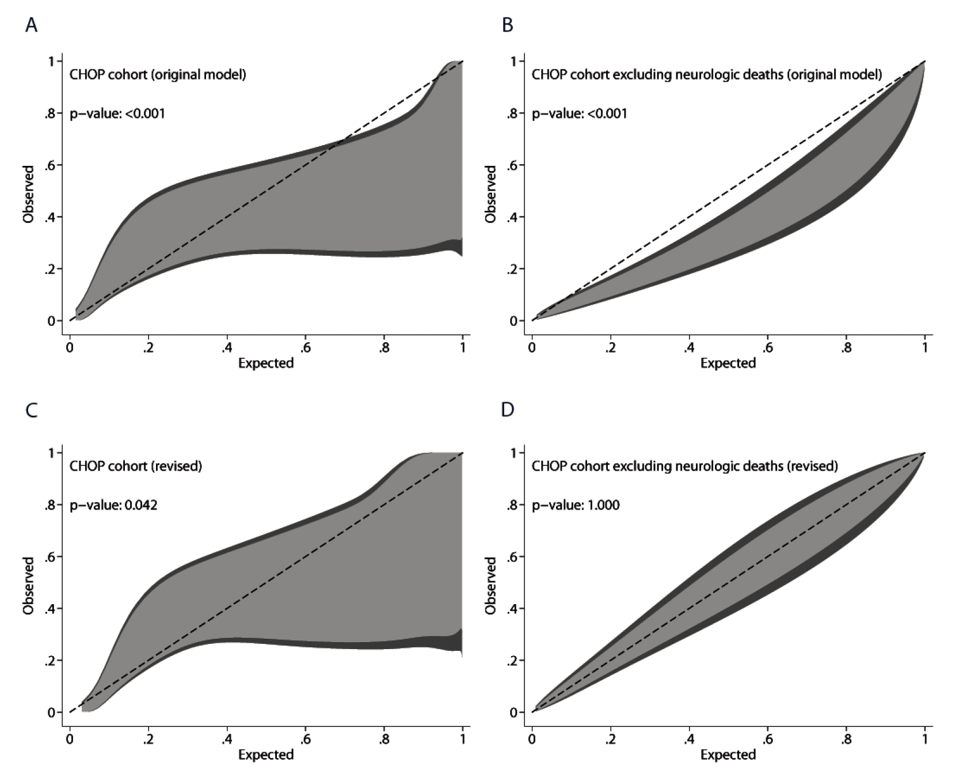
Supplementary Figure 2: Utility of mortality prediction models for stratification of ventilator-free days (VFDs) at 28 days, modeled as the probability of discontinuing ventilation with death as a competing risk, in the derivation cohort. As VFDs are commonly used as a primary outcome in PARDS, we assessed whether the four models developed for PICU mortality appropriately stratified VFDs. For the models developed in the whole V1 cohort (A) and the V1 cohort excluding neurologic deaths (B), we assessed the relationship between quartiles of predicted mortality (quartile 1 lowest, quartile 4 highest predicted mortality) and probability of discontinuing invasive (IMV) and non-invasive ventilation (NIV), as not all subjects were invasively ventilated. For the models restricted to intubated PARDS (C) and intubated PARDS excluding neurologic deaths (D), we assessed the relationship between quartiles of predicted mortality and probability of extubation from invasive ventilation.

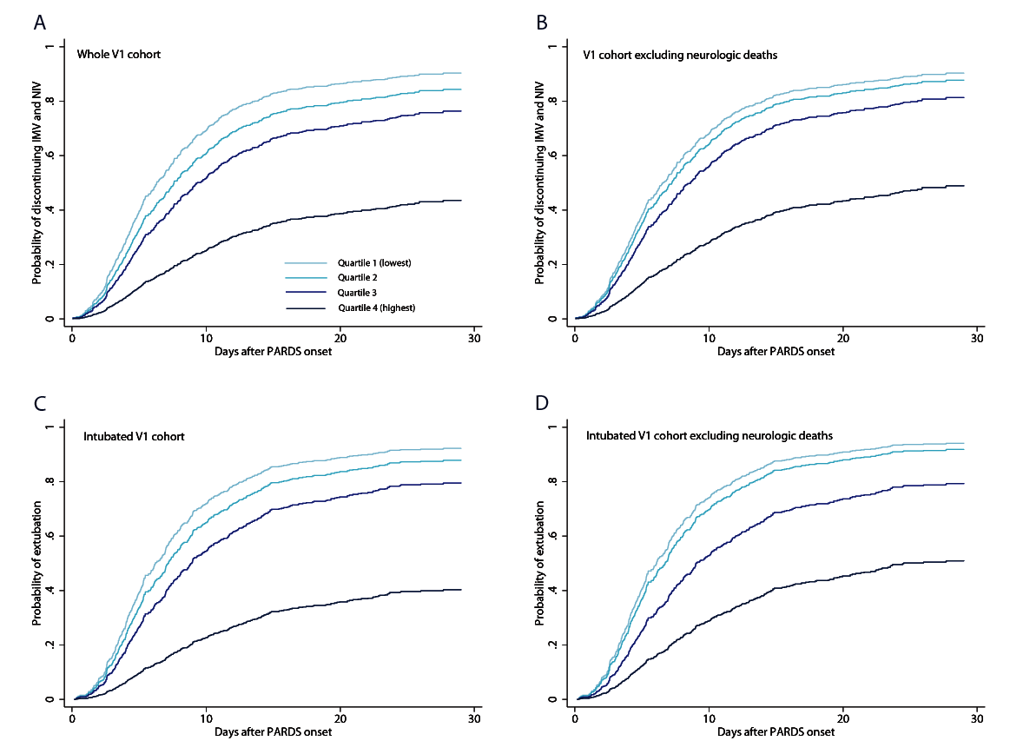

Supplementary Figure 3: Utility of mortality prediction models for stratification of ventilator-free days (VFDs) at 28 days, modeled as the probability of discontinuing ventilation with death as a competing risk, in the CHOP validation cohort. We applied the original model for the entire cohort (A) and original model excluding neurologic deaths (B), and assessed the relationship between quartiles of predicted mortality (quartile 1 lowest, quartile 4 highest predicted mortality) and probability of extubation, as all subjects were invasively ventilated. We also assessed the relationship between quartiles of predicted mortality and probability of extubation in the revised models including (C) and excluding (D) neurologic deaths.

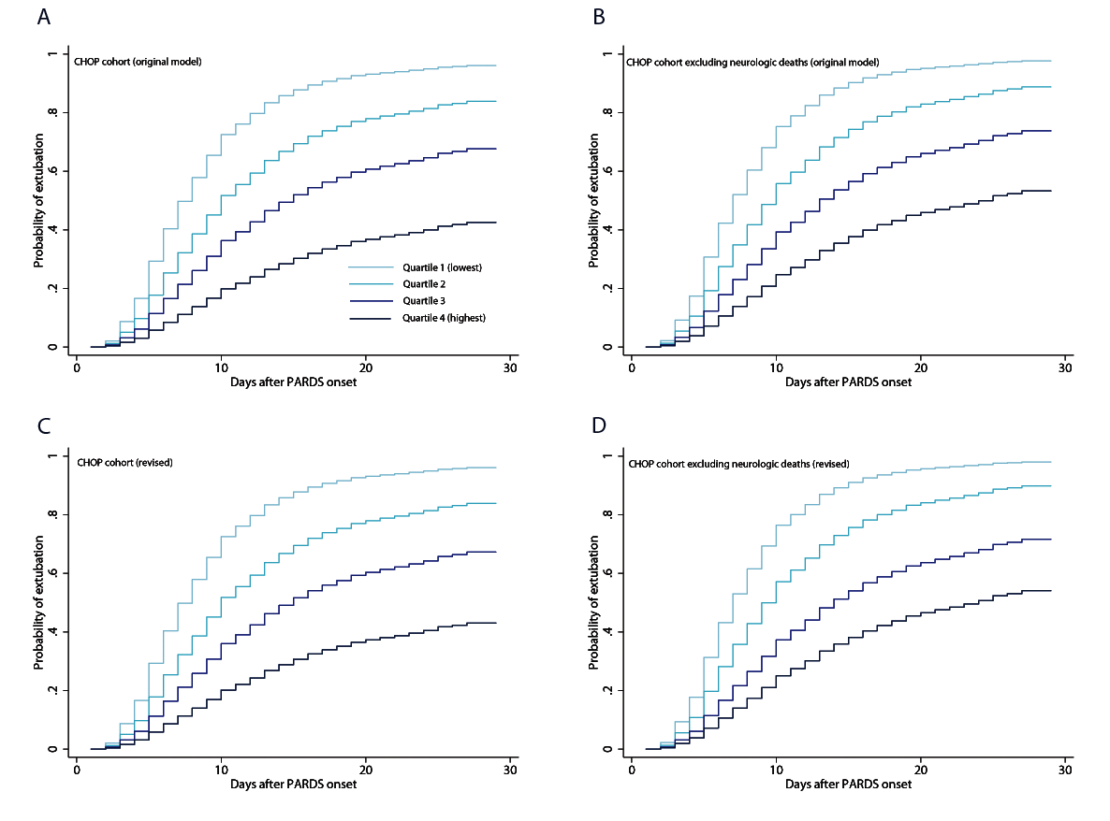
Appendix 1: TRIPOD checklist: prediction model development and validation
Section/Topic | Item |  | Checklist Item | Page
Title and abstract
Title | 1 | D;V | Identify the study as developing and/or validating a multivariable prediction model, the target population, and the outcome to be predicted. | 1
Abstract | 2 | D;V | Provide a summary of objectives, study design, setting, participants, sample size, predictors, outcome, statistical analysis, results, and conclusions. | 5
Introduction
Background and objectives | 3a | D;V | Explain the medical context (including whether diagnostic or prognostic) and rationale for developing or validating the multivariable prediction model, including references to existing models. | 7
 | 3b | D;V | Specify the objectives, including whether the study describes the development or validation of the model or both. | 8
Methods
Source of data | 4a | D;V | Describe the study design or source of data (e.g., randomized trial, cohort, or registry data), separately for the development and validation data sets, if applicable. | D-8; V-8
 | 4b | D;V | Specify the key study dates, including start of accrual; end of accrual; and, if applicable, end of follow-up. | D-8; V-8
Participants | 5a | D;V | Specify key elements of the study setting (e.g., primary care, secondary care, general population) including number and location of centres. | D-8; V-8
 | 5b | D;V | Describe eligibility criteria for participants. | D-8; V-8
 | 5c | D;V | Give details of treatments received, if relevant. | n/a
Outcome | 6a | D;V | Clearly define the outcome that is predicted by the prediction model, including how and when assessed. | 9
 | 6b | D;V | Report any actions to blind assessment of the outcome to be predicted. | n/a
Predictors | 7a | D;V | Clearly define all predictors used in developing or validating the multivariable prediction model, including how and when they were measured. | D-9;  V-10
 | 7b | D;V | Report any actions to blind assessment of predictors for the outcome and other predictors. | n/a
Sample size | 8 | D;V | Explain how the study size was arrived at. | n/a
Missing data | 9 | D;V | Describe how missing data were handled (e.g., complete-case analysis, single imputation, multiple imputation) with details of any imputation method. | D-Supp; V-n/a
Statistical analysis methods | 10a | D | Describe how predictors were handled in the analyses. | 9; Supp
 | 10b | D | Specify type of model, all model-building procedures (including any predictor selection), and method for internal validation. | 9; Supp
 | 10c | V | For validation, describe how the predictions were calculated. | 10
 | 10d | D;V | Specify all measures used to assess model performance and, if relevant, to compare multiple models. | 9
 | 10e | V | Describe any model updating (e.g., recalibration) arising from the validation, if done. | 10
Risk groups | 11 | D;V | Provide details on how risk groups were created, if done. | 10
Development vs. validation | 12 | V | For validation, identify any differences from the development data in setting, eligibility criteria, outcome, and predictors. | 10
Results
Participants | 13a | D;V | Describe the flow of participants through the study, including the number of participants with and without the outcome and, if applicable, a summary of the follow-up time. A diagram may be helpful. | 11
 | 13b | D;V | Describe the characteristics of the participants (basic demographics, clinical features, available predictors), including the number of participants with missing data for predictors and outcome. | Table 1, Supp Table 1, 4
 | 13c | V | For validation, show a comparison with the development data of the distribution of important variables (demographics, predictors and outcome). | Supp Table 4
Model development | 14a | D | Specify the number of participants and outcome events in each analysis. | Table 1; Supp Table 3
 | 14b | D | If done, report the unadjusted association between each candidate predictor and outcome. | Table 1
Model specification | 15a | D | Present the full prediction model to allow predictions for individuals (i.e., all regression coefficients, and model intercept or baseline survival at a given time point). | Table 2; Supp Table 3
 | 15b | D | Explain how to the use the prediction model. | 11
Model performance | 16 | D;V | Report performance measures (with CIs) for the prediction model. | D-11; Table 3-4; Supp Table 2; Fig 1  V-12; Table 4; Supp Fig 2-3
Model-updating | 17 | V | If done, report the results from any model updating (i.e., model specification, model performance). | 13; Table 4; Supp Fig 2-3
Discussion
Limitations | 18 | D;V | Discuss any limitations of the study (such as nonrepresentative sample, few events per predictor, missing data). | 16
Interpretation | 19a | V | For validation, discuss the results with reference to performance in the development data, and any other validation data. | 16-17
 | 19b | D;V | Give an overall interpretation of the results, considering objectives, limitations, results from similar studies, and other relevant evidence. | 17
Implications | 20 | D;V | Discuss the potential clinical use of the model and implications for future research. | 17
Other information
Supplementary information | 21 | D;V | Provide information about the availability of supplementary resources, such as study protocol, Web calculator, and data sets. | Supp; Appndx
Funding | 22 | D;V | Give the source of funding and the role of the funders for the present study. | 3

Appendix 2: List of V1 sites
Argentina

Hospital de Alta Complejidad en Red | Karina Cinquegrani
Hospital de Ninos de la Santisima Trinidad de Cordoba | Maria Jose Montes, Patricia Capocasa, Marcela Ferreyra
Hospital De Ninos Ricardo Gutierrez | Rossana Poterala
Hospital de Ninos sor Maria Ludovica | Pablo Castellani, Martin Giampieri, Claudia Pedraza
Hospital de Pediatria J.P. Garrahan | Luis Martin Landry, Maria Althabe
Hospital de Trauma y Emergencias Dr. Federico Abete | Yanina Vanesa Fortini
Hospital General de Agudos | Analia Fernandez, Antonio Avila Vera
Hospital Nacional Profesor Alejandro Posadas | Nilda Agueda Vidal, Deheza Rosemary, Gonzalo Turon, Cecilia Monjes
Hospital Pediatrico Juan Pablo II | Segundo Fernando Espanol
Hospital Universitario Austral | Alejandro Siaba Serrate, Thomas Iolster, Silvio Torres
Sanatorio de Ninos de Rosario | Fernando Paziencia
Australia
Princess Margaret Hospital for Children | Simon Erickson, Samantha Barr, Sara Shea
Royal Children's Hospital | Warwick Butt, Carmel Delzoppo, Alyssa Pintimalla
Bolivia
Hospital del Nino Manuel Ascencio Villaroel | Alejandro Fabio Martinez Leon, Gustavo Alfredo Guzman Rivera
Canada
CHU Sainte-Justine | Philippe Jouvet, Guillaume Emeriaud, Mariana Dumitrascu, Mary Ellen French
Chile
Hospital Base de Valdivia | Daniel Caro I
Hospital El Carmen de Maipu | Pablo Cruces Romero, Tania Medina
Hospital Luis Calvo Mackenna | Carlos Acuna
Hospital Padre Hurtado | Franco Diaz, Maria Jose Nunez
China
Children's Hospital of Fudan Univ | Yang Chen
Colombia
Clinica Infantil de Colsubsidio | Rosalba Pardo Carrero
Hospital de San Jose | Pablo Vasquez Hoyos
Hospital General de Medellin | Yurika Paola Lopez Alarcon
Hospital Infantil Los Angeles de Pasto | Liliana Mazzillo Vega
Hospital Militar Central | Ledys Maria Izquierdo
Hospital Pablo Tobon Uribe (HPTU) | Byron Enrique Piñeres Olave
France
CHU de Nantes | Pierre Bourgoin
Hopital d'enfants de Brabois - CHU de Nancy | Matthieu Maria
Lyon University Hospital - Hopital Femme Mere Enfant | Florent Baudin
Greece
University of Crete, University Hospital PICU | George Briassoulis, Stavroula Ilia
Italy
Children's Hospital Bambino Gesu | Matteo Di Nardo
Children's Hospital Vittore Buzzi | Anna Camporesi
Ospedale Pediatrico Bambino Gesu | Fabrizio Chiusolo
Japan
Hiroshima University | Nobuaki Shime, Shinichiro Ohshimo, Yoshiko Kida, Michihito Kyo
Malaysia
Universiti Kebangsaan Malaysia | Swee Fong Tang, Chian Wern Tai
University Malaya Medical Center | Lucy Chai See Lum (Lum LCS in PUBMED), Ismail Elghuwael
Mexico
Hospital Espanol De Mexico | Nestor Javier Jimenez Rivera
Hospital Infantil de Mexico Federico Gomez | Alberto E Jarillo Quijada
Peru
Hospital de Emergencias Pediatricas | Daniel Vasquez Miranda, Grimaldo Ramirez Cortez
Portugal
Hospital Prof. Doutor Fernando Fonseca, EPE | Carlos Gil Escobar, Marta Sousa Moniz
Hospital Santa Maria - Centro Hospitalar Lisboa Norte | Cristina Camilo
Saudi Arabia
King Abdullah Specialist Children's Hospital, King Abdulaziz Medical City | Tarek Hazwani, Nedaa Aldairi, Ahmed Al Amoudi, Ahmad Alahmadti
Spain
Cruces University Hospital | Yolanda Lopez Fernandez, Juan Ramon Valle, Lidia Martinez, Javier Pilar Orive
Hospital Regional Universitario de Malaga | Jose Manuel Gonzalez Gomez, Antonio Morales Martinez
Hospital Universitari I Politecnic La Fe, Valencia Spain | Vicent Modesto I Alapont
Hospital Universitario de Burgos | Maria Garcia Gonzalez
Hospital Virgen de la Salud | David Arjona Villanueva, Paula Garcia Casas
Sant Joan de Deu University Hospital | Marti Pons Odena
Universitario Central De Asturias | Alberto Medina
Virgen de la Arrixaca University Hospital | Susana Reyes Dominguez
Turkey
Akdeniz University School of Medicine | Oguz Dursun, Ebru Atike Ongun
Izmir Katip Celebi University Medical School and Tepecik Research and Training Hospital | Fulya Kamit Can, Ayse Berna Anil
United Kingdom
Evelina London Children's Hospital | Jon Lillie, Shane Tibby, Paul Wellman, Holly Belfield
Great Ormond St. Children's Hospital | Joe Brierley, Troy E. Dominguez, Eugenia Abaleke, Yael Feinstein
Leeds Children's Hospital, Leeds Teaching Hospital NHS Trust | Santosh Sundararajan
Noah's Ark Children's Hospital for Wales, Cardiff | Siva Oruganti
Nottingham University Hospitals | Catarina Silvestre
Oxford Radcliffe Hospitals NHS Foundation Trust | James Weitz
Royal Manchester Children's Hospital | Peter-Marc Fortune, Gayathri Subramanian, Claire Jennings
St. Mary's Hospital | David Inwald, Calandra Feather
The Great North Children's Hospital, The Newcastle upon Tyne Hospitals NHS Foundation Trust | Rachel Agbeko, Angela Lawton-Woodhall, Karen McIntyre
University Hospital Southampton, NHS Foundation Trust | Kim Sykes, Jon Pappachan, Helen Gale, Christie Mellish, Jenni McCorkell
United States
Akron Children's Hospital | Ryan Nofziger, Samir Latifi, Heather Anthony
Arkansas Children's Hospital | Ron Sanders, Glenda Hefley
Baylor College of Medicine, Texas Children's Hospital | Manpreet Virk, Nancy Jaimon
Children's Hospital and Medical Center, Omaha | Sidharth Mahapatra, Edward Truemper, Lucinda Kustka
Children's Hospital at Dartmouth | Sholeen T. Nett, Marcy Singleton, J. Dean Jarvis
Children's Hospital Colorado | Aline B. Maddux, Peter M. Mourani, Kimberly Ralston, Yamila Sierra
Children's Hospital Los Angeles | Robinder Khemani, Christopher Newth, Anoopindar Bhalla, Jeni Kwok, Rica Morzov
Children's Hospital of Philadelphia | Nadir Yehya, Natalie Napolitano, Marie Murphy, Laurie Ronan, Ryan Morgan, Sherri Kubis, Elizabeth Broden
Children's Hospital of Wisconsin | Rainer Gedeit, Kathy Murkowski, Katherine Woods, Mary Kasch
Children's Mercy Hospital and Clinics | Yong Y Han, Jeremy T Affolter, Kelly S Tieves, Amber Hughes-Schalk
Cincinnati Children's Hospital Medical Center | Ranjit S. Chima, Kelli Krallman, Erin Stoneman, Laura Benken, Toni Yunger
Cohen Children's Medical Center of New York | James Schneider, Todd Sweberg, Aaron Kessel
Connecticut Children's Medical Center | Christopher Carroll, James Santanelli
Golisano Children's Hospital at Strong-U of Rochester Med Ctr | Kate G Ackerman, Melissa Cullimore
Indiana Univ School of Medicine/ Riley Hospital for Children | Courtney Rowan, Melissa Bales
Inova Children's Hospital | W. Keith Dockery, Shirin Jafari-Namin, Dana Barry, Keary Jane't
John R. Oishei Children's Hospital | Omar Alibrahim, Nikhil Patankar, Haiping Qiao
Joseph M Sanzari Children's Hosp at Hackensack Univ Med Ctr | Shira Gertz
Nicklaus Children's Hospital | Fernando Beltramo, Balagangadhar Totapally, Beatriz Govantes
Northwestern University, Ann & Robert H Lurie Children's Hospital of Chicago | Bria Coates, Lawren Wellisch, Kiona Allen, Avani Shukla
Penn State Hershey Children's Hospital | Neal J. Thomas, Debbie Spear
Rainbow Babies and Children's Hospital | Steven L. Shein
Saint Barnabas Medical Center | Shira Gertz
Stony Brook Children's Hospital | Margaret M. Parker, Daniel Sloniewsky
The Children's Hospital of Oklahoma | Christine Allen, Amy Harrell
UCSF Benioff Children's Hospital Oakland | Natalie Cvijanovich
University of Arizona, Diamond Children's Medical Center | Katri Typpo, Connor Kelley, Caroline King
University of California, Los Angeles | Anil Sapru, Anna Ratiu, Neda Ashtari
University of Florida | Lindsay Sikora
University of Miami/ Holtz Children's Hospital | Asumthia S. Jeyapalan, Alvaro Coronado-Munoz
University of Michigan - C.S. Mott Children's Hospital | Heidi Flori, Mary K. Dahmer, Chaandini Jayachandran
University of Minnesota Masonic Children's Hosp | Janet Hume, Dan Nerheim
University of Virginia School of Medicine | Michael Spaeder, Michelle Adu-Darko
University of WA/ Seattle Children's Hospital | Lincoln Smith, Silvia Hartmann, Erin Sullivan, Courtney Merritt
University of Wisconsin-Madison | Awni Al-Subu, Andrea Blom
Washington University in St. Louis | John C. Lin, Philip Spinella
Weill Cornell Medical College | Deyin D. Hsing, Steve Pon, Jim Brian Estil, Richa Gautam
Yale School of Medicine | John S. Giuliano Jr, Joana Tala

Appendix 3: V1 mortality Prediction Tool from derivation cohort.
PARDS Mortality Prediction (Original)
PELOD day 0 | Points by severity level
 | 0 | 1 | 2 | 3 | 4 | 5 | 6
Neurologic  GCS  Pupils | ≥ 11  Both reactive | 5-10 |  |  | 3-4 | Both fixed
Cardiovascular  Lactate (mmol/L)  MAP (mmHg)  0 to < 1 mo  1-11 mo  12-23 mo  24-59 mo  60-143 mo  ≥ 144 mo | < 5.0  ≥ 46  ≥ 55  ≥ 60  ≥ 62  ≥ 65  ≥ 67 | 5.0-10.9 | 31-45  39-54  44-59  46-61  49-64  52-66 | 17-30  25-38  31-43  32-44  36-48  38-51 | ≥ 11.0 |  | ≤ 16  ≤ 24  ≤ 30  ≤ 31  ≤ 35  ≤ 37
Renal  Creatinine (µmol/L)  0 to < 1 mo  1-11 mo  12-23 mo  24-59 mo  60-143 mo  ≥ 144 mo | ≤ 69  ≤ 22  ≤ 34  ≤ 50  ≤ 58  ≤ 92 |  | ≥ 70  ≥ 23  ≥ 35  ≥ 51  ≥ 59  ≥ 93
Respiratory  PaO₂/FIO₂  PaCO₂  Invasive ventilation | ≥ 61  ≤ 58  No | 59-94 | ≤ 60 | ≥ 95  Yes
Hematologic  WBC (x 10⁹/L)  Platelets (x 10⁹/L) | > 2  ≥ 142 | 77-141 | ≤ 2  ≤ 76
Total PELOD | sum of the 5 PELOD organ dysfunction groups |  |  |  |  |  | Total PELOD
Immunocompromised: | oncologic diagnosis, congenital or acquired immunodeficiency, stem cell or solid organ transplant, or presence of a rheumatologic or inflammatory condition receiving immunosuppression |  |  |  |  |  | yes = 1  no = 0
Vasopressor-inotrope score (VIS) day 0 | dopamine (µg/kg/min) x 1 + dobutamine (µg/kg/min) x 1 + epinephrine (µg/kg/min) x 100 + norepinephrine (µg/kg/min) x 100 + milrinone (µg/kg/min) x 10; on calendar day of PARDS diagnosis |  |  |  |  |  | Total VIS
Fluid balance day 0 | All intake minus all output (mL/kg) on calendar day of PARDS diagnosis |  |  |  |  |  | Fluid balance (mL/kg)
PaO₂/FIO₂ at 6 hours after PARDS diagnosis | Calculate PaO₂/FIO₂ at 6 hours after qualifying for PARDS (hypoxemia and chest radiograph); if used SpO₂/FIO₂, convert to PaO₂/FIO₂ using PF = 0.443/(1/ SF – 0.00232) |  |  |  |  |  | PaO₂/FIO₂ at 6h

To calculate predicted probability of mortality:
1) calculate linear predictor (lp) = -2.91 + 0.189*(total PELOD day 0) + 1.961*(1 if immunocompromised, 0 if not) + 0.014*(VIS day 0) + 0.005*(fluid balance day 0) – 0.005*( PaO₂/FIO₂ at 6 hours)
2) generate individual probability of death = e^{lp}/(1 + e^{lp})

REFERENCES
1. Khemani RG, Smith L, Lopez-Fernandez YM, Kwok J, Morzov R, Klein MJ, et al. Paediatric acute respiratory distress syndrome incidence and epidemiology (PARDIE): an international, observational study. The Lancet Respiratory medicine. 2019;7(2):115-28.
2. Lopez-Fernandez Y, Azagra AM, de la Oliva P, Modesto V, Sanchez JI, Parrilla J, et al. Pediatric Acute Lung Injury Epidemiology and Natural History study: Incidence and outcome of the acute respiratory distress syndrome in children. Crit Care Med. 2012;40(12):3238-45.
3. Spicer AC, Calfee CS, Zinter MS, Khemani RG, Lo VP, Alkhouli MF, et al. A Simple and Robust Bedside Model for Mortality Risk in Pediatric Patients With Acute Respiratory Distress Syndrome. Pediatr Crit Care Med. 2016;17(10):907-16.
4. Flori HR, Glidden DV, Rutherford GW, Matthay MA. Pediatric acute lung injury: prospective evaluation of risk factors associated with mortality. Am J Respir Crit Care Med. 2005;171(9):995-1001.
5. Valentine SL, Sapru A, Higgerson RA, Spinella PC, Flori HR, Graham DA, et al. Fluid balance in critically ill children with acute lung injury. Crit Care Med. 2012;40(10):2883-9.
6. Parvathaneni K, Belani S, Leung D, Newth CJ, Khemani RG. Evaluating the Performance of the Pediatric Acute Lung Injury Consensus Conference Definition of Acute Respiratory Distress Syndrome. Pediatr Crit Care Med. 2017;18(1):17-25.
7. Yehya N, Thomas NJ. Disassociating Lung Mechanics and Oxygenation in Pediatric Acute Respiratory Distress Syndrome. Crit Care Med. 2017;45(7):1232-9.
8. Yehya N, Servaes S, Thomas NJ. Characterizing degree of lung injury in pediatric acute respiratory distress syndrome. Crit Care Med. 2015;43(5):937-46.
9. Yehya N, Keim G, Thomas NJ. Subtypes of pediatric acute respiratory distress syndrome have different predictors of mortality. Intensive Care Med. 2018;44(8):1230-9.
10. Yehya N, Thomas NJ, Khemani RG. Risk Stratification Using Oxygenation in the First 24 Hours of Pediatric Acute Respiratory Distress Syndrome. Crit Care Med. 2018;46(4):619-24.
11. Khemani RG, Thomas NJ, Venkatachalam V, Scimeme JP, Berutti T, Schneider JB, et al. Comparison of SpO2 to PaO2 based markers of lung disease severity for children with acute lung injury. Crit Care Med. 2012;40(4):1309-16.
12. Gaies MG, Gurney JG, Yen AH, Napoli ML, Gajarski RJ, Ohye RG, et al. Vasoactive-inotropic score as a predictor of morbidity and mortality in infants after cardiopulmonary bypass. Pediatr Crit Care Med. 2010;11(2):234-8.
13. Laffey JG, Madotto F, Bellani G, Pham T, Fan E, Brochard L, et al. Geo-economic variations in epidemiology, patterns of care, and outcomes in patients with acute respiratory distress syndrome: insights from the LUNG SAFE prospective cohort study. The Lancet Respiratory medicine. 2017;5(8):627-38.
14. Lederer DJ, Bell SC, Branson RD, Chalmers JD, Marshall R, Maslove DM, et al. Control of Confounding and Reporting of Results in Causal Inference Studies. Guidance for Authors from Editors of Respiratory, Sleep, and Critical Care Journals. Ann Am Thorac Soc. 2019;16(1):22-8.
15. Ambler G, Brady AR, Royston P. Simplifying a prognostic model: a simulation study based on clinical data. Statistics in medicine. 2002;21(24):3803-22.
16. Pavlou M, Ambler G, Seaman SR, Guttmann O, Elliott P, King M, et al. How to develop a more accurate risk prediction model when there are few events. BMJ. 2015;351:h3868.
17. Vrieze SI. Model selection and psychological theory: a discussion of the differences between the Akaike information criterion (AIC) and the Bayesian information criterion (BIC). Psychol Methods. 2012;17(2):228-43.
18. Kerlin MP, Epstein A, Kahn JM, Iwashyna TJ, Asch DA, Harhay MO, et al. Physician-Level Variation in Outcomes of Mechanically Ventilated Patients. Ann Am Thorac Soc. 2018;15(3):371-9.
19. Nattino G, Finazzi S, Bertolini G. A new calibration test and a reappraisal of the calibration belt for the assessment of prediction models based on dichotomous outcomes. Statistics in medicine. 2014;33(14):2390-407.
20. Dowell JC, Parvathaneni K, Thomas NJ, Khemani RG, Yehya N. Epidemiology of Cause of Death in Pediatric Acute Respiratory Distress Syndrome. Crit Care Med. 2018;46(11):1811-9.
21. Janssen KJ, Moons KG, Kalkman CJ, Grobbee DE, Vergouwe Y. Updating methods improved the performance of a clinical prediction model in new patients. J Clin Epidemiol. 2008;61(1):76-86.
22. Yehya N, Harhay MO, Curley MAQ, Schoenfeld DA, Reeder RW. Re-appraisal of Ventilator-free Days in Critical Care Research. Am J Respir Crit Care Med. 2019.

